CMPG 325-2026-118
Milestone3: Final Technical Report
Taung Boxing Club Network Implementation

Student Name | Ratilodi GG
Student Number | 38625660
Project ID | CMPG 325-2026-118
Client ID | CLI-118
Organisation | Taung Boxing Club
Networking Challenge | EtherChannel
Date | 16 October 2026

Executive Summary
This report presents the final implementation, testing and evaluation of the Taung Boxing Club network solution developed using Cisco Packet Tracer.
The project focused on designing and implementing a scalable, secure and efficient network infrastructure that meets the operational requirements of the organisation. The implemented solution includes VLAN segmentation, Inter-VLAN Routing, trunking, EtherChannel redundancy and structured IP addressing.
The network was tested to verify connectivity, routing and functionality between all departments. The results confirmed that the network operates according to the specified client requirements.

Project Objectives
The objectives of this project were:
- Design a logical network topology for Taung Boxing Club.
- Implement VLAN-based network segmentation.
- Configure Inter-VLAN Routing using a Layer 3 switch.
- Implement EtherChannel using LACP.
- Configure trunk links between switches.
- Implement an IP addressing scheme.
- Verify connectivity and functionality through testing.
- Produce documentation and evidence of implementation.

Network Overview
The final network consists of the following devices:
Device | Quantity
Cisco 3560 Layer 3 Switch | 1
Cisco 2960 Access Switches | 2
Cisco 1941 Routers | 2
Wireless Router | 1
Management PC | 1
Staff PCs | 4
Guest PCs | 4
Training PCs | 1

The Layer 3 switch performs Inter-VLAN Routing through Switch Virtual Interfaces (SVIs). EtherChannel provides redundant and aggregated switch links for improved performance and fault tolerance.

VLAN Implementation
The network was segmented into four VLANs to separate traffic and improve security.
VLAN ID | VLAN Name | Purpose
10 | MANAGEMENT | Administrative devices
20 | STAFF | Staff network
30 | TRAINING | Training devices
40 | GUEST | Guest access
99 | NATIVE | Native VLAN for trunking

IP Addressing Plan
VLAN | Network Address | Subnet Mask | Gateway
Management | 172.30.78.0/26 | 255.255.255.192 | 172.30.78.1
Staff | 172.30.78.64/26 | 255.255.255.192 | 172.30.78.65
Training | 172.30.78.128/26 | 255.255.255.192 | 172.30.78.129
Guest | 172.30.78.192/27 | 255.255.255.224 | 172.30.78.193

EtherChannel Implementation
The assigned networking challenge for this project was EtherChannel.
EtherChannel was implemented using the Link Aggregation Control Protocol (LACP) to combine multiple physical links into logical connections between switches.

Implementation
Port-Channel 1
GigabitEthernet0/1
GigabitEthernet0/2

Port-Channel 2
FastEthernet0/23
FastEthernet0/24
Benefits
- Increased bandwidth
- Link redundancy
- Improved reliability
- Load distribution

Verification Command
show etherchannel summary
Result
Po1(SU)
Po2(SU)
The successful status confirmed that EtherChannel was configured and operating correctly.

Trunking Implementation
Trunk links were configured between switches to carry multiple VLANs across the network.
Native VLAN
VLAN 99
Allowed VLANs
10
20
30
40
99
Verification was performed using:
show interfaces trunk
The output confirmed that all required VLANs were successfully passing across the trunk links.
Inter-VLAN Routing
Inter-VLAN Routing was implemented on the Layer 3 switch using Switch Virtual Interfaces (SVIs).
Configured Interfaces
VLAN | Gateway
VLAN 10 | 172.30.78.1
VLAN 20 | 172.30.78.65
VLAN 30 | 172.30.78.129
VLAN 40 | 172.30.78.193

Verification:
show ip interface brief
All interfaces displayed an operational status of:
up/up
confirming successful routing functionality.

Testing and Validation
Testing was performed to verify network functionality.
Test | Result
VLAN Verification | Pass
Trunk Verification | Pass
EtherChannel Verification | Pass
SVI Verification | Pass
Management Gateway Connectivity | Pass
Staff Gateway Connectivity | Pass
Training Gateway Connectivity | Pass
Guest Gateway Connectivity | Pass
Inter-VLAN Routing | Pass

Evidence
- VLAN Verification

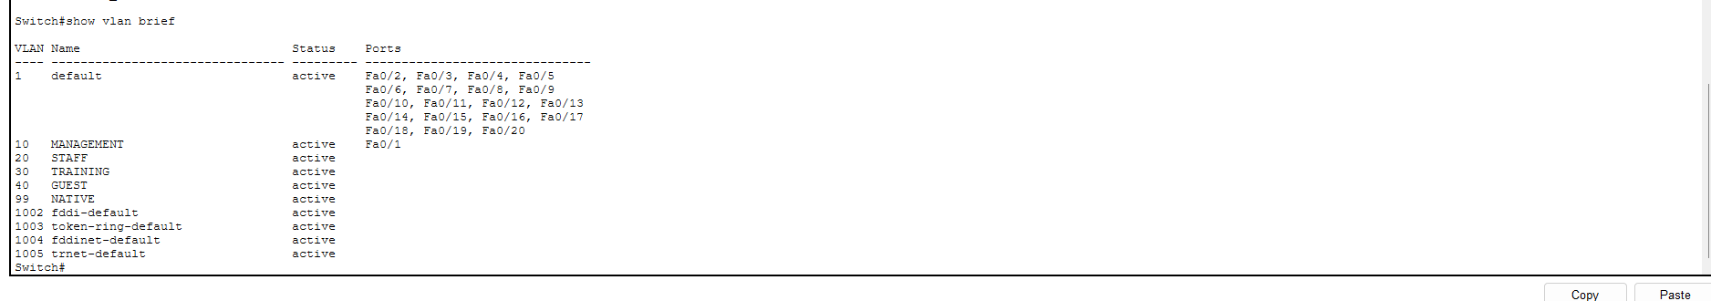

- Trunk Verification

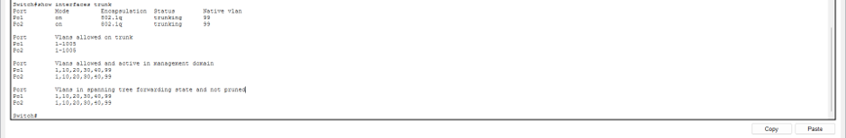

- EtherChannel Verification

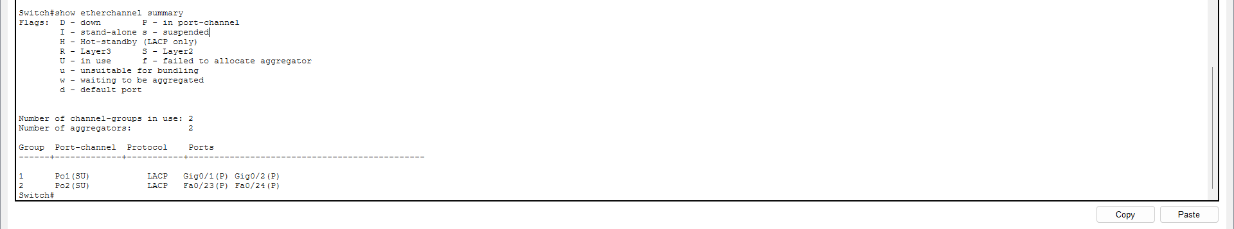

- SVI Verification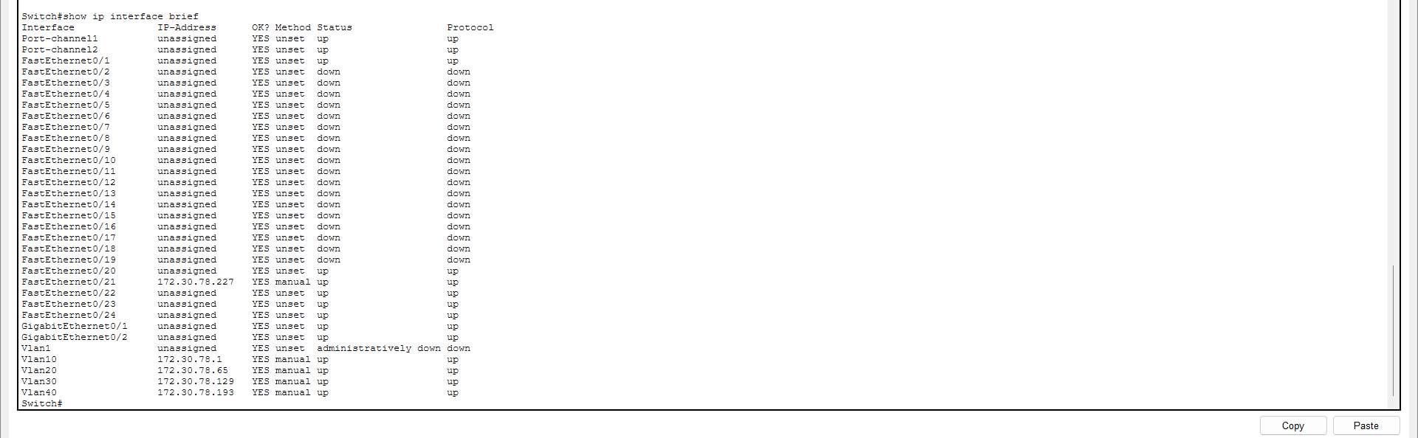

- Management Gateway Test

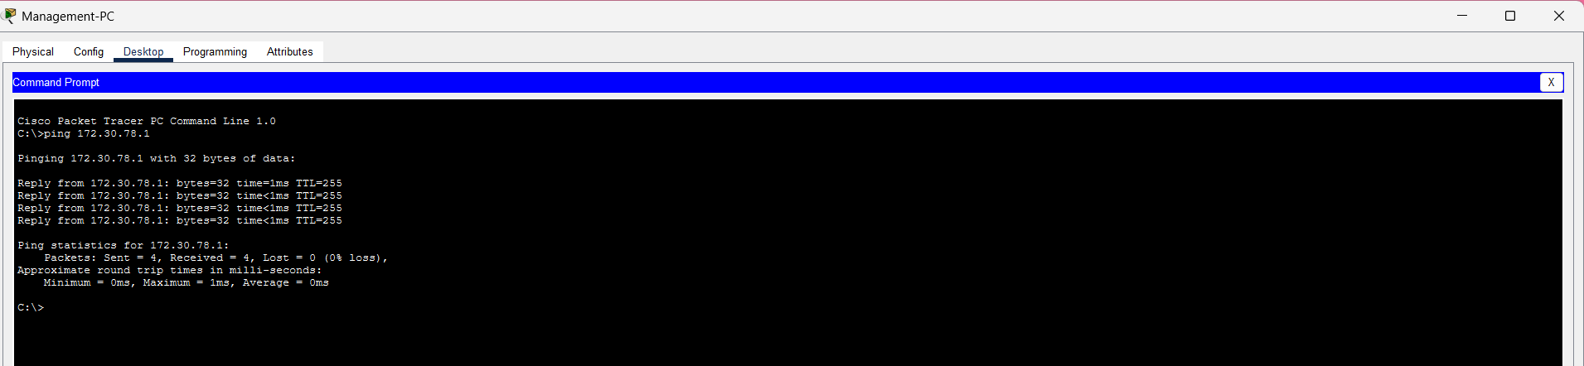

- Staff Gateway Test

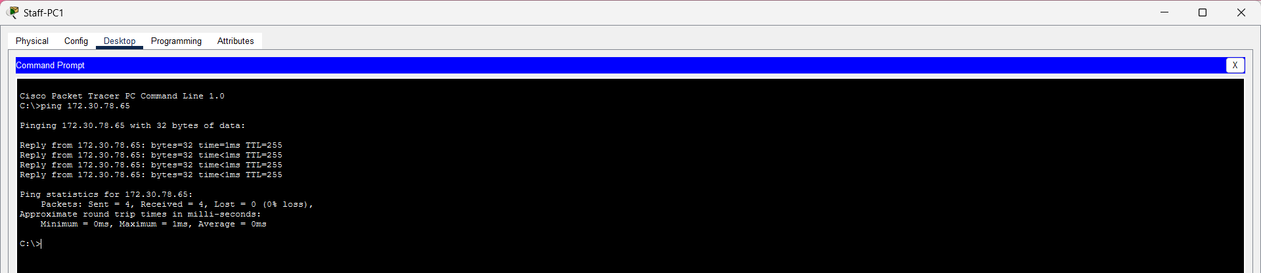

- Training Gateway Test

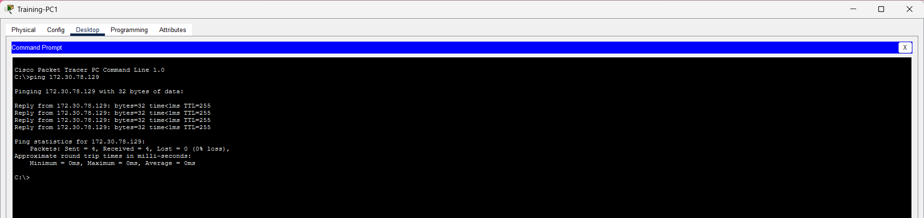

- Guest Gateway Test

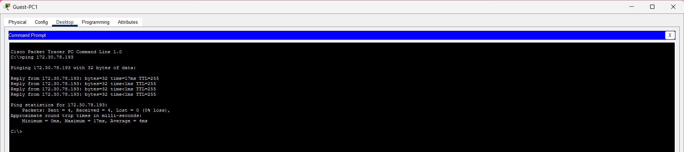

- Inter-VLAN Routing Test
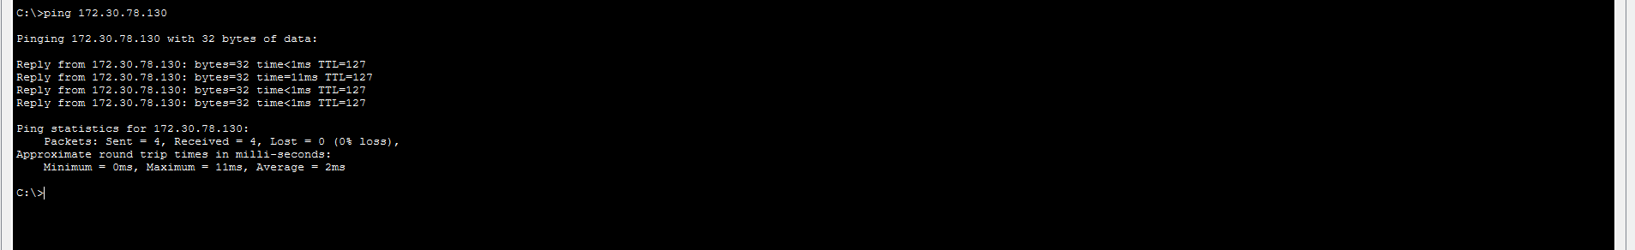

- Final Logical Topology

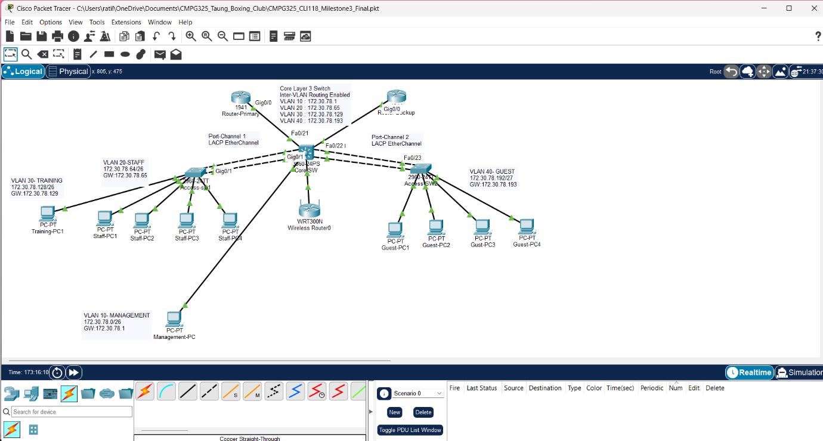

Challenges Encountered
Several challenges were encountered during implementation:
- EtherChannel configuration and verification.
- Correct VLAN assignment of end devices.
- Configuration of trunk links.
- Verification of Inter-VLAN communication.
- Integration of an additional Training VLAN device for testing.
These issues were successfully resolved through troubleshooting and configuration verification.

Project Evaluation
The final solution successfully met the client requirements identified during the design phase.
Implemented features include:
- VLAN Segmentation
- Inter-VLAN Routing
- EtherChannel (LACP)
- Trunking
- Structured IP Addressing
- Connectivity Verification
- Network Documentation
The network is scalable and can support future growth of the organisation.

Conclusion
The Taung Boxing Club network project was successfully designed, implemented, tested and documented in Cisco Packet Tracer. The network satisfies the client requirements and demonstrates effective use of VLANs, Inter-VLAN Routing, EtherChannel and trunking technologies.
Testing confirmed successful communication between devices and VLANs, proving that the implemented solution is functional, reliable and suitable for the organisation's operational requirements.

