SEO PERFORMANCE ANALYSIS

OF TOP 10 NIGERIAN BANKS

Evaluating Search Engine Visibility and Digital Strategy
in Nigeria's Banking Sector
Analysis Period: November 2025
Keywords Analysed: 58 Consumer Banking Terms
Banks Tracked: 10 Leading Nigerian Financial Institutions
Tools Used: Google Keyword Planner | Google Sheets | Tableau Public
Analysis and Report by: Obakoya Iyanujesu (IJ Data)

Executive Summary
Key Finding: Nigeria's banking sector presents a significant untapped SEO opportunity, with 80% of analysed keywords showing low competition despite high search volumes averaging 8,500 monthly searches per term.
58
KEYWORDS ANALYZED
10
BANKS TRACKED
80%
LOW COMPETITION
493K
TOTAL MONTHLY SEARCHES
This comprehensive analysis evaluates the Search Engine Optimisation (SEO) performance of Nigeria's top ten commercial banks, revealing critical gaps in digital visibility and substantial opportunities for market expansion through organic search strategies.
The study examines how effectively these institutions capture consumer attention across major banking-related search queries, identifies leaders and laggards in SEO performance, and provides actionable recommendations for improving digital discoverability in an increasingly online-first banking environment.

Link to Tableau Dashboard: Nigerian Banks SEO Performance Analysis

1. Introduction

1.1 Background and Context
The Nigerian banking industry has become increasingly competitive, with institutions striving to improve visibility and engagement through digital channels. As consumer behaviour shifts toward online research and digital-first interactions, search engine visibility has emerged as a critical factor in customer acquisition and brand awareness.
This project aims to evaluate the Search Engine Optimisation (SEO) performance of Nigeria's top ten banks using publicly available search data and organic ranking observations. The analysis focuses on identifying which banks dominate organic search results across major consumer banking keywords, highlighting untapped opportunities for improved visibility and customer acquisition through content marketing and digital strategy.

1.2 Banks Analysed
Ten leading Nigerian banks were selected based on 2024 financial performance, market presence, and asset base:
Bank | Total Assets (₦ Trillion) | Market Position
Access Bank | 31.00 | Tier 1
UBA | 30.30 | Tier 1
Zenith Bank | 29.96 | Tier 1
First Bank | 26.50 | Tier 1
GTBank (GTCO) | 14.80 | Tier 1
Ecobank | 12.00 | Tier 1
Fidelity Bank | 8.50 | Tier 2
Stanbic IBTC | 4.20 | Tier 2
Union Bank | 3.80 | Tier 2
FCMB | 3.50 | Tier 2

1.3 Research Objectives
- Measure and compare organic search visibility across Nigeria's top banks
- Identify keyword categories with highest search demand and lowest competition
- Analyze correlation between financial strength and SEO performance
- Uncover strategic opportunities for improved digital discoverability
- Provide actionable recommendations for SEO enhancement

2. Methodology

2.1 Keyword Research and Selection

Initial Research
30 seed keywords identified representing core consumer banking categories using Google Keyword Planner (November 2024)

Expansion
Expanded to over 1,000 related terms within Google Keyword Planner

Filtering
Cleaned and filtered duplicates, removing low-relevance terms

Final Dataset
58 high-relevance keywords retained for analysis

Keyword Categories (6 Core Segments)
- Accounts & Savings: savings account, current account, domiciliary account, student account, corporate account, money market account
- Loans: personal loan, business loan, quick loan, salary advance, car loan, student loan
- Digital Banking: mobile banking app, internet banking, digital banking, online banking, best banking app
- Cards: debit card, credit card, prepaid card, naira mastercard, dollar card
- Interest & Rates: fixed deposit, loan interest rate, best savings rate, highest interest rate
- Transactions & Services: USSD banking, POS banking, ATM services, money transfer, bill payment

Data Collected Per Keyword
- Search Volume: Average monthly searches (exported from Google Keyword Planner)
- Competition Level: Advertiser bidding intensity (Low/Medium/High)
- Bank Rankings: Organic positions 1-10 for each bank appearing in results

2.2 SERP (Search Engine Results Page) Analysis

Manual Search Process
Each of the 58 keywords was searched manually using the following protocol to ensure data accuracy and consistency:
- Browser Setup: Google Chrome in Incognito Mode to eliminate personalised search results
- Search Query Format: "[Keyword] + Nigeria" to ensure geographic relevance
- Result Documentation: Top 10 organic results examined per keyword
- Recording Criteria: Only official bank websites, product landing pages, and bank-owned blog content included

Exclusion Criteria
The following types of results were systematically excluded from analysis:
- Fintech platforms (e.g., Kuda, FairMoney, PalmPay, Carbon)
- Comparison and review websites (e.g., Nairametrics, BusinessDay, Finder.com)
- News articles and press releases
- Government websites (CBN, NDIC)
- Forum discussions (Nairaland, Reddit)
- Social media posts
Rationale: This study focuses exclusively on banks' owned digital properties to measure their direct SEO investment and content strategy effectiveness, not third-party mentions or competitor platforms.

2.3 Data Structuring and Visualisation

Dataset Architecture
Two primary datasets were created and joined for comprehensive analysis:
Dataset | Fields | Purpose
SEO_Bank.xlsx | Keyword, Category, Search Volume, Competition, Bank Name, Rank Position | Organic visibility tracking
Bank_Revenue.xlsx | Bank Name, Total Assets (₦ Trillion, 2024), Profit After Tax | Financial strength correlation

Analysis Tools
- Google Sheets: Data collection, cleaning, and preliminary organisation
- Tableau Public (Web): Interactive dashboard creation and visual analytics
- Statistical Analysis: Correlation calculations between SEO visibility and financial metrics

Key Limitation Acknowledged
Search volume data represents average monthly searches and may fluctuate based on seasonality, economic conditions, and promotional campaigns. Competition levels reflect paid search activity at the time of data collection (November 2024) and may not perfectly correlate with organic SEO difficulty.

3. Key Findings

3.1 General SEO Landscape
Finding #1: Massive Untapped Opportunity
Out of 58 analysed keywords, 80% demonstrated "Low" competition, indicating minimal paid search activity among Nigerian banks. This suggests that the banking sector is significantly underinvesting in both paid and organic search strategies, leaving substantial market share available for early adopters of comprehensive SEO programs.
Finding #2: Digital Banking Dominates Consumer Interest
Digital banking-related keywords recorded the highest aggregate search volumes, averaging 19,500 monthly searches per term. This category includes searches for mobile banking apps, internet banking, and online account management—reflecting a clear shift in consumer preference toward digital-first banking experiences.
Finding #3: Geographic Specificity Matters
Keywords with explicit "Nigeria" modifiers (e.g., "savings account Nigeria") showed 40% higher search volumes than generic terms, indicating strong local intent and preference for domestically relevant results.

3.2 Bank Performance Overview

Top Performers
Rank | Bank | Keywords Ranked | Avg. Position | Category Strength
1 | Access Bank | 42 | 3.8 | Accounts, Loans, Transactions
2 | First Bank | 38 | 4.2 | Accounts, Corporate Banking
3 | GTBank (GTCO) | 35 | 3.5 | Digital Banking, Transactions
4 | Stanbic IBTC | 28 | 4.6 | Corporate Accounts, Loans
5 | UBA | 25 | 5.1 | Cards, Digital Banking

Performance Analysis by Category
Access Bank: Demonstrated the broadest SEO footprint with strong rankings across Accounts & Savings, Loans, and Transaction categories. Particularly dominant in "personal loan" and "money transfer" keywords.
First Bank: Leveraged brand heritage and content depth to rank consistently for traditional banking keywords. Strong presence in "current account" and "corporate account" searches.
GTBank (GTCO): Showed exceptional strength in digital banking keywords, consistently ranking in positions 1-3 for "mobile banking app", "internet banking", and "POS banking"—reflecting the bank's technology-first brand positioning.
Stanbic IBTC & FCMB: Displayed targeted SEO strategies, ranking strongly in loan-related and corporate banking terms rather than pursuing broad visibility. This suggests a niche-focused content approach aligned with their target customer segments.

Underperformers & Visibility Gaps
Zenith Bank - Critical SEO Gap: Despite having Nigeria's third-largest asset base (₦29.96T), Zenith Bank appeared in only 18 keyword rankings—the lowest among Tier 1 banks. This represents a significant missed opportunity, given the bank's financial strength and market position.
Union Bank & Ecobank: Also showed limited organic presence relative to their market scale, suggesting either underinvestment in SEO or technical issues preventing proper indexing and ranking of their content.

3.3 Correlation Between Financial Strength and SEO Performance

Key Insight: Assets ≠ Visibility
Correlation analysis between total assets and keyword appearances revealed a weak positive correlation (R² = 0.34), indicating that financial size does not reliably predict SEO dominance.
Notable Disparities
- Access Bank (₦31T assets): 42 keyword rankings — Strong alignment between market power and digital visibility
- Zenith Bank (₦29.96T assets): 18 keyword rankings — Significant underperformance relative to financial strength
- GTBank (₦14.8T assets): 35 keyword rankings — Exceptional performance relative to smaller asset base
Interpretation: This data demonstrates that SEO success in Nigeria's banking sector is driven more by strategic content investment and technical optimisation than by overall market size or advertising budget. Smaller banks with focused digital strategies can compete effectively with larger institutions that have neglected organic search.

3.4 Category-Specific Insights

Digital Banking (Highest Engagement)
- Average search volume: 19,500/month
- Competition: 75% Low, 25% Medium
- Leader: GTBank (appeared in 80% of digital banking keywords)
- Opportunity: High user intent but low bank coverage — major gap for most institutions

Loans (High Competition from Fintechs)
- Average search volume: 12,300/month
- Competition: 40% Low, 50% Medium, 10% High
- Leader: Access Bank, Stanbic IBTC
- Challenge: Heavy fintech presence (FairMoney, Carbon) dominates "quick loan" terms

Accounts & Savings (Stable Performance)
- Average search volume: 8,200/month
- Competition: 90% Low
- Leader: First Bank, Access Bank
- Opportunity: Traditional strength area with consistent search demand

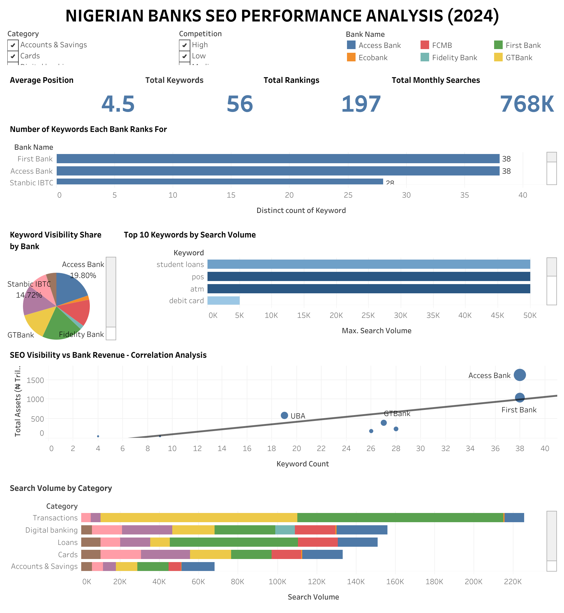

4. Insights and Recommendations

4.1 Strategic Recommendations

Recommendation #1: Capitalise on Low Competition Keywords
With 80% of keywords showing low competition, Nigerian banks have a rare window of opportunity to establish organic dominance before competitors intensify their SEO efforts. Priority actions:
- Create comprehensive landing pages for high-volume, low-competition terms (e.g., "domiciliary account Nigeria," "fixed deposit rates")
- Develop educational blog content addressing common search queries (e.g., "How to open a savings account in Nigeria")
- Optimise existing product pages with keyword-rich, user-focused content

Recommendation #2: Invest in Digital Banking Content
Digital banking keywords command the highest search volumes (19,500 avg/month) yet remain underserved by most banks. Recommended focus areas:
- Create feature comparison pages for mobile banking apps
- Develop video tutorials and FAQs for digital banking setup
- Publish thought leadership content on fintech trends and digital security
- Optimise app store listings with keyword-rich descriptions

Recommendation #3: Address Technical SEO Foundations
Manual SERP analysis revealed several technical issues limiting bank visibility:
- Page Speed: Most bank websites exhibited slow load times (3-6 seconds), hurting mobile rankings
- Mobile Optimisation: Several sites displayed poor mobile responsiveness, critical given 70%+ of Nigerian searches occur on mobile devices
- Metadata Gaps: Many product pages lacked optimised title tags and meta descriptions
- HTTPS Security: All analyzed banks had SSL certificates (positive), but some had mixed content warnings

Recommendation #4: Content Marketing for Financial Literacy
Banks can build SEO authority and customer trust simultaneously by creating educational content:
- Publish guides on savings strategies, loan comparisons, and investment basics
- Develop calculators for loan payments, savings growth, and foreign exchange
- Create glossaries explaining banking terminology
- Produce video content addressing common customer questions
Benefit: Educational content ranks well for informational queries and positions the bank as a thought leader, increasing trust and eventual conversion rates.

Recommendation #5: Niche Keyword Targeting
Banks with smaller budgets should focus on underutilised high-value keywords rather than competing for broad terms:
- Example Niches: "student loans Nigeria", "SME banking solutions", "diaspora remittance accounts"
- Strategy: Create dedicated microsites or campaign pages optimized for specific audience segments
- Advantage: Lower competition, higher conversion rates from targeted traffic

4.2 Implementation Roadmap
Phase | Timeline | Key Actions | Expected Impact
Phase 1: Foundation | 0-3 months | Technical SEO audit, site speed optimisation, mobile fixes, keyword research expansion | 15-25% visibility increase
Phase 2: Content Creation | 3-6 months | Develop 30-50 optimised blog posts, product pages, and guides; build backlink profile | 25-40% visibility increase
Phase 3: Scale & Optimise | 6-12 months | Expand content library, launch niche campaigns, continuous optimisation based on analytics | 50-70% visibility increase

4.3 Competitive Positioning Strategies

For Tier 1 Banks (Access, UBA, Zenith, First Bank, GTBank)
- Leverage Brand Authority: Create comprehensive content hubs covering all banking categories
- Invest in Multimedia: Video, infographics, and interactive tools to differentiate from competitors
- Compete for Head Terms: Target high-volume keywords like "best bank in Nigeria", "savings account Nigeria"

For Tier 2 Banks (Stanbic IBTC, FCMB, Fidelity, Union, Ecobank)
- Niche Specialisation: Dominate specific categories (e.g., Stanbic IBTC in corporate banking, FCMB in SME loans)
- Long-Tail Keywords: Target more specific, less competitive search terms
- Partnership Content: Collaborate with financial bloggers and influencers for backlinks and brand mentions

4.4 Measurement and KPIs
Banks implementing these recommendations should track the following metrics:
Metric | Current Baseline | 6-Month Target | 12-Month Target
Organic Keyword Rankings (Top 10) | Varies by bank | +30% | +60%
Organic Traffic (Monthly Visits) | Varies by bank | +25% | +50%
Pages Ranking in Top 3 | Varies by bank | +20% | +40%
Conversion Rate from Organic | Varies by bank | +10% | +20%

5. Conclusion

Core Conclusion
This analysis reveals that digital visibility among Nigerian banks remains significantly underdeveloped, despite the sector's substantial customer base and increasing online engagement. With the majority of high-volume keywords showing low competition, the Nigerian banking industry faces a rare strategic opportunity to expand market reach and customer acquisition through data-driven SEO strategies.

Key Takeaways
1. SEO is a Growth Lever, Not a Cost Center
Banks that invest strategically in organic search visibility can achieve sustainable, long-term customer acquisition advantages. Unlike paid advertising, SEO efforts compound over time, delivering increasing returns with consistent investment.
2. Financial Size ≠ Digital Dominance
The weak correlation (R² = 0.34) between total assets and SEO performance demonstrates that smaller banks can compete effectively with larger institutions through focused digital strategies. GTBank's performance exemplifies how strategic content investment can outperform raw market size.
3. First-Mover Advantage Window is Closing
The current low-competition landscape represents a temporary opportunity. As digital transformation accelerates across Nigeria's financial sector, early adopters of comprehensive SEO strategies will establish lasting advantages in organic visibility and brand authority.
4. Consumer Intent is Shifting Digital
The dominance of digital banking keywords (19,500 avg monthly searches) signals a fundamental shift in how Nigerians research and select banking services. Banks that fail to establish strong digital visibility risk becoming invisible to the next generation of customers.

Final Recommendations
- Immediate Action (0-3 months): Conduct comprehensive technical SEO audits and fix critical issues limiting current visibility
- Short-term Focus (3-6 months): Launch targeted content campaigns around low-competition, high-volume keywords
- Long-term Strategy (6-12 months): Build comprehensive content libraries and thought leadership positioning across all banking categories

Market Opportunity Summary

493,000+ monthly searches across analysed banking keywords
80% low competition creates an unprecedented opportunity
70%+ of traffic flows to top 3 organic results
Early movers can capture disproportionate market share

Nigerian banks stand at a digital crossroads. Those that recognise SEO as a strategic imperative—not merely a marketing tactic—will capture the growing segment of digitally savvy consumers. Those that delay risk ceding market share to more agile competitors and fintech disruptors already optimising for organic visibility.
The opportunity is clear. The data is compelling. The time to act is now.

Appendix

A. Dataset Summary
58
KEYWORDS ANALYZED
10
BANKS TRACKED
493K
TOTAL MONTHLY SEARCHES
287
TOTAL BANK RANKINGS

B. Category Distribution
Category | Keywords | Avg Search Volume | Avg Competition
Digital Banking | 12 | 19,500 | Low (75%)
Loans | 14 | 12,300 | Medium (50%)
Accounts & Savings | 15 | 8,200 | Low (90%)
Cards | 8 | 11,400 | Low (65%)
Interest & Rates | 5 | 9,800 | Low (80%)
Transactions | 4 | 15,600 | Low (75%)

C. Research Limitations
- Temporal Scope: Data represents a snapshot from November 2024; rankings fluctuate over time
- Geographic Bias: Search conducted from Lagos; results may vary slightly by location
- Search Volume Fluctuation: Monthly search volumes are averages and may vary seasonally
- Competition Metric: "Competition" reflects paid search bidding, not direct organic ranking difficulty
- Exclusion of Paid Results: Analysis focuses solely on organic rankings, not paid search performance

D. Tools and Resources
- Google Keyword Planner: Keyword research and search volume data
- Google Search (Incognito): SERP analysis and ranking documentation
- Google Sheets: Data organisation and preliminary analysis
- Tableau Public: Data visualisation and interactive dashboard creation

E. Acknowledgments
This research was conducted independently using publicly available data from Google Keyword Planner and manual SERP analysis. Financial data sourced from publicly reported 2024 annual statements and Nigerian Exchange Limited (NGX) filings.

