**Yaren Medion Un Avathar**

An exploration of Vampires as lower level monsters in Amtgard V8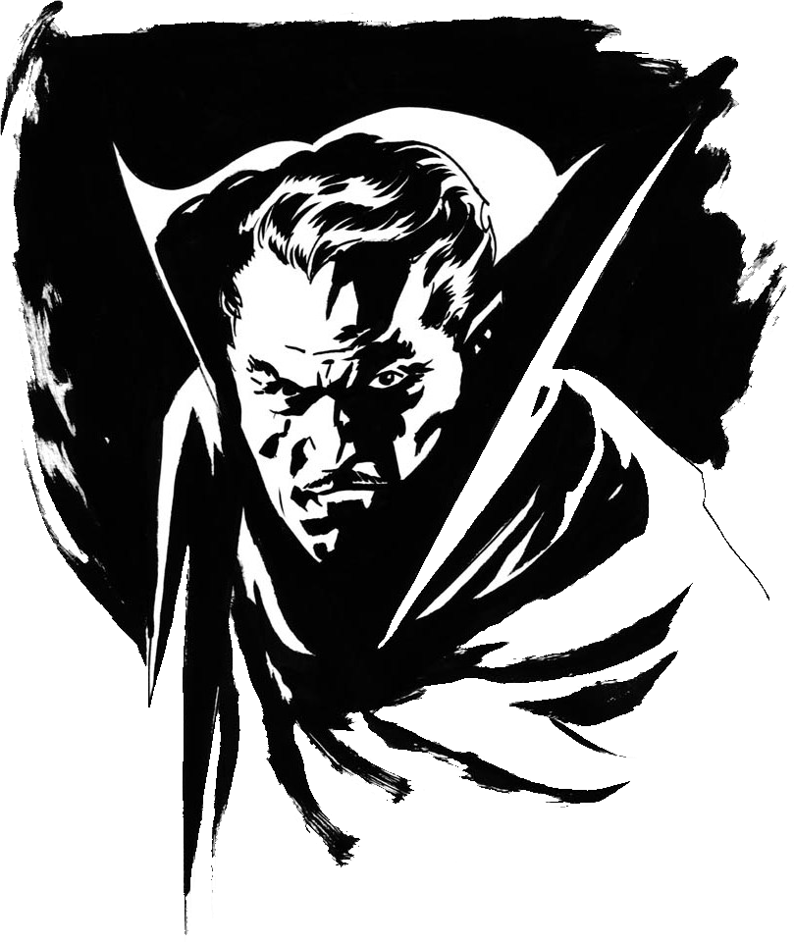

**MONSTER NOTES (Abbreviated From Dor Un Avathar X)**

|  |
| --- |
|  |

**GENERAL MONSTER RULES**



1. This book is not intended to be a standalone set of rules. It must be used in conjunction with the Amtgard Rules of Play Version 8, and it assumes a basic familiarity with those rules. General rules (such as States and Class Abilities) are not duplicated in this book. The Rules of Play supersedes all Monster supplements and handbooks in case of disputes. Nothing in this book replaces the rules contained in the Rules of Play, and everything in this book is optional, to be used at the discretion of the person running the game.
   1. Monsters may not unbalance a battlegame and must show a willingness to play in character.
   2. Monster Abilities may be removed at the Reeve’s option to help balance regular battlegame play.
   3. Monsters may not voluntarily “take a death” in order to prevent players from completing an objective or to gain a battlefield advantage. If the Scenario rules give Monsters an advantageous Respawn, those Monsters may not voluntarily

“take a death” to speed up their downtime or regain per-life abilities.

1. Monsters are generally treated as separate classes. Monsters may not stack a standard class in addition to its Monster entry unless the Monster has the Player Class Trait or this is otherwise specified as allowed.
2. All rulebook spells and abilities affect Monsters in the same way they would a standard player class, unless specified otherwise. This is usually specified using the Altered Effect ability.
3. Monsters may not use Magic Items unless granted them by an ability or as part of a quest or other special scenario.
4. Monsters generally may not wear enchantments from other players. Monsters that can wear enchantments from other players are specifically noted as being able to do so.

**MONSTER FORMAT**



Monsters detailed in this volume follow a distinctive format, each having similar entries, as detailed below.

**Description:** This includes physical descriptions and role-playing tips.

**Garb:** The distinguishing features of a particular Monster.Players should endeavor to look as much like this description as possible. Items listed as “Suggested” are optional, including gender suggestions. All monsters are required to carry a copy of the monster entry and wear a silver sash in addition to any listed Garb requirements. Exception: If the person playing a monster has excellent monster garb that leaves no doubt (from a distance) what monster they are playing as, then the game designer may waive the silver sash requirement

**Requirements:** Lists any in game restrictions on who mayplay the Monster, such as Knight only.

**Type:** There are a number of Monster types, each with specialqualities, including certain Immunities, Vulnerabilities, and other special rules. Monsters may have several types, and the effects are cumulative unless indicated otherwise in the specific Monster entry.

**Humanoid:** Monsters in this category generally have twoarms, two legs, and walk upright.

Note: Although not considered monsters, players of any standard class are considered Humanoid for the purpose of game effects.

**Undead:** These are the walking dead and the restless spiritsof those past.

Immunity (Command, Death)

**Level:** This entry indicates the minimum level in the MonsterClass that a player must have in order to play the Monster in a regular battlegame. Questmasters and game designers may allow a player to play a Monster regardless of the player’s actual Monster level. Only Battlegame Monsters have this entry

**Power Rating:** This entry indicates the monsters powerrelative to other monsters and is listed on a scale of 1-10. The higher the Power Rating, the stronger the monster.

**Armor:** Indicates the number of points and types of armorthe monster has. Worn armor points require rated, approved armor constructed using the guidelines in the Rules of Play.

**Shields:** Here is the largest shield the monster may use. AMonster may always choose to use a shield smaller than the type listed. If no shield types are listed, the Monster may not use any shields.

**Weapons:** This lists the specific categories of weapons themonster may use. If a weapon category is listed as Single, the monster may only wield one of that weapon type at a time, though the monster may carry more.

**Abilities:** This is a list of the various Abilities the Monsterhas access to.

**Vulnerabilities:** A list of limitations, restrictions, andweaknesses the creature has. This entry may be omitted if the creature has no significant vulnerabilities.

**Notes:** This section is used to explain and clarify some of the design choices made when creating specific monsters, and to indicate source or basis for different concepts as needed.

|  |
| --- |
|  |

**THE VAMPIRIC MENACE**

**The Vampire Thrall**

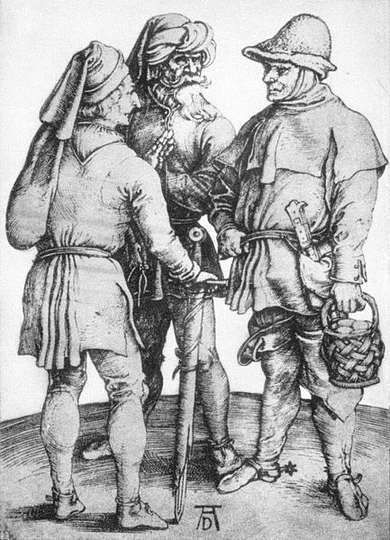**Description:** These poor souls are mostly peasants enslaved under the control of a more powerful vampire. Generally used for fodder (both in terms of food and on the battlefield), a special few may still be inducted into the ranks of the undead should they survive long enough.

**Garb:** Silver sash, dirty peasant garb.

Suggested: Symbol identifying their master.

**Type:** Humanoid

**Power Rating:** 0.5

**Level:** 1

**Armor:** 1 (Worn)

**Shields:** Small

**Weapons:** Single short, Dagger

**Abilities:**

Sheer Numbers (Ex) 2/life

**Vulnerabilities:**

Added Effect (T) [Magic]: If killed by any magic attack or effect, the thrall becomes Cursed and cannot activate Sheer Numbers

**NOTES**

This is intended to be the lowest monster in a vampire army – the peasant. It’s basically a Goblin with a little reworking. Thralls add an option to take a dagger but lose the goblin’s bow. They also lose fragile but become cursed if Killed by magic, which also prevents them using sheer numbers and forces a respawn. They’re designed as a general meat-grinder monster for the vampires – high numbers but low abilities. Like goblins.

For use in Vampire army battle games, this monster would gain the additional ability ‘Enchantable’, which would also suppress their sheer numbers. This would allow higher level vampires to use their spells and enchantments on a few favored thralls but by doing so they would become unique monsters and not subject to the effects of sheer numbers. This also allows for a vampire army to function effectively, since without targets for abilities the higher-level vampires lose the chance to use them.

**VAMPIRE FLEDGLING**

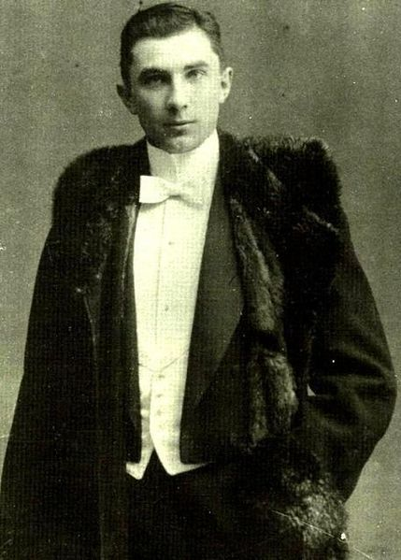**Description:** These are the newest of the vampires, and at this stage the curse of vampirism has taken hold and begun to make its presence felt. They may be just one step above a thrall, but it’s a big step to have taken. These vampires are perhaps the least subtle and most aggressive since they must carve out their place in the world quickly to avoid destruction.

**Garb:** Silver sash, make-up, fangs, dark garb.

**Type:** Undead

**Power Rating:** 1.5

**Level:** 2

**Armor:** 2 (Worn)

**Shields:** Small

**Weapons:** All Melee

**Abilities:**

Immune to Command (T)

Immune to Death (T)

Awe (M) 1/life

Steal Life Essence (Ex) 1/life

**Vulnerabilities:**

Cursed (T) – Their Steal Life Essence works through this.

**NOTES**

The Fledgling vampire is where the undead template starts to appear, granting them immunity to command and death. Since there are no major abilities a fledgling would have other than a form of presence, Awe seems to be an appropriate power for those not yet smart or skilled enough to work in the shadows and steal life essence works as a logical feeding ability as well as being useful for one of the battle games.

At this point, Fledglings are most comparable to a level 2 Paladin with Look the Part more than anything else. However, Fledges get reduced armor and shield compared to Paladins, and trading the Paladin’s Heal for SLE (requiring them to kill in order to heal) and removing any other form of healing feels true to their Vampire nature and an appropriate trade off (or more accurately, trade down).

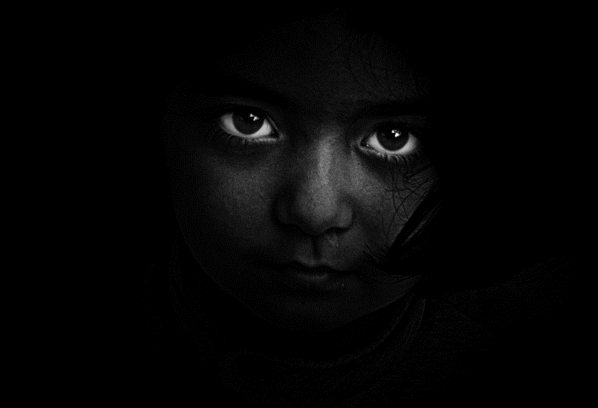**VAMPIRE APPRENTICE**

**Description:** By this stage, the weak have been culled and these vampires are the remainder, far more subtle and skillful than their fallen brethren. This stage of un-life is marked by subtlety and stealth, the vampire cannot pass for mortal as easily as they once could and are more attuned to the world of darkness than the world of light. Now they are as much hunted as they are hunters.

**Garb:** Silver sash, Make up, Fangs, Dark garb,

Suggested: cloak.

**Type:** Undead

**Power Rating:** 2

**Level:** 3

**Armor:** 2 (Worn)

**Shields:** Small

**Weapons:** All Melee

**Abilities:**

Immune to Command (T)

Immune to Death (T)

Steal Life Essence (Ex) 2/life

Blink (Ex) 1/life Charge x 5

Tracking (Ex) 1/life Charge x 5

Hold Person (Ex) 1/life

**Vulnerabilities:**

Cursed (T) – Their Steal Life Essence works through this.

**NOTES**

Apprentice marks a shift from aggression to subtlety and so the abilities change accordingly. Steal Life Essence uses increase to show power rise and add the ability to charge their shadow play abilities quicker. Awe is replaced by Hold Person (giving them a STAY! Rather than a GO! Power), and Blink and Tracking are added to cover their access and manipulation of the shadows – not only can they enter them, but they can force others out!

This template is based on a mix of Raptor and Zombie.

**LESSER VAMPIRE**

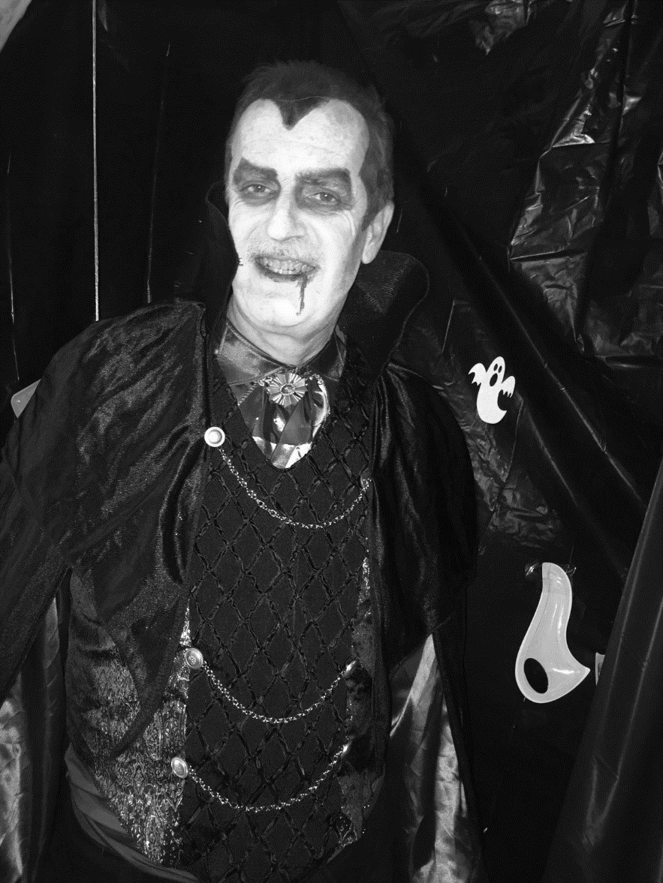**Description:** The last step before becoming a full creature of the night, at this point the vampire is integrating their newly mastered undead abilities with the skills they possessed in life to try and find some form of balance. Vampires at this level have an almost unpredictable skill set and are generally well versed in their most effective powers.

**Garb:** Silver sash, Make up, Fangs, Dark garb,

cloak.

**Type:** Undead

**Power Rating:** 2.5

**Level:** 4

**Armor:** as player class

**Shields:** as player class

**Weapons:** All Melee

**Abilities:**

Immune to Command (T)

Immune to Death (T)

Steal Life Essence (Ex) 2/life

Player Class (Any class the player has levels in, capped at 2)

Enchantable

**Vulnerabilities:**

Cursed (T) – Their Steal Life Essence works through this.

**NOTES**

This is the most viable build I can determine to move towards the Dor un Avathar X Vampire. By capping the player class at 2 there are still some abilities available, but not the full range that a true Vampire would have access to. It also shifts the other abilities of the vampire back towards the original concept and keeps a suitable progression. While I would love the flexibility of being able to say, “Any class at level 2”, that seems rife for abuse and so limiting them to classes they should know fixes that issue. Making this level enchantable also adds a nice little bump without having to overpower them.

They still have steal life essence at this point (instead of Adrenaline, which they receive as true Vampires), because it allows them to also fuel their player class powers where Adrenaline is simply healing. Given there are few low-level powers that are seriously abusable (Confidence and Sever Spirit, both of which would be very in character anyway) or that could be abused through Experienced (Corrosive Mist maybe, also pretty in character), it seems safe enough to keep it.

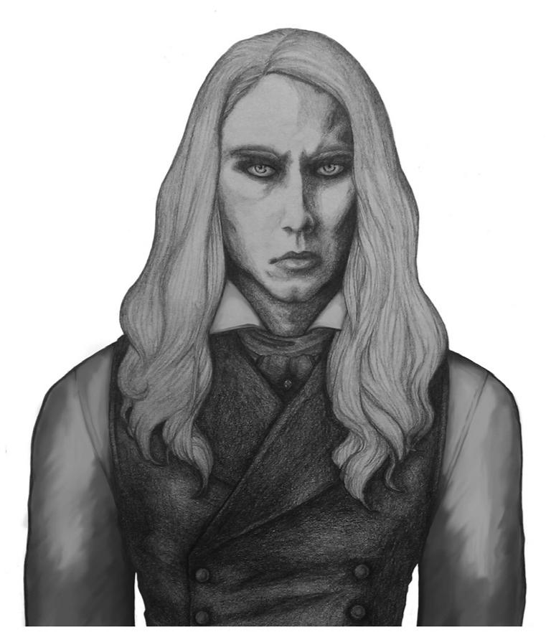**VAMPIRE (From Dor un Avathar)**

**Description:** Vampires are the ultimate form of parasite.They sustain their undead immortality with the blood of the living. Provided with regular “meals,” a vampire could virtually live forever.

**Garb:** Silver sash, white make-up or mask, fangs,

cloak. AND as per Player Class.

**Type:** Undead

**Power Rating:** 3

**Level:** 5

**Armor:** As per Player Class

**Shields:** As per Player Class

**Weapons:** As per Player Class

**Abilities:**

Immune to Command (T)

Immune to Death (T)

Enchantable (T)

Vampirism (T)

Player Class (T) (Any Class, at player’s current

level in that Class)

**Limitation:** A Vampire’s Enchantment limit is lowered by 1.

**NOTES**

This is the Dor un Avathar vampire – I take no credit for writing it, it is merely included here for comparison purposes.

**SCENARIO & BATTLE GAME IDEAS**

Obviously – Vampire Army. One side are all vampires, the other side are thralls. Fight to the Death (or the More Death, as appropriately)

Restrict vampires by forcing them to level up during games - Start all non-thrall vampires at level 2 Fledglings and they must use Steal Life to level up. If a Fledgling uses Steal Life, then instead of recharging an ability or regaining a wound they may power themselves (Incant: Your blood empowers my body!) and return to their respawn point. Once there, they may switch to the next level of vampire abilities and can repeat this process until they reach level 5. They would remain that level even if they were killed unless another vampire used Steal Life on them, in which case they would either drop down a level or return to fledgling status (Reeve’s call, depending on the flow of the game and players). This allows for a lot of dynamic switching between abilities but can become very complicated quickly, especially once players start hitting level 5. I would expect most players to stay as fledglings or even thralls most of the time for this.

Power down the Vampires – Similar to the concept above, but in reverse. When a vampire respawns it loses a level and the associated abilities until eventually it’s a thrall. Dead thralls are shattered. Definitely seems like a challenge to be getting weaker each death!

Other players as game objectives – Split into teams (can be vampires, hunters or a mix). Capture players from other teams by killing and either ‘biting’ or ‘cleansing’ for a 5 count over the corpse. Players captured then rise and fight for their new team.

Other players as *surprise* game objectives – Same as above, but don’t tell players there’s a vampire on their team!

Public Domain Artwork used:

Cover Art Dracula – Vampire by Thecount68 (Retrieved via WikiCommons)

Vampire Thrall Three Peasants by Albrecht Durer (Retrieved via WikiCommons)

Vampire Fledgling Bela Lugosi aged 18 (Retrieved via WikiCommons)

Vampire Apprentice Retrieved from Pixhere - https://pxhere.com/en/photo/938342

Lesser Vampire Retrieved from Pixhere - https://pxhere.com/en/photo/1059630

Vampire Art from Dor Un Avathar X by Eisley Darkjester