A Project Report on
Rama Real estate



by:

Meet Sakariya meetsakariya101@gmail.com
Mayank Vaghasiya mayankvaghasiya@gmail.com

Submitted in partial fulfillment of the requirements for the degree

BCA
September 2023-24

Guided By
Ms. PITUKUMARI BERA

Bachelor of Computer Application
Christ College, Rajkot
(Affiliated to Saurashtra University, Rajkot 360 005)

22
Certificate
We hereby certify that the work which is being presented in the BCA SEM-5 project report entitled
“Rama estate”, in partial fulfillment of the requirements for the award of the Bachelor of Computer Application and submitted to the Dept. Computer Application, Christ College, Rajkot is an authentic record of our own work carried out during a period from November 2023 to September 2024 under the supervision of Ms. Pintukumari Bera.

Signature of Students

1.Meet Sakariya
[003203213123]

2.Mayank Vaghasiya
[003203213113]

This is to certify that the above statement made by the candidates are correct to the best of my knowledge.

Head Guide
Dr. Shailendrasinh Jadeja Ms. Pintukumari Bera
Dept.of Computer Application Dept.of Computer Application
Christ College, Rajkot Christ College, Rajkot

Acknowledgement
When we embarked this project, it appeared to us as onerous task. Slowly as we progressed, we did realize that we were not alone after all. We wish to express our gratitude to Rev.Dr.Fr.Jommon Thommana, Director of CHRIST COLLEGE, Dr. Yvonne Fernandes, principal of CHRIST COLLEGE and all faculty members, Project guide who have extended their kind help, guidance and suggestion without which it could not have been possible for us to complete this project report.

Our sincere thanks to our faculty members Ms. Kruti Kotak for offering us all kinds of support and help in preparing the project. We are deeply indebted to our guide Ms. Pintukumari Bera for not only her valuable and enlightened, guidance but also for the freedom she rendered us during this project work.

We are thankful to our group members and other classmates, well-wishers who with their magnanimous and generous help and support made it a relative easier affair. Our hearts go out to our parents who bear with us all the trouble we caused then with smile during the entire study period and beyond.

Meet Sakariya

Mayank Vaghasiya

BCA-September 2023
CHRIST COLLEGE, RAJKOT

Preface
The project named "Rama Estate" eliminates offline efforts for buying and selling goods (Products) and promotes online platform on which above things can be done in few clicks. With this module, owner can directly sale their goods and products online.
Which minimizes the seller efforts of going to a agency and contact with agent and also buyer effort of higher agent to search for property.

Table of Contents
No | Description | Page no.
 | Introduction  - Problem Statement  - Project Overview  - Purpose of the Project | 5  5  5
 | Existing System  2.1 Gap Analysis  2.2 Need of Application  2.3 Feasibility Study | 6  6  6
 | Requirements | 7
 | SDLC | 8
 | Diagrams  5.1 E-R Diagram  5.2 Use Case Diagram  5.3 Activity Diagram  5.4 Process Flow Diagram | 9  11  12  14
 | Data Dictionary  6.1 Data Flow Diagram  6.2 List of Tables | 16  20
 | Project Overview  7.1 Screen shots  7.2 Code | 21  26
 | Testing and Results  8.1 Testing  8.2 Test Case (Result) | 36  36
 | Conclusion  9.1 Future Enhancement  9.2 Limitations | 37  37
 | Bibliography | 38
 | References  11.1 Web References  11.2 Books | 39  39

1. Introduction

  - Problem Statement
This system developed will reduce manual work and avoid redundant data . This system will help
to find residential property and save time . System will find reliable ,fast and nearby property.

  - Project Overview
Real Estate booking site have main two type of module.
1)Admin and seller can add property and all property managed by admin and seller own property manage by seller.
2) User can view property and add to wishlist and book appointment with ower of property.

  - Purpose of the Project

To provide best property without ant agent . Buyer can direct fix appointment with seller.

System will provide best , fast and reliable property.

- Existing System

  - Gap Analysis
Old System:
The older system was working slowly as compare to the current system of real estate booking site.Older system need more cost.
Current System:
The newer system has very good interface for the farmer, customer and admin of the system which makes it easy to use.
  - Need of Application
In our life everyone need property for resident. And this site provide residential home without any agent.

  - Feasibility Study
Technical Feasibility: this project is operational feasible as the website accessed by the admin to insert, update and delete the property on this website .
Operational Feasibility: The website is also technically feasible as it fulfills the hardware and software requirements

- Requirements
- Hardware
    - RAM : 2 GB or Higher
    - HDD : 80 GB or Higher
    - System Type : 32 Bit or Higher
- Software
      - Operating System : win 7 or Higher
      - Frontend : HTML, PHP, CSS
      - Backend : PHP
      - Database : MYSQL

      - MS office : PowerPoint - Presentation
: MS Word - Documentation
: MS Visio - Diagram

- SDLC

- Diagrams
  - E-R Diagram
List of Figures

  - Use Case Diagram

  - Activity Diagram
List of Figures

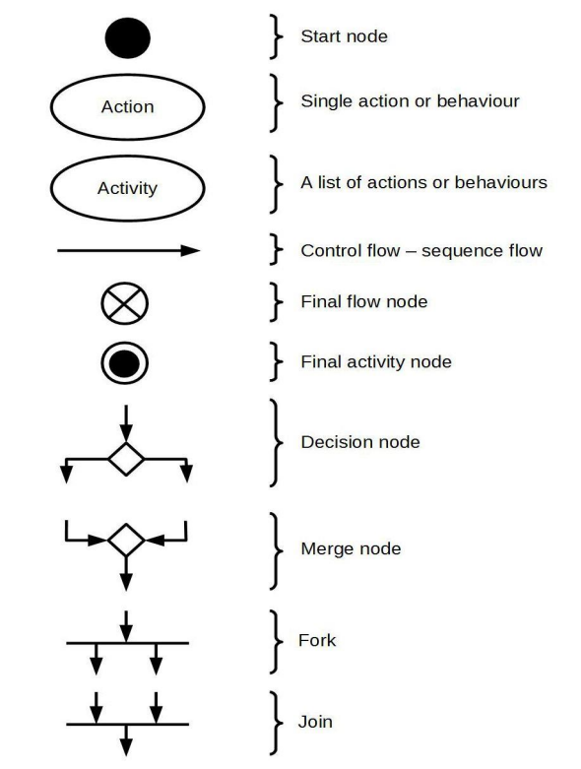

Activity Diagram(Admin)

Activity Diagram (User)
  - Process Flow Diagram
List of Figures

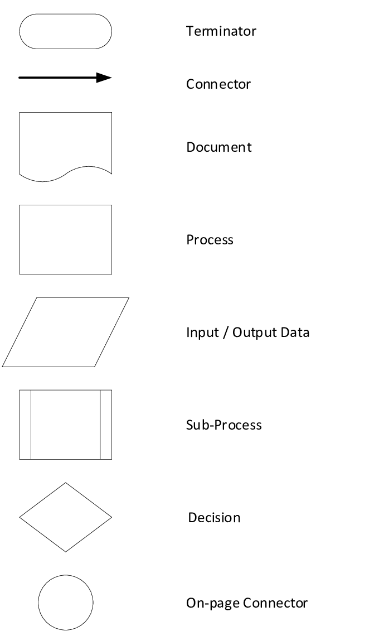

Process Flow (Admin)

Process Flow (Seller)

Process Flow (Buyer)

- Data Dictionary

  - Data Flow Diagram
A DFD also known as “bubble chart” has the purpose of clarifying system requirements and identifying major transformations. It shows the flow of data through a system. It is a graphical tool because it presents a picture. The DFD may be partitioned into levels that represent increasing information flow and functional detail. Four simple notations are used to complete a DFD.

DATA FLOW

The data flow is used to describe the movement of information from one part of the system to another part. Flows represent data in motion. It is a pipe line through which information flows. Data flow is represented by an arrow.

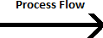

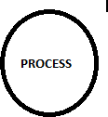
PROCESS
A circle or bubble represents a process that transforms incoming data to outgoing data. Process shows a part of the system that transforms inputs to outputs.

EXTERNAL ENTITY

A square defines a source or destination of system data. External entities represent any entity that supplies or receive information from the system but is not a part of the system.

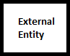

DATA STORE

The data store represents a logical file. A logical file can represent either a data store symbol which can represent either a data structure or a physical file on disk. The data store is used to collect data at rest or a temporary repository of data. It is represented by open rectangle.

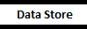

OUTPUT

The output symbol is used when a hard copy is produced and the user of the copies cannot be clearly specified or there are several users of the output
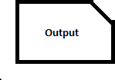

Dfd 0th level

Dfd 1st Level(Admin)

Dfd 1st level (Buyer)

Dfd 1st level (Seller)

Dfd 2nd level for 1.0(login)

Dfd 2nd level for 2.0(registration)

  - List of Tables

    - Admin

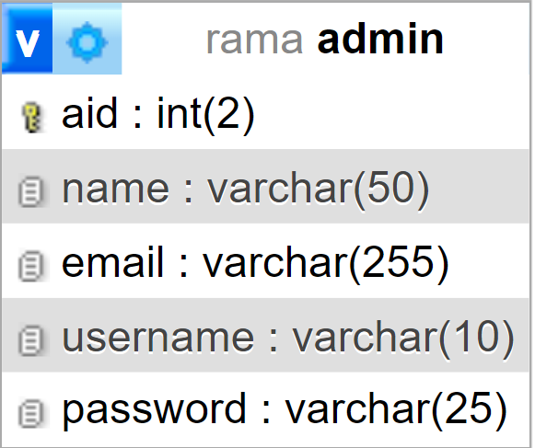

    - User

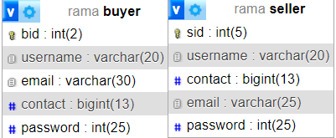

    - Contact us

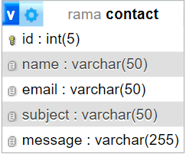

    - Property info

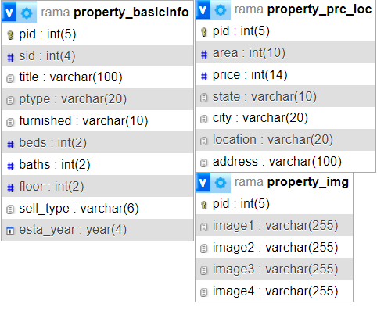

    - Wishlist

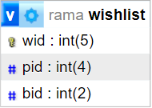

    - Appointment

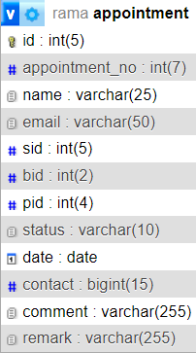

- Project Overview

  - Screen Shots
    - Login Page
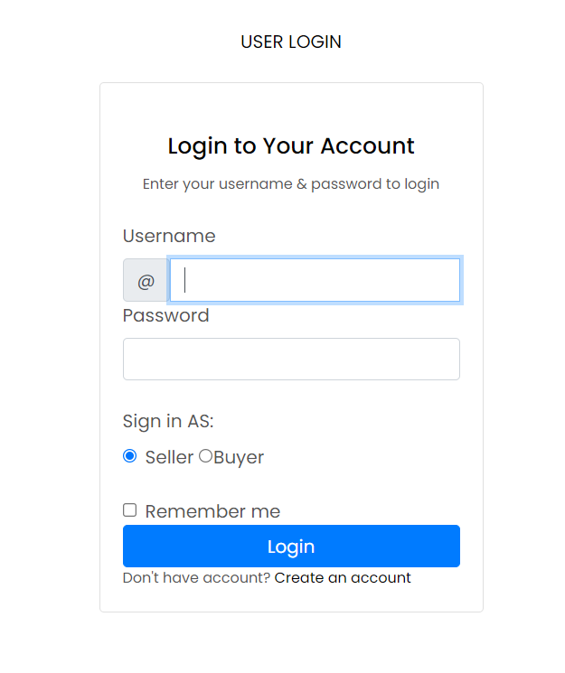

    - Registration
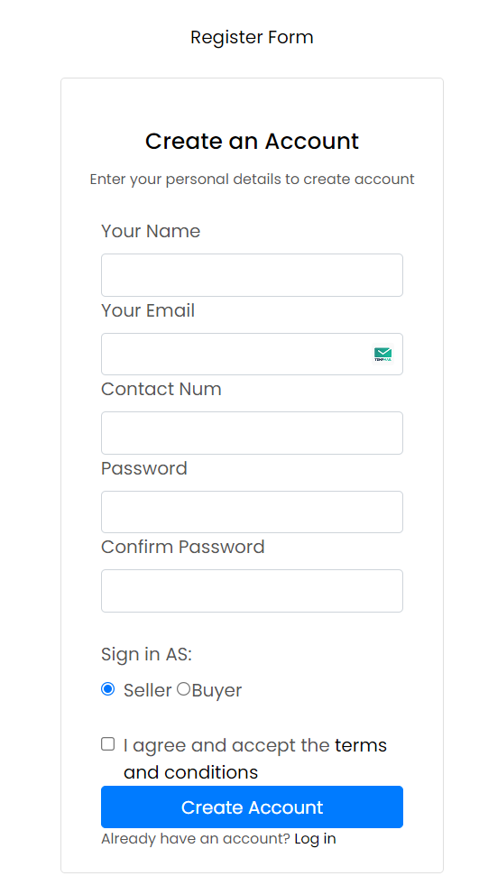

    - Add property

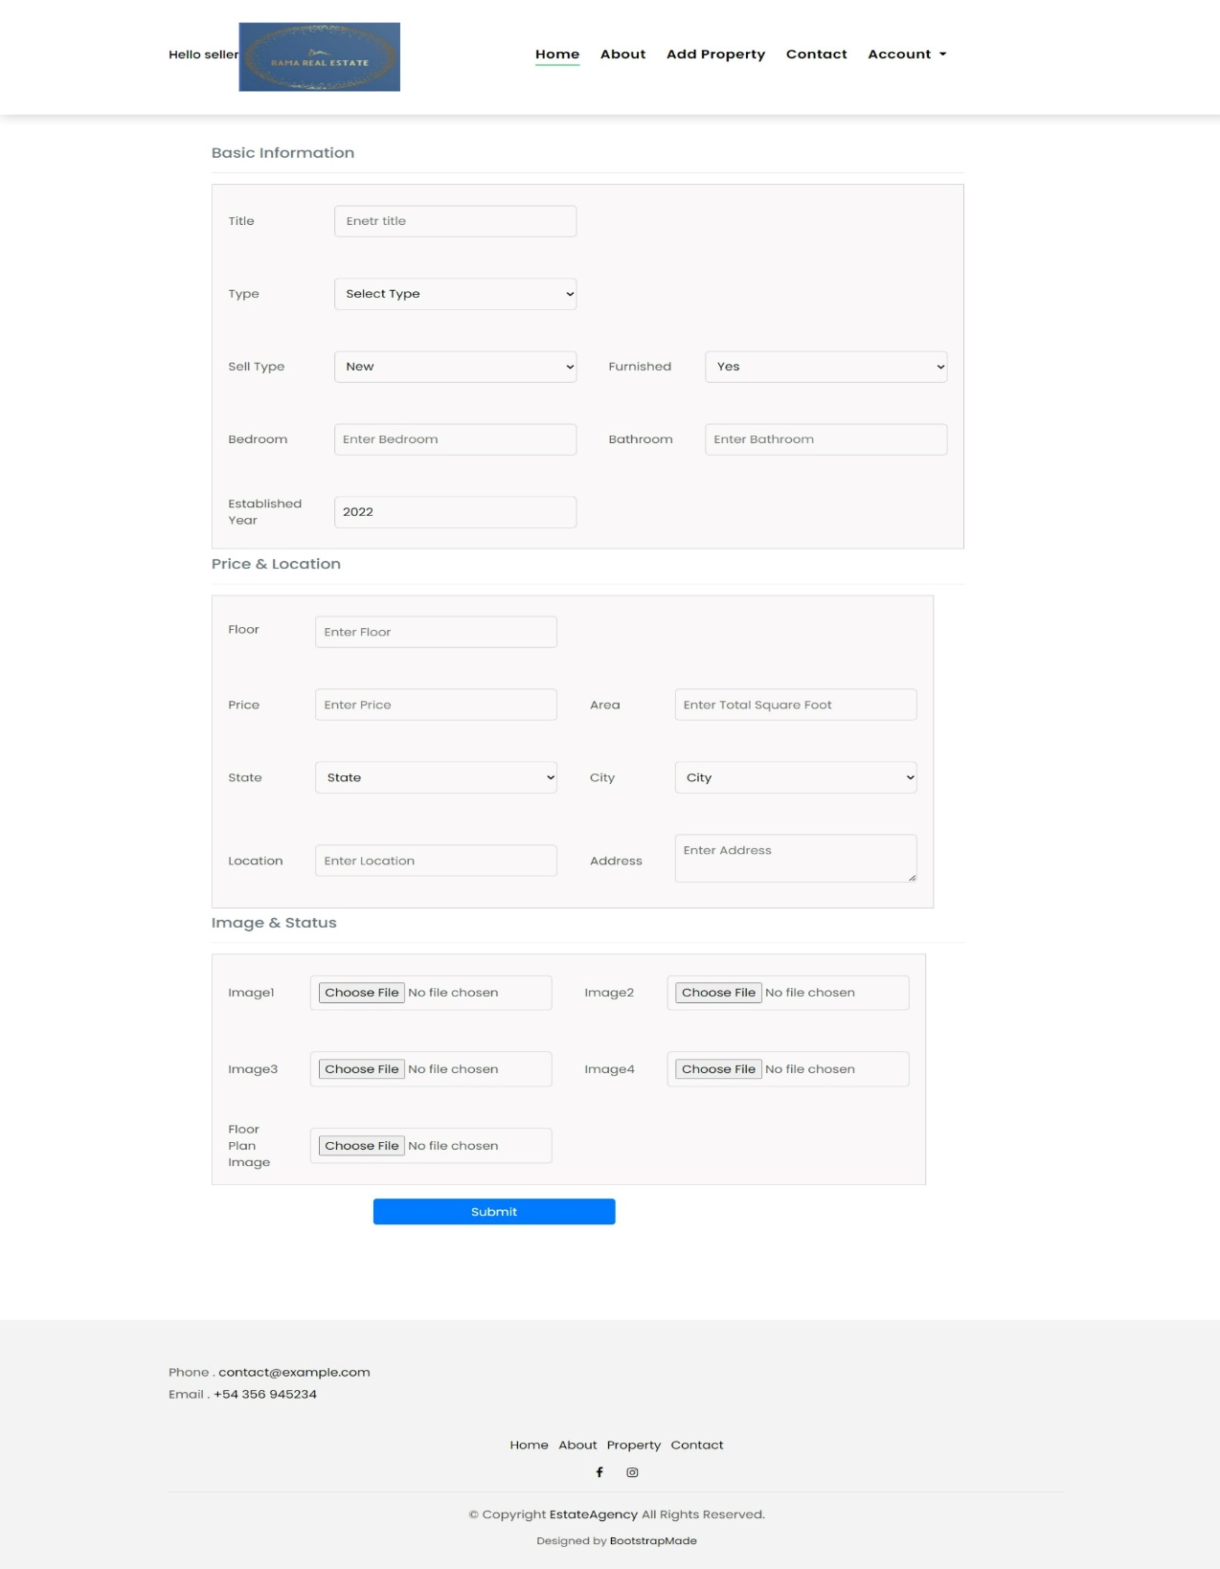
    - Account

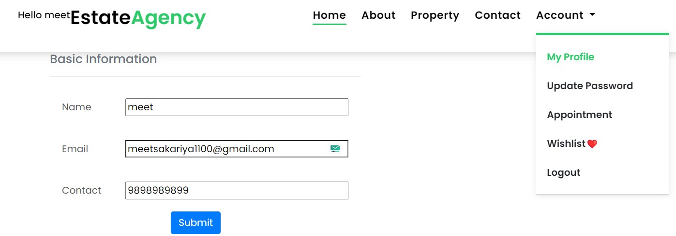
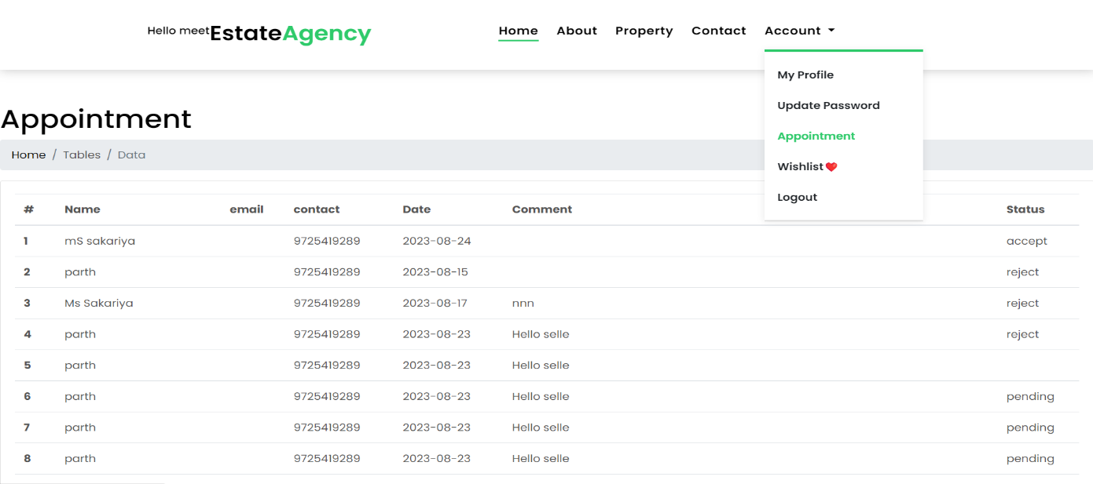

    - Dashboard

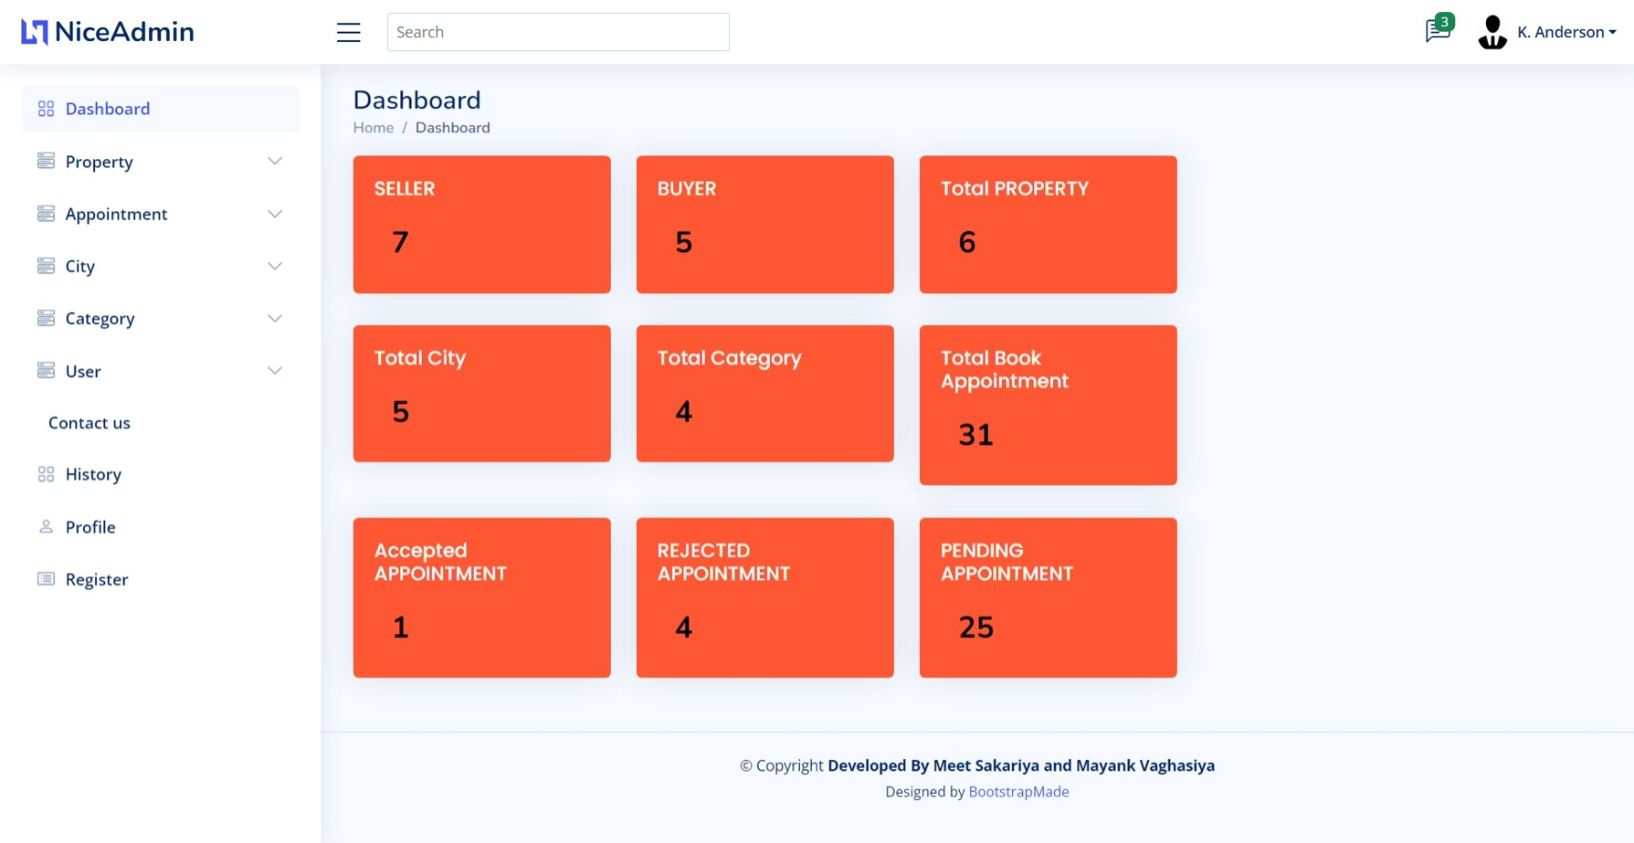

    - Manage Property
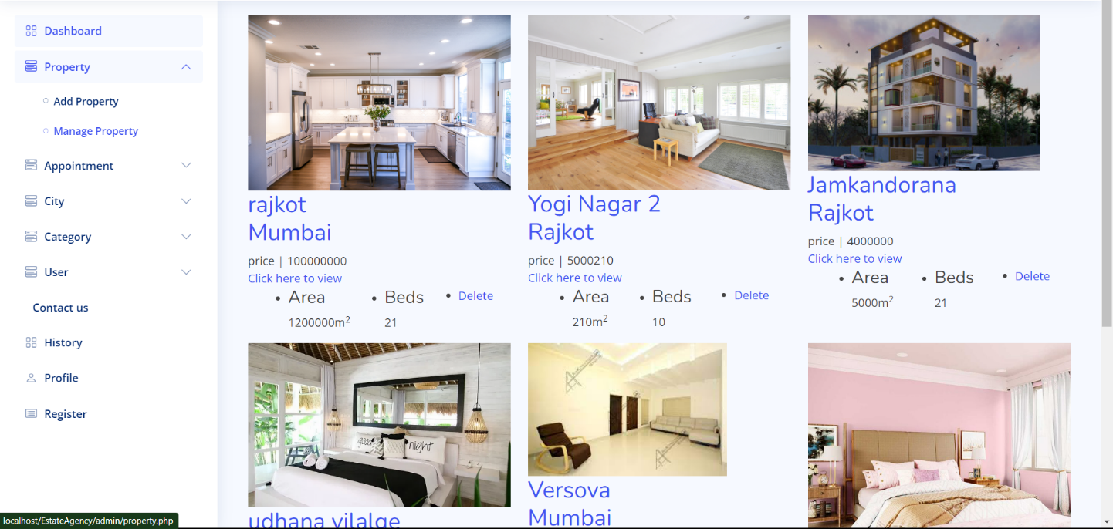

    - Manage Appointment

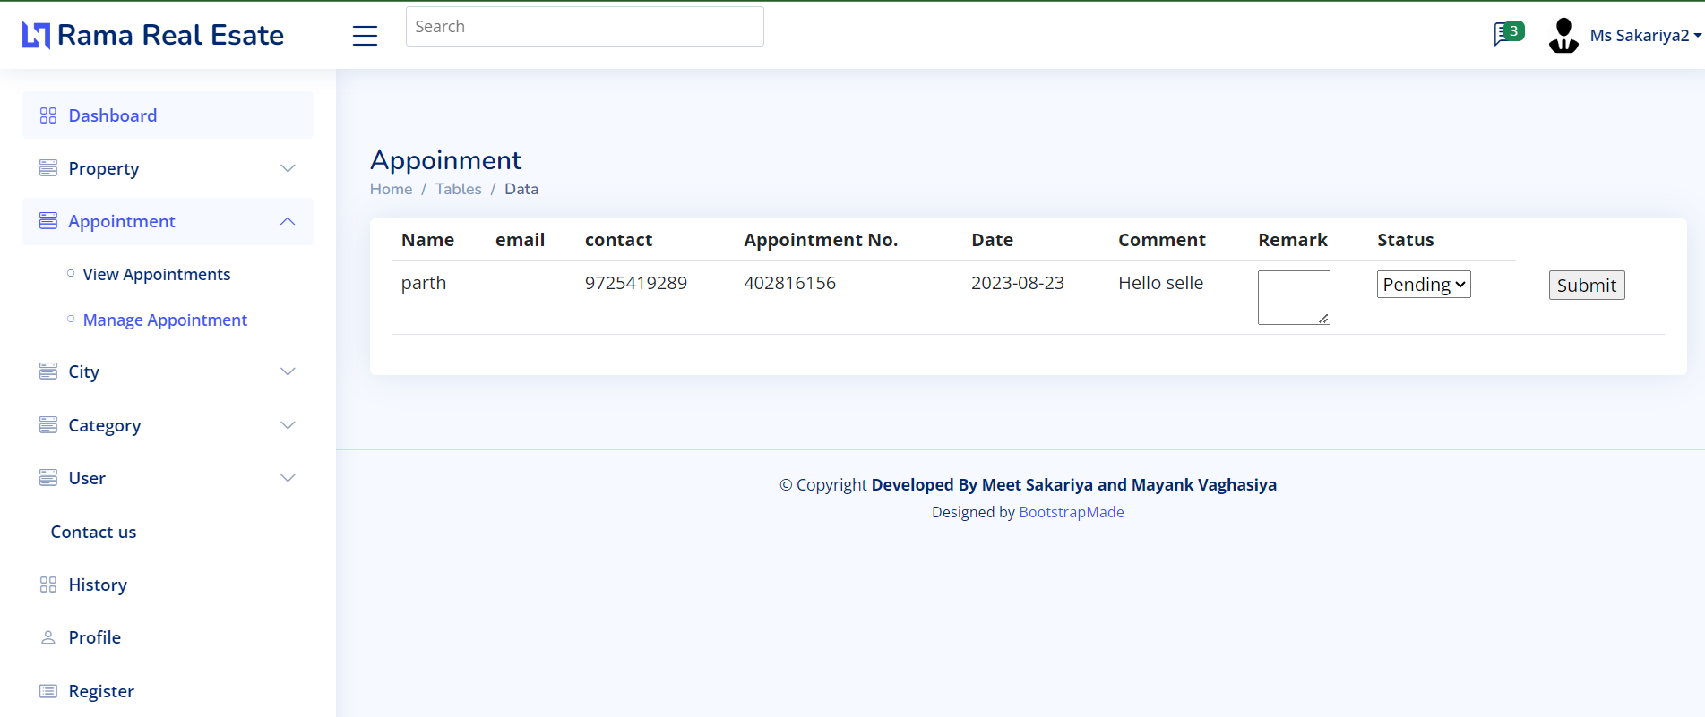

    - Manage city
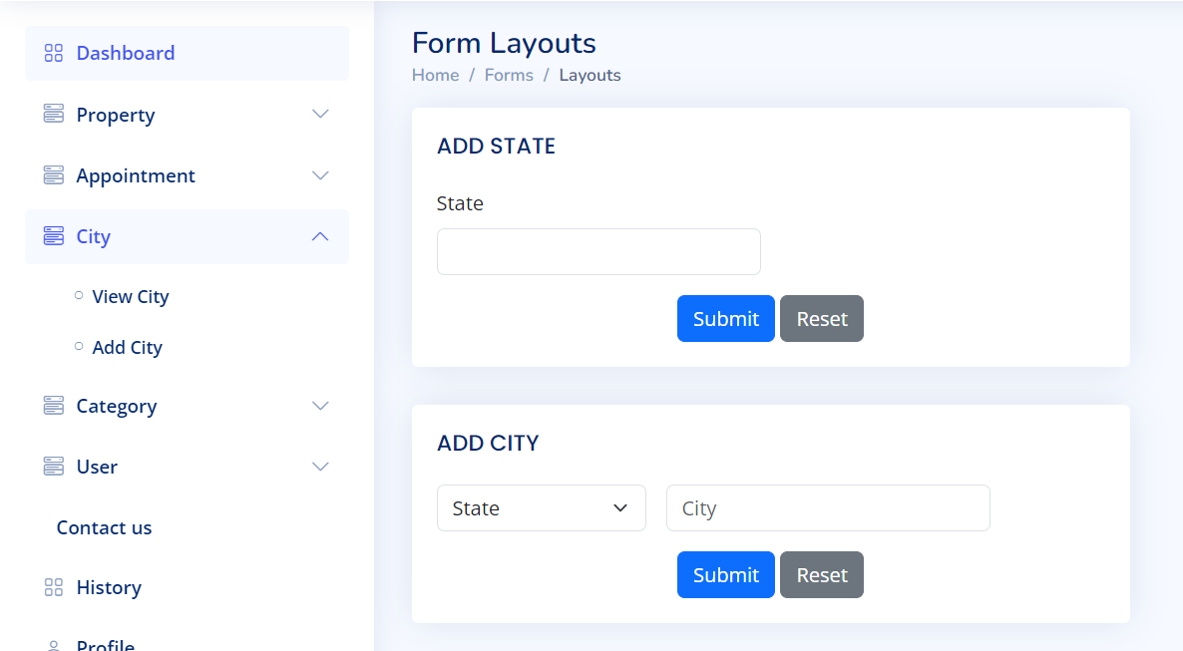

    - Contact Us

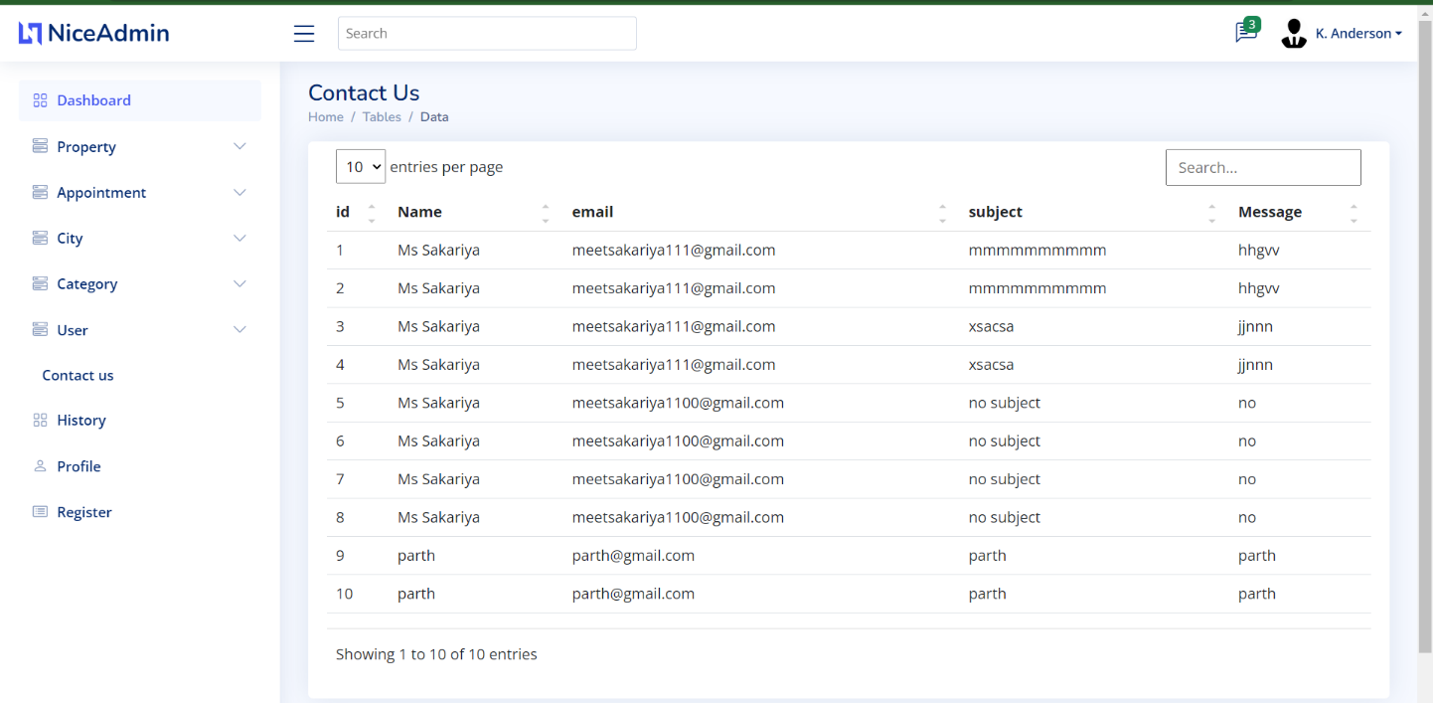

    - Profile
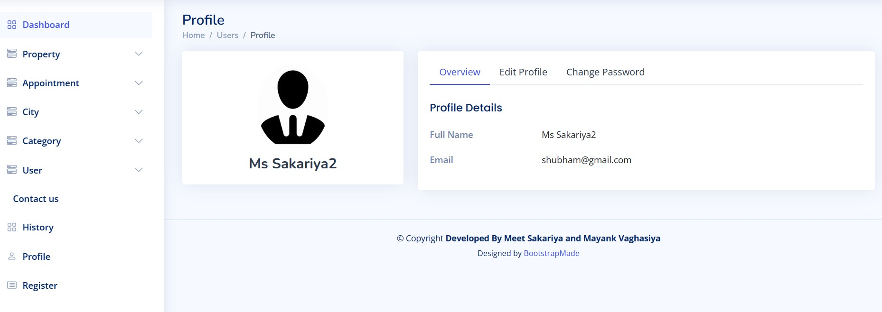

  - Code

7.2.1 Connection.php

<?php
$con=mysqli_connect("localhost","root","","rama") or exit("error in connection");
?>

    - Login.php
<?php
session_start();
include("connection.php");
mysqli_query($con, 'SET FOREIGN_KEY_CHECKS = 0');

// Check if the form is submitted
if (isset($_POST['login'])) {
// Retrieve the submitted username and password

$username = $_POST['username'];
$password = $_POST['password'];
$user = $_POST['user'];

$_SESSION['usertype']=$user;

function login( $username ,$password ,$con,$table)
{
$res=mysqli_query($con,"Select * from $table where password='$password' and (email='$username' or username='$username')");

if(mysqli_num_rows($res)>0)
{

$record=mysqli_fetch_array($res);

$_SESSION['uid']=$record[0];
<div class="d-flex justify-content-center py-4">
<a href="index.html" class="logo d-flex align-items-center w-auto">
<img src="assets/img/logo.png" alt="">
<span class="d-none d-lg-block"> USER LOGIN</span>
</a>
</div><!-- End Logo -->

<div class="card mb-3">

<div class="card-body">

<div class="pt-4 pb-2">
<h5 class="card-title text-center pb-0 fs-4">Login to Your Account</h5>
<p class="text-center small">Enter your username & password to login</p>
</div>

<form class="row g-3 needs-validation" method="post">

<div class="col-12">
<label for="yourUsername" class="form-label">Username</label>
<div class="input-group has-validation">
<span class="input-group-text" id="inputGroupPrepend">@</span>
<input type="text" name="username" class="form-control" id="yourUsername" name="username" required>
<div class="invalid-feedback">Please enter your username.</div>
</div>
</div>

<div class="col-12">
<label for="yourPassword" class="form-label">Password</label>
<input type="password" name="password" class="form-control" id="yourPassword" name="password" required>
<div class="invalid-feedback">Please enter your password!</div>
</div>
<div class="col-12"></div>
<br>
<div class="col-12">
<label class="form-label">Sign in AS: </label>

<div class="form-check">
<input class="form-check-input" type="radio" name="user" value="seller"checked >Seller
</div>
</div>
<div class="col-12"></div>
<br>
<div class="col-12">
<div class="form-check">
<input class="form-check-input" type="checkbox" name="remember" value="true" id="rememberMe">
<label class="form-check-label" for="rememberMe">Remember me</label>
</div>
</div>
<div class="col-12">
<button class="btn btn-primary w-100" type="submit" name="login">Login</button>
</div>
<div class="col-12">
<p class="small mb-0">Don't have account? <a href="register.php">Create an account</a></p>
</div>
</form>

    - Register.php

<?php
include("connection.php")
if(isset($_POST['register']))
{

// Retrieve form data
$name = $_POST["name"];
$email = $_POST["email"];
$contact = $_POST["contact"];
$user =$_POST["user"];
$password = $_POST["password"];
$cpassword = $_POST["cpassword"];

function register($user,$email,$contact,$password,$cpassword,$con,$table)
{

$sel=mysqli_query($con,"select * from $table");
$row=mysqli_num_rows($sel);

$insert=true;

if($password!=$cpassword)
{
$msg='Both Password are not same';
$insert=false;
}
while($result=mysqli_fetch_array($sel))
{
if($result['username']==$user)
{
$msg='Username already exist';
$insert=false;
break;
}
if($result['contact']==$contact)
{
$msg='contact already exist';
$insert=false;
break;
}
if($result['email']==$email)
{
$msg='Email already exist';
$insert=false;
break;
}

}
if($insert)
{
$res=mysqli_query($con,"insert into $table(username,email,contact,password)values('$user','$email','$contact','$password')");
// header("location:login.php");
echo "<script>alert('Registration Successful!');</script>";

}
else{
echo"<script>";
echo"alert('$msg');";
echo"</script>";
}
}

if($user=="buyer")
{

register($name,$email,$contact,$password,$cpassword,$con,"buyer");
}
else{

register($name,$email,$contact,$password,$cpassword,$con,"seller");
}
}

?>

<div class="card-body">

<div class="pt-4 pb-2">
<h5 class="card-title text-center pb-0 fs-4">Create an Account</h5>
<p class="text-center small">Enter your personal details to create account</p>
</div>
<form method="post">
<div class="col-12">
<label for="yourName" class="form-label">Your Name</label>
<input type="text" name="name" class="form-control" id="yourName" required>
<div class="invalid-feedback">Please, enter your name!</div>
</div>

<div class="col-12">
<label for="yourEmail" class="form-label">Your Email</label>
<input type="email" name="email" class="form-control" id="emailInput" required oninput="validateEmail(this)">
<div class="invalid-feedback">Please enter a valid Email adddress!</div>
</div>

<div class="col-12">
<label for="contact" class="form-label">Contact Num</label>
<input type="text" name="contact" class="form-control" id="contact" maxlength="10" minlength="10" required>
<div class="invalid-feedback">Please enter a valid Contact Number!</div>
</div>

<!-- <div class="col-12">
<label for="yourUsername" class="form-label">Username</label>
<div class="input-group has-validation">
<span class="input-group-text" id="inputGroupPrepend">@</span>
<input type="text" name="username" class="form-control" id="yourUsername" required>
<div class="invalid-feedback">Please choose a username.</div>
</div>
</div> -->

<div class="col-12">
<label for="yourPassword" class="form-label">Password</label>
<input type="password" name="password" class="form-control" id="password" required>
<div class="invalid-feedback">Please enter your password!</div>
</div>

<div class="col-12">
<div class="invalid-feedback"> Re enter your password!</div>
</div>
<div class="col-12"></div>
<br>
<div class="col-12">
<label class="form-label">Sign in AS: </label>

<div class="form-check">
<input class="form-check-input" type="radio" name="user" value="selelr"checked >Seller
<input class="form-radio-input" type="radio" name="user" value="buyer" >Buyer
</div>
</div>
<div class="col-12"></div>
<br>
<div class="col-12">
<div class="form-check">
<input class="form-check-input" name="terms" type="checkbox" value="" id="acceptTerms" required>
<label class="form-check-label" for="acceptTerms">I agree and accept the <a href="#">terms and conditions</a></label>
<div class="invalid-feedback">You must agree before submitting.</div>
</div>
</div>
<div class="col-12">
<button class="btn btn-primary w-100" type="submit" name="register">Create Account</button>
</div>
<div class="col-12">
<p class="small mb-0">Already have an account? <a href="login.php">Log in</a></p>
</div>
</form>

    - Property-grid . php

<?php
session_start();

if(empty($_SESSION['user']))
{
header("location:login.php");
}
include('connection.php');
include('header.php');

?>
<!--/ Property Grid Star /-->
<br><br>
<section class="property-grid grid">
<div class="container">
<div class="row">
<div class="col-sm-12">
<div class="grid-option">

<?php
if($_SESSION['usertype']=="buyer")
{
?>
<br><br>
<button type="button" class="btn btn-b-n navbar-toggle-box-collapse d-none d- md-block" data-bs-toggle="collapse"
data-bs-target="#navbarTogglerDemo01" aria-expanded="false" name="search">

<span class="fa fa-search" aria-hidden="true"></span>

</button>
<?php
}
?>
</div>
</div>

<?php
function add_property($pid,$pimage,$price,$city,$title,$area,$room){
echo'<div class="col-md-4">';
echo'<div class="card-box-a card-shadow">';
echo'<div class="img-box-a">';
echo'<a href="login.php" class="link-a"><img src='.$pimage.' height="50px" width="400px" alt="" class="img-a img-fluid"></a>';
echo'</div>';
echo'<div class="card-overlay">';
echo'<div class="card-overlay-a-content">';
echo'<div class="card-header-a">';
echo'<h2 class="card-title-a">';
echo'<a href="#">'.$title;
echo'<br /> '.$city.'</a>';
echo'</h2>';
echo' </div>';
echo'<div class="card-body-a">';
echo'<div class="price-box d-flex">';
echo' <span class="price-a">price | '.$price.'</span>';
echo' </div>';
echo "<a class='link-a' href='property-single.php?id=" . $pid . "'>Click here to view</a>";

echo' <span class="ion-ios-arrow-forward"></span>';
echo' </a>';
echo' </div>';
echo'<div class="card-footer-a">';
echo'<ul class="card-info d-flex justify-content-around">';
echo'<li>';
echo'<h4 class="card-info-title">Area</h4>';
echo'<span>'.$area.'m';
echo'<sup>2</sup>';
echo'</span>';
echo'</li>';
echo'<li>';
echo'<h4 class="card-info-title">Beds</h4>';
echo' <span>'.$room.'</span>';
echo'</li>';
echo' <li>';
echo'<a href="addwishlist.php?id='.$pid.' & img='.$pimage.' & page=0" style="background-color: #10c53a; color: #fff;" name="wishlist">&#10084;</a>';
// echo'<span>4</span>';
// <button style="background-color: #10c53a; color: #fff; border: none; height: 40px; width: 40px;" name="wishlist" >
// </button>
echo'</li>';
echo'</ul>';
echo'</div>';
echo'</div>';
echo'</div>';
echo'</div>';
echo'</div>';

}
?>
<?php

$SQL="SELECT property_basicinfo.pid,
property_basicinfo.title AS title1,
property_basicinfo.ptype AS ptype1,
property_basicinfo.beds AS beds1,
property_basicinfo.baths AS baths1,
property_basicinfo.sell_type AS tsell1,
property_basicinfo.esta_year AS eyear1,
property_img.image1 AS img11,
property_img.image2 AS img21,
property_img.image3 AS img31,
property_img.image4 AS img41,
property_prc_loc.area AS area1,
property_prc_loc.price AS price1,
property_prc_loc.city AS city1,
property_prc_loc.location AS location11

FROM property_basicinfo
JOIN property_img ON property_basicinfo.pid = property_img.pid
JOIN property_prc_loc ON property_basicinfo.pid = property_prc_loc.pid";

if (isset($_POST['filter']))
{
$price_min = isset($_POST['minprice']) ? intval($_POST['minprice']) : 0;
$price_max = isset($_POST['maxprice']) ? intval($_POST['maxprice']) : PHP_INT_MAX;
// $location = isset($_POST['location']) ? $_POST['location'] : '';
$city = isset($_POST['city']) ? $_POST['city'] : '';
$ptype = isset($_POST['ptype']) ? $_POST['ptype'] : '';
if($price_max==6000001)
{S

$price_max=PHP_INT_MAX;
}
if((isset($price_max)) && (empty($price_min)) && ($price_max==PHP_INT_MAX))
{
$price_min=6000000;
}
if ((!empty($city)) || (!empty($ptype))) {
$price_max=PHP_INT_MAX;

}
if ((empty($city)) && (empty($ptype)) && (empty($price_min)) && (empty($price_max))) {
echo"<script>window.location.href='property-grid.php'</script>";

}

$query1="SELECT property_prc_loc.* , property_basicinfo.*
FROM property_prc_loc
join property_basicinfo ON property_basicinfo.pid=property_prc_loc.pid
WHERE (property_prc_loc.price >= $price_min AND property_prc_loc.price <= $price_max)";

if (!empty($city)) {
$escapedCity = mysqli_real_escape_string($con, $city);
$query1 .= " AND property_prc_loc.city = '$escapedCity'";
}
if (!empty($ptype)) {
$escapedtype = mysqli_real_escape_string($con, $ptype);
$query1 .= " AND property_basicinfo.ptype = '$escapedtype'";
}

$result1 = mysqli_query($con, $query1);

while($r=mysqli_fetch_row($result1))
{
$propid=$r[0];

$QUERY =" WHERE property_basicinfo.pid=$propid";
$sql1=$SQL . $QUERY;

$pro1=mysqli_query($con,$sql1);

if (mysqli_num_rows($pro1) > 0)
{
$row1 = mysqli_fetch_assoc($pro1);
add_property($propid,$row1['img21'],$row1['price1'],$row1['city1'],$row1['title 1'],$row1['area1'],$row1['beds1']);
}
else {
echo "No results found.";
}
}

}

else
{
$pro=mysqli_query($con,$SQL);

if (mysqli_num_rows($pro) > 0)
{
while ($row = mysqli_fetch_assoc($pro)) {
add_property($row['pid'],$row['img21'],$row['price1'],$row['city1'],$row['title1' ],$row['area1'],$row['beds1']);
}
}
else {
echo "No results found.";
}
}

?>

    - Wishlist.php
<?php
session_start();
if(empty($_SESSION['user']))
{
header("location:login.php");
}
include("connection.php");
mysqli_query($con, 'SET FOREIGN_KEY_CHECKS = 0');

include('header.php');
?>
<br><br><br><br>
<section class="property-grid grid">
<div class="container">
<div class="row">
<di77v class="col-sm-12">
<div class="grid-option">
</div>
</div>
<?php
function add_property($pid,$pimage,$price,$city,$location,$area,$room)
{
echo'<div class="col-md-4">';
echo'<div class="card-box-a card-shadow">';
echo'<div class="img-box-a">';
echo'<a href="login.php" class="link-a"><img src='.$pimage.' alt="" class="img-a img-fluid"></a>';
echo'</div>';
echo'<div class="card-overlay">';
echo'<div class="card-overlay-a-content">';
echo'<div class="card-header-a">';
echo'<h2 class="card-title-a">';
echo'<a href="#">'.$location;
echo'<br /> '.$city.'</a>';
echo'</h2>';
echo' </div>';
echo'<div class="card-body-a">';
echo'<div class="price-box d-flex">';
echo' <span class="price-a">price | '.$price.'</span>';
echo' </div>';
echo "<a class='link-a' href='property-single.php?id=" . $pid . "'>Click here to view</a>";
echo' <span class="ion-ios-arrow-forward"></span>';
echo' </a>';
echo' </div>';
echo'<div class="card-footer-a">';
echo'<ul class="card-info d-flex justify-content-around">';
echo'<li>';
echo'<h4 class="card-info-title">Area</h4>';
echo'<span>'.$area.'m';
echo'<sup>2</sup>';
echo'</span>';
echo'</li>';
echo'<li>';
echo'<h4 class="card-info-title">Beds</h4>';
echo' <span>'.$room.'</span>';
echo'</li>';
echo'</ul>';
echo'</div>';
echo'</div>';
echo'</div>';
echo'</div>';
echo'</div>';
}
?>
<?php
$uid=$_SESSION['uid'];
// $pimage="property_image/seller/20038/pexels-binyamin-mellish-186077.jpg";
if($_SESSION['usertype']=="seller")
{
$squery="SELECT pid from property_basicinfo where sid=$uid";
}
else
{
$squery="SELECT pid from wishlist where bid=$uid";
}
$result=mysqli_query($con,$squery);
while($r=mysqli_fetch_row($result))
{
$pro=mysqli_query($con,$sql);
if (mysqli_num_rows($pro) > 0) {
while ($row = mysqli_fetch_assoc($pro)) {

add_property($row['pid'],$row['img1'],$row['price'],$row['city'],$row['location1'],$row['area'],$row['beds']);
}
} else {
echo "No results found.";
}
}
?>
<?php
mysqli_query($con, 'SET FOREIGN_KEY_CHECKS = 1');
include('footer.php');
?>
    - Addproperty.php

<?php
session_start();
//error_reporting(0);
include("connection.php");
if(empty($_SESSION['user']))
{
header("location:login.php");
}
mysqli_query($con, 'SET FOREIGN_KEY_CHECKS = 0');
$query=mysqli_query($con,"SELECT pid FROM property_basicinfo ORDER BY pid DESC LIMIT 1");
$result=mysqli_fetch_row($query);
$folder=$_SESSION['user'];
$sfolder=$result[0]+1;
function file_upload($folder,$sfol,$con,$pid)
{
$file_nam 1=array($_FILES['img1']['name'],$_FILES['img2']['name'],$_FILES['img3']['name'],$_FILES['img4']['name']);
$file_tmp1 =array($_FILES['img1']['tmp_name'],$_FILES['img2']['tmp_name'],$_FILES['img3']['tmp_name'],$_FILES['img4']['tmp_name']);

if(!is_dir("admin/property_image/$folder") )
{ mkdir("admin/property_image/$folder"); }

if(!is_dir("admin/property_image/$folder/$sfol") )
{
mkdir("admin/property_image/$folder/$sfol");
}

$path ="admin/property_image/$folder/$sfol/";
$upload = array(
move_uploaded_file($file_tmp1[0], $path . $file_name1[0]),
move_uploaded_file($file_tmp1[1], $path . $file_name1[1]),
move_uploaded_file($file_tmp1[2], $path . $file_name1[2]),
move_uploaded_file($file_tmp1[3], $path . $file_name1[3])
);

if($upload)
{
$query = mysqli_query($con, "INSERT INTO property_img (pid, image1, '$path$file_name1[1]', '$path$file_name1[2]', '$path$file_name1[3]')");
}
}

if(isset($_POST['add']))
{
$title=$_POST['title'];
$uid=$_SESSION['uid'];
$ptype=$_POST['ptype'];

$beds=$_POST['bed'];
$baths=$_POST['bath'];
$floor=$_POST['floor'];
$sell_type=$_POST['sell_type'];
$year=$_POST['year'];
$area=$_POST['area'];
$price=$_POST['price'];
$state=$_POST['state'];
$city=$_POST['city'];
$location=$_POST['location'];
$address=$_POST['address'];
$furnished=$_POST['furnished'];
$iquery="INSERT into property_basicinfo(sid,title,ptype,furnished,beds,baths,floor,sell_type,esta_year) values($uid,'$title','$ptype','$furnished','$beds','$baths','$floor','$sell_type','$year')";
$squery="SELECT pid from property_basicinfo ORDER BY pid DESC LIMIT 1";

$select1=mysqli_query($con,$squery);
$sresult=mysqli_fetch_row($select1);
$pid=$sresult[0]+1;
if(mysqli_query($con,$iquery))
{
$iquery2="INSERT into property_prc_loc(pid,area,price,state,city,location,address) values($pid,$area,$price,'$state','$city','$location','$address')";

if(mysqli_query($con,$iquery2))
{
if($_FILES['img1'])
{
file_upload($folder,$sfolder,$con,$pid);
echo"<script>alert('Success fully inserted')</script>";
}
}
}
include('header.php');
?>

<h2 class="text-secondary double-down-line text-center">Submit Property</h2>
</div>
</div>
<table>
<tr>
<td>Title</td>
<td><input type="Text" name="title" placeholder=" Enetr title" size="40" required></td>
</tr>
<tr>
<td> Type </td>
<td>
<select name="ptype" onchange="toggleInputField(this.value)">
<option>Select Type</option>
<?php

$categoryquery = "SELECT subcat FROM category ";
$resultcategory = mysqli_query($con, $categoryquery);

while ($row1 = mysqli_fetch_row($resultcategory)) {
echo "<option value='$row1[0]'>$row1[0]</option>";
}
?>
</select>
<td>Sell Type</td>
<td><select name="sell_type" required>
<option value="new">New</option>
<option value="resell">Resell</option>
</select></td>

<td>Furnished</td>
<td><select name="furnished" required>
<option value="yes">Yes</option>
<option value="no">No</option>
</select></td>
</tr>
<tr >
<td>Bedroom</td>
<td><input type="text" name="bed" placeholder="Enter Bedroom" required></td>
<td>Bathroom</td>
<td><input type="text" name="bath" placeholder="Enter Bathroom" required></td>
</tr> <tr >
<td>Established Year</td>
<td><input type="number" name="year" min="1950" max="2023" placeholder=" Year" value="2022" required></td>
</tr>

</table>
<h5 class="text-secondary">Price & Location</h5><hr>
<table>
<tr>
<td> <label>Floor</label></td>
<td><input type="text" name="floor" placeholder="Enter Floor" required></td>
</tr>

<tr><td>Price</td><td><input type="text" name="price" placeholder="Enter Price" required></td>
<td>Area</td><td><input type="text" name="area" placeholder="Enter Total Square Foot" required></td></tr>

<tr>
<td>State</td>
<td>
<select name="state" required>
<option selected value="">State</option>
<?php
$statequery = "SELECT DISTINCT state FROM city";
$resultstate = mysqli_query($con, $statequery);

while ($row = mysqli_fetch_row($resultstate)) {
echo "<option value='$row[0]'>$row[0]</option>";
}
echo' </select></td>
<td>City</td><td><select name="city" required>
<option selected value="">City</option>';

$state = mysqli_real_escape_string($con, $_GET['state']);
$cityquery = "SELECT DISTINCT city FROM city ";
$resultcity = mysqli_query($con, $cityquery);

while ($row1 = mysqli_fetch_row($resultcity)) {
echo "<option value='$row1[0]'>$row1[0]</option>";

?>
</select></td></tr>
<tr>
<td>Location </td><td><input type="text" name="location" placeholder="Enter Location" required></td>
<td>Address</td><td><textarea rows="2" cols="30" name="address" placeholder="Enter Address" required></textarea></td></tr>
</table>

<h5 class="text-secondary">Image & Status</h5><hr>
<table>
<tr>

<input type="submit" value="Submit" class="btn btn-primary" name="add" style="margin-left:200px;">
</div>
</form>
</div>
</div>
</div>
<script>
</script>
<?php
include('footer.php');
?>

7.2.7 logout.php
<?php
session_start();
include('connection.php');
session_destroy();
header("location:login.php");
exit();
?>

- Results

  - Testing

A Test Plan can be defined as a document describing the scope, resources, and schedule of intended Testing activities. A project may fail without a complete Test Plan. Test planning is particularly important in large software system development.

  - Test Case Result

No | Test | Action | Scenario | Result
1 | Login | If email and password is correct | Redirect to home screen. | yes
 |  | If user is not verified | Redirect to verification screen. | yes
 |  | Any or Both Invalid | Alert box with Message “Your Login name or password in Invalid”. | yes
2 | Register | If all details are Correct. | user registered successfully and verification OTP sent to mail. | yes
3 | Book Appointment | Buyer book appointment. | Receive email . | yes

- Conclusion
  - Future Enhancement
- Add more Main category.
- Expand in More City.

  - Limitations
- This application is used for particular one class.
- User can not register by application.
- This application needs internet application.

- Bibliography

PHP | PHP is a script language and interpreter that is freely available and used primarily on Linux Web servers. PHP, originally derived from Personal Home Page Tools, now stands for PHP: Hypertext Preprocessor.
MySQL | MySQL is an Oracle-backed open source relational database management system (RDBMS) based on Structured Query Language (SQL).
Html | HTML (Hyper Text Markup Language) is the code that is used to structure a web page and its content. For example, content could be structured within a set of paragraphs, a list of bulleted points, or using images and data tables.

- References

  - Web References

- www.w3schools.com
- https://chat.openai.com.

  - Books Referred

- Beginning Android Program with Android Studio.
-J.F.DiMarzio
- Introduction to Android Application Development.
-Joseph Annuzz

