*Dear Jeremaine Youngblood*

Dear Jeremaine Youngblood,

I never gave up on you I'm trying many ways to contact you I request video visits you never answer them I cry every night in because of hurt & pain Maine I can't do this without you I'm a half of a person when you're not around I'm attached to you I can't let you leave me out here all alone you were the only person I really had helped me and somewhat loved me when my family did me like shit please let me know you still care please 🥺🥺 I have a new number 8506044055 and I sent you a Icare I love you so much I can't get you off my mind not any day I'm on house arrest I wanna be next to you when you get out please 🥺

Sincerely,

Kisha Brown

brownlakisha91@gmail.com

1109 Kirklin Ave, Panama City, FL 32401, USA

04/12/23

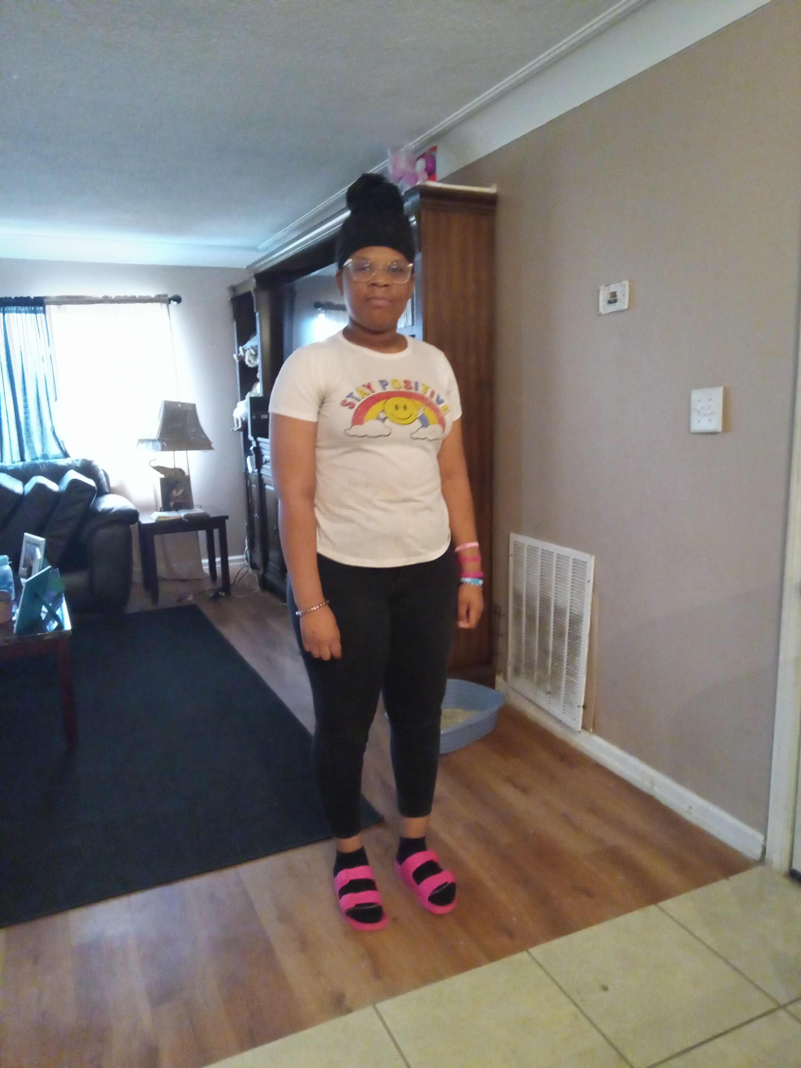

**Replying to the Sender via DoNotPay**

The original sender of this letter has elected to allow responses via DoNotPay. The following are instructions on how to format and send your letter such that it can be digitized and received by them:

On the first page of your letter, include the (1) name, (2) email, and (3) address of the recipient on the top right-hand corner of the page.

Address and send letters to:

Kisha Brown

237 A St

PMB 33301

San Diego, California 92101-4003 US

Note that if you reply via DoNotPay, the recipient will receive a digitized copy of your letter and not the physical letter itself.