# Steps of this assignment:

Step 1.

* Download and install Solr on laptop.
* Copy all the html files for Boston Globe, and index these pages using Solr.
* Create a website on my laptop with Apache Server that can deliver web pages, and run scripts.
* Write a PHP program as solr-php-client that accepts input from the user in a HTML form, and sends requests to the Solr server. (Here I modified example code from <https://github.com/PTCInc/solr-php-client)>
* Search in the webpage, and get top 10 result for each query.

Step 2.

* In order to use PageRank as ranking algorithm in Solr, we need to create an external file that stores rank.
* Loop each webpage in directory, and extract outgoing links using JSoup Library.(Here I referred code from <http://www-scf.usc.edu/~csci572/2017Fall/hw4/ExtractingLinks.pdf> )
* Use Boston_Global_Map.csv to create two map files, fileUrlMap and urlFileMap, and filter out resource outside the news website domain and those are not html files.
* Create a directed graph using the mapping file and extracted URLs. Vertices in the graph are webpage files and detected edge between two files represent a link between two. (Here I used edgeList format, when creating edges. )
* Load the web graph to NetworkX, and compute PageRank using paramenters: “alpha=0.85, personalization=None, max_iter=30, tol=1e-06, nstart=None, weight='weight', dangling=None”.
* Make the document id the same as the one presented in index.
* Name the pageRank scores file “external_pageRankFile”, and put this file under the data folder of the core I created.
* There are 2 modifications of configuration files. First, add the field in the managed-schema which refers to this score. Second, define 2 listeners within the <query> element in solrconfig.xml file.
* Reload the index, or create a new core and configure it as above and leave the former one only for Lucene method.

Step 3.

* Compare the top 10 results for each query of the two ranking algorithms.

# **Why some pages have higher PageRank values than others?**

Answer: The PageRank score of a webpage is high when it is important. The more importance the page has, the more webpages have link to it. That is why the results via PageRank are more likely to be [https://www.bostonglobe.com](https://www.bostonglobe.com/) or category pages. These pages have more in-links than others and gain a higher PageRank value.

# Flow Screenshots (query = Elon Musk)

Initial page

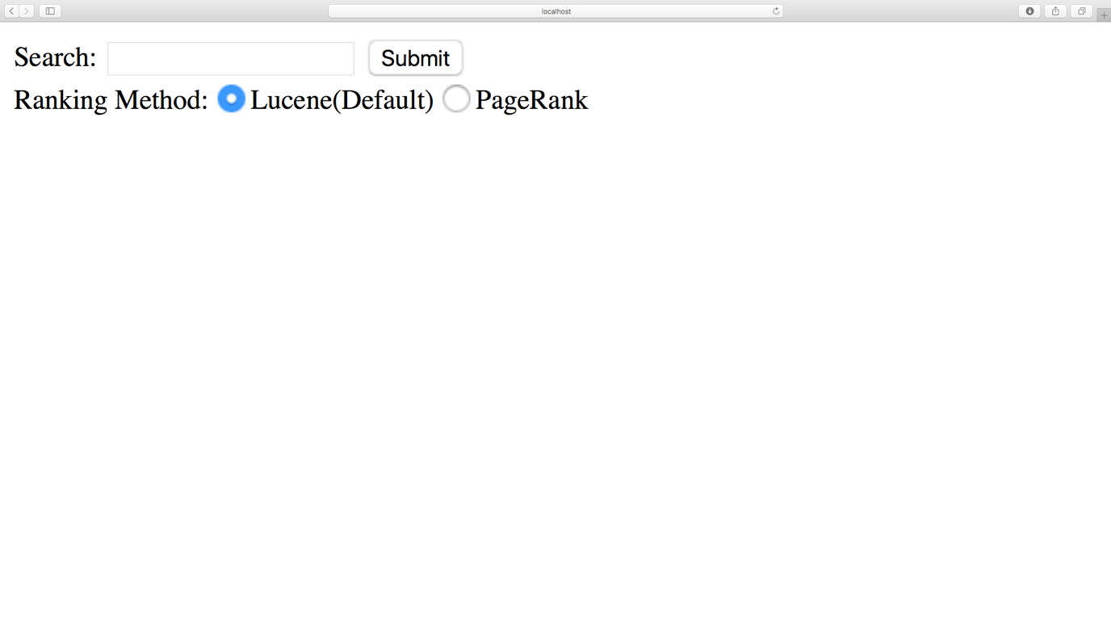

Result for Lucene(Default)

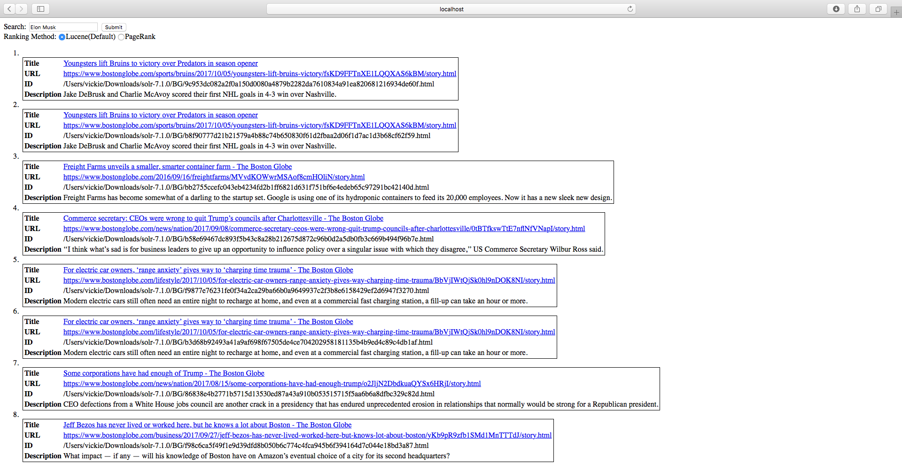

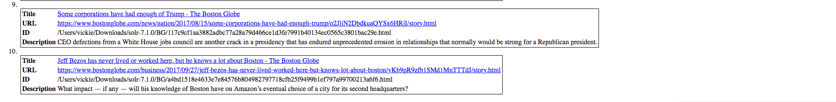

Result of PageRank

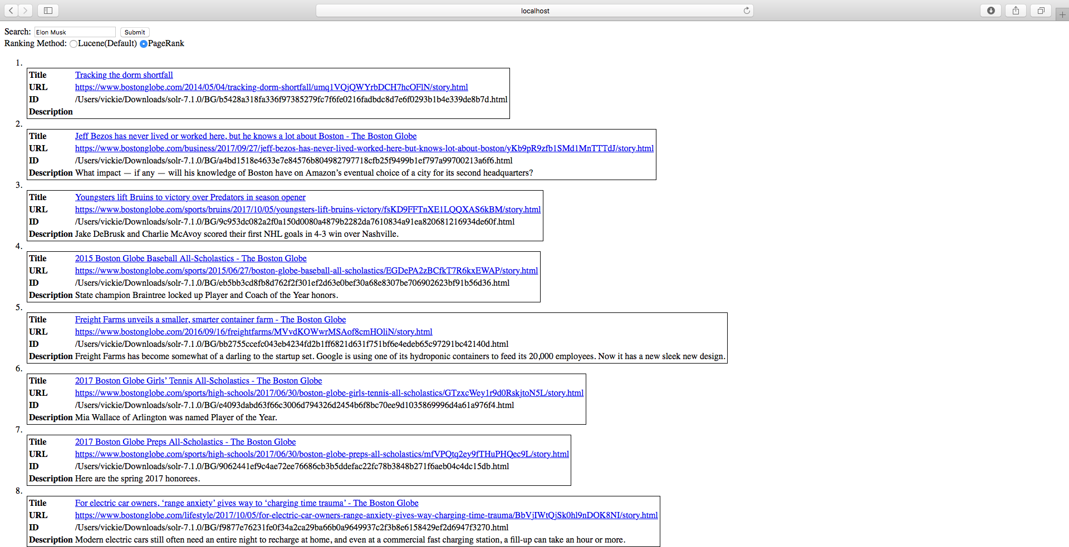

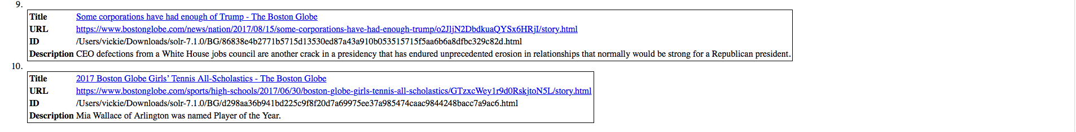

Click url <https://www.bostonglobe.com/lifestyle/2017/10/05/for-electric-car-owners-range-anxiety-gives-way-charging-time-trauma/BbVjIWtQjSk0hl9nDOK8NI/story.html>

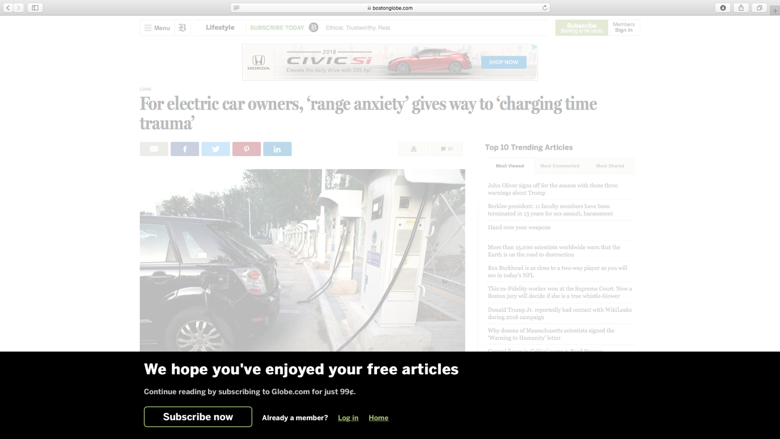

# URLs of Top 10 Results

Query = Elon Musk

|  |  |  |
| --- | --- | --- |
| **#** | **Results of Lucene** | **Results of PageRank** |
| **1** | <https://www.bostonglobe.com/sports/bruins/2017/10/05/youngsters-lift-bruins-victory/fsKD9FFTnXE1LQQXAS6kBM/story.html> | <https://www.bostonglobe.com/2014/05/04/tracking-dorm-shortfall/umq1VQjQWYrbDCH7hcOFlN/story.html> |
| **2** | <https://www.bostonglobe.com/sports/bruins/2017/10/05/youngsters-lift-bruins-victory/fsKD9FFTnXE1LQQXAS6kBM/story.html> | <https://www.bostonglobe.com/business/2017/09/27/jeff-bezos-has-never-lived-worked-here-but-knows-lot-about-boston/yKb9pR9zfb1SMd1MnTTTdJ/story.html> |
| **3** | <https://www.bostonglobe.com/2016/09/16/freightfarms/MVvdKOWwrMSAof8cmHOliN/story.html> | <https://www.bostonglobe.com/sports/bruins/2017/10/05/youngsters-lift-bruins-victory/fsKD9FFTnXE1LQQXAS6kBM/story.html> |
| **4** | <https://www.bostonglobe.com/news/nation/2017/09/08/commerce-secretary-ceos-were-wrong-quit-trump-councils-after-charlottesville/0tBTfkswTtE7nflNfVNapI/story.html> | <https://www.bostonglobe.com/sports/2015/06/27/boston-globe-baseball-all-scholastics/EGDePA2zBCfkT7R6kxEWAP/story.html> |
| **5** | <https://www.bostonglobe.com/lifestyle/2017/10/05/for-electric-car-owners-range-anxiety-gives-way-charging-time-trauma/BbVjIWtQjSk0hl9nDOK8NI/story.html> | <https://www.bostonglobe.com/2016/09/16/freightfarms/MVvdKOWwrMSAof8cmHOliN/story.html> |
| **6** | <https://www.bostonglobe.com/lifestyle/2017/10/05/for-electric-car-owners-range-anxiety-gives-way-charging-time-trauma/BbVjIWtQjSk0hl9nDOK8NI/story.html> | <https://www.bostonglobe.com/sports/high-schools/2017/06/30/boston-globe-girls-tennis-all-scholastics/GTzxcWey1r9d0RskjtoN5L/story.html> |
| **7** | <https://www.bostonglobe.com/news/nation/2017/08/15/some-corporations-have-had-enough-trump/o2JljN2DbdkuaQYSx6HRjI/story.html> | <https://www.bostonglobe.com/sports/high-schools/2017/06/30/boston-globe-preps-all-scholastics/mfVPQtq2ey9fTHuPHQec9L/story.html> |
| **8** | <https://www.bostonglobe.com/business/2017/09/27/jeff-bezos-has-never-lived-worked-here-but-knows-lot-about-boston/yKb9pR9zfb1SMd1MnTTTdJ/story.html> | <https://www.bostonglobe.com/lifestyle/2017/10/05/for-electric-car-owners-range-anxiety-gives-way-charging-time-trauma/BbVjIWtQjSk0hl9nDOK8NI/story.html> |
| **9** | <https://www.bostonglobe.com/news/nation/2017/08/15/some-corporations-have-had-enough-trump/o2JljN2DbdkuaQYSx6HRjI/story.html> | <https://www.bostonglobe.com/news/nation/2017/08/15/some-corporations-have-had-enough-trump/o2JljN2DbdkuaQYSx6HRjI/story.html> |
| **10** | <https://www.bostonglobe.com/business/2017/09/27/jeff-bezos-has-never-lived-worked-here-but-knows-lot-about-boston/yKb9pR9zfb1SMd1MnTTTdJ/story.html> | <https://www.bostonglobe.com/sports/high-schools/2017/06/30/boston-globe-girls-tennis-all-scholastics/GTzxcWey1r9d0RskjtoN5L/story.html> |

Query = Star Wars

|  |  |  |
| --- | --- | --- |
| **#** | **Results of Lucene** | **Results of PageRank** |
| **1** | <https://www.bostonglobe.com/arts/movies/2015/12/15/the-force-with-star-wars-the-force-awakens/KyOQ1W4zeMyVDncrIirp5M/story.html> | [https://www.bostonglobe.com](https://www.bostonglobe.com/) |
| **2** | <https://www.bostonglobe.com/arts/movies/2015/12/15/the-force-with-star-wars-the-force-awakens/KyOQ1W4zeMyVDncrIirp5M/story.html> | [https://www.bostonglobe.com](https://www.bostonglobe.com/) |
| **3** | <https://www.bostonglobe.com/metro/2015/12/17/first-line-for-the-force-fan-stakes-out-spot-for-latest-star-wars-film/QBYM4R1QwbCoA7c7cBs8wO/story.html> | <https://www.bostonglobe.com/sports> |
| **4** | <https://www.bostonglobe.com/lifestyle/style/2015/12/18/for-star-wars-die-hards-hour-marathon-daunting-but-enjoyable-task/W08Q3d2TeXWCQzDalZaZsI/story.html> | [https://www.bostonglobe.com](https://www.bostonglobe.com/) |
| **5** | <https://www.bostonglobe.com/arts/2015/12/12/starwarsgenerations/PLDMidc6USG536AfUaPA7N/story.html> | <https://www.bostonglobe.com/business> |
| **6** | <https://www.bostonglobe.com/lifestyle/style/2015/12/12/star-wars-sneakers-not-just-for-kids/XnHidQOeClvVNY94HfptQJ/story.html> | <https://www.bostonglobe.com/arts> |
| **7** | <https://www.bostonglobe.com/metro/2015/12/17/charlie-baker-not-fan-new-star-wars-flicks/UX6q3i6wY5F6AIuydftuTI/story.html> | <https://www.bostonglobe.com/business> |
| **8** | <https://www.bostonglobe.com/arts/movies/2015/12/12/getting-latest-scoop-scoops-star-wars/1CDNVgBUSzNeG9FPW50yJP/story.html> | [https://www.bostonglobe.com](https://www.bostonglobe.com/) |
| **9** | <https://www.bostonglobe.com/arts/movies/2015/12/12/getting-latest-scoop-scoops-star-wars/1CDNVgBUSzNeG9FPW50yJP/story.html> | <https://www.bostonglobe.com/arts> |
| **10** | <https://www.bostonglobe.com/arts/movies/2015/12/12/oscar-isaac-talks-about-acting-new-star-wars-movie/Z85IkTprnFbJz9wT7PoygM/story.html> | <https://www.bostonglobe.com/sports> |

Query = North Korea

|  |  |  |
| --- | --- | --- |
| **#** | **Results of Lucene** | **Results of PageRank** |
| **1** | <https://www.bostonglobe.com/news/world/2017/09/08/korea-braces-for-another-possible-korea-missile-test/wrfYUFe7CEgGvKbcg41ZbN/story.html> |  |
| **2** | <https://www.bostonglobe.com/news/world/2017/08/09/trump-threatens-fire-and-fury-against-north-korea-endangers/sSaFxbsoTVeQ3syE8gJvgO/story.html> | [https://www.bostonglobe.com](https://www.bostonglobe.com/) |
| **3** | <https://www.bostonglobe.com/news/world/2017/08/09/trump-threatens-fire-and-fury-against-north-korea-endangers/sSaFxbsoTVeQ3syE8gJvgO/story.html> | <https://www.bostonglobe.com/metro> |
| **4** | <https://www.bostonglobe.com/opinion/2017/08/09/plan-for-north-korea-before-this-spirals-out-control/Q23bbp1BbDPlTxdvYxv3LK/story.html> | [https://www.bostonglobe.com](https://www.bostonglobe.com/) |
| **5** | <https://www.bostonglobe.com/opinion/2017/08/09/plan-for-north-korea-before-this-spirals-out-control/Q23bbp1BbDPlTxdvYxv3LK/story.html> | <https://www.bostonglobe.com/lifestyle/crossword> |
| **6** | <https://www.bostonglobe.com/news/world/2017/09/25/north-korea-minister-says-can-shoot-down-bombers/8TtjEtXdimYcIXEArVHu5K/story.html> | <https://www.bostonglobe.com/opinion> |
| **7** | <https://www.bostonglobe.com/news/politics/2017/09/26/north-korea-seeks-help-from-republican-analysts-what-with-trump/Iro675CGFxHP3wqY4ZbzhK/story.html> | <https://www.bostonglobe.com/sports> |
| **8** | <https://www.bostonglobe.com/news/politics/2017/09/26/north-korea-seeks-help-from-republican-analysts-what-with-trump/Iro675CGFxHP3wqY4ZbzhK/story.html> | [https://www.bostonglobe.com](https://www.bostonglobe.com/) |
| **9** | <https://www.bostonglobe.com/news/nation/2017/09/03/trump-says-north-korea-very-hostile-and-dangerous/SoR0T7tl6i3MdNpwHonu9M/story.html> | <https://www.bostonglobe.com/lifestyle> |
| **10** | <https://www.bostonglobe.com/news/nation/2017/09/03/trump-says-north-korea-very-hostile-and-dangerous/SoR0T7tl6i3MdNpwHonu9M/story.html> | <https://www.bostonglobe.com/lifestyle> |

Query = LA Dodgers

|  |  |  |
| --- | --- | --- |
| **#** | **Results of Lucene** | **Results of PageRank** |
| **1** | <https://www.bostonglobe.com/sports/2017/10/07/mlb-boxscore-dodgers-diamondbacks/TAdQkAqY6OqncGtJjZyG8O/story.html> | <https://www.bostonglobe.com/arts> |
| **2** | <https://www.bostonglobe.com/sports/2012/08/26/gonzo/Avzuwi4ZrRfOBdQKd1UFGP/story.html> | <https://www.bostonglobe.com/arts> |
| **3** | <https://www.bostonglobe.com/lifestyle/names/2017/09/28/carl-crawford-boston-carried-hate-for-that-city-for-long-time/SKvbZfN6QwarHEy24f965H/story.html> | <https://www.bostonglobe.com/lifestyle/names> |
| **4** | <https://www.bostonglobe.com/lifestyle/names/2017/09/28/carl-crawford-boston-carried-hate-for-that-city-for-long-time/SKvbZfN6QwarHEy24f965H/story.html> | <https://www.bostonglobe.com/lifestyle/names> |
| **5** |  | <https://www.bostonglobe.com/arts/2017/10/06/seuss-controversy-illuminates-cultural-clash/9bg6jN1x3Dzsk5yT1dv8XP/story.html> |
| **6** |  | <https://www.bostonglobe.com/arts/2017/10/06/seuss-controversy-illuminates-cultural-clash/9bg6jN1x3Dzsk5yT1dv8XP/story.html> |
| **7** |  | <https://www.bostonglobe.com/arts> |
| **8** | <https://www.bostonglobe.com/sports/2017/09/30/baseball-standings/G6K9mjYu6AokJmy36PkhcL/story.html> | <https://www.bostonglobe.com/news/bigpicture/2017/04/12/animal-expressions/jqzgvgqvk5GqncG2shUP1O/story.html> |
| **9** | <https://www.bostonglobe.com/sports/redsox/2017/09/16/indians-have-central-title-grasp/gBRKvUTjvx5LirE6i6HviO/story.html> | <https://www.bostonglobe.com/arts> |
| **10** | <https://www.bostonglobe.com/sports/redsox/2017/10/04/diamondbacks-advance-after-wild-one-over-rockies/ZXhz3EJeboHWpmrFA4UcRP/story.html> | <https://www.bostonglobe.com/news/bigpicture/2017/04/12/animal-expressions/jqzgvgqvk5GqncG2shUP1O/story.html> |

Query = Puerto Rico

|  |  |  |
| --- | --- | --- |
| **#** | **Results of Lucene** | **Results of PageRank** |
| **1** | <https://www.bostonglobe.com/news/politics/2017/10/03/six-things-trump-probably-shouldn-have-said-about-puerto-rico-while-puerto-rico/z2A6pU5IozLPkJdMzSY3HP/story.html> | [https://www.bostonglobe.com](https://www.bostonglobe.com/) |
| **2** | <https://www.bostonglobe.com/news/politics/2017/10/03/six-things-trump-probably-shouldn-have-said-about-puerto-rico-while-puerto-rico/z2A6pU5IozLPkJdMzSY3HP/story.html> | https://www.bostonglobe.com |
| **3** | <https://www.bostonglobe.com/news/politics/2017/10/03/six-things-trump-probably-shouldn-have-said-about-puerto-rico-while-puerto-rico/z2A6pU5IozLPkJdMzSY3HP/story.html> | <https://www.bostonglobe.com/business> |
| **4** | <https://www.bostonglobe.com/news/politics/2017/10/03/six-things-trump-probably-shouldn-have-said-about-puerto-rico-while-puerto-rico/z2A6pU5IozLPkJdMzSY3HP/story.html> | <https://www.bostonglobe.com/business> |
| **5** | <https://www.bostonglobe.com/news/politics/2017/10/03/six-things-trump-probably-shouldn-have-said-about-puerto-rico-while-puerto-rico/z2A6pU5IozLPkJdMzSY3HP/story.html> | https://www.bostonglobe.com |
| **6** | <https://www.bostonglobe.com/news/politics/2017/10/03/six-things-trump-probably-shouldn-have-said-about-puerto-rico-while-puerto-rico/z2A6pU5IozLPkJdMzSY3HP/story.html> | https://www.bostonglobe.com |
| **7** | <https://www.bostonglobe.com/opinion/editorials/2017/09/26/where-urgency-puerto-rico-response/oFxAJlj9duwxiaxVGK0LIL/story.html> | https://www.bostonglobe.com |
| **8** | <https://www.bostonglobe.com/opinion/editorials/2017/09/26/where-urgency-puerto-rico-response/oFxAJlj9duwxiaxVGK0LIL/story.html> | https://www.bostonglobe.com |
| **9** | <https://www.bostonglobe.com/opinion/editorials/2017/09/23/don-let-puerto-rico-languish/k7iPpkMGa54CDFd65Iwh4H/story.html> | https://www.bostonglobe.com |
| **10** | <https://www.bostonglobe.com/opinion/editorials/2017/09/23/don-let-puerto-rico-languish/k7iPpkMGa54CDFd65Iwh4H/story.html> | https://www.bostonglobe.com |

Query = Hurricane Harvey

|  |  |  |
| --- | --- | --- |
| **#** | **Results of Lucene** | **Results of PageRank** |
| **1** | <https://www.bostonglobe.com/news/nation/2017/09/08/house-seals-deal-hurricane-relief/mgMI2SyD8kUIb4ewoFSBII/story.html> | <https://www.bostonglobe.com/1970/01/13/terms-service/XpUbEbX2aS9pkwUa7aOKTI/story.html> |
| **2** | <https://www.bostonglobe.com/news/bigpicture/2017/08/28/hurricane-harvey-devastates-southeast-texas/ZWm7Ln0xffqQqpglzffYxL/story.html> | <https://www.bostonglobe.com/1970/01/05/term-purchase/RfO4zG3drUPKl8BRZNKlDP/story.html> |
| **3** | <https://www.bostonglobe.com/news/bigpicture/2017/08/28/hurricane-harvey-devastates-southeast-texas/ZWm7Ln0xffqQqpglzffYxL/story.html> | <https://www.bostonglobe.com/1970/01/13/privacy-policy/LZx4MmGtzRGBg8CkDCIadI/story.html> |
| **4** | <https://www.bostonglobe.com/news/bigpicture/2017/08/28/hurricane-harvey-devastates-southeast-texas/ZWm7Ln0xffqQqpglzffYxL/story.html> | <https://www.bostonglobe.com/newsletters> |
| **5** | <https://www.bostonglobe.com/news/bigpicture/2017/08/28/hurricane-harvey-devastates-southeast-texas/ZWm7Ln0xffqQqpglzffYxL/story.html> | <https://www.bostonglobe.com/tools/help/stafflist> |
| **6** | <https://www.bostonglobe.com/news/bigpicture/2017/08/28/hurricane-harvey-devastates-southeast-texas/ZWm7Ln0xffqQqpglzffYxL/story.html> | <https://www.bostonglobe.com/tools/help/stafflist> |
| **7** | <https://www.bostonglobe.com/news/bigpicture/2017/08/28/hurricane-harvey-devastates-southeast-texas/ZWm7Ln0xffqQqpglzffYxL/story.html> | <https://www.bostonglobe.com/newsletters> |
| **8** | <https://www.bostonglobe.com/news/bigpicture/2017/08/28/hurricane-harvey-devastates-southeast-texas/ZWm7Ln0xffqQqpglzffYxL/story.html> | <https://www.bostonglobe.com/1970/01/05/term-purchase/RfO4zG3drUPKl8BRZNKlDP/story.html> |
| **9** | <https://www.bostonglobe.com/news/bigpicture/2017/08/28/hurricane-harvey-devastates-southeast-texas/ZWm7Ln0xffqQqpglzffYxL/story.html> | <https://www.bostonglobe.com/1970/01/13/terms-service/XpUbEbX2aS9pkwUa7aOKTI/story.html> |
| **10** | <https://www.bostonglobe.com/news/bigpicture/2017/08/28/hurricane-harvey-devastates-southeast-texas/ZWm7Ln0xffqQqpglzffYxL/story.html> | <https://www.bostonglobe.com/1970/01/13/privacy-policy/LZx4MmGtzRGBg8CkDCIadI/story.html> |

Query = iPhone X

|  |  |  |
| --- | --- | --- |
| **#** | **Results of Lucene** | **Results of PageRank** |
| **1** | <https://www.bostonglobe.com/business/2017/09/21/should-you-queue-for-new-iphone-wait-for/MZLL85K3mhI2iGVYuy8ofN/story.html> |  |
| **2** | <https://www.bostonglobe.com/business/2017/09/21/should-you-queue-for-new-iphone-wait-for/MZLL85K3mhI2iGVYuy8ofN/story.html> |  |
| **3** | <https://www.bostonglobe.com/ideas/2017/09/12/apple-world-iphone-doesn-need-look-like-iphone/C8EFHm2BFe6eV9oeCudAKO/story.html> | <https://www.bostonglobe.com/1970/01/13/terms-service/XpUbEbX2aS9pkwUa7aOKTI/story.html> |
| **4** | <https://www.bostonglobe.com/ideas/2017/09/12/apple-world-iphone-doesn-need-look-like-iphone/C8EFHm2BFe6eV9oeCudAKO/story.html> | <https://www.bostonglobe.com/1970/01/05/term-purchase/RfO4zG3drUPKl8BRZNKlDP/story.html> |
| **5** | <https://www.bostonglobe.com/ideas/2017/09/12/apple-world-iphone-doesn-need-look-like-iphone/C8EFHm2BFe6eV9oeCudAKO/story.html> | <https://www.bostonglobe.com/1970/01/13/privacy-policy/LZx4MmGtzRGBg8CkDCIadI/story.html> |
| **6** | <https://www.bostonglobe.com/business/2017/09/12/super-new-iphone-may-not-quite-super-enough-for-price/cVm5OkTOwWHIRtNtC0RVDJ/story.html> | <https://www.bostonglobe.com/newsletters> |
| **7** | <https://www.bostonglobe.com/business/2017/09/12/super-new-iphone-may-not-quite-super-enough-for-price/cVm5OkTOwWHIRtNtC0RVDJ/story.html> | <https://www.bostonglobe.com/tools/help/stafflist> |
| **8** | <https://www.bostonglobe.com/business/2017/09/12/super-new-iphone-may-not-quite-super-enough-for-price/cVm5OkTOwWHIRtNtC0RVDJ/story.html> | <https://www.bostonglobe.com/tools/help/stafflist> |
| **9** | <https://www.bostonglobe.com/business/2017/09/12/super-new-iphone-may-not-quite-super-enough-for-price/cVm5OkTOwWHIRtNtC0RVDJ/story.html> | <https://www.bostonglobe.com/newsletters> |
| **10** |  | <https://www.bostonglobe.com/1970/01/05/term-purchase/RfO4zG3drUPKl8BRZNKlDP/story.html> |

Query = Paris Climate Deal

|  |  |  |
| --- | --- | --- |
| **#** | **Results of Lucene** | **Results of PageRank** |
| **1** |  | <https://www.bostonglobe.com/1970/01/13/privacy-policy/LZx4MmGtzRGBg8CkDCIadI/story.html> |
| **2** | <https://www.bostonglobe.com/news/politics/2017/06/02/john-kerry-calls-trump-climate-change-announcement-day-craven-ignorance-and-cynicism/GWBwSaQwm24lsxfX5jHmWM/story.html> | <https://www.bostonglobe.com/1970/01/13/privacy-policy/LZx4MmGtzRGBg8CkDCIadI/story.html> |
| **3** | <https://www.bostonglobe.com/news/politics/2017/06/02/john-kerry-calls-trump-climate-change-announcement-day-craven-ignorance-and-cynicism/GWBwSaQwm24lsxfX5jHmWM/story.html> | [https://www.bostonglobe.com](https://www.bostonglobe.com/) |
| **4** | <https://www.bostonglobe.com/magazine/2015/07/22/energy-secretary-ernie-moniz-cabinet-star-born/PsqmP1TairoTYQ1OSbt3uJ/story.html> | <https://www.bostonglobe.com/news/bigpicture> |
| **5** | <https://www.bostonglobe.com/business/2017/06/14/stata-slowing-down-hardly/xBhdDp7fFMfsxpjCzGunQJ/story.html> | [https://www.bostonglobe.com](https://www.bostonglobe.com/) |
| **6** | <https://www.bostonglobe.com/metro/2017/06/02/climate/qELM7JPNpKnORMMqkzi2XJ/story.html> | <https://www.bostonglobe.com/opinion> |
| **7** | <https://www.bostonglobe.com/metro/2017/06/02/climate/qELM7JPNpKnORMMqkzi2XJ/story.html> | <https://www.bostonglobe.com/sports> |
| **8** | <https://www.bostonglobe.com/metro/2017/06/02/climate/qELM7JPNpKnORMMqkzi2XJ/story.html> | [https://www.bostonglobe.com](https://www.bostonglobe.com/) |
| **9** | <https://www.bostonglobe.com/metro/2017/07/04/united-church-christ-approves-emergency-resolution-climate-change/pgzKhYbm3UEyJcxA21GPAI/story.html> | <https://www.bostonglobe.com/news/politics> |
| **10** | <https://www.bostonglobe.com/metro/2017/07/04/united-church-christ-approves-emergency-resolution-climate-change/pgzKhYbm3UEyJcxA21GPAI/story.html> | <https://www.bostonglobe.com/business> |

# Overlap graph