CyberGuide
B-conception.docx
Conception and Organisation
Hassan — Member 3
EPITA Paris — 2025–2026

Points | 4 points: 2pts diagrams + 1pt task tracking + 1pt self-reflection
Branch | feat/docs

Part A — Software Architecture (2 points)
This section presents the three architecture diagrams produced during the planning phase of CyberGuide. Each diagram is accompanied by an explanation of what it shows and the key design decisions it reflects.

Diagram 1 — System Overview (3-Layer Architecture)
The system overview diagram shows three distinct layers: the User Browser (React frontend), the Node.js backend (Express server), and the External AI Providers (Groq and Mistral via OpenRouter). Arrows show how each layer communicates with the next.

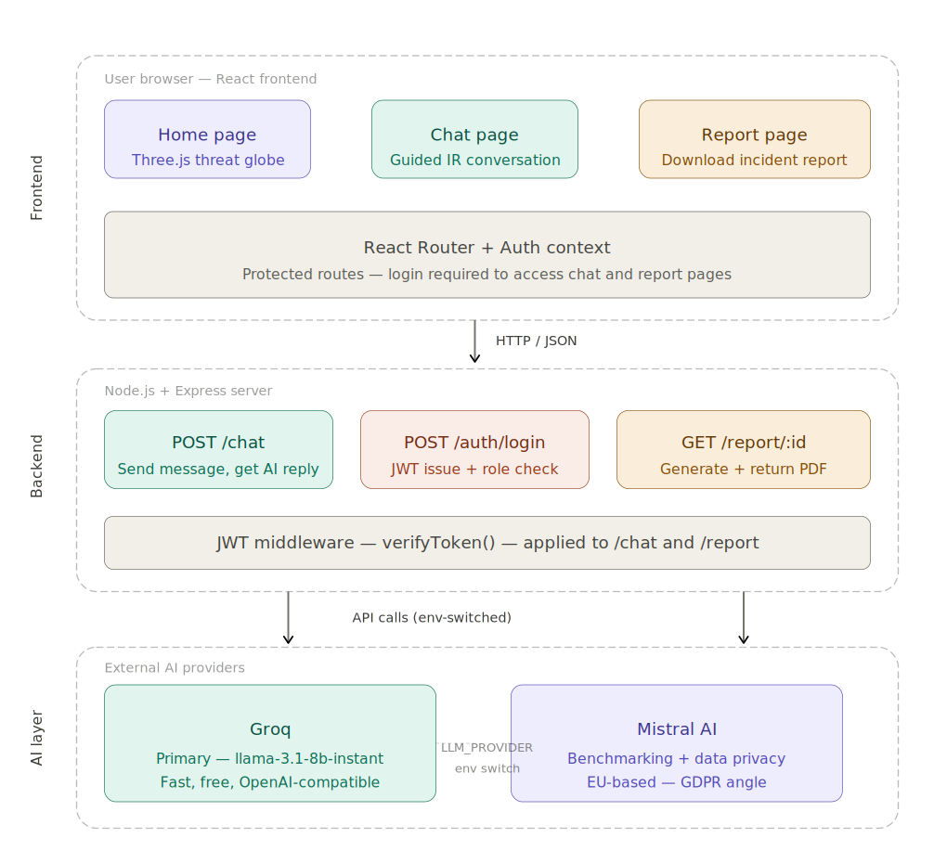
Figure 1 — CyberGuide System Architecture (3 layers)

What this architecture means for the project:
- The frontend runs on port 5173 and is served by Vite. It communicates with the backend exclusively via HTTP requests — it never contacts AI providers directly.
- The backend runs on port 3001 and exposes three routes: /api/auth, /api/chat, and /api/report.
- The backend never forwards the user's message to the AI without first prepending the system prompt. The full conversation history is included in every API call to maintain context.
- API keys (Groq and OpenRouter) are stored only on the server in the .env file. They are never sent to the browser. This is a deliberate security decision.

Diagram 2 — Chat Message Data Flow (6 Steps)
This diagram traces the complete journey of a single chat message: from the user typing it in the browser, through authentication and AI processing on the backend, to the reply appearing on screen.

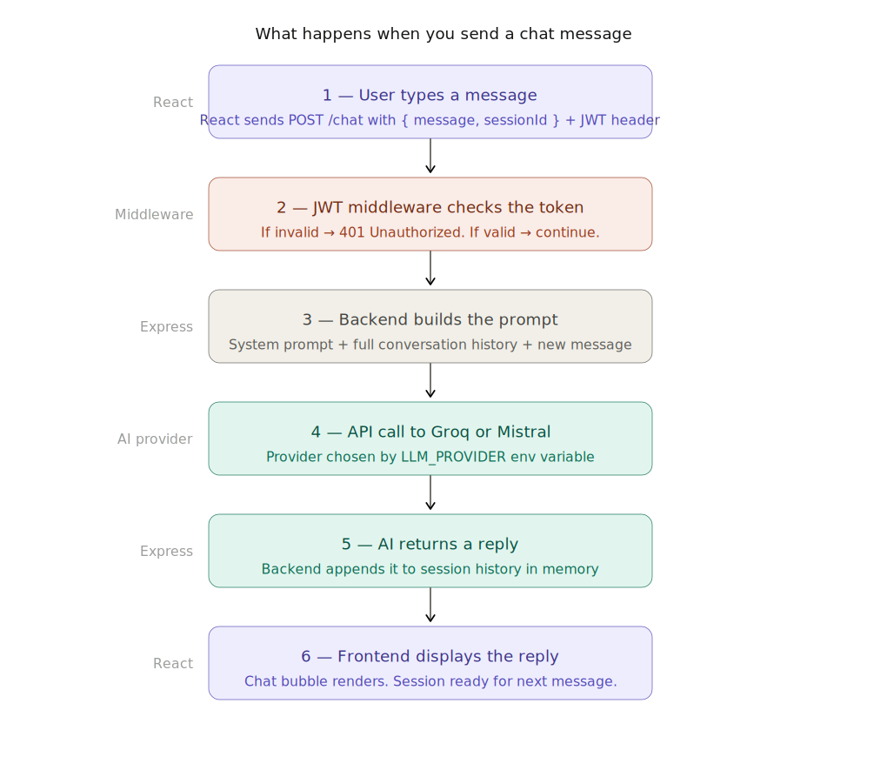
Figure 2 — Chat Message Data Flow (6-step sequence)

Step-by-step explanation:
- User types a message and clicks Send. The React component calls sendMessage(), which prepares a POST request.
- The frontend sends POST /api/chat with three fields: the message text, a sessionId (UUID), and the JWT token in the Authorization header.
- The verifyToken() middleware extracts and validates the JWT. If the token is missing or expired, a 401/403 is returned immediately and the request goes no further.
- The chat route builds the message array for the AI: the system prompt is prepended first, followed by all previous messages from the session history, then the new user message.
- llm.js reads the LLM_PROVIDER environment variable and calls either Groq (llama-3.1-8b-instant) or OpenRouter/Mistral, depending on configuration.
- The AI response is saved to the in-memory session history and returned to the frontend as JSON. React renders it in the chat interface.

Diagram 3 — Project Folder Structure
This diagram shows how the CyberGuide repository is organised. The project is split into three top-level folders: /client (React frontend), /server (Node.js backend), and /docs (all written documents).

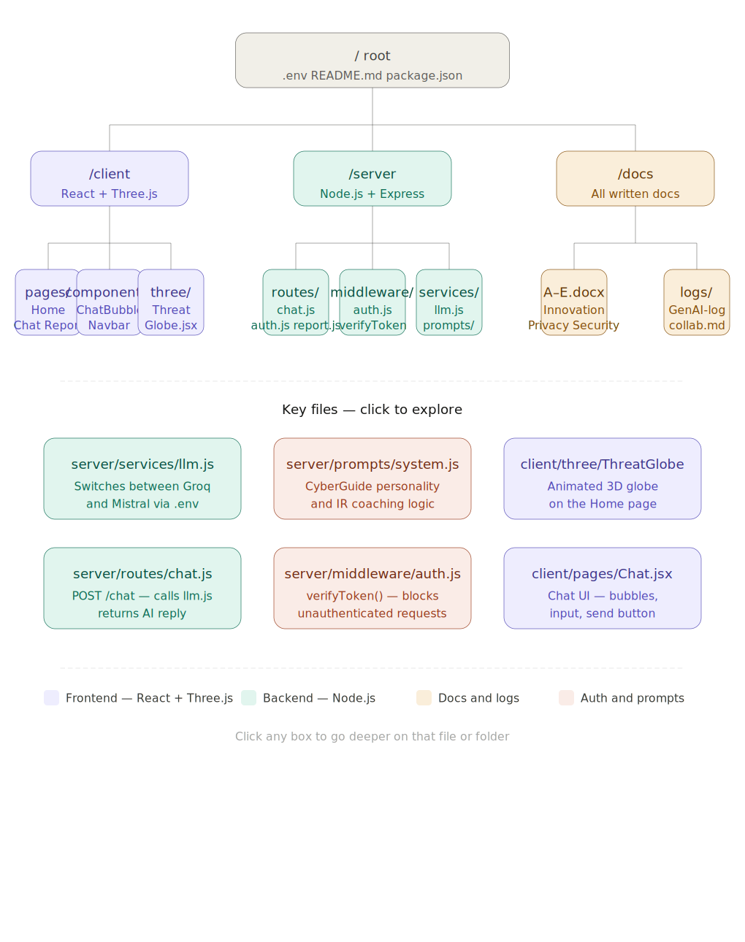
Figure 3 — Repository Folder Structure

Key folders and files:
- /server/index.js — entry point: sets up Express, mounts routes, starts the server on port 3001.
- /server/routes/ — three route files: auth.js (login/verify), chat.js (message handling + history), report.js (session summary).
- /server/middleware/auth.js — verifyToken() function used to protect chat and report routes.
- /server/services/llm.js — AI provider abstraction layer. Switching providers requires only changing LLM_PROVIDER in .env.
- /server/prompts/system.js — the system prompt that defines CyberGuide's behaviour as a cybersecurity incident coach.
- /client/src/pages/ — three pages: Home.jsx (login), Chat.jsx (main interface), Report.jsx (session summary).
- /client/src/context/AuthContext.jsx — global auth state using React Context. Stores JWT and user info after login.
- /docs/ — all written deliverables: A-innovation, B-conception, D-privacy, E-security, GenAI-log, collaboration-log.

Architecture Decisions
For each key technology decision, this section explains the reasoning behind the choice made by the team.

Decision | Rationale
Node.js + Express | Fast setup, JavaScript across the full stack, huge ecosystem, ideal for building API prototypes quickly. The team already knew JavaScript from the frontend, so reusing it on the backend reduced context switching.
React + Vite | Component-based architecture means each page is its own file (Home, Chat, Report). Vite is significantly faster than Create React App during development. React is the industry standard for modern frontend work.
Groq as primary AI | Free tier, no credit card required, fast response times, and fully compatible with the OpenAI SDK format. Switching to another provider requires zero code changes — only the environment variable.
Mistral via OpenRouter | Mistral AI is a French company with EU-based servers. For the GDPR analysis in D-privacy.docx, this is the most important architectural choice: switching to Mistral makes the app GDPR-compliant by default for EU deployments.
JWT authentication | Stateless — the server does not need to store session data. The token carries user identity and role. Works cleanly with a single .env secret and expires automatically after 8 hours.
In-memory session storage | Sufficient for a prototype with no persistent state requirement. No database to set up or configure. Restarting the server clears all sessions, which is acceptable for a demo environment.

Part B — Task Tracking (1 point)

GitHub Projects Screenshot
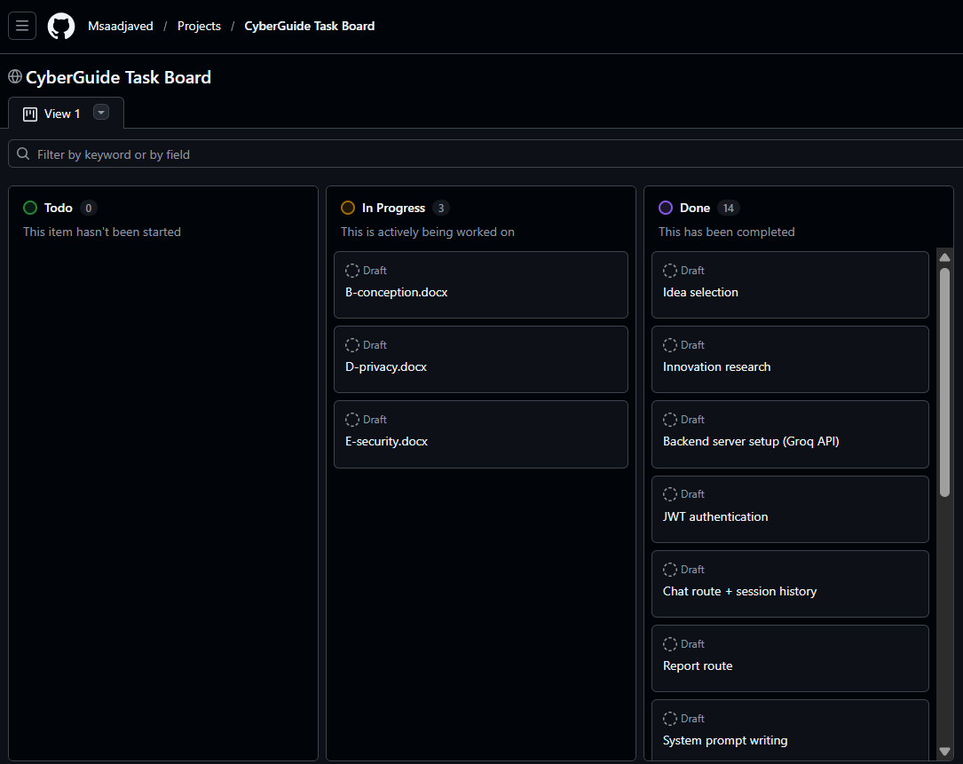
The board should show all 17+ tasks with columns: To Do | In Progress | Done

How we used the task board:
The GitHub Projects board was set up at the start of the project with tasks divided across all three members. Each task was assigned to the relevant member and moved through the columns (To Do → In Progress → Done) as work progressed. The board made it easy to see at a glance who was working on what and whether anything was blocked.
Tasks were updated at the end of each working session rather than in real time. This meant the board was accurate as a daily snapshot rather than a live tracker. What worked well was the column structure — having a Review column meant tasks were not marked Done until a second pair of eyes had checked them. What did not work as well was consistency: some tasks were created partway through and backdated, so the board did not fully reflect the true chronology of the work.

Part C — Individual Reflection (1 point)

Hassan (Member 3)
My role in this project was to own all the written documentation: the conception document, the privacy analysis, and the security analysis. Going into the project, I was not the person writing the code — but the oral defense means I still needed to understand every part of it. That was actually one of the more challenging aspects for me: reading through the server files (especially llm.js and auth.js) and being able to explain them clearly, not just summarise them.
How I planned my own work: I used the instruction document I was given as a checklist and worked through each document in order. For each section, I read the relevant code first, then wrote the corresponding section in the document. I worked in focused sessions of one to two hours, usually in the evening, and used Claude as a thinking partner to check whether my explanations of the code were accurate.
What went well: the structure of the instruction document made it very clear what was expected. I never had to guess what to write — the framework was there and I just had to fill it with accurate content grounded in the actual code. Keeping the GenAI log updated alongside my work also meant I did not have to reconstruct it at the end.
What did not go well: I underestimated how long it would take to genuinely understand the code well enough to explain it. Reading auth.js is quick; being able to explain why JWT is stateless and what that means in practice takes longer. I should have started reading the code earlier, before I started writing.
What I would do differently: start with the code, not the documents. If I had read through all the server files in the first session, the writing would have gone much faster because I would not have had to pause and go back to the code every few paragraphs.

Makuo (Member 1)
My role was building the entire backend: the Express server, the three API routes (auth, chat, report), the JWT authentication middleware, and the AI integration with Groq and Mistral. I planned my work by starting with the core server first — getting a response from the Groq API via curl before the frontend existed — because I wanted to prove the AI integration worked before building anything on top of it. What went well was the provider abstraction: putting both Groq and Mistral behind a single LLM_PROVIDER environment variable meant switching providers required zero code changes, which turned out to be important for the privacy analysis. What did not go well was documentation — I did not log my progress in the collaboration log as I went, which meant my entries were sparse compared to Javed's. If I started over, I would write short notes after each working session rather than trying to reconstruct decisions at the end.

Muhammad Saad Javed (Member 2)
I built the entire frontend in one session: three React pages (Home, Chat, Report), the ChatBubble component, and the ThreatGlobe Three.js visualisation. I planned my work by reading the existing backend routes first so I knew exactly what data each API call would return before I wrote a single line of frontend code. What went well was the scaffold — Makuo's backend was clean and well-structured, so I could focus entirely on styling and UX without fighting the architecture. What did not go well was the package-lock.json conflict when I merged main into my branch; I had to regenerate the lock file which took a few tries to get right. What I would do differently is create the branch from the latest main from the start, rather than merging mid-way through, to avoid the conflict entirely.

