DiagnoBot Project Figures and Screenshots
Labeled visual evidence for the prototype report
This figure set groups the supplied skin examples with upload-result screens when the uploaded filename is visible. Each figure includes a suggested report location. Screenshots show prototype behavior; they are not clinical validation.

Suggested report order
- Prototype overview: Figures 1 and 2
- Image upload and classifier behavior: Figures 3 to 8; keep each input beside its matching result.
- Dashboard and assistant interface: Figures 9 to 12
- Model training and evaluation: Figures 9 to 12
- Appendix: Figure 13, the additional supplied skin-image sample.
The doctor dashboard screenshot with oncology claims and “10,000+ scans” is explicitly marked illustrative; these values are not supported by project evaluation files.

Prototype home screen
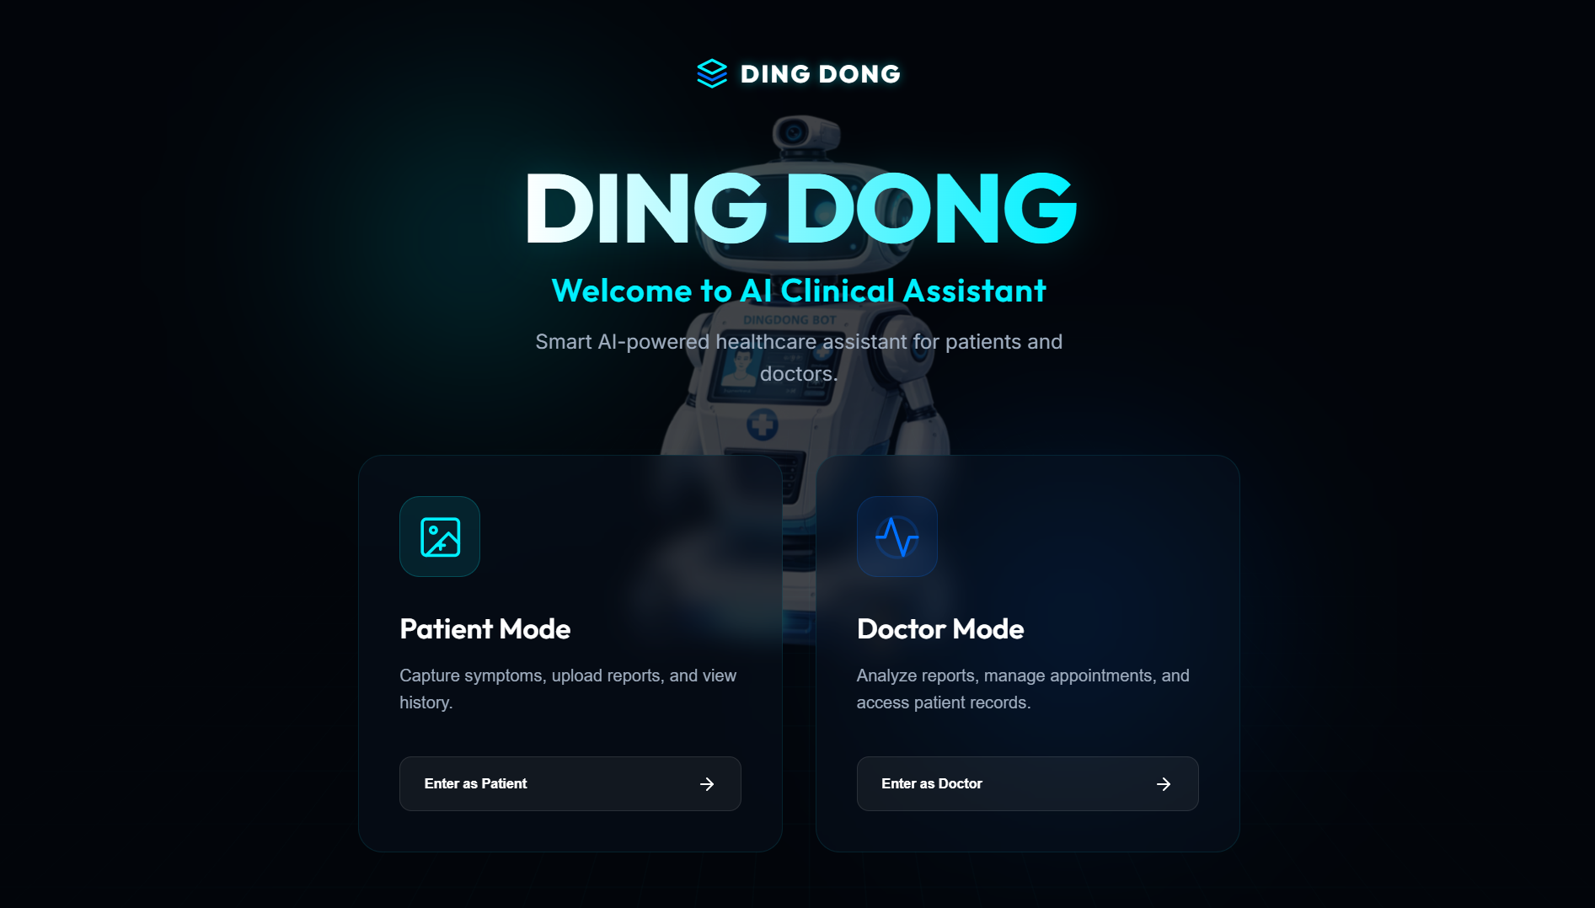
Figure 1. DiagnoBot landing screen showing Patient Mode and Doctor Mode.
Suggested placement: System overview / Prototype design

Patient AI assistant screen
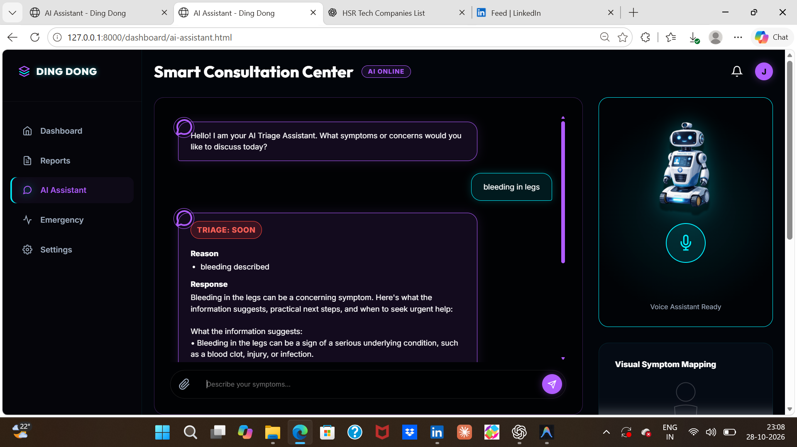
Figure 2. AI assistant interface displaying a symptom-based triage response.
Suggested placement: Prototype interface / Assistant workflow

Acne image and its upload result
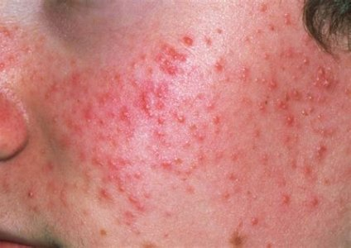 | 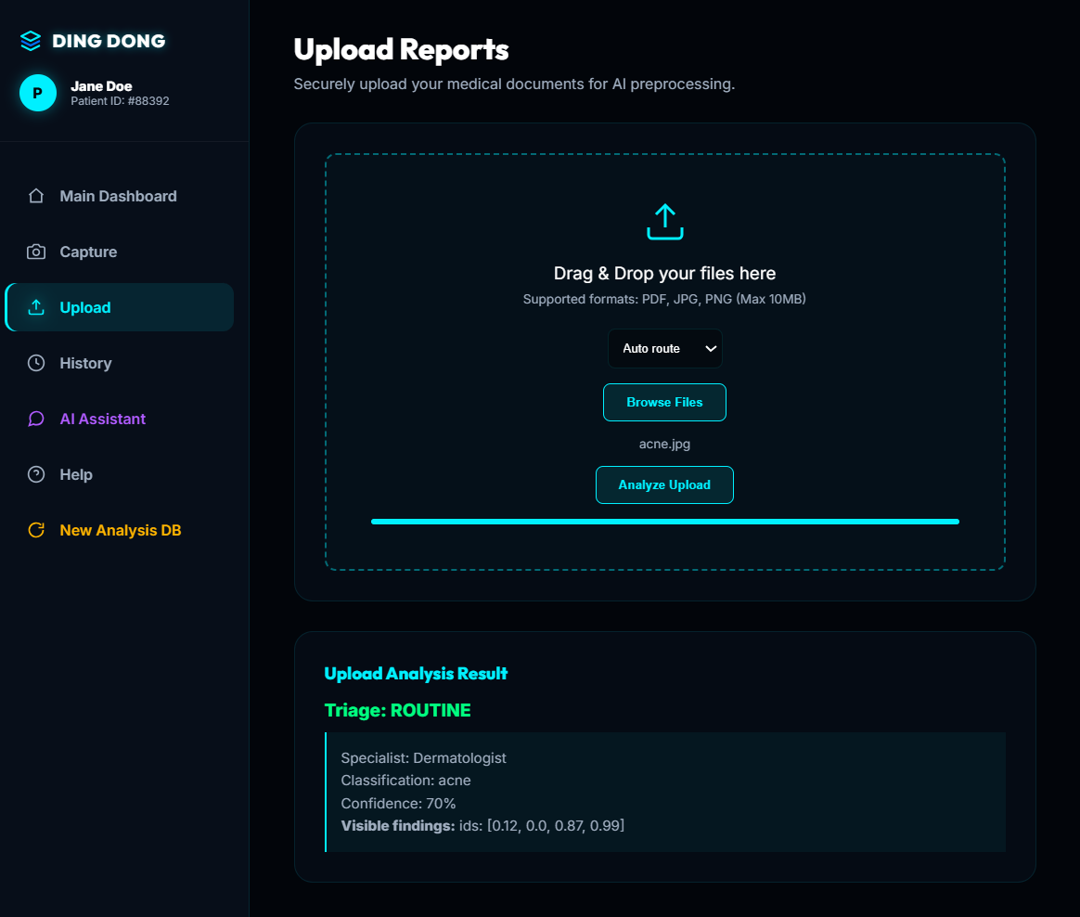
Figure 3a. Supplied acne reference image. Figure 3b. Upload and analysis result for acne.jpg; routine result at 70% confidence.
Suggested placement: Place the supplied acne image directly beside its matching upload result in Prototype Results.

Separate acne classifier result screen
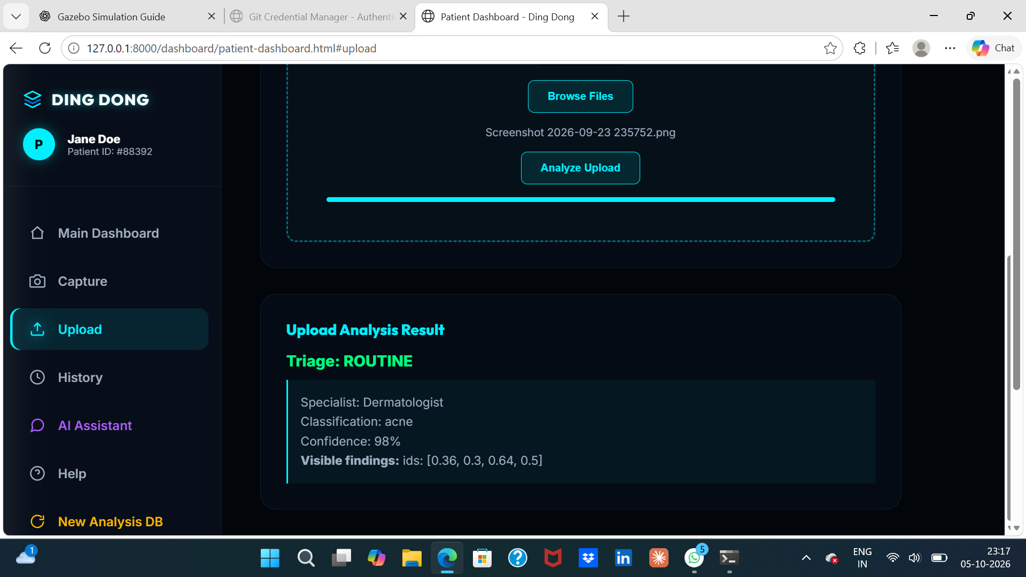
Figure 4. Acne upload-result screen showing 98% classifier confidence and routine triage. This is an application output, not an accuracy measurement.
Suggested placement: Prototype test cases / Upload results

Uncertain image result
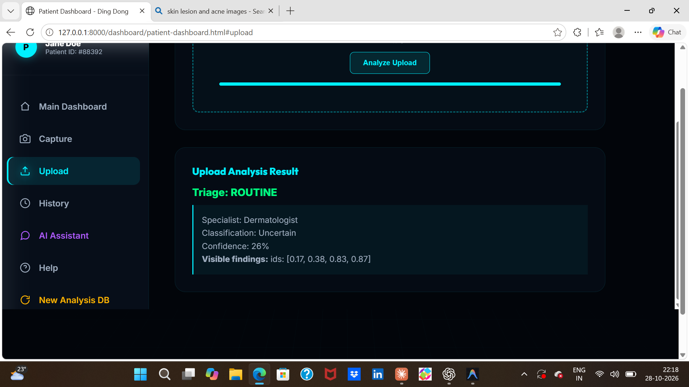
Figure 5. Upload result labeled Uncertain with 26% confidence.
Suggested placement: Prototype test cases / Low-confidence handling

Fallback behavior warning
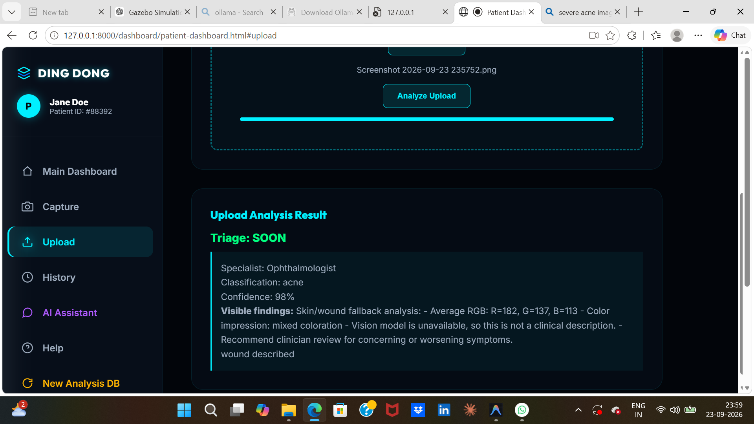
Figure 6. Upload result showing vision-model-unavailable fallback text. It also routes the image to an ophthalmologist, which appears inconsistent with the skin-image workflow and should be corrected before presentation.
Suggested placement: Limitations / Failure handling

Bullous pemphigoid image and its triage result
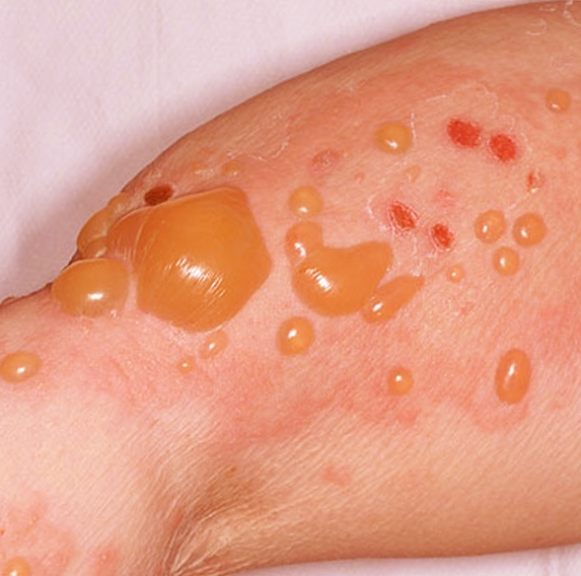 | 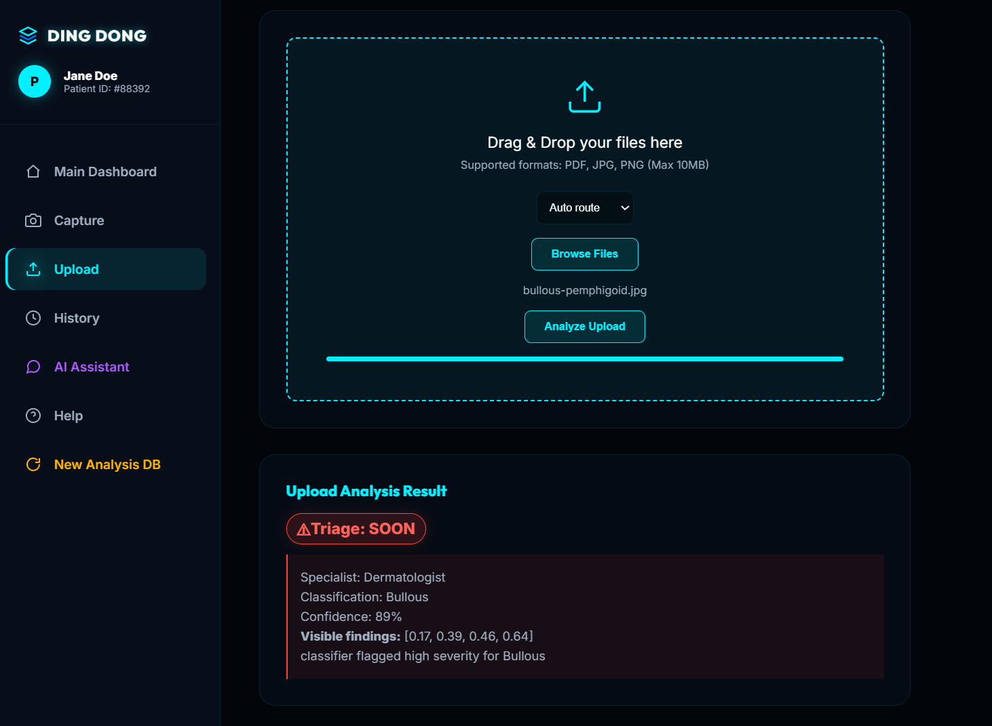
Figure 7a. Supplied bullous pemphigoid reference image. Figure 7b. Matching upload result for bullous-pemphigoid.jpg with red SOON alert.
Suggested placement: Keep the input and matching alert together in Prototype Results.

Doctor dashboard illustrative metrics
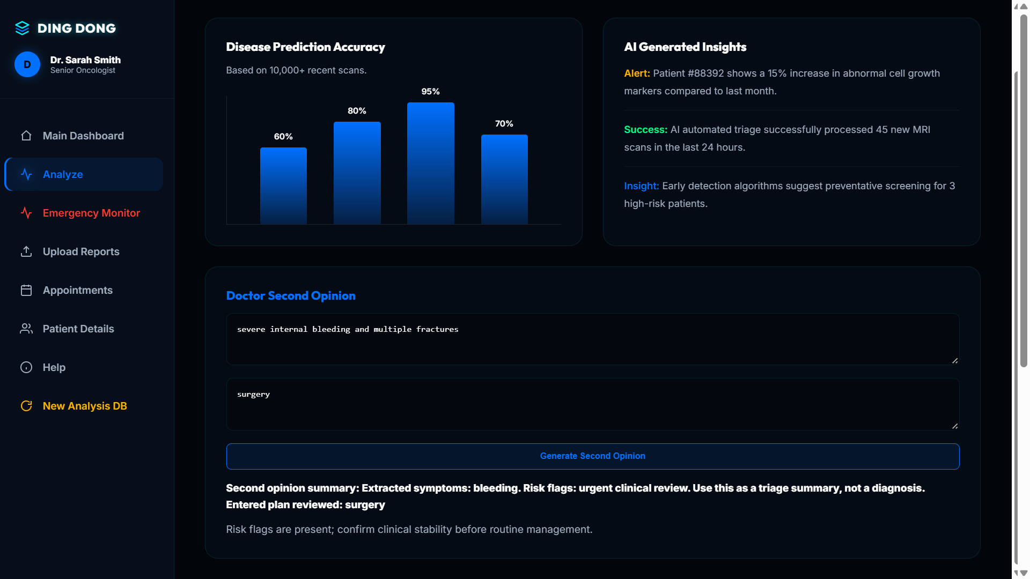
Figure 8. Doctor dashboard mockup. “10,000+ scans,” accuracy bars, MRI counts, and oncology alerts are not substantiated by this project’s evaluation and must not be presented as measured results.
Suggested placement: Prototype mockup / Label as illustrative, not experimental evidence

Project evaluation dashboard
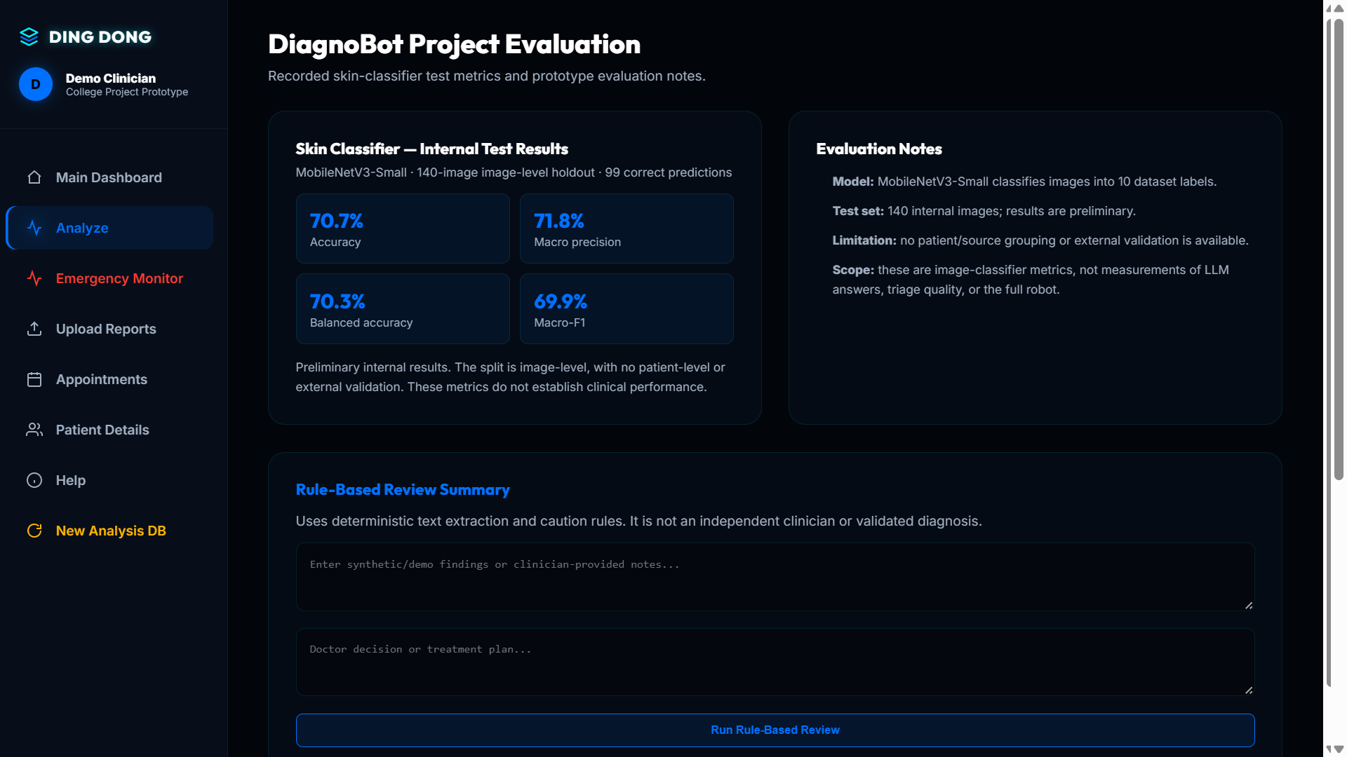
Figure 9. Dashboard displaying saved internal skin-classifier test metrics: 70.7% accuracy, 71.8% macro precision, 70.3% balanced accuracy, and 69.9% macro F1.
Suggested placement: Evaluation results / Skin-classifier performance

Training progress console
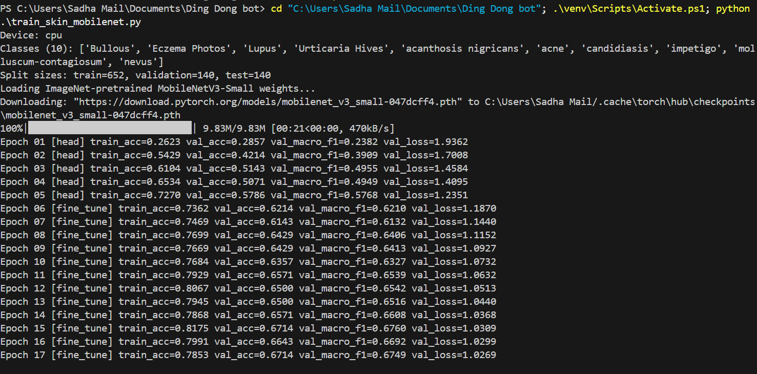
Figure 10. Training log showing training and validation metrics across epochs.
Suggested placement: Methodology / Training process

Model test metrics console
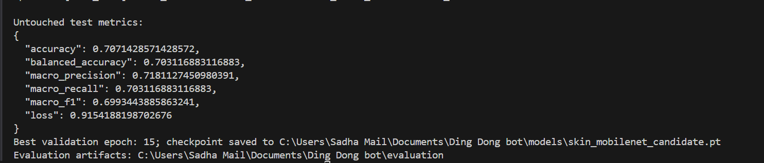
Figure 11. Console output with held-out test-set metrics and checkpoint details.
Suggested placement: Evaluation results / Test-set metrics

Held-out test confusion matrix
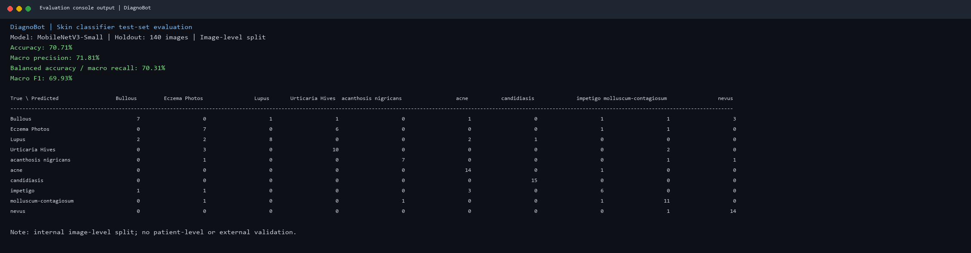
Figure 12. Console transcript generated by print_skin_test_confusion_matrix.py from the saved test metrics and confusion-matrix CSV. Rows are true labels; columns are predicted labels.
Suggested placement: Evaluation results / Confusion matrix. The test set has 140 images and uses an image-level split.

Additional supplied skin test image
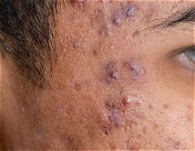
Figure 13. Additional supplied skin-image sample. No result is paired because the supplied screenshots do not show this filename with a corresponding analysis.
Suggested placement: Appendix / Sample test images

Source files and use notes
The sample_documents folder contains the supplied one-page blood-test PDF, skin images, this figure document, and the unique copied project screenshots. Use the suggested placement under each figure when adding it to the project report.
The classifier metrics describe the saved 140-image internal test split only. They do not measure clinical safety, triage quality, assistant-answer quality, or performance on new patients. Some screenshots show earlier prototype behavior.

