**TRAFFIC MANAGEMENT SYSTEM**

**Phase 5: Project documentation and submission**

**PROJECT OBJECTIVES :**

The IOT-based Traffic Management System aims to optimize traffic flow and reduce congestion by implementing an intelligent traffic signal control system. The system utilizes Arduino Mega as the primary microcontroller, an ultrasonic sensor to detect vehicle presence, and traffic light signals to regulate traffic. The output is interfaced using Beeceptor and MIT App. Additionally, an HTTP server is created to provide a user-friendly interface. ESP32 is used for the project.

**COMPONENTS USED :**

List of components used in the project:

●Arduino Mega: The Arduino Mega microcontroller was chosen for its extensive I/O capabilities and enhanced processing power, ensuring comfortable and efficient implementation of the 4-way traffic management system.In addition, we're integrating a dynamic control system that responds to the density of traffic.

●Ultrasonic sensors

●LEDs for traffic lights  
 ●Jumper wires  
 ●Breadboard

●ESP32

**SOFTWARE USED :**

* Beeceptor: Used for interfacing the output and collecting data from the system.
* MIT App: Provides a user-friendly interface to interact with the system.

**WIRING DIAGRAM :**

We provide a detailed wiring diagram to illustrate the connections between the Arduino Mega, ultrasonic sensors, and LEDs for the traffic lights. This diagram serves as a visual guide for setting up the project.

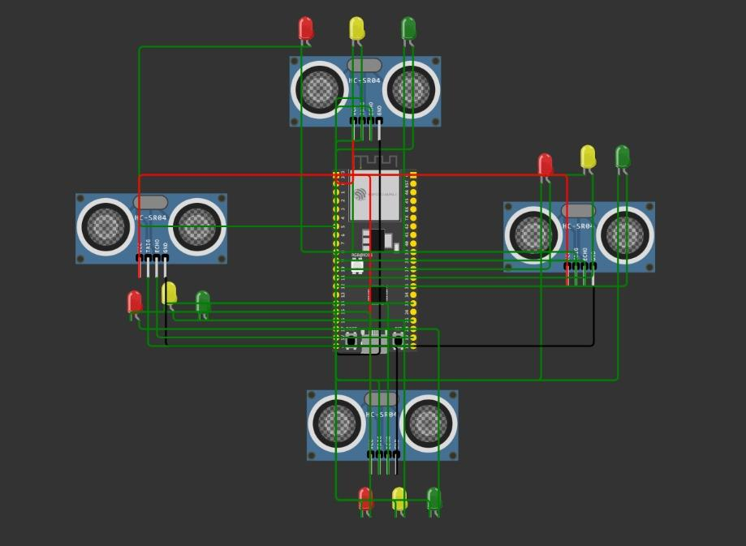 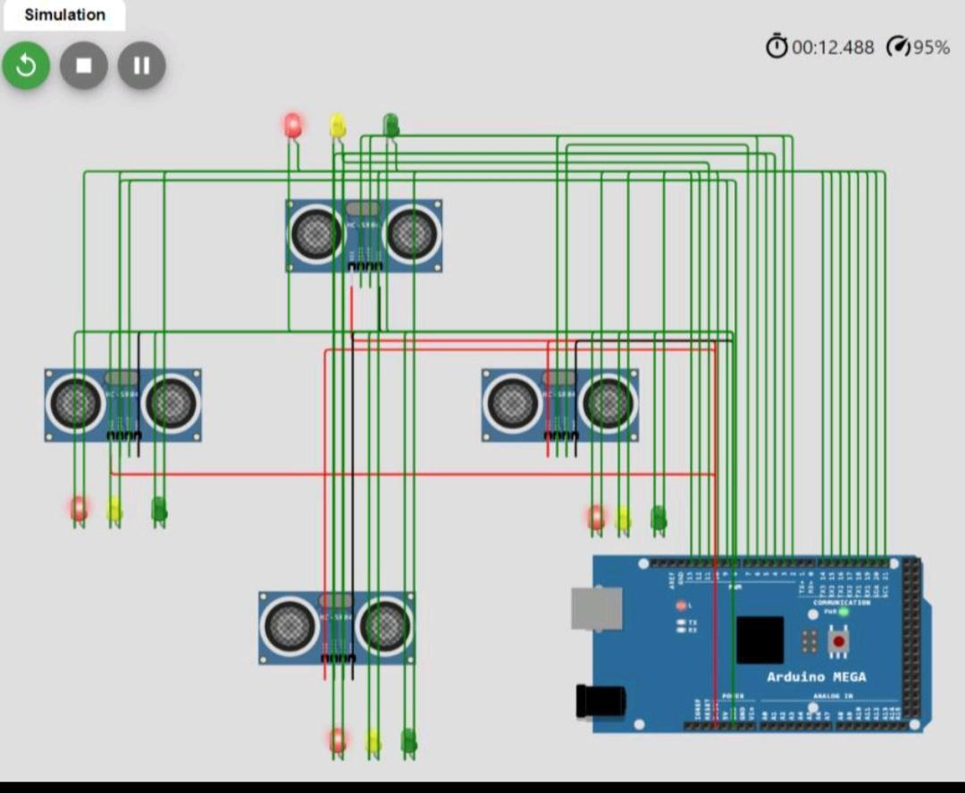

**CODE EXPLANATION:**

**Ultrasonic Sensor Measurement:**

* - Triggers the ultrasonic sensor to measure distance by sending a pulse.
* - Measures the duration of the echo signal.
* - Converts the duration into a distance in centimeters.

**Traffic Density Calculation:**

* - Simulates vehicle density based on the measured distance.
* - If the distance is less than 20 cm, it sets `trafficDensity` to 3 (high traffic density).
* - If the distance is between 20 cm and 50 cm, it sets `trafficDensity` to 2 (moderate traffic density).
* - If the distance is greater than 50 cm, it sets `trafficDensity` to 1 (low traffic density).

**Traffic Light Control:**

* - Adjusts the traffic light based on the calculated `trafficDensity`.
* - If `trafficDensity` is 1, it switches to a green light.
* - If `trafficDensity` is 2, it switches to a yellow light.
* - If `trafficDensity` is 3, it switches to a red light.

**Serial Output (for Debugging):**

* - Sends the current `trafficDensity` and distance to the serial monitor for debugging.

In summary, the code uses an ultrasonic sensor to measure the distance from an object and calculates a simulated traffic density based on that distance. It then adjusts the traffic light color (red, yellow, green) based on the simulated traffic density and provides debugging information through serial communication.

**PROJECT EXECUTION:**

To set up the project, follow the provided wiring diagram and upload the Arduino code to the Arduino Mega. The code will start executing, and the system will actively control traffic at the junction.

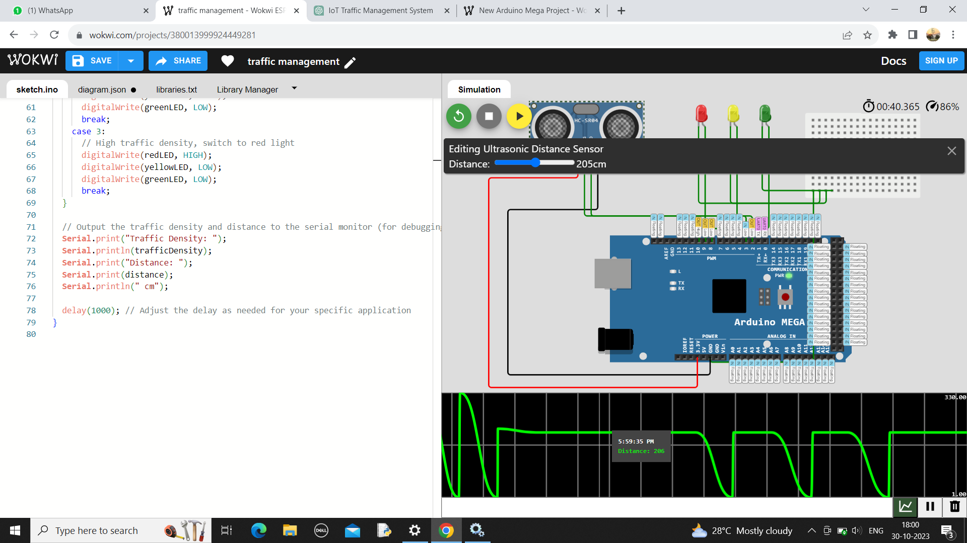

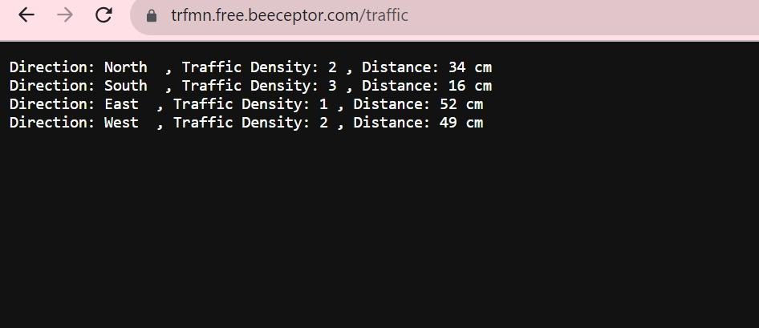

FIG .BEECEPTOR OUTPUT

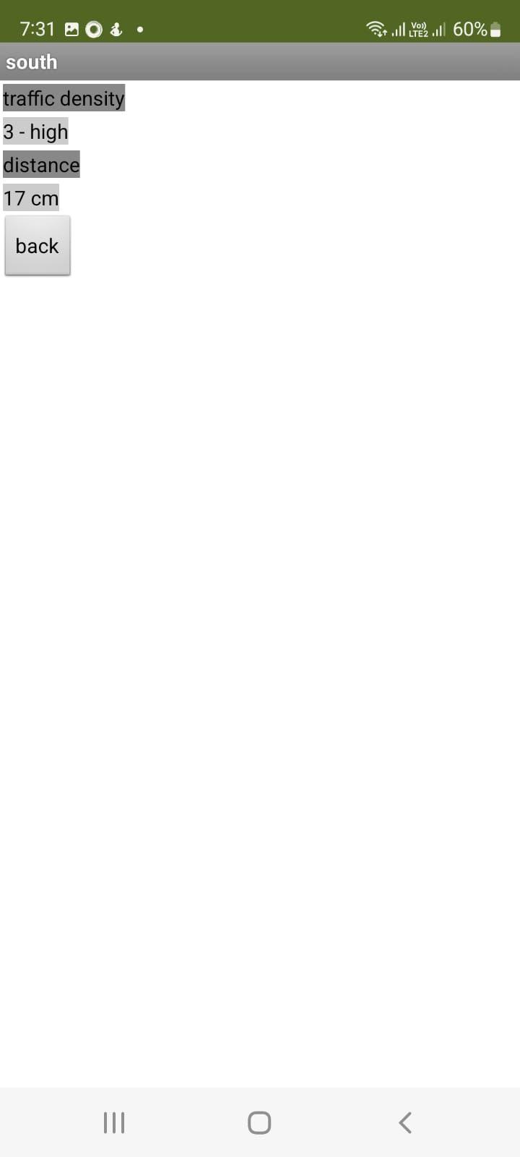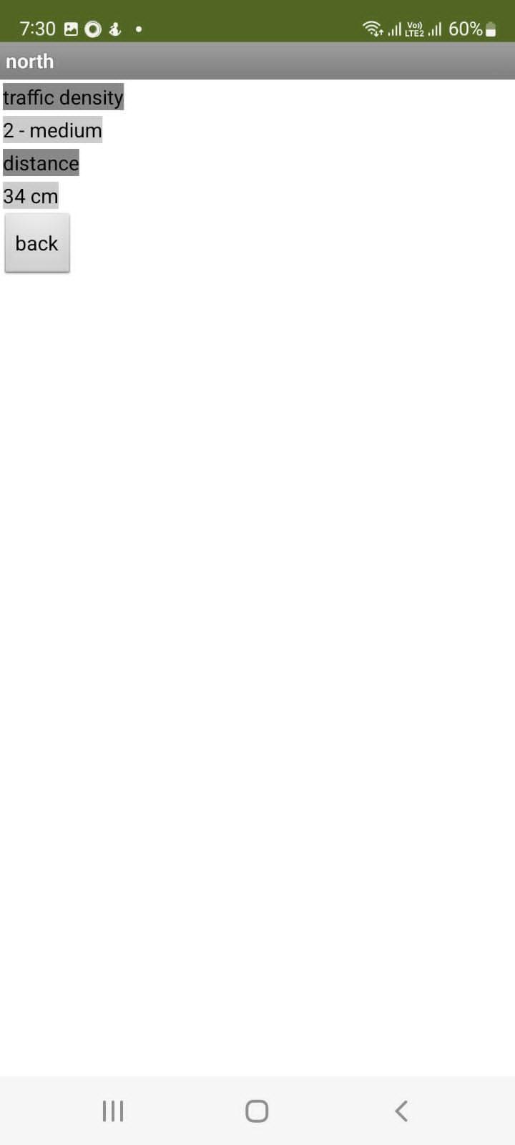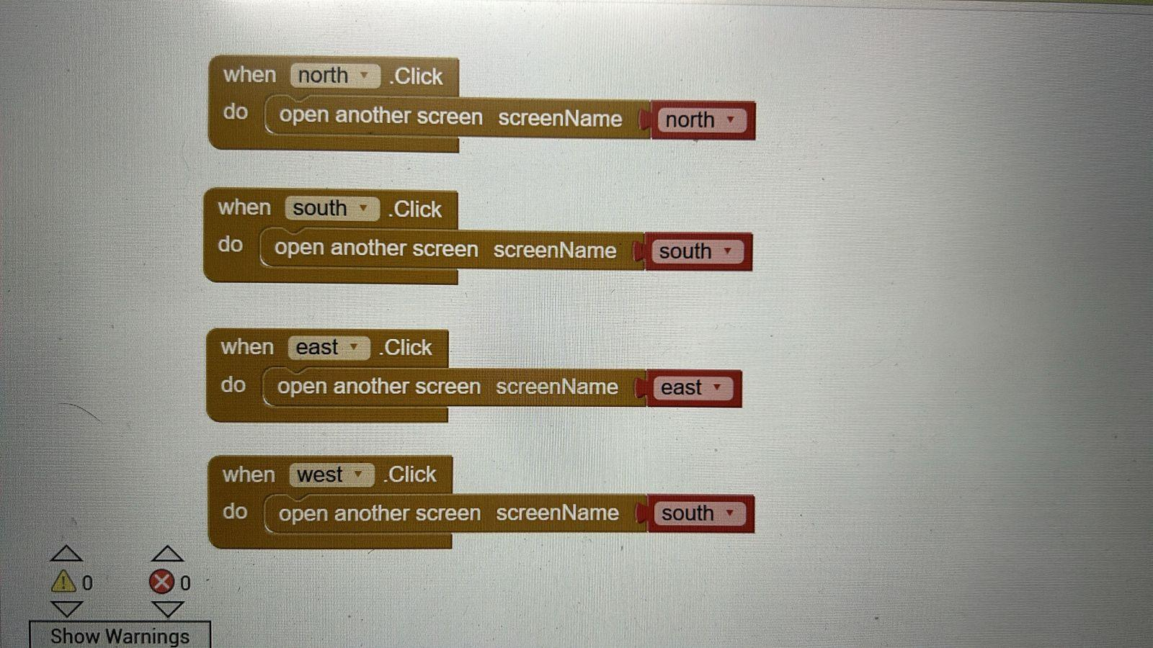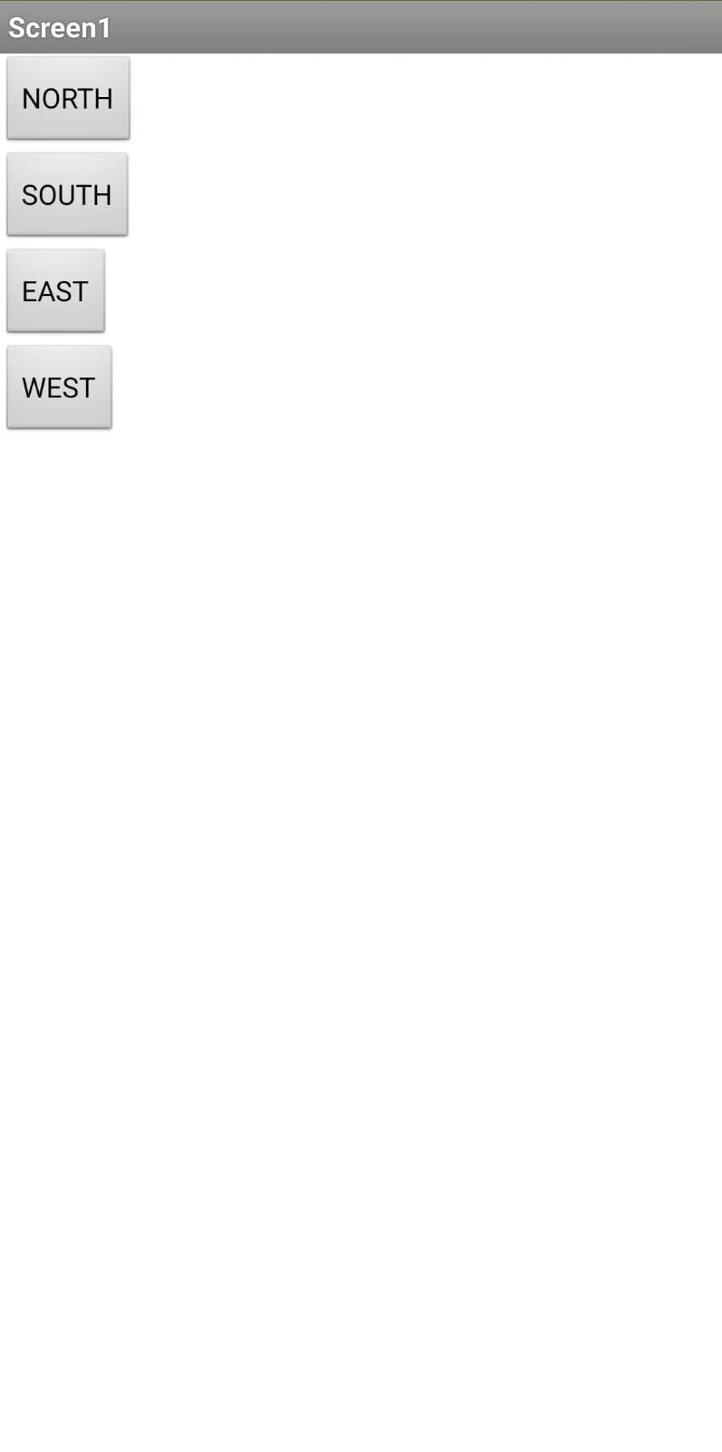

FIG. MIT APP INVENTOR OUTPUTS

**TESTING AND RESULTS :**

We have assessed the project in multiple situation,emulating traffic condition at four intersection.the system adeptly react to the presence of vehicles ,streamlined traffic control and integrating a dynamic control system that responds to the density of traffic.

**CONCLUSION:**

In conclusion, the IOT-based Traffic Management System using Arduino Mega, ultrasonic sensor, traffic light signals, and wires is an effective solution for optimizing traffic flow and reducing congestion. By intelligently controlling traffic signals based on vehicle presence, the system ensures a smoother flow of vehicles and reduces waiting times at intersections. The integration with Beeceptor and MIT App allows for easy monitoring and analysis of the system's performance, while the implementation of an HTTP server provides a user-friendly interface for interaction. Through testing and validation, the system can demonstrate its efficiency in regulating traffic and improving overall traffic management.