

**Orange Coding Academy**

**Master Project Report**

Flash Cards

**Prepared by:**

Msallam Yousef Daas

# Table of Content

Declaration ……………………………………………………………………………... 4

Introduction ……………………………………………………………………………. 5

Overview ………………………………………………………………………………… 6

Requirements …………………………………………………………………………. 7

Software requirements ………………………………………………………………………… 7

Functional requirements ……………………………………………………………………………. 7

Nonfunctional requirements ………………………………………………………………………… 9

Analysis & Design ……………………………………………………………………. 10

Use Case Diagram ………………………………………………………………………………………. 10

Class Diagram ……………………………………………………………………………………………. 11

User Manual ……………………………………………………………………………... 12

Home Page……………………………………………………………………………………………… 13

Register Page………………………………………………………………………………………………. 14

Login Page 15

Categories Page 16

Reviews Page 17

Cards Page 18

Cards Page 19

Study Plan Page 20

How To Use Page 21

Create Cards Button… 22

Delete Cards Button 23

Edit Cards Button 24

Add Cards Button 25

Conclusion & Future work …………………………………………………………. 26

# Introduction

Educators throughout history have intuitively understood that

personalized instruction is among the most effective methods

of imparting knowledge and skills to others. From ancient craft

apprenticeships, through today's academic tutoring businesses, we've

consistently found that personalized human instruction offers a level

of adaptivity that cannot easily be attained with large class sizes.

Psychologist Benjamin Bloom famously illustrated the benefits of such

personalized instruction in his influential 1984 study, where he showed

that students receiving 1-on-1 tutoring were able to perform a whopping 2 *standard deviations* higher on achievement tests than students who

did not receive personalized interventions, conveying an extreme

advantage (Bloom, 1984). Social justice advocates have accordingly

recognized these inequities and have lobbied for smaller class sizes

and against the expensive tutors enjoyed only by the elites.

Yet there may be a more practical and affordably scalable solution to

the so-called "2 Sigma Problem", with the answer hiding in Bloom's

original 1984 paper itself.

The key is to examine the variables impacting student achievement

*other* than tutorial instruction. It turns out that four of Bloom's other

top success factors, when measured *individually*, still have an impressive

1-sigma impact on learning outcomes. The opportunity unforeseen by

Bloom and his researchers are that these factors could eventually be *combined*

 by educational software to create a potentially greater aggregate

benefit than human tutorial instruction.

"Student time on task", for example, could be enhanced by software

features that both improve motivation, through the use of frequent

feedback and variable rewards; and by features that help students with planning their study sessions, through the use of learning schedules

and the provision of a mobile interface that a student could access easily

on their smartphone.

Similarly, the benefits of breaking concepts into more digestible "cues & explanations" could be leveraged by a flashcard-like Q&A software that

engages users' active recall and [metacognitive self-assessment faculties](https://brainscape.com/academy/metacognition-strategies-studying/), thereby deepening the cognitive processing involved with each exposure.

The programs' spaced repetition algorithms can also automate the

processes of "corrective feedback" and "reinforcement" and thus mitigate

the forgetting that would otherwise occur with traditional study methods.

The confluence of these four major ideas is what has motivated the

Flashcards team to create our learning software in the way that we have.

Flashcards is a web and mobile study application that advances upon the traditional flashcard concept by [improving student motivation](https://brainscape.com/academy/study-motivation-procrastination/), alleviating

the burdens of planning study sessions, and deepening the amount

of cognitive processing involved in each exposure —all in the service of

crafting a personalized spaced repetition algorithm that mitigates

forgetting and enhances retention.

Millions of students, teachers, tutors, corporate trainers, and independent

learners of all ages have used Flashcards to find, create, organize, and share flashcards for thousands of subjects, ranging from science, to law, to foreign languages. These flashcards can be studied in a web browser or

smartphone, and come equipped with an engaging user experience that

 repeats concepts within a specific personalized interval of time, based

on the user's self-rated confidence of each flashcards.

From its core, Flashcards has been based upon the principles of cognitive

science that most effectively, conveniently, and enjoyably improve [learning outcomes](https://brainscape.com/academy/student-knowledge-retention/), in a way that resembles or improves upon the benefits that a

human tutor would otherwise offer. This paper explores the scientific underpinnings of Flashcards and identifies areas where additional research

may be beneficial.

# Overview

## Improving study motivation & planning.

Long-term motivation is a primary prerequisite to any deliberate learning endeavor. Whether that motivation is driven by intrinsic interest in the

subject, by professional ambition, by the desire to learn to communicate

in a foreign language, or simply by the fear of parental punishment in

the event of poor test scores, the prospect of an eventual "endgame" is a necessary spark that catalyzes any sustained educational pursuit.

The problem is that humans are not inherently skilled at conjuring the required *short-*term motivation that allows us to make progress toward

those long-term goals in smaller steps. We suffer from a phenomenon

known as hyperbolic discounting (or delay discounting), in which our

instinctive brains subconsciously prefer smaller but more immediate

rewards, even as our conscious brains still want the longer-term

prize (Ainslie & Haslam 1992).

Fitness and diet are often cited as typical examples of delay discounting.

We may *want* to get into physical shape, but that motivation does not

necessarily ensure that we will schedule adequate gym time today. We may *want* to lose weight, but that chocolate cake looks so delicious right *now.*

To address this well-known myopia, students with financial means have

traditionally hired personal human tutors to enforce structured study

sessions onto their calendars, in the same way that they might pay for

a personal trainer to schedule them a series of workout appointments

they can't afford to miss.

Such forced accountability confers an unfair advantage upon students who

are able to hire a human study coach, versus those left to wrestle with

their own hyperbolic discounting weaknesses. Flashcards aims to bridge

these gaps by providing the rigor that is necessary for learners to maintain

short-term motivation and to schedule appropriately spaced study

sessions over time.

**Requirement:**

##### Software requirements

* + Front end:

1. HTML
2. CSS
3. JavaScript
4. Bootstrap
   * Back end:

1.Laravel

* + Database Technology:

1.MySql

##### Functional requirements

###### R.1: Login

Description: The user will have to login.

Input: Click the login button, then enter your username and password

Then enter join button.

Output: The website will go to the home screen.

###### R.2: Register

Description: The user will have to register.

Input: Click the login button, then enter your username, email and password

Then enter join button.

Output: The website will go to the home page.

###### R.3: Edit cards

Description: the user can edit cards.

###### R.4: Delete cards

Description: the user can delete cards.

###### R.5: Logout

Description: The user can logout from the application at any moment in time.

Input: Click the logout button.

Output: The website will go back to the login page.

###### R.6: Add cards to review

Description: in the event that the cards are not easy to memorize for a user, the

User can add the card to the checklist, so that he can distinguish the card among

The other cards.

Input: Click the add card to review button.

Output: The website will go to the review page.

###### R.7: Study plan

Description: The user can put the study plan for you.

##### Nonfunctional requirements

###### Availability Requirement

The system is available 100% for the user and is used 24 hrs a day and 365 days a year. The system shall be operational 24 hours a day and 7 days a week.

###### Efficiency requirement

Mean Time to Repair (MTTR) - Even if the system fails, the system will be recovered back up within an hour or less.

**Analysis & Design**

##### -Use Case Diagram

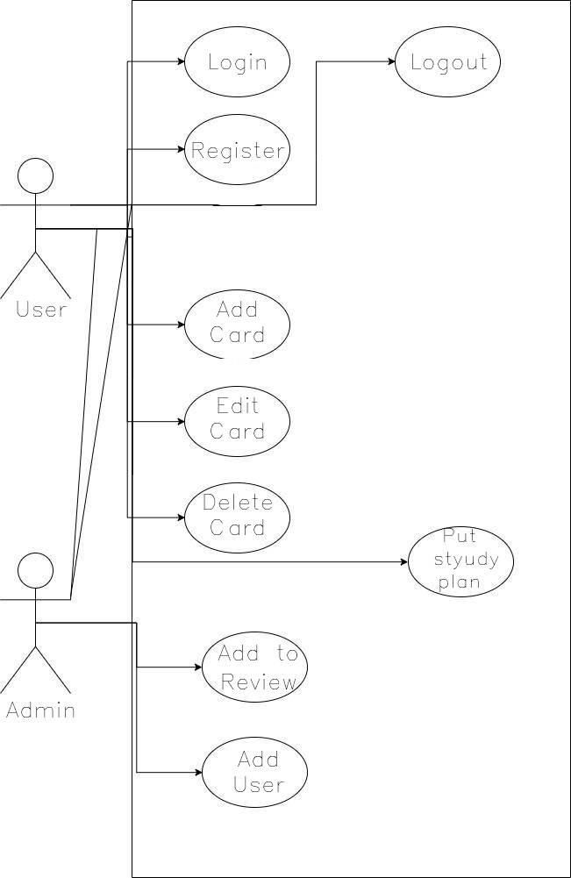

##### Class Diagram

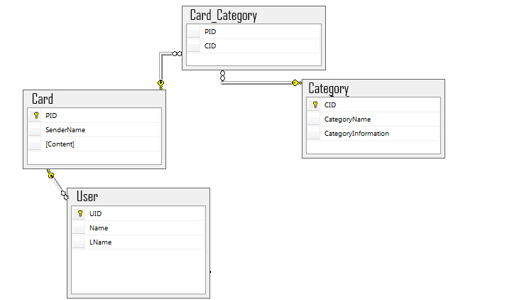

## - User Manual

* **Home page**

When the user first enters the website a home page will appear.

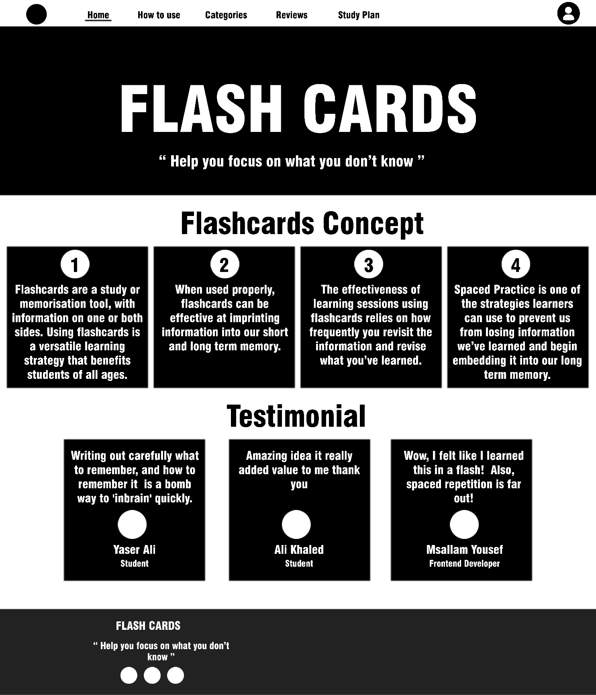

## Register page

If you do not have an account on the site, it is preferable to go to the registration

page and fill in the data.

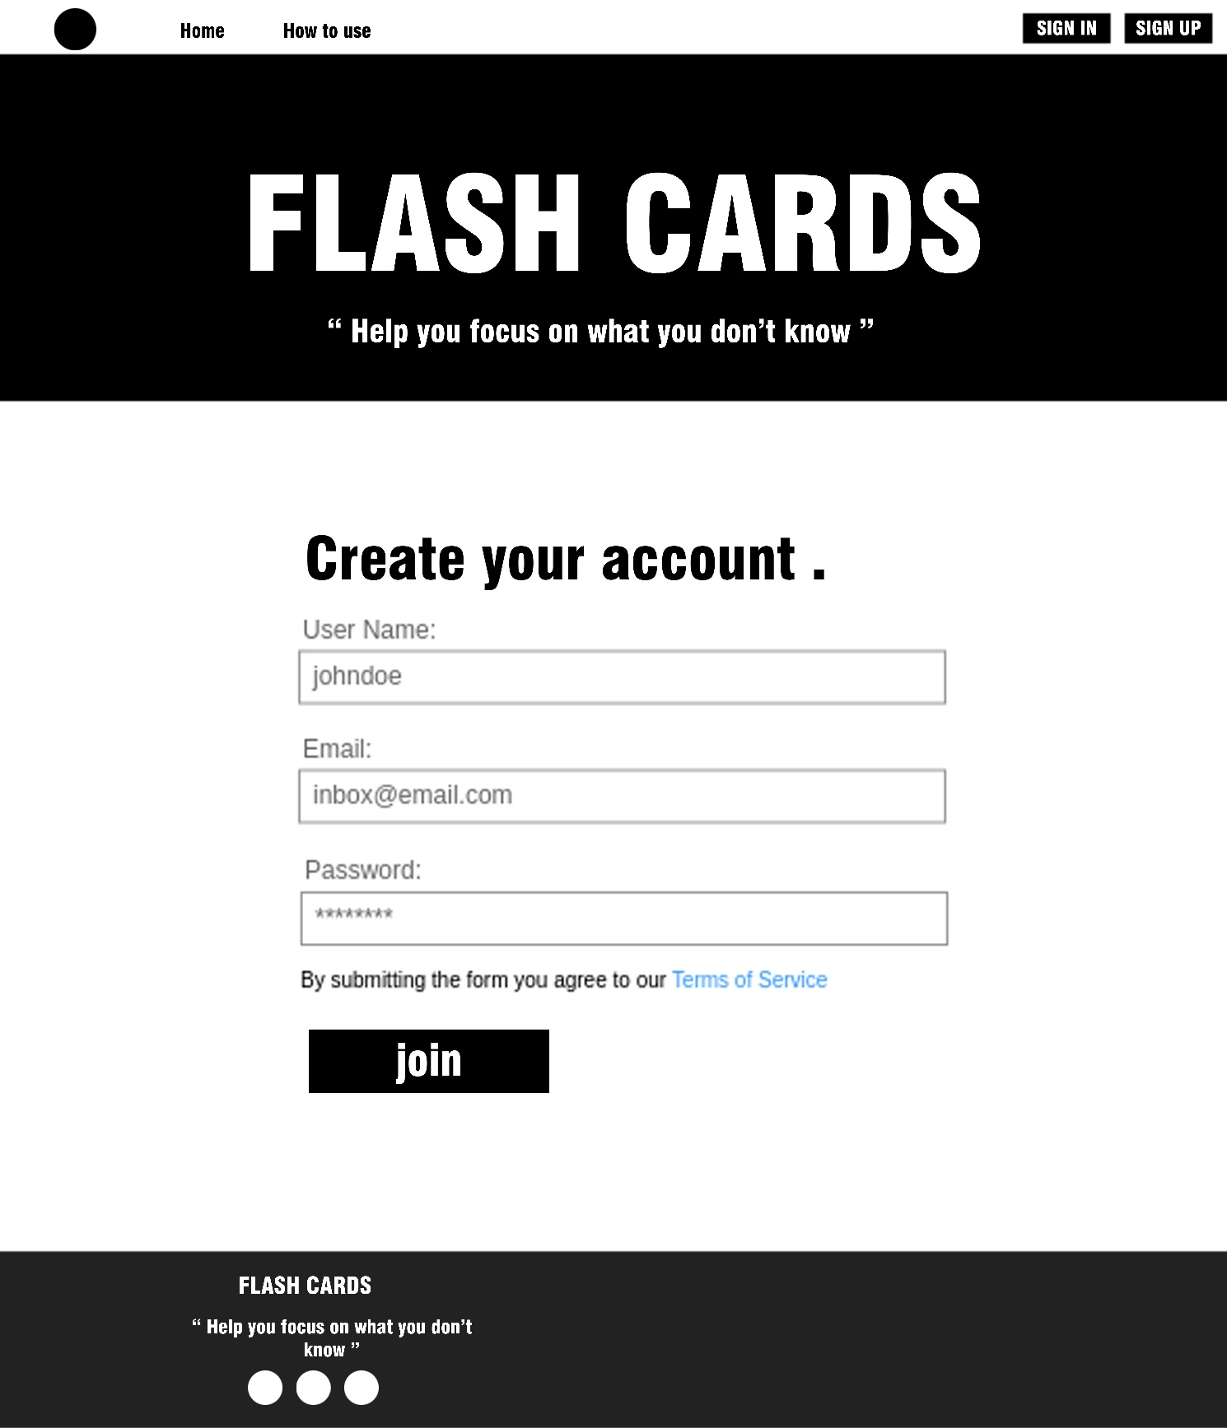

## Login page

If you have an account on the site, it is preferable to go to the login page

and fill in the data.

فف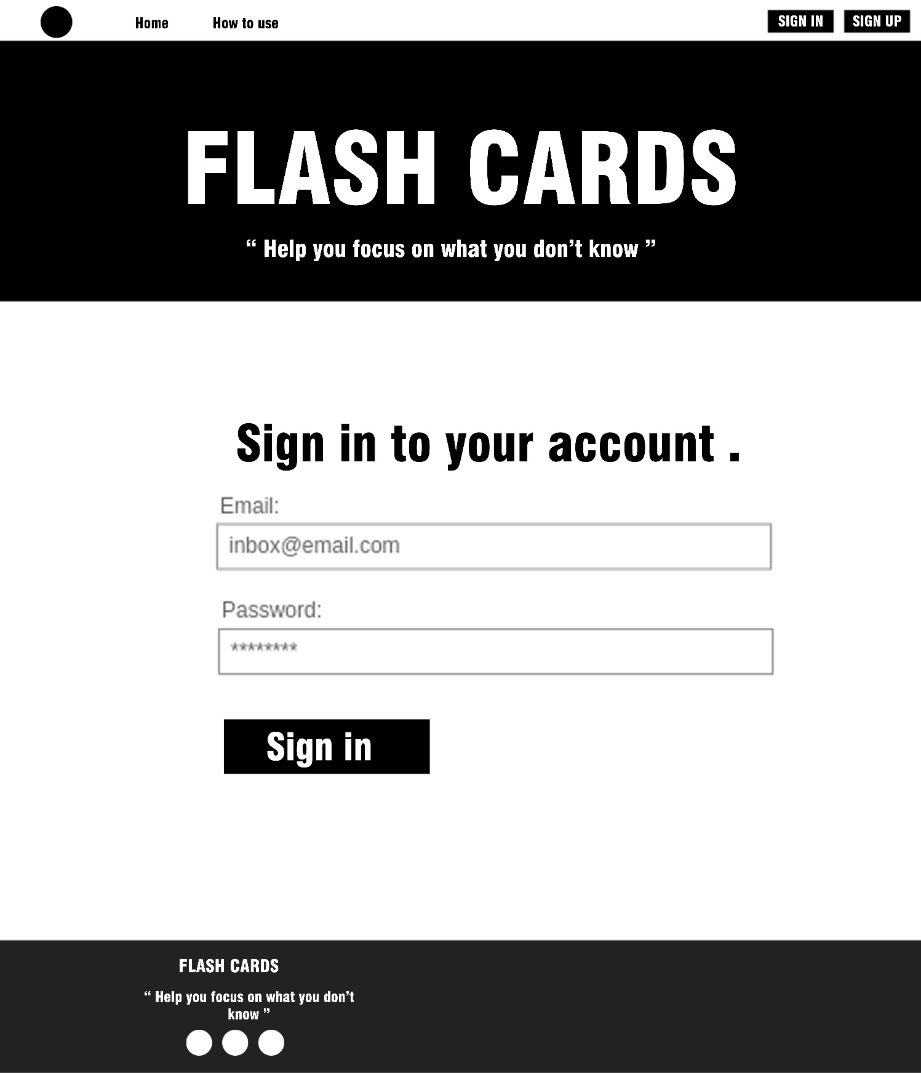

## -Categories page

In this page we view the categories.

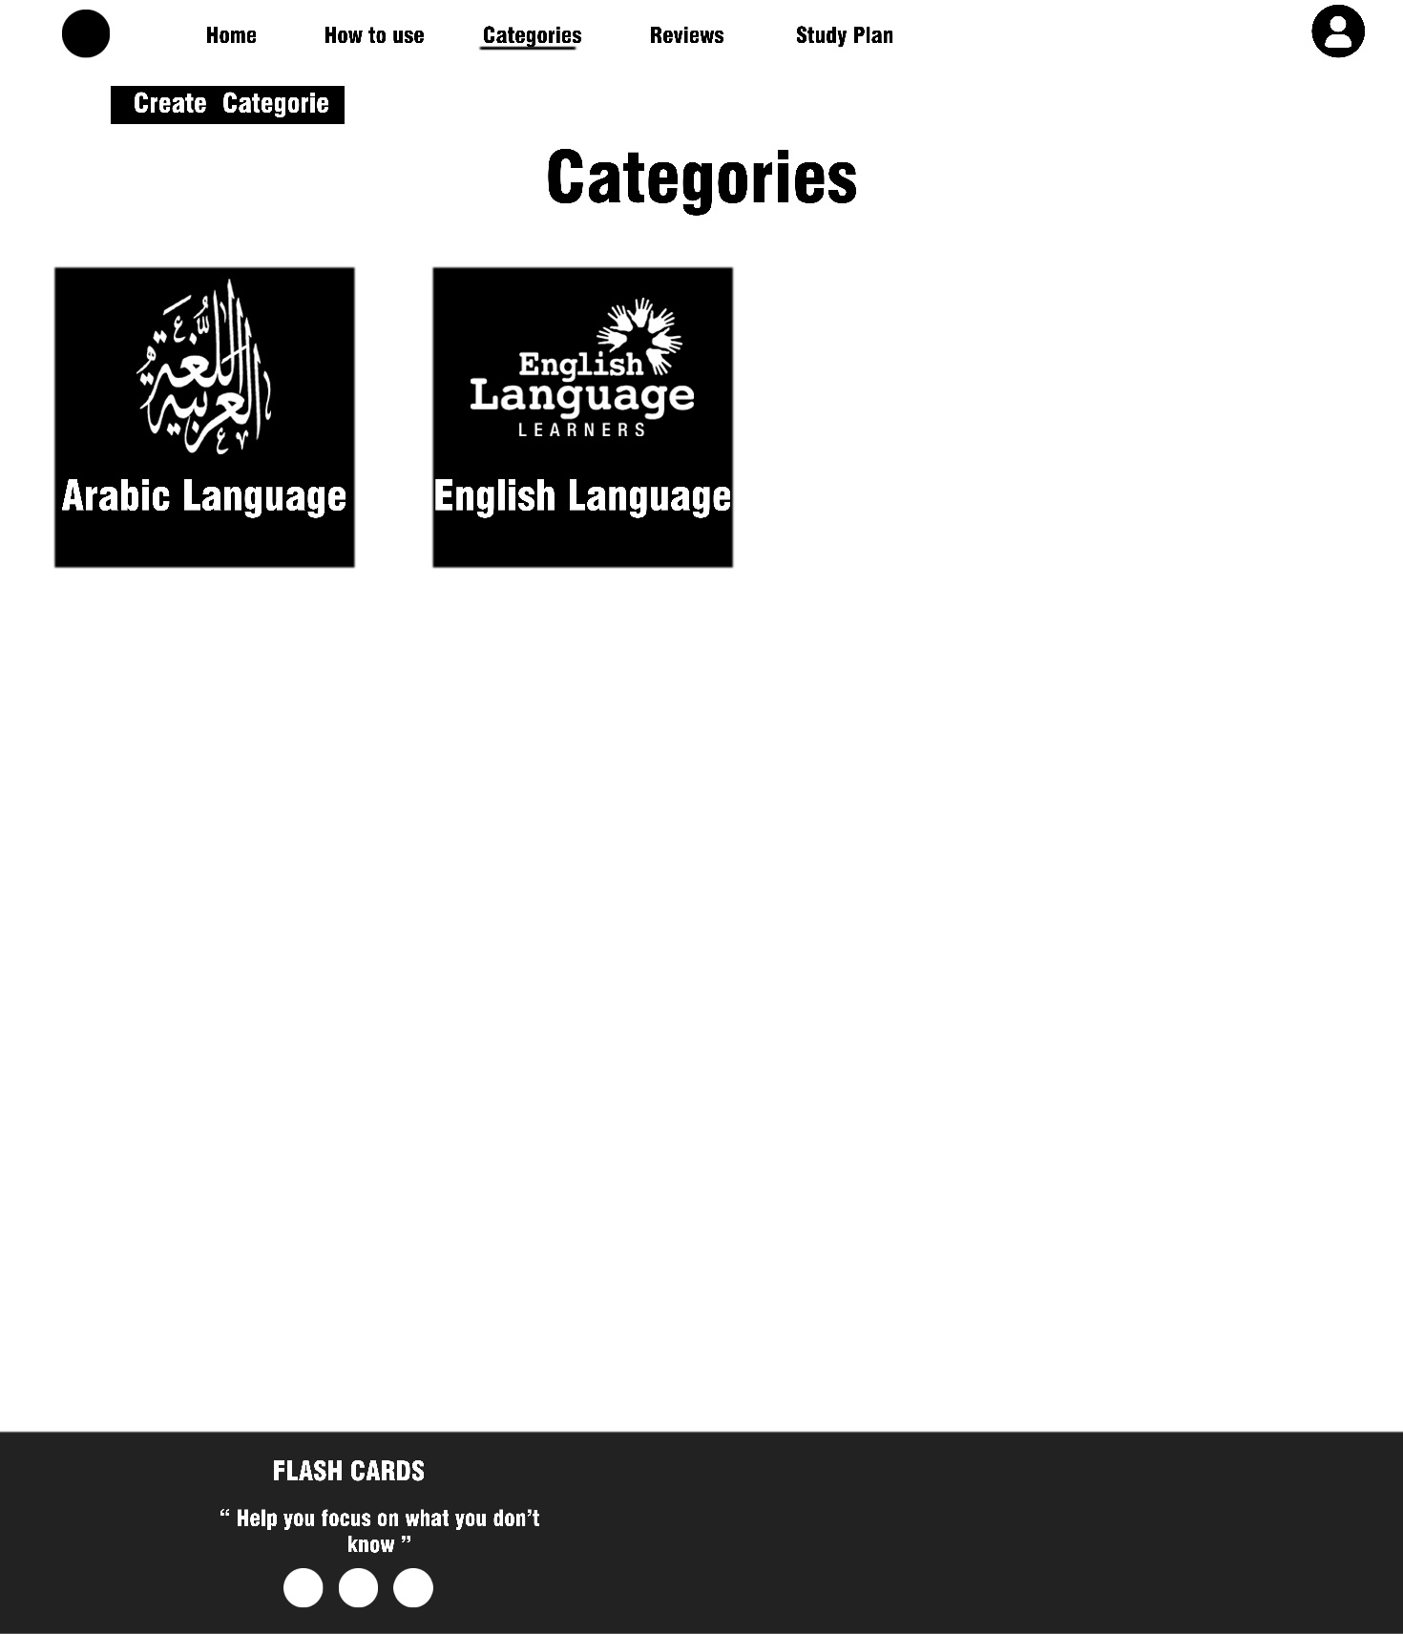

## -Reviews page

In this page we view the reviews cards.

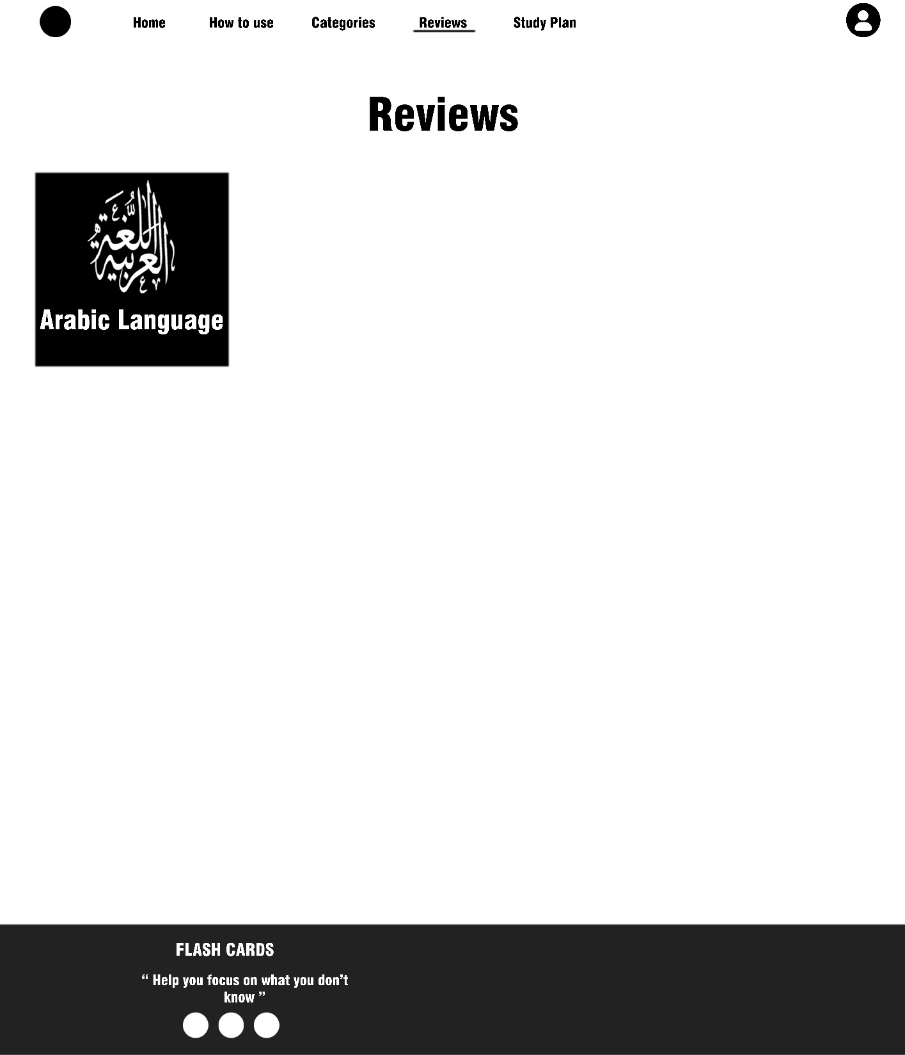

## -Cards page

In this page we view the cards.

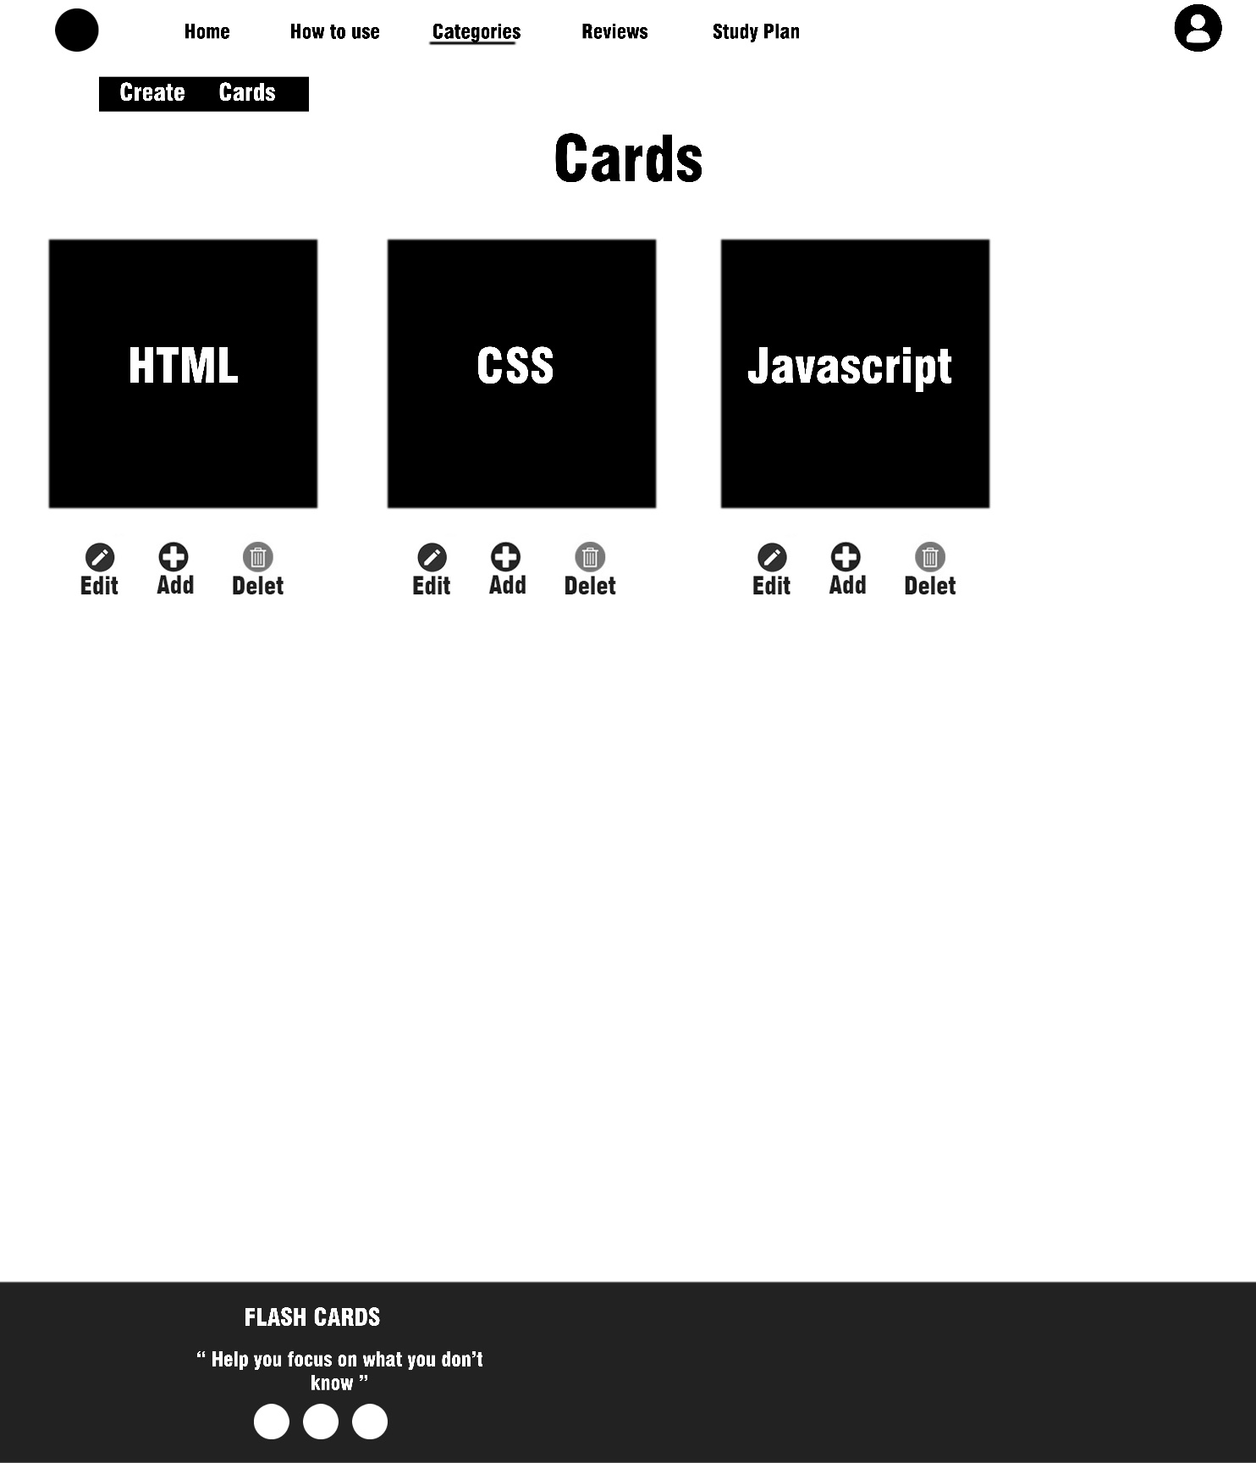

## -Study plan page

In this page we view the study plan.

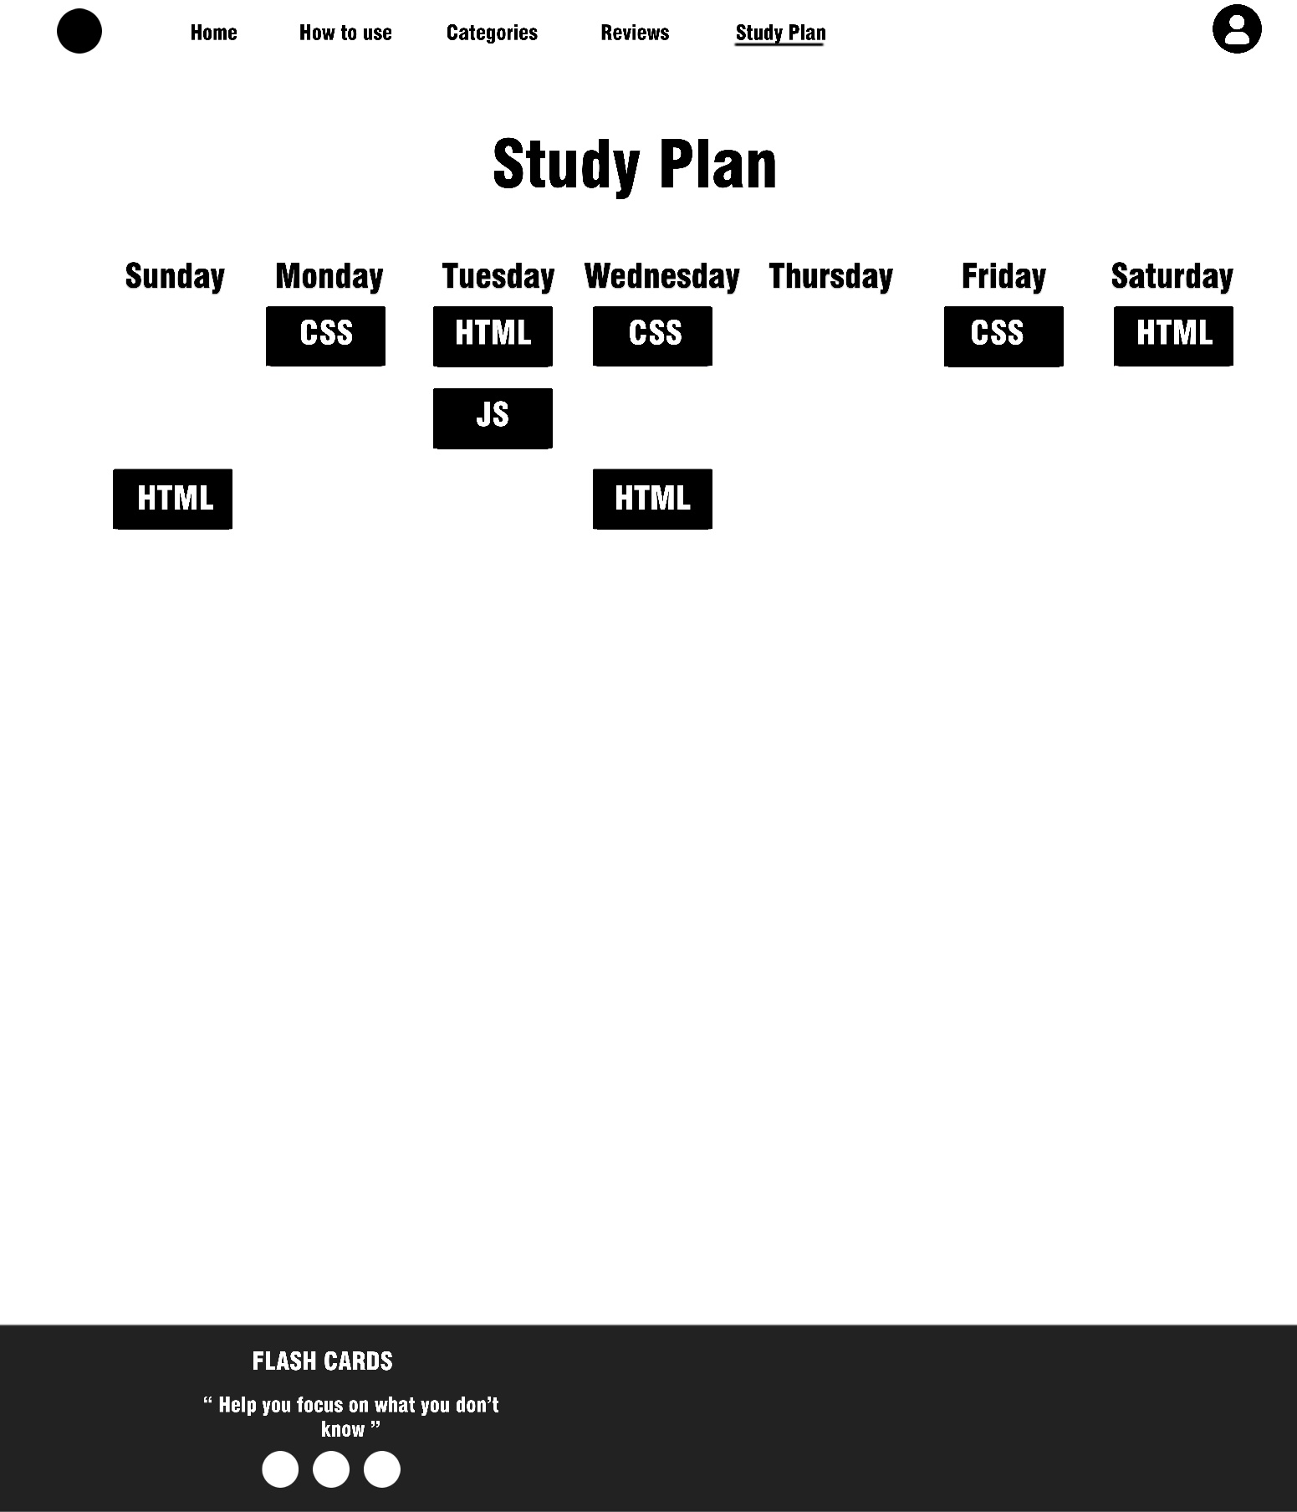

## -How to use page

In this page we view how to use website.

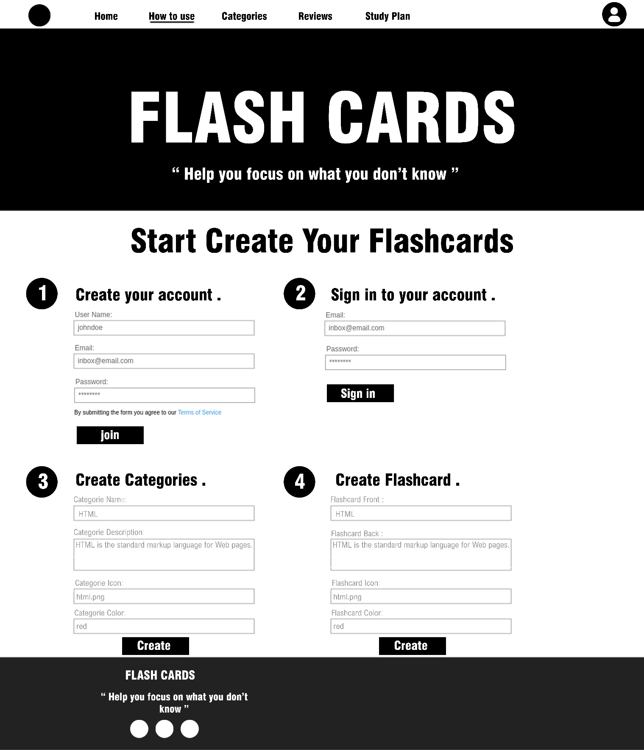

## Create cards Button

## 

This button allows you to create new flash cards.

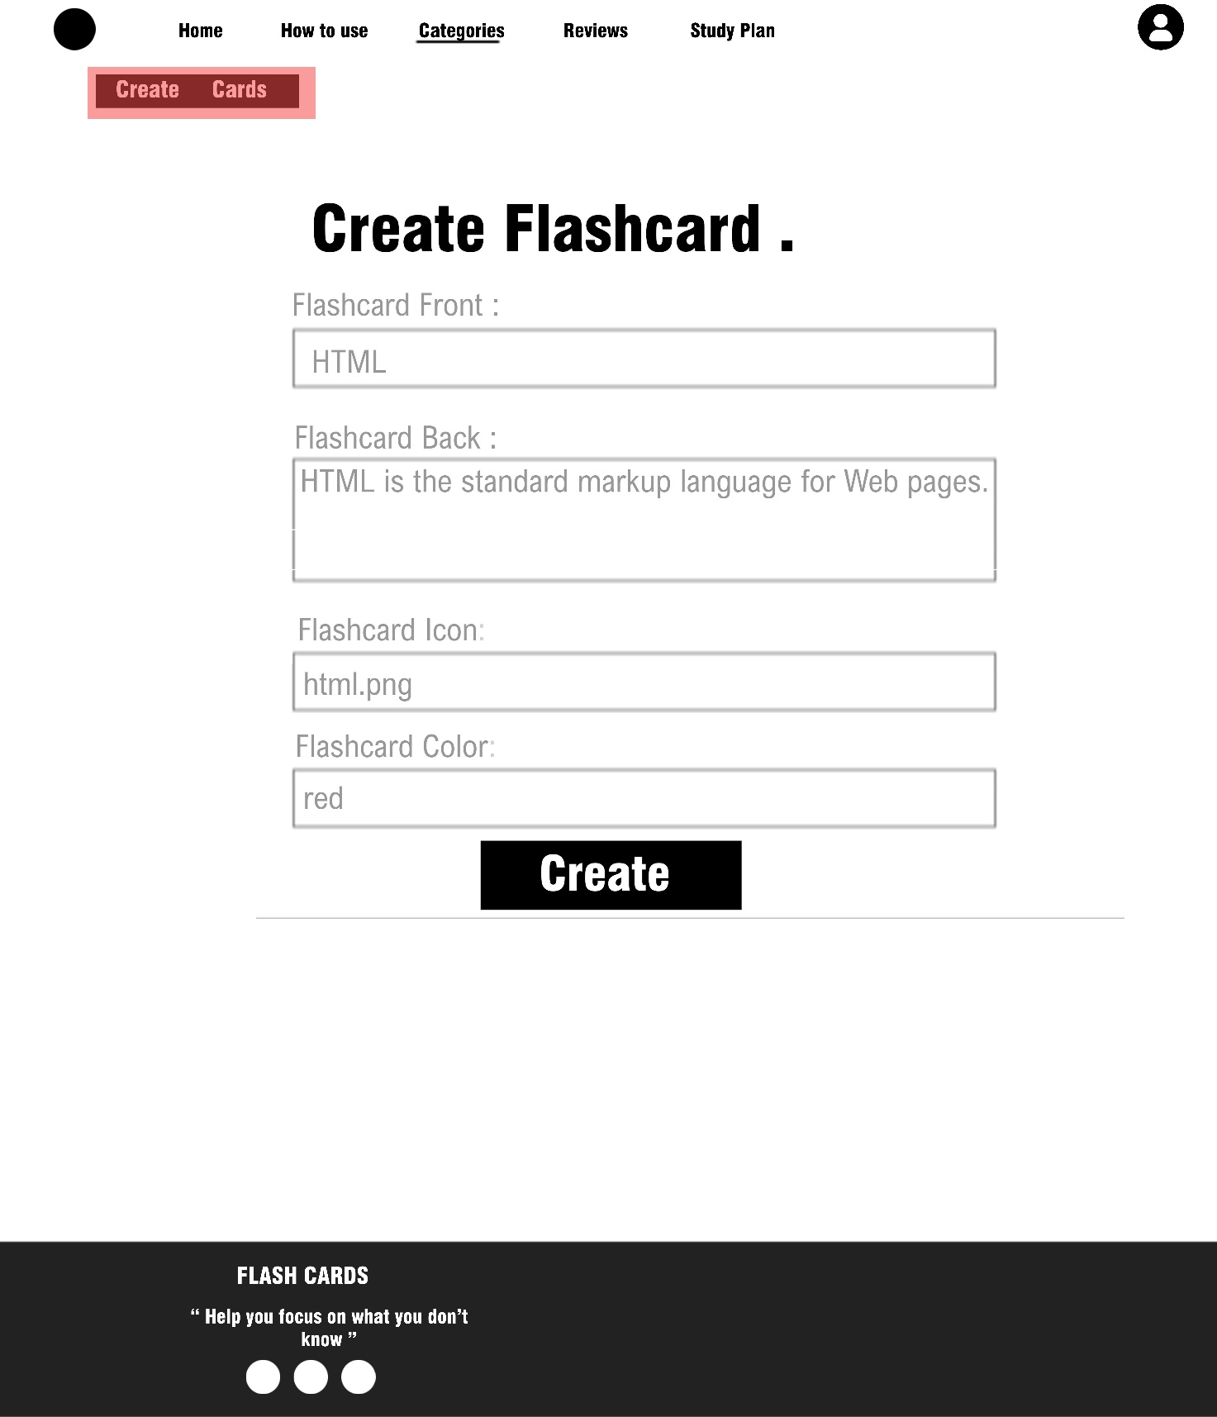

## Delete cards Button

## 

## Edit cards button

## 

## Add cards button

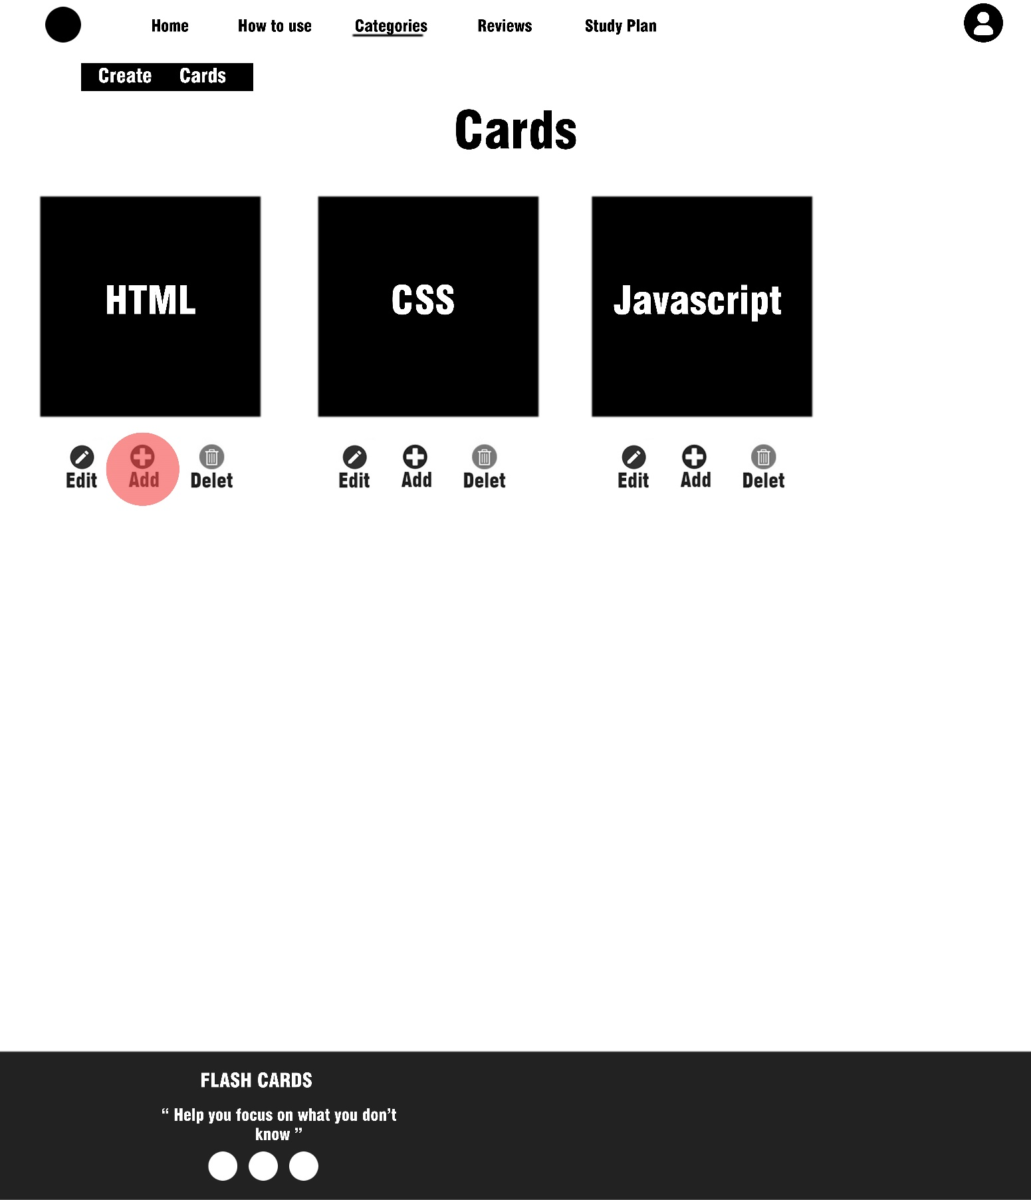

This button allows you to add card to reviews page.

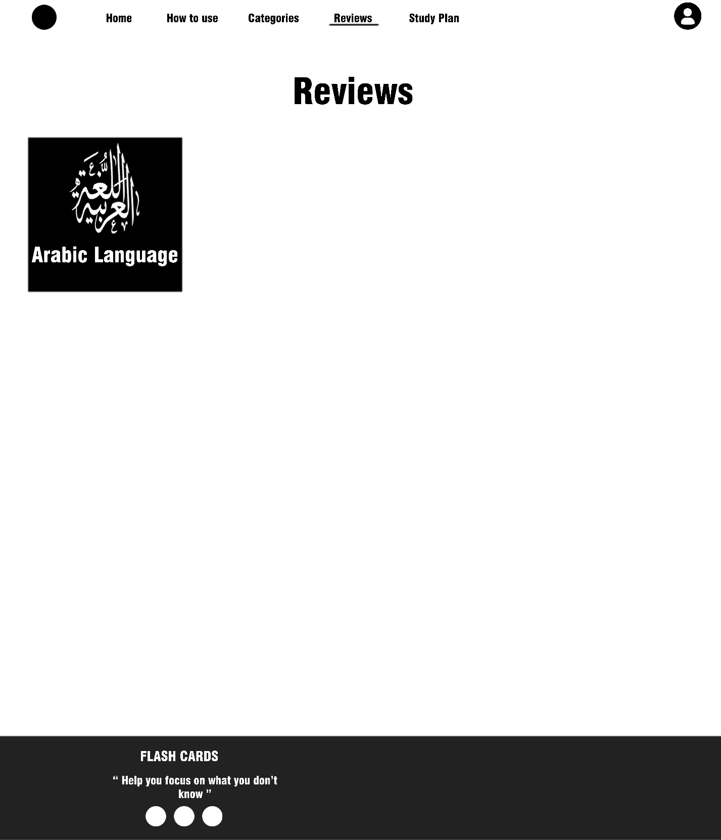

## - Create cards Button

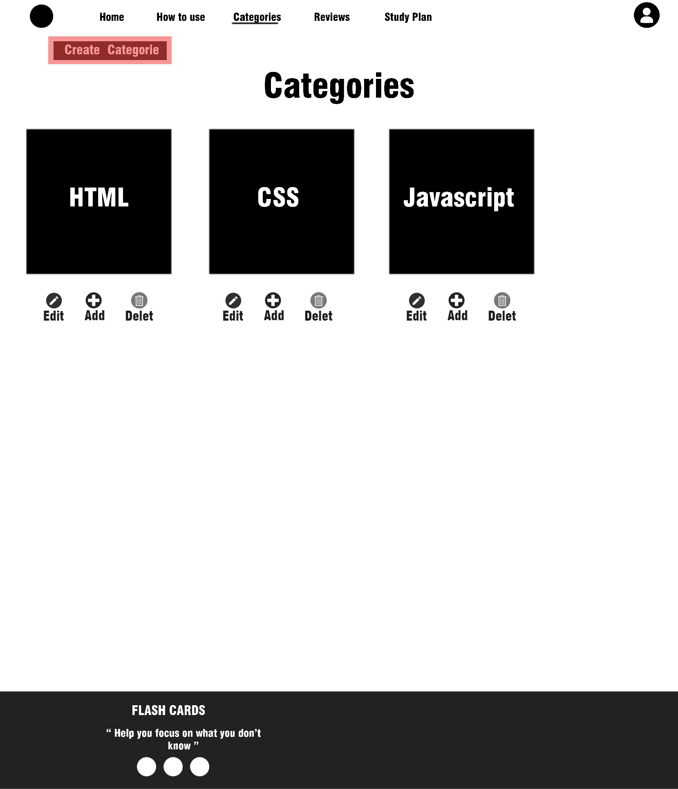

This button allows you to create new Categories.

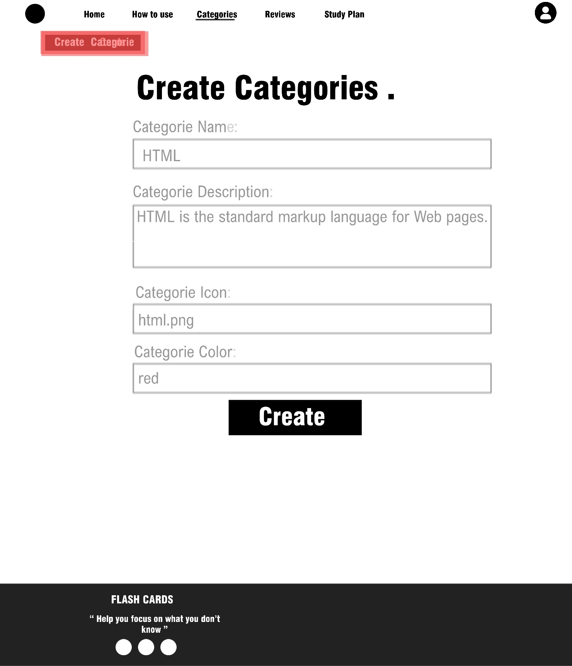

**Conclusion**

A flashcard or flash card (also known as an index card) is a card

bearing [information](https://en.wikipedia.org/wiki/Information) on both sides, which is intended to be used as

an aid in [memorization](https://en.wikipedia.org/wiki/Memorization). Each flashcard bears a question on one side

and an answer on the other. Flashcards are often used to memorize

[vocabulary](https://en.wikipedia.org/wiki/Vocabulary), historical dates, formulas or any subject matter that can be

learned via a question-and-answer format. Flashcards can be virtual

(part of a [flashcard software](https://en.wikipedia.org/wiki/List_of_flashcard_software)), or physical.

Flashcards are an application of the [testing effect](https://en.wikipedia.org/wiki/Testing_effect) − the finding

that [long-term memory](https://en.wikipedia.org/wiki/Long-term_memory) is increased when some of the learning

period is devoted to retrieving the information through testing with

proper feedback. Study habits affect the rate at which a flashcard-user

learns, and proper [spacing of flashcards](https://en.wikipedia.org/wiki/Spaced_repetition) has been proven to accelerate

learning.

A number of [spaced repetition software programs](https://en.wikipedia.org/wiki/Spaced_repetition#List_of_spaced_repetition_software_programs) exist which take

advantage of this principle.

In general, the duty of mapping all of the world's micro-learning

objectives into their most optimization-friendly format is what drives

the Flashcards team every day. We constantly iterate upon both us

learning algorithms and our users’ experience in order to provide

an increasingly effective learning tool, for an ever-increasing number

of subjects, in a way that can affordably impact more learners at a

greater scale than 1-to-1 human instruction ever could.

With the right continued applications of the latest cognitive science

research, we can continue to create a smarter world by simplifying

and accelerating the learning process itself.

**Future Work**

##### Some addition can be added to the project:

1. Considering people with special needs, as features will be added to make it easier for them to deal with the site, such as adding the ability to hear text.
2. The ability to share cards with friends via social media.
3. Possibility to print cards.