Table of Contents

1. Introduction

          1.1 Purpose

          1.2 Scope

          1.3 Definitions

                   1.3.1 Overview

          1.4 Additional Information

2. General Description

3. Functional Requirement

          3.1 Description

          3.2 Technical Issues

4. Interface Requirement

          4.1 GUI

          4.2 Hardware Interface

          4.3 Software Interface

5. Performance Requirement

6. Design Constraints

7. Other non Functional requirement

          7.1 Security

          7.2 Reliability

          7.3 Availability

          7.4 Maintainability

          7.5 Portability

8. Operational Scenario

9. Preliminary Schedule

1. Introduction

1.1 Purpose

This document is meant to delineate the features of OSS, so as to serve as a guide to the developers on one hand and a software validation document for the prospective client on the other. The Online Shopping System (OSS) for furniture shop web application is intended to provide complete solutions for vendors as well as customers through a single get way using the internet. It will enable vendors to setup online shops, customer to browse through the shop and purchase them online without having to visit the shop physically.

            1.2 Scope

This system allows the customer’s to maintain their cart for add or remove the product over the internet.

            1.3 Definitions

                   OSS- Online shopping System (for furniture shop)

                   SRS- Software Requirement Specification

                   GUI- Graphical User Interface

                   Stockholder- The person who will participate in system

                   Ex. Customer, Administrator, Visitor etc.

1.3.1 Overview

This system provides an easy to solution customer’s to buy the product without go to the shop and also shop owner to sale the product.

            1.4 Additional Information

The system work on internet server, so it will operated by any end user for the buying purpose.

2. General Description

The Online Shopping system (OSS) application enables vendors to set up online shops, customers to browse through the shops, and a system administrator to approve and reject requests for new shops and maintain lists of shop categories. Also the developer is designing an online shopping site to manage the items in the shop and also help customers purchase them online without having to visit the shop physically.The online shopping system will use the internet as the sole method for selling goods to its consumers.

3. Functional Requirement

This section provides requirement overview of the system. Various functional modules that can be implemented by the system will be -

3.1 Description

3.1.1 Registration

If customer wants to buy the product then he/she must be registered, unregistered user can’t go to the shopping cart.

          3.1.2 Login

Customer logins to the system by entering valid user id and password for the shopping.

          3.1.3 Changes to Cart

Changes to cart means the customer after login or registration can make order or cancel order of the product from the shopping cart.

          3.1.4 Payment

For customer there are many type of secure billing will be prepaid as debit or credit card, postpaid as after shipping, check or bank draft. The security will provide by the third party like Pay-Pal etc.

          3.1.5 Logout

After the payment or surf the product the customer will logged out.

          3.1.6 Report Generation

After all transaction the system can generate the portable document file (.pdf) and then sent one copy to the customer’s Email-address and another one for the system data base to calculate the monthly transaction .

          3.2 Technical Issues

This system will work on client-server architecture. It will require an internet server and which will be able to run PHP application. The system should support some commonly used browser such as IE etc.

4. Interface Requirement

          Various interfaces for the product could be-

          1. Login Page

          2. Registration Form

3. There will be a screen displaying information about product that the shop having.

4. If the customers select the buy button then another screen of shopping cart will be opened.

5. After all transaction the system makes the selling report as portable document file (.pdf) and sent to the customer E-mail address.

4.1 GUI

          1. Login Page

[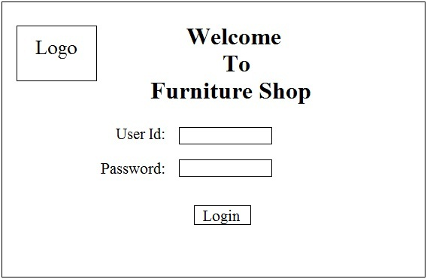](https://3.bp.blogspot.com/-YSXf1m_1AQM/T3lxY5QXeHI/AAAAAAAAAHw/1D_aTN22zAE/s1600/login.jpg)

                   2. Registration Form

[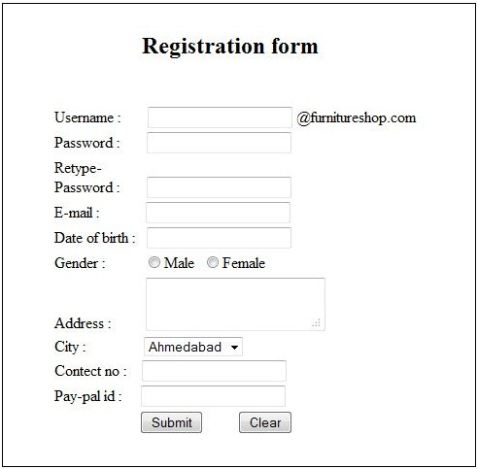](https://2.bp.blogspot.com/-OvXeYcs3hoU/T3lyIVD3jaI/AAAAAAAAAH4/2n-SJxr8Vec/s1600/registration.JPG)

3. Product Page

[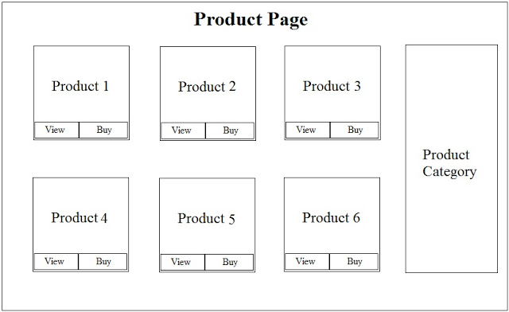](https://2.bp.blogspot.com/-ini1wn7dPYk/T3lyw7ki2uI/AAAAAAAAAIA/2WDPNzPSSRM/s1600/Product+page.jpg)

                   4. Shopping Cart

[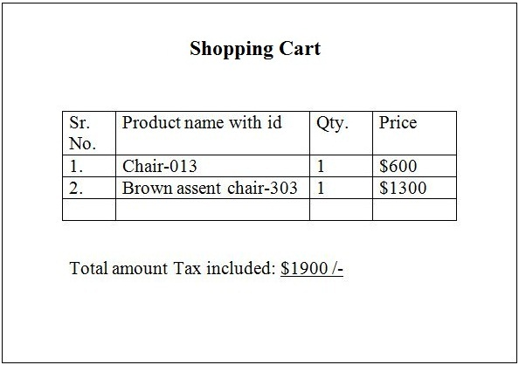](https://2.bp.blogspot.com/-Wquggg3MM9Q/T3l0u3MDE_I/AAAAAAAAAII/gLo1zWjVZ-w/s1600/Shopping+cart.jpg)

5. Portable Document file (.pdf) buying report

[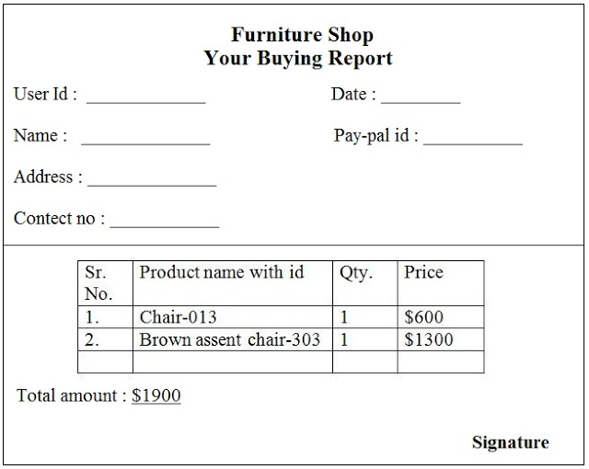](https://1.bp.blogspot.com/-mrh9t5Crzqo/T3l2GiSMBjI/AAAAAAAAAIQ/NcPg9X6Hhl0/s1600/portable+buying+report.jpg)

          4.2 Hardware Interface

The System must run over the internet, all the hardware shall require to connect internet will be hardware interface for the system. As for e.g. Modem, WAN – LAN, Ethernet Cross-Cable.

          4.3 Software Interface

The system is on server so it requires the any scripting language like PHP, VBScript etc. The system require Data Base also for the store the any transaction of the system like MYSQL etc. System also require DNS (domain name space) for the naming on the internet. At the last user need web browser for interact with the system.

5. Performance Requirement

There is no performance requirement in this system because the server request and response is depended on the end user internet connection.

6. Design Constrain

The system shall be built using a standard web page development tool that conforms to Microsoft’s GUI standards like HTML, XML etc.

7. Other non-Functional requirement

          7.1 Security

The system must automatically log out all customers after a period of inactivity.

The system should not leave any cookies on the customer’s computer containing the user’s password.

The system’s back-end servers shall only be accessible to authenticated administrators.

Sensitive data will be encrypted before being sent over insecure connections like the internet.

7.2 Reliability

The reliability of the overall program depends on the reliability of the separate components. The main pillar of reliability of the system is the backup of the database which is continuously maintained and updated to reflect the most recent changes.

7.3 Availability

The system should be available at all times, meaning the user can access it using a web browser, only restricted by the down time of the server on which the system runs. In case of a of a hardware failure or database corruption.Also in case of a hardware failure or database corruption, backups of the database should be retrieved from the server and saved by the administrator. Then the service will be restarted. It means 24 X 7 availability.

          7.4 Maintainability

A commercial database is used for maintaining the database and the application server takes care of the site. In case of a failure, a re-initialization of the program will be done. Also the software design is being done with modularity in mind so that maintainability can be done efficiently.

          7.5 Portability

The application is HTML and scripting language based. So the end-user part is fully portable and any system using any web browser should be able to use the features of the system, including any hardware platform that is available or will be available in the future.

An end-user is use this system on any OS; either it is Windows or Linux.

The system shall run on PC, Laptops.

8. Operational Scenario

The customer wants to buy item. The system shows all product categories to customer. If customer select item then they listed in shopping cart for buying.

The payment will made with credit card or bank check. If customer wants to cancel the order before shipping then he or she can cancel it.

Customer can see the buying report on account detail.

9. Preliminary Schedule

[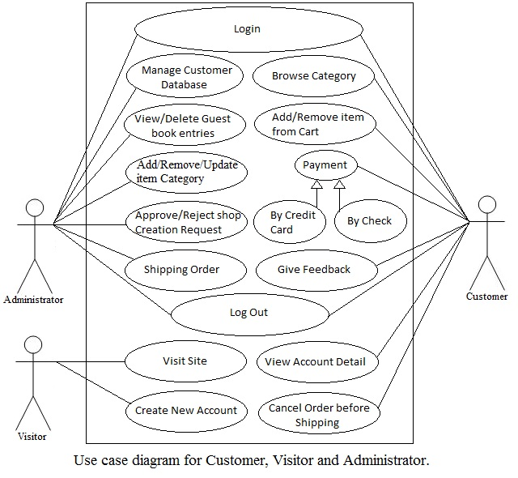](https://2.bp.blogspot.com/-X0Q7fkLSULM/T3nV0Nur2CI/AAAAAAAAAIo/XYDzSQSYwI4/s1600/custo%2Cvisitor%2Cadmin.jpg)