**ARTIFICIAL INTELLIGENCE**

**Natural Disaster Intensity Analysis &**

**Classification Using AI**

|  |  |
| --- | --- |
| **Date** | **15-10-2022** |
| **Team Id** | **PNT2022TMID45294** |
| **Project Name** | **Natural Disater Intensity Analysis & Classification Using AI** |

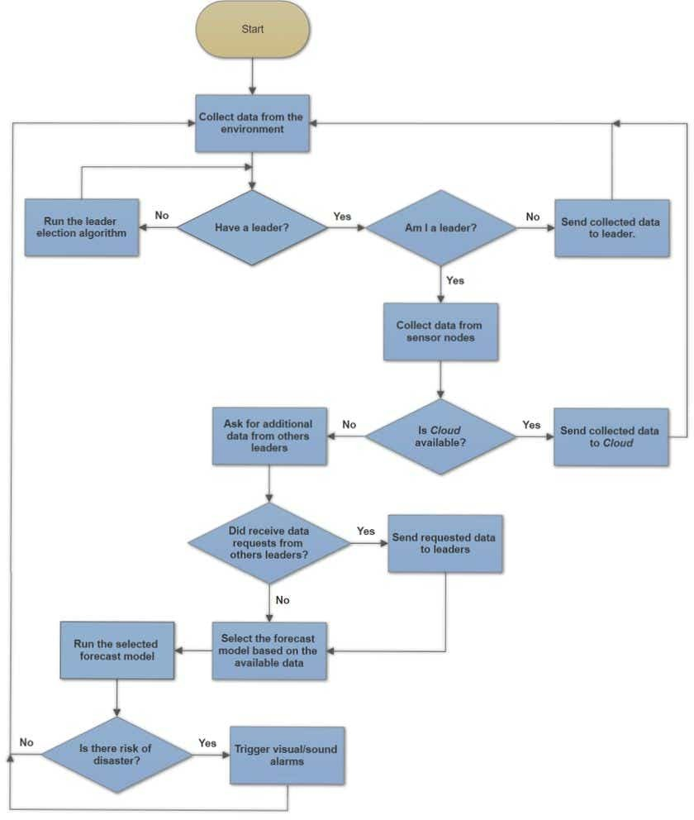**FLOW CHART**