**Artificial intelligence**

**Natural disasters intensity analysis & classification using ai**

|  |  |
| --- | --- |
| Date | 03-10-2022 |
| Team id | PNT2022TMID45294 |
| Project name | Natural disasters intensity analysis and classification using ai |

**Project ideation:**

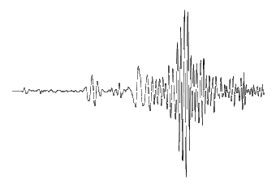

*Sources/Usage: Public Domain.*

An example of a seismic wave. (Public domain.)

* ****Earthquake prediction**** Investigate and find out if anyone has a consistent successful way to predict earthquakes. If not, why were they not successful. Come up with your own idea for predicting earthquakes, and test it. Explain why it did or did not work.

* ****Earthquake myths**** Examine earthquake myths and interview people about these myths to find out what they think. What would be the best way to get rid of myths? Is there any group of people who tend to believe myths more? Older people? Younger people? Other groups?

* ****Seismic waves****What types of seismic waves are there? What do they look like on a seismogram (recording)? What effects do different kinds of waves have on different kinds of buildings?

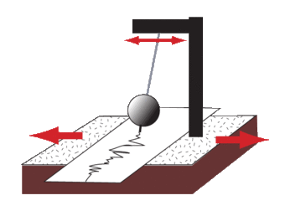

*Sources/Usage: Public Domain.*

The cartoon sketch of the seismograph shows how the insrument shakes with the earth below it, but the recording device remains stationary (instead of the other way around). (Public domain.)

* ****Seismograph**** Make a seismograph.

* ****World-wide earthquake hazards**** Which areas around the world are most vulnerable to earthquakes and why? What are the major problems dealing with earthquakes in different areas?

* ****Earthquake risks**** Investigate the current earthquake risks in your area. If there are none currently, have there ever been earthquakes there in the past? Why, and why aren't there any now?

* ****Plate tectonic model****Build a model that simulates plate motions and their effects.

* ****San Andreas Fault**** Learn about the different segments of the San Andreas Fault. Demonstrate how each segment behaves differently and why.

* ****Plate tectonics**** Cut a world map along the plate boundaries, and try to fit the pieces back together like they were millions of years ago. Observe how each piece has moved to its current position.

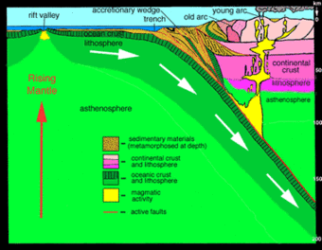

*Sources/Usage: Public Domain.*

As one tectonic plate dives under another, the material at the surface where they meet gets compressed and bunched up into a geologic formation called an accretionary wedge. (Public domain.)

* ****Tsunamis**** Demonstrate how a tsunami is created.

* ****Fault models**** Make models of different kinds of faults and investigate the tectonic setting of each (where are these types of faults generally found?).

* ****Earthquake-proof buildings****Try to design a building that can withstand an earthquake. What works? What doesn't work?Why?

* ****Earthquake preparedness**** Find the most effective ways to prepare for an earthquake. Test the effectiveness of different types of earthquake brackets and straps, etc. Determine the safest places to be inside the house, outside, in car, etc. Prepare on earthquake plan for your family, class, school.

* ****Monitoring earthquakes**** Monitor earthquakes locally, regionally, or globally, and plot them on a map.

* ****Locating an earthquake**** Show how earthquakes are located. Create a fictional story about an earthquake and write a news story with a map showing the epicenter.

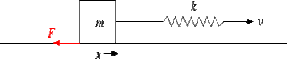

*Sources/Usage: Public Domain.*

The cartoon sketch shows the forces involved in stick-slip behavior on a fault. (Public domain.)

* ****Stress & strain****Make a model to show how stress and strain affect different materials (wood, silly putty, etc.)

* ****Earthquakes & volcanoes**** Investigate how earthquakes and volcanoes are related.

* ****Magnitude & intensity**** Show the difference between magnitude and intensity. What controls the magnitude of an earthquake? What affects the shaking intensity?

* ****Earthquakes on other planets**** Do earthquakes occur on other planets? Which ones? Why or why not?

* ****Other ideas to brainstorm**** Interior of the earth, earthquakes & roads, earthquakes & buildings, earthquakes and the Eastern US, “Ring of Fire”.

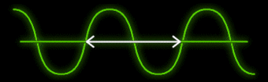

*Sources/Usage: Public Domain.*

Seismic waves produced from earthquakes contain sine waves of many different frequencies. (Public domain.)