**My Pets**

**Description**: We implement a website for user to know some animals’ food. The information will be returned by server in Json type.

**Environment**: JRE 1.8, Tomcat 9.0

**Stack**: Java, HTML, jQuery, Bootstrap

**How to use**:

1. First, add server for the project, and start.

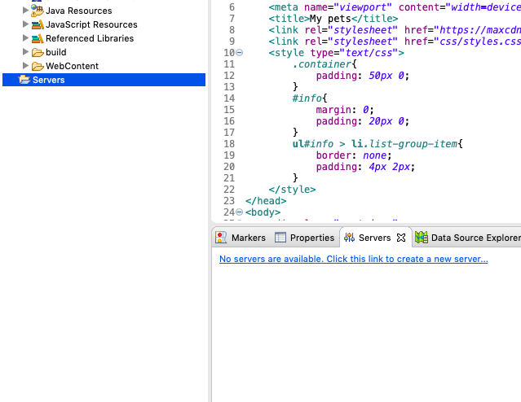

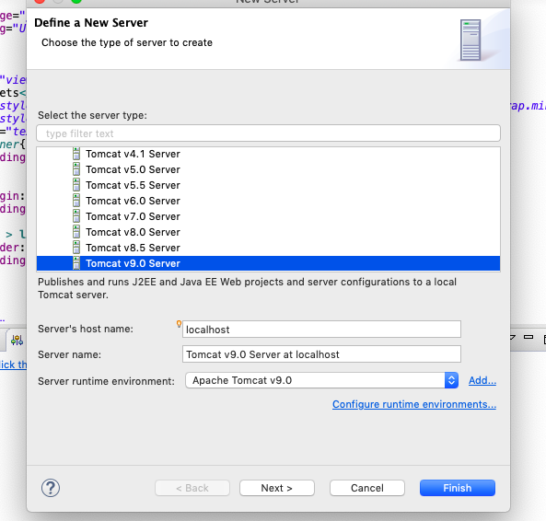

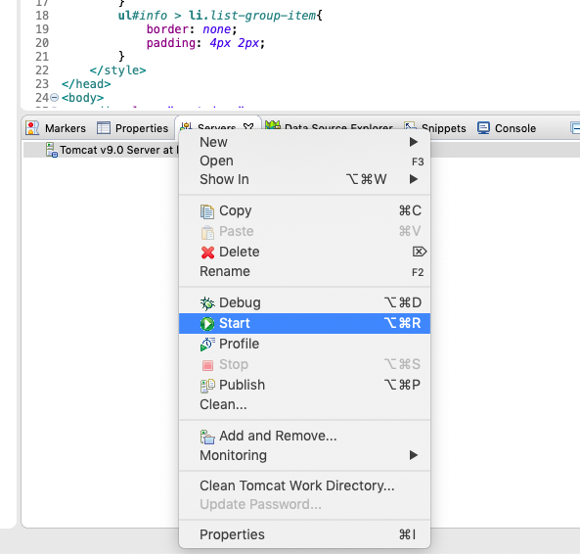

1. Make Sure that library Gson is within the project and added to lib.

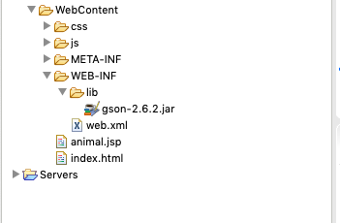

1. Run project on server.

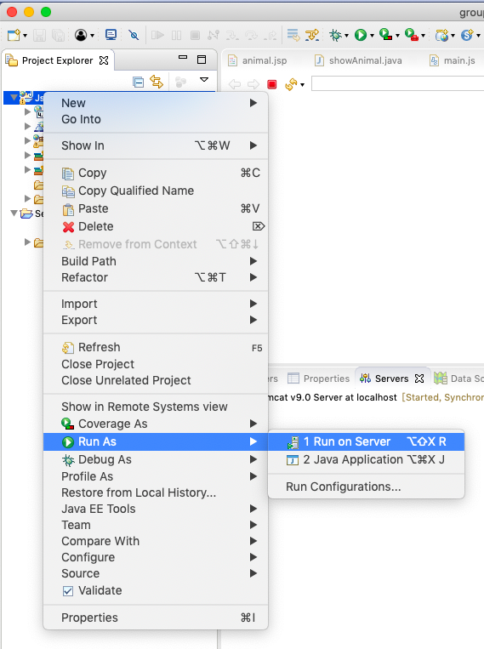

1. Open your browser and type: localhost:8080/Json/animal.jsp

8080 is default Tomcat port for HTTP

Then you will see the user interface.

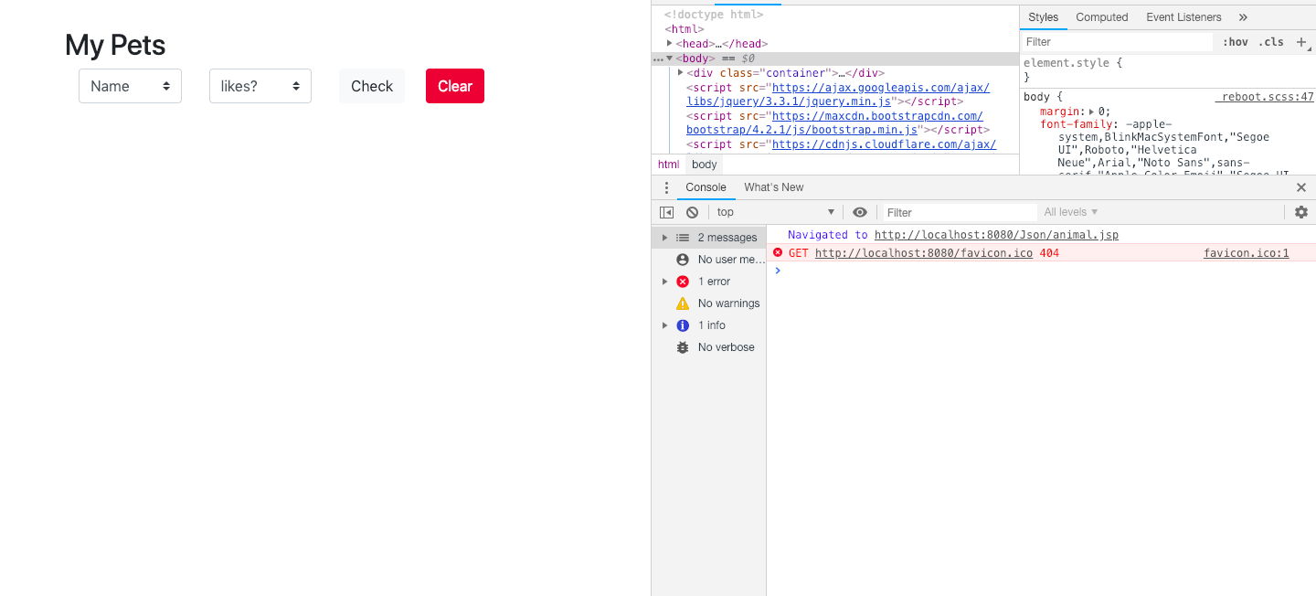

After you click the Check Button with default options:

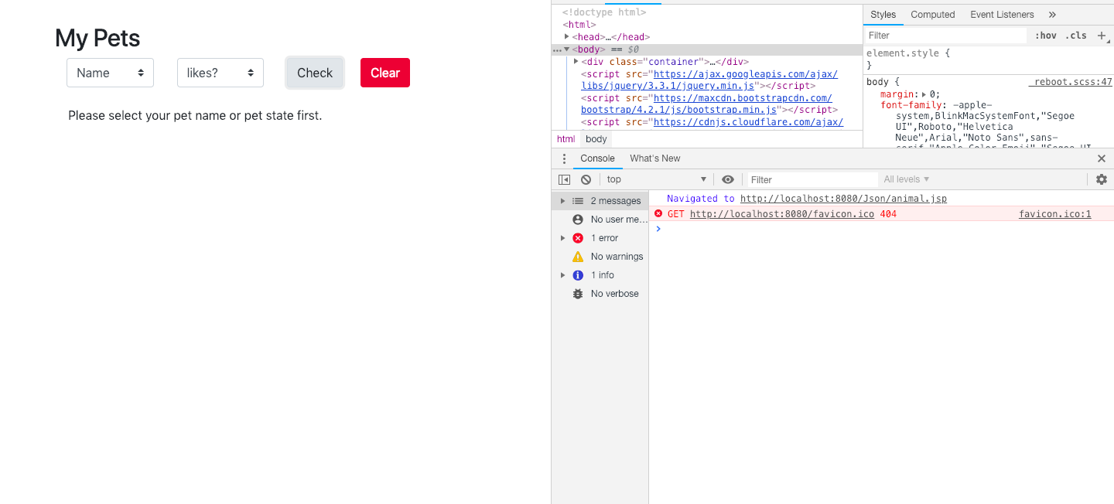

Check with valid options:

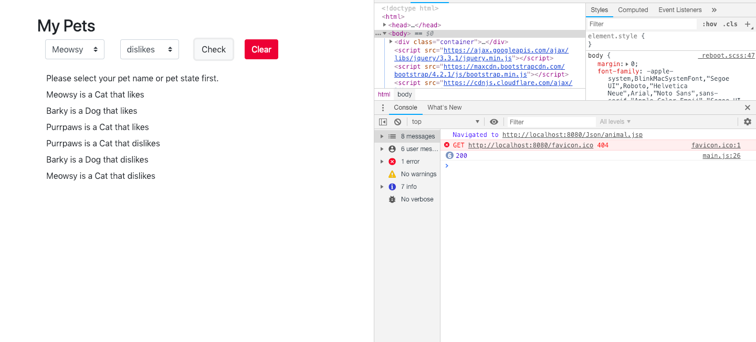

Hit Clear:

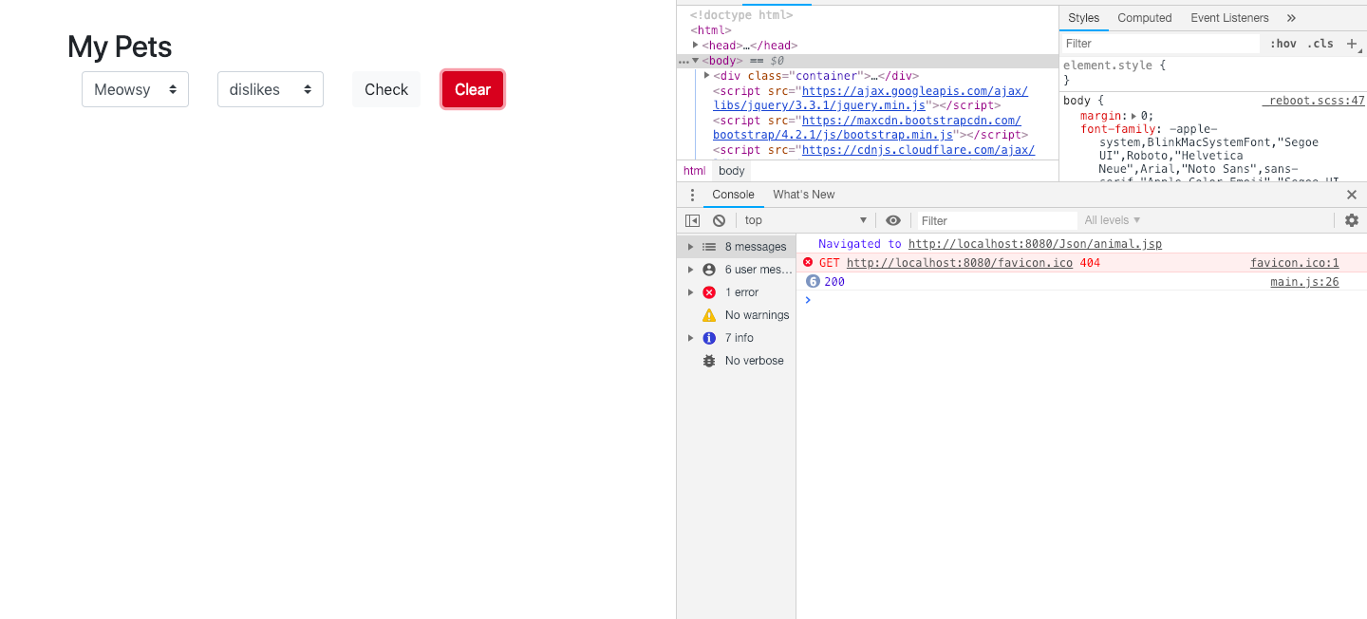

If there is bug in server side:

