**My Pets**

**Description**: We implemented a website for users to know some animals’ food. The information will be returned by server in Json type. In the main directory, we include Tomcat 9.0, and Gson 2.6.2 for you.

**Environment**: JRE 1.8, Tomcat 9.0

**Stack**: Java, HTML, jQuery, Bootstrap

**How to use**:

1. First, add server for the project

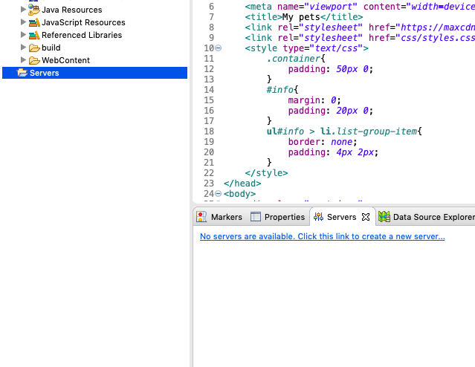

If it is a new server never been used, click “Add” to set runtime environment.

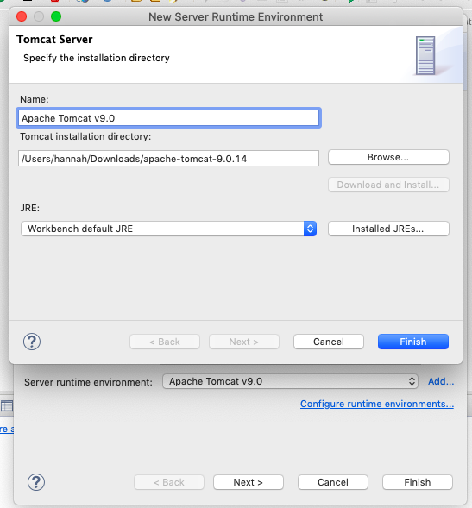

Finish and start

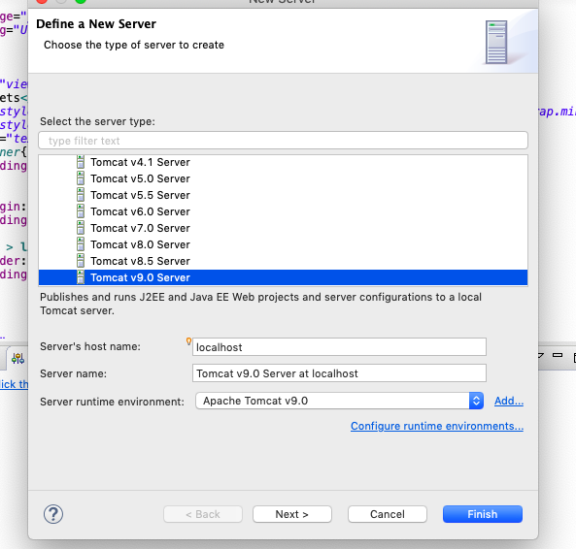

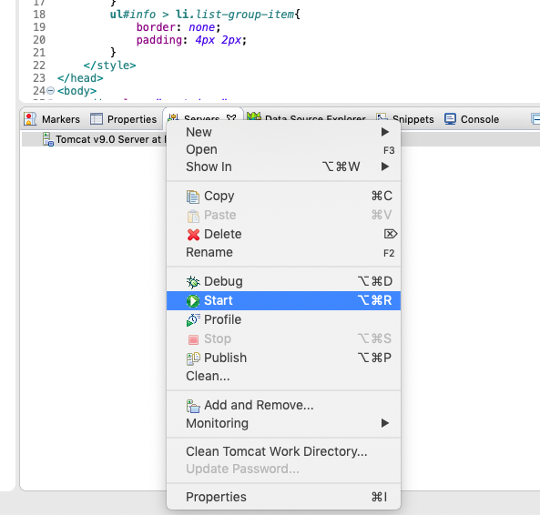

1. Make Sure that library Gson 2.6.2 is within the project and added to lib directory.

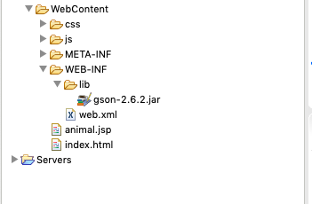

1. Run project on server.

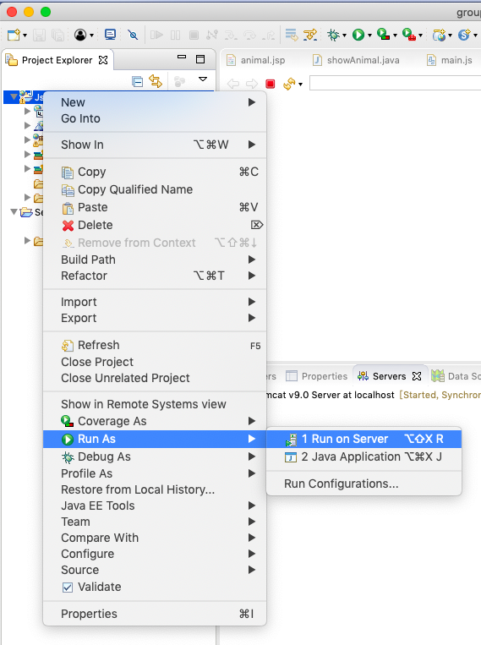

1. Open your browser and go to: localhost:8080/Json/animal.jsp

8080 is default Tomcat port for HTTP

Then you will see the user interface.

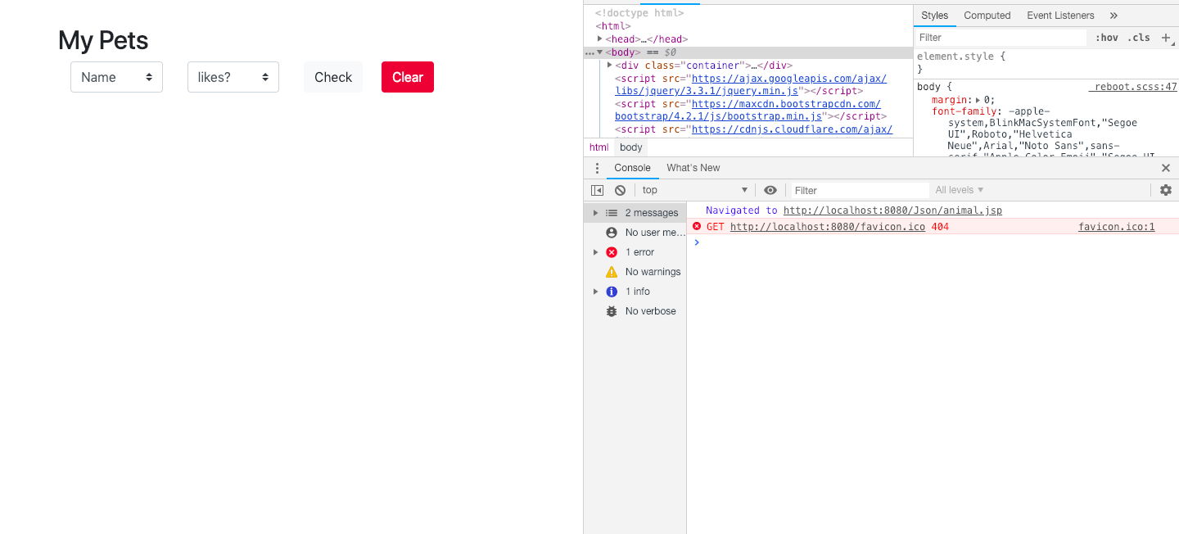

After clicking the Check button with default options:

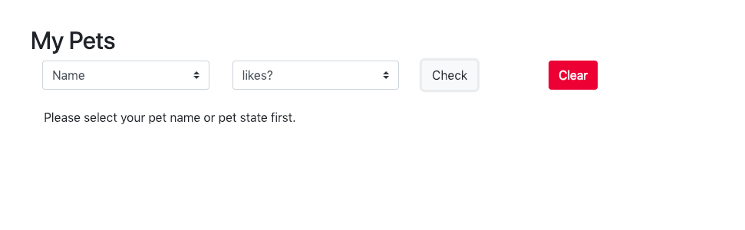

Check with valid options:

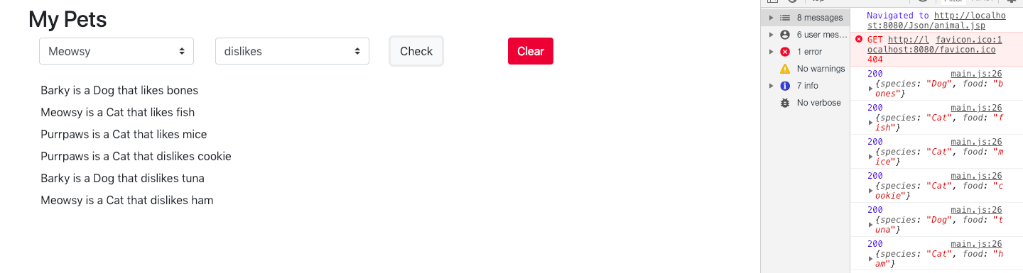

Hit Clear:

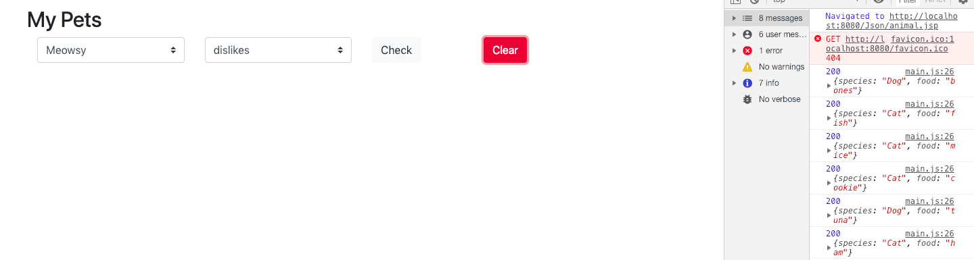

If there is something wrong in the server side:

