PPT CONTENT & DESIGN PLAN
Craftverse Hackathon Submission Deck — 8 Slides
Slide-by-slide content, copy-ready text, and exact visual placement instructions for the uploaded template
This document maps our project (predictive cash-flow & accounts receivable system for MSMEs) onto the exact 8-slide Craftverse template provided — slide by slide, field by field. For every slide it gives: the verbatim text to type into each placeholder, expanded talking points for what to actually say while presenting it, and precise instructions for what visual to add and where to place it, reusing diagrams already built for this project wherever possible.

0. Template Analysis — What We're Working With
The uploaded deck is a fixed hackathon-provided template (Craftverse, presented by a college whose seal appears top-left on every slide). Before touching content, here is exactly what's fixed vs. what we control, and where the empty space actually is — measured directly from the file, not eyeballed.

0.1 Canvas & fixed elements
- Canvas size: 20" x 11.25" (widescreen 16:9, scaled up) — all coordinates below are in inches on this canvas.
- Fixed, do not move or delete: college seal + Craftverse logo (top-left, ~0-3.3" x 0-1.5"), the pink hexagon cluster (top-right, roughly x=17-20", y=0-6.6"), the pink circle/triangle/square outline icons (far-left column, decorative section markers), and the "CRAFTVERSE — A NATIONAL LEVEL HACKATHON" footer band (y=10.5-11.25").
- Slide titles (TITLE, IDEA AND PROPOSED SOLUTION, etc.) are fixed template headings — do not rename them; the hackathon likely grades against this exact structure.
- Bullet prompts ("Describe Idea", "Technologies used", etc.) are instructions for what to write, not final slide text — replace each with real content, don't leave the prompt text on screen.

0.2 The open canvas — where our visuals go
On every content slide (3, 4, 5, 6, 7), there is a large untouched area roughly from x=8" to x=16.8" and y=2" to y=9.3" — about 8.8" x 7.3" of empty space between the bullet text and the hexagon decoration. This is exactly where every diagram in this plan should be placed. Never place a visual on top of the hexagon cluster or the footer band.

0.3 Consistent design rules to apply across all 8 slides
- Keep the existing template palette: black text, coral/pink accent (matches the template's own pink, roughly hex E8557A/C0392B range), white background — don't introduce a new color scheme; make our diagrams match the template's pink instead of the navy/blue used in earlier project documents.
- One visual per content slide, sized consistently (~8-8.5" wide) so the deck feels designed as one unit rather than assembled piecemeal.
- Keep bullet text short on-slide; put the expanded explanation in the speaker notes (this document provides both, clearly separated, for every slide).
- Project name: the template never asks for a project/product name explicitly, but one should appear on Slide 2 above the field list for immediate identification. This plan uses the working name “CashGuard” — replace with the team's final choice if different.

1. Slide 1 — Cover (Fixed)
SLIDE 1 — CRAFTVERSE Cover
Fully fixed hackathon branding — college seal, Craftverse logo, “A NATIONAL LEVEL HACKATHON.” Nothing to add or edit. Leave exactly as provided.

2. Slide 2 — TITLE
SLIDE 2 — TITLE
Add above the field list: Project Name (new text, not in the original template)
CashGuard
Predictive Cash-Flow & Accounts Receivable Intelligence for MSMEs
Say the name once, clearly, then move straight into problem statement title below — this is a 5-second slide, not a pitch moment.
Problem Statement Title :
Predictive Cash-Flow & Accounts Receivable Risk System for Small and Medium Enterprises
If the hackathon issued an official, fixed wording for this problem statement, use that exact wording instead — organizers often score against verbatim match.
Domain :
FinTech — Financial Inclusion & AI/ML for MSMEs
Team Name :
[Insert team name]
Team Members & Size :
[Insert names] · Team size: [N]
College Name :
[Insert college name — likely pre-filled to match the seal already on the template]
Visual to add
None needed — keep this slide clean and information-only; adding a diagram here would compete with the hexagon decoration for a slide that's meant to be read in 10 seconds.

3. Slide 3 — IDEA AND PROPOSED SOLUTION
SLIDE 3 — IDEA AND PROPOSED SOLUTION
Describe Idea
CashGuard predicts, days in advance, exactly when an MSME will run short of cash — and automatically recommends and drafts the specific action (chase an invoice, delay a payment, or draw pre-qualified credit) needed to close that gap before it happens.
Expand verbally: existing tools (Tally, Zoho, Excel) only record what already happened — who owes you, what's overdue. None of them predict a future shortfall or tell the owner what to do about it. CashGuard is the first layer that turns bookkeeping data into a forward-looking warning system plus a ready-to-send action.
How is the problem approached
A three-layer prediction pipeline: (1) per-invoice payment-probability modeling, (2) Monte Carlo simulation of future cash position, (3) an optimization engine that ranks and recommends the lowest-friction combination of actions to close any detected gap.
Keep this to one sentence per layer on the slide; use the architecture diagram (see Visual below) to carry the rest of the explanation visually rather than in text.
Why is this problem important or relevant? Who is affected by this issue
₹8.1 lakh crore is currently locked in delayed payments to Indian MSMEs (Economic Survey 2025-26). 82% of small-business failures involve poor cash-flow management, and the median small business has only ~27 days of cash buffer. This affects all 7.47 crore MSMEs in India, employing 32.82 crore people — and 27% of them cite access to finance/cash visibility as their single biggest obstacle.
These four statistics are the single most important numbers in the whole deck — memorize them, they will very likely be asked about directly by judges.
Visual to add
Place a simplified 3-box version of the architecture pipeline (Data -> Predict -> Simulate -> Recommend) in the open canvas area (~x=8.5-16.5", y=2.5-7"). Keep it to 3-4 boxes with one-line labels — this is the idea-level view; the full detailed architecture diagram belongs on Slide 4, not here.

4. Slide 4 — TECHNICAL APPROACH
SLIDE 4 — TECHNICAL APPROACH
Technologies used
Python (scikit-survival / lifelines) for survival-model prediction · NumPy for Monte Carlo simulation · Google OR-Tools for the action-optimization engine · Flask/FastAPI backend · WhatsApp Business API / Twilio for automated delivery · Figma for UI/UX prototyping · PostgreSQL for data storage
Process of Implementation (Expressed in form of flowcharts, prototypes, architectures)
See embedded architecture diagram — data flows from invoices/payables through the AR survival model and Monte Carlo simulator into a shortfall detector, which feeds an action-optimization engine and automated WhatsApp/SMS delivery, with a continuous learning loop feeding real outcomes back into the model.
Walk the diagram left to right when presenting — this single slide should carry most of the technical credibility of the whole pitch, so slow down here.
Key Features (Technically)
Per-invoice payment-probability curves, not late/on-time labels · Cold-start cohort-prior blending for brand-new customers · Monte Carlo cash-flow simulation with confidence bands, not a single-number forecast · Expected-Risk ranked action list (Value × Probability × Urgency) · Constrained optimization for gap-closing actions · Automatic re-simulation when a payment promise is broken · Explainability panel on every risk flag
Visual to add
This is the slide to embed the full architecture diagram already built for this project (Figure 1 below) — resize to fit roughly x=8-17", y=1.8-9". This single image communicates more technical depth than any amount of bullet text; do not shrink it to make room for extra bullets.
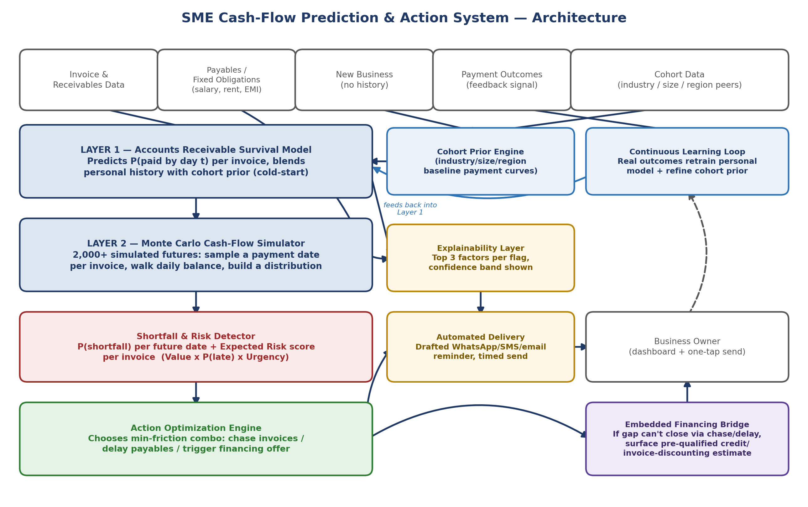
Figure 1. Architecture diagram to embed on Slide 4 (already built — file: architecture_diagram.png).

5. Slide 5 — FEASIBILITY AND OVERALL IMPACT
SLIDE 5 — FEASIBILITY AND OVERALL IMPACT
Analysis of the feasibility of the idea
Every core technique is already proven in production: survival-based payment prediction, Monte Carlo cash-flow simulation, and ML-driven collections prioritization are all live in deployed systems (Tesorio, HighRadius) and in a published, real-world-deployed SME system (arXiv:2511.03631v2, built with startup partner Cluee). 2,000+ simulation runs complete in under a second on ordinary hardware — fully buildable within a hackathon timeframe.
Potential challenges and risks
Sparse data for brand-new customer relationships (“cold start”) · Users' verbal payment promises are unreliable and could be mistaken for guaranteed cash · Risk of the model overstating confidence and losing user trust · Adoption resistance from non-technical, low-tech-literacy business owners
Strategies for overcoming these challenges / Scalability or real-world application
Cold start solved via cohort-prior blending (borrow patterns from similar businesses until personal history builds up) · Broken promises handled by treating them as probabilistic evidence with a learned “promise-keep-rate,” never as certainty, with automatic re-simulation the moment a promise is missed · Every prediction ships with a visible confidence level, never false precision · WhatsApp-native, one-tap interactions designed specifically for this user base. Scalability: the cohort model gets more accurate as more businesses join — a genuine network effect — and the architecture extends naturally to an embedded-financing marketplace for monetization.
Visual to add
Use the second wireframe set (Explainability + Promise-Broken screens, already built) as the visual here — it's the most concrete, concise proof that “challenges” in the left column have real, demoable “strategies” attached, not just words. Place at roughly x=8-17", y=2-9".
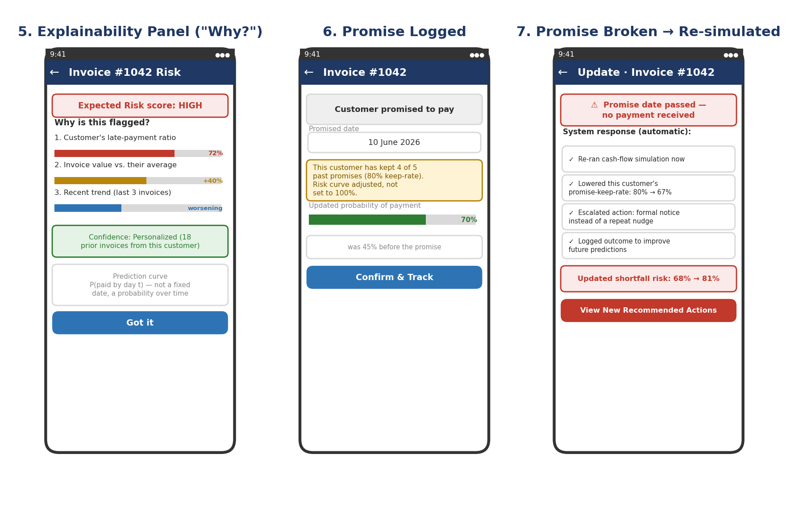
Figure 2. Suggested visual for Slide 5 — shows the exact UI mechanism for handling the 'broken promise' risk named at left (file: wireframes_set2.png).

6. Slide 6 — PROTOTYPE DEMONSTRATION
SLIDE 6 — PROTOTYPE DEMONSTRATION
Details/Links of the reference
Live interactive prototype (Figma): [insert Figma share link]
Demo video: [insert YouTube/Drive link]
GitHub repository: [insert repo link]
This slide is the demo moment — if a live click-through or video is possible during the pitch, say so explicitly and cue the judges to watch the screen rather than the slide.
Visual to add
This slide has the largest open canvas of the whole deck (bullet text is a single short line). Embed 3-4 of the mobile wireframe screens already built (Figure 3) directly on the slide as a visual gallery — Home Dashboard, Shortfall Detail & Actions, and Message Draft & Send tell the whole story in one glance. Place across roughly x=6-18", y=2-9".
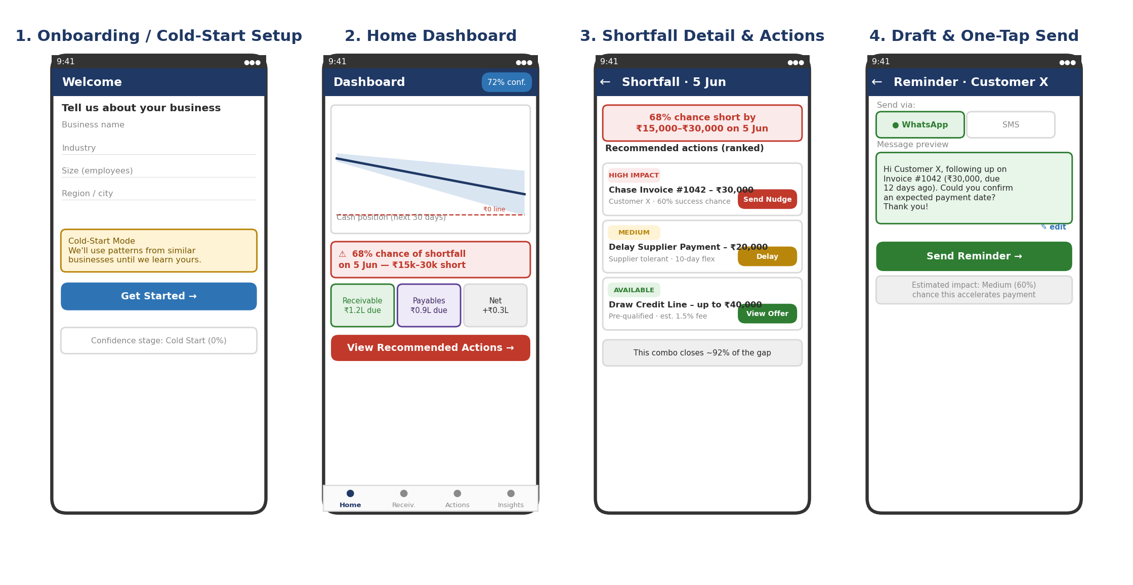
Figure 3. Suggested visual for Slide 6 — the core-loop wireframes already built (file: wireframes_set1.png). Crop to the 3 middle screens if the full set of 4 feels crowded at this size.

7. Slide 7 — CONCLUSION, REFERENCES AND FUTURE ENHANCEMENTS
SLIDE 7 — CONCLUSION, REFERENCES AND FUTURE ENHANCEMENTS
Impact on Target Audience
Gives owners of India's 7.47 crore MSMEs advance warning of cash shortfalls instead of discovering them after the fact — directly addressing the ₹8.1 lakh crore currently locked in delayed payments and the 27% of MSMEs who cite finance access as their top obstacle.
Conclusion
CashGuard turns cash-flow management from reactive bookkeeping into proactive, automated decision support — combining proven prediction methodology with a novel action-optimization layer, validated by both a real deployed precedent (Cluee/Tesorio-style systems) and independent government-level recognition of the same problem (Economic Survey 2025-26, Parliamentary Committee Report No. 333).
Future Enhancements / References
Future: upgrade to Random Survival Forests at scale · regional-language and voice interface · embedded invoice-discounting/financing partner integration · cross-business cohort benchmarking network effect · GST/Udyam data integration for instant onboarding.
References: Economic Survey of India 2025-26 (Highlights & Ch. VIII) · Rajya Sabha Standing Committee on Industry, Report No. 333 (2026) · Małkus, Bobek & Nalepa, “Financial Management System for SMEs,” arXiv:2511.03631v2 (2026) · Appel et al., invoice payment prediction methodology · HighRadius & Tesorio public technical documentation
Visual to add
A simple 3-step “Now → Next → Later” horizontal roadmap (three boxes with an arrow between) fits this slide's open canvas well and visually distinguishes it from the bullet-heavy slides before it — avoid another wireframe or diagram here so the deck doesn't feel repetitive at the end.

8. Slide 8 — Thank You (Fixed, optional addition)
SLIDE 8 — THANK YOU
Fixed template slide. Optional, low-risk addition: place contact details or a QR code (linking to the Figma prototype or GitHub repo) in the open canvas area to the left of “THANK YOU” (roughly x=2-8", y=6-9") — judges often photograph this final slide, so a scannable link here has real value at near-zero design risk.
- Suggested addition: “Team [Name] · [email] · [Figma/GitHub link]” in small (14-16pt) grey text below the THANK YOU heading, left-aligned, not centered.

9. Build Checklist
- Confirm the official Problem Statement Title wording with hackathon organizers before finalizing Slide 2.
- Replace every [bracketed placeholder] with real team information.
- Insert the four visuals (Slides 3, 4, 5, 6) at the coordinates given, keeping ~8.5" width consistently.
- Do not alter the college seal, Craftverse logo, hexagon decoration, or footer band on any slide.
- Run a full read-through out loud once content is in — every slide's talking points in this document should take 30-45 seconds spoken, matching a typical 5-6 minute total pitch.
- Export and proofread for leftover template prompt text (e.g. “Describe Idea”) before submission — this is the single most common and most easily avoided deduction in hackathon judging.

