Industrial Internship Report on
”Crop and weed detection & Forecasting of Smart city traffic patterns”
Prepared by
DHARSHINI M S

Executive Summary
This report presents the Industrial Internship conducted through Upskill Campus and The IoT Academy in collaboration with UniConverge Technologies Pvt Ltd (UCT). The internship focused on two projects: “Crop and Weed Detection” and “Smart City Traffic Pattern Forecasting”.
The first project used image processing and object detection to identify crops and weeds for targeted pesticide spraying and reduced pesticide wastage. The second project analyzed traffic data from four junctions to forecast traffic patterns and support efficient traffic management and infrastructure planning.
The internship provided practical experience in AI, Machine Learning, Computer Vision, Data Science, data preprocessing, forecasting, and problem-solving.

TABLE OF CONTENTS
1 Preface 3
2 Introduction 4
2.1 About UniConverge Technologies Pvt Ltd 4
2.2 About upskill Campus 8
2.3 Objective 9
2.4 Reference…………………………………………………………………………………………………………………………………..10
2.5 Glossary…………………………………………………………………………………………………………………………………………11
3 Problem statement….……………………………………………………………………………………………………………………..12
4 Existing and Proposed solution………………………………………………………………………………………………………..14
5 Proposed Design/ Model…………………………………………………………………………………………………………………17
5.1 High Level Diagram (if applicable)…………………………………………………………………………………………….…17
5.2 Low Level Diagram (if applicable) 18
5.3 Interfaces (if applicable) 20
6 Performance Test 22
6.1 Test Plan/ Test Cases 22
6.2 Test Procedure 23
6.3 Performance Outcome 25
7 My learnings 27
8 Future work scope 29

Preface
The rapid development of Artificial Intelligence, Machine Learning, Computer Vision, and Data Science has created significant opportunities to solve real-world problems. As an Information Technology student, practical exposure to these technologies is essential for understanding how theoretical concepts can be applied to real-life applications.
This report presents the work carried out on two data-driven projects: Crop and Weed Detection and Forecasting of Smart City Traffic Patterns. Both projects focus on applying computational techniques to practical problems in agriculture and urban management.
The first project, Crop and Weed Detection, focuses on identifying crops and unwanted weeds from agricultural images using image processing and object detection techniques. The main objective is to support precision agriculture by enabling pesticides to be selectively applied to weeds while minimizing contact with crops.
The second project, Forecasting of Smart City Traffic Patterns, focuses on analyzing historical traffic information from four junctions and forecasting future traffic patterns. The project considers variations caused by working days, holidays, and special occasions to support better traffic management and future infrastructure planning.
The projects provided practical exposure to dataset collection, data cleaning, image preprocessing, data augmentation, image annotation, machine learning concepts, data analysis, forecasting, testing, and documentation.
This report describes the problem statements, existing and proposed solutions, system design, testing procedures, outcomes, learning experiences, and future scope of the projects.
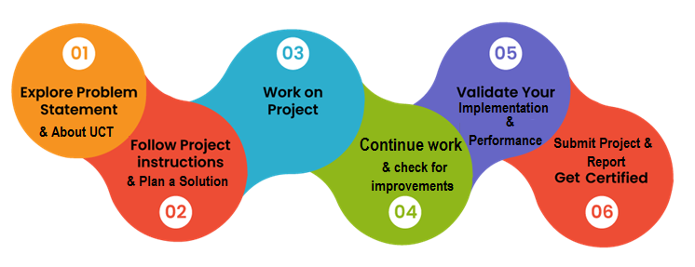

Introduction

2.1 About UniConverge Technologies Pvt Ltd.
A company established in 2013 and working in Digital Transformation domain and providing Industrial solutions with prime focus on sustainability and RoI.
For developing its products and solutions it is leveraging various Cutting Edge Technologies e.g. Internet of Things (IoT), Cyber Security, Cloud computing (AWS, Azure), Machine Learning, Communication Technologies (4G/5G/LoRaWAN), Java Full Stack, Python, Front end etc.
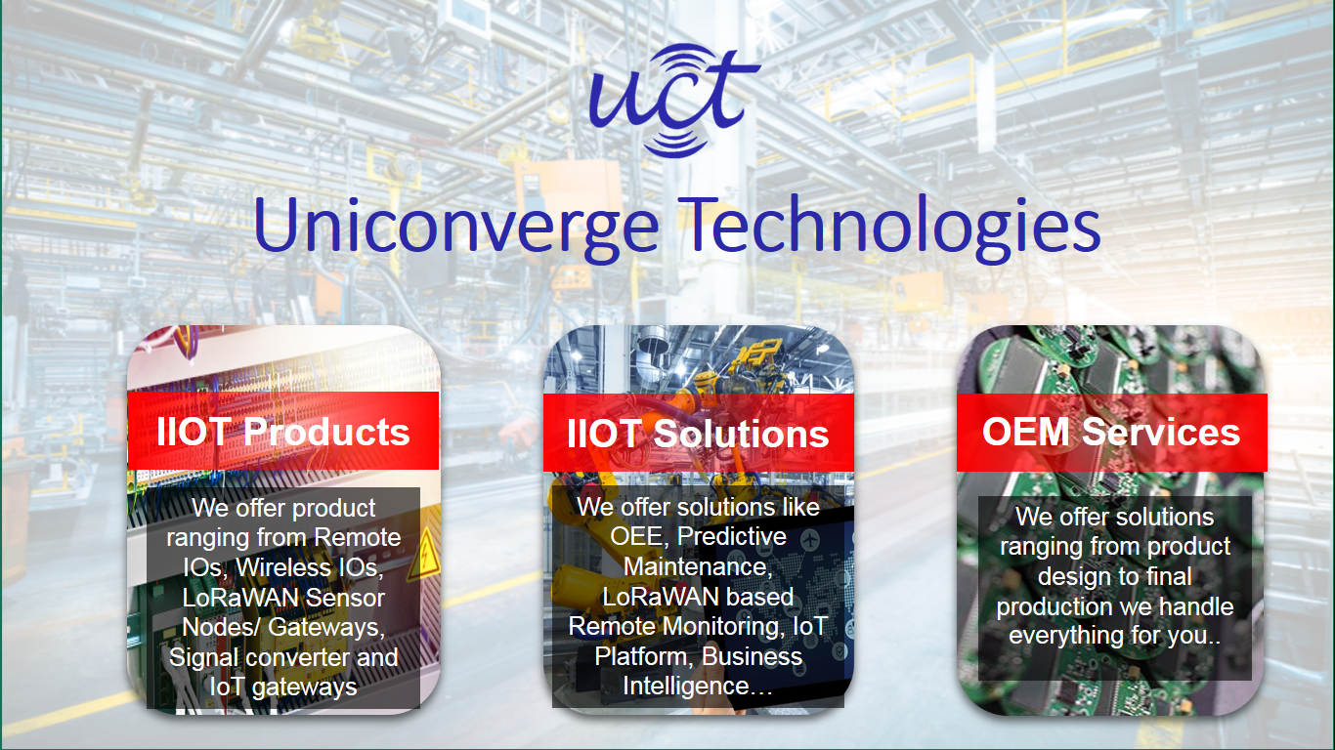
- UCT IoT Platform ()
UCT Insight is an IOT platform designed for quick deployment of IOT applications on the same time providing valuable “insight” for your process/business. It has been built in Java for backend and ReactJS for Front end. It has support for MySQL and various NoSql Databases.
- It enables device connectivity via industry standard IoT protocols - MQTT, CoAP, HTTP, Modbus TCP, OPC UA
- It supports both cloud and on-premises deployments.
It has features to
• Build your own dashboard
• Analytics and Reporting
• Alert and Notification
• Integration with third party application(Power BI, SAP, ERP)
• Rule Engine
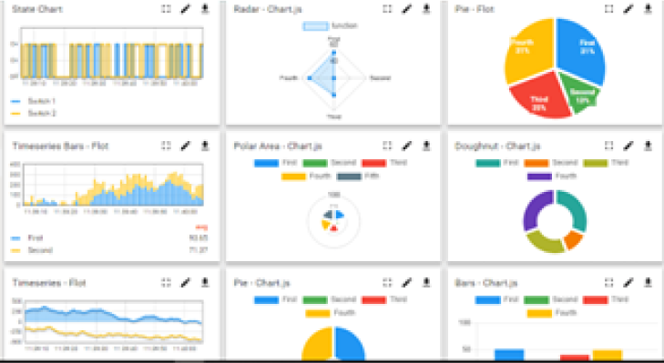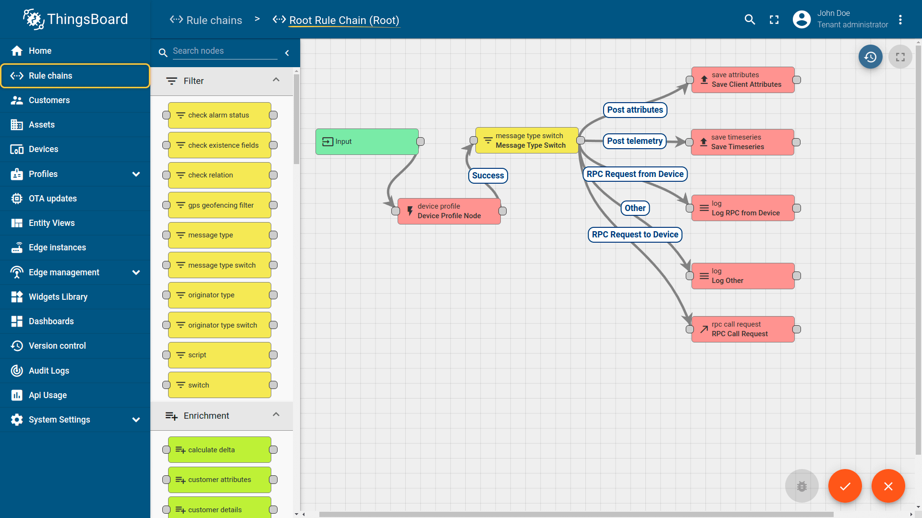

- Smart Factory Platform ()
Factory watch is a platform for smart factory needs.
It provides Users/ Factory
- with a scalable solution for their Production and asset monitoring
- OEE and predictive maintenance solution scaling up to digital twin for your assets.
- to unleased the true potential of the data that their machines are generating and helps to identify the KPIs and also improve them.
- A modular architecture that allows users to choose the service that they what to start and then can scale to more complex solutions as per their demands.
Its unique SaaS model helps users to save time, cost and money.
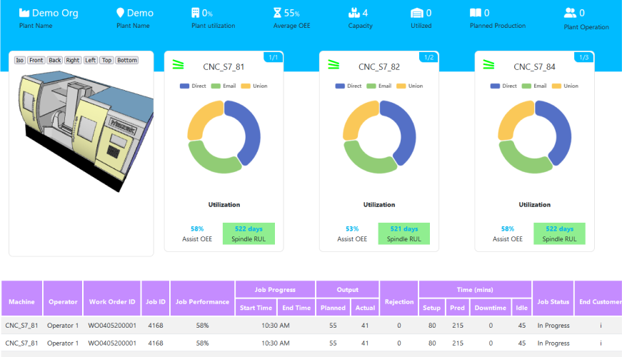

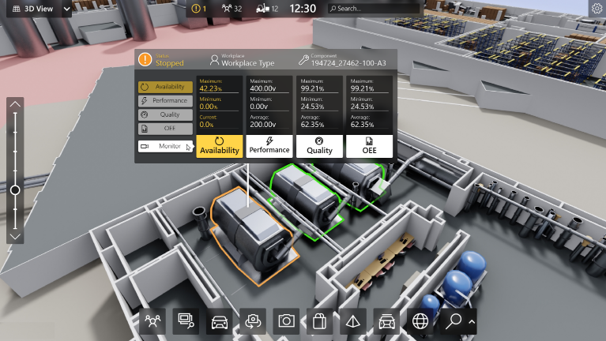
-  based Solution
UCT is one of the early adopters of LoRAWAN teschnology and providing solution in Agritech, Smart cities, Industrial Monitoring, Smart Street Light, Smart Water/ Gas/ Electricity metering solutions etc.
- Predictive Maintenance
UCT is providing Industrial Machine health monitoring and Predictive maintenance solution leveraging Embedded system, Industrial IoT and Machine Learning Technologies by finding Remaining useful life time of various Machines used in production process.
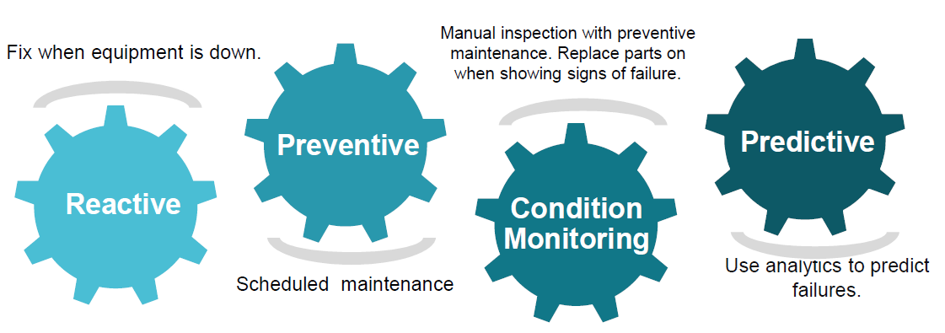
2.2 About Upskill Campus (USC)
upskill Campus along with The IoT Academy and in association with Uniconverge technologies has facilitated the smooth execution of the complete internship process.
USC is a career development platform that delivers personalized executive coaching in a more affordable, scalable and measurable way.






upSkill Campus aiming to upskill 1 million learners in next 5 year
Seeing need of upskilling in self paced manner along-with additional support services e.g. Internship, projects, interaction with Industry experts, Career growth Services

https://www.upskillcampus.com/
https://www.upskillcampus.com/
https://www.upskillcampus.com/
https://www.upskillcampus.com/

The IoT Academy
The IoT academy is EdTech Division of UCT that is running long executive certification programs in collaboration with EICT Academy, IITK, IITR and IITG in multiple domains.

Objectives of this Internship program
The overall objective of the project work was to gain practical knowledge of Artificial Intelligence, Machine Learning, Computer Vision, Data Processing, and Data Analysis by working on real-world problem statements.
Objectives of Project 1: Crop and Weed Detection
The major objectives were:
- To collect images of crops and weeds from agricultural environments.
- To clean the collected image dataset.
- To preprocess and resize images into a consistent format.
- To increase the dataset size using data augmentation techniques.
- To manually annotate crops and weeds using bounding boxes.
- To prepare image data in YOLO-compatible format.
- To develop a foundation for crop and weed object detection.
- To support precision pesticide spraying.
- To reduce unnecessary pesticide usage.
- To minimize the possibility of pesticide application directly on crops.

Objectives of Project 2: Forecasting of Smart City Traffic Patterns
The major objectives were:
- To analyze traffic data collected from four city junctions.
2. To identify regular traffic patterns.
- To study traffic variations on working days and holidays.
- To identify peak traffic periods.
- To understand the impact of special occasions on traffic.
- To forecast future traffic conditions.
- To provide useful information for traffic management.
- To support future infrastructure planning.
- To help authorities prepare for traffic peaks.
- To contribute towards intelligent and data-driven smart-city management.

2.4 Reference
The following resources and technologies can be referred to during the development of the projects:
[1] TensorFlow Documentation – Image Processing and Data Augmentation
https://www.tensorflow.org/
[2] Ultralytics YOLO Documentation – Object Detection
https://docs.ultralytics.com/
[3] Keras Documentation – Image Data Augmentation
https://keras.io/api/data_loading/image/
[4] OpenCV Documentation – Computer Vision and Image Processing
https://docs.opencv.org/
[5] Scikit-learn Documentation – Machine Learning and Evaluation
https://scikit-learn.org/stable/
[6] Pandas Documentation – Data Analysis and Processing
https://pandas.pydata.org/docs/
[7] Matplotlib Documentation – Data Visualization
https://matplotlib.org/stable/
[8] Google Research – Machine Learning and AI Research
https://research.google/

2.5 Glossary
Terms | Acronym
AI | Artificial Intelligence
ML | Machine Learning
DL | Deep Learning
CNN | Convolutional Neural Network
YOLO | You Only Look Once, an object-detection approach

Problem Statement

Project 1 – Crop and Weed Detection
Weeds are unwanted plants that compete with crops for essential resources such as water, nutrients, sunlight, and land. Their presence can negatively affect crop growth and agricultural productivity.
One of the common methods used to control weeds is the application of pesticides or herbicides. Conventional spraying methods may apply pesticides over a large area without distinguishing between crops and weeds.
This can result in:
- Excessive pesticide consumption
- Increased agricultural expenses
- Unnecessary chemical exposure
- Possible pesticide deposition on crops
- Environmental pollution
- Potential health concerns
- Reduced efficiency of agricultural operations
Therefore, there is a need for an intelligent system that can distinguish weeds from crops and provide information for targeted pesticide application.
The proposed project aims to detect crops and weeds from agricultural images using computer vision and object detection techniques.
Project 2 – Forecasting of Smart City Traffic Patterns
Traffic congestion is one of the major challenges faced by rapidly developing cities.
Traffic conditions can vary according to:
- Time of day
- Day of the week
- Working days
- Weekends
- Public holidays
- Festivals
- Special events
- Seasonal conditions
- Road conditions
- Local activities
If traffic peaks can be predicted in advance, government authorities can prepare appropriate traffic-management strategies.
The problem addressed by this project is to understand the traffic patterns of four city junctions and use historical traffic information to forecast future traffic behavior.
The analysis can help authorities:
- Identify traffic peaks
- Plan traffic-control measures
- Improve road utilization
- Prepare for holiday traffic
- Support infrastructure planning
- Improve transportation services

Existing and Proposed solution

Project 1 – Crop and Weed Detection
Existing Solution
Traditional weed management generally involves:
- Manual weed removal
- Mechanical weed removal
- Uniform pesticide spraying
- Human identification of weeds
These approaches may require considerable time, labor, and resources.
Uniform pesticide spraying has the disadvantage of applying chemicals even where weeds are not present.
Proposed Solution
The proposed solution uses computer vision to identify crops and weeds from images.
The general workflow is:
Image Collection → Image Cleaning → Image Preprocessing → Data Augmentation → Annotation → Model Training → Object Detection → Targeted Spraying
The system can detect weed locations and provide information to a precision-spraying mechanism.
Advantages
- Reduces unnecessary pesticide usage
- Improves spraying efficiency
- Helps protect crops from unnecessary chemical exposure
- Reduces manual effort
- Supports precision agriculture
- Can potentially reduce agricultural costs
- Can improve weed-management accuracy

Project 2 – Smart City Traffic Forecasting
Existing Solution
Traditional traffic management often depends on:
- Manual observation
- Fixed traffic signals
- Historical assumptions
- Basic traffic counts
- Reactive traffic management
These approaches may not respond effectively to unexpected changes in traffic.
Proposed Solution
The proposed system uses historical traffic data to identify traffic patterns and forecast future traffic.
General workflow:
Traffic Data Collection → Data Cleaning → Data Analysis → Pattern Identification → Feature Preparation → Forecasting → Performance Evaluation → Traffic Management Decision
The system considers differences between normal working days, holidays, and special occasions.
Advantages
- Early identification of traffic peaks
- Better traffic management
- Data-driven decision-making
- Support for infrastructure planning
- Better preparation for holidays and special events
- Improved understanding of junction-level traffic behavior

Code submission
https://github.com/Msd2007/test_code/tree/main/weed%20detection
https://github.com/Msd2007/test_code/tree/main/smart-city-traffic-patterns

Report submission
https://github.com/Msd2007/test_code/blob/main/internship_report.docx

Proposed Design/ Model

Given more details about design flow of your solution. This is applicable for all domains. DS/ML Students can cover it after they have their algorithm implementation. There is always a start, intermediate stages and then final outcome.

5.1 High Level Diagram

Project 1 – Crop and Weed Detection
The high-level architecture can be represented as:
┌──────────────────────┐
│ Agricultural Images │
└──────────┬───────────┘
↓
┌──────────────────────┐
│ Dataset Cleaning │
└──────────┬───────────┘
↓
┌──────────────────────┐
│ Image Preprocessing │
│ 512 × 512 │
└──────────┬───────────┘
↓
┌──────────────────────┐
│ Data Augmentation │
└──────────┬───────────┘
↓
┌──────────────────────┐
│ Manual Annotation │
│ Crop / Weed Labels │
└──────────┬───────────┘
↓
┌──────────────────────┐
│ Object Detection │
│ Model │
└──────────┬───────────┘
↓
┌──────────────────────┐
│ Crop / Weed Detection│
└──────────┬───────────┘
↓
┌──────────────────────┐
│ Targeted Pesticide │
│ Spraying │
└──────────────────────┘

Project 2 – Smart City Traffic Forecasting
┌─────────────────────────┐
│ Historical Traffic Data │
└────────────┬────────────┘
↓
┌─────────────────────────┐
│ Data Cleaning │
└────────────┬────────────┘
↓
┌─────────────────────────┐
│ Exploratory Data │
│ Analysis │
└────────────┬────────────┘
↓
┌─────────────────────────┐
│ Feature Preparation │
│ Time / Day / Holiday │
└────────────┬────────────┘
↓
┌─────────────────────────┐
│ Traffic Forecasting │
│ Model │
└────────────┬────────────┘
↓
┌─────────────────────────┐
│ Predicted Traffic │
│ Pattern │
└────────────┬────────────┘
↓
┌─────────────────────────┐
│ Traffic Management & │
│ Infrastructure Planning │
└─────────────────────────┘

Low Level Diagram

Project 1 – Crop and Weed Detection
Input Images
↓
Dataset Collection
↓
Dataset Cleaning
↓
Image Resizing (512 × 512 × 3)
↓
Data Augmentation
↓
Image Annotation
(Crop / Weed Bounding Boxes)
↓
YOLO Format Dataset
↓
Object Detection Model
↓
Crop & Weed Identification
↓
Targeted Pesticide Spraying

Project 2 – Smart City Traffic Forecasting
Historical Traffic Data
↓
Data Cleaning
↓
Data Preprocessing
↓
Feature Selection
(Time, Day, Holiday, Junction)
↓
Traffic Pattern Analysis
↓
Forecasting Model
↓
Predicted Traffic Patterns
↓
Peak Traffic Identification
↓
Traffic Management & Infrastructure Planning

Interfaces
Project 1 – Crop and Weed Detection
The basic interface consists of:
Input
An agricultural image containing crops and/or weeds.
Processing
The image is:
- Loaded.
- Resized.
- Preprocessed.
- Passed to the object-detection model.
Output
The system provides:
- Detected object
- Object class
- Bounding box
- Confidence score
Example:
Input:
Agricultural Field Image

Output:
Crop → Detected
Weed → Detected
Weed → Detected
Crop → Detected
Project 2 – Traffic Forecasting
Input
Historical traffic information.
Processing
The data is cleaned, analyzed, transformed, and passed to the forecasting model.
Output
The system produces predicted traffic values or traffic patterns for the required future period.
Possible output formats include:
- Tables
- Line graphs
- Junction-wise traffic charts
- Peak-hour graphs
- Predicted traffic values

Performance Test

Performance testing was conducted to evaluate whether the proposed solutions effectively address real-world requirements. The major constraints considered were accuracy, processing time, data quality, scalability, and prediction reliability.
For the Crop and Weed Detection project, image quality, dataset size, detection accuracy, and processing time are important factors. Image preprocessing and augmentation were used to improve data quality and model reliability.
For the Smart City Traffic Forecasting project, data quality, prediction accuracy, traffic variations, and scalability across four junctions were considered. Historical data and different traffic conditions such as working days, holidays, and peak periods were taken into account.
Where complete performance measurements were not available, the identified constraints and their impact were documented for future evaluation.
6.1 Test Plan / Test Cases
Project 1: Crop and Weed Detection
Test Case | Test Condition | Expected Result
TC01 | Crop image | Crop should be detected correctly
TC02 | Weed image | Weed should be detected correctly
TC03 | Crop and weed in same image | Both should be identified
TC04 | Different image conditions | Objects should be detected reliably
TC05 | Augmented images | Model should handle image variations
TC06 | 512 × 512 input image | Image should be processed correctly

Project 2: Smart City Traffic Forecasting
Test Case | Test Condition | Expected Result
TC01 | Normal working-day data | Traffic pattern should be identified
TC02 | Holiday data | Holiday variation should be considered
TC03 | Peak-hour data | Traffic peak should be identified
TC04 | Four junctions | Junction-wise patterns should be analyzed
TC05 | Historical traffic data | Future traffic should be forecast
TC06 | Varying traffic conditions | Model should provide reliable predictions
Key constraints:
- Crop & Weed Detection: detection accuracy, image quality, dataset size, and processing speed.
- Traffic Forecasting: prediction accuracy, data quality, traffic variability, and scalability.

Test Procedure
Project 1
The testing procedure was performed using images that were not used during the preparation/training process.
The general procedure was:
- Select test images.
- Load the images into the detection system.
- Preprocess the images.
- Run the detection model.
- Observe predicted bounding boxes.
- Compare predicted classes with actual labels.
- Calculate appropriate evaluation metrics.
- Analyze incorrect detections.
- Record the results.
The purpose of testing was to determine whether the system could distinguish crops and weeds under different image conditions.

Project 2
The testing procedure consists of:
- Preparing historical traffic data.
- Dividing the data into training and testing portions.
- Training the forecasting model.
- Providing unseen data to the model.
- Generating traffic predictions.
- Comparing predicted and actual values.
- Calculating forecasting errors.
- Analyzing traffic patterns.
- Recording the performance.
Special attention should be given to holiday and peak-hour traffic because these conditions may differ significantly from normal traffic.

Performance Outcome

Project 1: Crop and Weed Detection
The implementation successfully prepared the agricultural dataset for object detection. Initially, 589 images were collected and 546 images remained after cleaning. Through data augmentation, the dataset was increased to approximately 1,300 images. All images were standardized to 512 × 512 × 3 and annotated with crop and weed bounding boxes in YOLO format.
The preprocessing and augmentation steps helped address dataset size and image-quality constraints. The prepared dataset provides a suitable foundation for developing a reliable crop and weed detection system for targeted pesticide spraying.
Major Constraint | Solution Applied | Outcome
Limited dataset | Data augmentation | Dataset increased to approximately 1,300 images
Large image size | Image resizing | Images standardized to 512 × 512 × 3
Poor-quality images | Dataset cleaning | 546 suitable images retained
Annotation accuracy | Manual bounding-box annotation | Crop and weed labels prepared in YOLO format
Image variations | Data augmentation | More diverse training samples generated

Project 2: Smart City Traffic Forecasting
The implementation analyzed traffic patterns across four city junctions while considering working days, holidays, peak periods, and special occasions. The analysis provided insights into traffic variations and supported forecasting of future traffic conditions.
The project demonstrated how historical traffic data can be used to identify peak periods and support traffic management and infrastructure planning.

Major Constraint | Solution Applied | Outcome
Traffic variation | Time, day, and holiday analysis | Different traffic patterns identified
Multiple junctions | Junction-wise analysis | Four junctions considered
Peak traffic | Historical pattern analysis | Peak periods identified
Holiday variations | Holiday-based analysis | Differences from normal days considered
Future traffic uncertainty | Historical traffic forecasting | Future traffic patterns estimated

My learning

The projects provided significant technical and practical learning experience.

Technical Learning
1. Dataset Collection
I learned how important high-quality data is for developing reliable machine-learning systems. Collecting sufficient and relevant images is an important first step in a computer-vision project.
2. Data Cleaning
I understood that raw datasets often contain unsuitable or poor-quality data. Removing irrelevant and low-quality images helps improve the quality of the dataset.
3. Image Preprocessing
I learned how large images can be resized into a standard format suitable for machine-learning models. In the crop and weed detection project, images were converted from approximately 4000 × 3000 resolution to 512 × 512 RGB images.
4. Data Augmentation
I learned how data augmentation can increase the effective size and diversity of an image dataset.
5. Image Annotation
Manual annotation helped me understand the importance of correctly labeling training data. Bounding boxes need to be carefully placed around the objects of interest.
6. YOLO Annotation Format
I gained knowledge about object-detection annotations and the structure used by YOLO-compatible datasets.
7. Computer Vision
The crop and weed project provided practical exposure to image-based object detection and its applications in precision agriculture.
8. Data Analysis
The traffic forecasting project helped me understand how historical data can be analyzed to identify trends and patterns.
9. Forecasting
I learned that historical information can be used to predict future conditions and support decision-making.
10. Real-World Problem Solving
Both projects demonstrated how Artificial Intelligence and Data Science can be applied to real-world problems.
Professional Learning
Apart from technical skills, the projects helped me improve:
- Problem-solving ability
- Analytical thinking
- Research skills
- Documentation skills
- Time management
- Team collaboration
- Technical communication
- Presentation skills
- Understanding of project workflows
The experience also helped me understand that successful machine-learning projects depend not only on algorithms but also on data quality, preprocessing, testing, and proper evaluation.

8. FUTURE WORK SCOPE

Crop and Weed Detection

The crop and weed detection project can be further improved in several ways.
1. Larger Dataset
A larger and more diverse dataset can be collected from different:
- Farms
- Soil conditions
- Weather conditions
- Growth stages
- Lighting conditions
This can improve generalization.
2. More Weed Classes
Instead of treating all weeds as one class, individual weed species can be identified.
For example:
Crop
Weed Type 1
Weed Type 2
Weed Type 3
Weed Type 4
3. Real-Time Detection
The system can be integrated with a camera mounted on an agricultural vehicle or drone to perform real-time weed detection.
4. Automated Spraying
The detection system can be connected to an automated spraying mechanism.
The overall system could operate as:
Camera
↓
Image Processing
↓
Weed Detection
↓
Weed Location
↓
Sprayer Control
↓
Targeted Pesticide Application
5. GPS Integration
GPS can be used to record weed locations and create weed-density maps.
6. Edge Computing
The model can be optimized to run on edge devices, allowing detection directly on agricultural equipment.
7. Mobile Application
A mobile application could allow farmers to capture an image and receive crop/weed detection results.
8. Improved Model Accuracy
Different object-detection architectures can be compared to identify the model that provides the best balance between accuracy and processing speed.

Smart City Traffic Forecasting
The traffic forecasting project also has significant future potential.
1. Real-Time Traffic Prediction
Live traffic data from cameras, sensors, or IoT devices can be integrated with the forecasting system.
2. More Junctions
The system can be expanded from four junctions to the entire city.
3. Real-Time Traffic Signals
Forecasting results can be connected to intelligent traffic signals.
4. Event-Based Prediction
The system can incorporate information about:
- Festivals
- Sports events
- Public gatherings
- School schedules
- Road closures
- Construction activities
5. Weather Integration
Weather conditions such as heavy rain can significantly influence traffic. Weather data can therefore be included as an additional feature.
6. Route Recommendation
Predicted congestion can be used to recommend alternative routes to drivers.
7. Smart-City Dashboard
A dashboard can display:
- Current traffic
- Predicted traffic
- Peak hours
- Junction status
- Historical trends
- Traffic alerts
8. Advanced Forecasting Models
More advanced time-series and deep-learning approaches can be evaluated to improve prediction accuracy.
9. Infrastructure Planning
Long-term traffic forecasts can assist government authorities in deciding where additional:
- Roads
- Flyovers
- Bridges
- Public transport
- Junction improvements
may be required.

