*Homework 1 – Business Process Modeling and Analysis*

Question 1: Business Process Model (BPM) for P1 Store POS Transactions

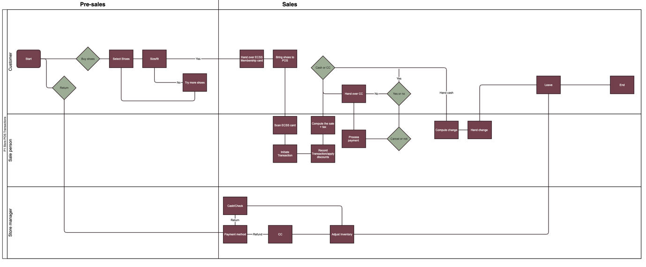

*Question 2: Business Process Improvement Recommendation*

**Improve customer satisfaction by streamlining the payment process.**

Implement self-checkout kiosks for customers paying with credit card. Self-checkout kiosks allow customers paying with credit card to complete their transactions quickly, reducing waiting times and enhancing their shopping experience. This improvement aligns with the goal of improving customer satisfaction by providing a more convenient and efficient payment option.

*Question 3: Recommendation to Improve Process Analytics Data*

**Implement inventory management technology to track the movement of merchandise within the store.**

IM technology provides real-time data on the movement of merchandise, allowing for better inventory management and identification of popular items. This data can be used to evaluate the effectiveness of the process improvement by analyzing sales patterns and identifying areas for further optimization.

*Question 4: Recommendation for Process Extension*

**Implement a loyalty program to incentivize repeat customers.**

A loyalty program will encourage customers to return to the store, increasing customer retention and driving sales. By offering rewards for purchases, such as discounts or exclusive offers, the loyalty program supports P1 by fostering customer loyalty and increasing sales volume.