**“Control Electrical Appliances”**

**Abstract:**

The computer had seen a lot of evolution both in hardware and software

Sides, yet there are some features which remain unbeatable and one among

them is the structure oriented programming language or **C**. Apart from

computer Programming they are fused in circuit boards, microcontrollers..,

etc to carry out Specified functions. The reason is the elegance and

simplicity of the keywords used in c.

This paper is about **Controlling Home/Industrial Appliance with**

**computer using C**. This idea is evolved from the in-out features of

microcontroller. The same can be extended to a PC where the output from

PC is a pulse which will activate a relay and hence controlling

electrical/electronic appliance. This is possible in all PCs having printer port.

CONTENTS

UNIT 1 –INTRODUCTION TO COMPONENTS USED

TRANSISTOR(BC148)

RESISTANCE

PRINTED CIRCUIT BOARD

25 pin connector(DB25 female) and Cable

Optocoupler

Relay 9v

1N4001 diode

6v battery

UNIT 2- BREADBOARD

BREADBOARD

BUS AND TERMINALS STRIPS

LIMITATIONS

UNIT 3 – SOLDERING

APPLICATIONS

SOLDERS

FLUX AND DEFECTS

SOLDERING TOOLS

UNIT 4- To Control Electrical Appliances using computer

**DESCRIPTION**

CIRCUIT DIAGRAM

APPLICATION OF CIRCUIT ON BREADBOARD

LIST OF COMPONENTS USED

UNIT 5 –DATASHEETS

TRANSISTOR BC148

Optocoupler 4n35

UNIT 6 – Software:

UNIT 7 – CONCLUSION

CONCLUSION

SCOPE OF THE PROJECT

❖

**UNIT 1 –INTRODUCTION TO COMPONENTS USED**

1. RESISTOR

A resistor is a two-terminal electronic component that produces a voltage across its

terminals that is proportional to the electric current through it in accordance

with Ohm's law:

*V* = *IR*

Resistors are elements of electrical networks and electronic circuits and are

ubiquitous in most electronic equipment. Practical resistors can be made of various

compounds and films, as well as resistance wire (wire made of a high-resistivity

alloy, such as nickel/chrome). The primary characteristics of a resistor are

the resistance, the tolerance, maximum working voltage and the power rating.

Other characteristics include temperature coefficient, noise, and inductance.

Resistors can be integrated into hybrid and printed circuits, as well as integrated

circuits. Size, and position of leads (or terminals) are relevant to equipment

designers; resistors must be physically large enough not to overheat when

dissipating their power.

**Units:** The ohm (symbol:

Ω) is a SI-driven unit of electrical resistance, named

after Georg Simon Ohm. Commonly used multiples and submultiples in electrical

and electronic usage are the milliohm (1x10-3), kilohm (1x103), and megohm

(1x106).

•

•

**Carbon film resistor**

**Color coding of resistors**

Resistor values are always coded in ohms.

▪

▪

▪

band **A** is first significant figure of component value

band **B** is the second significant figure

band **C** is the decimal multiplier

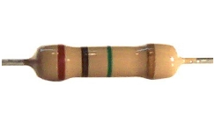

▪

band **D** if present, indicates tolerance of value in percent (no color means

20%)

• COLOR CODING TABLE

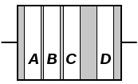

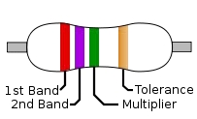

|  |  |  |  |  |  |  |
| --- | --- | --- | --- | --- | --- | --- |
| **Color** | **Significan**  **t**  **figures** | **Multiplier** | **Tolerance** | | **Temp.**  **Coefficient**  **(ppm/K)** | |
| [Black](http://en.wikipedia.org/wiki/Black) | 0 | 0  ×10 | – | | 250 | U |
| [Brown](http://en.wikipedia.org/wiki/Brown) | 1 | 1  ×10 | ±1% | F | 100 | S |
| [Red](http://en.wikipedia.org/wiki/Red) | 2 | 2  ×10 | ±2% | G | 50 | R |
| [Orange](http://en.wikipedia.org/wiki/Orange_(colour)) | 3 | 3  ×10 | – | | 15 | P |
| [Yellow](http://en.wikipedia.org/wiki/Yellow) | 4 | 4  ×10 | – | | 25 | Q |
| [Green](http://en.wikipedia.org/wiki/Green) | 5 | 5  ×10 | ±0.5% | D | 20 | Z |
| [Blue](http://en.wikipedia.org/wiki/Blue) | 6 | 6  ×10 | ±0.25% | C | 10 | Z |
| [Violet](http://en.wikipedia.org/wiki/Violet_(color)) | 7 | 7  ×10 | ±0.1% | B | 5 | M |
| [Gray](http://en.wikipedia.org/wiki/Grey) | 8 | 8  ×10 | ±0.05% | A | 1 | K |
| [White](http://en.wikipedia.org/wiki/White) | 9 | 9  ×10 | – | | – | |
| [Gold](http://en.wikipedia.org/wiki/Gold_(color)) | – | -1  ×10 | ±5% | J | – | |
| [Silver](http://en.wikipedia.org/wiki/Silver_(color)) | – | -2  ×10 | ±10% | K | – | |
| None | – | – | ±20% | M | – | |

2. BIPOLAR JUNCTION TRANSISTOR

A bipolar (junction) transistor (BJT) is a three-terminal electronic device constructed

of doped semiconductor material and may be used in amplifying or switching

applications. *Bipolar* transistors are so named because their operation involves

both electrons and holes. Charge flow in a BJT is due to bidirectional diffusion of

charge carriers across a junction between two regions of different charge

concentrations. This mode of operation is contrasted with *unipolar transistors,* such

as field-effect transistors, in which only one carrier type is involved in charge flow

due to drift. By design, most of the BJT collector current is due to the flow of

charges injected from a high-concentration emitter into the base where they

are minority carriers that diffuse toward the collector, and so BJTs are classified

as *minority-carrier* devices.

•

**WORKING OF TRANSISTOR**

An NPN transistor can be considered as two diodes with a shared anode. In typical

operation, the emitter–base junction is forward biased and the base–collector

junction is reverse biased. In an NPN transistor, for example, when a positive

voltage is applied to the base–emitter junction, the equilibrium between thermally

generated carriers and the repelling electric field of the depletion becomes

unbalanced, allowing thermally excited electrons to inject into the base region.

These electrons wander (or "diffuse") through the base from the region of high

concentration near the emitter towards the region of low concentration near the

collector. The electrons in the base are called *minority carriers* because the base

is doped p-type which would make holes the *majority carrier* in the base.

To minimize the percentage of carriers that recombine before reaching the

collector–base junction, the transistor's base region must be thin enough that

carriers can diffuse across it in much less time than the semiconductor's minority

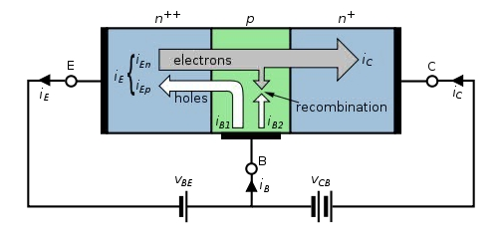

carrier lifetime. In particular, the thickness of the base must be much less than

the diffusion length of the electrons. The collector–base junction is reverse-biased,

and so little electron injection occurs from the collector to the base, but electrons

that diffuse through the base towards the collector are swept into the collector by

the electric field in the depletion region of the collector–base junction. The

thin *shared* base and asymmetric collector–emitter doping is what differentiates a

bipolar transistor from two *separate* and oppositely biased diodes connected in

series.

•

**NPN**

NPN is one of the two types of bipolar transistors, in which the letters "N" and "P"

refer to the majority charge carriers inside the different regions of the transistor.

Most bipolar transistors used today are NPN, because electron mobility is higher

than hole mobility in semiconductors, allowing greater currents and faster

operation.

NPN transistors consist of a layer of P-doped semiconductor (the "base") between

two N-doped layers. A small current entering the base in common-emitter mode is

amplified in the collector output. In other terms, an NPN transistor is "on" when its

base is pulled high relative to the emitter. The arrow in the NPN transistor symbol is

on the emitter leg and points in the direction of the conventional current flow when

the device is in forward active mode.

•

**Regions of operation**

Bipolar transistors have five distinct regions of operation, defined mostly by applied

bias:

➢

➢

**Forward-active** (or simply, **active**): The emitter–base junction is forward

biased and the base–collector junction is reverse biased. Most bipolar

transistors are designed to afford the greatest common-emitter current

gain, β*F*, in forward-active mode. If this is the case, the collector–emitter

current is approximately proportional to the base current, but many times

larger, for small base current variations.

**Reverse-active** (or **inverse-active** or **inverted**): By reversing the biasing

conditions of the forward-active region, a bipolar transistor goes into reverse-

active mode. In this mode, the emitter and collector regions switch roles.

Because most BJTs are designed to maximize current gain in forward-active

mode, the β*F* in inverted mode is several (2–3 for the ordinary germanium

transistor) times smaller. This transistor mode is seldom used, usually being

considered only for failsafe conditions and some types of bipolar logic. The

reverse bias breakdown voltage to the base may be an order of magnitude

lower in this region.

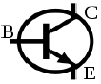

➢

➢

•

**Saturation**: With both junctions forward-biased, a BJT is in saturation mode

and facilitates high current conduction from the emitter to the collector. This

mode corresponds to a logical "on", or a closed switch.

**Cutoff**: In cutoff, biasing conditions opposite of saturation (both junctions

reverse biased) are present. There is very little current flow, which

corresponds to a logical "off", or an open switch.

**Transistor 'alpha' and 'beta'**

The proportion of electrons able to cross the base and reach the collector is a

measure of the BJT efficiency. The heavy doping of the emitter region and light

doping of the base region cause many more electrons to be injected from the

emitter into the base than holes to be injected from the base into the emitter.

The *common-emitter current gain* is represented by βF; it is approximately the ratio

of the DC collector current to the DC base current in forward-active region. It is

typically greater than 100 for small-signal transistors but can be smaller in

transistors designed for high-power applications. Another important parameter is

the common-base current gain, αF. The common-base current gain is approximately

the gain of current from emitter to collector in the forward-active region. Alpha and

beta are more precisely related by the following identities (NPN transistor):







3.

**SPDT RELAY:**

A relay is an electromechanical switch. More importantly, relays are used in virtually

every type of electronic device to switch voltages and electronic signals.

A relay operates based on the principals of electromagnetic. Inside a relay is an

inductor (a wire coil) that, when energized with an electric pulse, will generate a

magnetic field. The second part of a relay is a system of metallic arms which make

up the physical contacts of the switch. When the relay is off, or no electric pulse is

given to the relay, the arm of the switch is in one position. When the relay is on, or

an electric pulse is sent to the relay, the swing or switching arm of the switch

moves to another contact of the switch. The arm moves as the generated magnetic

field pulls the swinging arm toward the inductor (or wire coil). There are many

different configurations of relays but this is the simplest form of the internal

switching. Relays can have as few as 1 moving arm up to many inside of a single

relay box.

•

**A Look At A Relay**

When the relay is in the “off” position, the swing arm is in contact with the normally

closed contact. This means that when the relay is in the “off” position, the normally

closed contact is also conducting to the main contact. When the relay is activated,

the magnetic field created by the inductor coil pulls the swing arm until it makes

contact with the normally open contact connecting the circuit connected to the

normally open contact to the circuit connected to the main contact.

•

**Relay Terms:**

➢ **Inductor Coil:** generates a magnetic field inside the relay housing when

voltage is applied.

➢ **Swing Arm:** the only moving part of a relay. Switches between contacts of

the relay when pulled by the magnetic field generated the inductor coil.

➢ **Normally Open Contact:** the contact or pin that is NOT in contact with the

swing arm when the relay is in the off position but is the contact the swing

arm switches to when the relay is activated.

➢ **Normally Close Contact:** the contact or pin that IS in contact with the

swing arm when the relay is in the off position but is the contact the swing

arm switches away from when the relay is activated.

➢ **Main Contact:** connected to the swing arm. The primary purpose of the

switching of the relay allows the primary contact to jump or switch between

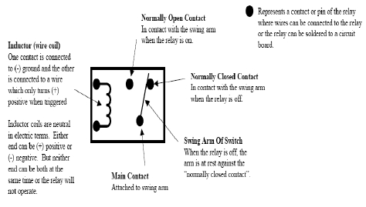

the circuits attached to the normally open and normally closed contacts when

the relay is turn on and off.

**Protection diodes for relays:**

Transistors and ICs must be protected from

the brief high voltage produced when a relay

coil is switched off. The diagram shows how a

signal diode (eg 1N4148) is connected

'backwards' across the relay coil to provide

this protection.

Current flowing through a relay coil creates a

magnetic field which collapses suddenly

when the current is switched off. The sudden

collapse of the magnetic field induces a brief

high voltage across the relay coil which is

very likely to damage transistors and ICs. The protection diode allows the induced

voltage to drive a brief current through the coil (and diode) so the magnetic field

dies away quickly rather than instantly. This prevents the induced voltage becoming

high enough to cause damage to transistors and ICs.

**Relays and transistors compared**

Like relays, transistors can be used as an electrically operated switch. For switching

small DC currents (< 1A) at low voltage they are usually a better choice than a

relay. However, transistors cannot switch AC (such as mains electricity) and in

simple circuits they are not usually a good choice for switching large currents

(> 5A). In these cases a relay will be needed, but note that a low power transistor

may still be needed to switch the current for the relay's coil!

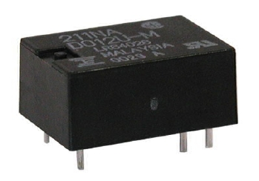

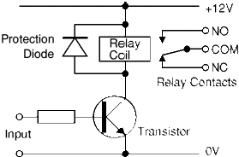

**Diode**

Figure 7: Typical diode packages in same alignment as diode symbol. Thin bar

depicts the [cathode.](http://en.wikipedia.org/wiki/Cathode)

In electronics, a **diode** is a two-terminal electronic component that conducts

[electric current](http://en.wikipedia.org/wiki/Electric_current) in only one direction. The term usually refers to a **semiconductor**

**diode**, the most common type today, which is a crystal of semiconductor connected

[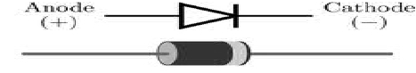](http://en.wikipedia.org/wiki/File:Diode_3D_and_ckt.pn)

to two electrical terminals, a P-N junction. A **vacuum tube diode**, now little used,

is a vacuum tube with two electrodes; a plate and a cathode. The most common

function of a diode is to allow an electric current in one direction (called the diode's

*forward* direction) while blocking current in the opposite direction (the *reverse*

direction). Thus, the diode can be thought of as an electronic version of a [check](http://en.wikipedia.org/wiki/Check_valve)

[valve.](http://en.wikipedia.org/wiki/Check_valve) This unidirectional behavior is called rectification, and is used to convert

[alternating current](http://en.wikipedia.org/wiki/Alternating_current) to direct current, and extract modulation from radio signals in

radio receivers.

**Current–voltage characteristic**

A semiconductor diode’s behavior in a circuit is given by its [current–voltage](http://en.wikipedia.org/wiki/Current%E2%80%93voltage_characteristic)

[characteristic,](http://en.wikipedia.org/wiki/Current%E2%80%93voltage_characteristic) or I–V graph (see graph at right). The shape of the curve is

determined by the transport of charge carriers through the so-called [*depletion layer*](http://en.wikipedia.org/wiki/Depletion_zone)

or *depletion region* that exists at the p-n junction between differing semiconductors.

When a p-n junction is first created, conduction band (mobile) electrons from the N-

[doped](http://en.wikipedia.org/wiki/Dopant) region diffuse into the P-doped region where there is a large population of

holes (vacant places for electrons) with which the electrons “recombine”. When a

mobile electron recombines with a hole, both hole and electron vanish, leaving

behind an immobile positively charged donor (dopant) on the N-side and negatively

charged acceptor (dopant) on the P-side. The region around the p-n junction

becomes depleted of charge carriers and thus behaves as an [insulator.](http://en.wikipedia.org/wiki/Nonconductor)

However, the width of the depletion region (called the depletion width) cannot grow

without limit. For each electron-hole pair that recombines, a positively-charged

[dopant](http://en.wikipedia.org/wiki/Dopant) ion is left behind in the N-doped region, and a negatively charged dopant ion

is left behind in the P-doped region. As recombination proceeds more ions are

created, an increasing electric field develops through the depletion zone which acts

to slow and then finally stop recombination. At this point, there is a “built-in”

potential across the depletion zone.

If an external voltage is placed across the diode with the same polarity as the built-

in potential, the depletion zone continues to act as an insulator, preventing any

significant electric current flow (unless electron/hole pairs are actively being

created in the junction by, for instance, light. see photodiode). This is the [*reverse*](http://en.wikipedia.org/wiki/P-n_junction)

[*bias*](http://en.wikipedia.org/wiki/P-n_junction) phenomenon. However, if the polarity of the external voltage opposes the built-

in potential, recombination can once again proceed, resulting in substantial electric

current through the p-n junction (i.e. substantial numbers of electrons and holes

recombine at the junction).. For silicon diodes, the built-in potential is approximately

0.6 V. Thus, if an external current is passed through the diode, about 0.6 V will be

developed across the diode such that the P-doped region is positive with respect to

the N-doped region and the diode is said to be “turned on” as it has a [*forward bias*.](http://en.wikipedia.org/wiki/P-n_junction)

Figure 5: I–V characteristics of a P-N junction diode (not to scale).

A diode’s '***I–V characteristic'*** can be approximated by four regions of operation

(see the figure at right). At very large reverse bias, beyond the [peak inverse voltage](http://en.wikipedia.org/wiki/Peak_Inverse_Voltage)

or PIV, a process called reverse breakdown occurs which causes a large increase in

current (i.e. a large number of electrons and holes are created at, and move away

from the pn junction) that usually damages the device permanently. The [avalanche](http://en.wikipedia.org/wiki/Avalanche_diode)

[diode](http://en.wikipedia.org/wiki/Avalanche_diode) is deliberately designed for use in the avalanche region. In the [zener diode,](http://en.wikipedia.org/wiki/Zener_diode)

the concept of PIV is not applicable. A zener diode contains a heavily doped p-n

junction allowing electrons to tunnel from the valence band of the p-type material to

the conduction band of the n-type material, such that the reverse voltage is

“clamped” to a known value (called the *zener voltage*), and avalanche does not

occur. Both devices, however, do have a limit to the maximum current and power in

the clamped reverse voltage region. Also, following the end of forward conduction in

any diode, there is reverse current for a short time. The device does not attain its

full blocking capability until the reverse current ceases.

The second region, at reverse biases more positive than the PIV, has only a very

small reverse saturation current. In the reverse bias region for a normal P-N rectifier

diode, the current through the device is very low (in the µA range). However, this is

temperature dependent, and at suffiently high temperatures, a substantial amount

of reverse current can be observed (mA or more).

The third region is forward but small bias, where only a small forward current is

conducted. As the potential difference is increased above an arbitrarily defined

“cut-in voltage” or “on-voltage” or “diode forward voltage drop (Vd)”, the diode

current becomes appreciable (the level of current considered “appreciable” and the

value of cut-in voltage depends on the application), and the diode presents a very

low resistance. The current–voltage curve is exponential. In a normal silicon diode

at rated currents, the arbitrary “cut-in” voltage is defined as 0.6 to 0.7 volts. The

value is different for other diode types — Schottky diodes can be rated as low as 0.2

V and red or blue light-emitting diodes (LEDs) can have values of 1.4 V and 4.0 V

respectively. At higher currents the forward voltage drop of the diode increases. A

drop of 1 V to 1.5 V is typical at full rated current for power diodes.

[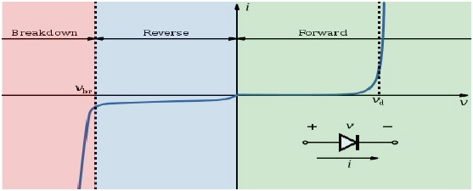](http://en.wikipedia.org/wiki/File:Diode-IV-Curve.sv)

**Opto-coupler:**

In electronics, an **opto-isolator** (or **optical isolator**, **optical coupling device**,

**optocoupler**, **photocoupler**, or **photoMOS**) is a device that uses a short [optical](http://en.wikipedia.org/wiki/Optical)

[transmission](http://en.wikipedia.org/wiki/Transmission_(telecommunications)) path to transfer an electronic signal between elements of a [circuit,](http://en.wikipedia.org/wiki/Electrical_network)

typically a transmitter and a receiver, while keeping them electrically isolated—

since the electrical signal is converted to a light beam, transferred, then converted

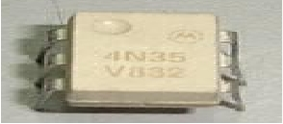

back to an electrical signal, there is no need for electrical connection between the

source and destination circuits. Isolation between input and output is rated at 7500

Volt peak for 1 second for a typical component costing less than 1 US$ in small

quantities.

The opto-isolator is simply a package that contains both an infrared [light-emitting](http://en.wikipedia.org/wiki/Light-emitting_diode)

[diode](http://en.wikipedia.org/wiki/Light-emitting_diode) (LED) and a photodetector such as a photosensitive silicon diode, transistor

Darlington pair, or silicon controlled rectifier (SCR). The wave-length responses of

the two devices are tailored to be as identical as possible to permit the highest

measure of coupling possible. Other circuitry—for example an output amplifier—

may be integrated into the package. An opto-isolator is usually thought of as a

single integrated package, but opto-isolation can also be achieved by using

separate devices.

**Configurations**

Schematic diagram of a very simple opto-isolator with an LED and phototransistor. The dashed line

represents the isolation barrier, over which there is no electrical contact.

A common implementation is a LED and a phototransistor in a light-tight housing to

exclude ambient light and without common electrical connection, positioned so that

light from the LED will impinge on the photodetector. When an electrical signal is

applied to the input of the opto-isolator, its LED lights and illuminates the

photodetector, producing a corresponding electrical signal in the output circuit.

Unlike a transformer the opto-isolator allows DC coupling and can provide any

desired degree of electrical isolation and protection from serious overvoltage

conditions in one circuit affecting the other. A higher transmission ratio can be

obtained by using a Darlington instead of a simple phototransistor, at the cost of

reduced noise immunity and higher delay.

With a photodiode as the detector, the output current is proportional to the intensity

of incident light supplied by the emitter. The diode can be used in a [photovoltaic](http://en.wikipedia.org/wiki/Photovoltaic)

mode or a photoconductive mode. In photovoltaic mode, the diode acts as a current

source in parallel with a forward-biased diode. The output current and voltage are

dependent on the load impedance and light intensity. In photoconductive mode, the

diode is connected to a supply voltage, and the magnitude of the current conducted

is directly proportional to the intensity of light. This optocoupler type is significantly

faster than photo transistor type, but the transmission ratio is very low; it is

common to integrate an output amplifier circuit into the same package.

[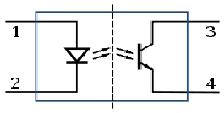](http://en.wikipedia.org/wiki/File:Optoisolator_Pinout.sv)

The optical path may be air or a dielectric waveguide. When high noise immunity is

required an optical conductive shield can be integrated into the optical path. The

transmitting and receiving elements of an optical isolator may be contained within a

single compact module, for mounting, for example, on a circuit board; in this case,

the module is often called an **optoisolator** or **opto-isolator**. The photosensor may

be a photocell, phototransistor, or an optically triggered SCR or TRIAC. This device

may in turn operate a power relay or contactor. Analog optoisolators often have two

independent, closely matched output phototransistors, one of which is used to

linearize the response using [negative feedback.](http://en.wikipedia.org/wiki/Negative_feedback)

**D-subminiature**

DB25 Female

DB25 Male

The **D-subminiature** or **D-sub** is a common type of electrical connector used

particularly in computers. A D-sub contains two or more parallel rows of pins or

sockets usually surrounded by a D-shaped metal shield that provides

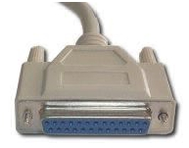

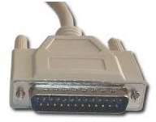

mechanical support, some screening against [electromagnetic interference,](http://en.wikipedia.org/wiki/Electromagnetic_interference)

and ensures correct orientation. The part containing pin contacts is called

the *male connector* or *plug*, while that containing socket contacts is called

the *female connector* or *socket*. The socket's shield fits tightly inside the

plug's shield. The shields are connected to the overall screens of the cables

(when screened cables are used), creating an electrically continuous screen

covering the whole cable and connector system.

DB25 female connector & Cable

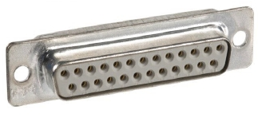

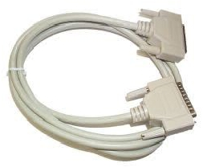

|  |  |  |  |  |
| --- | --- | --- | --- | --- |
| **Pin No (DB25)** | **Signal name** | **Direction** | **Register - bit** | **Inverted** |
| 1 | nStrobe | Out | Control-0 | Yes |
| 2 | Data0 | In/Out | Data-0 | No |
| 3 | Data1 | In/Out | Data-1 | No |
| 4 | Data2 | In/Out | Data-2 | No |
| 5 | Data3 | In/Out | Data-3 | No |
| 6 | Data4 | In/Out | Data-4 | No |
| 7 | Data5 | In/Out | Data-5 | No |
| 8 | Data6 | In/Out | Data-6 | No |
| 9 | Data7 | In/Out | Data-7 | No |
| 10 | nAck | In | Status-6 | No |
| 11 | Busy | In | Status-7 | Yes |
| 12 | Paper-Out | In | Status-5 | No |
| 13 | Select | In | Status-4 | No |
| 14 | Linefeed | Out | Control-1 | Yes |

**4.**

**PRINTED CIRCUIT BOARD**

A **printed circuit board**, or **PCB**, is used to mechanically support and electrically

connect electronic components using conductive pathways, tracks, or [traces,](http://en.wikipedia.org/wiki/Signal_trace)

[etched](http://en.wikipedia.org/wiki/Industrial_etching) from copper sheets laminated onto a non-conductive *substrate*. It is also

referred to as **printed wiring board** (**PWB**) or **etched wiring board**. A PCB

populated with electronic components is a **printed circuit assembly** (**PCA**), also

known as a **printed circuit board assembly** (**PCBA**). PCBs are inexpensive, and

can be highly reliable. They require much more layout effort and higher initial cost

than either wire-wrapped or point-to-point constructed circuits, but are much

cheaper and faster for high-volume production. Much of the electronics industry's

PCB design, assembly, and quality control needs are set by standards that are

published by the IPC organization.

|  |  |  |  |  |
| --- | --- | --- | --- | --- |
| 15 | nError | In | Status-3 | No |
| 16 | nInitialize | Out | Control-2 | No |
| 17 | nSelect-Printer | Out | Control-3 | Yes |
| 18-25 | Ground | - | - | - |

Conducting layers are typically made of thin copper foil. Insulating layers [dielectric](http://en.wikipedia.org/wiki/Dielectric)

are typically laminated together with epoxy resin prepreg. The board is typically

coated with a solder mask that is green in color. Other colors that are normally

available are blue and red. There are quite a few different dielectrics that can be

chosen to provide different insulating values depending on the requirements of the

circuit. Some of these dielectrics are polytetrafluoroethylene (Teflon), FR-4, FR-1,

CEM-1 or CEM-3. Well known prepreg materials used in the PCB industry are [FR-2](http://en.wikipedia.org/wiki/FR-2)

(Phenolic cotton paper), FR-3 (Cotton paper and epoxy), FR-4 (Woven glass and

epoxy), FR-5 (Woven glass and epoxy), FR-6 (Matte glass and polyester), G-10

(Woven glass and epoxy), CEM-1 (Cotton paper and epoxy), CEM-2 (Cotton paper

and epoxy), CEM-3 (Woven glass and epoxy), CEM-4 (Woven glass and epoxy), CEM-

5 (Woven glass and polyester).

❖

**UNIT 2- BREADBOARD**

**1. BREADBOARD:**

A breadboard (protoboard) is a construction base for a one-of-a-kind electronic

circuit, a prototype. In modern times the term is commonly used to refer to a

particular type of breadboard, the solder less breadboard (plug board).

Because the solder less breadboard does not require soldering, it is reusable, and

thus can be used for temporary prototypes and experimenting with circuit design

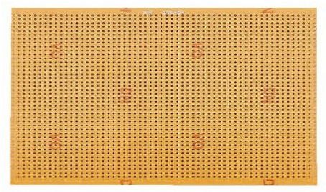

more easily. Other, often historic, breadboard types don't have this property. This is

also in contrast to strip board (veroboard) and similar prototyping printed circuit

boards, which are used to build more permanent soldered prototypes or one-offs,

and cannot easily be reused.

•

**Typical specifications**

A modern solder less breadboard consists of a perforated block of plastic with

numerous tin plated phosphor bronze or nickel silver alloy spring clips under the

perforations. The spacing between the clips (lead pitch) is typically

0.1" (2.54 mm). Integrated circuits (ICs) in dual in-line packages (DIPs) can be

inserted to straddle the centreline of the block. Interconnecting wires and the leads

of discrete components (such as capacitors, resistors, inductors, *etc.*) can be

inserted into the remaining free holes to complete the circuit. Where ICs are not

used, discrete components and connecting wires may use any of the holes.

•

**BUS AND TERMINAL STRIPS**

Solder less breadboards are available from several different manufacturers, but

most share a similar layout. The layout of a typical solder less breadboard is made

up from two types of areas, called strips. Strips consist of interconnected electrical

terminals.

➢ **Terminal strips**

The main area to hold most of the electronic components. In the middle of a

terminal strip of a breadboard, one typically finds a notch running in parallel to the

long side. The notch is to mark the centreline of the terminal strip and provides

limited airflow (cooling) to DIP ICs straddling the centreline. The clips on the right

and left of the notch are each connected in a radial way; typically five clips (i.e.,

beneath five holes) in a row on each side of the notch are electrically connected.

The five clip columns on the left of the notch are often marked as A, B, C, D, and E,

while the ones on the right are marked F, G, H, I and J.

➢ **BUS STRIPS**

To provide power to the electronic components. A bus strip usually contains two

columns, one for ground, and one for a supply voltage. But some breadboards only

provide a single-column power distributions bus strip on each long side.

•

**Diagram**

A "full size" terminal breadboard strip typically consists of around 56 to 65 rows of

connectors, each row containing the above mentioned two sets of connected clips

(A to E and F to J). "Small size" strips typically come with around 30 rows.

•

**Terminal Strip:**

A B C D E F G H I J

1

2

3

~

~

61

62

63

o-o-o-o-o v o-o-o-o-o

o-o-o-o-o o-o-o-o-o

o-o-o-o-o o-o-o-o-o

o-o-o-o-o o-o-o-o-o

o-o-o-o-o o-o-o-o-o

o-o-o-o-o ^ o-o-o-o-o

•

**Bus Strip:**

V

o

|

o

|

o

|

o

|

o

G

o

|

o

|

o

|

o

|

o

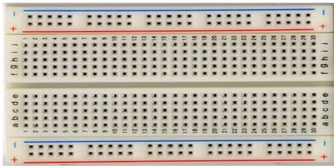

|

|

o

|

o

|

o

|

o

|

o

|

|

~

~

o

|

o

|

|

o

|

o

|

o

|

o

|

o

|

|

o

|

o

•

**Jump wires**

The jump wires for solder less bread boarding can be obtained in ready-to-use jump

wire sets or can be manually manufactured. The latter can become tedious work for

larger circuits. Shorter stripped wires might result in bad contact with the board's

spring clips (insulation being caught in the springs). Longer stripped wires increase

the likelihood of short-circuits on the board. Needle-nose pliers and tweezers are

helpful when inserting or removing wires, particularly on crowded boards.

•

**Limitations**

Solder less breadboards usually cannot accommodate Surface mount

technology devices (SMD) or non 0.1" (2.54 mm) grid spaced components, like for

example those with 2 mm spacing. Due to large stray capacitance (from 2-25pF

per contact point), high inductance of some connections and a relatively high and

not very reproducible contact resistance, solder less breadboards are limited to

operate at relatively low frequencies, usually less than 10 MHz, depending on the

nature of the circuit. The relative high contact resistance can already be a problem

for DC and very low frequency circuits. Solder less breadboards are further limited

by their voltage and current ratings. Complex circuits can become unmanageable

on a breadboard due to the large amount of wiring necessary.

❖

**1.**

**UNIT 3 – SOLDERING**

**SOLDERING**

Soldering is a process in which two or more metal items are joined together by

melting and flowing a filler metal into the joint, the filler metal having a relatively

low melting point. Soft soldering is characterized by the melting point of the filler

metal, which is below 400 °C (752 °F). The filler metal used in the process is

called solder.

Soldering is distinguished from brazing by use of a lower melting-temperature filler

metal; it is distinguished from welding by the base metals not being melted during

the joining process. In a soldering process, heat is applied to the parts to be joined,

causing the solder to melt and be drawn into the joint by capillary action and to

bond to the materials to be joined by wetting action. After the metal cools, the

resulting joints are not as strong as the base metal, but have adequate strength,

electrical conductivity, and water-tightness for many uses.

**+**

**=**

**+**

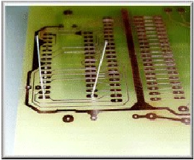

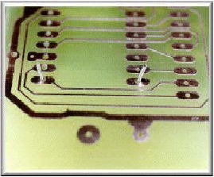

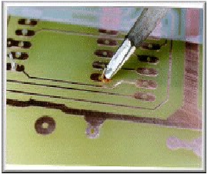

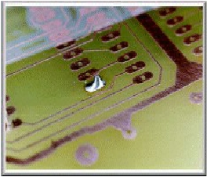

•

**Applications**

One of the most frequent applications of soldering is assembling electronic

components to printed circuit boards (PCBs). Another common application is making

permanent but reversible connections between copper pipes in plumbing systems.

Joints in sheet metal objects such as food cans, roof flashing, rain gutters and

automobile radiators have also historically been soldered, and occasionally still are.

•

**Solders**

Soldering filler materials are available in many different alloys for differing

applications. In electronics assembly, the eutectic alloy of 63% tin and 37% lead (or

60/40, which is almost identical in performance to the eutectic) has been the alloy

of choice. A eutectic formulation has several advantages for soldering; chief among

these is the coincidence of the liquidus and solidus temperatures, i.e. the absence

of a plastic phase. This allows for quicker wetting out as the solder heats up, and

quicker setup as the solder cools. A non-eutectic formulation must remain still as

the temperature drops through the liquidus and solidus temperatures. Any

differential movement during the plastic phase may result in cracks, giving an

unreliable joint. Additionally, a eutectic formulation has the lowest possible melting

point, which minimizes heat stress on electronic components during soldering.

Lead-free solders are suggested anywhere children may come into contact with

(since children are likely to place things into their mouths), or for outdoor use where

rain and other precipitation may wash the lead into the groundwater. Some

examples of solder types and their applications are tin-lead (general purpose), tin-

zinc for joining aluminium, lead-silver for strength at higher than room temperature,

cadmium-silver for strength at high temperatures, zinc-aluminium for aluminium

and corrosion resistance, and tin-silver and tin-bismuth for electronics. Specialty

alloys are available with properties such as higher strength, better electrical

conductivity and higher corrosion resistance.

•

**Flux**

In high-temperature metal joining processes (welding, brazing and soldering), the

primary purpose of flux is to prevent oxidation of the base and filler materials. Tin-

lead solder, for example, attaches very well to copper, but poorly to the various

oxides of copper, which form quickly at soldering temperatures. Flux is a substance

which is nearly inert at room temperature, but which becomes strongly reducing at

elevated temperatures, preventing the formation of metal oxides. Secondarily, flux

acts as a wetting agent in the soldering process, reducing the surface of the molten

solder and causing it to better wet out the parts to be joined.

•

**Soldering defects**

The most common defect when hand-soldering results from the parts being joined

not exceeding the solder's liquidus temperature, resulting in a "cold solder" joint.

This is usually the result of the soldering iron being used to heat the solder directly,

rather than the parts themselves. Properly done, the iron heats the parts to be

connected, which in turn melt the solder, guaranteeing adequate heat in the joined

parts for thorough wetting. In 'electronic' hand soldering solder the flux

is *embedded* in the solder. Therefore heating the solder *first* may cause the flux to

evaporate before it cleans the surfaces (pcb pad and component connection) being

soldered.

In electronics non-corrosive fluxes are often used. Therefore cleaning flux off may

merely be a matter of aesthetics or to make visual inspection of joints easier in

specialised 'mission critical' applications such as medical devices, military and

aerospace i.e. satellites . For satellites also to reduce weight slightly but usefully. In

some conditions i.e. high humidity, even non-corrosive flux might remain slightly

active, therefore the flux may be removed to absolutely negate the possibility of

corrosion over time. In some applications, the PCB might also be coated in some

form of protective material such as a lacquer to protect it and/or exposed solder

joints from the environment.

Movement of metals being soldered before the solder has cooled will cause a highly

unreliable cracked joint. In electronics' soldering terminology this is known as a 'dry'

joint. It has a characteristically dull or grainy appearance immediately after the joint

is made, rather than being smooth, bright and shiny. This appearance is caused by

crystallization of the liquid solder. A dry joint is weak mechanically and a poor

conductor electrically. In general a good looking soldered joint *is* a good joint. As

mentioned it should be smooth, bright and shiny. If not smooth i.e. lumps or balls of

otherwise shiny solder the metal has not 'wetted' properly. Not being bright and

shiny suggests a weak 'dry' joint. In electronics a 'concave' fillet is ideal. This

indicates good wetting and minimal use of solder (therefore minimal *heating* of heat

sensitive components). A joint may be good, but if a large amount of unnecessary

solder is used then more heating is obviously required. Excessive heating of a PCB

may result in 'delamination', the copper track may actually lift off the board,

particularly on single sided PCBs without 'through hole' plating.

•

**Tools**

Hand-soldering tools include the electric soldering iron, which has a variety of tips

available ranging from blunt to very fine to chisel heads for hot-cutting plastics, and

the soldering gun, which typically provides more power, giving faster heat-up and

allowing larger parts to be soldered. Hot-air guns and pencils allow rework of

component packages which cannot easily be performed with electric irons and

guns.

❖

**UNIT 4- To Control Electrical Appliances using**

**computer**

**1.**

**Introduction**

Here is a circuit diagram for using the printer port of a PC, for control application

using software and some interface hardware. The interface circuit along with the

given software can be used with the printer port of any PC for controlling up to eight

equipments. The interface circuit shown in is drawn for only two device, being

controlled by D0 and D1 bit at pin 2 and pin 3 of the 25-pin parallel port. Identical

circuits for the remaining data bits D2 through D7 (available at pins 4 through 9)

have to be similarly wired. The use of opto-coupler ensures complete isolation of the

PC from the relay driver circuitry.

Lots of ways to control the hardware can be implemented using software. In C/C++

one can use the outportb (portno,value) function where portno is the parallel port

address (usually 378hex for LPT1) and 'value' is the data that is to be sent to the

port. For a value=0 all the outputs (D0-D7) are off. For value=1 D0 is ON, value=2

D1 is ON, value=4, D2 is ON and so on. e.g. If value=29(decimal)

= 00011101(binary) ->D0, D2, D3, D4 are ON and the rest are OFF.

•

**WORKING:**

First of all, connect the DB25 cable to the parallel port of computer as well as DB25

female connector on the circuit board. Now open the software “Portctrl” which is

written in “c” and is very easy to understand. The screen in the software shows the

status of the Data pins of the computer’s parallel port.

Initially, All the pins are in the off state i.e. 0. Now Press the appropriate numeric

key to turn on/off pins of the computer’s port. This in turn sends either 3.5-5v

signal(on state) if the key is pressed once and if it is pressed again then it sends 0-

1.5v(off state) signal. The software converts the number pressed in to hex code

which is also shown on the screen and then sends the value to parallel port address

(usually 378hex for LPT1). Maximum up to 8 appliances can be controlled by

pressing appropriate keys.

When any of the port is in “on” state then the voltage forward biases the LED in the

Optocoupler and sends the light to a phototransistor. The Optocoupler provides

complete isolation from the computer’s port. The phototransistor in turn activates

the transistor BC148 used to energize relay. Inside a relay is an inductor (a wire

coil) that, when energized with an electric pulse, will generate a magnetic field. The

second part of a relay is a system of metallic arms which make up the physical

contacts of the switch. When the relay is off, or no electric pulse is given to the

relay, the arm of the switch is in one position. When the relay is on, or an electric

pulse is sent to the relay, the swing or switching arm of the switch moves to another

contact of the switch. The arm moves as the generated magnetic field pulls the

swinging arm toward the inductor (or wire coil). And hence the AC circuit is

completed and the electrical appliance is turned on.

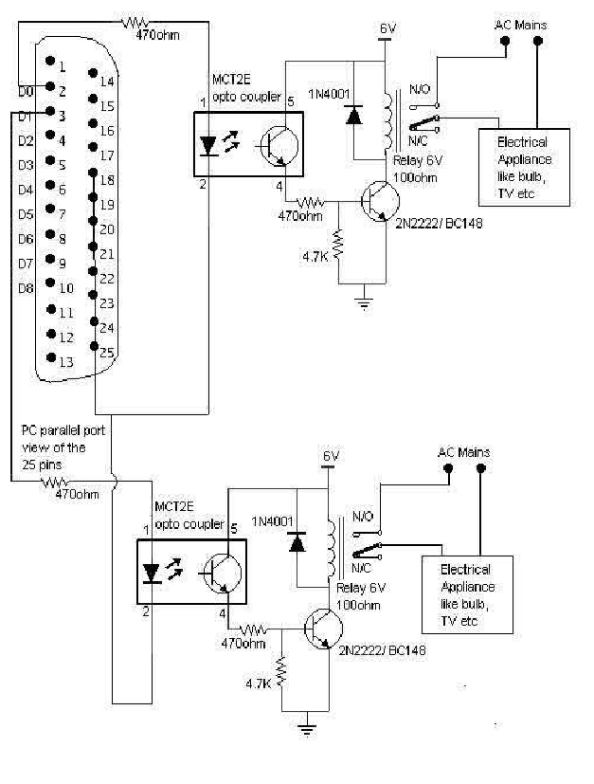

However, Transistors and ICs must be protected from the brief high voltage

produced when a relay coil is switched off. The protection diode allows the induced

voltage to drive a brief current through the coil (and diode) so the magnetic field

dies away quickly rather than instantly. This prevents the induced voltage becoming

high enough to cause damage to transistors and ICs.

**2.**

**Background:**

Parallel port is a simple and inexpensive tool for building computer controlled

devices and projects. The simplicity and ease of programming makes parallel port

popular in electronics hobbyist world. The parallel port is often used in computer

controlled robots, home automation, etc. Here is a simple tutorial on parallel port

interfacing and programming, with some examples. The primary use of parallel port

is to connect printers to the computer and is specifically designed for this purpose.

Thus it is often called as printer Port or Centronics port (this name came from a

popular printer manufacturing company 'Centronics' which devised some standards

for parallel port). You can see the parallel port connector in the rear panel of your

PC. It is a 25 pin female (DB25) connector (to which printer is connected). On almost

all the PCs only one parallel port is present, but you can add more by buying and

inserting ISA/PCI parallel port cards.

•

**Parallel port modes**

The IEEE 1284 Standard which has been published in 1994 defines five modes of

data transfer for parallel port. They are:

1.

2.

3.

4.

5.

Compatibility Mode

Nibble Mode

Byte Mode

EPP

ECP

The programs, circuits, and other information found in this tutorial are compatible to

almost all types of parallel ports and can be used without any problems.

•

**Hardware**

The pin outs of DB25 connector is shown in the picture below: The lines in DB25

connector are divided into three groups, they are:

1. Data lines (data bus)

2. Control lines

3. Status lines

As the name refers, data is transferred over data lines. Control lines are used to

control the peripheral, and of course, the peripheral returns status signals back to

the computer through Status lines. These lines are connected to Data, Control And

Status registers internally. The details of parallel port signal lines are given below:

•

**Parallel port registers:**

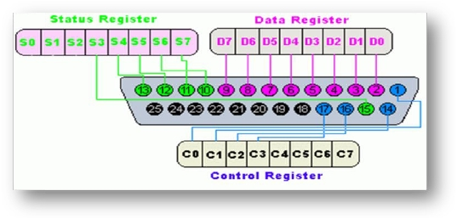

|  |  |  |  |  |
| --- | --- | --- | --- | --- |
| **Pin No (DB25)** | **Signal name** | **Direction** | **Register - bit** | **Inverted** |
| 1 | nStrobe | Out | Control-0 | Yes |
| 2 | Data0 | In/Out | Data-0 | No |
| 3 | Data1 | In/Out | Data-1 | No |
| 4 | Data2 | In/Out | Data-2 | No |
| 5 | Data3 | In/Out | Data-3 | No |
| 6 | Data4 | In/Out | Data-4 | No |
| 7 | Data5 | In/Out | Data-5 | No |
| 8 | Data6 | In/Out | Data-6 | No |
| 9 | Data7 | In/Out | Data-7 | No |
| 10 | nAck | In | Status-6 | No |
| 11 | Busy | In | Status-7 | Yes |
| 12 | Paper-Out | In | Status-5 | No |
| 13 | Select | In | Status-4 | No |
| 14 | Linefeed | Out | Control-1 | Yes |
| 15 | nError | In | Status-3 | No |
| 16 | nInitialize | Out | Control-2 | No |
| 17 | nSelect-Printer | Out | Control-3 | Yes |
| 18-25 | Ground | - | - | - |
|  |  |  |  |  |
|  |  |  |  |  |

As you know, the Data, Control and Status lines are connected to there

corresponding registers inside the computer. So, by manipulating these registers in

program, one can easily read or write to parallel port with programming languages

like 'C' and BASIC. The registers found in a

standard parallel port are:

1. Data register

2. Status register

3. Control register

As their names specify, Data register is connected to Data lines, Control register is

connected to Control lines and Status register is connected to Status lines. (Here

the word connection does not mean that there is some physical connection between

data/control/status lines. The registers are virtually connected to the corresponding

lines.) So, whatever you write to these registers will appear in the corresponding

lines as voltages. Of course, you can measure it with a multimeter. And whatever

you give to Parallel port as voltages can be read from these registers (with some

restrictions). For example, if we write '1' to Data register, the line Data0 will be

driven to +5v. Just like this, we can programmatically turn on and off any of the

Data lines and Control lines.

•

**Where these registers are?**

In an IBM PC, these registers are IO mapped and will have an unique address. We

have to find these addresses to work with the parallel port. For a typical PC, the

base address of LPT1 is 0x378 and of LPT2 is 0x278. The Data register resides at

this base address, Status register at base address + 1 and the control register is at

base address + 2. So, once we have the base address, we can calculate the address

of each register in this manner. The table below shows the register addresses of

LPT1 and LPT2.

|  |  |  |
| --- | --- | --- |
| **Register** | **LPT1** | **LPT2** |
| Data register (baseaddress + 0) | 0x378 | 0x278 |
| Status register (baseaddress + 1) | 0x379 | 0x279 |
| Control register (baseaddress + 2) | 0x37a | 0x27a |
|  |  |  |
|  |  |  |

**3. LIST OF COMPONENTS USED:**

1. 25 pin connector (DB25 male) and DB25 cable.

2. Two 470ohm resistors.

3. 4n35 optocoupler.

4. 4.7Kohm resistor.

5. 2N2222/BC148.

6. Relay 6v/100ohm.

7. 1N4001Diode.

8. 6v battery.

9. One 3 pin plug and socket.

10.One LED.

11.Connecting wires.

12.230 v A.C. main supply.

13.Printed Circuit Board.

**4. Applications:**

The project can be used for various applications wherever you require control using

pc.

a) Hotel power management.

b) Street light management.

c) Home automation.

d) High voltage grid control.

e) Industrial automation and many more.

❖

•

**UNIT 5 –DATASHEETS**

**TRANSISTOR BC148**

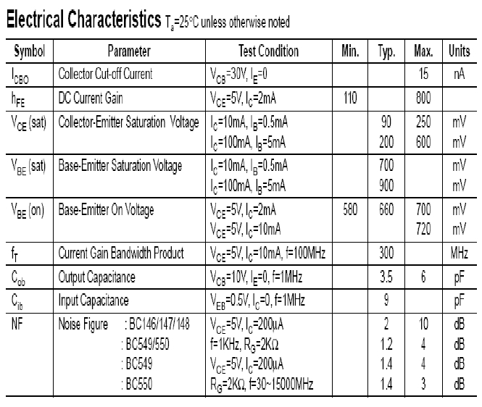

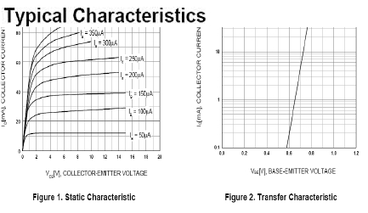

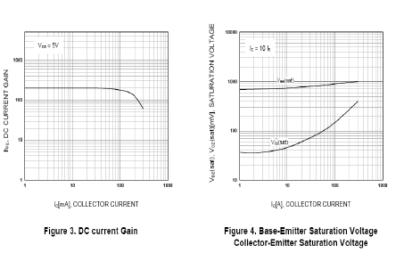

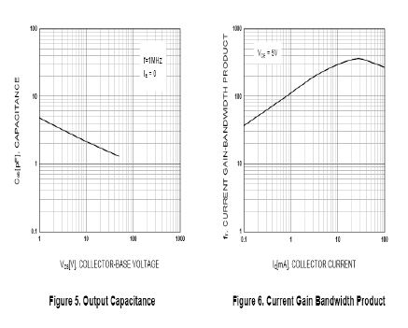

•

**Optocoupler(4n35)**

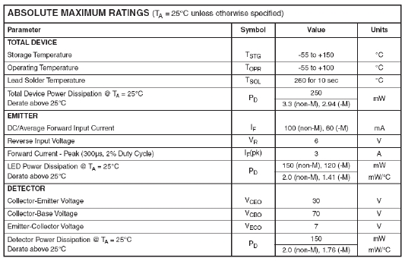

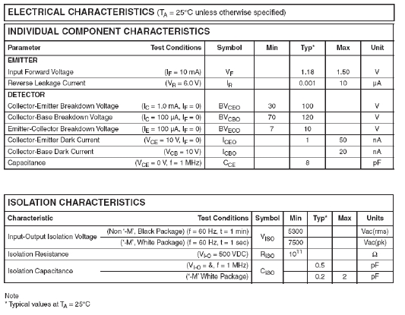

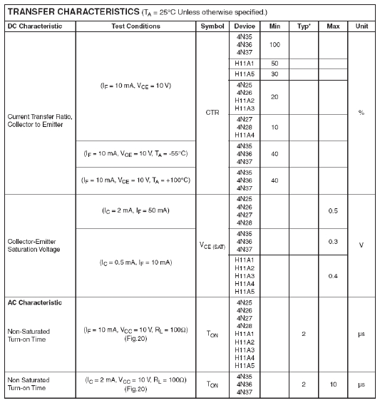

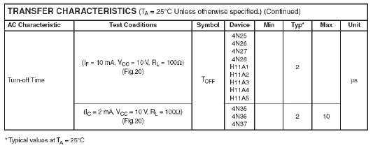

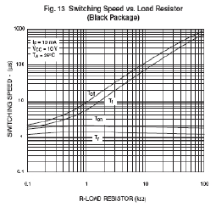

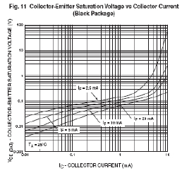

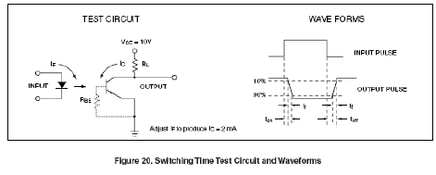

❖

•

**UNIT 6 – Software:**

**program written in C**

/*program to control devices using PC parallel port

The devices are controlled by pressing the keys 1-8

that corresponds to each of the 8 possible devices

*/

#include<dos.h>

#include<stdio.h>

#include<conio.h>

#define PORT 0x378 /* This is the parallel port address */

main()

{

char val=0,key=0;

char str1[]="ON ";

char str2[]="OFF";

char *str;

clrscr();

printf("Press the approriate number key to turn on/off devices:\n\n");

printf("Here Device1 is connected to D0 of parallel port and so on\n\n");

printf("Press \"x\" to quit\n\n");

gotoxy(1,8);

printf("Device1:OFF Device2:OFF Device3:OFF Device4:OFF\n");

printf("Device5:OFF Device6:OFF Device7:OFF Device8:OFF");

while(key!='x' && key!='X')

{

gotoxy(1,12);

printf("Value in hex sent to the port:");

key=getch();

switch(key){

case '1':

gotoxy(9,8);

val=(val&0x01)?(val&(~0x01)):val|0x01;

str=(val&0x01)?str1:str2;

printf("%s",str);

outportb(PORT,val);

gotoxy(1,13);

printf("%x",val);

break;

case '2':

gotoxy(21,8);

val=(val&0x02)?(val&(~0x02)):val|0x02;

str=(val&0x02)?str1:str2;

printf("%s",str);

outportb(PORT,val);

gotoxy(1,13);

printf("%x",val);

break;

case '3':

gotoxy(33,8);

val=(val&0x04)?(val&(~0x04)):val|0x04;

str=(val&0x04)?str1:str2;

printf("%s",str);

outportb(PORT,val);

gotoxy(1,13);

printf("%x",val);

break;

case '4':

gotoxy(45,8);

val=(val&0x08)?(val&(~0x08)):val|0x08;

str=(val&0x08)?str1:str2;

printf("%s",str);

outportb(PORT,val);

gotoxy(1,13);

printf("%x",val);

break;

case '5':

gotoxy(9,9);

val=(val&0x10)?(val&(~0x10)):val|0x10;

str=(val&0x10)?str1:str2;

printf("%s",str);

outportb(PORT,val);

gotoxy(1,13);

printf("%x",val);

break;

case '6':

gotoxy(21,9);

val=(val&0x20)?(val&(~0x20)):val|0x20;

str=(val&0x20)?str1:str2;

printf("%s",str);

outportb(PORT,val);

gotoxy(1,13);

printf("%x",val);

break;

case '7':

gotoxy(33,9);

val=(val&0x40)?(val&(~0x40)):val|0x40;

str=(val&0x40)?str1:str2;

printf("%s",str);

outportb(PORT,val);

gotoxy(1,13);

printf("%x",val);

break;

case '8':

gotoxy(45,9);

val=(val&0x80)?(val&(~0x80)):val|0x80;

str=(val&0x80)?str1:str2;

printf("%s",str);

outportb(PORT,val);

gotoxy(1,13);

printf("%x",(unsigned char)val);

break;

}

}

}

❖

**UNIT 7 – CONCLUSION**

• **CONCLUSION**

The conclusion of the project is that whenever the voltage or a digital signal ‘1’ is

applied on the parallel port of the computer using the software which is written in

“c” then the voltage on the corresponding pin drives the optocoupler.

When the voltage is applied, then the optocoupler activates the transistor inside

the optocoupler which drives the transistor BC 148. The transition in the

resistance of the circuit due to variation in voltages across the optocoupler makes

the transistor BC 148 ON. The transistor in turn energizes the coil in the relay .The

energized coil makes connection between the two terminals of the other circuit in

which the electrical appliance is connected. And hence the AC circuit is

completed.

Another very interesting conclusion of this project is use of the relay whose

connection is to be made very carefully otherwise the circuit will not work.

Precautions must be taken under every step of soldering the circuit.

• **SCOPE OF THE PROJECT**

The project helps in understanding the working of the 25 pin parallel port of the

computer, SPDT Relay and Optocoupler. The scope of this project is huge with the

modernization and advancement in computer fields.

The project can be used for various applications wherever you require control

using pc.

a) Hotel power management.

b) Street light management.

c) Home automation.

d) High voltage grid control.

e) Industrial automation and many more.