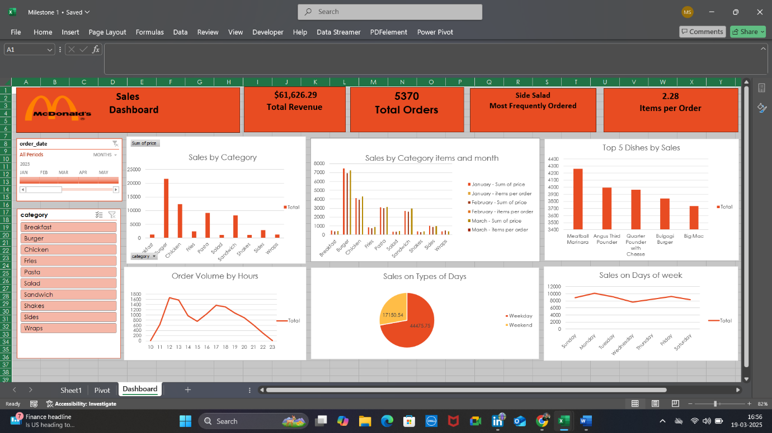

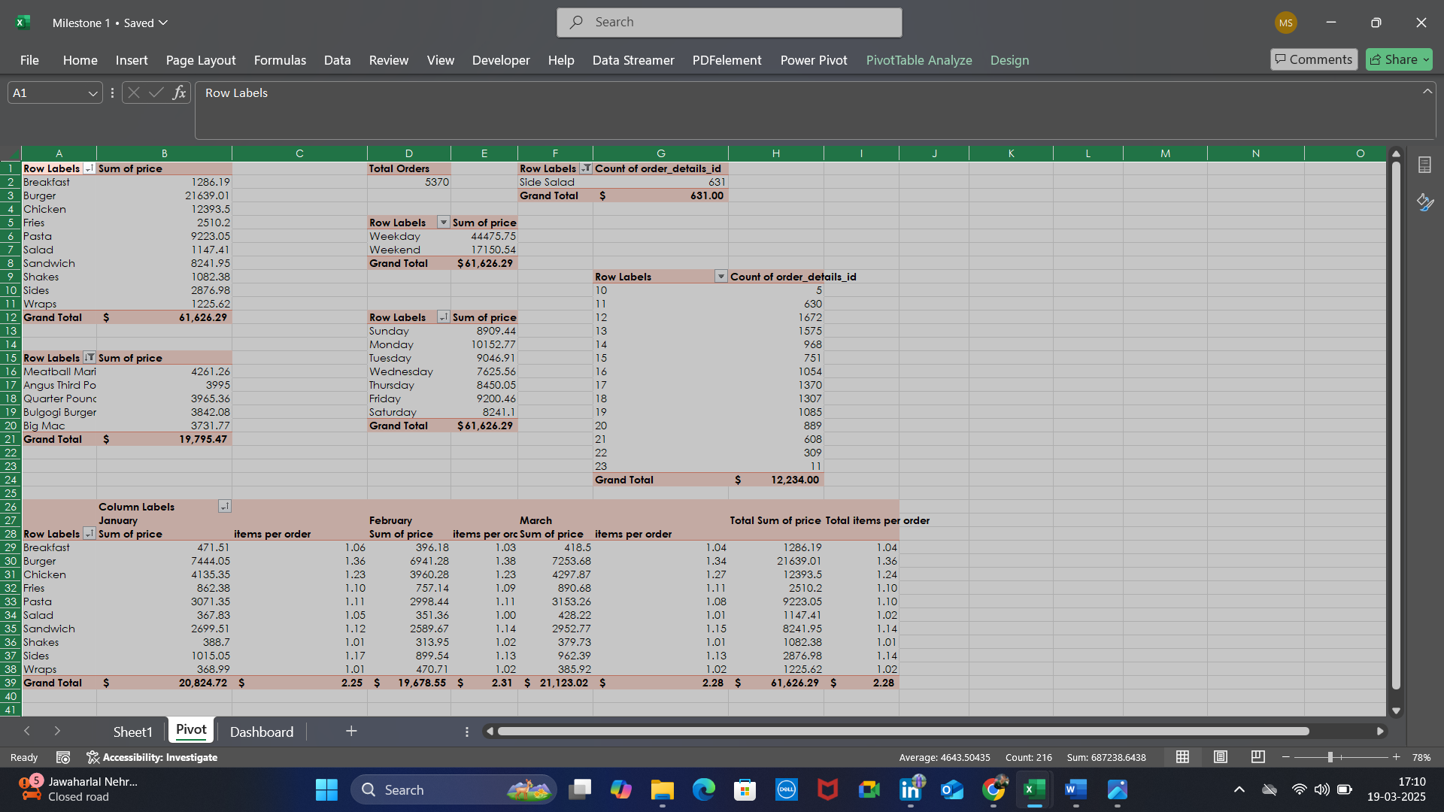

**McDonald's Sales Dashboard – Executive Summary**

**Overview**

The sales dashboard provides a detailed analysis of McDonald's sales performance, including total revenue, order trends, popular items, and sales distribution across different categories and timeframes.

**Key Metrics**

* **Total Revenue:** $61,626.29
* **Total Orders:** 5,370
* **Average Items per Order:** 2.28
* **Most Frequently Ordered Item:** Side Salad

**Sales Performance by Category**

* **Top-Selling Categories:** Chicken, Burger, and Fries generate the highest revenue.
* **Sales by Category Over Time:** Chicken and Burger sales remain consistent across months.

**Top 5 Dishes by Sales**

1. Meatball Marinara
2. Angus Third Pounder
3. Quarter Pounder with Cheese
4. Bulgogi Burger
5. Big Mac

**Order Trends & Customer Behavior**

* **Peak Order Hours:** Highest sales volumes occur between 12 PM and 8 PM, with a notable peak around lunch and dinner hours.
* **Sales by Day Type:**
  + **Weekdays:** $44,475.75
  + **Weekends:** $17,150.54
* **Sales Distribution Across the Week:** Orders remain steady across all days, with no major drop-offs.

**Insights & Recommendations**

* **High Demand for Chicken & Burger:** Focus on promotional offers for these categories to maximize sales.
* **Strong Lunch & Dinner Sales:** Optimize staffing and inventory for peak hours.
* **Side Salad as a Popular Item:** Consider bundle deals with other meals to increase overall order value.
* **Weekend Sales Improvement:** Introduce weekend-specific deals or promotions to increase weekend revenue.

This summary provides a quick yet comprehensive view of McDonald's sales data, offering actionable insights for business growth.