1. Download env1 and unzip where desired
2. Inside scripts I have a testcase file for input
3. Copy path from inside scripts file/ up to scripts. (I set up virtual Python environment, so you do not need to install python on your machine.)

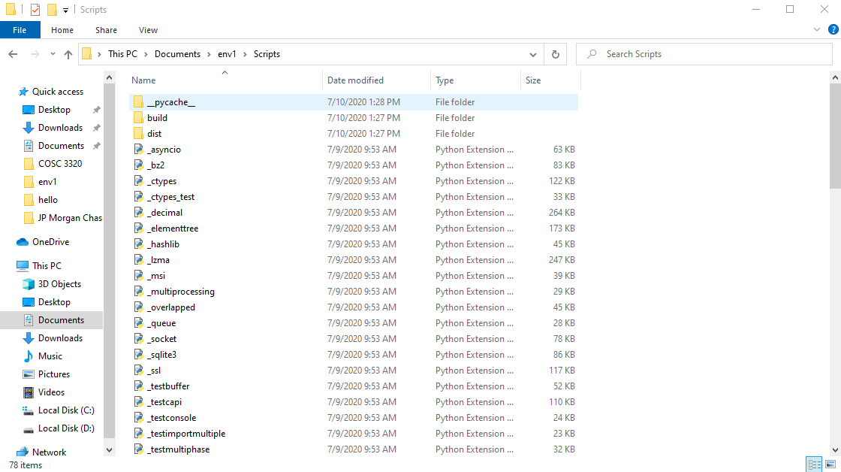

1. Open CMD (Command Prompt)

1. Cd into the file path you copied.

1. Run “python manage.py runserver” on the cmd line

1. After it runs you should see a http link, copy and paste that into your browser for output.

