**GUI GUIDE**

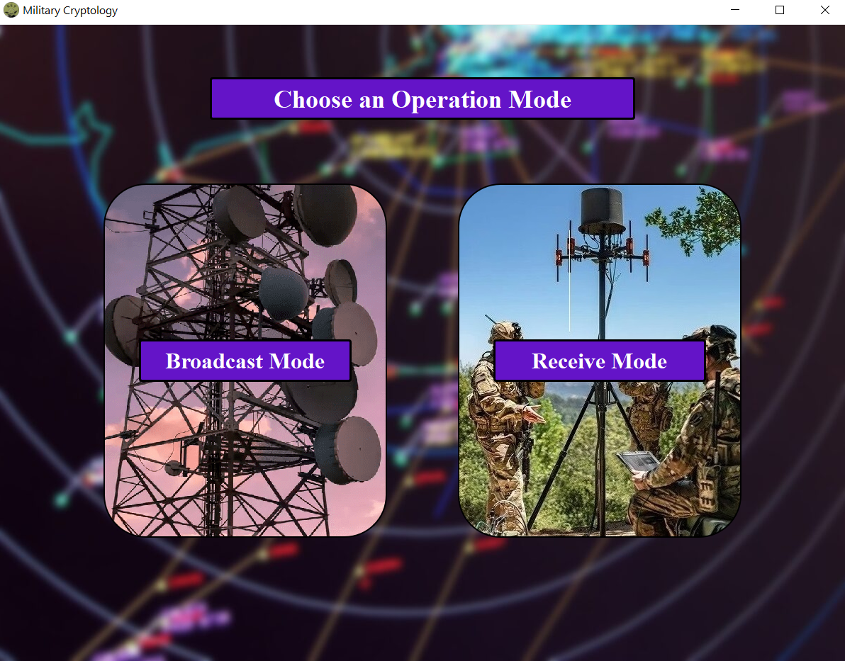

Figure : Startup Window

“Broadcast Mode” is where the keys are generated and written, and the plaintext is encrypted to ciphertext broadcasted.

“Receive Mode” is where the keys are read and, and the ciphertext fetched and is decrypted to plaintext.

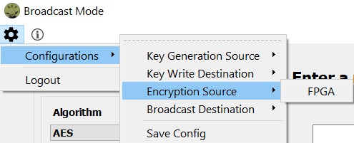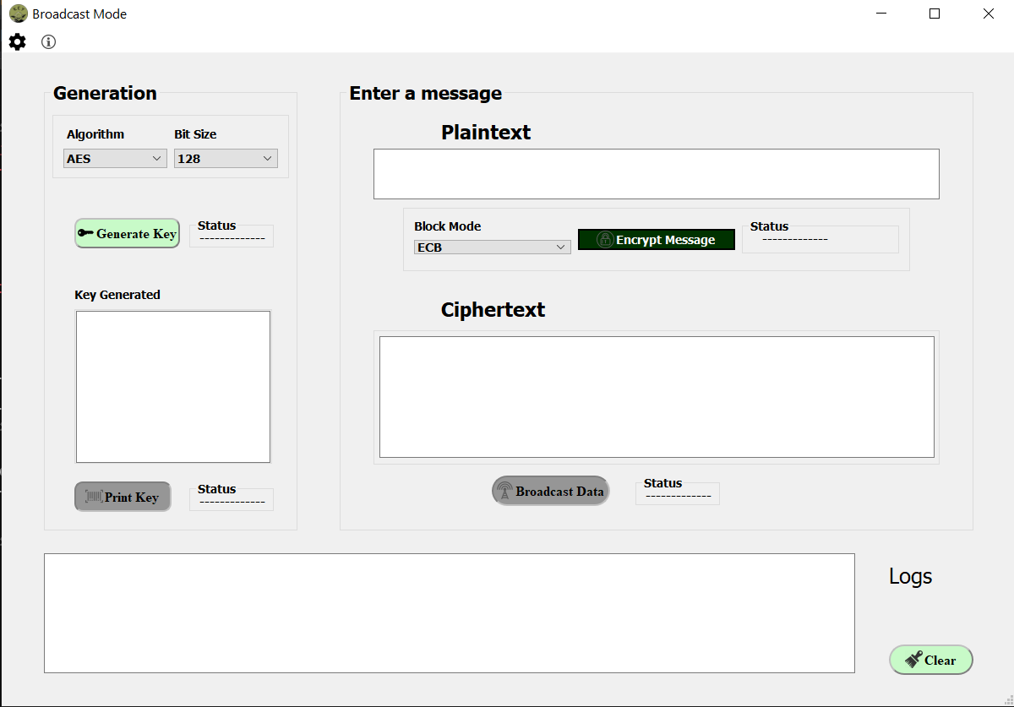I

Figure : Broadcast Mode Window

Figure : Broadcast Mode Settings Section

In the generation section you are to choose one of available algorithms to generate the appropriate key with the bit available bit sizes.

Figure : Successful Key Generation

Once generated you can print the Key either to as key.txt in “Key” folder in the project directory, or onto an RFID tag if available by configuring the “Key Write Destination”.

Figure 5: Successful write key.txt onto folder

Notice the logs indicating the path.

Also notice now the Encrypt Button is enabled.

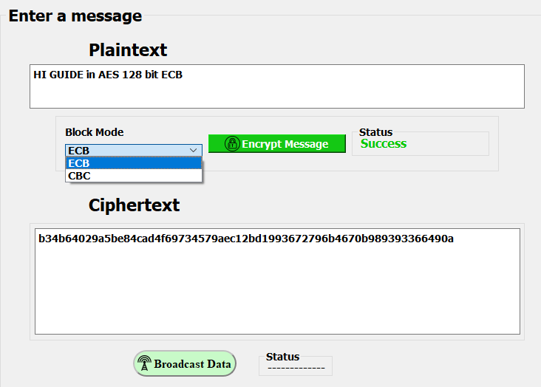Now you can enter the plaintext of your chose and choose a block mode.

Figure : Successful Encrypt

You can even change the encryption source from the settings if the chosen algorithm has an implementation in an FPGA.

Finally, you can broadcast the cipher either by the cloud implemented in the program, or by saving it onto .txt file in

“Data” folder in project directory, and broadcasting by your method of choice.

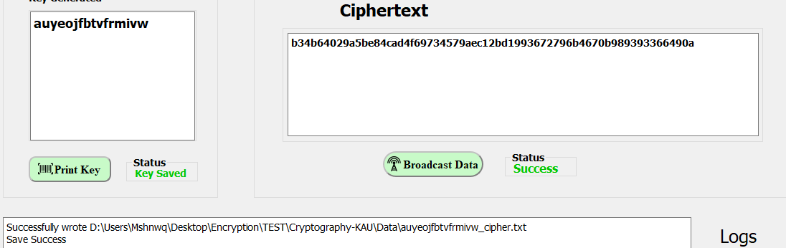

Figure : Saving Cipher.txt onto a folder.

Figure : Receive Mode Window

Figure : Receive Mode Settings Section

Configure your settings here to reflect the broadcast settings.

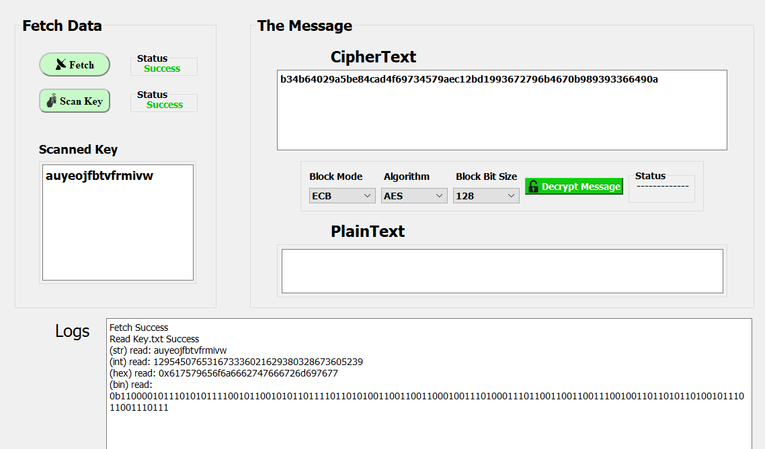Now you are to gather the required inputs depending on your method of broadcast.

Figure : Gathering Success

Finally choose the block mode, block bit size, and algorithm of decryption