- أكتب خوارزمية تصميم تروس أسطوانية متحركة Cycloidal drive

A cycloidal drive or cycloidal speed reducer is a mechanism for reducing the speed of an input shaft by a certain ratio.
The input shaft drives an eccentric bearing that in turn drives the cycloidal disc in an eccentric, cycloidal motion. The perimeter of this disc is geared to a stationary ring gear and has a series of output shaft pins or rollers placed through the face of the disc. These output shaft pins directly drive the output shaft as the cycloidal disc rotates. The radial motion of the disc is not translated to the output shaft. The input shaft is mounted eccentrically to a Rolling-element bearing (typically a cylindrical roller bearing), causing the cycloidal disc to move in a circle.
The cycloidal disc will independently rotate around the bearing as it is pushed against the ring gear. This is similar to planetary gears, and the direction of rotation is opposite to that of the input shaft.
The number of pins on the ring gear is larger than the number of pins on the cycloidal disc. This causes the cycloidal disc to rotate around the bearing faster than the input shaft is moving it around, giving an overall rotation in the direction opposing the rotation of the input shaft.
The cycloidal disc has holes that are slightly larger than the output roller pins that go inside them. The output pins will move around in the holes to achieve steady rotation of the output shaft from the wobbling movement of the cycloidal disc.
The reduction rate of the cycloidal drive is obtained from the following formula, where P means the number of the ring gear pins and L is the number of lobes on the cycloidal disc.
Single stage efficiency approaches 93% and double stage approaches 86%. Single stage reductions are available commercially up to 119:1 and double stage up to 7,569:1
The cycloid disc is usually designed with a shortened cycloid in order to minimize the eccentricity of the disc and the associated unbalance forces at high speeds.[4] For this reason, two cycloid discs are often mounted offset by 180°.

Refrences:
https://www.youtube.com/watch?v=rP4kJjTSm-g
https://www.youtube.com/watch?v=7uXN_y7JdyM
https://en.wikipedia.org/wiki/Cycloidal_drive

- صمم القطع المكونة للتروس الأسطوانية Cycloidal drive gears
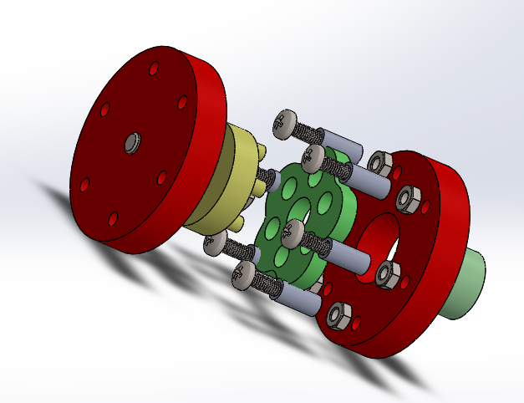

القطعة تم تصميمها في برنامج SOLIDWORKS
The rotational RPM input to output ratio for the specific Cycloidal gearbox is 6:1
Dimension and Equations listed as follow

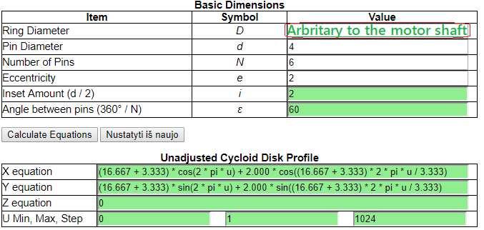

- حدد المحرك المناسب للربط مع التروس الأسطوانية

Motor of choice is the Nema 32 stepper motor, found at https://etqan.sa/product/nema23-stepper-motor

