Student Performance Analytics System
Python with AI — Mini Project Documentation
Student Name: [MOHD SHOAIB]
Student ID / Roll Number: [shoaibwork965@gmail.com]
Department / Class: [Python with AI Batch-2]
Trainer: [CHANDANI]

1. Project Objective
The objective of this project is to build a Python-based Student Performance Analytics System that reads student records, processes marks and attendance, and produces meaningful summaries. It automates total and average calculations, grade assignment, pass/fail checks, subject-wise analysis, class statistics, and identification of top performers.

2. Technologies Used
Python 3, Pandas, NumPy, CSV files, VS Code (or another Python editor), and GitHub.

3. Dataset Description
The sample dataset contains 20 fictional student records. Columns include StudentID, Name, Department, Python, Maths, AI, and Attendance. Subject marks and attendance are represented on a 0–100 scale. The dataset is stored in students.csv.

4. Implementation
- The program imports Pandas and NumPy and reads students.csv into a Pandas DataFrame.
- It checks that required columns exist, the dataset is not empty, and marks/attendance are numeric and between 0 and 100.
- Reusable functions in functions.py assign grades, check pass/fail status, and add calculated columns.
- Pandas calculates total and average marks for each student.
- NumPy calculates overall class average, highest average, and lowest average.
- A loop prints subject-wise statistics. The program also counts pass/fail students, displays the top three performers, and compares subject averages by department.
- The final analyzed DataFrame is saved as student_analysis_results.csv.

5. Grading and Pass/Fail Rules
Grade A: average ≥ 90; Grade B: average ≥ 80 and < 90; Grade C: average ≥ 70 and < 80; Grade D: average ≥ 60 and < 70; Grade F: average < 60.
A student passes only if each subject mark is at least 40 and attendance is at least 75%. These are sample rules and should be adjusted if the trainer specifies another policy.

6. Key Features
- CSV input and data validation
- Total and average marks for each student
- Automatic grade assignment
- Pass/fail classification
- Class and subject-level statistics
- Top-three performer identification
- Department-wise subject averages
- Export of the analyzed dataset

7. Output / Screenshots
After running python main.py, insert screenshots of the terminal output and, if useful, the generated student_analysis_results.csv.

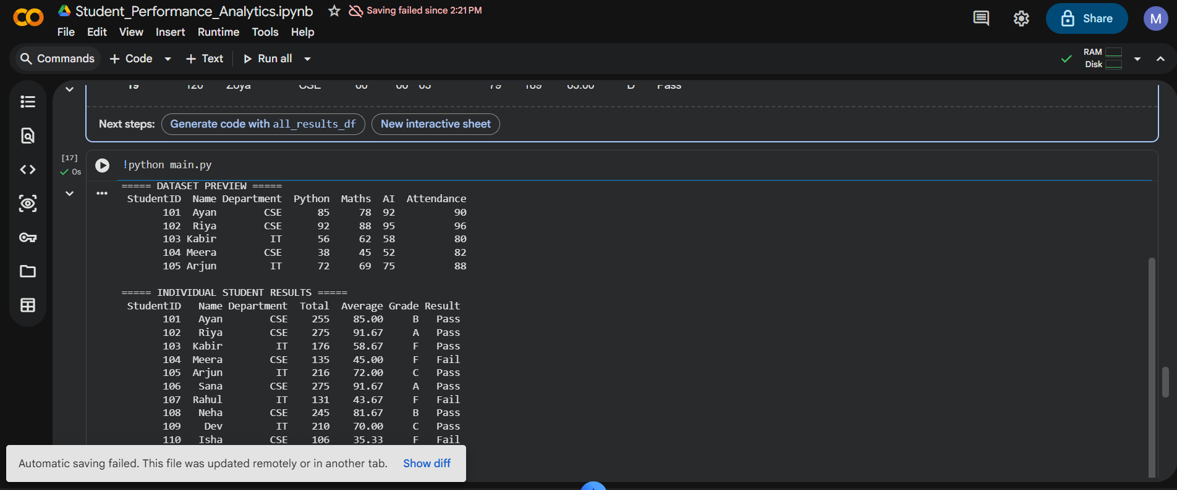

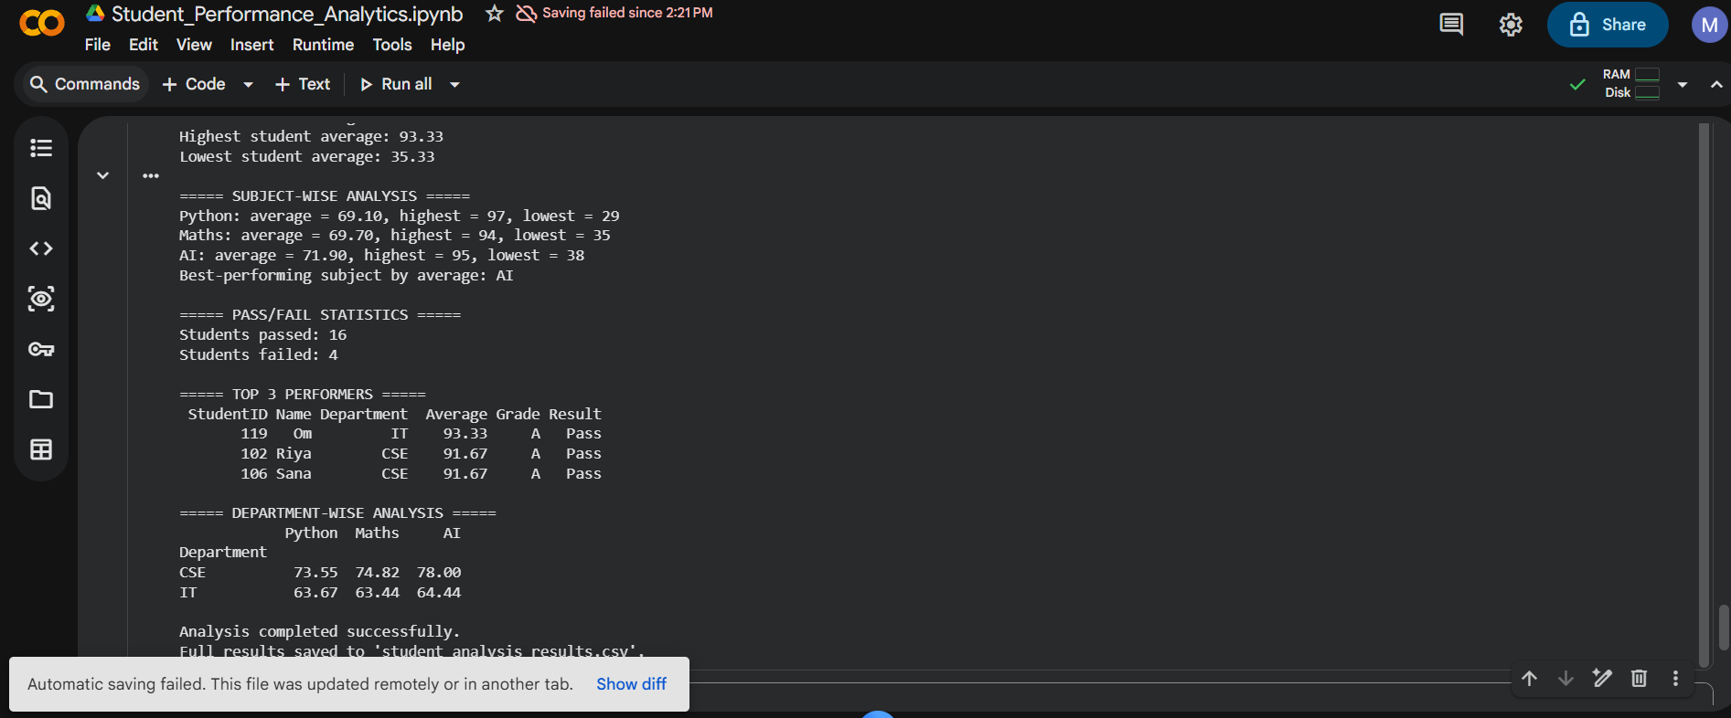

8. Final Outcome
The project demonstrates how Python fundamentals, functions, loops, conditions, Pandas, and NumPy can be combined to automate student performance analysis. It produces a readable terminal report and a CSV file containing the calculated results.

9. Challenges and Learning
Complete this section honestly after testing the project. Example topics include handling CSV files, checking column names and data types, understanding DataFrames, using axis=1, writing reusable functions, and debugging file-path or package-installation errors.

10. GitHub Repository
Repository URL: https://github.com/Mshoaib98/Student-Performance-Analytics-Copy

