STUDENTS DATABASE CRUD APPLICATION
Project Documentation

Submitted by | [MOHD SHOAIB]
Project | Students Database CRUD Application
Technologies | Python, FastAPI, SQLite
Submission date | [26-10-2026]

1. Project Overview
This backend application manages student records through API endpoints to create, view, update, filter and delete records. FastAPI exposes the API and SQLite stores the records.

2. Project Objective
The EWB assignment asks for a Python backend application to manage student records using Create, Read, Update and Delete (CRUD) operations, using FastAPI and SQLite. The optional Ollama AI extension is not required for the core submission.

3. Assignment Requirements and How the Project Addresses Them
Requirement from assignment | How this project addresses it | Screenshot evidence
Create records | POST /students creates a record in SQLite. | Successful POST response
Read records | GET /students lists/filters records; GET /students/{student_id} retrieves one. | List and retrieve responses
Update records | PATCH /students/{student_id} updates selected fields. | Successful PATCH response
Delete records | DELETE /students/{student_id} deletes a record by ID. | Successful DELETE response
Required technology | Python, FastAPI and SQLite are used. | Swagger page and GitHub files
Student fields | Unique ID, name, DOB, email and/or phone; optional course, address and enrollment date. | GET response showing record
Validation and missing records | Input validation and duplicate/missing-record handling. | Optional duplicate-email/404 response
README and dependencies | README.md provides instructions; requirements.txt lists dependencies. | GitHub repository file list
Optional Ollama extension | Not required for the core project; do not claim it is implemented unless tested. | Not required

4. Technologies Used
- Python — backend programming language.
- FastAPI — defines API endpoints and interactive Swagger documentation.
- SQLite — persistent storage for student records.
- Pydantic/FastAPI validation — validates incoming data.
- Uvicorn — runs the FastAPI server.

5. Project Files and Their Purpose
- main.py — main application code: creates the FastAPI app, database setup, data validation and CRUD endpoints.
- requirements.txt — lists the Python packages needed; install using pip install -r requirements.txt.
- README.md — describes the project, prerequisites, installation, run commands and API testing.
- .gitignore — helps prevent generated or local files from being tracked in Git.
- sample_requests.json — contains example API request data for testing.

6. Student Record Fields and Demonstration Data
The assignment requires a unique student ID, name, date of birth and contact information (email and/or phone). Course, address and enrollment date are optional. Use fictional data only; do not upload real student personal information. The application returns/assigns the student ID.
Name | Date of birth | Email | Phone | Course | Address | Enrollment date
Aarav Sharma | 2005-04-12 | aarav.sharma@example.com | 9876500001 | BTech AIML | New Delhi | 2026-08-01
Priya Verma | 2004-09-20 | priya.verma@example.com | 9876500002 | BTech CSE | Faridabad | 2026-08-05
Rahul Singh | 2005-01-15 | rahul.singh@example.com | 9876500003 | BCA | Gurugram | 2026-08-10
Create each record separately using POST /students. If an email already exists, use another unique email.

7. API Endpoints and CRUD Operations
Endpoint | CRUD operation | Purpose
POST /students | Create | Adds a student using a JSON request body.
GET /students | Read | Lists students and supports the filters implemented in the application.
GET /students/{student_id} | Read | Retrieves one record using its actual ID.
PATCH /students/{student_id} | Update | Updates selected fields; send only the fields to change.
DELETE /students/{student_id} | Delete | Deletes a record by ID in the URL; do not paste the creation JSON here.

8. How to Run and Test in Google Colab
- Upload students_crud_project.zip to Colab and extract it to /content/students_crud_project.
- Install dependencies: %cd /content/students_crud_project followed by !pip install -r requirements.txt.
- Start the server with: python -m uvicorn main:app --host 0.0.0.0 --port 8000.
- Open the Colab proxied URL and add /docs to open Swagger UI.
- Use POST /students to create fictional records; use a unique email for each.
- Use GET /students to verify the records and GET /students/{student_id} to retrieve one by its returned ID.
- Use PATCH /students/{student_id} with a small JSON body such as {"course": "Computer Science"}.
- Use DELETE /students/{student_id} with the actual ID in the path. The delete endpoint does not need the full student JSON body.
- Colab servers can stop when the runtime disconnects; restart the server cell when you need to demonstrate it again.

9. Screenshots / Evidence to Insert
Replace each placeholder below with your own clear screenshot. Ensure the endpoint name and response code/result are visible. These screenshots should show actual tests you completed.

Screenshot 1 — Application running
Show the Colab output with the application URL or running server.
[ INSERT YOUR S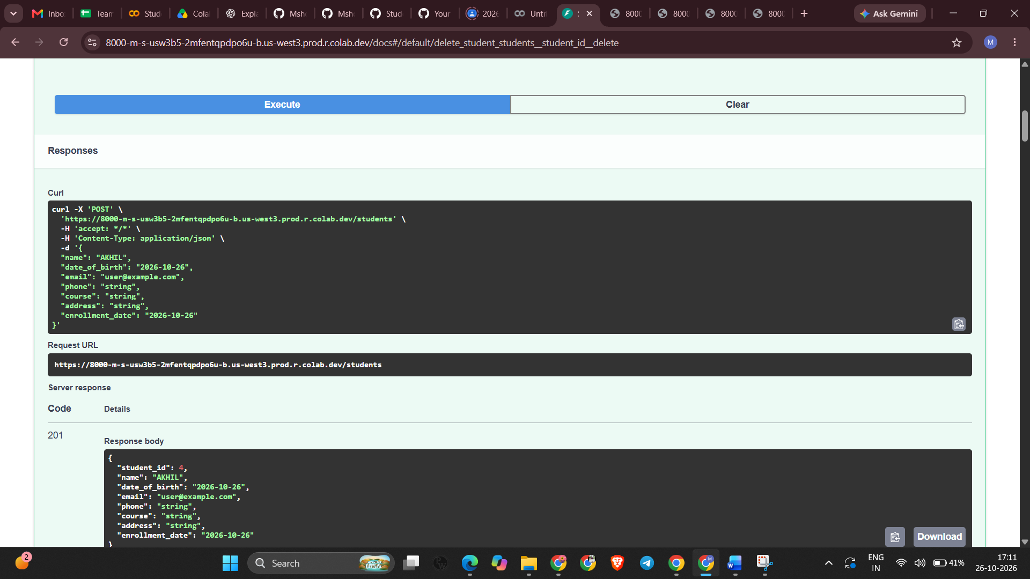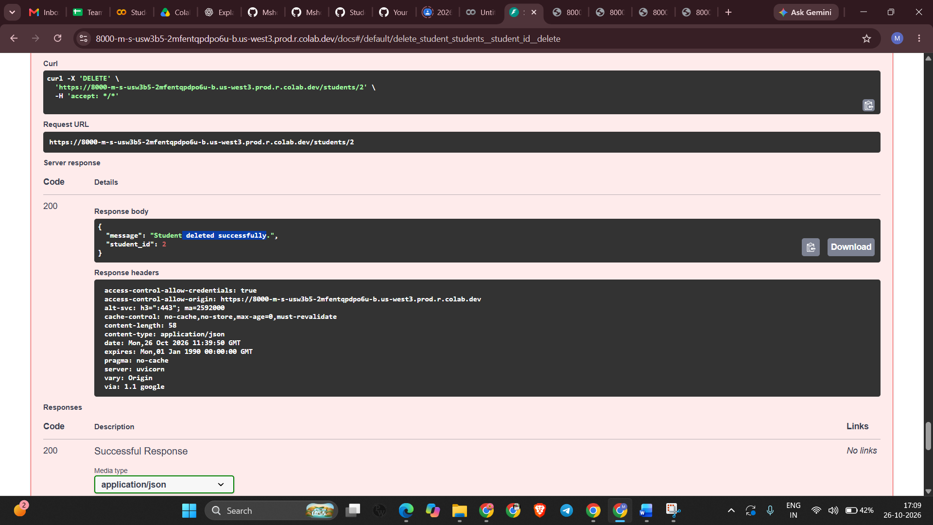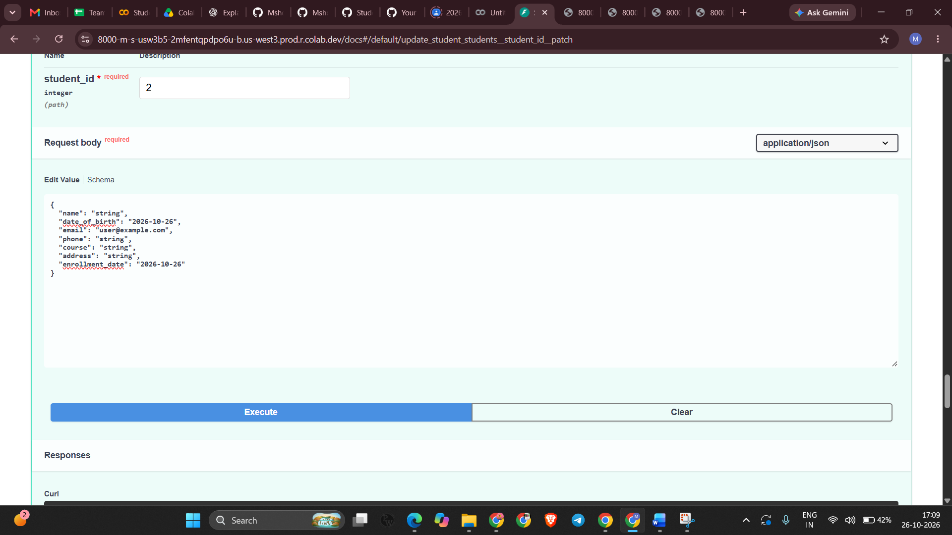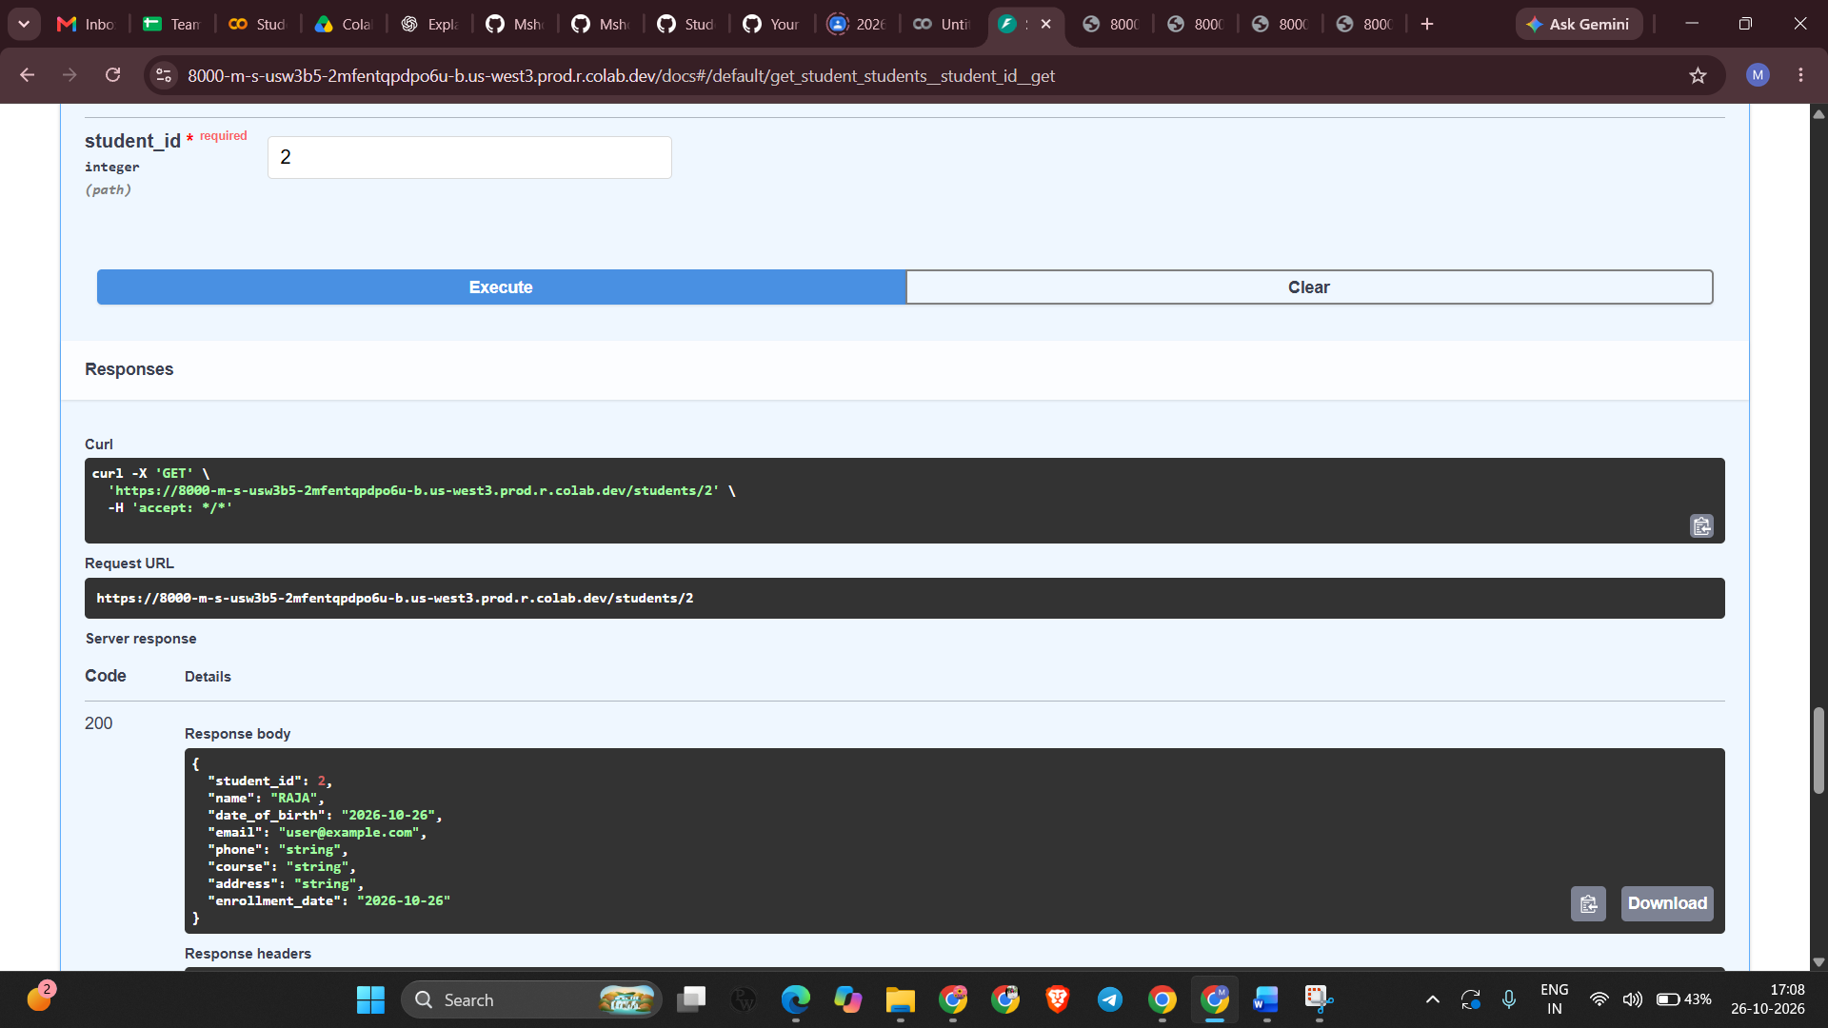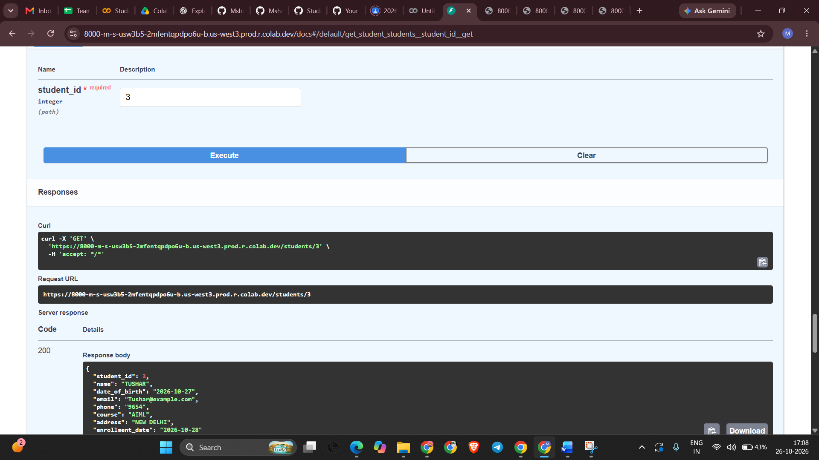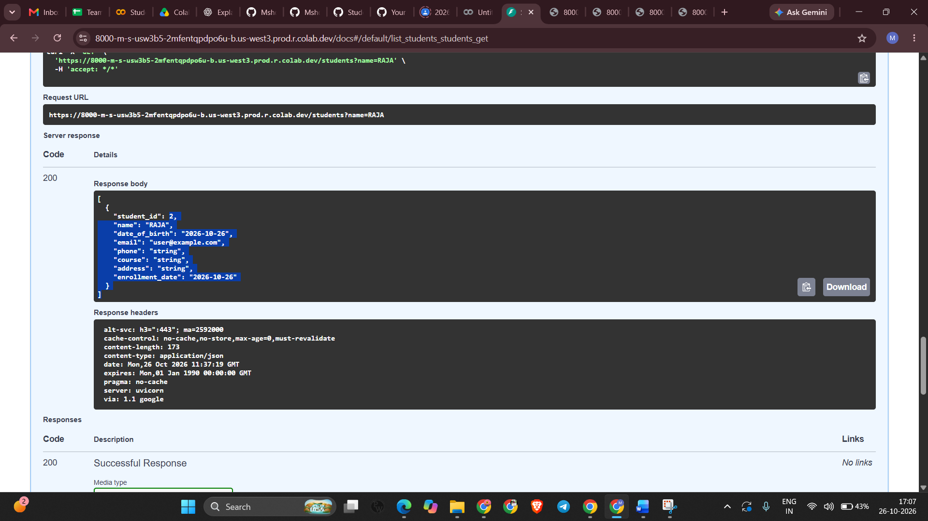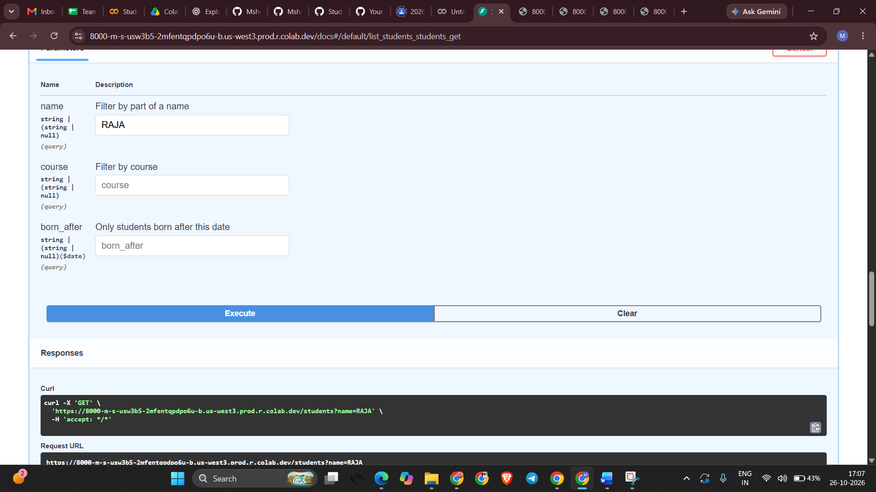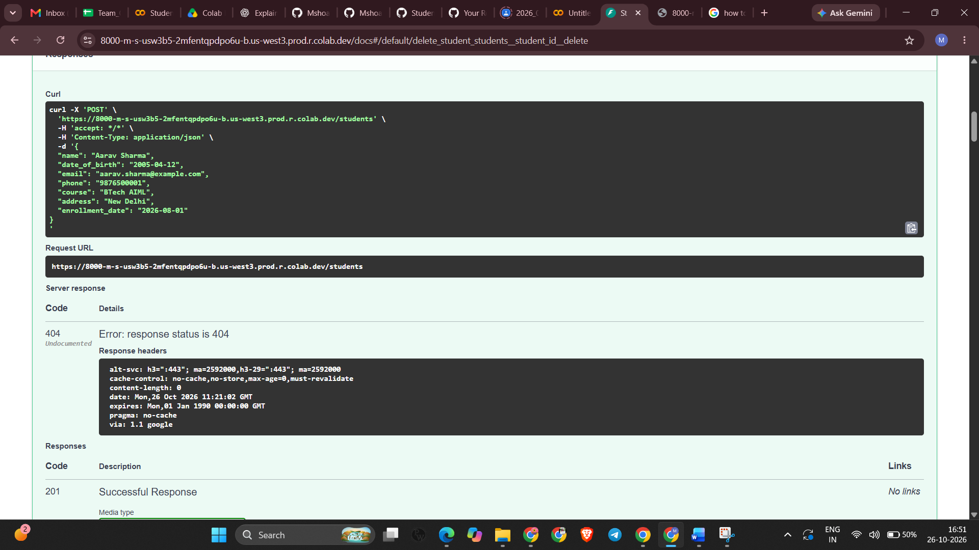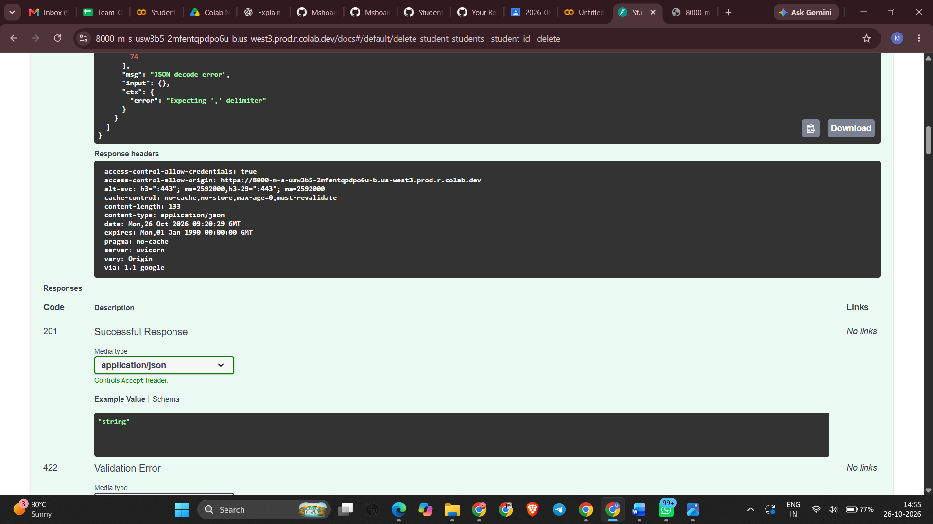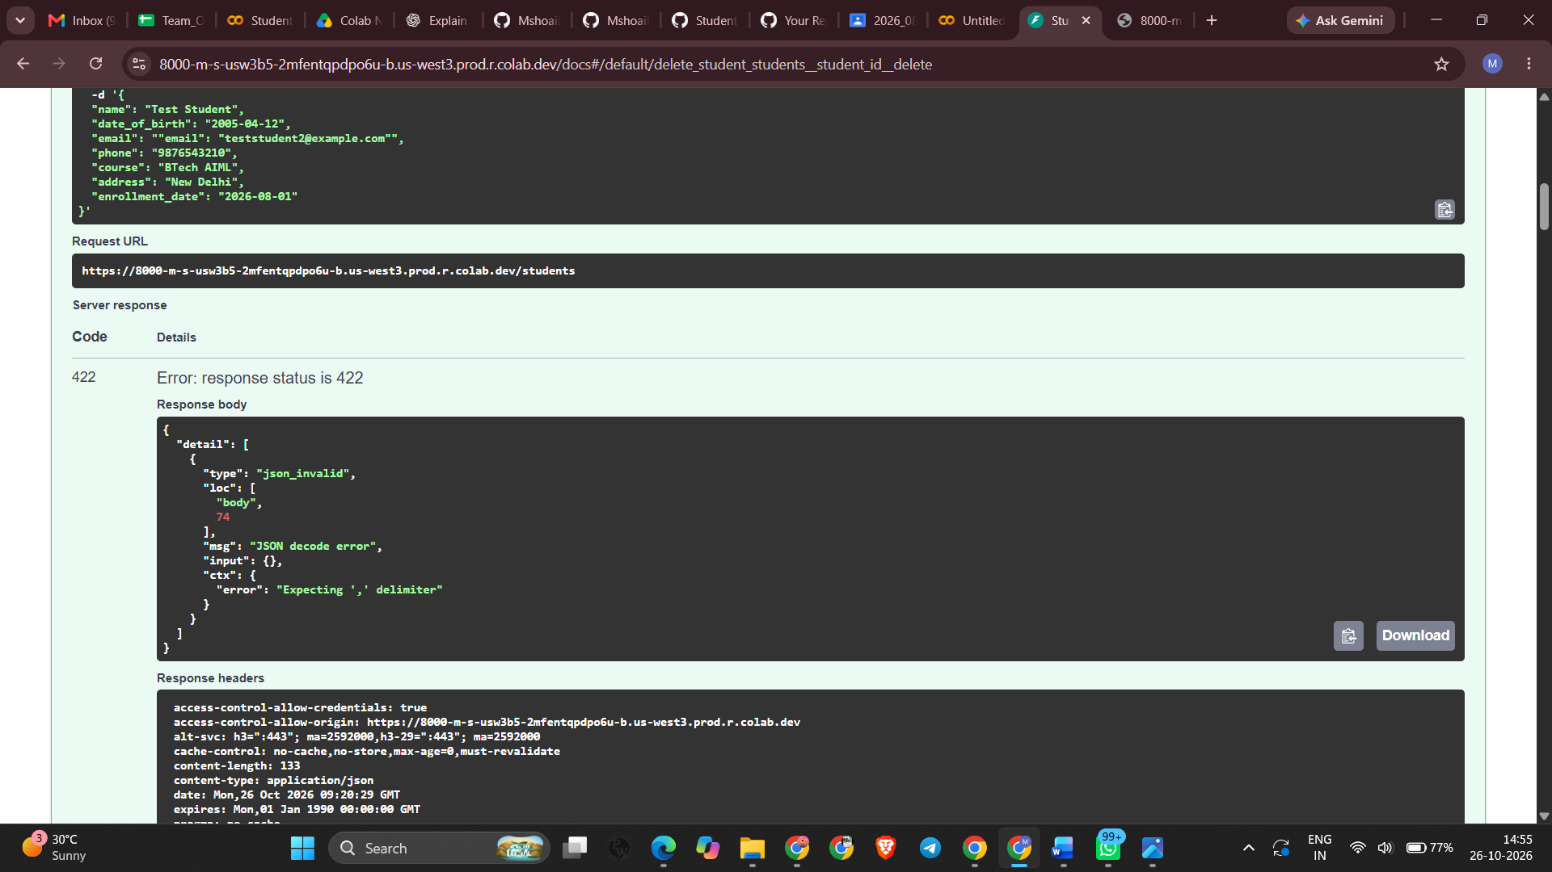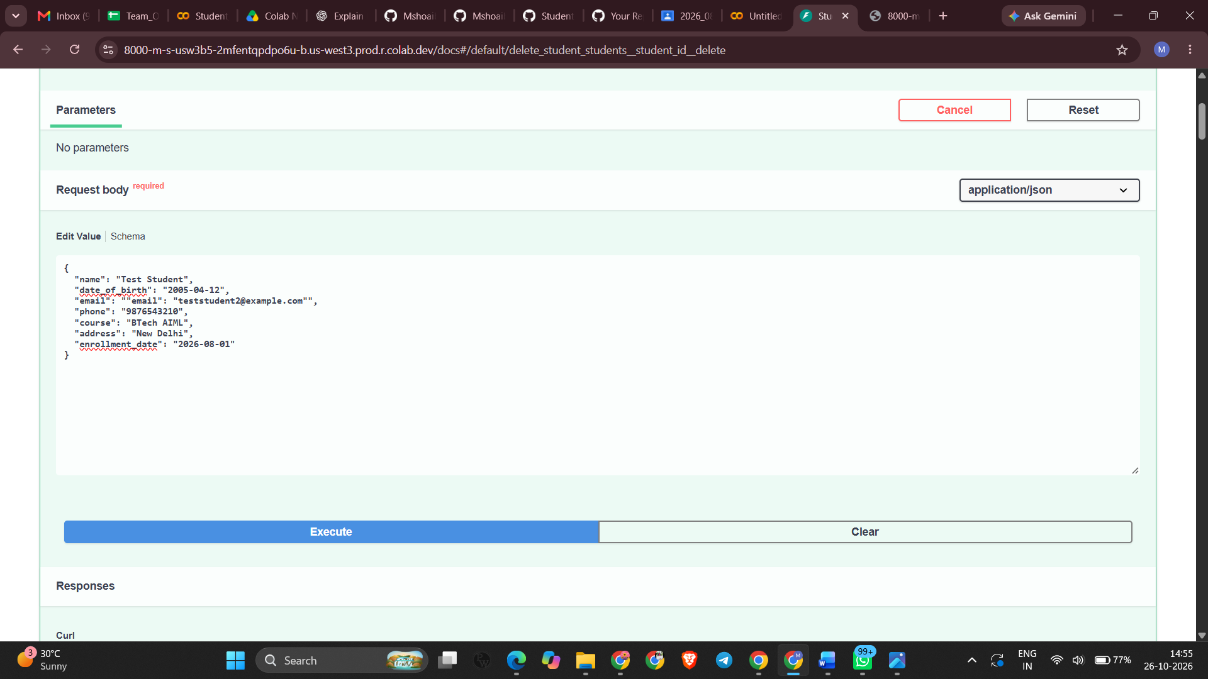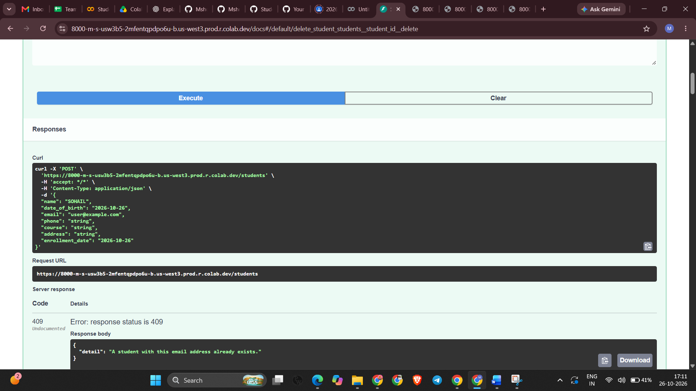CREENSHOT HERE ]

Screenshot — GitHub repository
Show the uploaded files in your repository.
[ INSERT YOUR SCREENSHOT HERE ]

10. Testing Results
Complete the Actual Result column after testing. Mark a test as passed only if you observed the result in Swagger.
Test | Expected result | Actual result
Create student | Record is created and response includes record details/ID. | [Fill after testing]
List students | Created records appear in the list. | [Fill after testing]
Retrieve student | The record matching the supplied ID is returned. | [Fill after testing]
Update student | Selected field changes and can be verified with GET. | [Fill after testing]
Delete student | Record is removed; a later GET by that ID reports not found. | [Fill after testing]
Duplicate email (optional) | Duplicate email is rejected with a conflict response. | [Fill after testing]

11. Why This Project Was Created
The project demonstrates practical backend development: receiving API requests, validating data, storing and retrieving records from a database, updating and deleting records, and handling cases such as duplicate email addresses or a missing student ID.

12. Conclusion
The mandatory project is a Python + FastAPI + SQLite application with CRUD functionality. Before submission, test all four CRUD operations, check that README.md has reproducible instructions, upload the source code and dependencies to GitHub, and submit the GitHub repository link through the channel announced by the EWB trainer. The Ollama extension is optional.

13. GitHub Submission Checklist
- main.py
- requirements.txt
- README.md
- .gitignore
- sample_requests.json
- This documentation with screenshots inserted (if requested by the trainer)
- Submit the GitHub repository URL through the trainer's announced channel

