Assignment - 2

Session 8 – Exploratory

Data Analytics

**5.Problem Statement**

library(RcmdrPlugin.IPSUR)

data(RcmdrTestDrive)

Perform the below operations:

1. Compute the measures of central tendency for salary and reduction which variable has highest center?

Ans:

library(RcmdrPlugin.IPSUR)

> x<- c(mean(RcmdrTestDrive$salary),median(RcmdrTestDrive$salary))

> x

[1] 724.5164 710.1500

> y<- c(median(RcmdrTestDrive$reduction),mean(RcmdrTestDrive$reduction))

> y

[1] 139.500 223.631

> library(psych)

> kurtosi(RcmdrTestDrive$salary)

[1] 0.2006576

> kurtosi(RcmdrTestDrive$reduction)

[1] 10.01655

> x<-RcmdrTestDrive$salary

> h<-hist(x,breaks=10,col="red",xlab="salary",main="histogram of salary with normal curve")

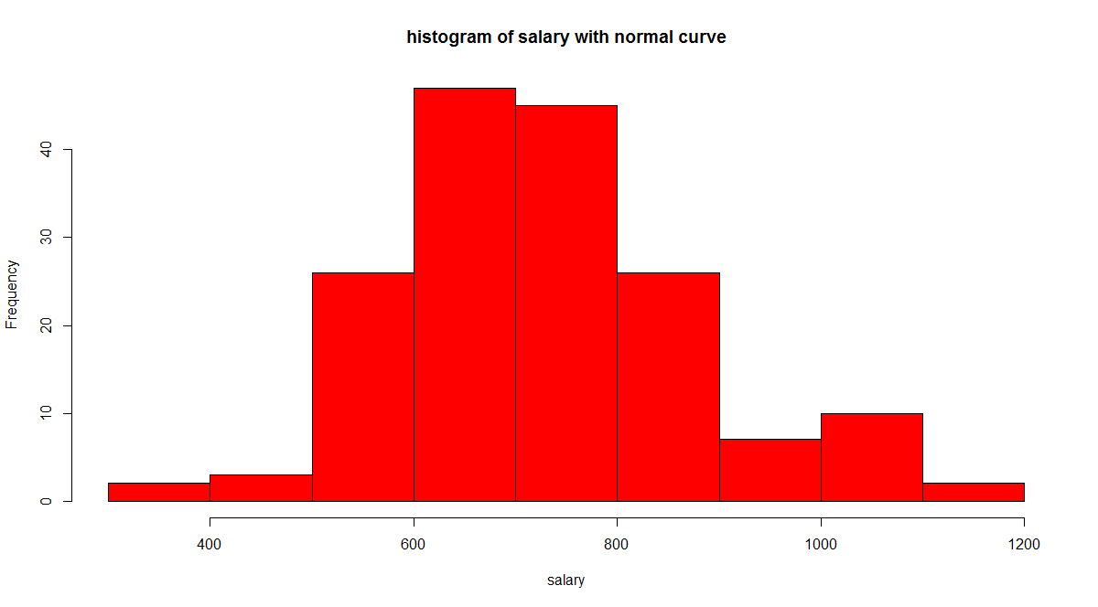

> y<-RcmdrTestDrive$reduction

> h<-hist(y,breaks=10,col="blue",xlab="reduction",main="histogram of reduction with normal curve")

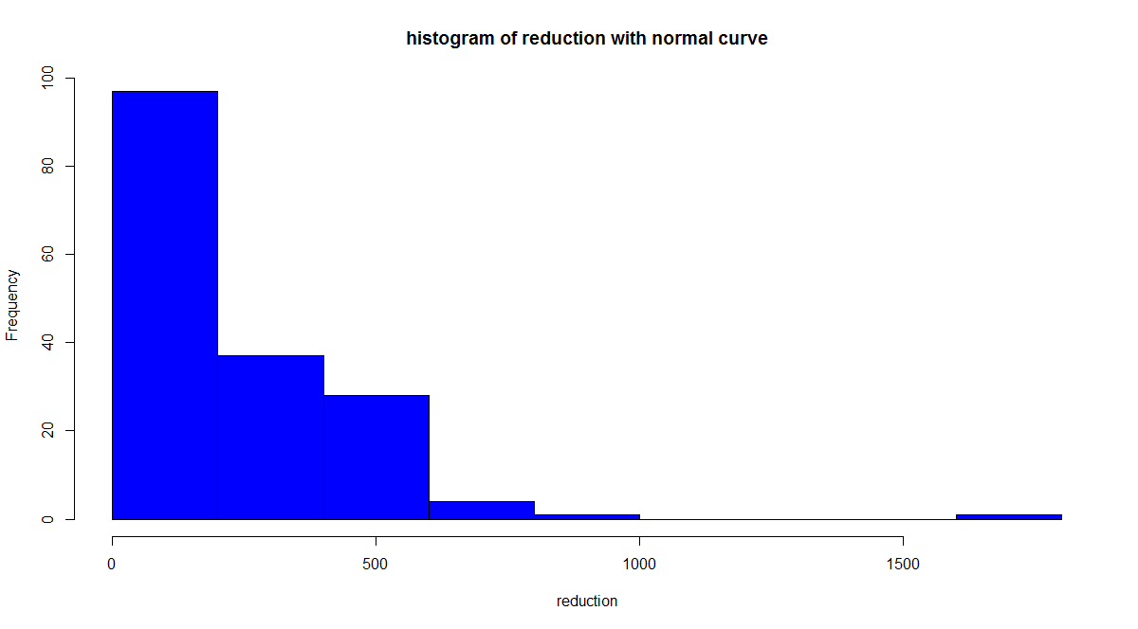

2. Which measure of center is more appropriate for before and after?

Ans:

> #by boxplot we can check for median where it lies

> boxplot(RcmdrTestDrive$before,horizontal=T,col="red",xlab="before",ylab="Boxplot")

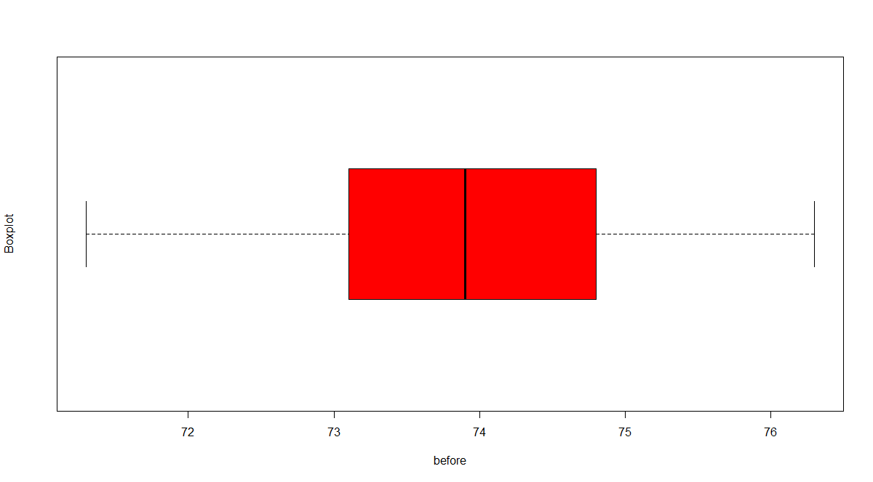

> boxplot(RcmdrTestDrive$after,horizontal=T,col="red",xlab="after",ylab="Boxplot")

> #if we check the skewness of variables

> skew (RcmdrTestDrive$before)

[1] -0.03510369

> skew (RcmdrTestDrive$after)

[1] -1.164056

