CLOUD DATA ENGINEER ASSESSMENT

SECTION A: ADVANCED SQL
Question 1: Database Design and Advanced Queries
(a) Display employee, department and manager names
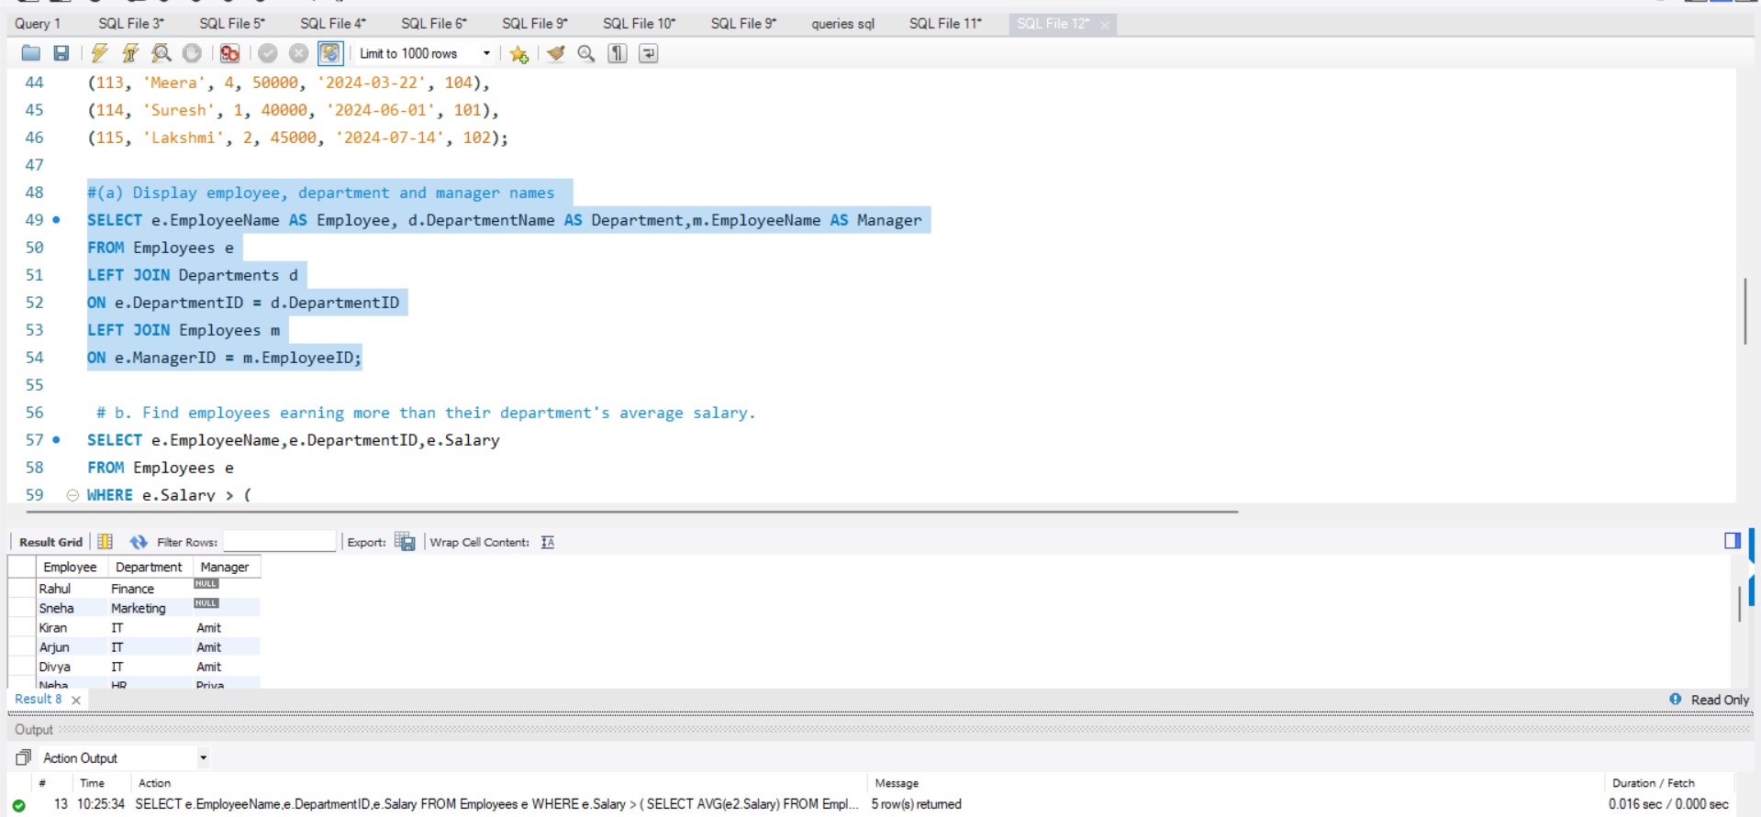

b. Find employees earning more than their department's average salary.
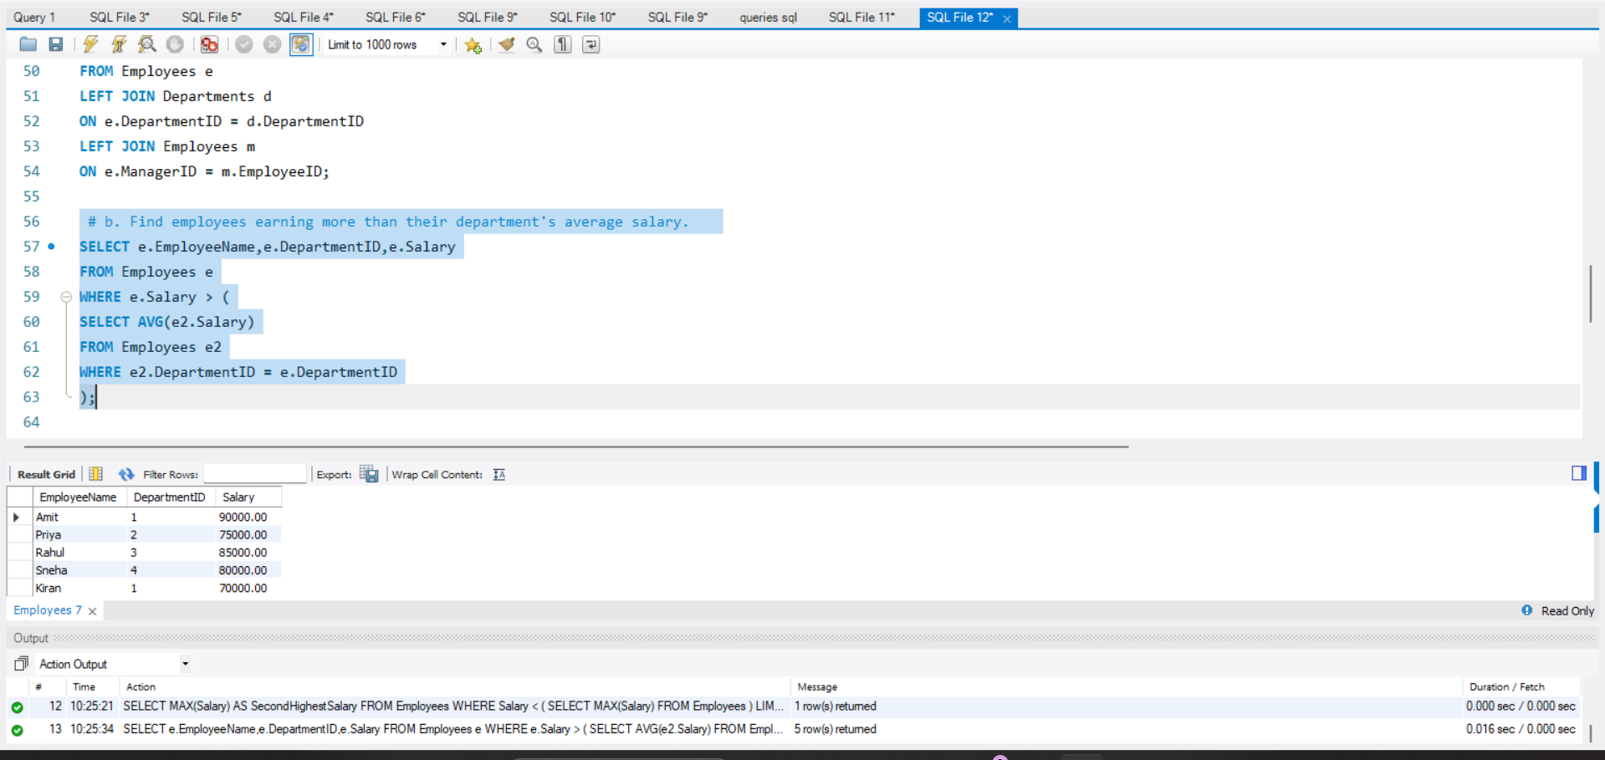

c. Find the second-highest distinct salary without using LIMIT, TOP, or FETCH FIRST.
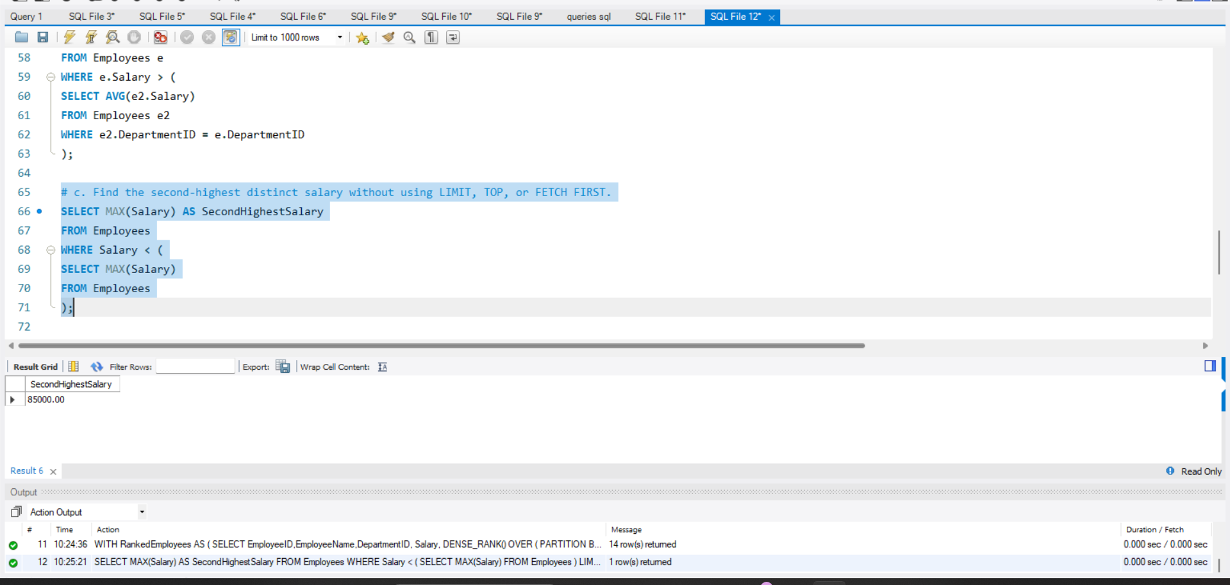

d. Rank employees by salary within each department and display the top three employees per department, retaining ties at the cutoff.
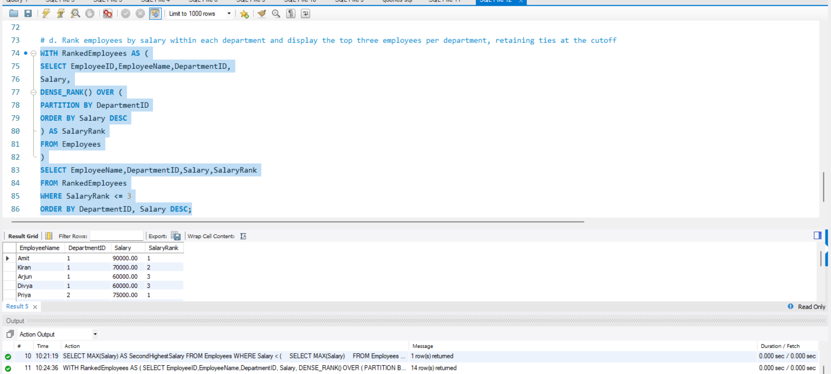

Question 2: Sales Analytics and Query Optimization
a. Calculate total revenue for each product.
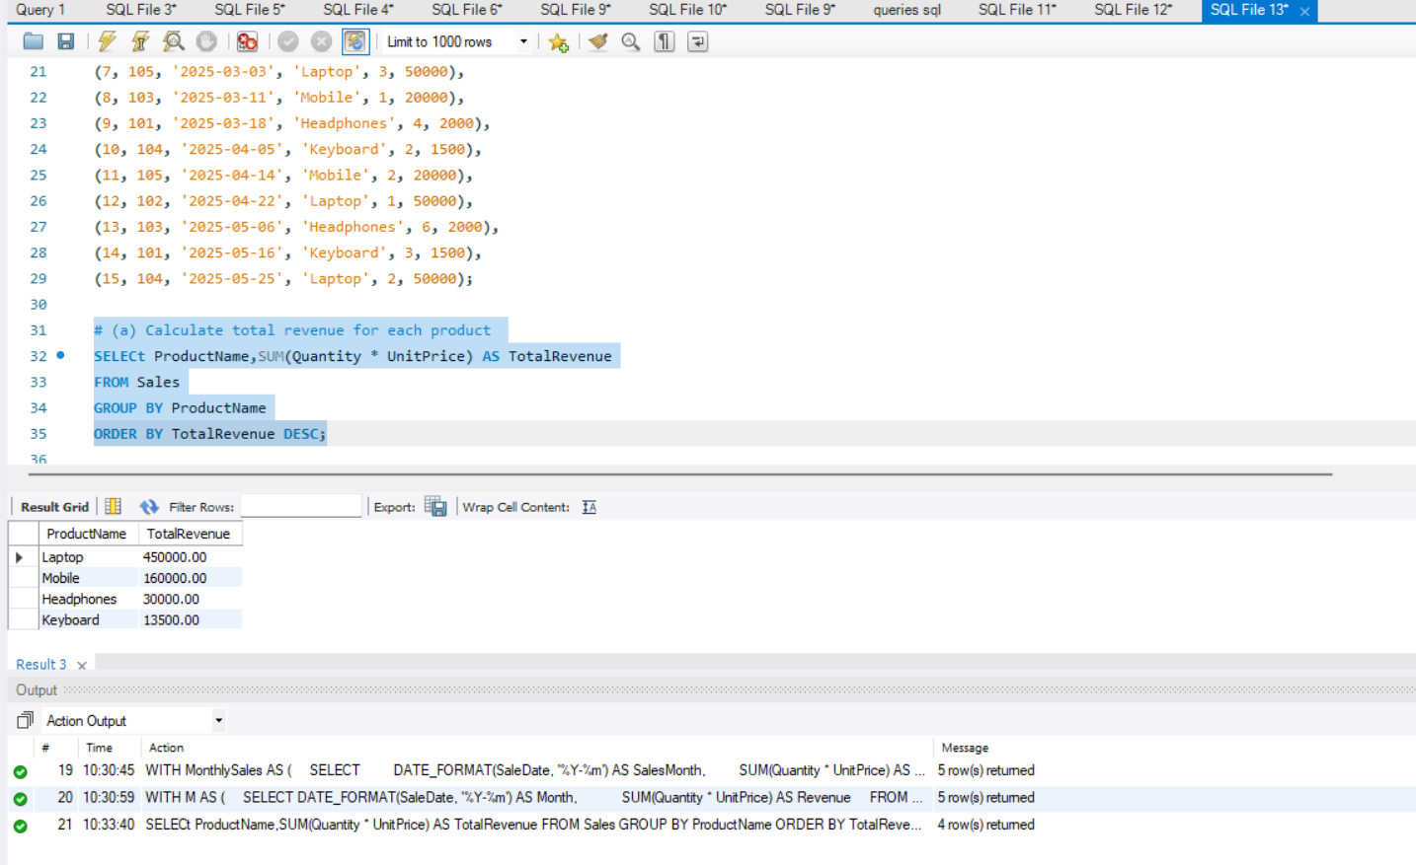
b. Calculate monthly revenue and month-over-month revenue change using a window function. (2 marks)
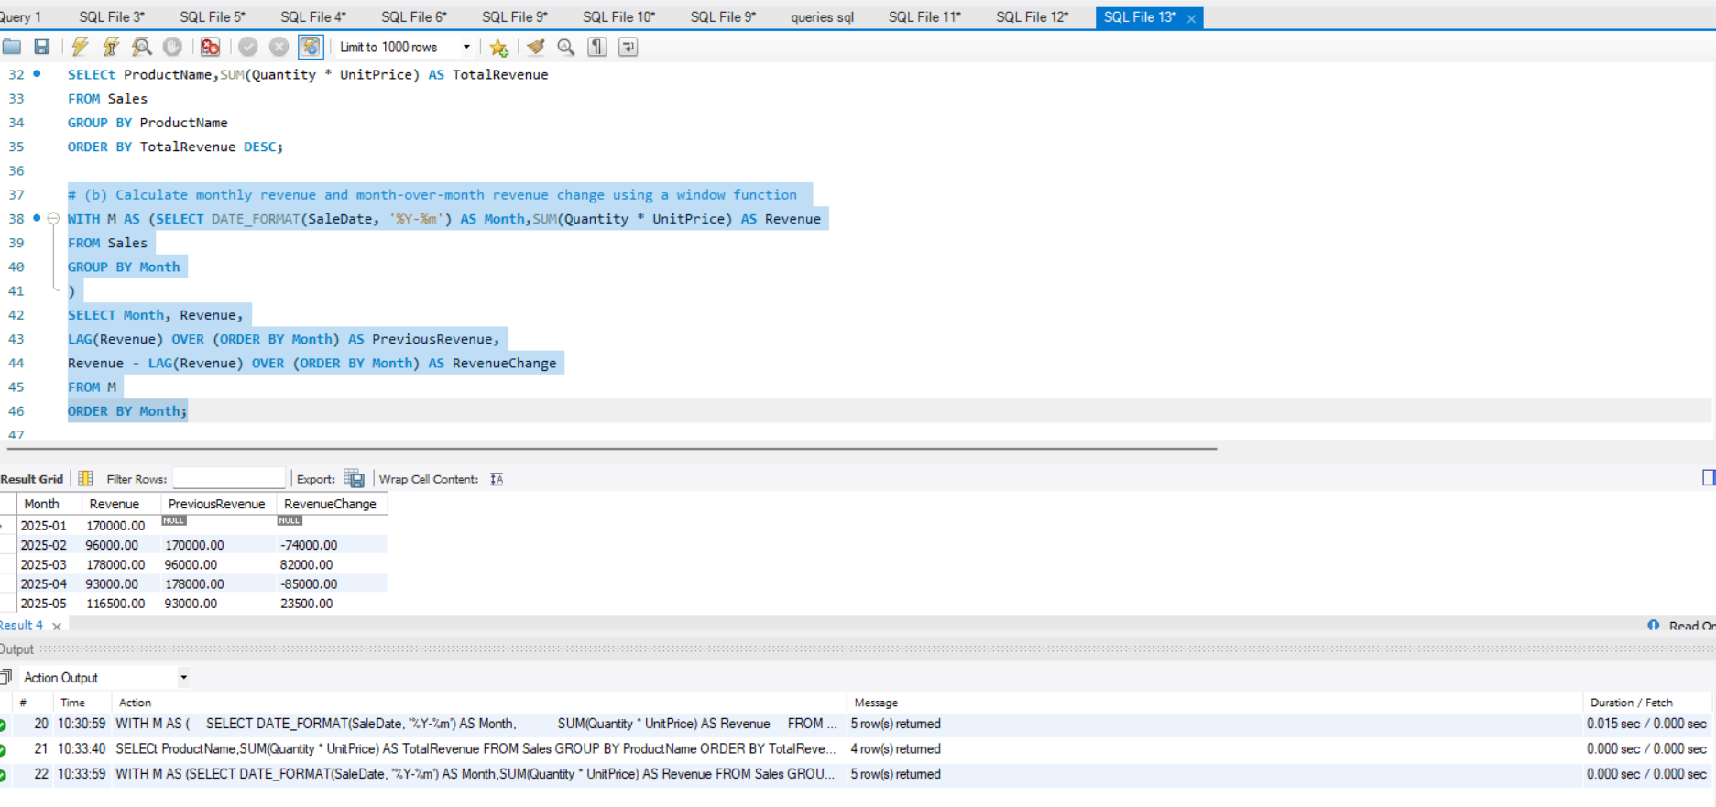

c. Rewrite the following query to improve the potential for index usage and explain why your version may perform better.
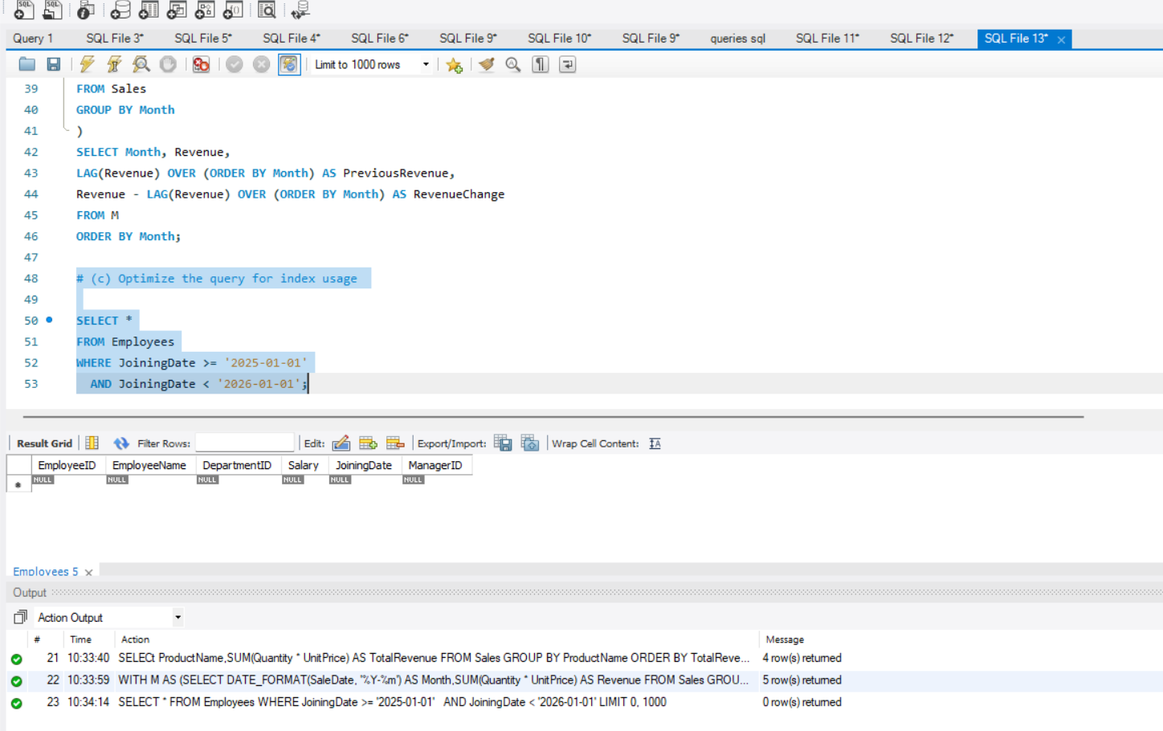

Question 3: SQL Troubleshooting
(a) Explain how an execution plan helps identify expensive operations in a query.
An execution plan shows how the database executes a SQL query and helps identify performance.
- It provides estimated or actual row counts and costs to help optimize the query.
Ex:
EXPLAIN
SELECT *FROM Employees
WHERE DepartmentID = 1;
Explanation: EXPLAIN shows how MySQL plans to execute the query and whether an index can be used.

(b) Recommend an appropriate index strategy for DepartmentID and Salary.
EX:
CREATE INDEX idx_dept_salary
ON Employees (DepartmentID, Salary);
Quary :
SELECT *FROM Employees
WHERE DepartmentID = 1
AND Salary > 50000;
- DepartmentID is the first column, so the index supports filtering by department.
- Salary is the second column, supporting salary range filtering within a department.
- A composite index can reduce the no of rows examined and improve query performance.

(c) Identify duplicate customer email addresses occurring more than once.
SELECT Email, COUNT(*) AS Total
FROM Customers
GROUP BY Email
HAVING COUNT(*) > 1;
- GROUP BY Email groups records with the same email address.
- COUNT(*) counts occurrences of each address.
- HAVING COUNT(*) > 1 displays only duplicate email addresses.

SECTION B: LINUX
Question 4: Log Analysis
(a) Find all lines containing ERROR:
grep "ERROR" /var/log/application.log
(b) Display the 20 most recent error entries
grep "ERROR" /var/log/application.log | tail -n 20
(c) Count the total number of error entries
grep -c "ERROR" /var/log/application.log
(d) Extract error entries for a specified date into a separate file
grep "2026-10-28" /var/log/application.log | grep "ERROR" > errors_2026-10-28.log
(e) Calculate the number of errors occurring in each hour
grep "ERROR" /var/log/application.log |
awk '{print substr($2,1,2)}' |
sort | uniq -c
- awk extracts the hour from the timestamp (for ex, 10 from 10:15:23).
- sort groups identical hours together.
- uniq -c counts the errors for each hour.

Question 5: Permissions and System Troubleshooting
a) Create a group named finance and a report file
sudo groupadd finance
sudo touch financial_report.txt
- roupadd creates the group, and touch creates the report file.
(b) Set the required permissions
CMD :
sudo chown "$USER":finance financial_report.txt
chmod 640 financial_report.txt
(c) Identify processes consuming the most CPU
CMD : ps aux --sort=-%cpu | head
(d) Display memory usage and filesystem disk utilization
free -h : displays memory usage
df -h : displays filesystem disk space
(e) Find files larger than 100 MB under an application directory
CMD : find /var/www/app -type f -size +100M

Question 6: Bash Scripting
Create the script file : nano backup_check.sh
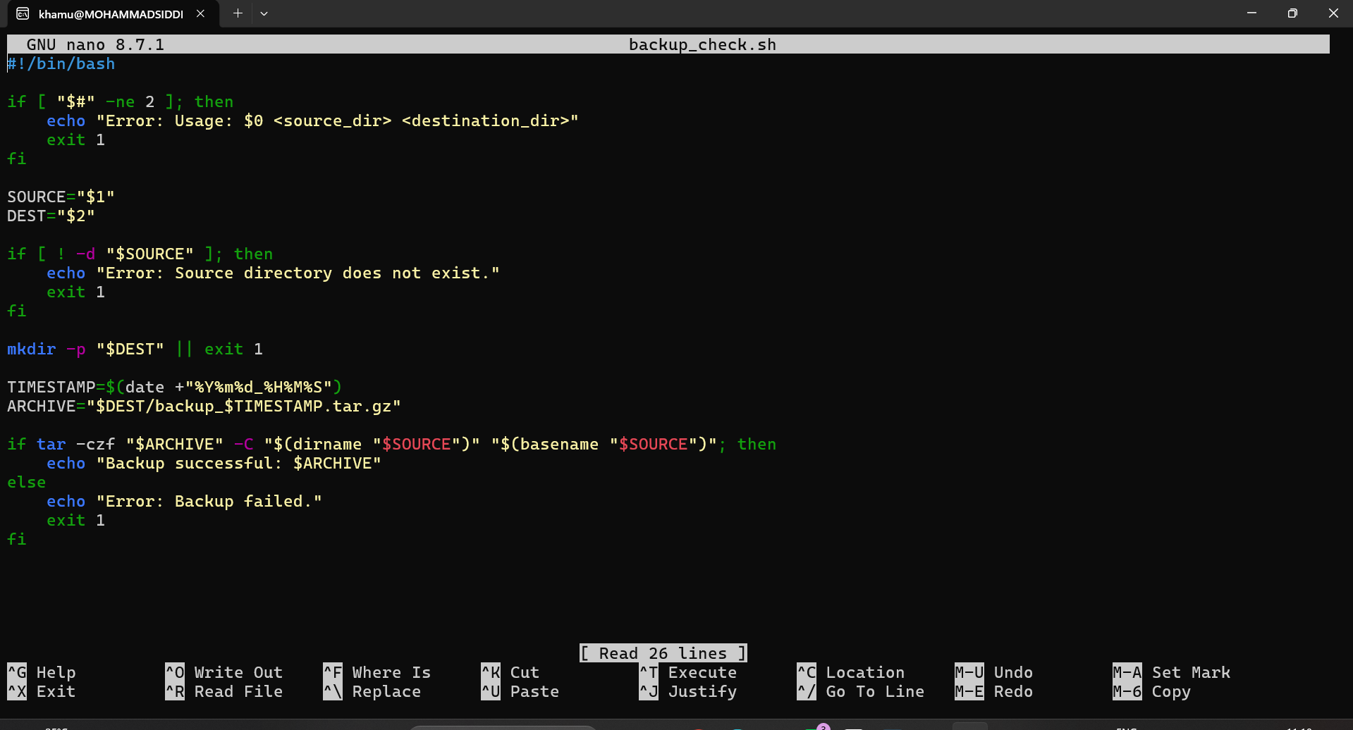
UBUNTU TERMINAL OUTPUTS:
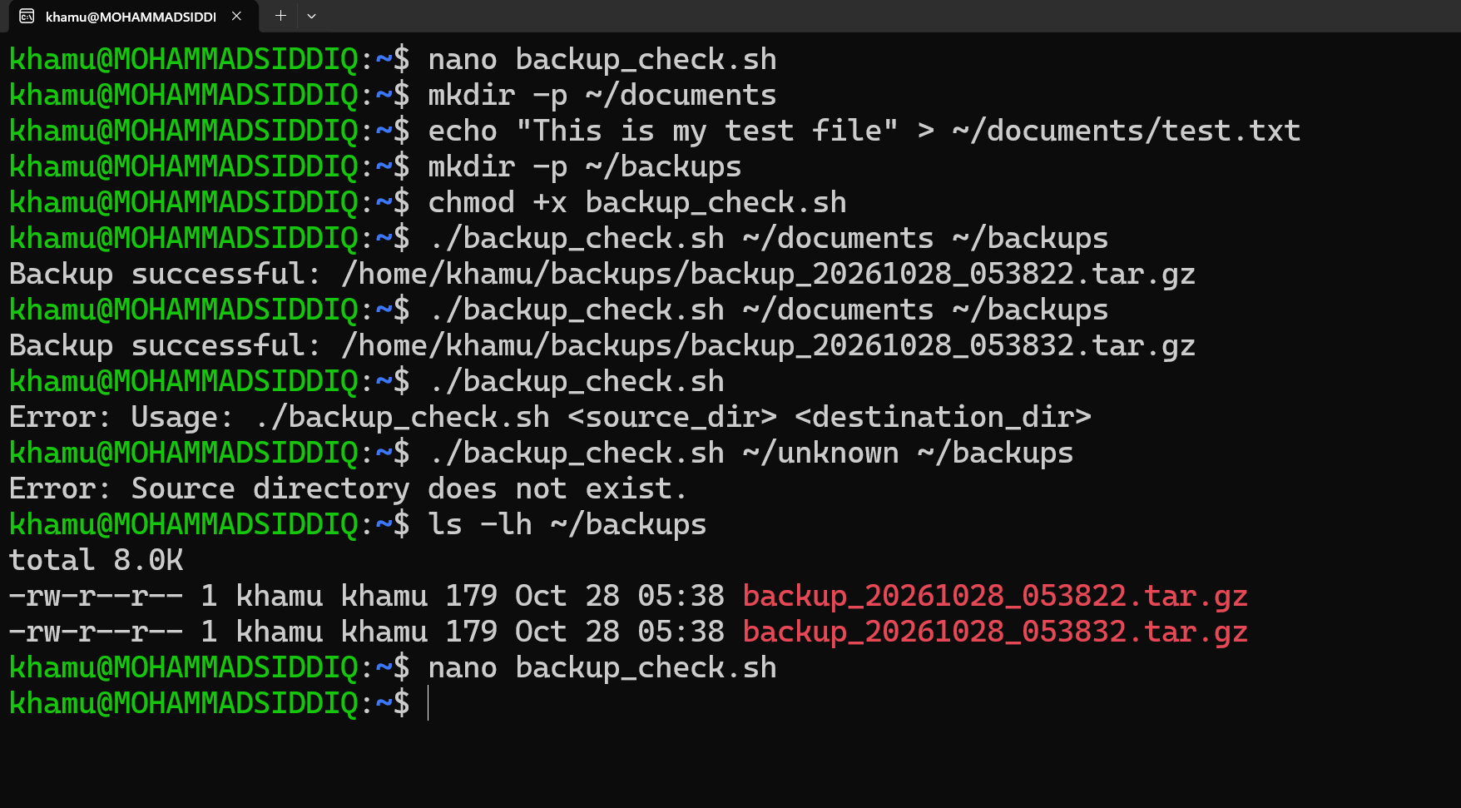
Output: Backup successful
Error: Usage
SECTION C: PYSPARK DATA ENGINEERING
Question 7: PySpark DataFrame Operations
Create a PySpark DataFrame
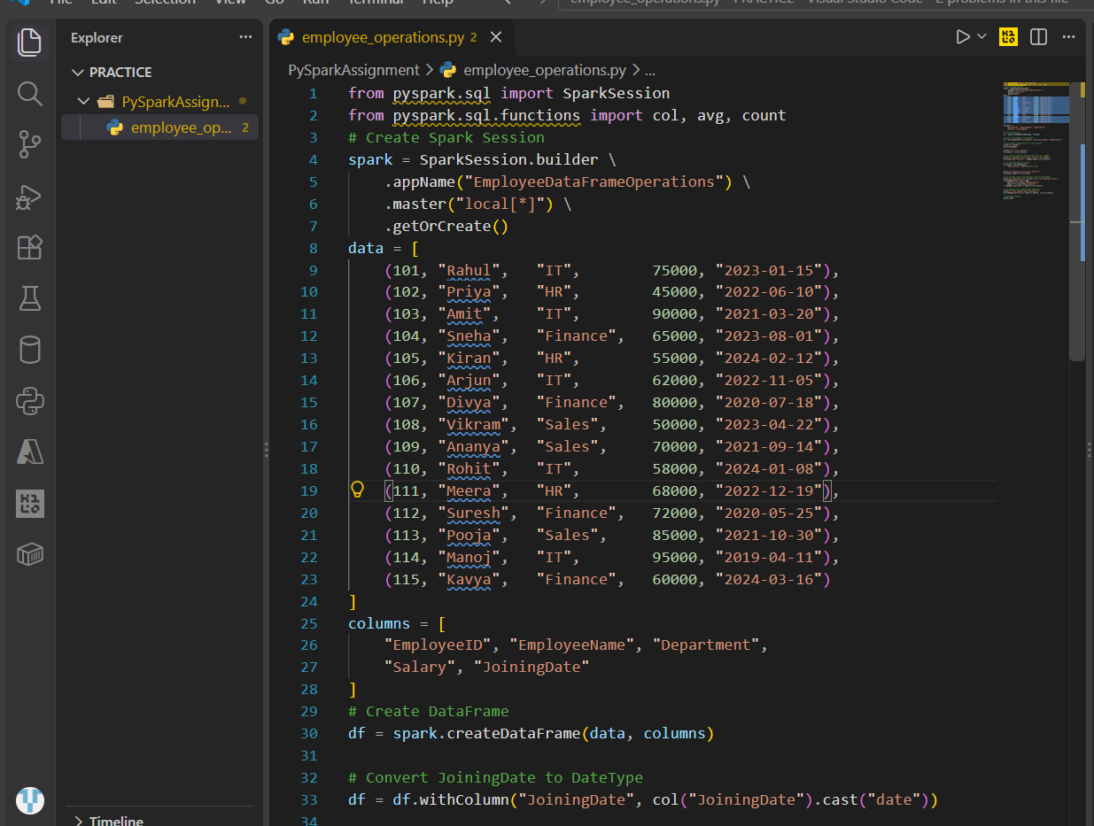
a. Display the schema and first five records.
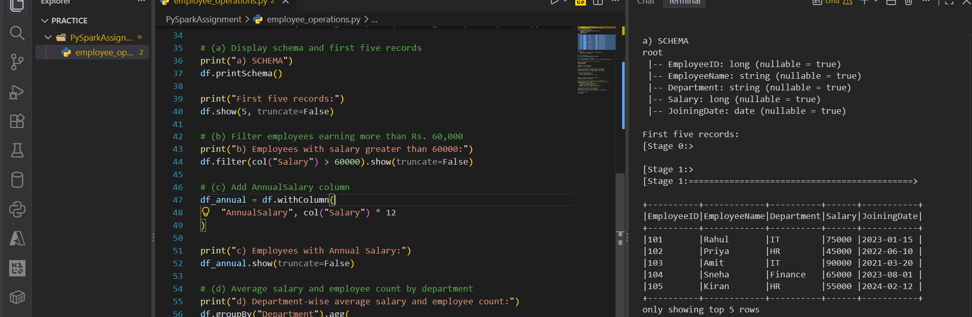
b. Filter employees whose monthly salary is greater than ₹60,000.
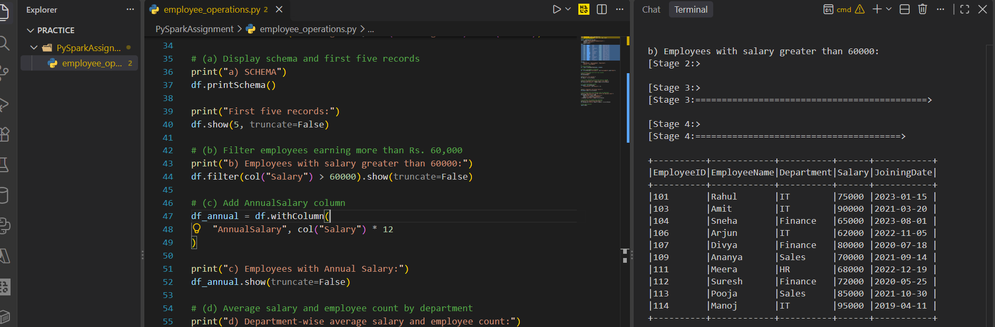
c. Add an AnnualSalary column calculated from the monthly salary
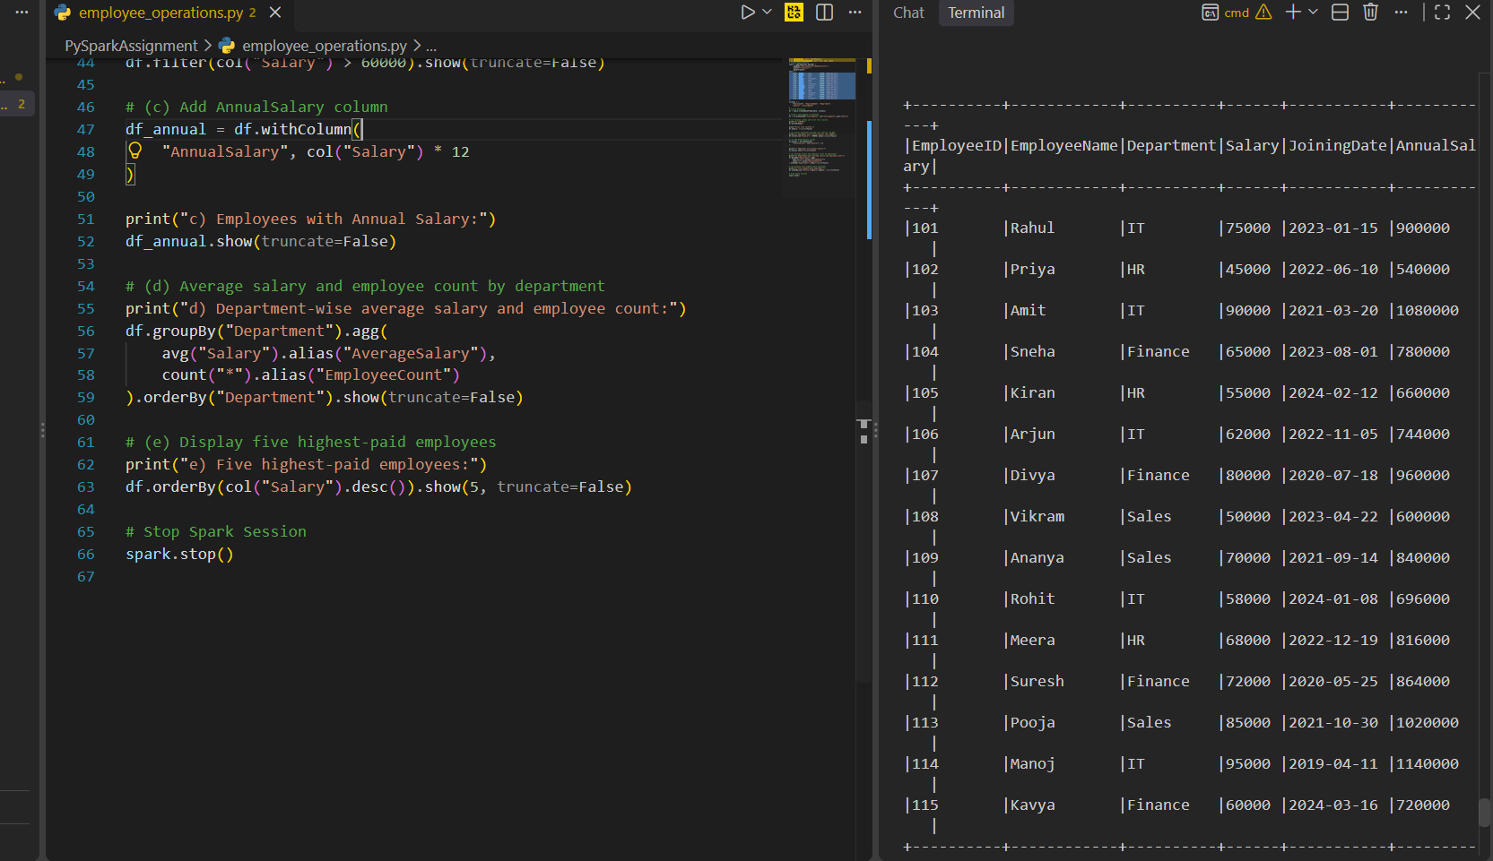
d. Group employees by department and calculate the average salary and employee count. &
e. Display the five highest-paid employees.
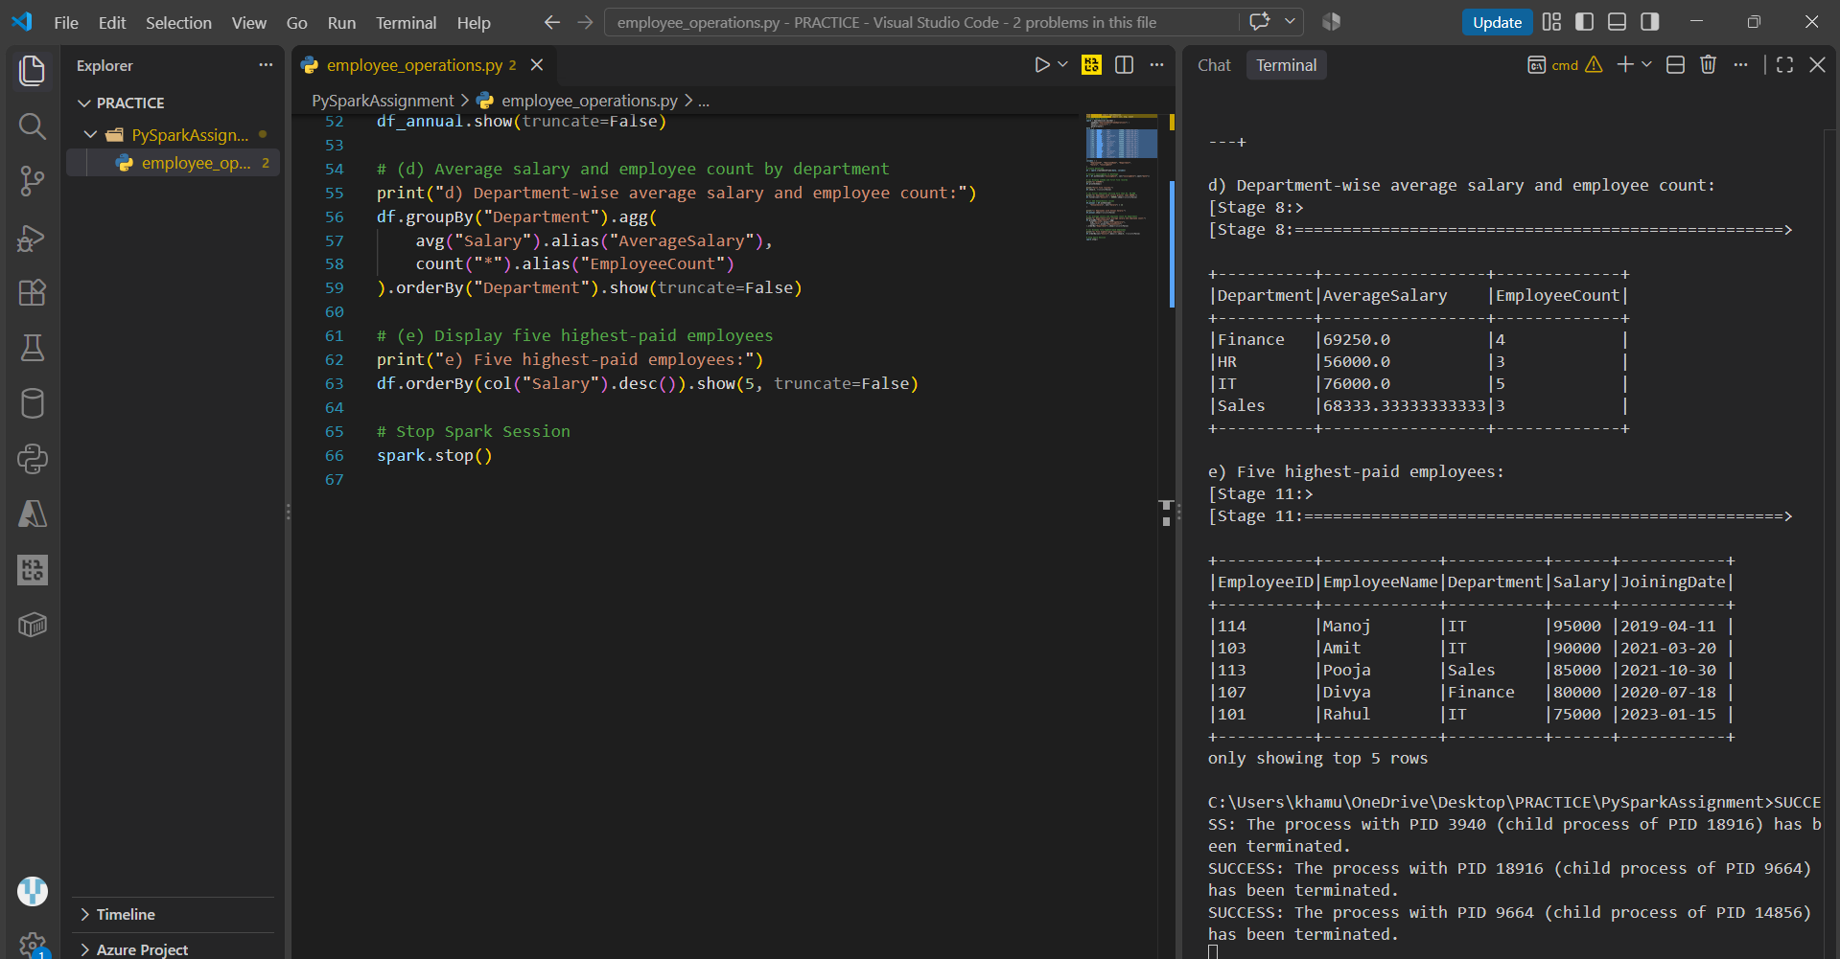

Question 8: Data Cleaning and Aggregation
a. Read the CSV file using an appropriate schema.
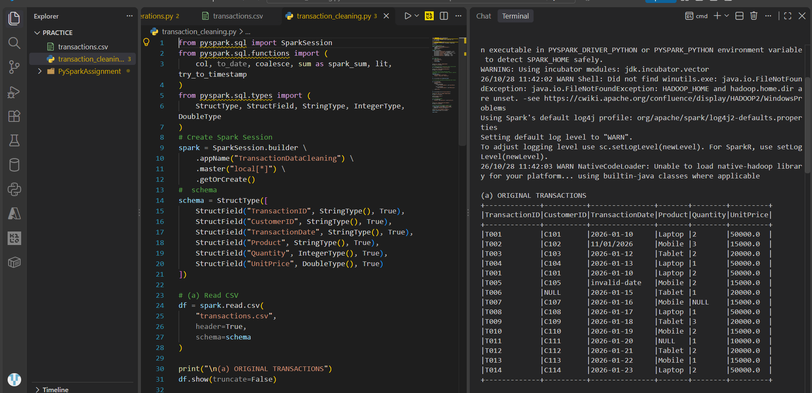
b. Identify and remove duplicate transactions using a suitable business key
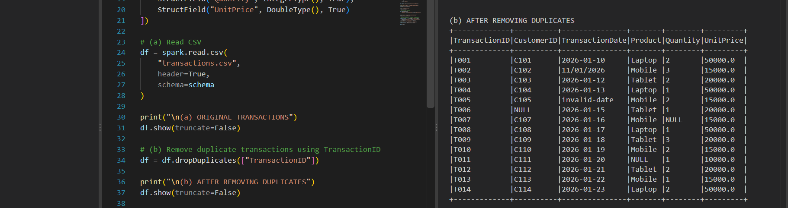
c. Handle missing values in required fields and explain your chosen approach. &
d. Convert TransactionDate into a date type and handle invalid dates.
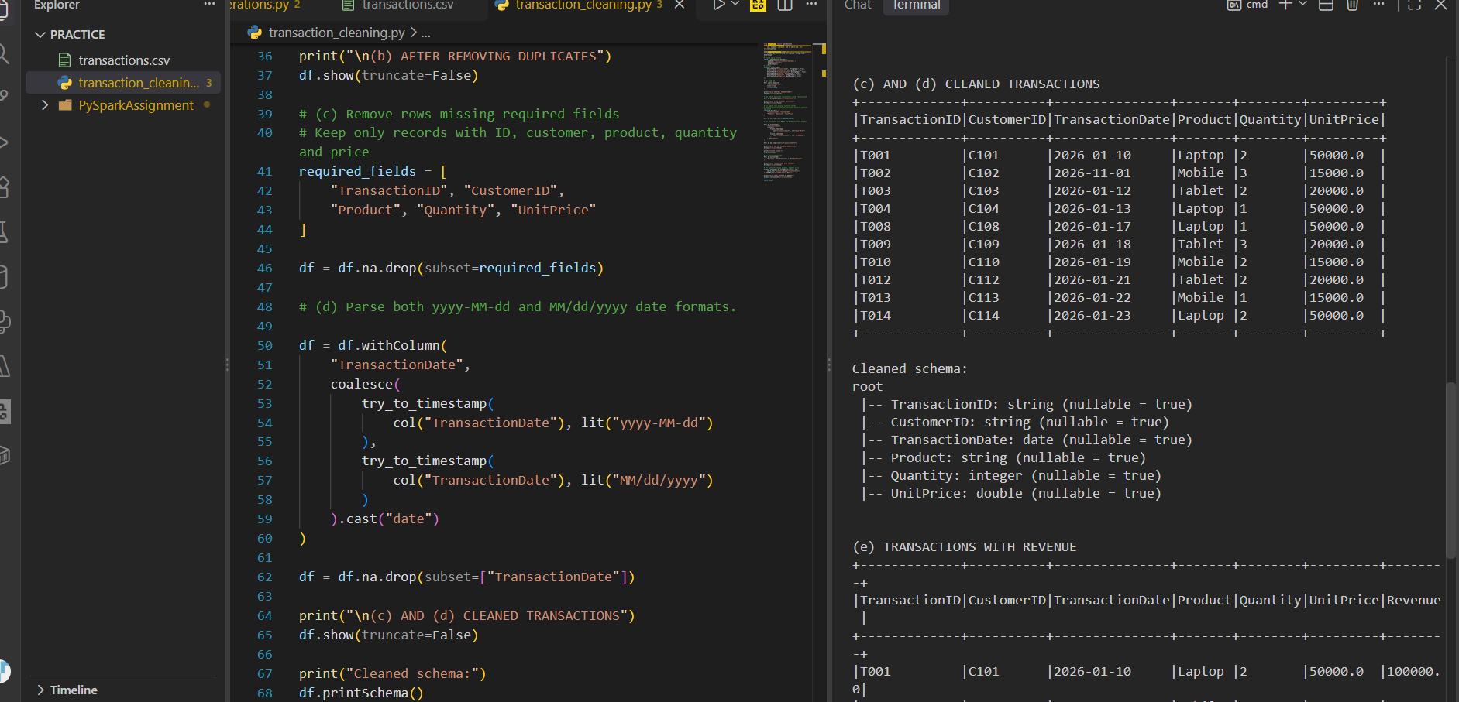
e. Calculate revenue using Quantity × UnitPrice
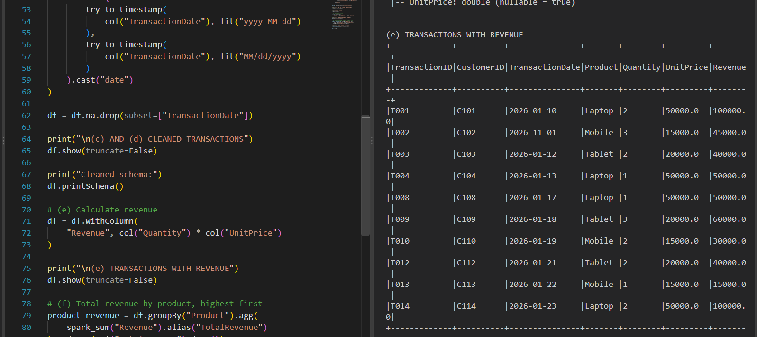
f. Calculate total revenue by product and display the results in descending order.
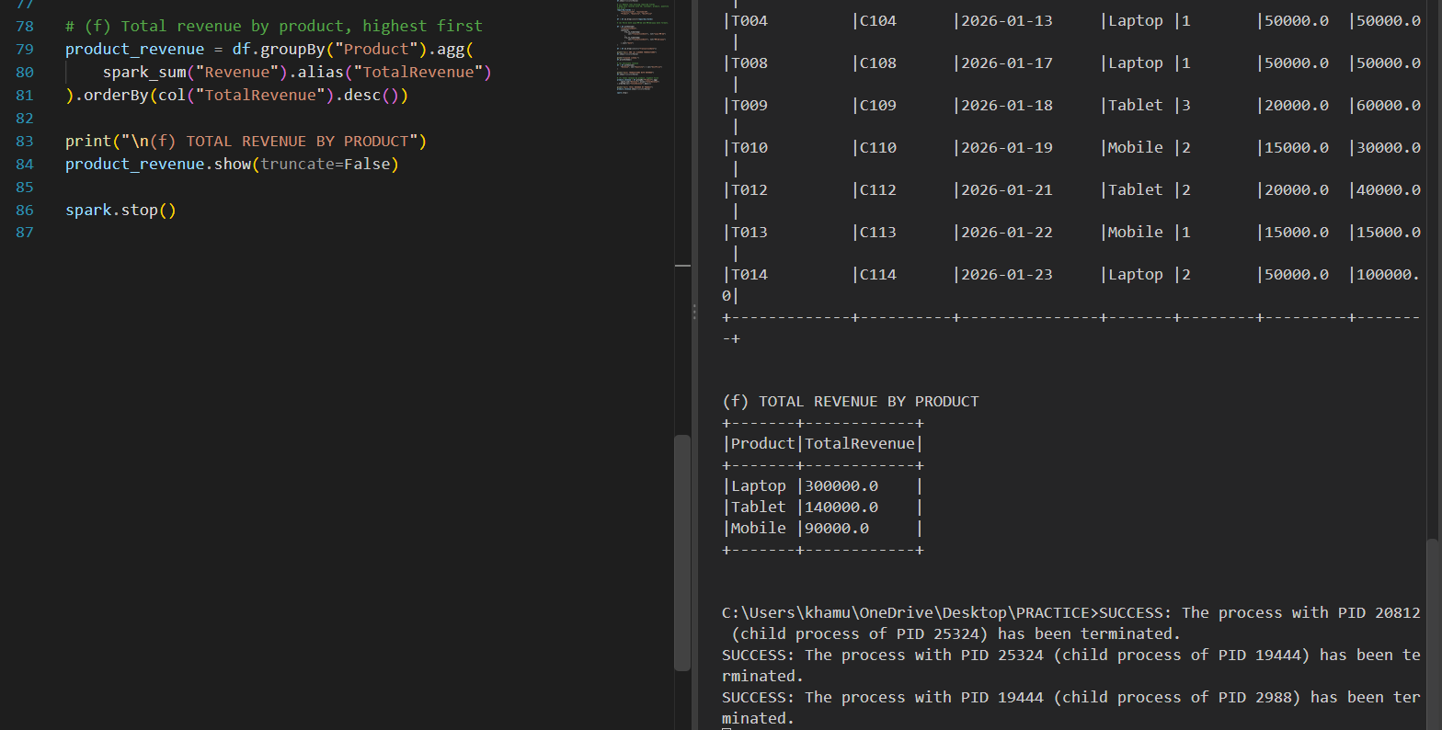

Question 9: PySpark Joins and Performance
a. Load both datasets into DataFrames.
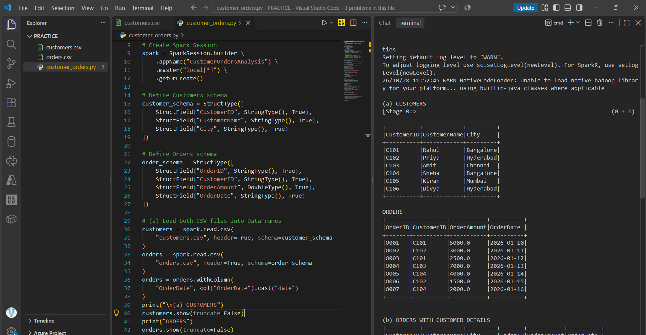
b. Join the datasets to display orders with customer details
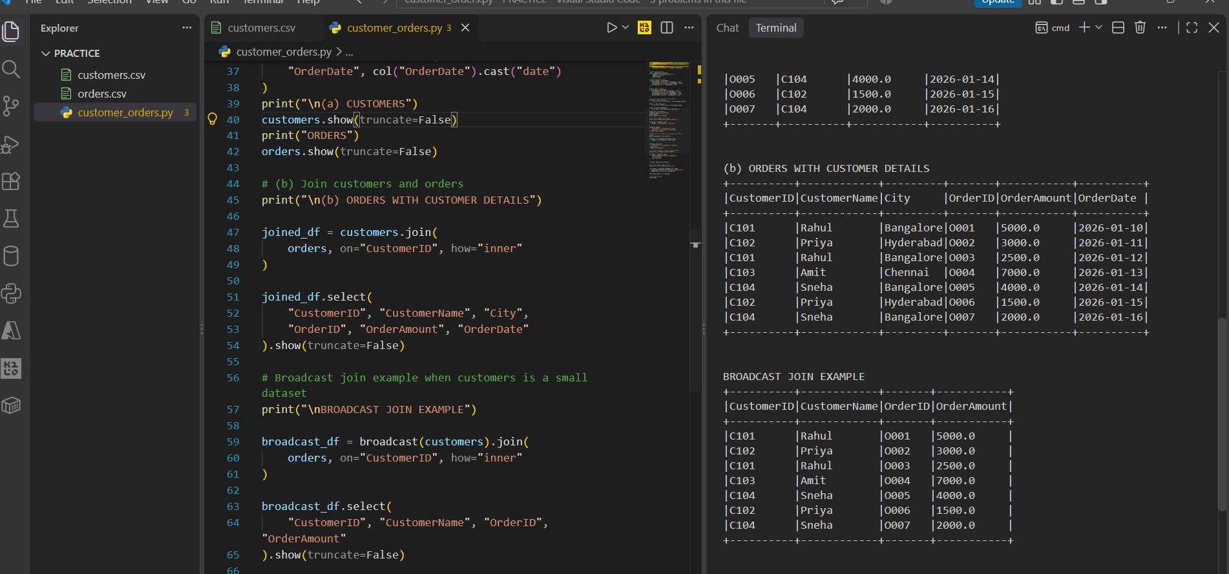
c. Identify customers who have never placed an order.
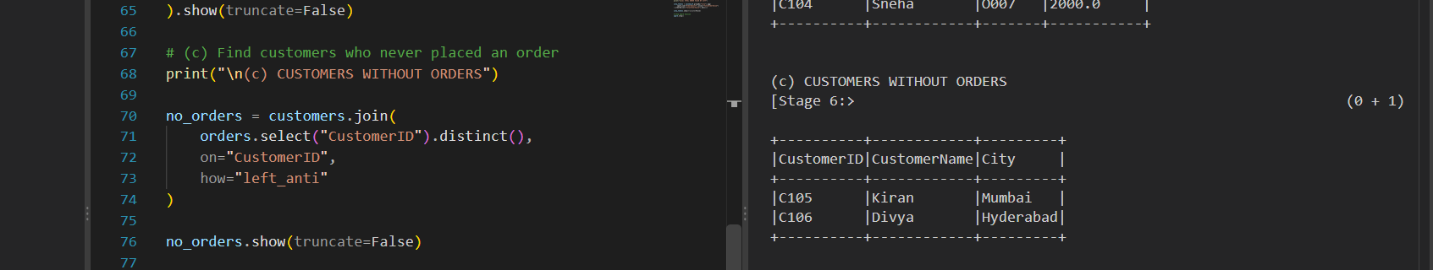

d. Calculate the total order value by city.
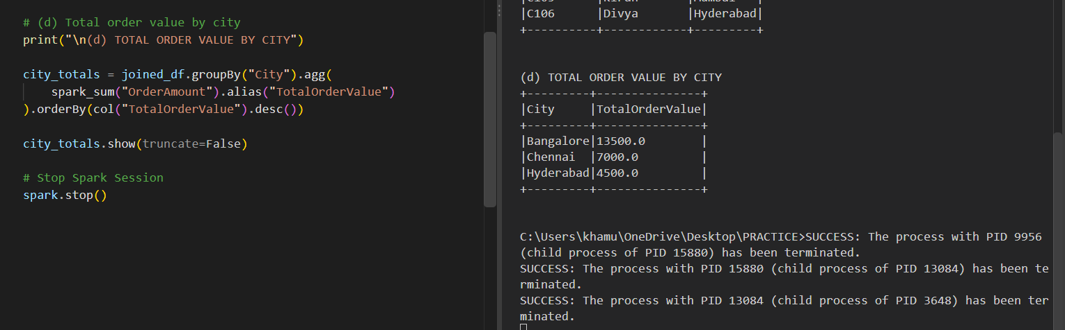
e. Explain when a broadcast join is useful and what conditions make it appropriate.
A broadcast join is a PySpark optimization in which a small DataFrame is sent to all worker nodes to join it with a larger DataFrame. It reduces data shuffling and improves performance.
Conditions: Use a broadcast join when one DataFrame is small enough to fit in each worker's memory and the other DataFrame is comparatively large.
f. Explain the difference between transformations and actions, giving one example of each.
Transformation : filtered = orders.filter(orders.OrderAmount > 3000)
Create a new DataFrame or RDD from existing data. [ Ex: filter(), select(), join()]
Action : filtered.show()
Execute computations to produce results or write data. [Ex: show(), count(), collect()]

SECTION D: AWS CLOUD SERVICES
Question 10: S3 and IAM Security
a. Create an S3 bucket with Block Public Access enabled and upload a sample file.
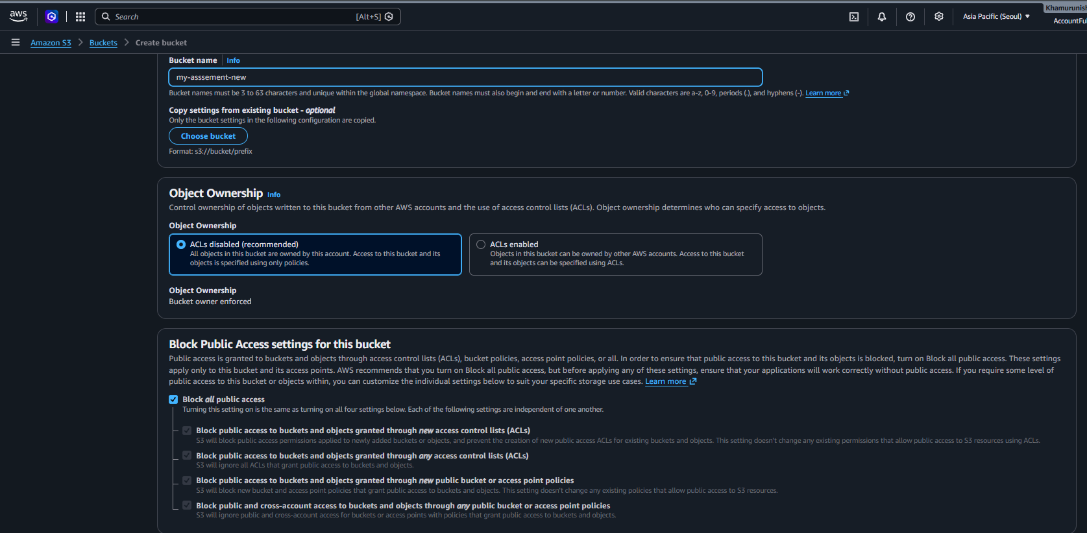
UPLOAD:
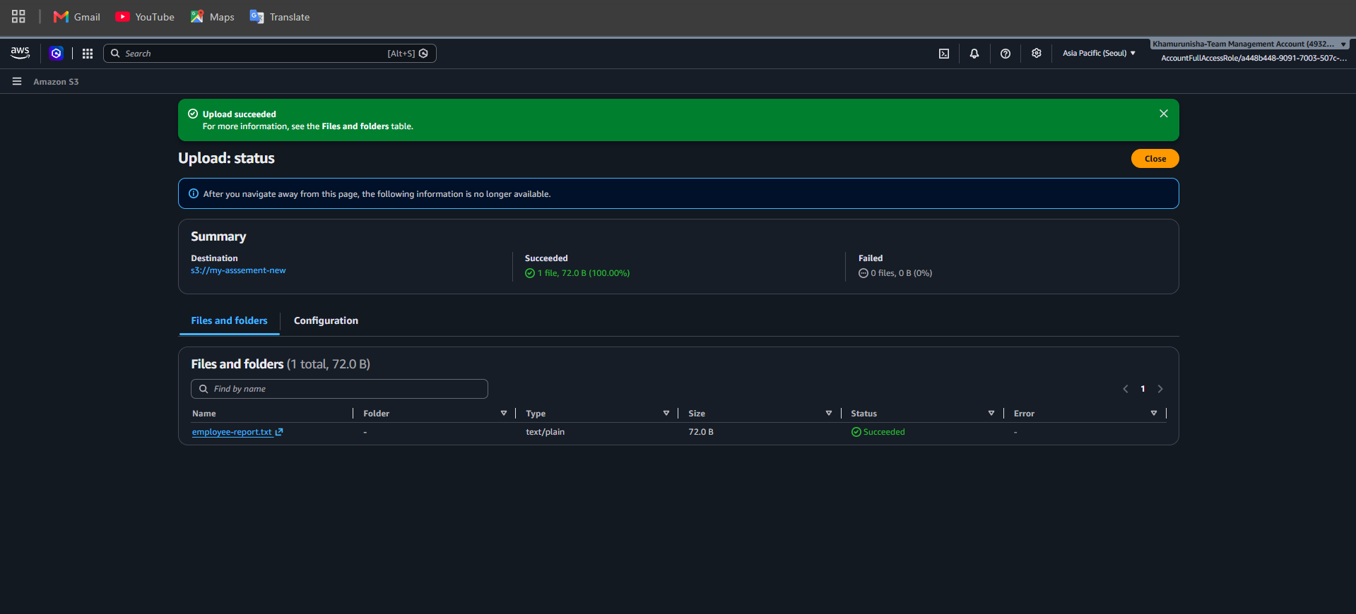

b. Design an IAM policy that grants read access to objects in the designated bucket without granting access to unrelated buckets.
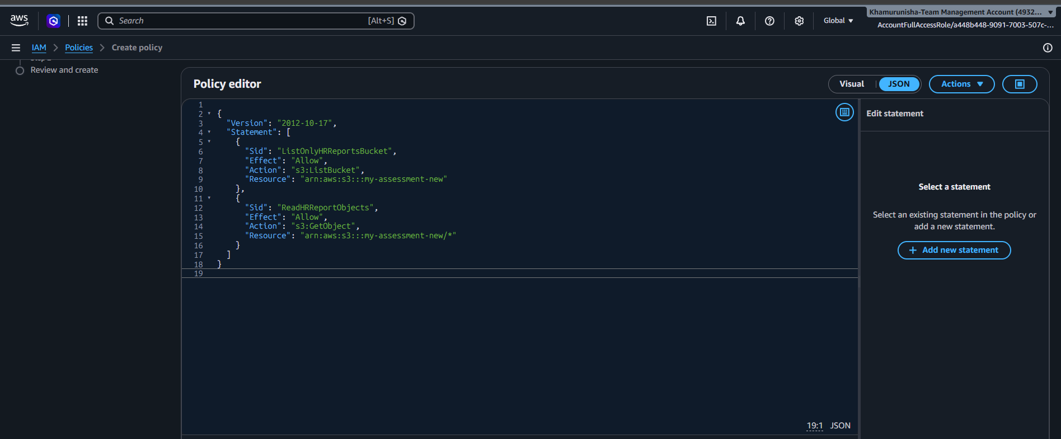

c. Explain how you would verify that an unauthorized user cannot read the file.
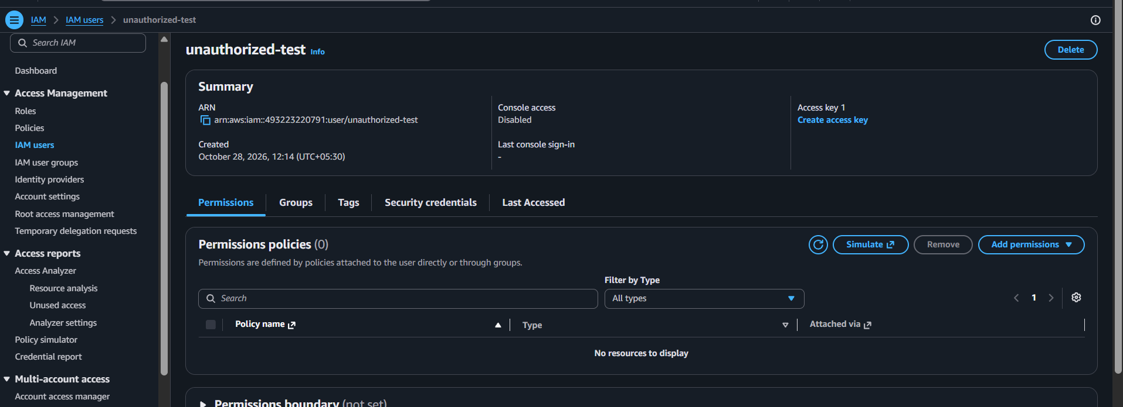
Sign in using an IAM test user or role that does not have permission to read the HR reports.

d. Explain how encryption at rest protects the stored data.
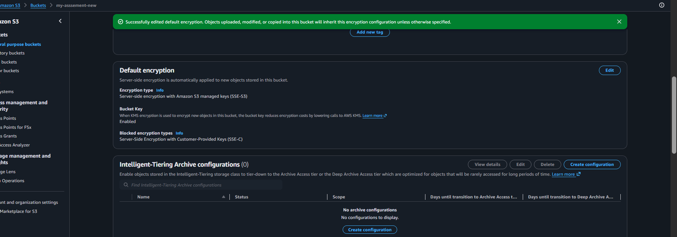
Encryption at rest protects data stored in Amazon S3 by converting it into unreadable encrypted form. S3 supports SSE-S3 and SSE-KMS to help protect confidential employee reports from unauthorized access.
Question 11: EC2 Troubleshooting and CloudWatch
a. Check the EC2 instance state and status checks.
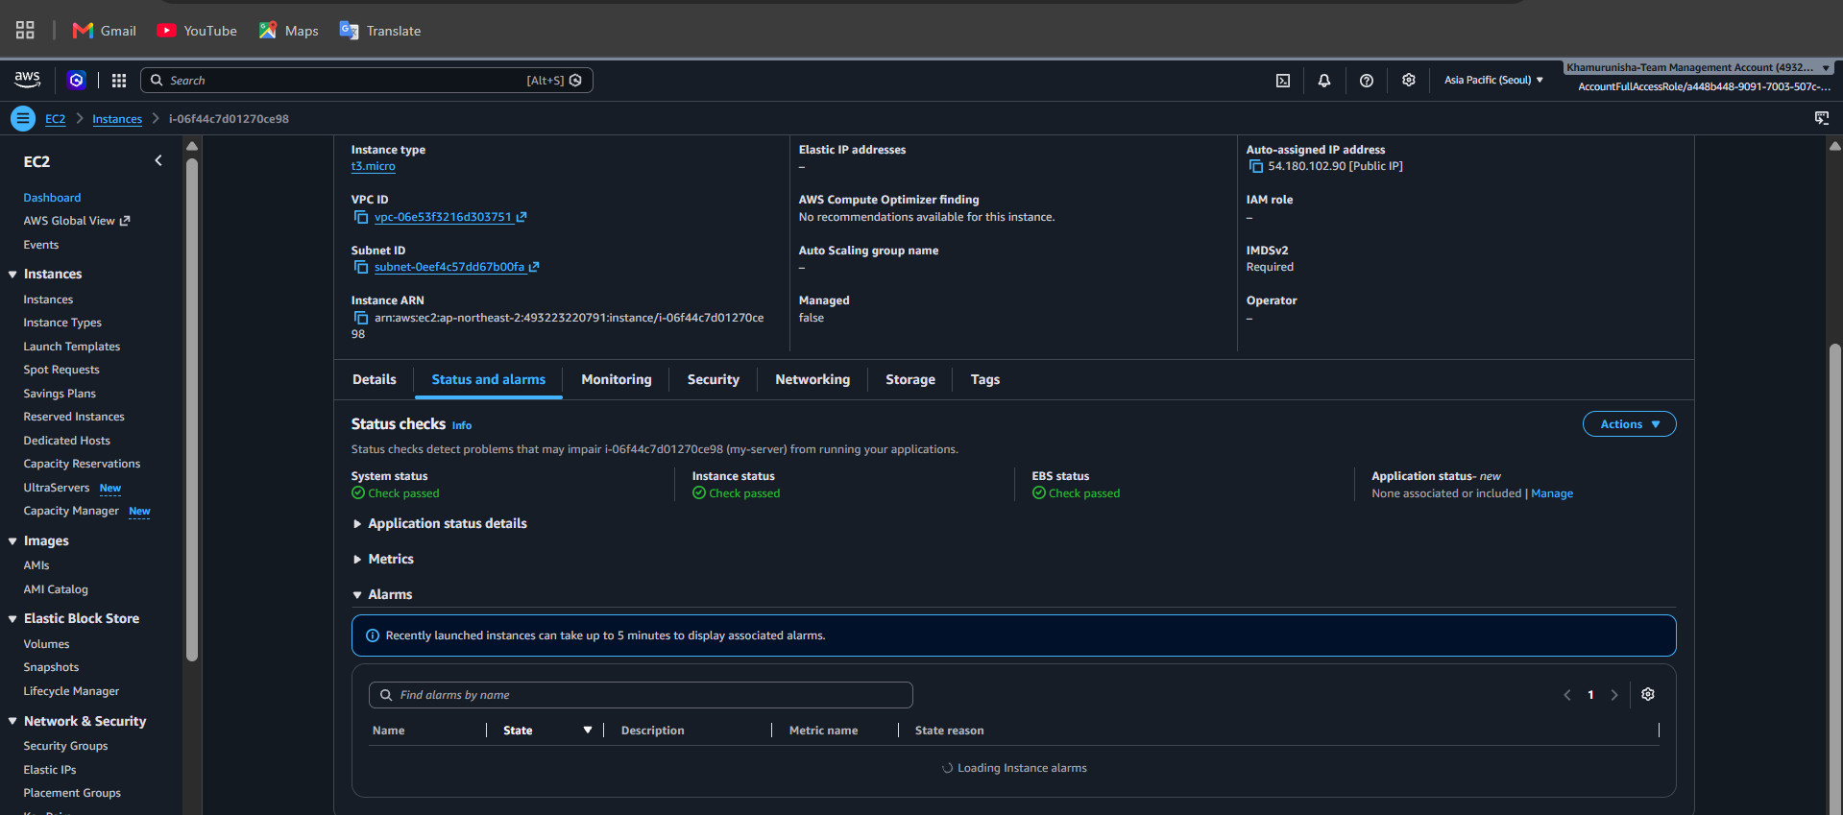

b. Explain how security groups and route tables can affect application connectivity.
A. Security groups act as virtual firewalls for EC2 instances. They control
inbound [HTTP (port 80) or HTTPS (port 443) traffic is not allowed]
and outbound traffic [external services].
B. Route tables determine where network traffic is sent.
- A public subnet typically needs a route to an Internet Gateway (0.0.0.0/0) for direct internet connectivity.
- A private subnet generally needs suitable routing, such as through a NAT Gateway for outbound internet access.
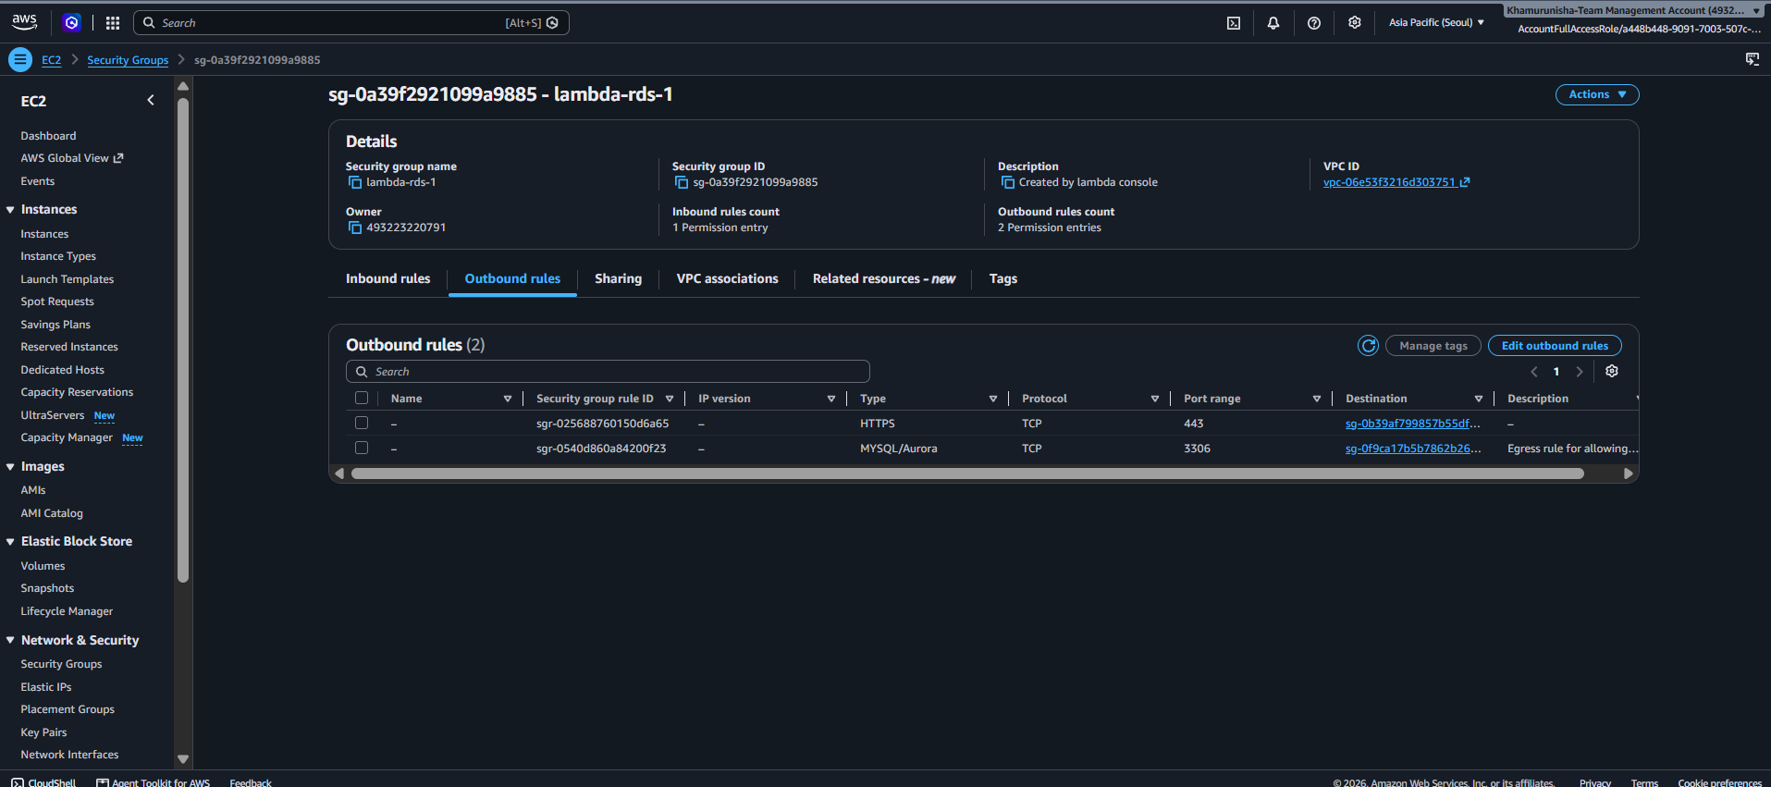

c. Explain how to configure a CloudWatch alarm when CPU utilization exceeds 85% for a defined evaluation period.
We'll create an alarm that triggers when the average CPU utilization exceeds 85% for two consecutive five-minute evaluation periods.
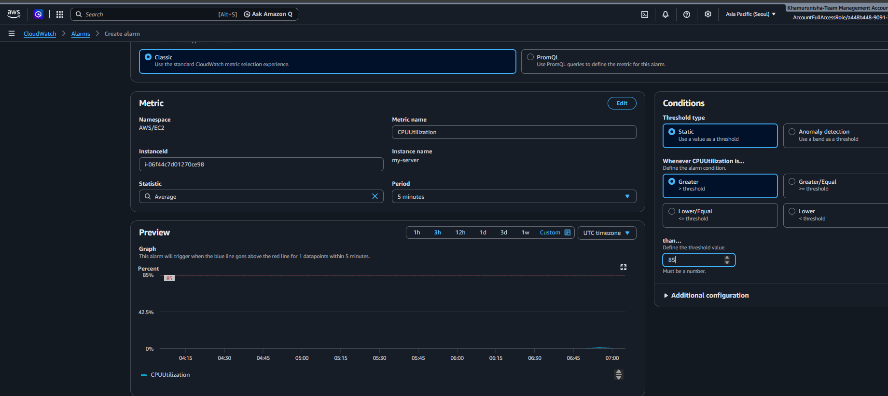
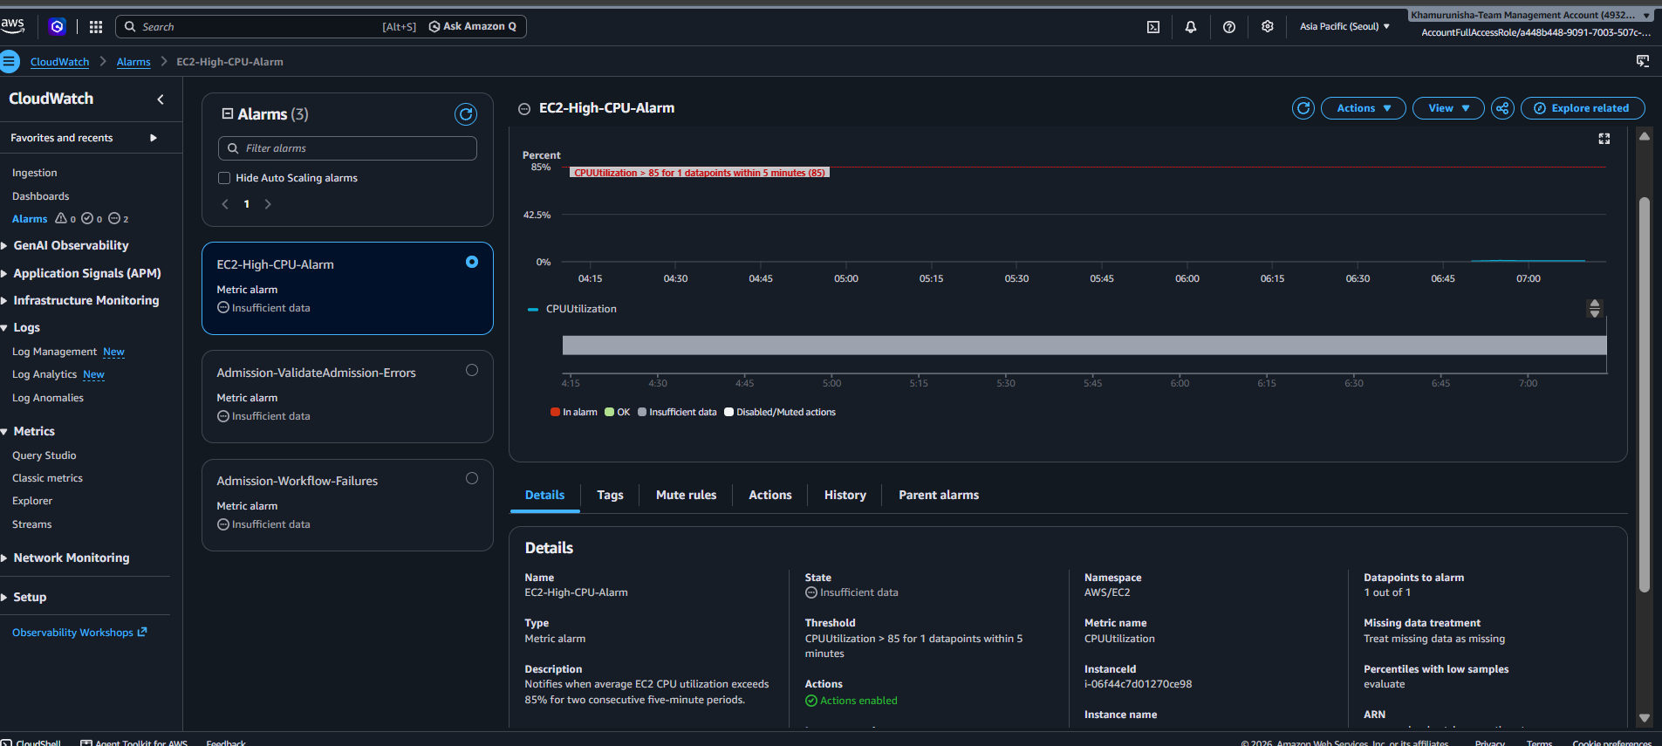
The alarm will notify your subscribed email when CPU utilization exceeds 85% for the configured evaluation period. You do not need to add a Lambda action for this assignment.

d. Identify one method for investigating the root cause of high CPU utilization.
Method: Using the Linux top command.
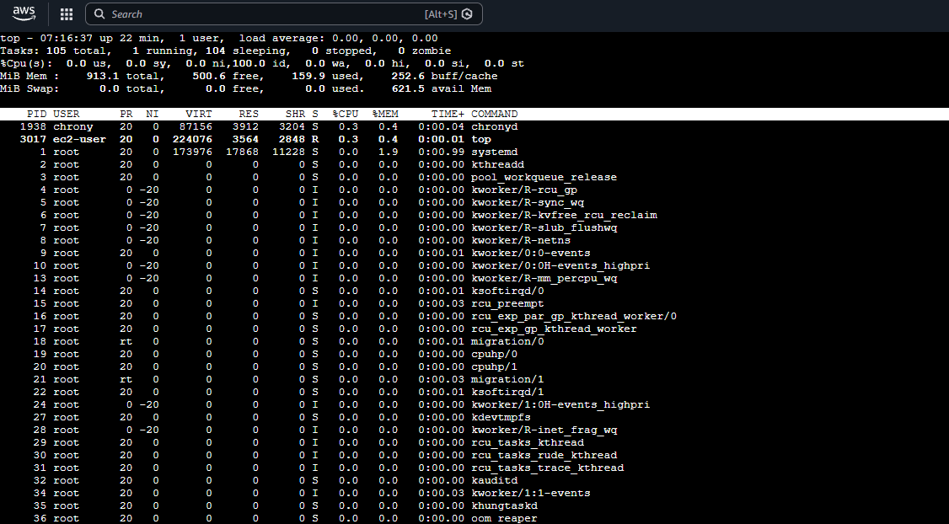

Question 12: Event-Driven Processing
a. Identify a suitable service for executing the processing code.
AWS Lambda is suitable because it executes code without requiring the company to manage servers. A Lambda function can read a CSV file, validate its contents, transform the data, and save the results to another S3 bucket.
b. Explain how an S3 upload can trigger processing.
- Configure an Amazon S3 event notification for the ObjectCreated event on the input bucket and set AWS Lambda as the destination. Whenever a CSV file is uploaded, S3 invokes the Lambda function, which processes the file.
- A suffix filter such as .csv can restrict triggering to CSV files.

c. Explain the IAM permissions needed to read the input file and write the results.
Create an IAM execution role for Lambda with a least-privilege policy.
- s3:GetObject on the input bucket's CSV objects.
- s3:PutObject on the output bucket's result objects.
- CloudWatch Logs permissions to create log streams and write logs.

d. Explain how errors and processing logs can be captured.
Use Amazon CloudWatch Logs to capture Lambda execution logs, including processing status, validation failures, and exception messages. Configure CloudWatch alarms for errors or repeated failures. For failed asynchronous invocations, configure a dead-letter queue or a Lambda destination to retain failure information for investigation.
e. Explain how to prevent duplicate processing or recursive triggering.
- Prevent duplicate processing: Make the Lambda function idempotent by recording processed object identifiers, such as the bucket, object key, and version ID, in a database or deduplication store. Check the record before processing again.

- Prevent recursive triggering: Store results in a separate output bucket, or configure the S3 event notification to trigger only for an input prefix such as incoming/ and write results under processed/.

SECTION E: AWS STEP FUNCTIONS
Question 13: State Machine Design
a. Identify suitable states for validation, processing, storage, and notification.
State | Purpose
ValidateInput — Task | Invokes Lambda to validate the sales file.
CheckValidation — Choice | Routes valid and invalid files.
TransformData — Task | Cleans and transforms sales records.
CalculateSales — Task | Calculates total sales grouped by product.
StoreResults — Task | Writes the results to Amazon S3.
SendNotification — Task | Publishes a completion message through Amazon SNS.
ProcessingFailed — Fail | Ends the workflow when validation or processing fails.
Success — Succeed | Marks successful completion.

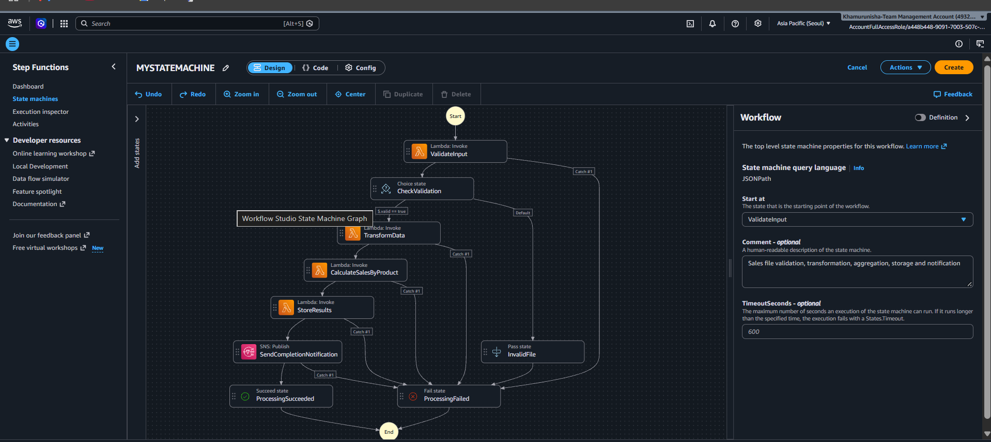

b. Explain how a Choice state can route invalid files to a failure path and valid files to processing.
The CheckValidation Choice state checks the Boolean value $.validation.isValid.
- If isValid = true, execution proceeds to TransformData.
- If isValid = false, execution follows the default path to ProcessingFailed.
This prevents invalid files from entering the transformation and calculation stages.
c. Explain how Retry and Catch can handle transient failures and permanent errors.
- Retry: Automatically retries a task when a temporary error occurs, such as throttling or a transient service failure. IntervalSeconds sets the initial delay, MaxAttempts limits retries, and BackoffRate increases the delay between attempts.
- Catch: Handles errors that remain after retries or other task failures. It captures error details in $.error and routes execution to ProcessingFailed.
For example, if a Lambda function temporarily fails , Step Functions can retry it. If it still fails, Catch routes the workflow to the failure state.

d. Explain how the state machine can invoke Lambda functions or other supported AWS services.
Step Functions uses Task states to invoke Lambda functions through the optimized Lambda integration, such as arn:aws:states:::lambda:invoke. It can also integrate directly with supported AWS services, such as Amazon SNS for notifications. An execution role grants permission to perform these operations.
e. Explain how execution history helps troubleshoot a failed workflow.
Step Functions execution history records state transitions, inputs, outputs, errors, and retry attempts. By opening the failed execution in the AWS console, a developer can identify the state that failed, inspect the error message, and determine whether the issue occurred during validation, transformation, calculation, storage, or notification.
Question 14: Step Functions Implementation
a. Write an ASL JSON definition containing the three sequential tasks. Use placeholders for resource ARNs where necessary.
The following AWS Step Functions definition contains the three sequential tasks: ValidateFile, TransformData, and LoadResults. It uses your AWS Region (ap-northeast-2) and account ID (493223220791), reuses your existing ValidateAdmission Lambda for the validation step, and uses placeholders for the other two Lambda functions.
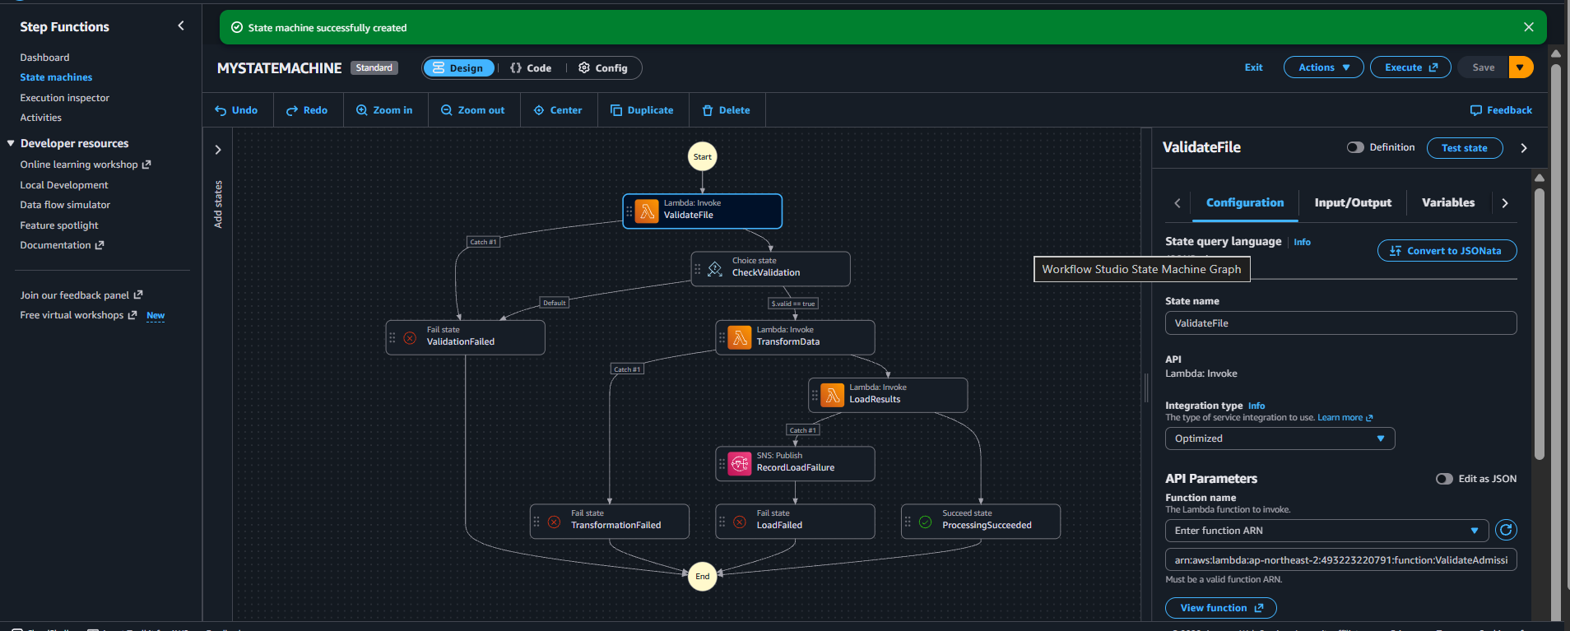

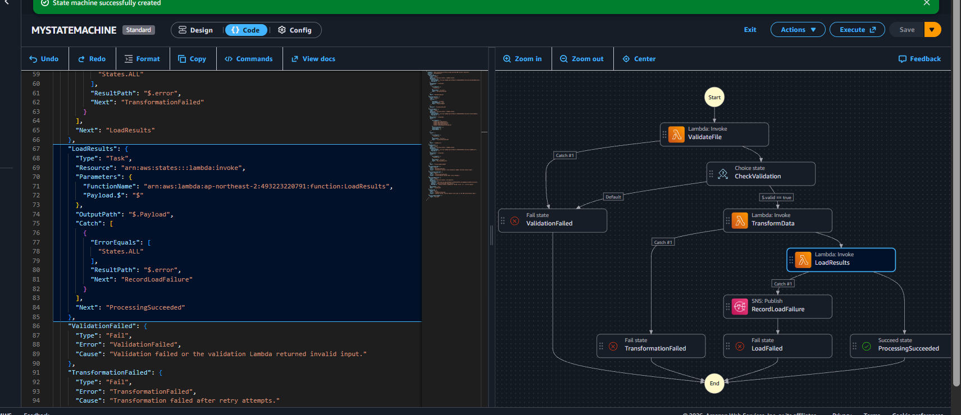
b. Configure a retry policy for the transformation task with an appropriate error category, retry interval, and maximum attempts.
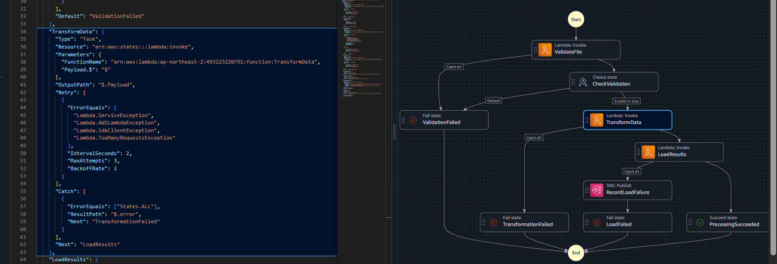

Setting | Value | Explanation
ErrorEquals | Lambda service and throttling errors | Specifies retryable errors
IntervalSeconds | 2 | Wait 2 seconds before the first retry
MaxAttempts | 3 | Retry up to 3 times
BackoffRate | 2 | Doubles the delay after each retry

This provides retry delays of approximately 2, 4, and 8 seconds if all three retries are needed.

c. Configure a Catch transition for the loading task that routes to an error-handling state.
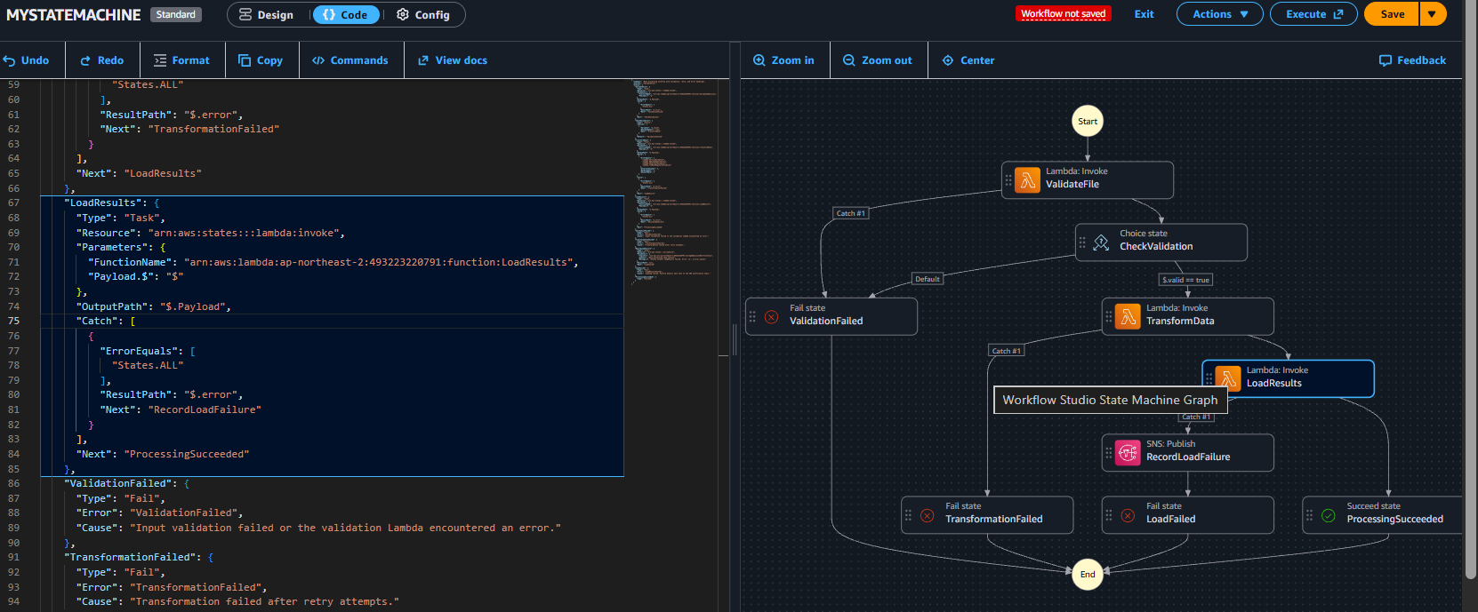
- ErrorEquals: ["States.ALL"] catches errors from the loading task.
- ResultPath: "$.error" saves the error details in the workflow data.
- Next: "RecordLoadFailure" routes the workflow to the error-handling state.
- RecordLoadFailure publishes a failure notification through your existing SNS topic, CollegeAdmissionNotifications.
- LoadFailed then marks the execution as failed.

d. Explain how data from one task is passed to the next task.
- AWS Step Functions passes data between tasks through JSON input and output. Each task receives the previous task's output as its input.
- In our state machine, "Payload.$": "$" passes the current state input to the Lambda function, while "OutputPath": "$.Payload" extracts the Lambda function's response to pass to the next state.
{
"valid": true,
"file": "sales.csv"
}
If ValidateFile returns this data, TransformData receives it as input. The transformed output is then passed to LoadResults.

e. Explain how you would test successful and failed executions.
1. Successful execution: Run the Step Functions workflow with valid JSON input. Verify that all tasks execute successfully and the workflow reaches ProcessingSucceeded.
2. Failed execution: Run the workflow with invalid or incomplete input, such as a missing email. Verify that validation fails and the workflow reaches ValidationFailed. Check the execution graph and CloudWatch logs to identify errors and confirm error handling.
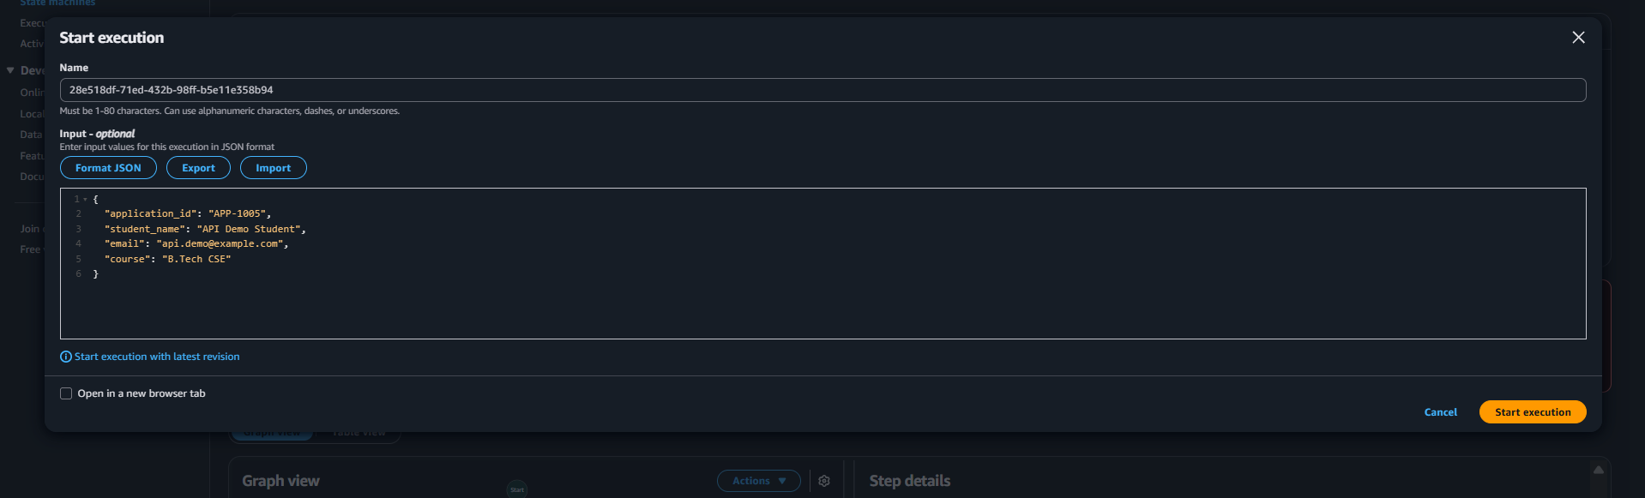

SECTION F: MICROSOFT AZURE
Question 15: Azure Data Lake Storage and Security
a. Configure or describe a storage account with hierarchical namespace enabled for Azure Data Lake Storage Gen2.
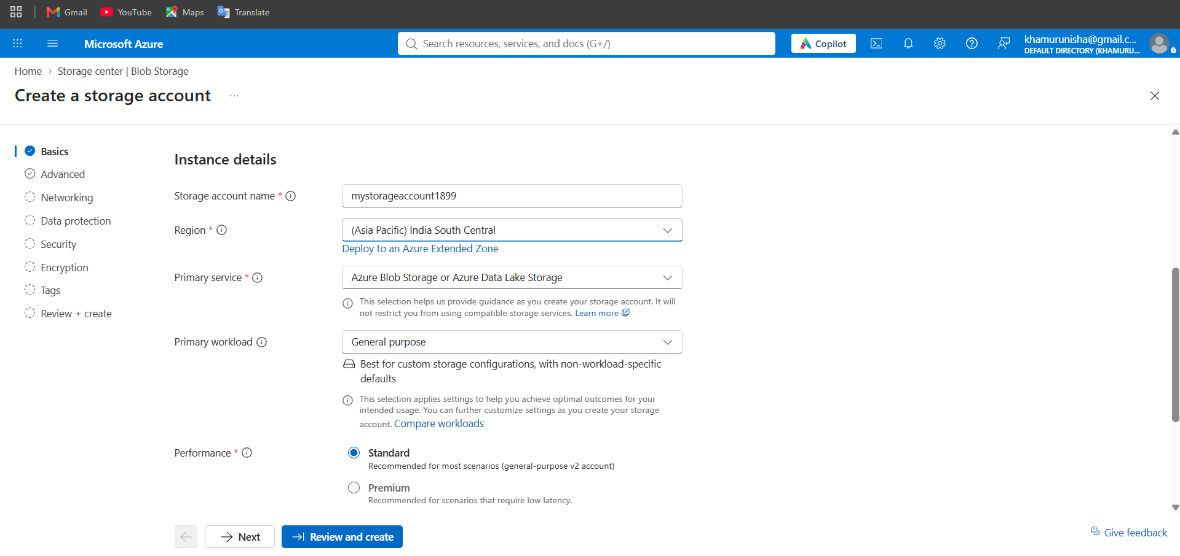

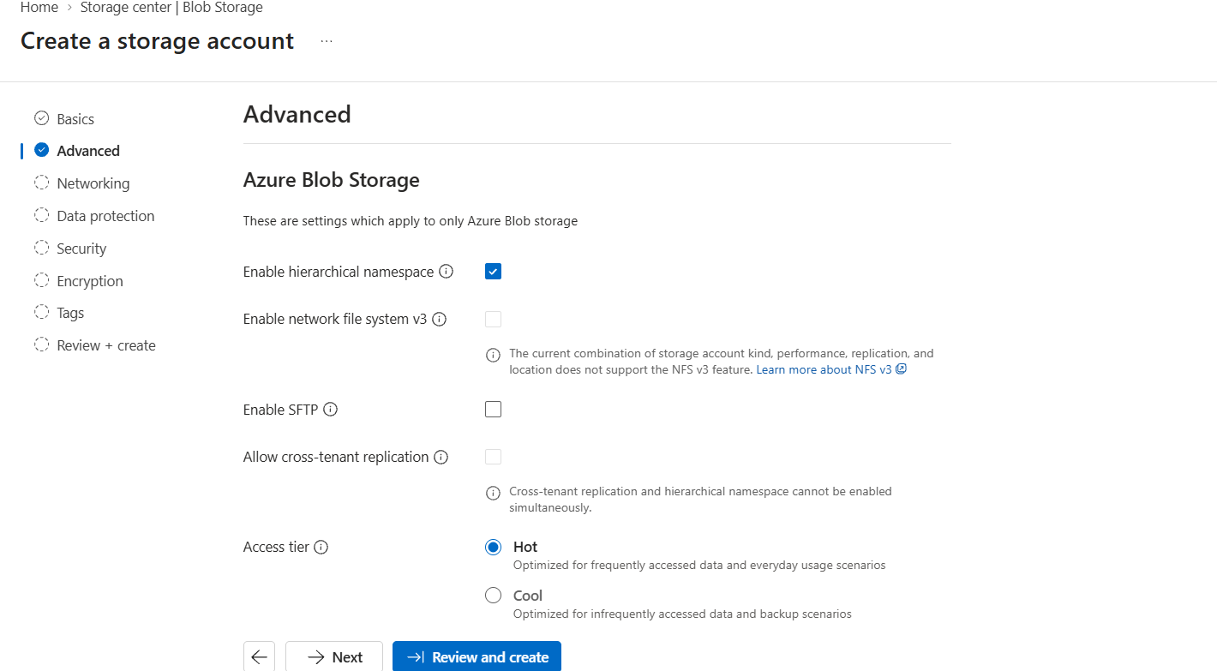

b. Create a filesystem or container and upload a sample dataset.
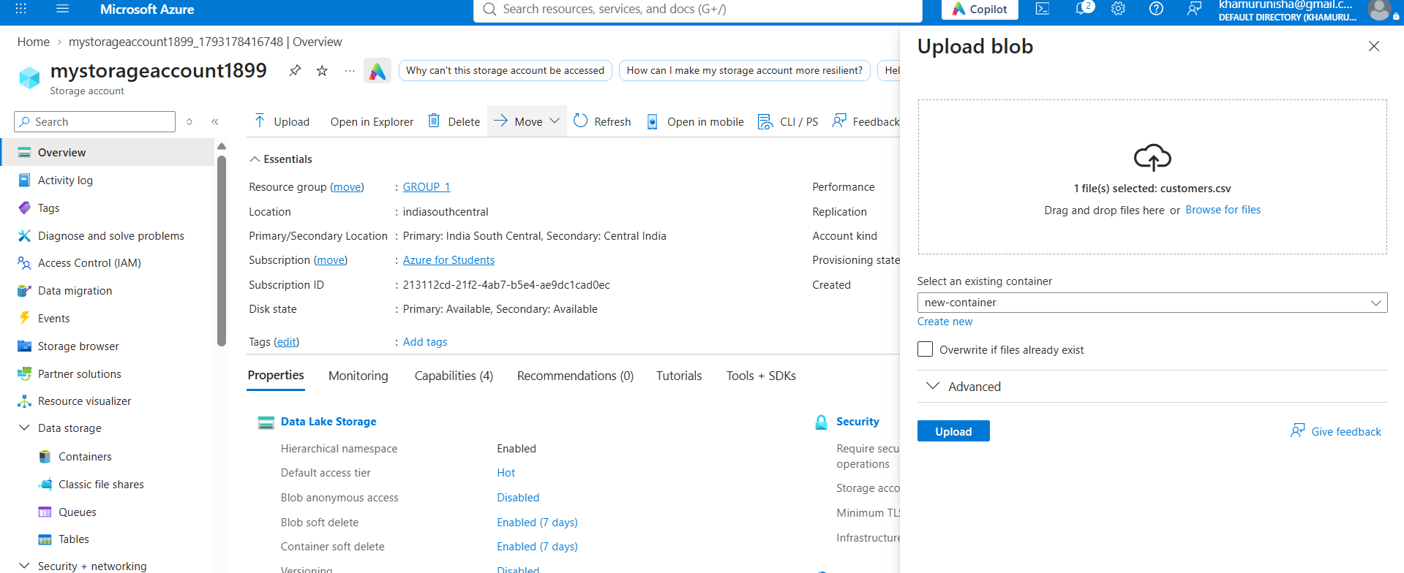

c. Explain how Microsoft Entra ID and Azure role-based access control can manage access to the data.
- Microsoft Entra ID manages user identities, groups, and authentication.
- Azure RBAC assigns roles such as Storage Blob Data Reader for read-only access and Storage Blob Data Contributor for reading, writing, and deleting data.
- Assign permissions to authorized users or groups and follow the principle of least privilege.
- Use Azure Data Lake Storage access control lists (ACLs) when more granular file- and directory-level permissions are required.
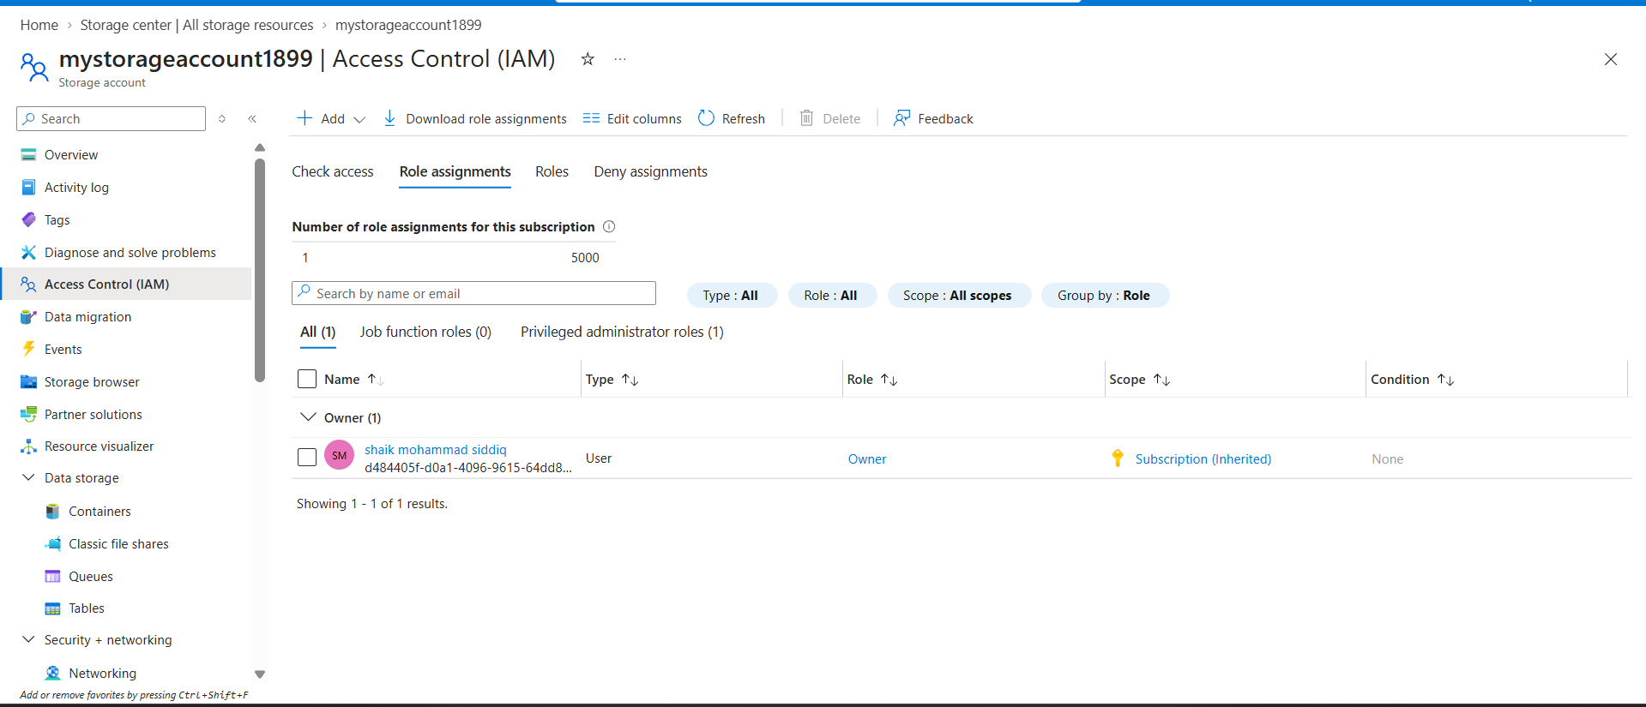

d. Explain how you would verify that unauthorized users cannot access the dataset.
I would sign in as a user who does not have permission to access the Azure Data Lake Storage dataset and attempt to open or download the file. If access is denied with a 403 Forbidden error, it confirms that unauthorized access is restricted. I would also verify that an authorized user can access the dataset successfully.
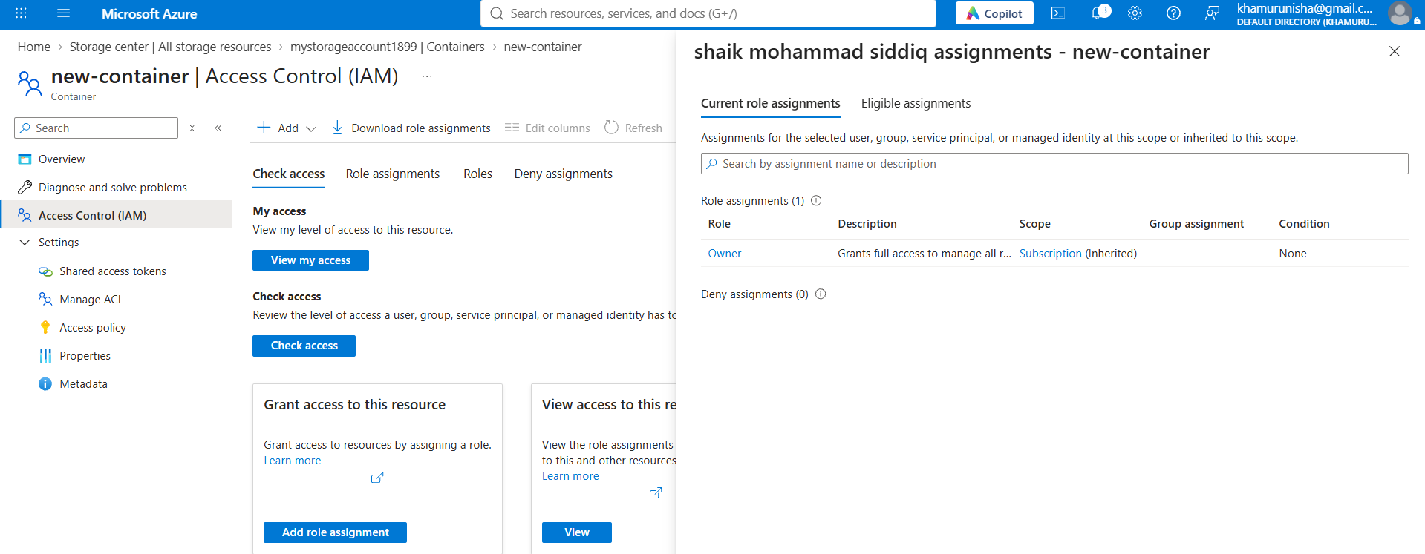

Question 16: Azure VM Troubleshooting
a. Verify the VM's provisioning and power states.
Open Azure Portal → Virtual Machines → Select the VM → Overview. Check the provisioning state is Succeeded and the power state is Running.
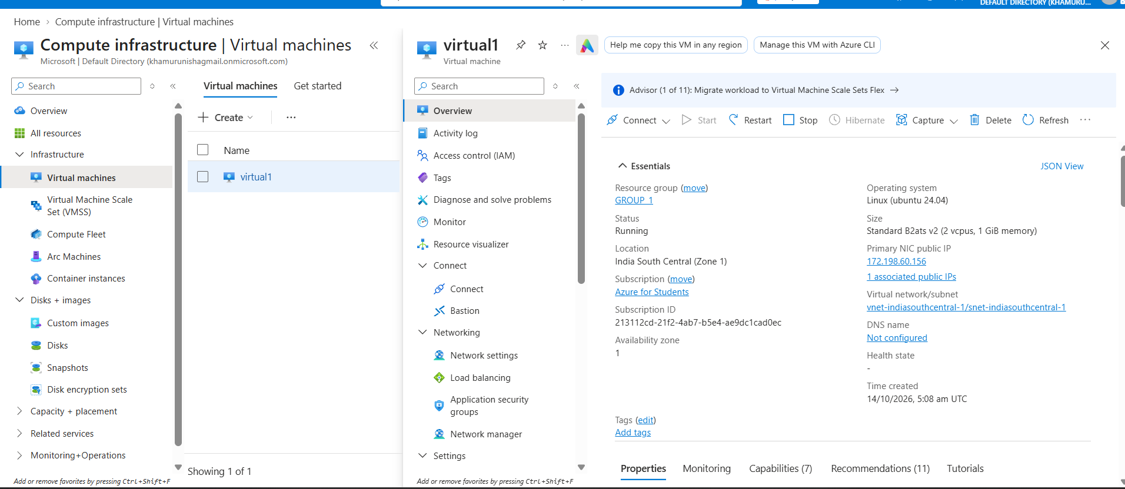

b. Explain how Network Security Group rules can prevent connectivity.
NSG rules may block connectivity if inbound traffic on required ports, such as SSH (22) or RDP (3389), is denied. Verify inbound rules, priorities, source IP addresses, and destination ports.
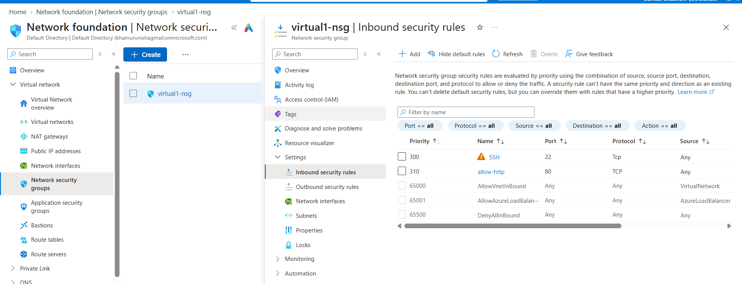

c. Explain how subnet and routing configuration affect connectivity.
Incorrect subnet configuration, route tables, or user-defined routes can prevent traffic from reaching the VM. Verify the subnet association, route table, next-hop settings, and network connectivity.

d. Recommend a secure troubleshooting method that avoids unnecessarily exposing the VM to the public internet.
Use Azure Bastion to connect to the VM through the Azure Portal without exposing the VM's public IP or opening SSH/RDP ports to the public internet. Alternatively, use Azure Serial Console for supported troubleshooting scenarios. Review NSG flow logs or Network Watcher connection troubleshooting to identify blocked traffic, and grant access only to authorized administrators.
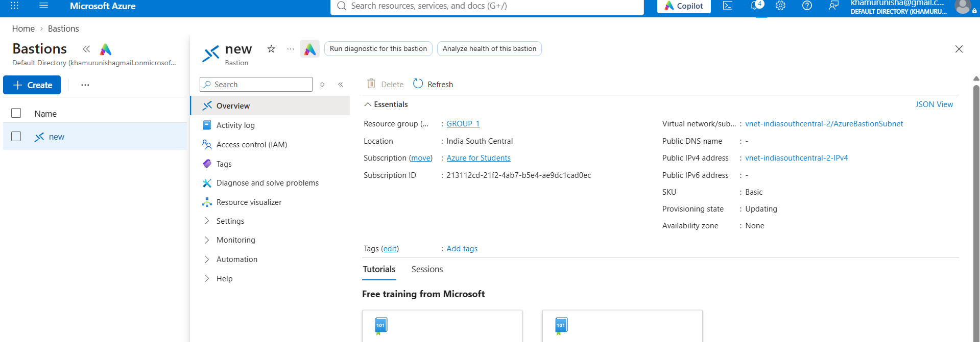

Question 17: Azure Data Integration
a. Select an appropriate service to orchestrate data movement.
Use Azure Data Factory (ADF) to create and schedule a data pipeline that moves customer transaction data from the source to Azure Data Lake Storage Gen2.
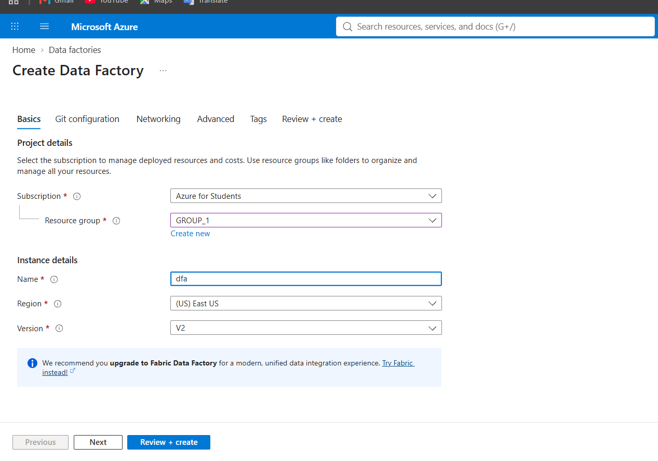

b. Explain how to copy the CSV file into Azure Data Lake Storage Gen2.
Create a Copy Data activity in Azure Data Factory. Configure the CSV file as the source using a linked service and configure Azure Data Lake Storage Gen2 as the destination. Run the pipeline to copy the file.

c. Describe how to organize files by ingestion date.
Store files in date-based folders, such as:
customer-transactions/
year=2026/
month=10/
day=28/
transactions.csv
This makes data easier to manage, query, and analyze by ingestion date.

d. Explain how to handle malformed records and missing values.
Use Azure Data Factory Mapping Data Flows or Azure Databricks to validate and transform records. Send malformed records to a separate error folder, and handle missing values by filling defaults or rejecting records according to business rules.

e. Explain how to monitor pipeline execution and validate data completeness.
Use Azure Data Factory Monitor and Azure Monitor to check pipeline status, duration, and errors. Compare source and destination record counts and verify that all expected files were copied successfully.

