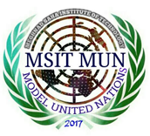 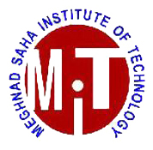

**MEGHNAD SAHA INSTITUTE OF TECHNOLOGY**

**MODEL UNITED NATIONS 2017**

**United Nations Security Council**

**Country matrix**

**Permanent members**:

United States of America

Russia

Peoples Republic of China

United Kindom of Great Britian and Northern Ireland

French Republic

**NON-Permanent members :**

Republic of Angola

Arab Republic of Egypt

Ethiopia

Japan

Italy

Malaysia

New Zealand

Republic of Senegal

Kingdom of Spain

Ukraine

Sweden

Azerbaijan

Eastern Republic of Uruguay

Jordan

Uruguay

Bolivarian Republic of Venezuela

Argentina

Netherlands

Turkey

Colombia

**Observer nations:**

Commonwealth of Australia

Brunei

Republic of India

Spain

Republic of Maldives

Republic of the Philippines

Republic of Korea

Democratic Socialist Republic of Sri Lanka

Republic of China (Taiwan)

Kingdom of Thailand

Socialist Republic of Vietnam

Kazakhstan

Lithuania

Chile

Chad

Nigeria

Austria

Croatia

Indonesia

Libya