Technologies : Spring Boot, Jpa, H2 ,Junit(added junits)

Run Junit testcases (MovieServiceTest.java)

1. Create movie details using post request, use below json data.

http://localhost:8080/createMovie

{

"title":"ET",

"director":"Steven Spielberg"

}

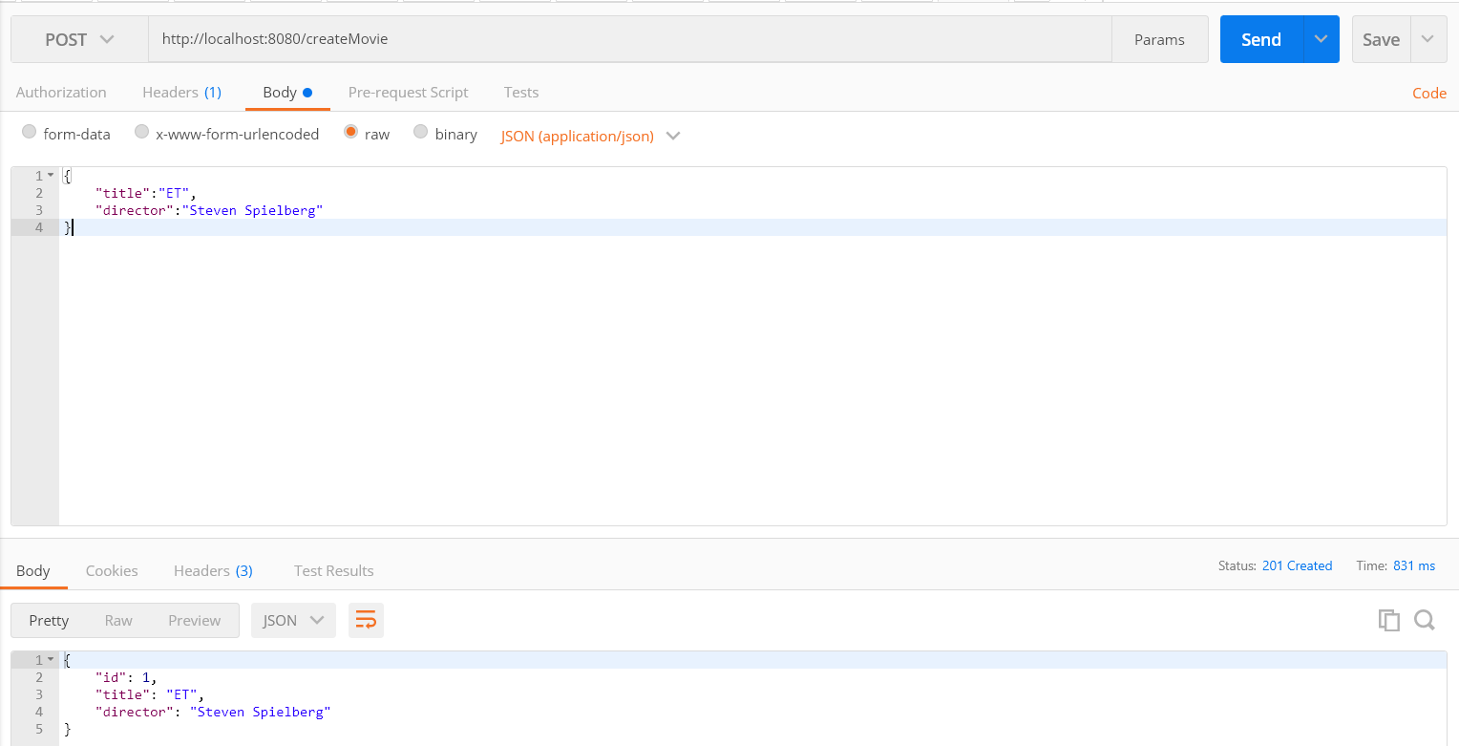

1. Get Movie details (http://localhost:8080/getMovie/1)

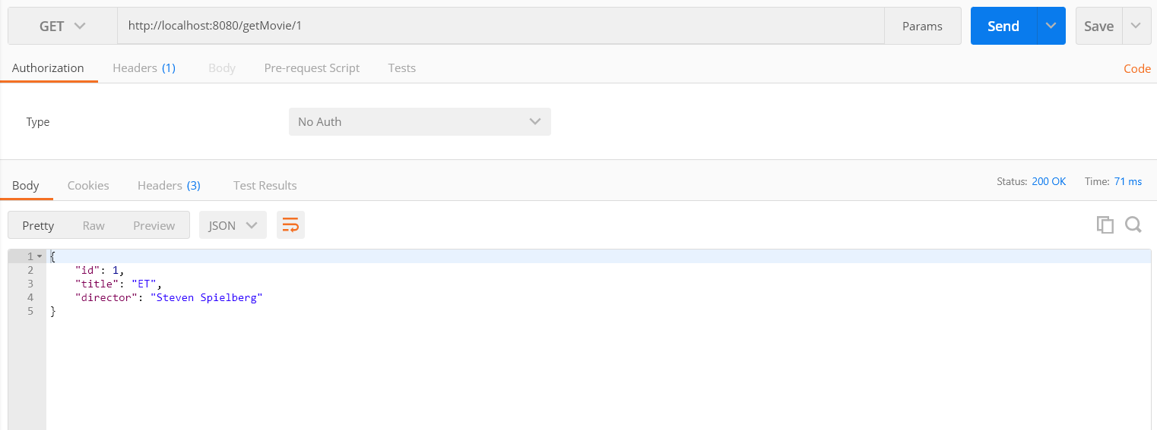

1. Update movie details (http://localhost:8080/updateMovie/1)

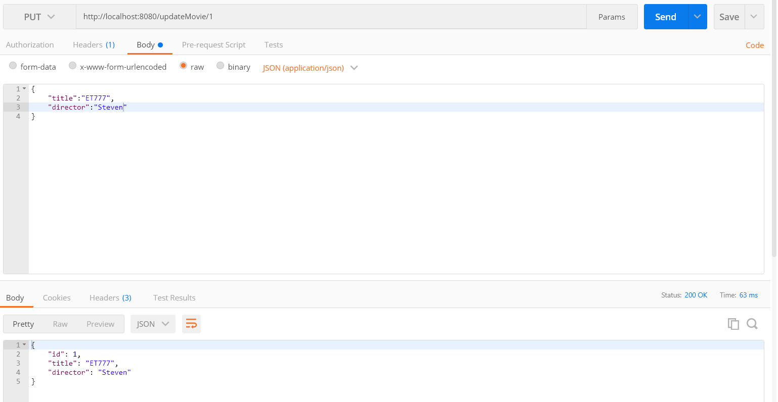

1. Delete movie details (<http://localhost:8080/deleteMovie/1>)

