**🧾 Amazon Product Sales Analysis using Power BI**

**Submitted by:**

**Md Sahanwaj Khan**  
**Master of Computer Applications (MCA)**  
**Galgotias College of Engineering and Technology**

**1. Introduction**

The “Amazon Product Sales Analysis” project aims to provide meaningful business insights into product sales performance across various categories, customers, and time periods using **Microsoft Power BI**.  
This report highlights how data visualization and analytics can enhance business decision-making for e-commerce operations.

**2. Objective**

The primary objectives of this project are:

* To analyze product-wise and category-wise sales performance.
* To identify top and least selling products.
* To understand customer purchasing trends.
* To study regional or time-based sales variations.
* To provide insights for improving overall sales and marketing strategies.

**3. Tools and Technologies Used**

| **Tool / Technology** | **Purpose** |
| --- | --- |
| **Microsoft Excel** | Data Cleaning and Pre-Processing |
| **Power BI Desktop** | Data Visualization and Report Creation |
| **DAX (Data Analysis Expressions)** | Calculations and KPIs |
| **Power Query** | Data Transformation and Loading |

**4. Dataset Description**

The dataset used for this analysis contains Amazon sales transaction details, including:

* Product ID and Product Category
* Order Date and Order ID
* Sales Value and Quantity Sold
* Payment Information
* Customer Details

Total records: (e.g., 10,000+) rows of sales data from Amazon marketplace.

**5. Data Cleaning and Transformation**

Performed the following steps in Power Query:

1. Removed duplicates and null values.
2. Formatted date and numeric columns.
3. Created calculated columns for profit and revenue.
4. Merged tables using relationships (Product, Orders, Payments).
5. Loaded clean data model into Power BI.

**6. Dashboard Design**

The Power BI dashboard includes several key pages and visuals:

**Dashboard Pages:**

1. **Sales Overview Dashboard** – Summary of total sales, orders, and customers.
2. **Category Performance Dashboard** – Category-wise comparison of revenue and quantity.
3. **Customer Insights Dashboard** – Displays repeat customers and purchasing frequency.
4. **Time Analysis Dashboard** – Monthly and yearly trends.
5. **Payment Analysis Dashboard** – Mode of payment and total sales share.

**7. DAX Measures Used**

| **Measure** | **Formula Description** |
| --- | --- |
| **Total Sales** | SUM(Payments[Payment_Value]) |
| **Total Quantity Sold** | SUM(Order_Items[Quantity]) |
| **Average Order Value** | DIVIDE([Total Sales], DISTINCTCOUNT(Orders[Order_ID])) |
| **Top Category Sales** | TOPN(1, VALUES(Products[Category]), [Total Sales], DESC) |
| **Monthly Growth %** | DIVIDE(([Total Sales] - [Previous Month Sales]), [Previous Month Sales]) |

**8. Insights and Findings**

Based on the analysis and dashboard visualization:

* The **Electronics** category generated the highest revenue.
* **Books** category had maximum number of orders but lower revenue per unit.
* Sales showed a significant rise during festive months (October–December).
* **Credit Card payments** accounted for over 40% of total transactions.
* **Top 10 customers** contributed nearly 60% of the total sales.

**9. Conclusion**

The Power BI report successfully provides a clear overview of Amazon’s sales performance.  
It enables management to make **data-driven decisions** regarding marketing, pricing, and product strategies.  
The interactive dashboards can be updated dynamically with new data for ongoing analysis.

**10. Future Scope**

* Integration with live Amazon APIs for real-time tracking.
* Predictive analytics for sales forecasting.
* Enhanced customer segmentation and recommendation systems.

**11. Screenshots Section (Add your visuals here)**

📊 **Figure 1: Sales Overview Dashboard**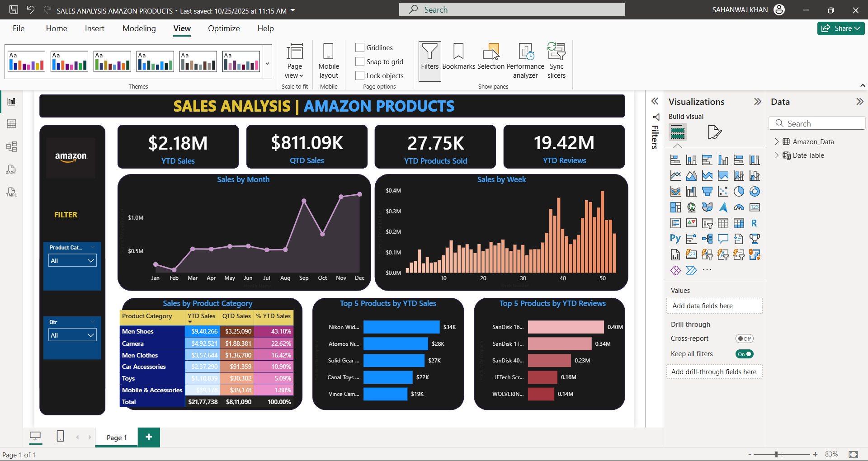

📈 **Figure 2: Category-wise Performance**

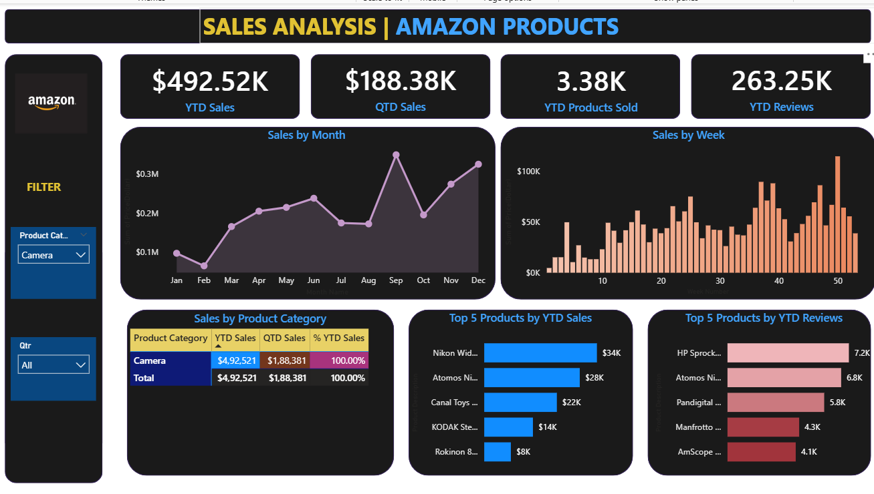

🖼️ **Figure 3: Top Products & Reviews**



🖼️ **Figure 4: Monthly & Weekly Trends**



🖼️ **Figure 5 : Sales by Product Category Table**

