# Pizza Sales Analysis Project Report

## 1. Introduction

This project focuses on analyzing Pizza Sales data using SQL for data extraction and Microsoft Power BI for visualization. The aim is to derive key business insights such as total revenue, total orders, average order value, and performance of various pizza categories and sizes.

## 2. Objectives

1. To analyze the pizza sales performance.  
2. To calculate KPIs like Total Revenue, Total Orders, Average Order Value, and Pizzas Sold.  
3. To visualize trends by day, month, category, and size.  
4. To identify best and worst performing pizzas by revenue, orders, and quantity.

## 3. SQL Queries Used for Analysis

### Total Revenue

* SELECT SUM(total_price) AS Total_Revenue FROM pizza_sales;

### Average Order Value

* SELECT (SUM(total_price) / COUNT(DISTINCT order_id)) AS Avg_order_Value FROM pizza_sales;

### Total Pizzas Sold

* SELECT SUM(quantity) AS Total_pizza_sold FROM pizza_sales;

### Total Orders

* SELECT COUNT(DISTINCT order_id) AS Total_Orders FROM pizza_sales;

### Average Pizzas Per Order

* SELECT CAST(CAST(SUM(quantity) AS DECIMAL(10,2)) / CAST(COUNT(DISTINCT order_id) AS DECIMAL(10,2)) AS DECIMAL(10,2)) AS Avg_Pizzas_per_order FROM pizza_sales;

## 4. Trend Analysis

A. Daily Trend for Total Orders:  
SELECT DATENAME(DW, order_date) AS order_day, COUNT(DISTINCT order_id) AS total_orders FROM pizza_sales GROUP BY DATENAME(DW, order_date);

B. Monthly Trend for Orders:  
SELECT DATENAME(MONTH, order_date) AS Month_Name, COUNT(DISTINCT order_id) AS Total_Orders FROM pizza_sales GROUP BY DATENAME(MONTH, order_date);

## 5. Sales by Category and Size

• % of Sales by Pizza Category  
• % of Sales by Pizza Size  
• Total Pizzas Sold by Pizza Category

## 6. Top and Bottom Pizzas Analysis

• Top 5 Pizzas by Revenue  
• Bottom 5 Pizzas by Revenue  
• Top 5 Pizzas by Quantity  
• Bottom 5 Pizzas by Quantity  
• Top 5 Pizzas by Total Orders  
• Bottom 5 Pizzas by Total Orders

## 7. Power BI Dashboard Overview

Two dashboards were designed in Power BI:  
1. Overall Pizza Sales Overview – showing KPIs, Daily & Monthly Trends, and Category Performance.  
2. Best/Worst Sellers Dashboard – showing Top and Bottom performing pizzas by revenue, quantity, and orders.

## 8. Key Insights

1. The highest number of orders occur during weekends.  
2. The ‘Classic’ category contributes the most to total revenue.  
3. Large-sized pizzas dominate sales in terms of revenue.  
4. July and January recorded maximum sales.  
5. The Thai Chicken Pizza is the best seller by revenue and orders.

## 9. Conclusion

The Pizza Sales Analysis provided actionable insights into business performance. It helped identify profitable categories and underperforming products. The analysis can guide marketing strategies, inventory management, and promotional decisions.

## 10. Dashboard Snapshots

Dashboard 1: Overall Sales Overview

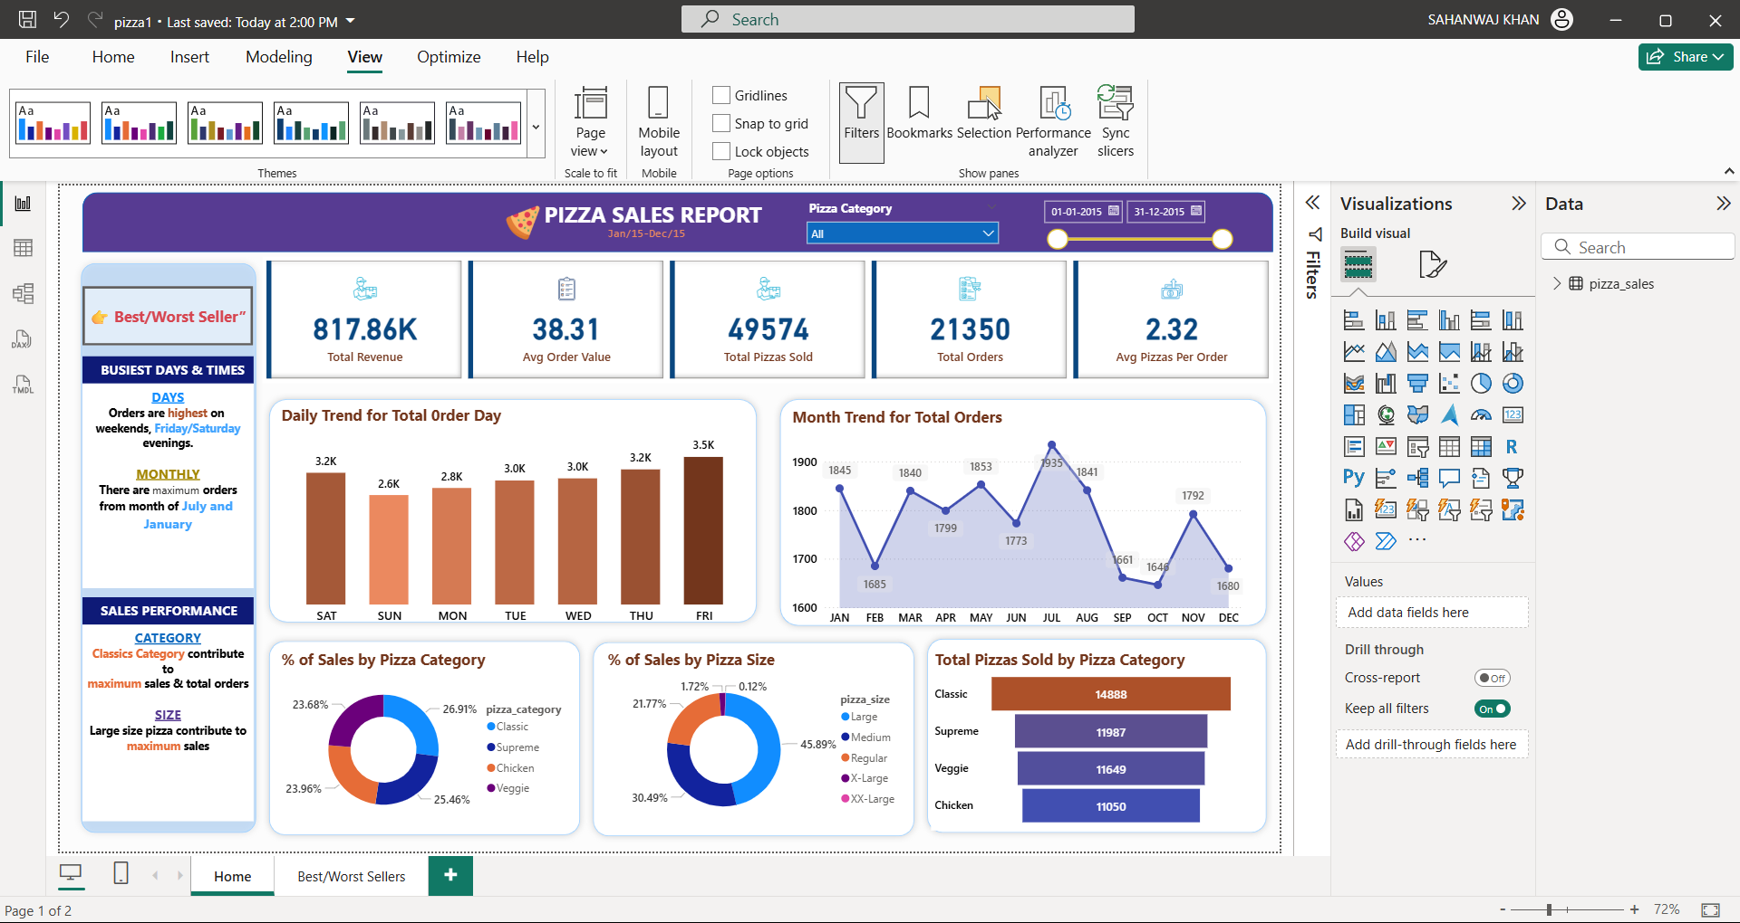

Dashboard 2: Best/Worst Sellers

