**Summary**

**Women in the Workforce - Data Analysis**

Contributors: Tamara Najjar, Mohammed Sajid Khan, Kathleen Graham

Per our analysis, we found that since the 1960s, there has been a noticeable influx of women in the workforce. The focus of our analysis is to dig deeper into this phenomenon and try to discover other societal and macro-economic changes that were possibly caused by more women contributing to the labor market.

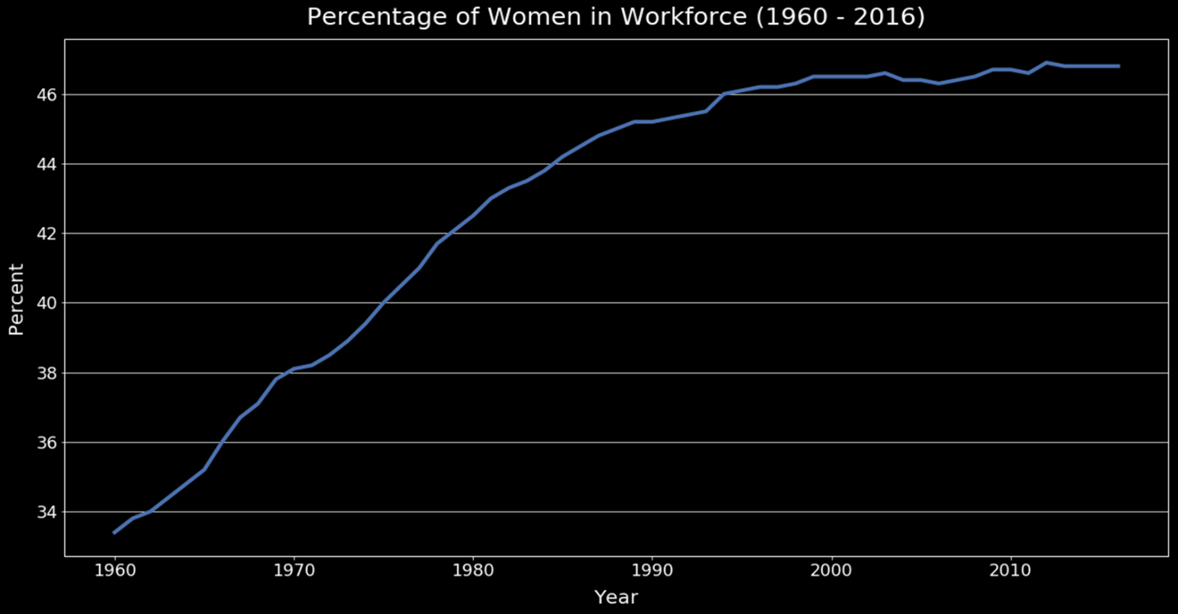

Data Exploration and Cleanup:

Once we found a good data set showing the percentage of women in the workforce over many decades, we plotted and easily saw a steady increase. Most of the data sets were messy, had more information than needed, or didn't have enough information. We had to rename, group, parse dates, find averages, and merge data sets in order to be able to plot together in a meaningful way.

There were many road blocks that we encountered during the clean-up process. Finding a credible data source was the first challenge that we had to solve. Once we had the data sets we had to use python code to map each column to a consistent format and naming convention. We had to drop rows that were skewing our results or were incomplete. During plotting we had to tackle creating a second axis to better represent our data visually. We optimized legends and added titles to our graphs as well. We explored and imported API data sets to further enrich our analysis. The API source only allowed each decade of data to be called at one time and thus we had to write code that would pull in multiple decades of data. We also made sure not to call on the API too many times or risk crossing our daily limit.

Data Sources:

We utilized the following governmental and public data sources to extract meaningful and credible data.

* <https://fred.stlouisfed.org/> (Federal Reserve Bank of St. Louis, Eight District)
* <https://www.dol.gov/> (U.S. Department of Labor)
* <https://statusofwomendata.org/> (Institute for Women’s Policy Research)
* <https://yhoo.it/2XJ4JvL> (Yahoo Finance)
* <https://catalog.data.gov/> (U.S. Department of Labor, Bureau of Labor Statistics)

Analysis:

After determining the participation of women in the labor force has definitely increased, we also explored how this varies across different age and racial groups.

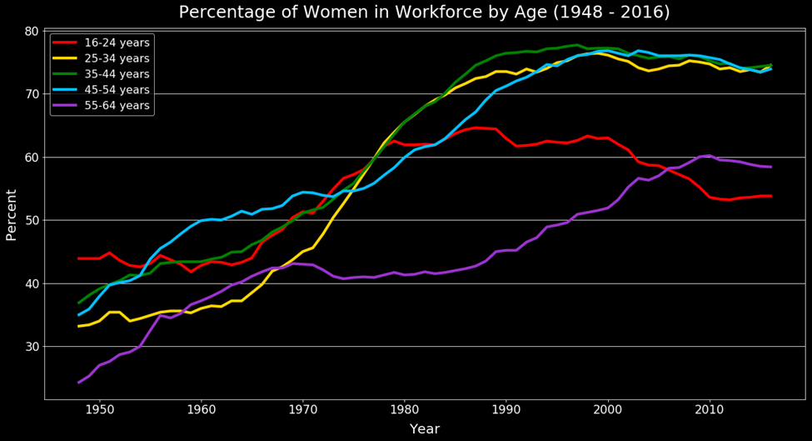

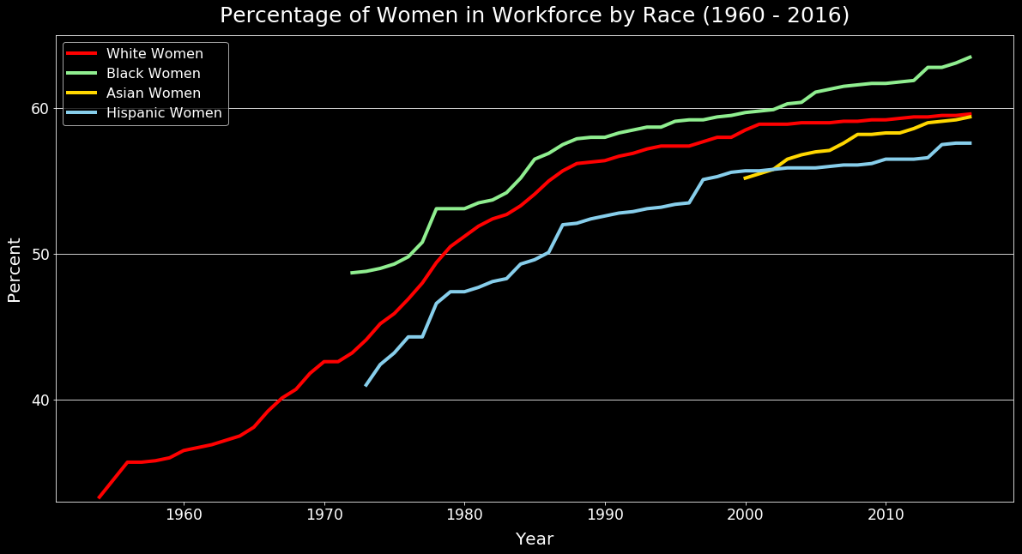

Per our data sources, the rate of increase of the participation of women in the US workforce is not driven by any individual race or age group. The incline is across the board, women of all ages, and women across various demographics entering the work force.

Societal Changes:

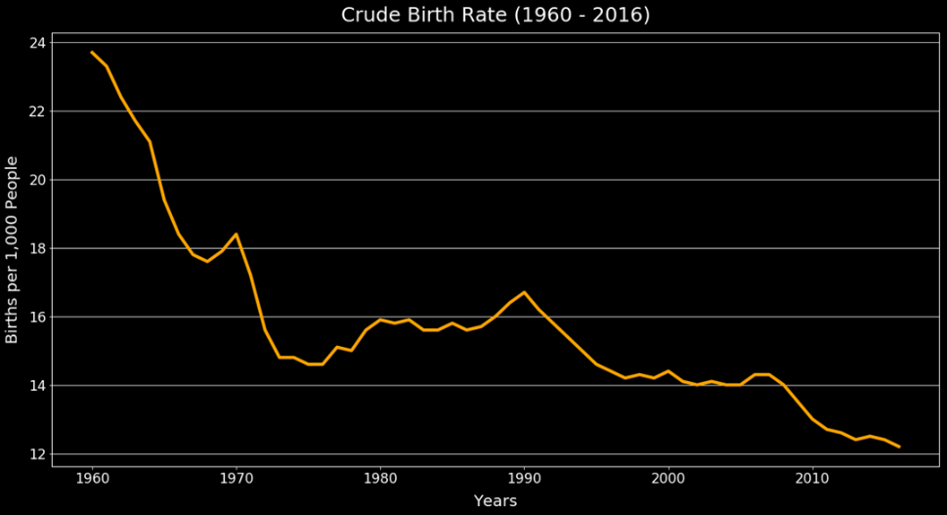

As we explored our data further, we analyzed the US crude birth rate and found that around the same time as when we noticed the spike in number of women entering workforce, the birth rate has started to drop significantly in the US. We wanted to confirm that working women were still having babies.

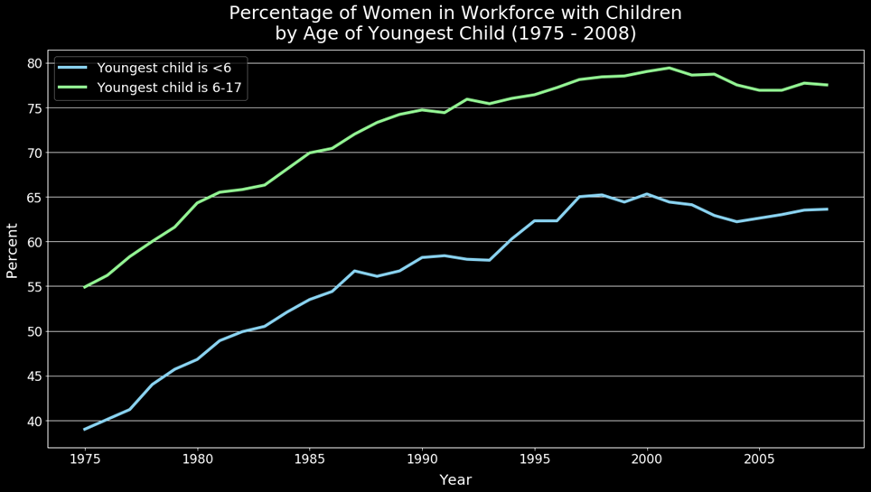

Per our data we confirmed that, women are still having babies and they are returning to full-time employment post-pregnancy at a much higher rate than previous generations did.

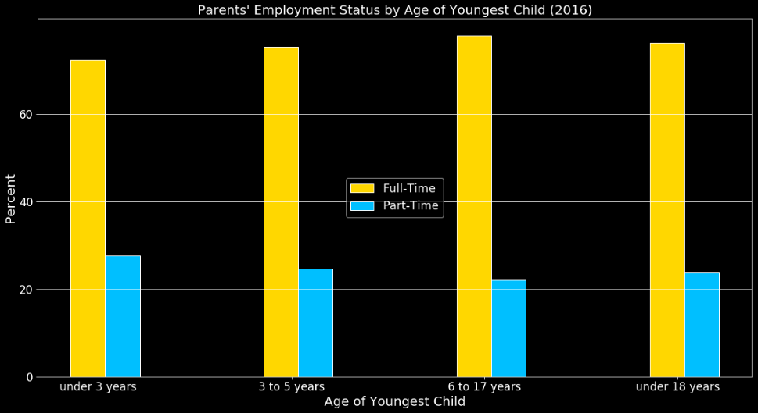

Economic Factors:

Naysayers argue that having more women in the workforce has contributed to the increase in the cost to employ now versus in the previous generation. We found that this statement is factual. The average hourly cost per employee has increased since the 1960s due to the increase in legally required benefits that are now available to the workforce.

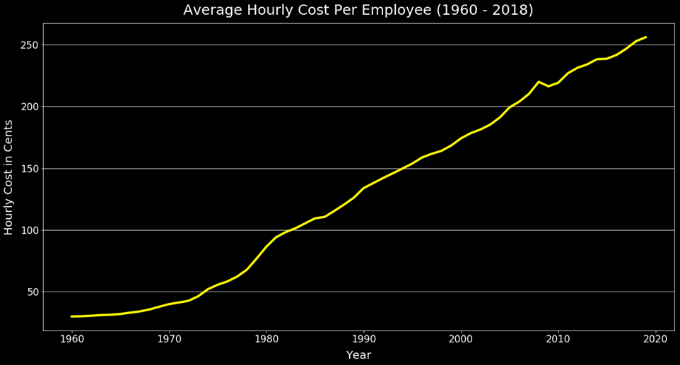

As you will see in the following graph, our analysis confirms that this increase in expense is outweighed by the fact that US GDP and the S&P500 value have both increased. This suggests having women in the workforce has made our country more productive and that Wall Street has also benefitted from such a diverse workforce.

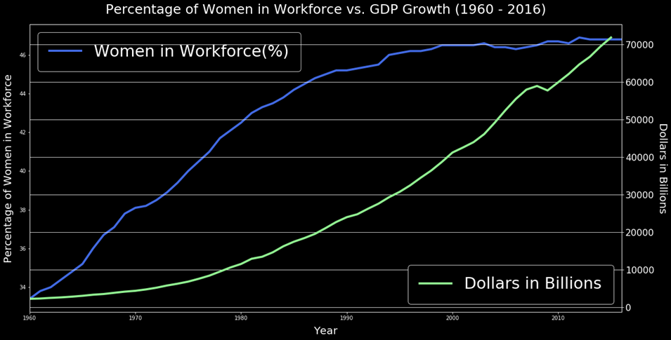

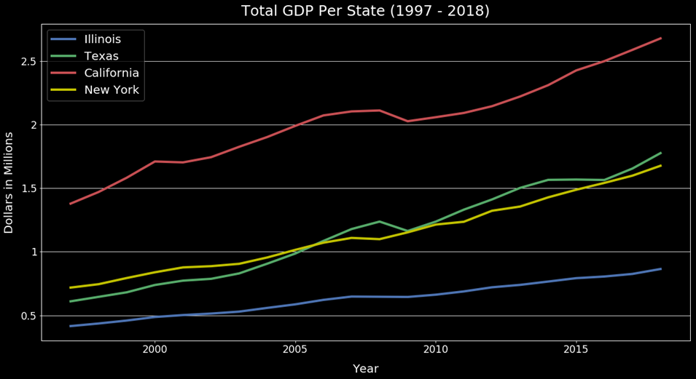

Not only has the overall GDP of the country increased, but individual states have also experienced growth in the form of growing state productivity.

More Household Income:

With more women in the workforce it is safe to assume that the household income in the US has increased as well. Thus, we explored US commerce data and found certain industries that have had a significantly stronger demand due to women being employed and birth rates falling.

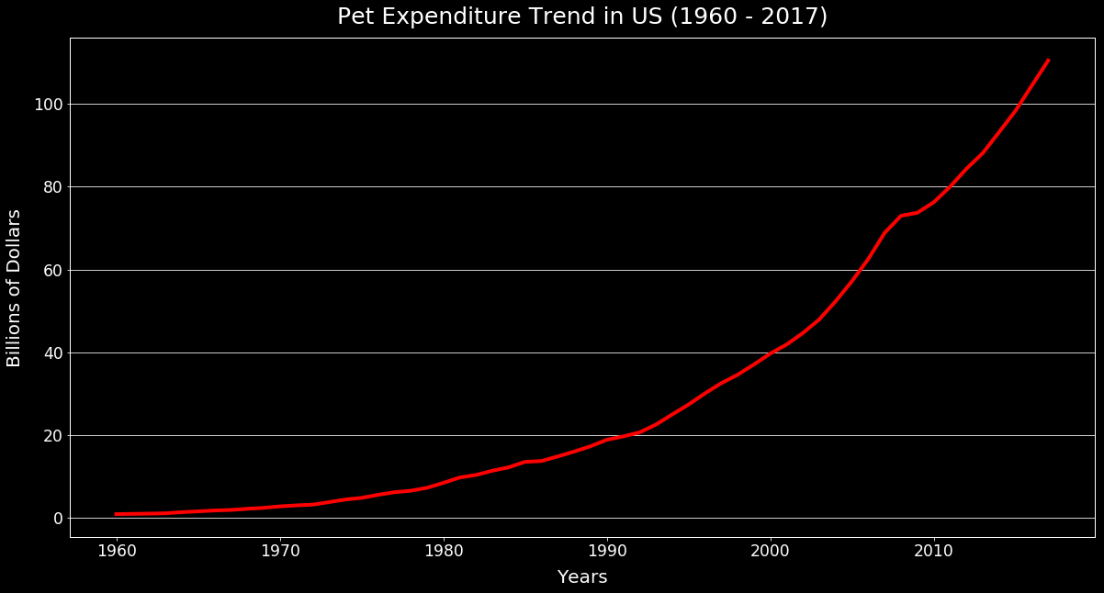

Interestingly, the pet industry has almost the same trajectory of incline as the number of women in the workforce and inverse to the US crude birth rate. It may not be too much of a conjecture to suggest that people are replacing having babies with having pets.

Future Considerations:

Given more time we would also like to investigate other factors such as :

* Diving into the demographics of pet owners (i.e. age, income, etc.).
* Identifying what other factors have contributed to increased pet expenditure.
* Exploring additional functionality of Python, pandas, NumPy, Matplotlib, and other libraries.
* Exploring ways to present more data at one time (i.e. state data over time).
* Exploring what other factors have contributed to a declining birth rate (i.e. accessibility to birth control).
* Exploring what other factors have contributed to an increase in GDP (i.e. technology/automation).
* Exploring additional effects of increased women in the workplace (i.e. divorce rates, average age of women at marriage, etc.).
* Exploring if there are any contributing health factors to increased women in the workplace (i.e. mental health, physical health, etc.).