# **CREATING A VPC & ITS COMPONENTS IN AWS**

**STEP 1: login to aws account**

**STEP 2:** Now click sign in AWS console & log into AWS console using the username & password.

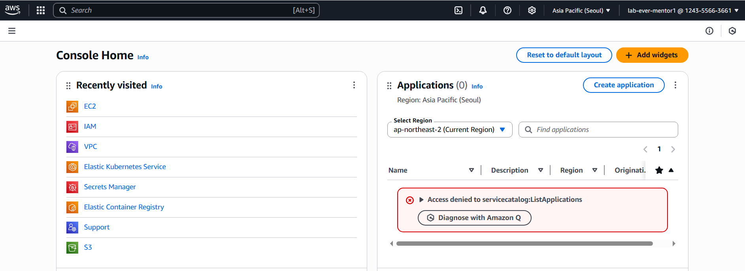

**CREATING VPC:**

**STEP 1:** After aws log in , click on VPC. In VPC home page, click create VPC.

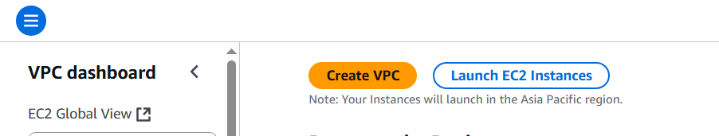

**STEP 2:** Now select VPC only option . give any name to the VPC . 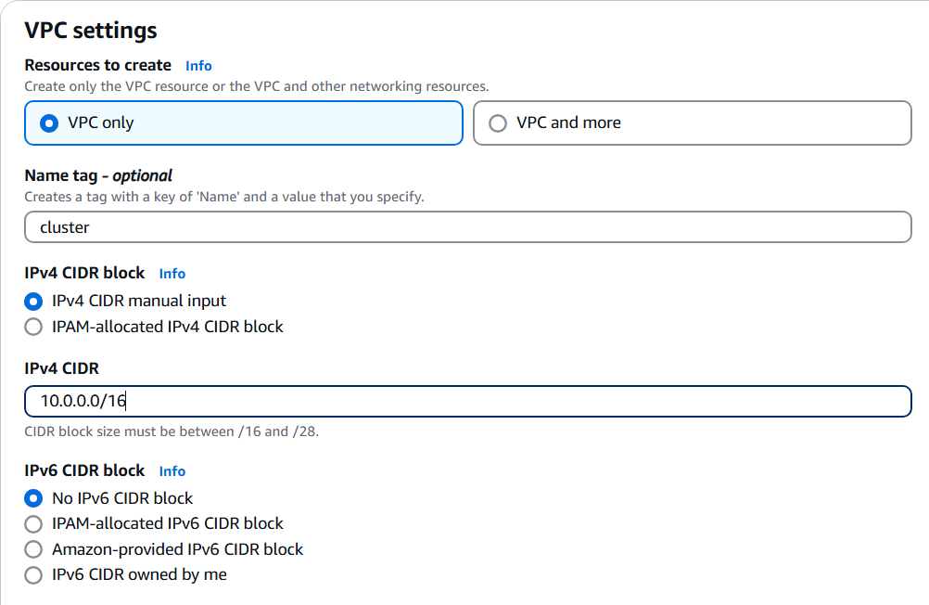

**STEP 3:** Give default under tenancy because determined costs.

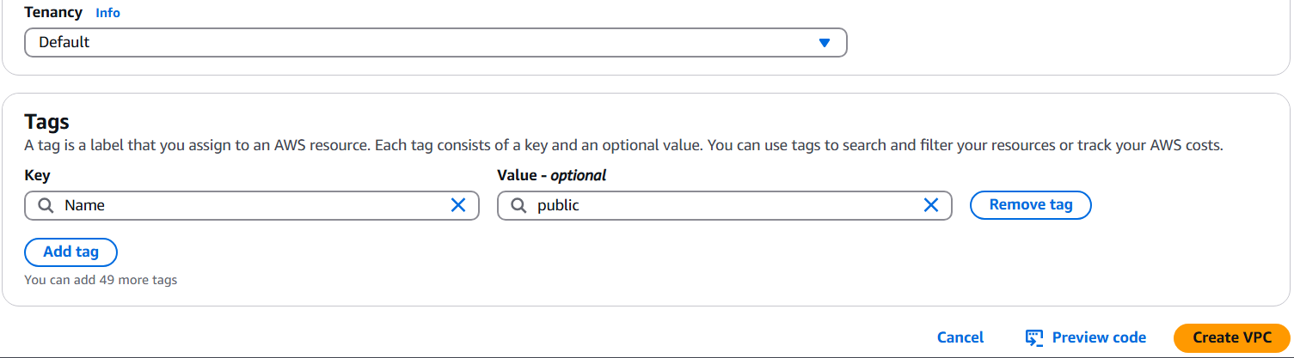

**CREATING SUBNET( PUBLIC) :**

**STEP 1:** Go to subnet option in the left . create subnet . select the created VPC under VPC ID .

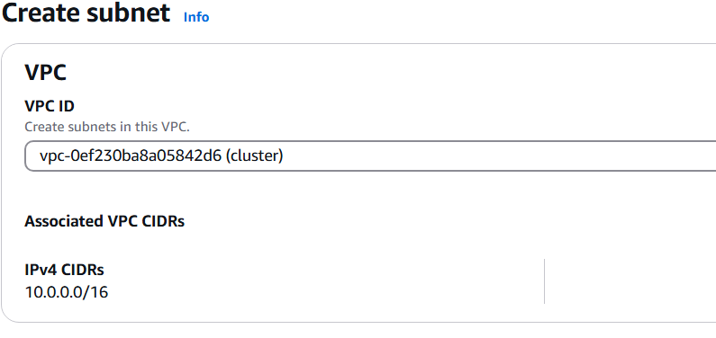

**STEP 2:** Then go to subnet settings & fill the details like this.Then click create subnet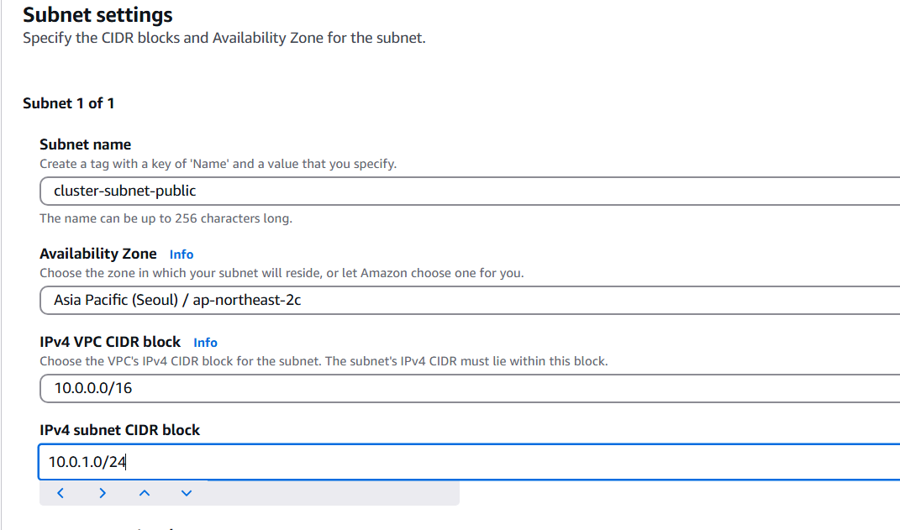

**CREATING SUBNET ( PRIVATE):**

**STEP 1:** Same process is followed as how we created public subnet but name is changed.

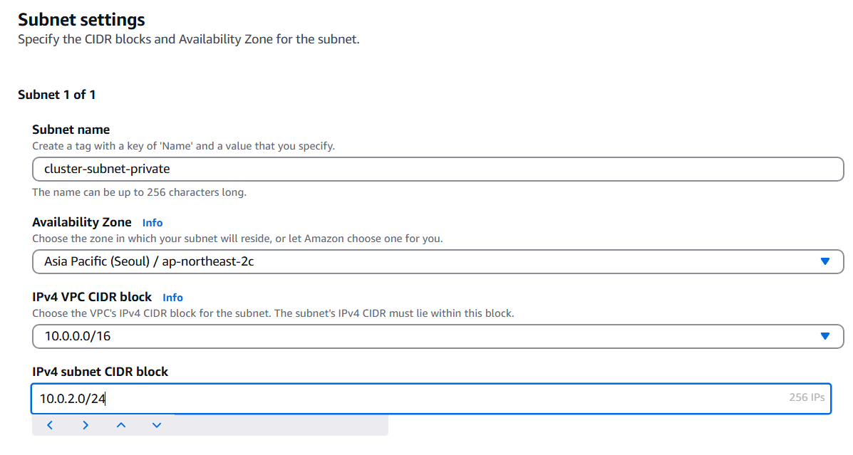

**CREATING INTERNET GATEWAY:**

**STEP 1:** Go to the home page of VPC . select internet gateway option on left side. Click create internet gateway. Give name & click create internet gateway.

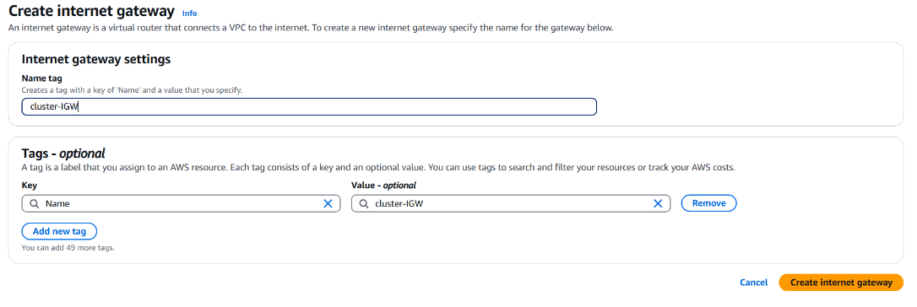

**STEP 2:** After creating , we see a notification asking to attach VPC . click on it & attach to the created VPC .

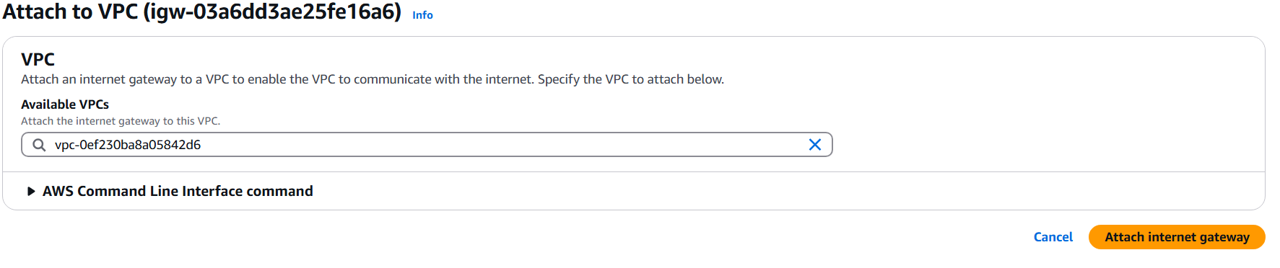

**CREATING NAT GATEWAY:**

**STEP 1:** Go to the home page of VPC . Select the option NAT gateway from left side. Give name & select subnet cluster of public , connectivity type must be public because private type is not supported. Click allocate elastic ip . click create NAT gateway.

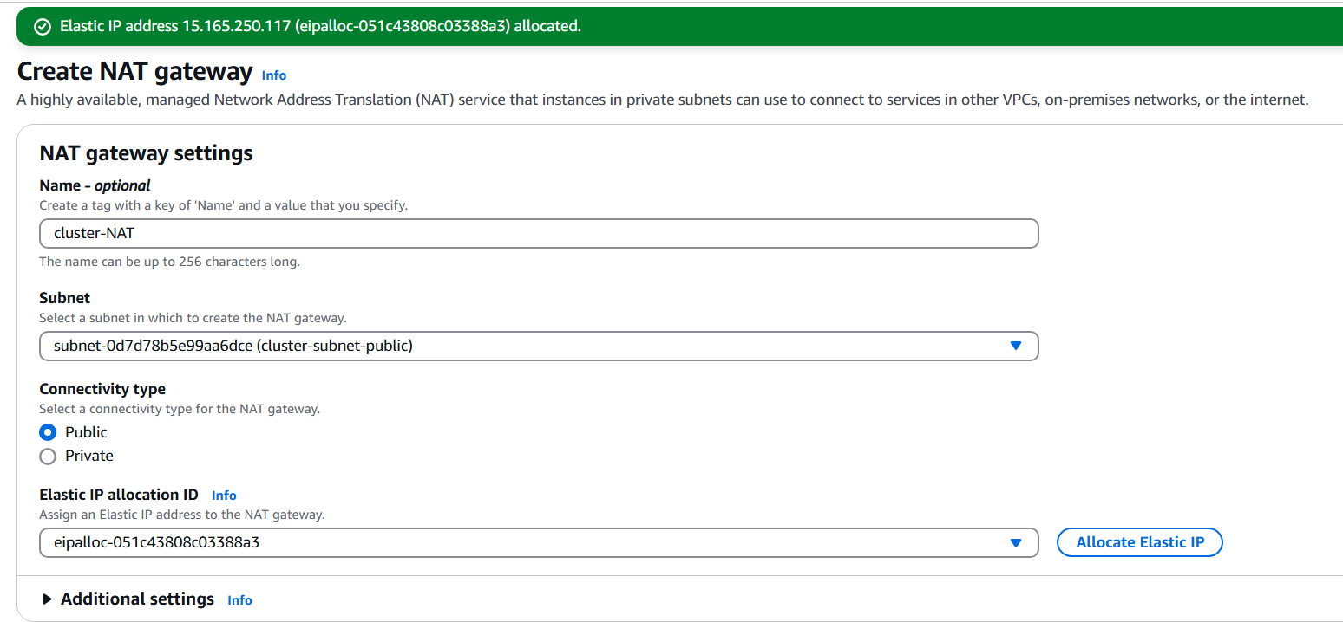

**CREATING ROUTE TABLE (PUBLIC):**

**STEP 1:** Go to route table . click create route table. Fill the details & click create route table.

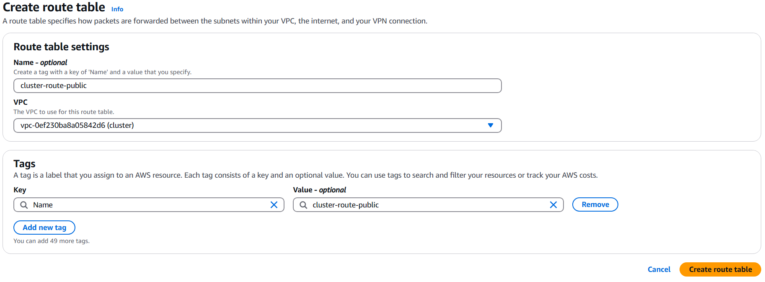

**STEP 2:** Go to homepage of route table. Click on the route created & click on edit routes .

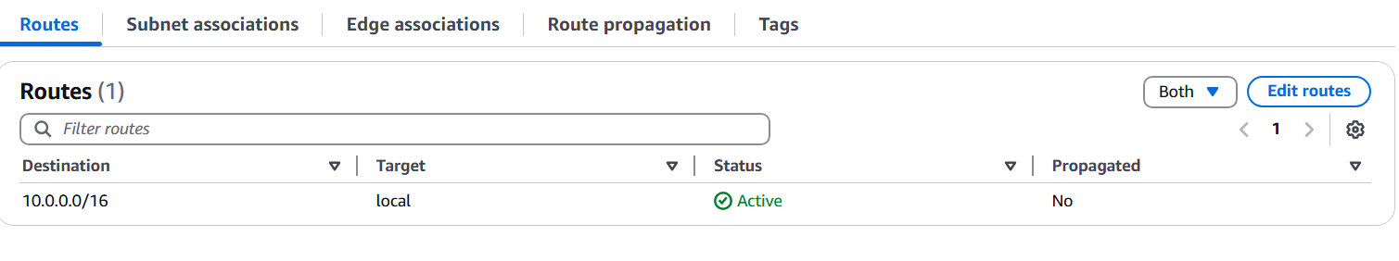

**STEP 3:** Then in that click add route.

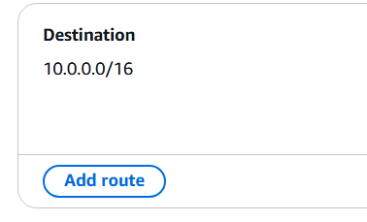

**STEP 4:** Give the details like this. We have to give internet gateway because it is public route map. After that click save changes.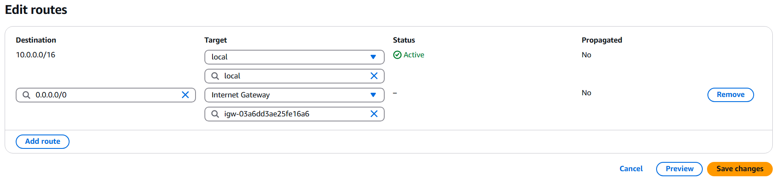

**CREATING ROUTE TABLE(PRIVATE):**

**STEP 1:** Everything is as same as public route table but here we give the route name as private & NAT instead of internet gateway.

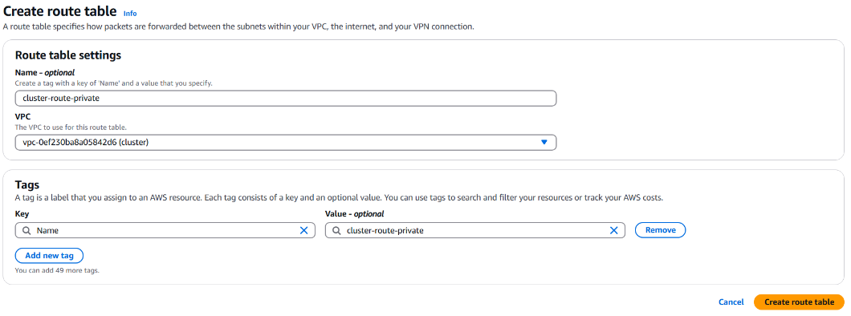

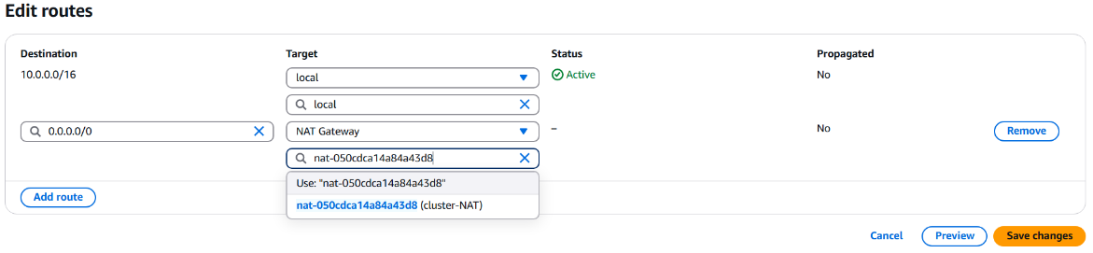

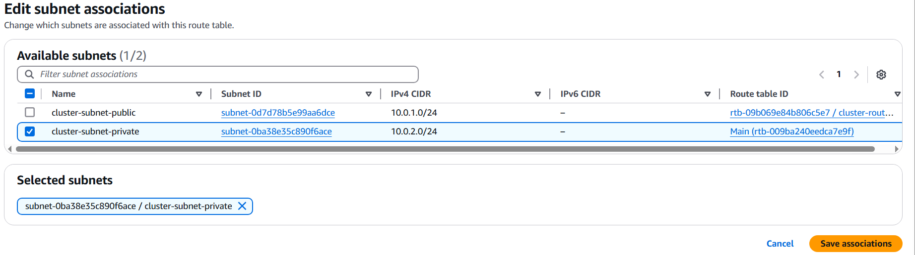

**ADDING ROUTE TABLE TO SUBNET (PUBLIC):**

**STEP 1:** Click on the route table (public) . besides that there is actions option . click it.



**STEP 2:** Under actions options , click edit subnet associations option .

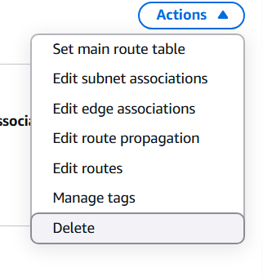

**STEP 3:** Select public route . click save associations & Same process for private also.

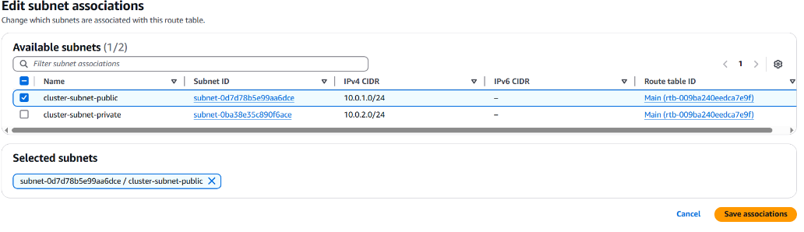

**CREATING EC2 INSTANCE :**

**STEP 1:** Go to aws console homepage. Click EC2 option .This is the home page of EC2 . now click on launch instance which is on the right side.

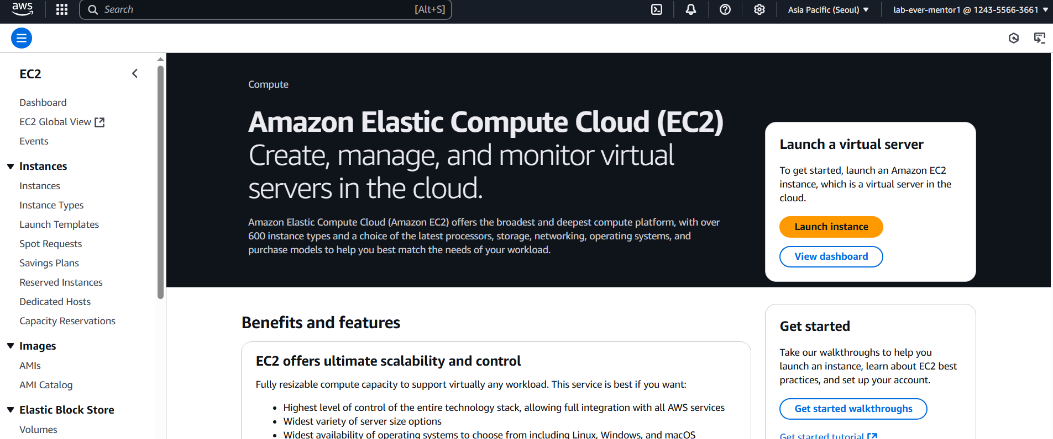

**STEP 2 :** Click launch instance option. Give name & select Ubuntu as AMI & Ubuntu server SSD volume type.

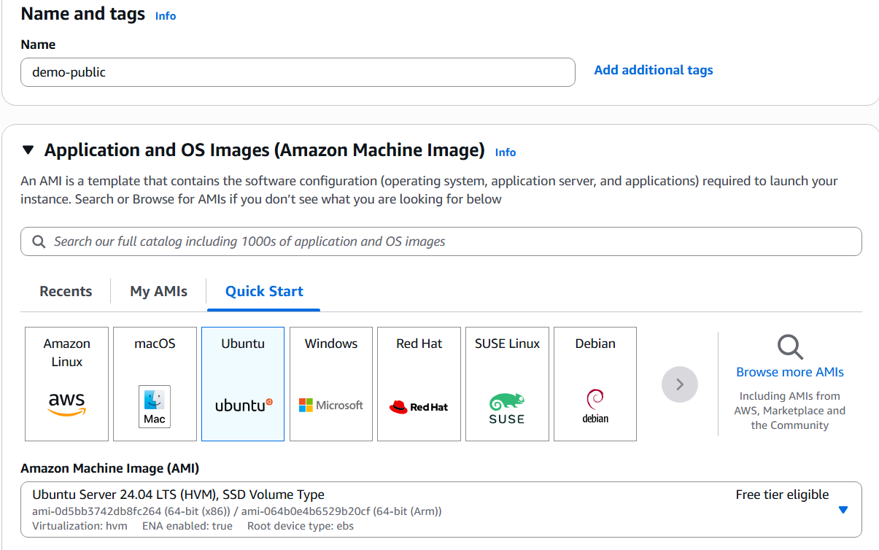

For private :

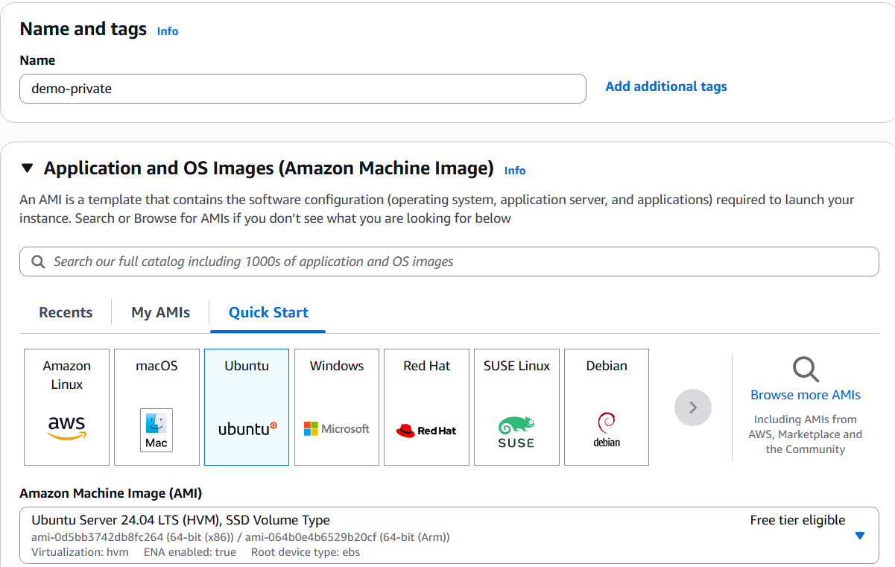

**STEP 3:** Select instance type as shown below for both public & private.

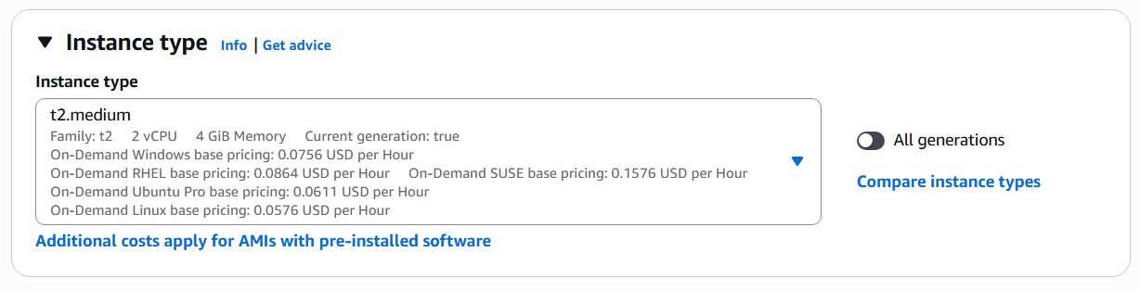

**STEP 4:** Create a keypair for any one of the instance & use that keypair to the other also.

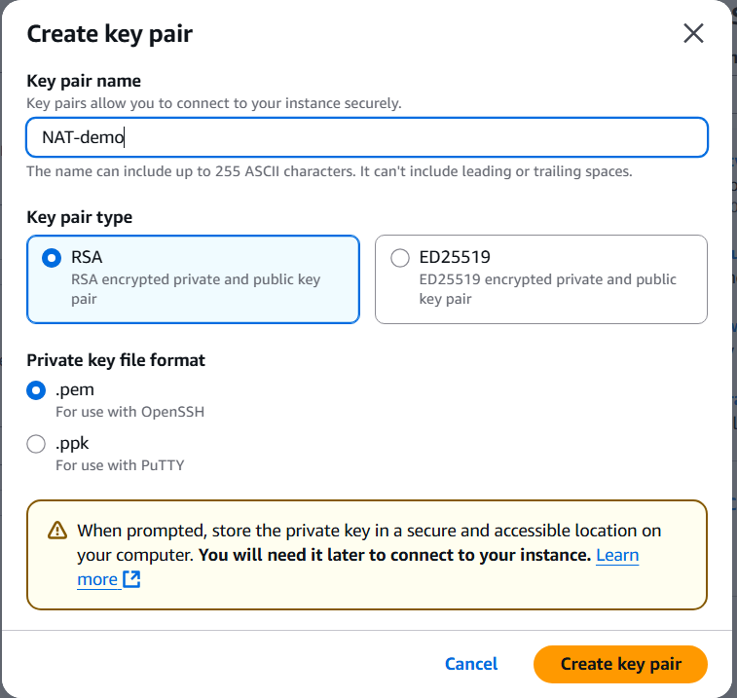

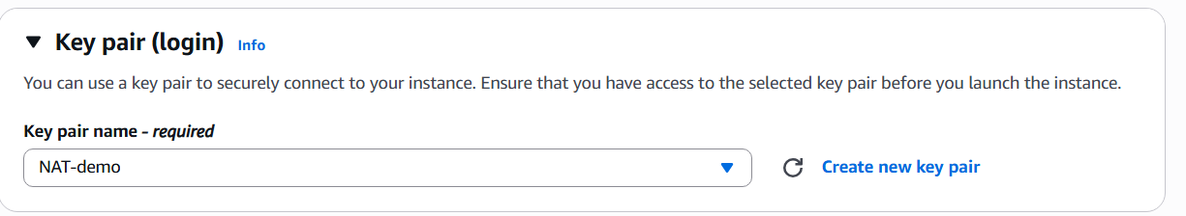

**STEP 5:** Under network settings , select created VPC , subnet of public for public instance & subnet of private for private instance.

For public:

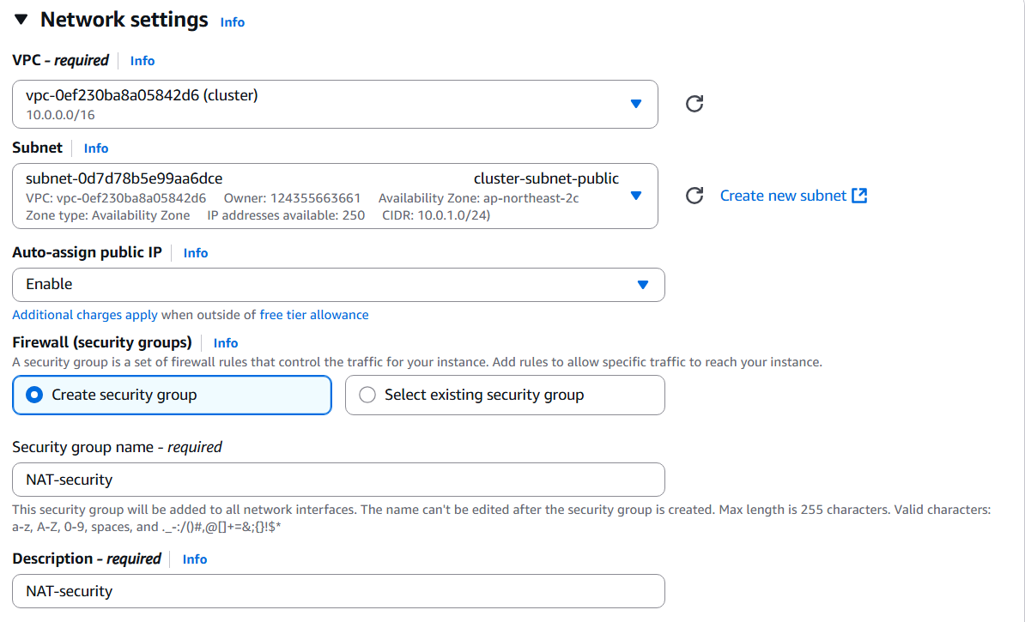

For private :

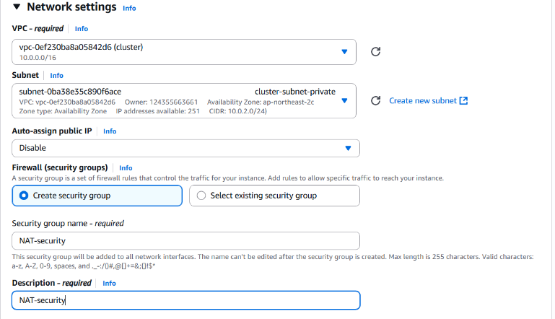

Common for both:

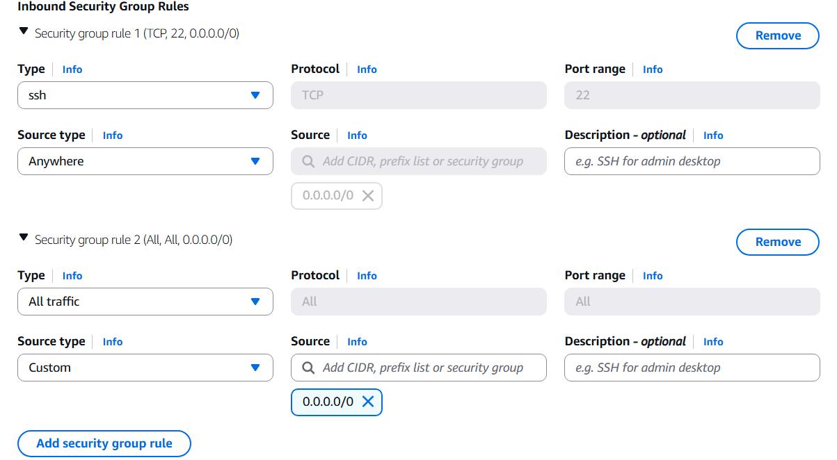

**STEP 6:** Select the configuration storage between 15 – 20 GIB .

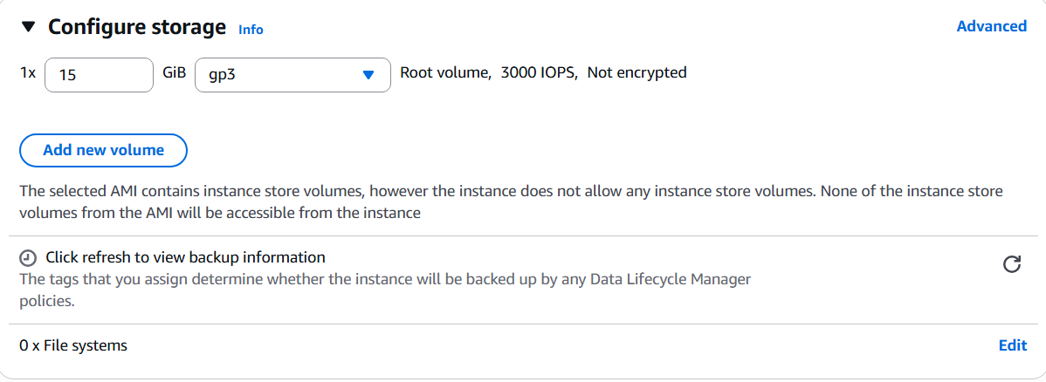

**STEP 7:** Under additional details, paste this data & click launch instance.

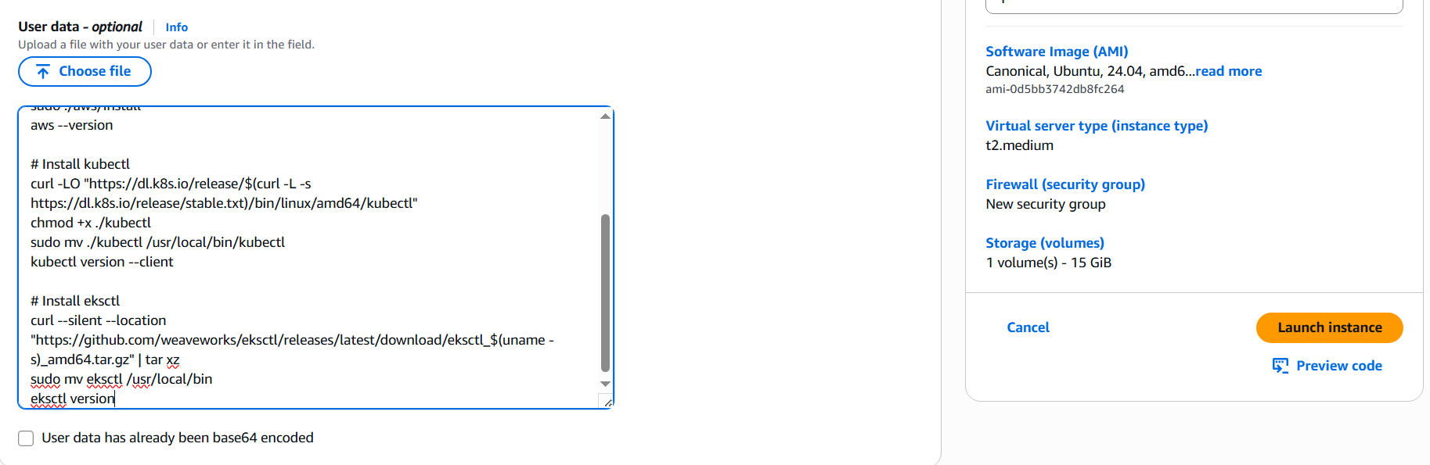

**CREATING CLUSTER USING TUNNELING PROCESS :**

**STEP 1:** Go to the path of the pem file . click command ls to check whether the file is existed or not.

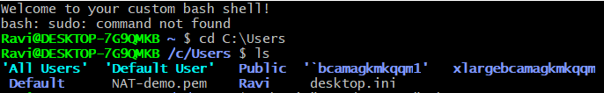

**STEP 2:** Now the commandused here is of public ip address of the public instance.

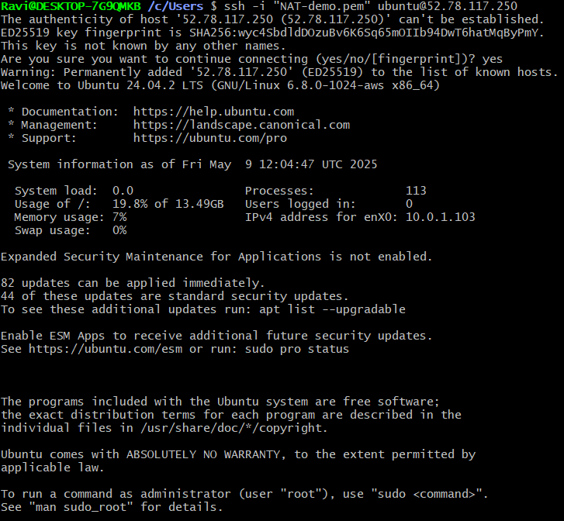

**STEP 3:** Go to root user by typing the command sudo su. Then give the command to give the pem key & check whether the pem file is read or not.

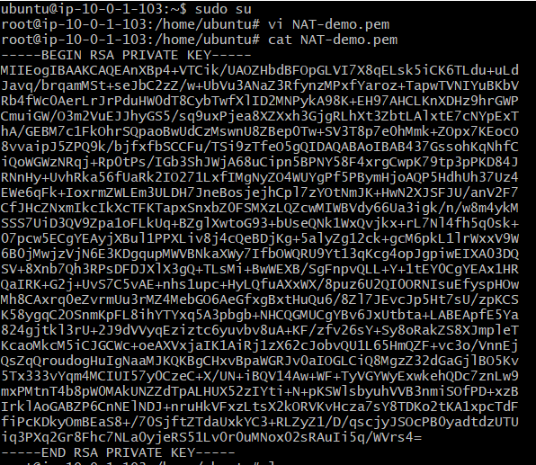

This is to read the .pem file .

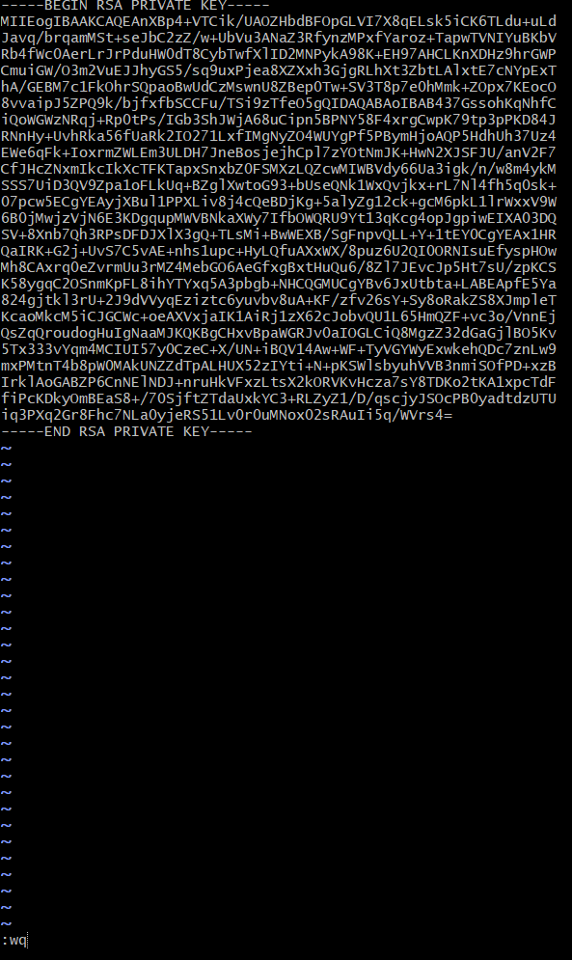

**STEP 4:** Check whether the .pem file is in the device or not.



**STEP 5:** Now give the commands of private ip address of private instance.

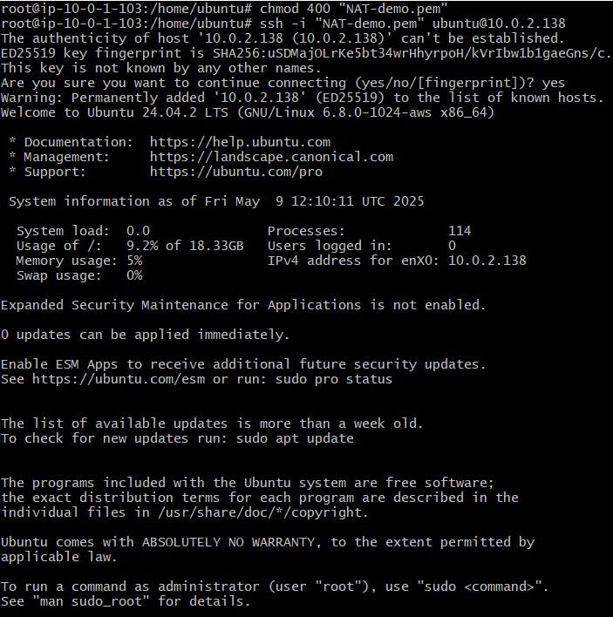

**STEP 6:** Now go to root user & install aws.

