STEPS TO WORK WITH SNOWFLAKE

CREATE WORKSPACE
CREATE DATABASE
CRETAE SCHEMA
CREATE DATAWAREHOUSE
-- create DB / schema
CREATE OR REPLACE DATABASE demo_db;
CREATE OR REPLACE SCHEMA demo_db.demo_schema;

-- create a small warehouse to use
CREATE OR REPLACE WAREHOUSE demo_whTESTING.PUBLIC
WAREHOUSE_SIZE = 'XSMALL'
AUTO_SUSPEND = 60
AUTO_RESUME = TRUE;
USE WAREHOUSE demo_wh;
USE DATABASE demo_db;
USE SCHEMA demo_schema;

SHOW WAREHOUSES;
SELECT CURRENT_WAREHOUSE(), CURRENT_DATABASE(), CURRENT_SCHEMA();

CRETAE STAGING AREA;-
CREATE OR REPLACE STAGE bronze_cus_stg;
UPLOAD RAW FILES IN TO STAGING ARES
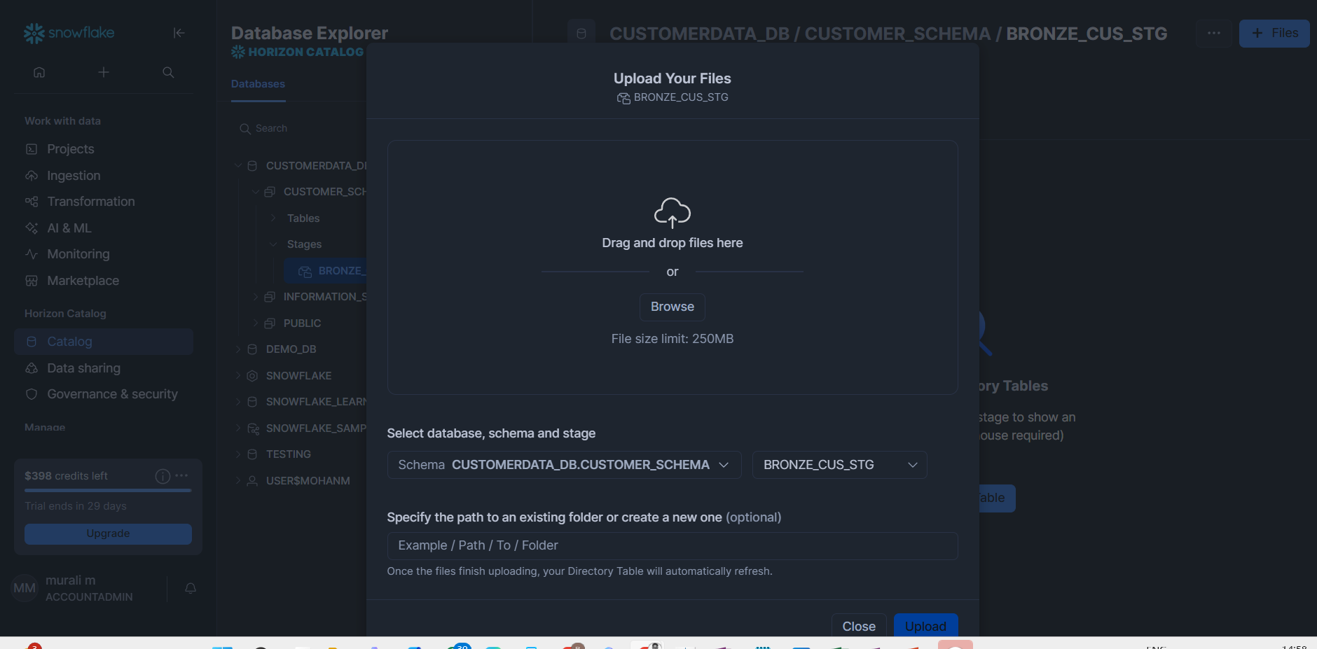

CHECK FILES UPLOADED OR NOT
LIST @STAGING_NAME;-

CREATE TABLE (permanent/temp/transi)

CREATE OR REPLACE TABLE customers (
id INT,
name STRING,
email STRING,
country STRING
);

Copy data from staging to tables..>

COPY INTO customers
FROM @mystage/customers.csv
FILE_FORMAT = (TYPE = CSV FIELD_DELIMITER = ',' SKIP_HEADER = 1)
ON_ERROR = 'ABORT_STATEMENT';

SELECT * FROM customers;

Integrate with cloud :

Create file format object:
CREATE OR REPLACE FILE FORMAT csv_ff
TYPE = 'CSV' FIELD_DELIMITER = ',' SKIP_HEADER = 1
NULL_IF = ('NULL', 'null', '');

CREATE OR REPLACE FILE FORMAT json_ff
TYPE = 'JSON'
STRIP_OUTER_ARRAY = TRUE
IGNORE_UTF8_ERRORS = TRUE
COMPRESSION = 'AUTO';

CREATE OR REPLACE FILE FORMAT parquet_ff
TYPE = 'PARQUET'
COMPRESSION = 'AUTO'
BINARY_AS_TEXT = FALSE;

CREATE OR REPLACE FILE FORMAT avro_ff
TYPE = 'AVRO'
COMPRESSION = 'AUTO';

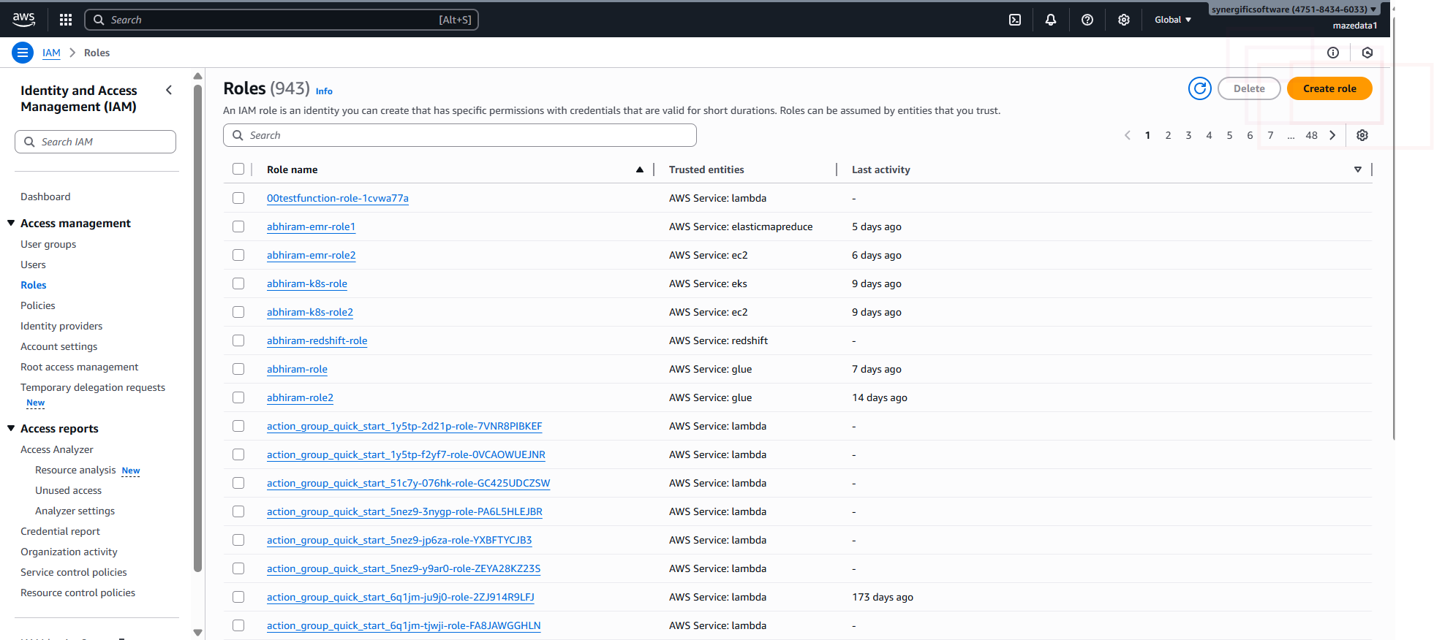
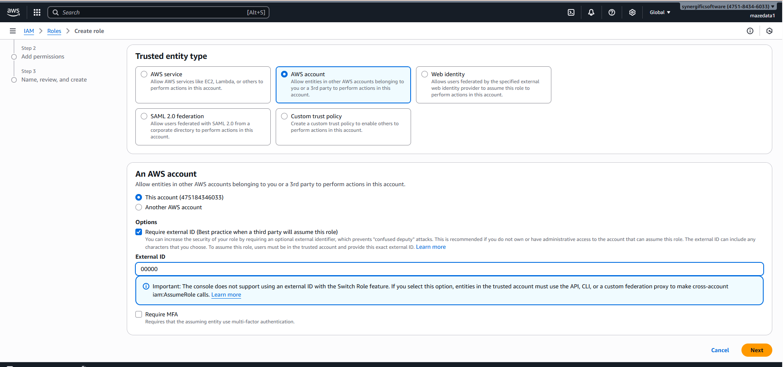

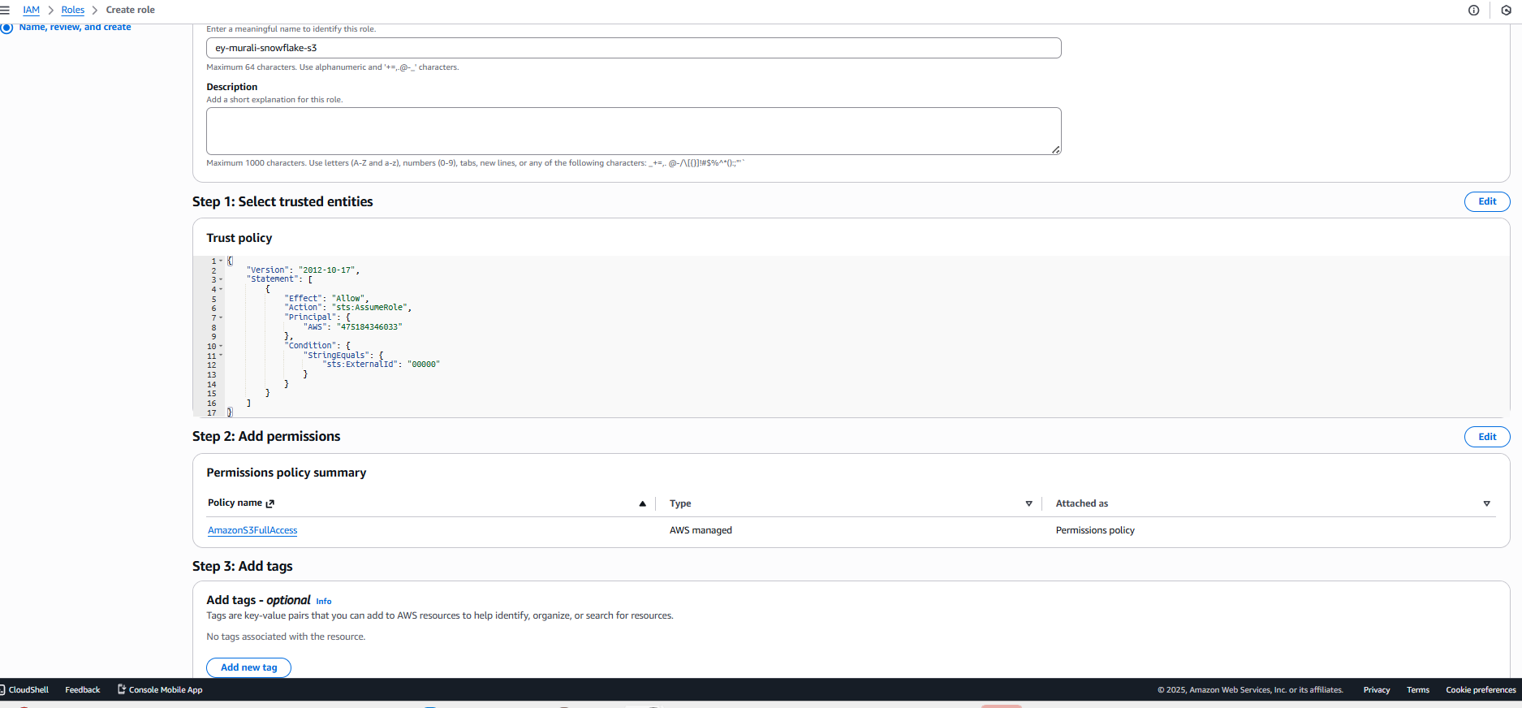

CREATE S3 BUCKET

CREATE OR REPLACE STORAGE INTEGRATION s3int
TYPE = EXTERNAL_STAGE
STORAGE_PROVIDER = 'S3'
ENABLED = TRUE
STORAGE_AWS_ROLE_ARN = 'arn:aws:iam::475184346033:role/ey-murali-snowflake-s3'
STORAGE_ALLOWED_LOCATIONS = ('s3://snf-murali-customer/raw/');

DESC STORAGE INTEGRATION s3int;

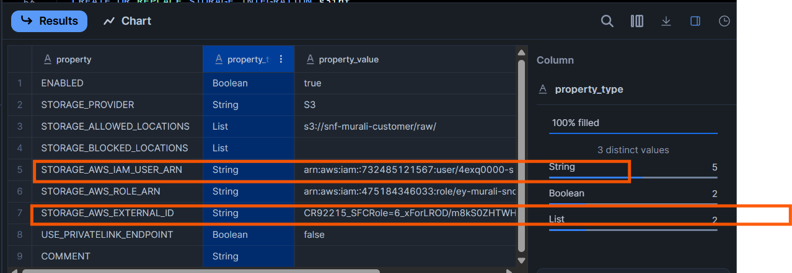

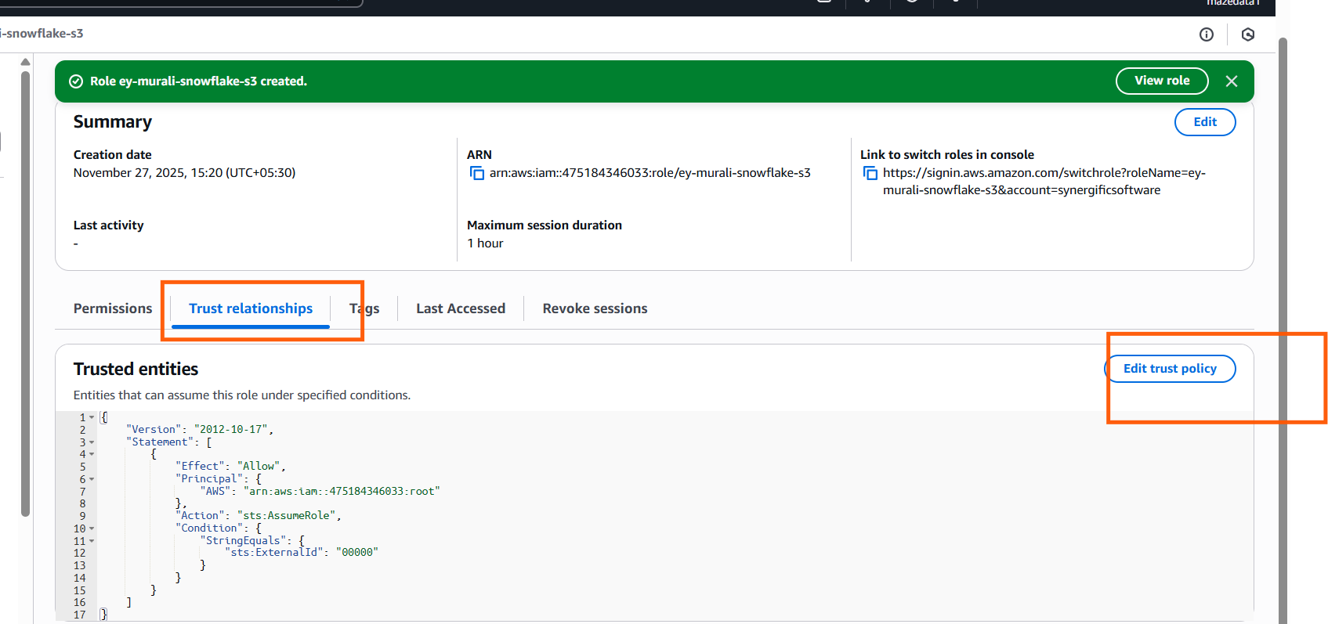
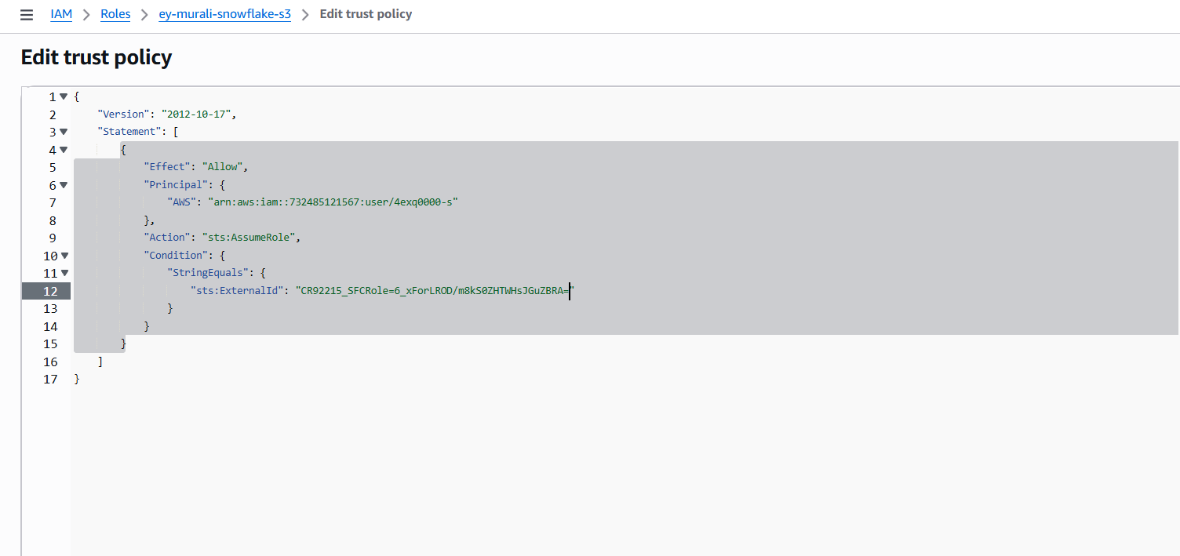

SQL QUERIES WITH SNOWFLAKE COPY DATA FROM LOCAL STAGE TO TAABLES AND CLOUD INTEGRATION
use role accountadmin;
use warehouse compute_wh;
-- create DB / schema
CREATE OR REPLACE DATABASE demo_db;
CREATE OR REPLACE SCHEMA demo_db.demo_schema;

-- create a small warehouse to use
CREATE OR REPLACE WAREHOUSE demo_whTESTING.PUBLIC
WAREHOUSE_SIZE = 'XSMALL'
AUTO_SUSPEND = 60
AUTO_RESUME = TRUE;
USE WAREHOUSE demo_wh;
USE DATABASE demo_db;
USE SCHEMA demo_schema;

SHOW WAREHOUSES;
SELECT CURRENT_WAREHOUSE(), CURRENT_DATABASE(), CURRENT_SCHEMA();

CREATE OR REPLACE TABLE customers (
id INT,
name STRING,
email STRING,
country STRING
);
LIST @mystage;

COPY INTO customers
FROM @mystage/customers.csv
FILE_FORMAT = (TYPE = CSV FIELD_DELIMITER = ',' SKIP_HEADER = 1)
ON_ERROR = 'ABORT_STATEMENT';

SELECT * FROM customers;

CREATE OR REPLACE FILE FORMAT csv_ff
TYPE = 'CSV' FIELD_DELIMITER = ',' SKIP_HEADER = 1
NULL_IF = ('NULL', 'null', '');

CREATE OR REPLACE FILE FORMAT json_ff
TYPE = 'JSON'
STRIP_OUTER_ARRAY = TRUE
IGNORE_UTF8_ERRORS = TRUE
COMPRESSION = 'AUTO';

CREATE OR REPLACE FILE FORMAT parquet_ff
TYPE = 'PARQUET'
COMPRESSION = 'AUTO'
BINARY_AS_TEXT = FALSE;

CREATE OR REPLACE FILE FORMAT avro_ff
TYPE = 'AVRO'
COMPRESSION = 'AUTO';

USE ROLE ACCOUNTADMIN;

CREATE OR REPLACE STORAGE INTEGRATION s3int
TYPE = EXTERNAL_STAGE
STORAGE_PROVIDER = 'S3'
ENABLED = TRUE
STORAGE_AWS_ROLE_ARN = 'arn:aws:iam::475184346033:role/ey-murali-snowflake-s3'
STORAGE_ALLOWED_LOCATIONS = ('s3://snf-murali-customer/raw/');

DESC STORAGE INTEGRATION s3int;

CREATE OR REPLACE STAGE murali_s3_stage
STORAGE_INTEGRATION=s3int
URL='s3://snoflake-mike/raw/'
FILE_FORMAT = csv_ff;
LIST @murali_s3_stage;

COPY INTO customers
FROM @murali_s3_stage
FILE_FORMAT = (FORMAT_NAME = csv_ff)
ON_ERROR = 'CONTINUE';

SELECT COUNT(*) FROM customers;

CREATE OR REPLACE STAGE mystage;

