Azure Networking

Big Picture (Explain FIRST to students)
Before diving into each topic, explain this story:
“In Azure, a VNet is like our own private city.
Inside the city, we create subnets (areas).
Some areas are public, some are private.
To go outside the city, we need Internet Gateway (IGW) or NAT Gateway.
Route tables decide where traffic goes.
NSG is the security guard.
Elastic IP (Public IP) is the fixed address of our building.”

Virtual Network (VNet)

What is a VNet?
A VNet is a private network in Azure where you launch resources.

Why do we need it?
- Network isolation
- Control IP ranges
- Secure communication between resources

Real-world analogy
A gated community

Azure Portal (Console) – Create VNet
- Azure Portal → Create a resource
- Search Virtual Network
- Click Create
- Fill:
  - Name: my-vnet
  - Address space: 10.0.0.0/16
  - Resource Group
- Click Review + Create
Done
- Configure following details as per below images
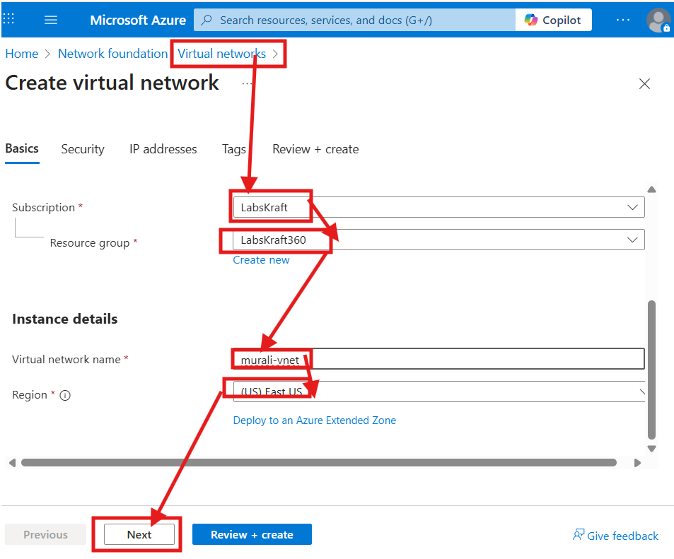

- Configure following details
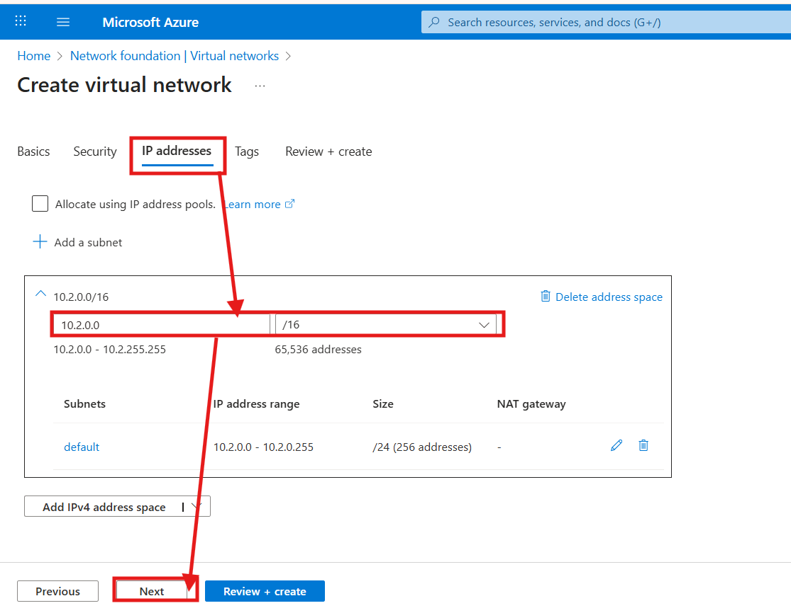

- Click on create
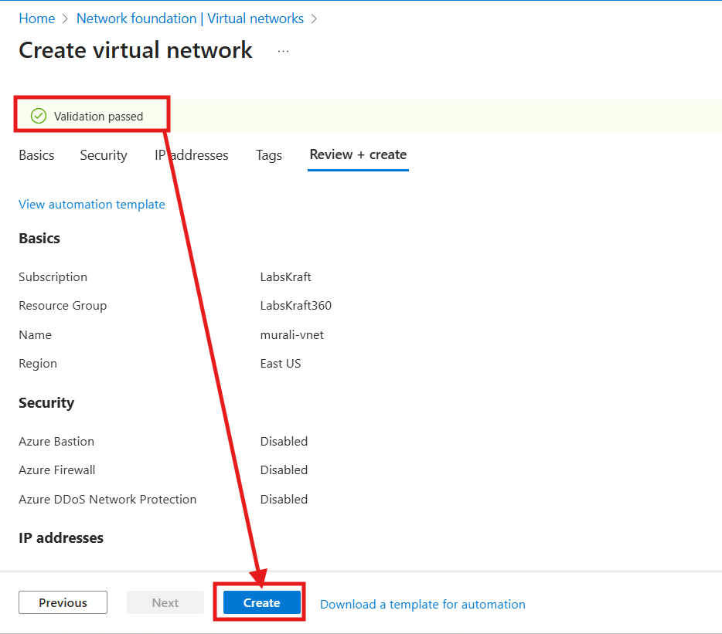
- Vnet got created
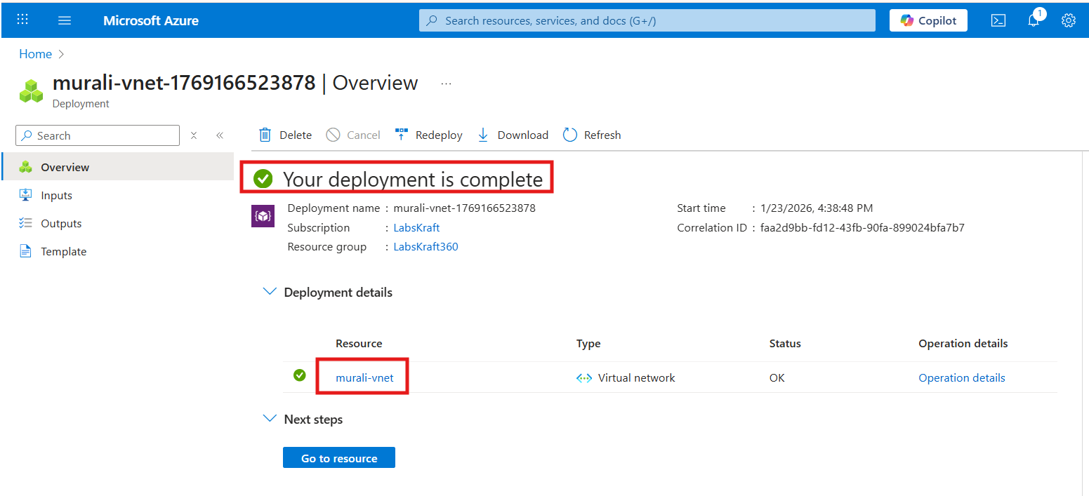
- All details of vnet after its creation
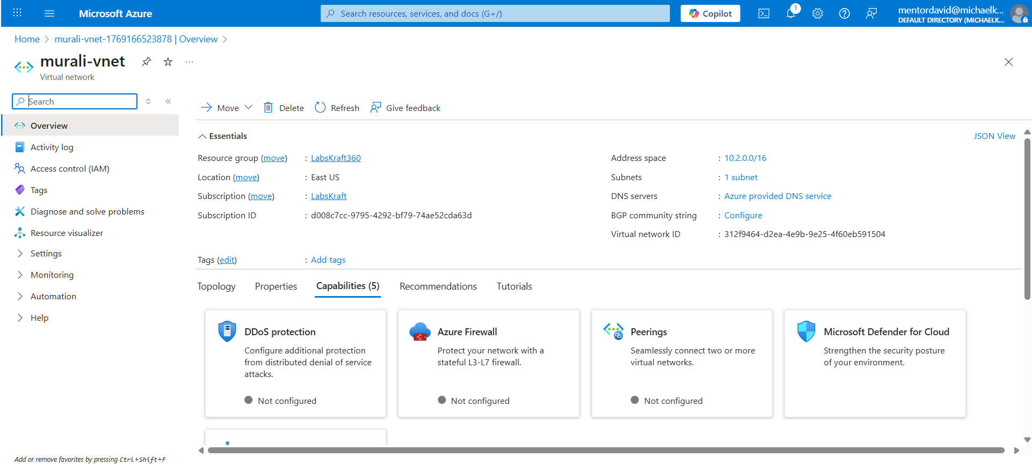

Subnets (Public & Private)

What is a Subnet?
A subnet is a smaller network inside a VNet.

Public Subnet
- Can access the internet
- Used for: Web servers, Load Balancers

Private Subnet
- No direct internet access
- Used for: Databases, internal services

Azure Portal – Create Subnets
- Open VNet
- Go to Subnets
- Add subnet:
  - Name: public-subnet
  - Address: 10.0.1.0/24
- Add another:
  - Name: private-subnet
  - Address: 10.0.2.0/24

- Create public subnet by following below steps
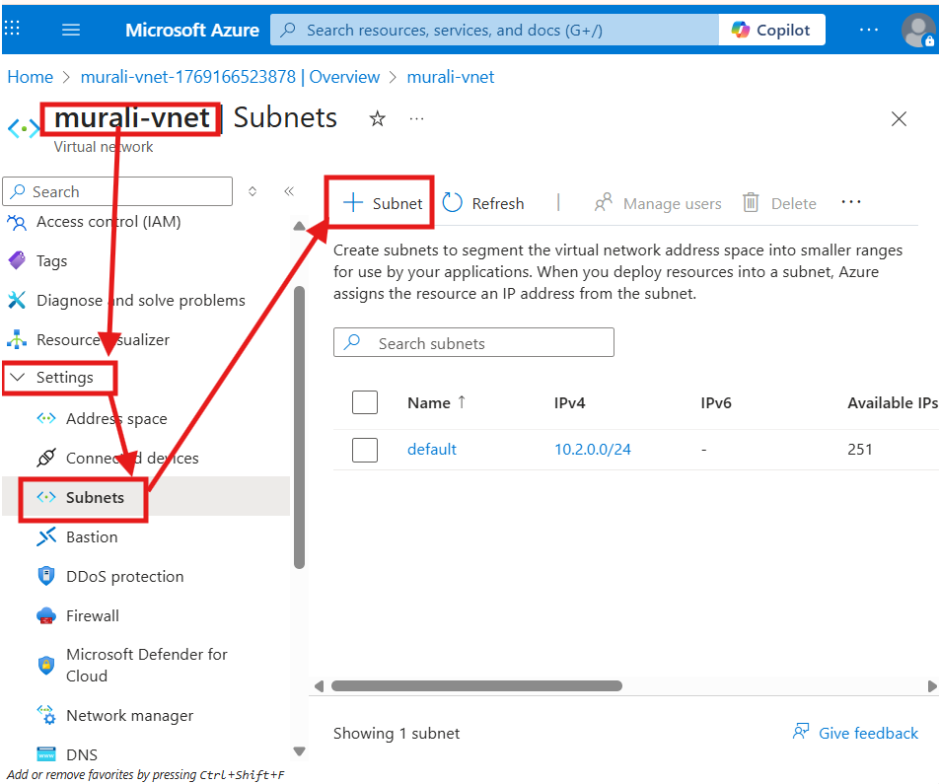
- Configure following details
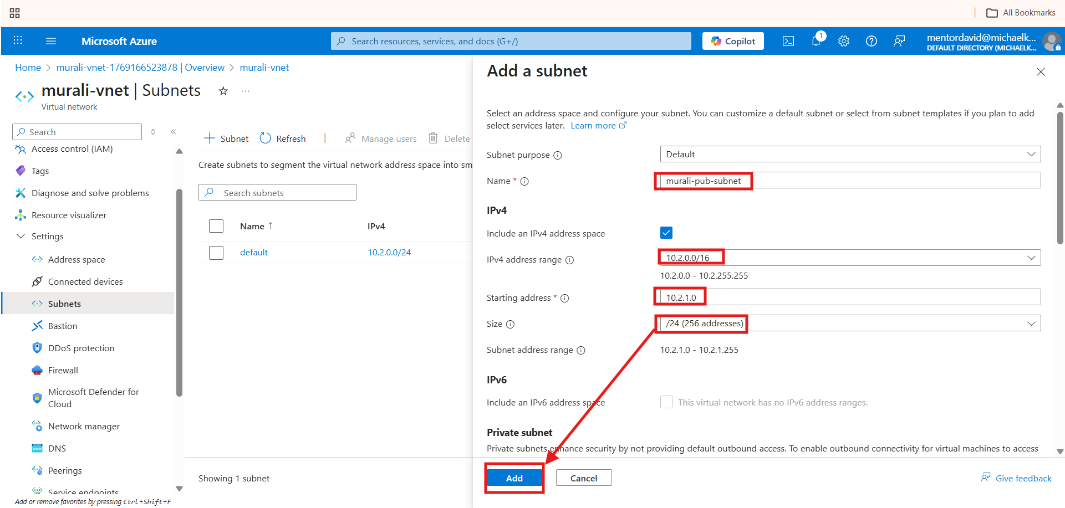

- Public subnet got created
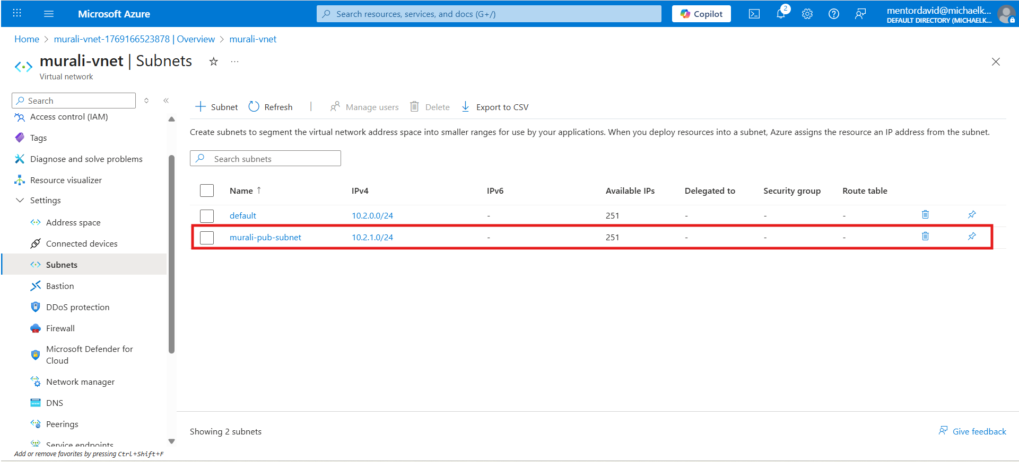

- Create pvt subnet
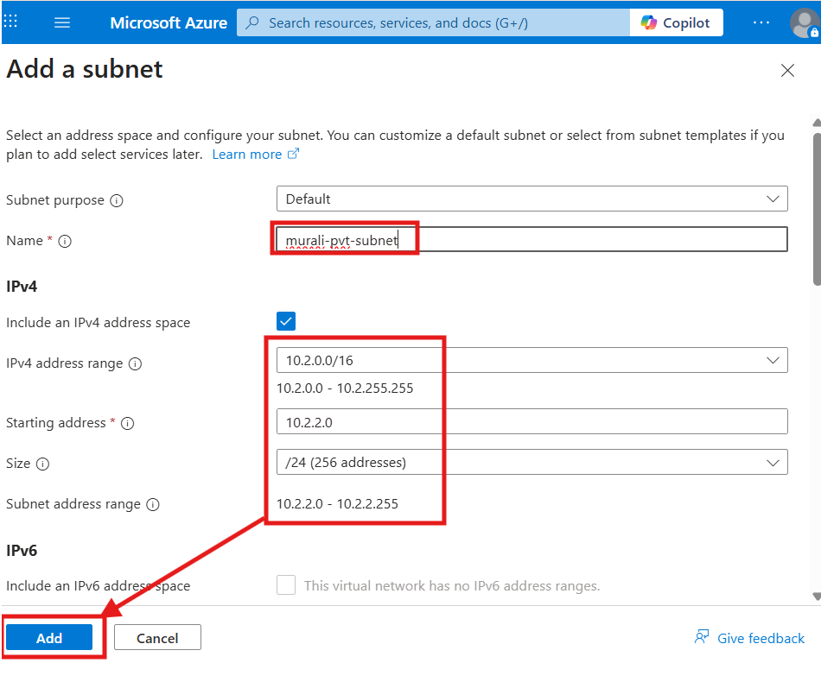
- Pvt subnet got created
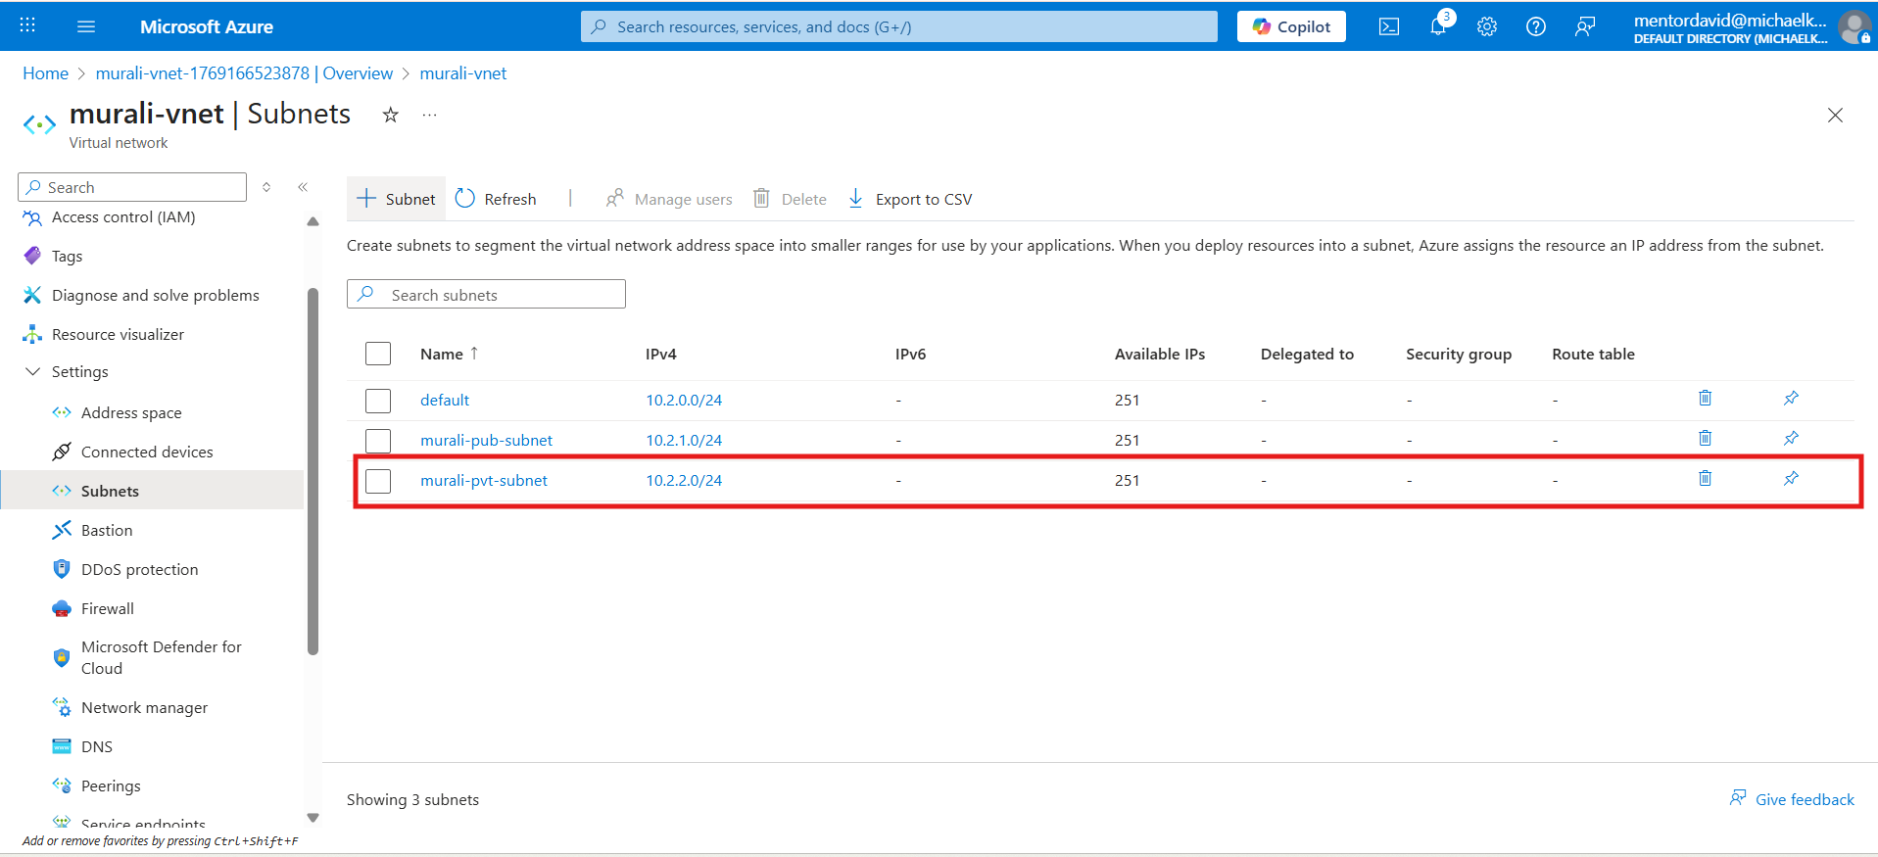

Internet Gateway (Azure way)
Important Azure Concept
Azure does NOT have a separate “Internet Gateway” like AWS.
Internet access happens via:
- Public IP
- Route table
- NSG

NAT Gateway

What is NAT Gateway?
Allows private subnet resources to access internet
Internet cannot initiate traffic back

Why needed?
- OS updates
- Package downloads
- Security

Azure Portal – NAT Gateway
- Create → NAT Gateway
- Assign:
  - Public IP
  - Subnet: private-subnet

- Click on create
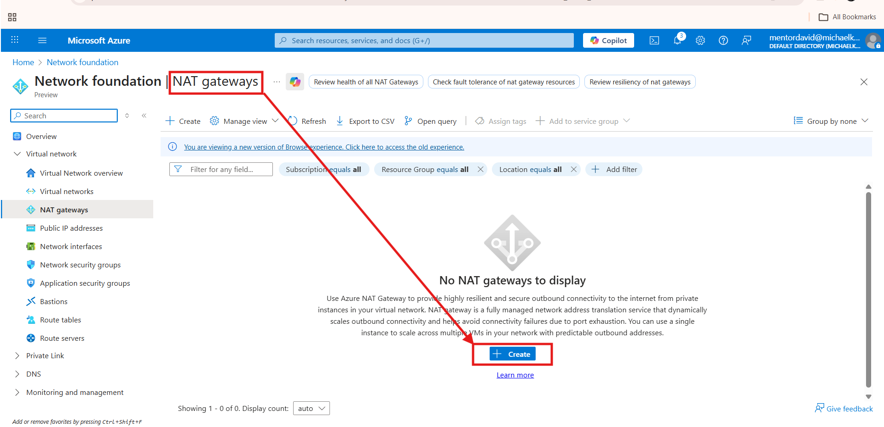

- Configure following details
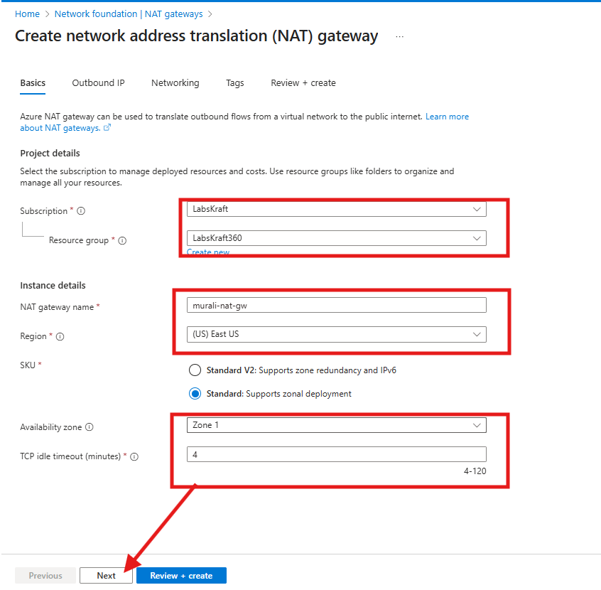

- Configure pub ip add for nat gw
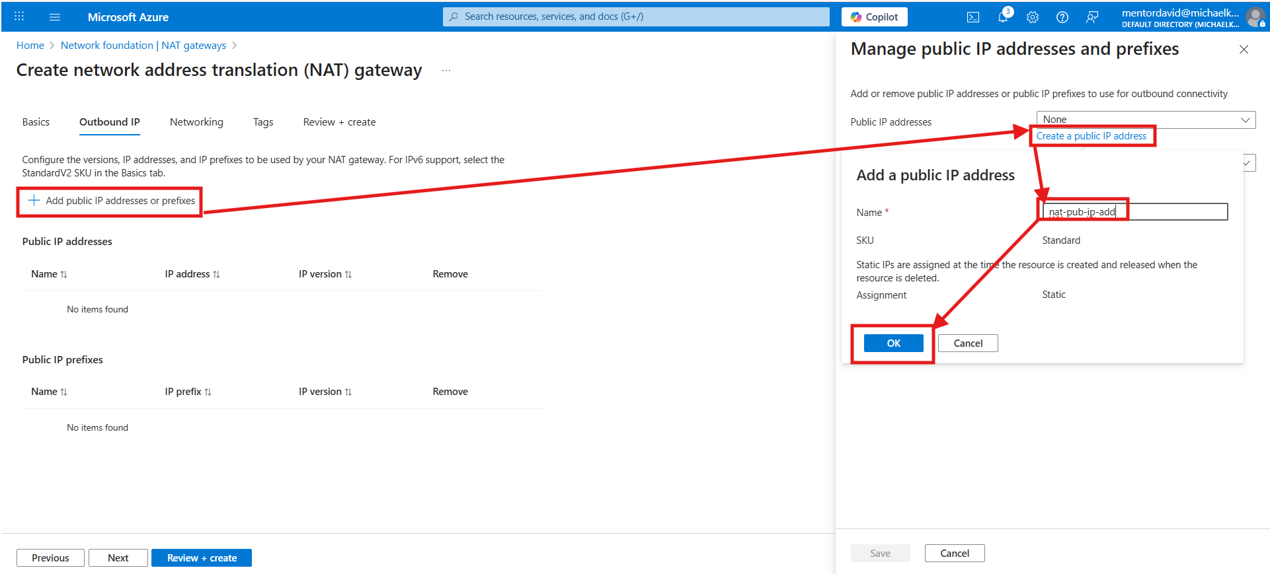

- Click on save
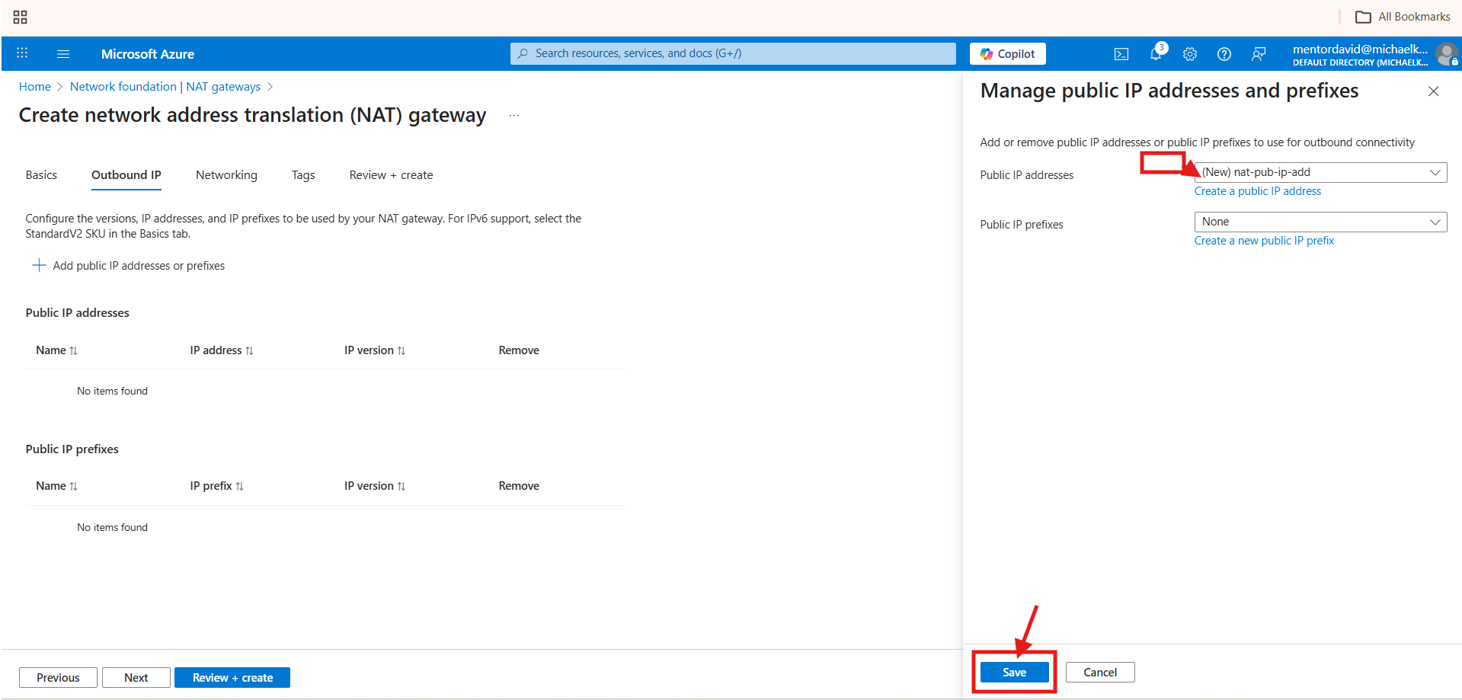

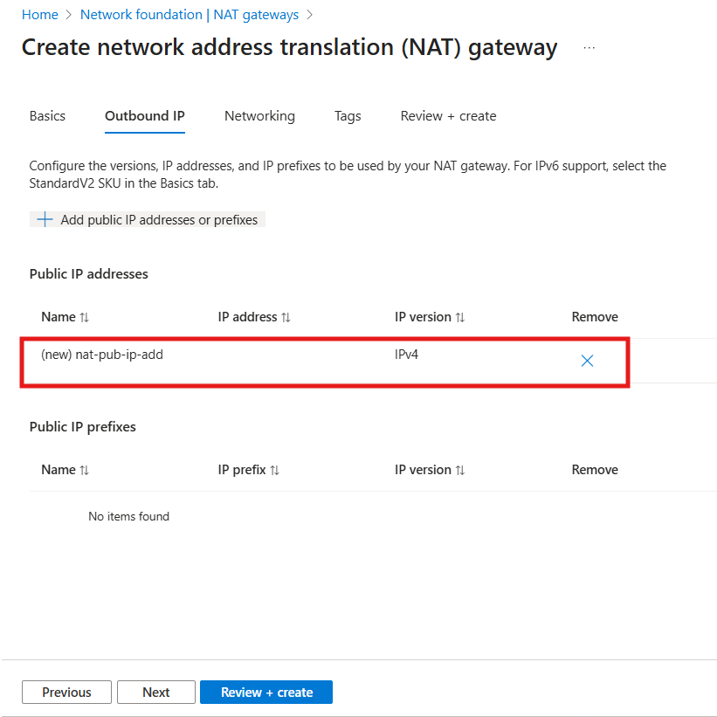

- Click on review and create
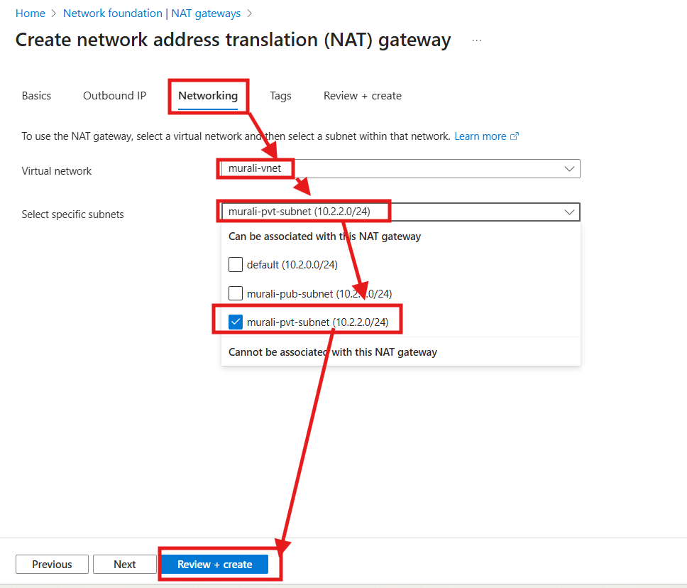

- Click on create
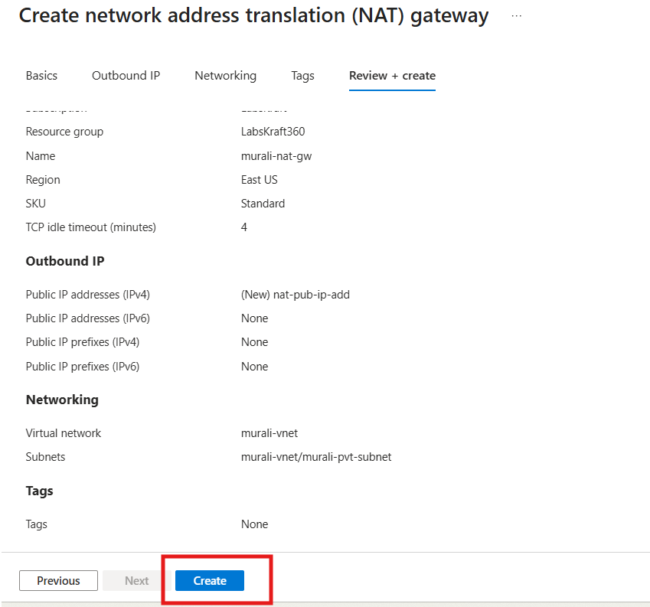

- Nat gw got created
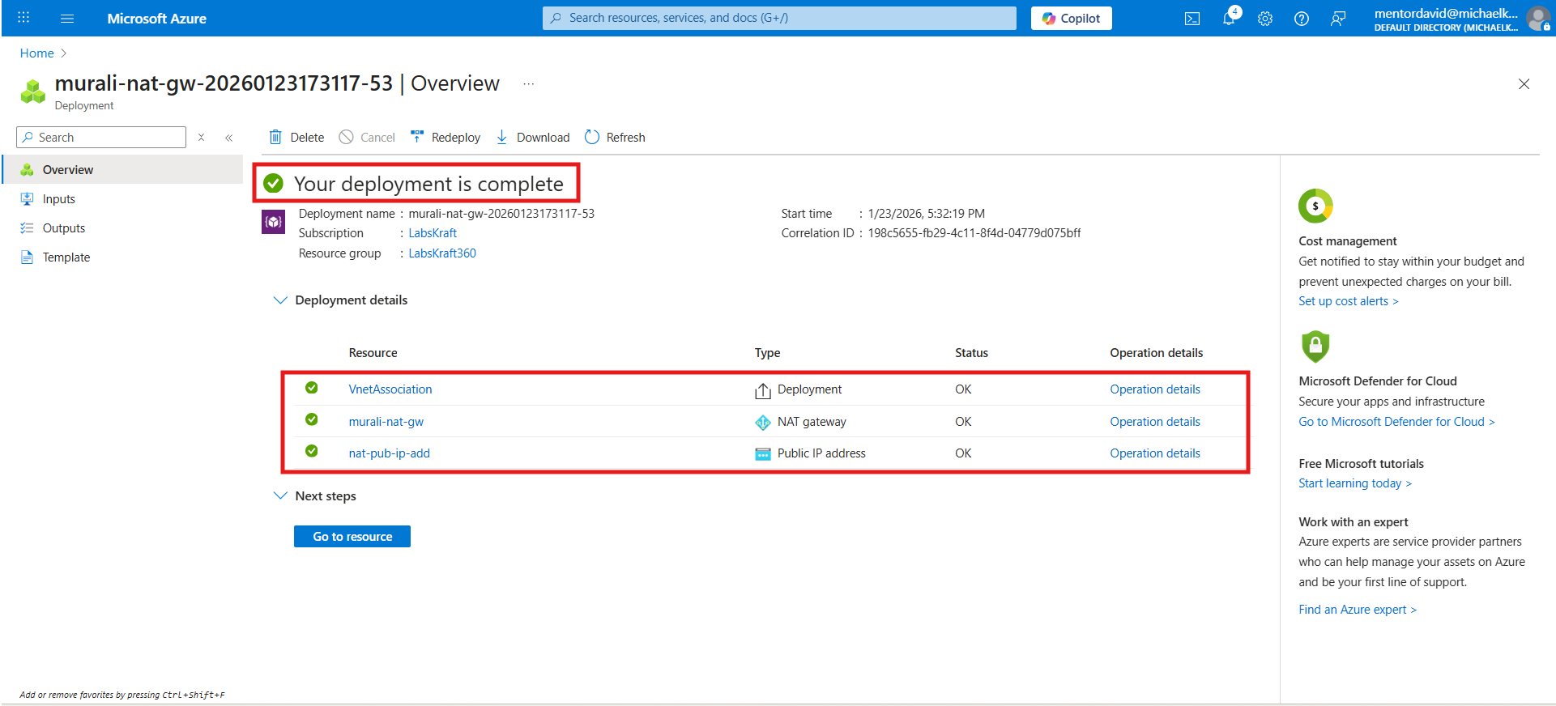
Explain:
“Private subnet → can go OUT
Internet → cannot come IN”

Route Tables

What is a Route Table?
Decides where traffic should go.
Example:
- Internet traffic → NAT
- Internal traffic → VNet

How to create Route Tables in Azure (Step-by-step)

Step 1: Create Public Route Table
- Go to Route tables
- Click Create
- Name:
public-rt
- Resource Group & Region → same as VNet
- Create

Add route
Go to public-rt → Routes → Add:
Field | Value
Route name | internet-route
Address prefix | 0.0.0.0/0
Next hop type | Internet
Save.

Associate with public subnet
public-rt → Subnets → Associate → select public-subnet.
- Click on create
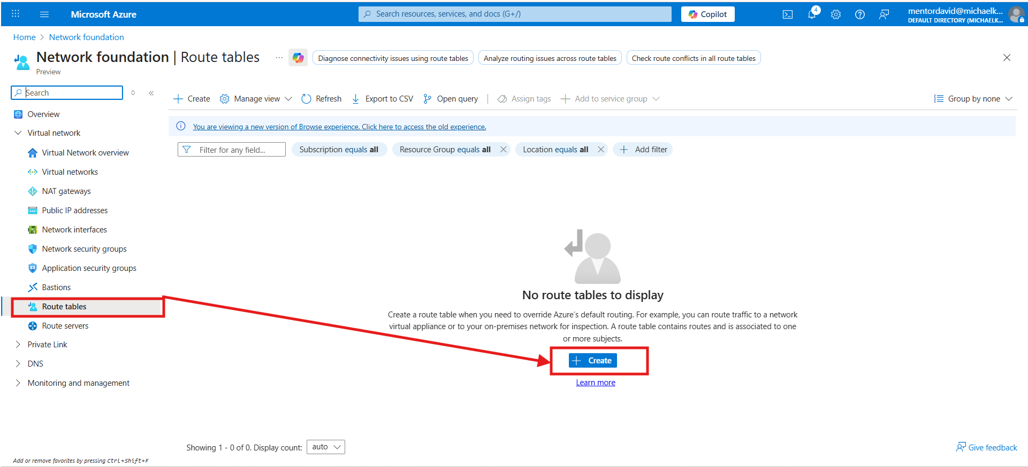
- Click on review n create
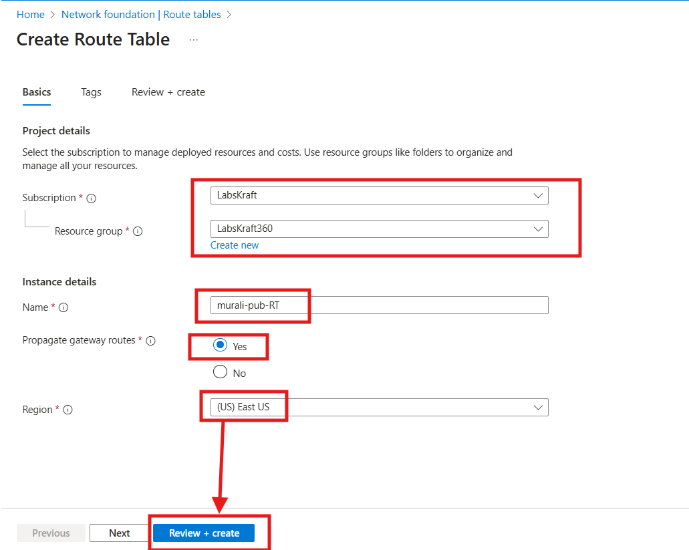
- Click on create
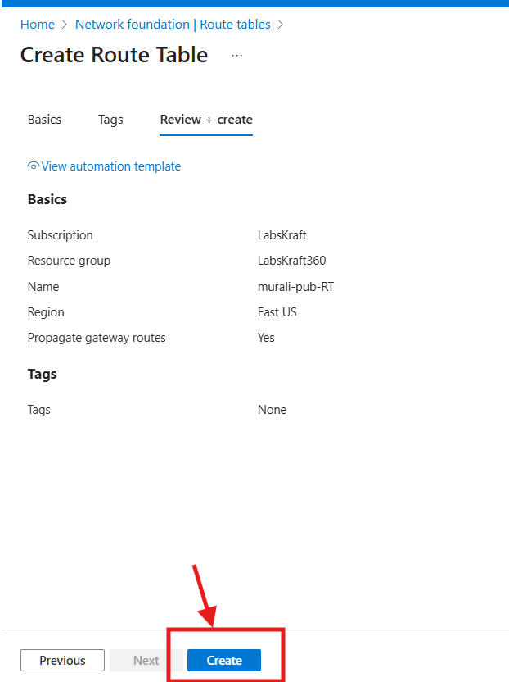

- Pub route table created
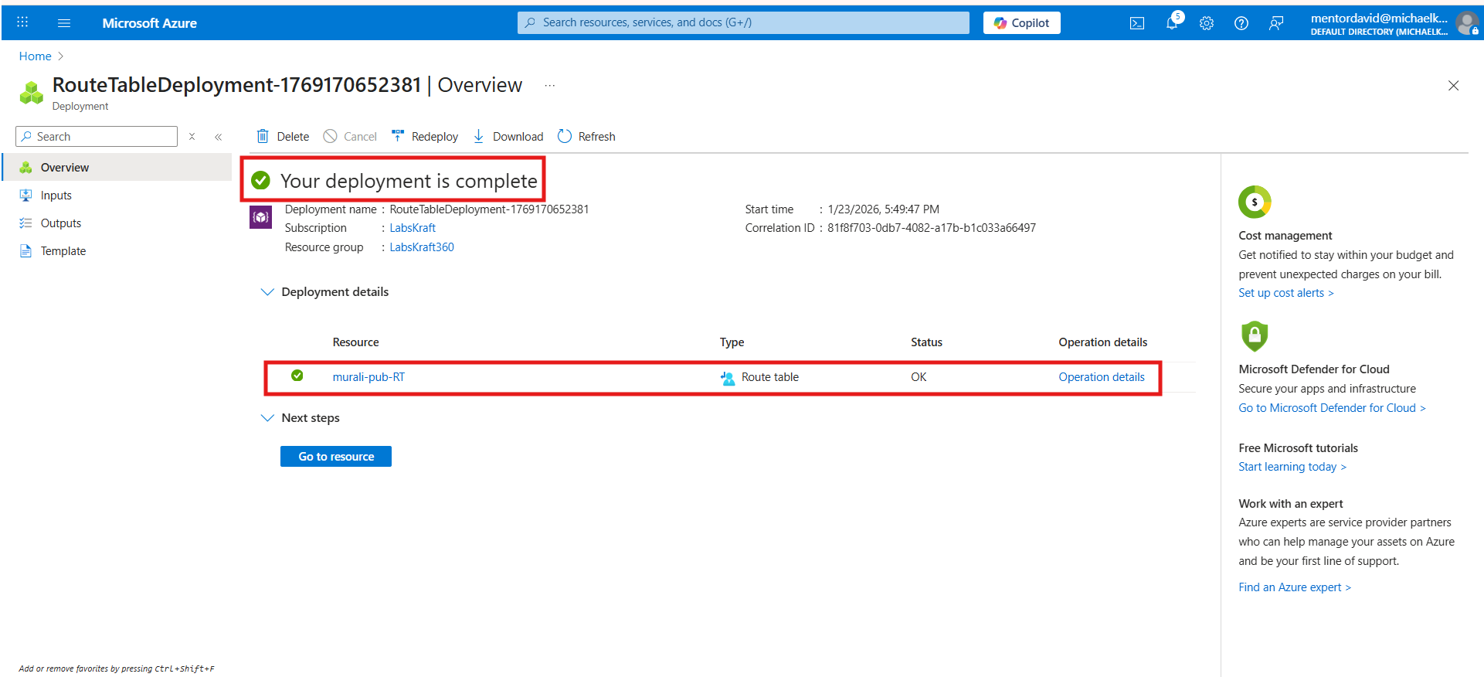

- Route added in pub RT
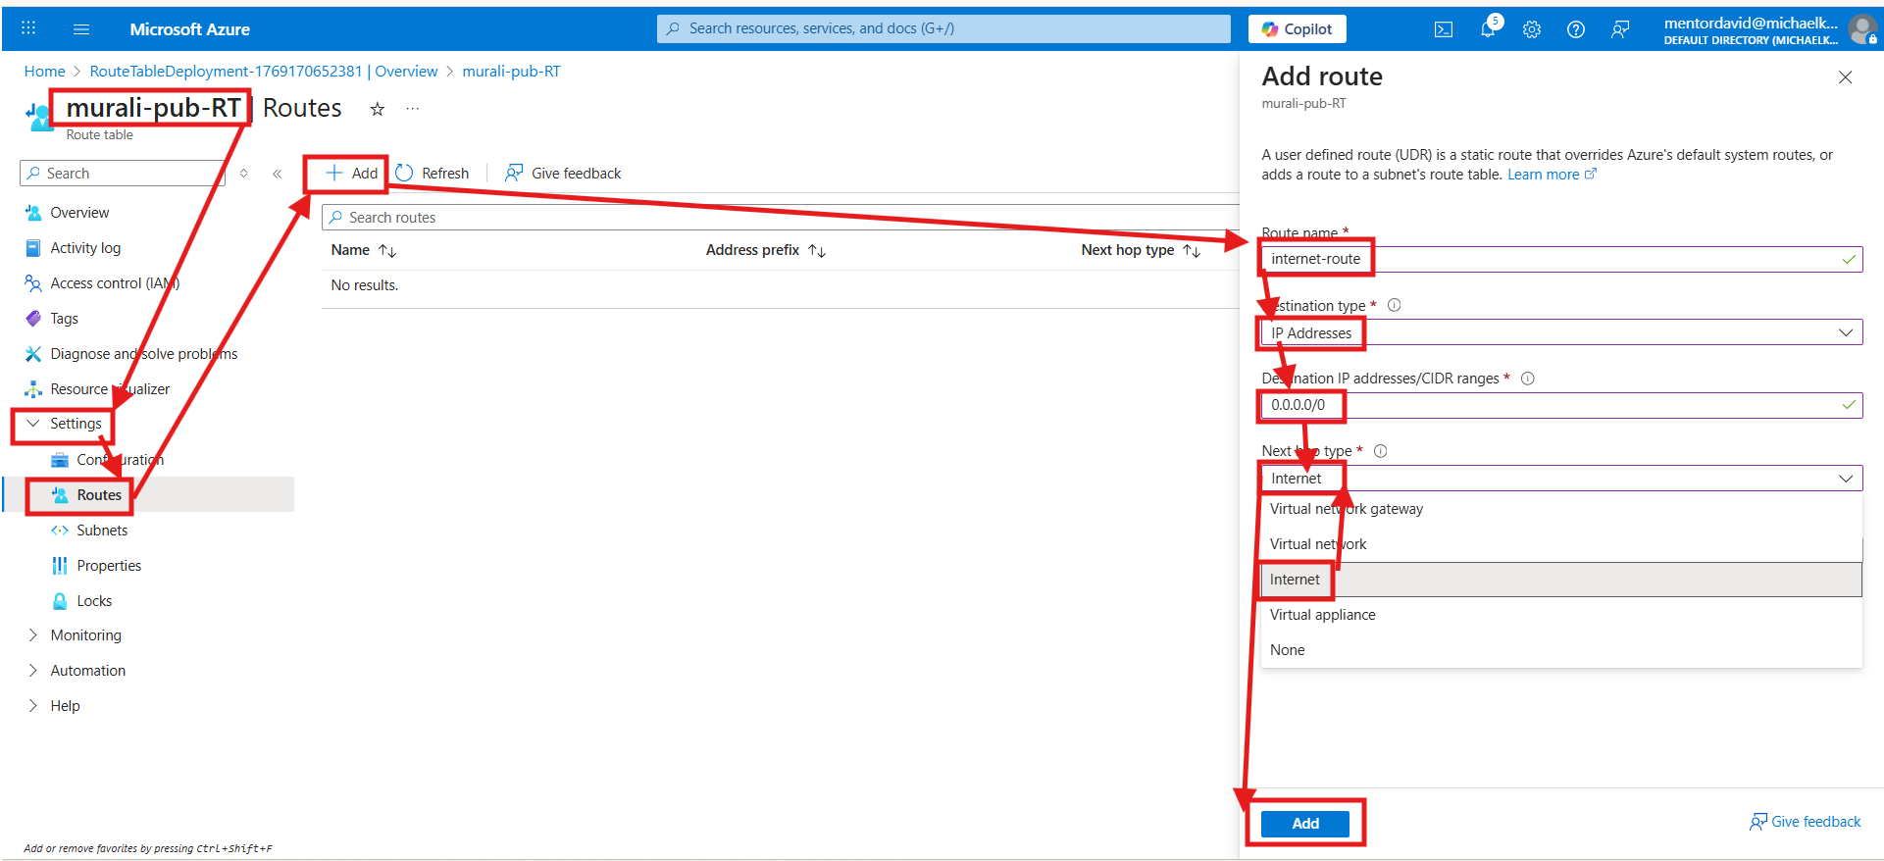

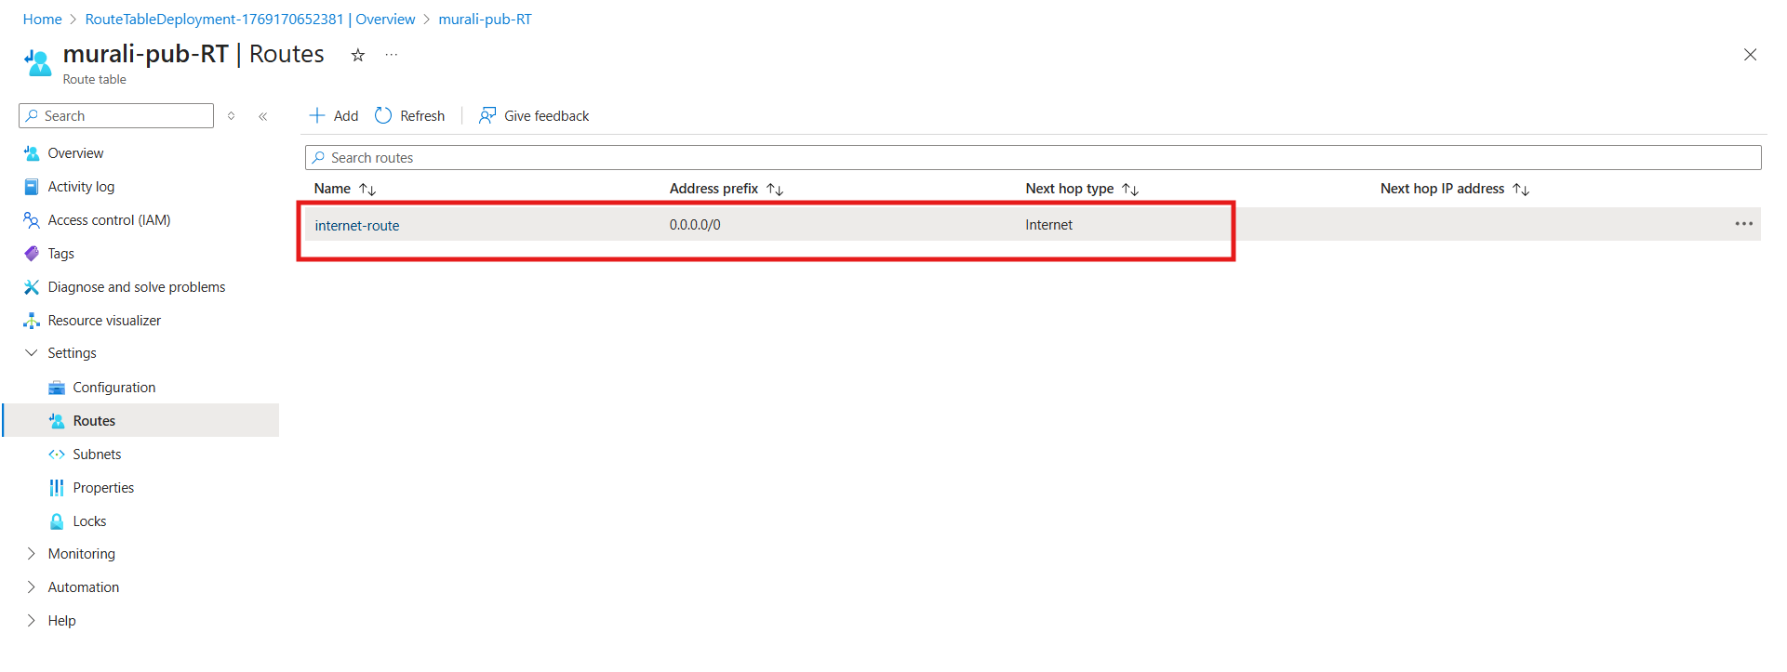
Associate with public subnet
public-rt → Subnets → Associate → select public-subnet.
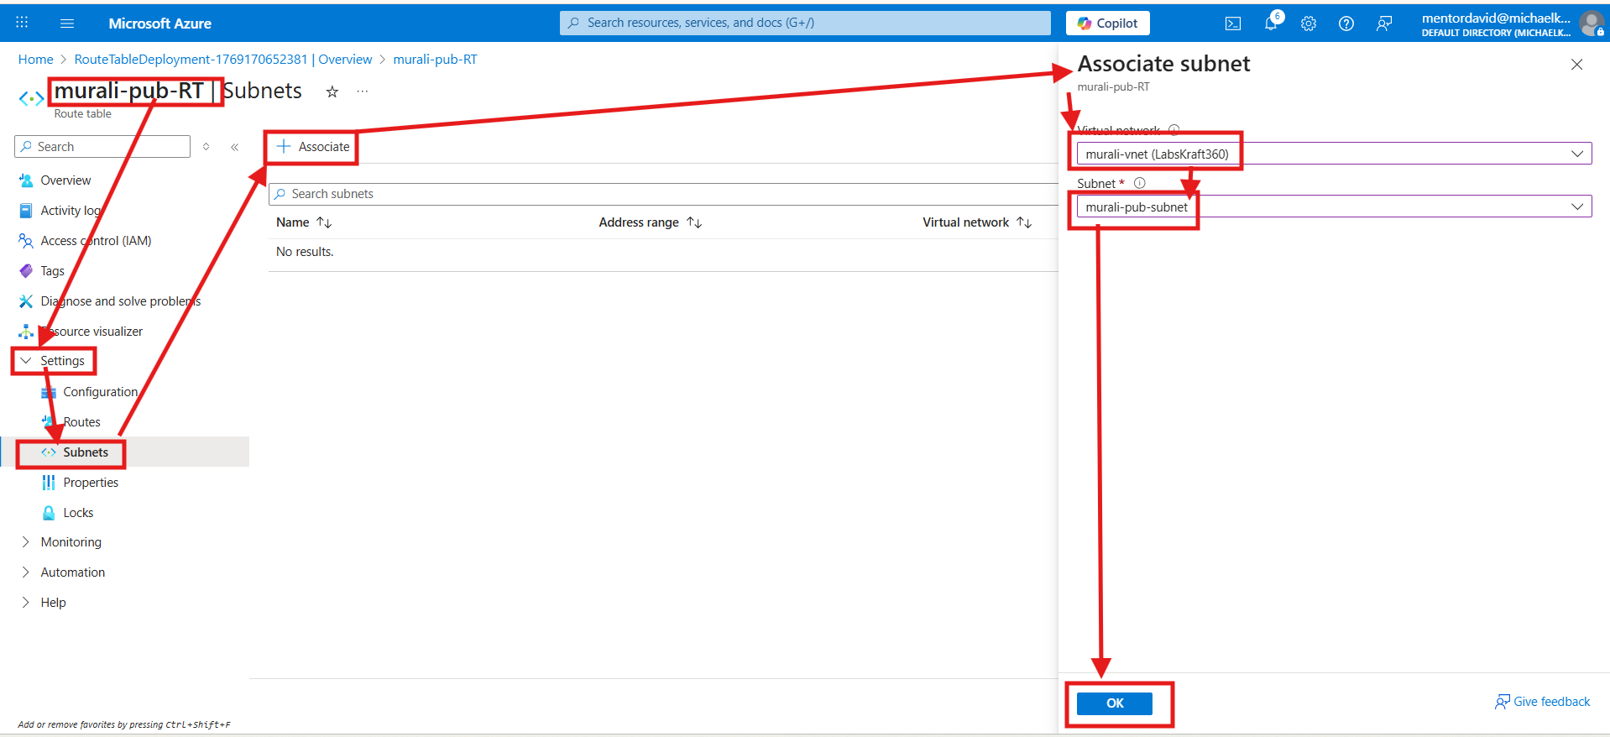
- Pub subnet associated with pub RT
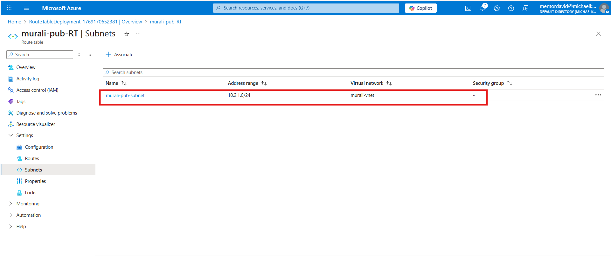
- Now lets create pvt RT as following same steps for PUB RT
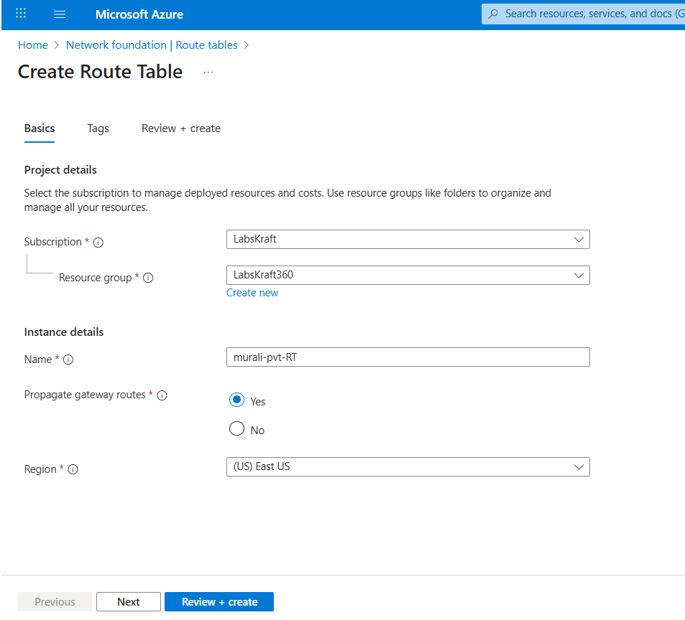
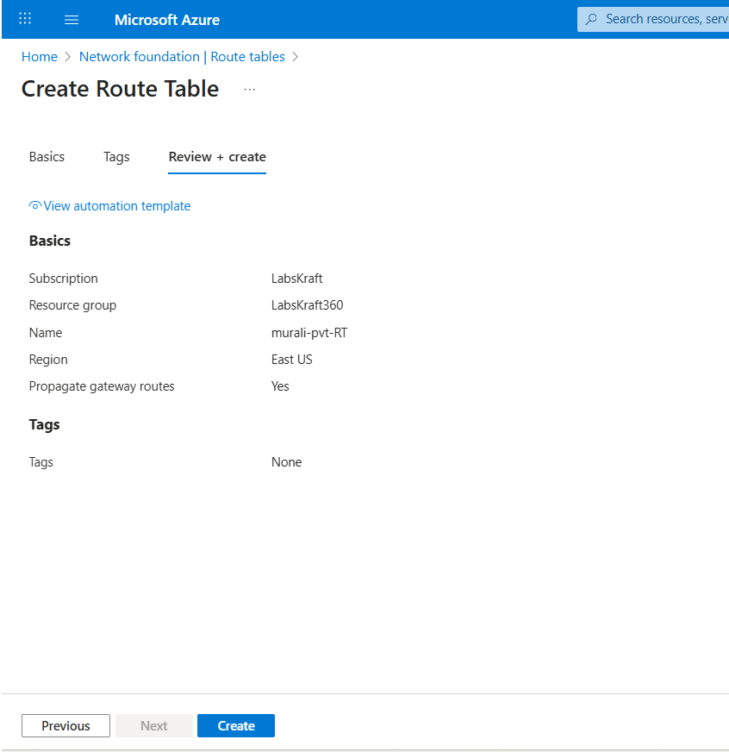
- Pvt RT created
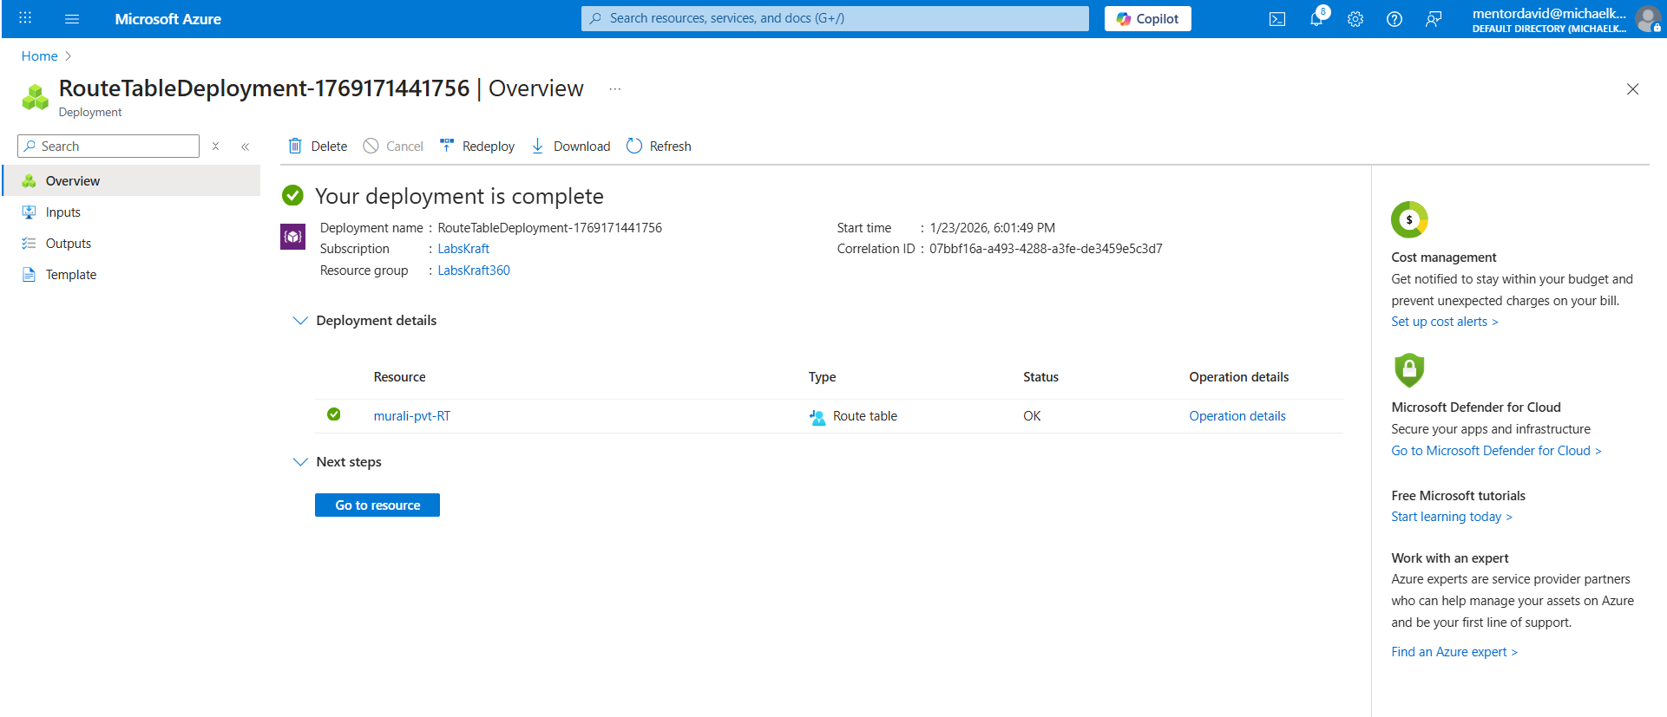
- For pvt RT no need to add route nat gw automatically creates a route but you must attach pvt subnet to nat gw and must associate pvt subnet with pvt RT
- Now associate pvt subnet with pvt RT
