𝗟𝗲𝘁’𝘀 𝘁𝗮𝗸𝗲 𝗮 𝗰𝗹𝗼𝘀𝗲𝗿 𝗹𝗼𝗼𝗸 𝗮𝘁 𝘁𝗵𝗲 𝗱𝗶𝗳𝗳𝗲𝗿𝗲𝗻𝘁 𝘀𝗲𝗿𝘃𝗶𝗰𝗲 𝘁𝘆𝗽𝗲𝘀.  
  
𝗖𝗹𝘂𝘀𝘁𝗲𝗿𝗜𝗣 𝗦𝗲𝗿𝘃𝗶𝗰𝗲𝘀 :

ClusterIP is the default service type in Kubernetes, and it provides internal connectivity between different components of our application. Kubernetes assigns a virtual IP address to a ClusterIP service that can solely be accessed from within the cluster during its creation. This IP address is stable and doesn’t change even if the pods behind the service are rescheduled or replaced.  
  
ClusterIP services are an excellent choice for internal communication between different components of our application that don’t need to be exposed to the outside world. For example, if we have a microservice that processes data and sends it to another microservice for further processing, we can use a ClusterIP service to connect them.

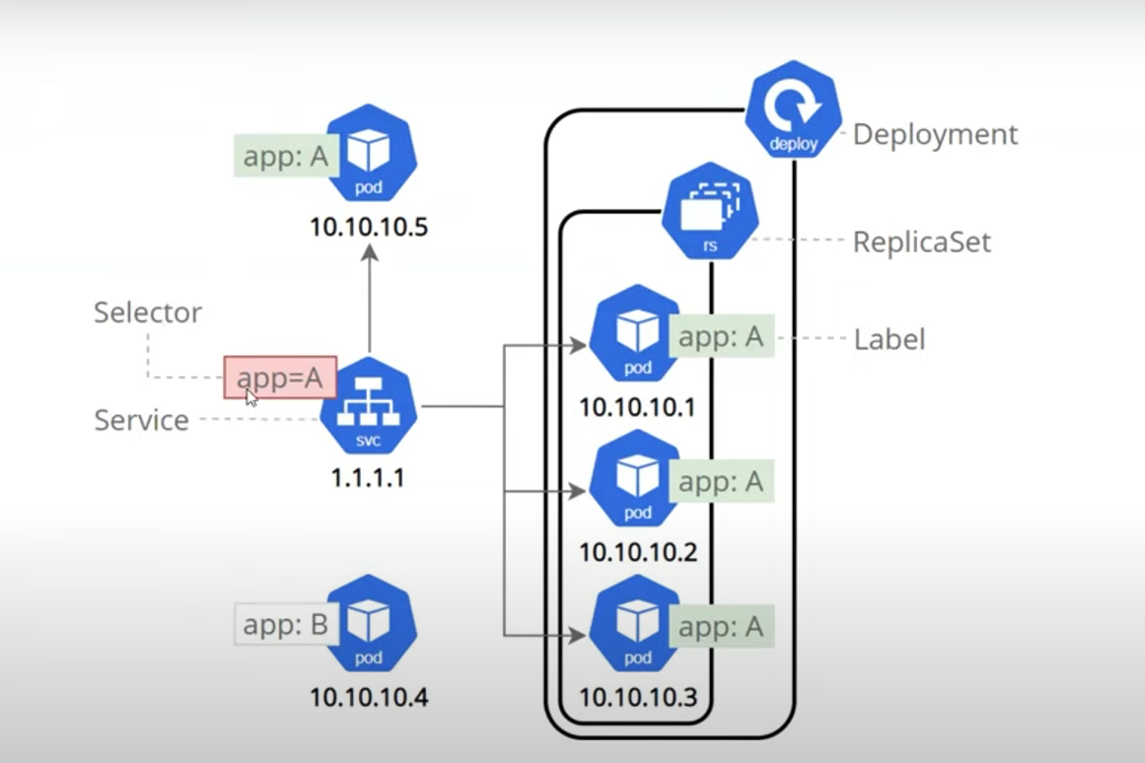

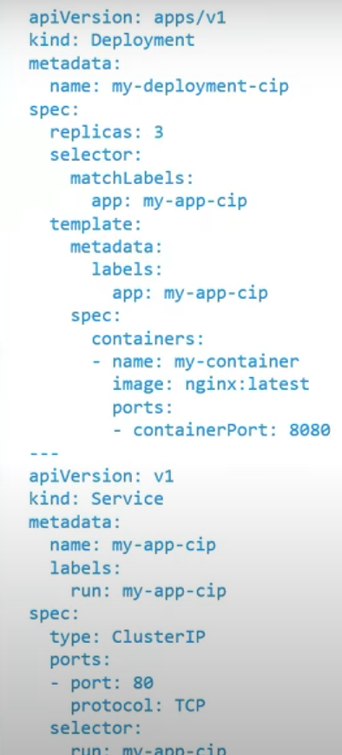  
  
𝗡𝗼𝗱𝗲𝗣𝗼𝗿𝘁 𝗦𝗲𝗿𝘃𝗶𝗰𝗲𝘀 :

NodePort services extend the functionality of ClusterIP services by enabling external connectivity to our application. When we create a NodePort service on any node within cluster that meets the defined criteria, Kubernetes opens a designated port that forwards traffic to corresponding ClusterIP service running on the node.  
  
These services are ideal for applications that need to be accessible from outside the cluster, such as web applications or APIs. With NodePort services, we can access our application using the node’s IP address and the port number assigned to the service.

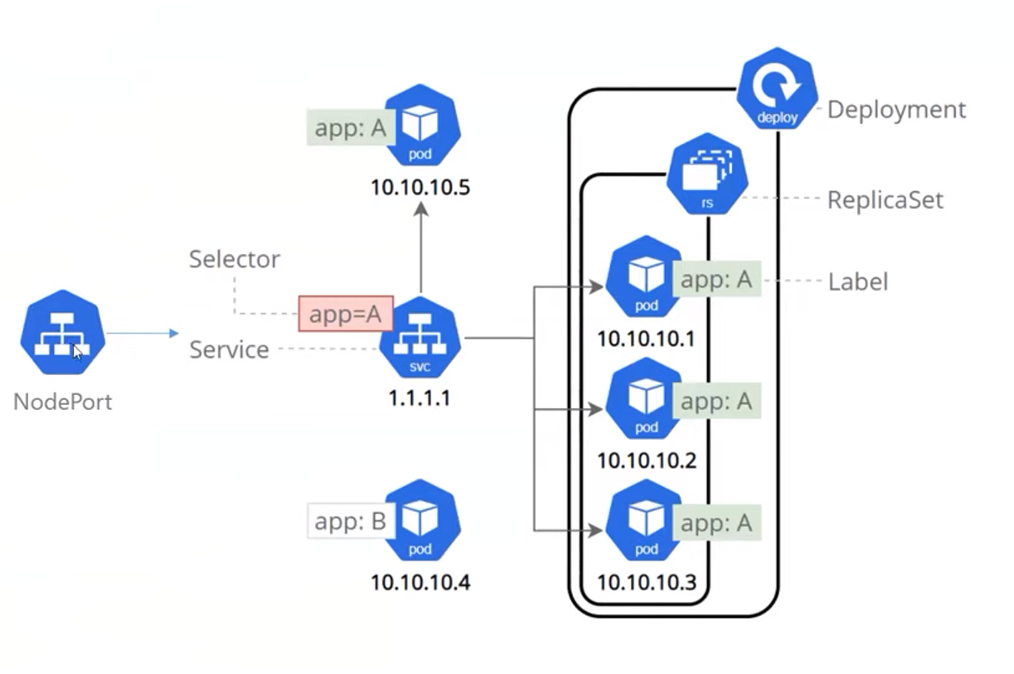

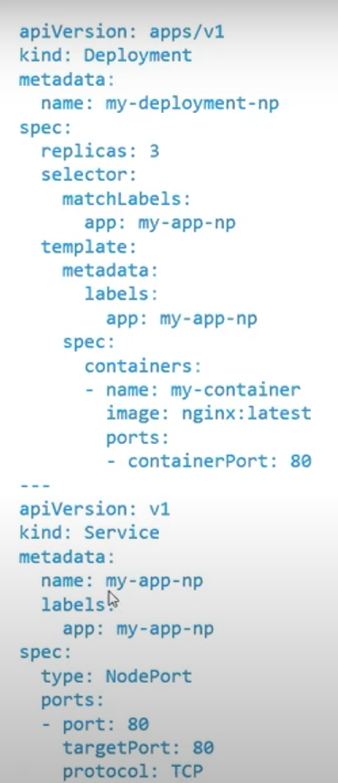  
  
𝗟𝗼𝗮𝗱𝗕𝗮𝗹𝗮𝗻𝗰𝗲𝗿 𝗦𝗲𝗿𝘃𝗶𝗰𝗲𝘀:

LoadBalancer services connect our applications externally, and production environments use them where high availability and scalability are critical. When we create a LoadBalancer service, Kubernetes provisions a load balancer in our cloud environment and forwards the traffic to the nodes running the service.  
  
LoadBalancer services are ideal for applications that need to handle high traffic volumes, such as web applications or APIs. With LoadBalancer services, we can access our application using a single IP address assigned to the load balancer.

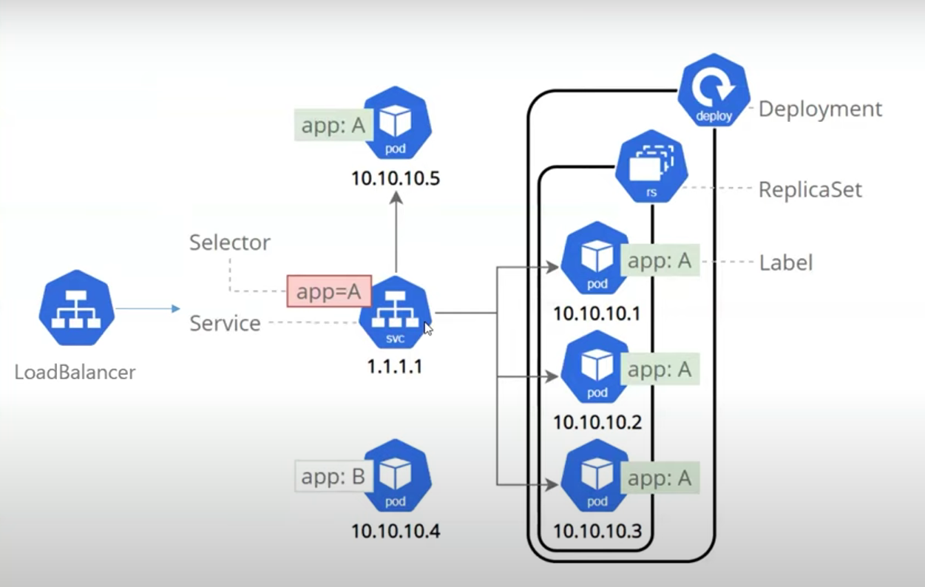  
  
𝗜𝗻𝗴𝗿𝗲𝘀𝘀:

Ingress is not considered an official Kubernetes service, but it can be used to expose services. You can configure an Ingress service by creating rules to define which inbound connections should reach which services. services on the cluster. An Ingress is a Kubernetes object that sits in front of multiple services and acts as an intelligent router. It defines how external traffic can reach the cluster services, and it configures a set of rules to allow inbound connections to reach the  
  
Ingress rules are typically defined by annotations. The Ingress controller reads these annotations and configures iptables or NGINX accordingly. There are many types of Ingress controllers that possess different capabilities.Ingress is the most powerful service type used to expose services, , which can be cheaper than using a LoadBalancer service type.

