ARCHITECT WORKSHOP
Cross-Repository Discovery • Dependency Mapping • Options Trade-Off • ADR Draft
Facilitator Explanation Guide | Smart Hospital Case Study
Purpose: help architects use an AI engineering agent such as Devin as an evidence-led architecture analysis assistant. Participants examine a multi-repository system, understand dependencies, compare architecture choices and prepare a reviewable Architecture Decision Record (ADR).

1. Workshop overview
Item | Description
Audience | Solution, Technical, Enterprise and Application Architects; senior engineers.
Core outcome | Move from scattered repository knowledge to an evidence-backed architecture recommendation and ADR draft.
Case study | Smart Hospital platform modelled as eight FastAPI microservices. Use synthetic data only.
Suggested duration | 3–4 hours, adjustable to repository readiness.
Working principle | AI assists discovery and analysis; the architect validates evidence, owns trade-offs and approves decisions.

2. Learning objectives
- Discover architecture across multiple Git repositories, not one codebase at a time.
- Identify service, API, data, library, infrastructure and external dependencies.
- Trace a business workflow and assess failure paths and change impact.
- Compare alternatives against explicit requirements and constraints.
- Produce an ADR explaining context, options, rationale, consequences, risks and validation.
- Recognise what source code can establish and what needs runtime evidence or stakeholder confirmation.

3. Smart Hospital case-study landscape
The following eight services form the workshop model. These are logical responsibilities; verify actual repository names, APIs, ownership and runtime relationships from the supplied code.
Service | Responsibility | Architect questions
Identity & Access | Authentication and authorization | How are tokens issued and validated? How are roles enforced?
Patient | Patient profiles | Who owns patient data? Which APIs expose it?
Provider | Doctor/provider management | How are providers identified and maintained?
Facility & Department | Hospital and department information | How are facilities and departments related?
Scheduling & Availability | Provider schedules and slots | How are slots reserved and concurrent bookings prevented?
Appointment | Appointment lifecycle and orchestration | What is the source of truth for booking state?
Encounter / Visit | Clinical visit workflow | When is an encounter created?
Notification | SMS/email notifications | Are notifications synchronous or event-driven? How are retries handled?

4. Cross-repository discovery
Definition: systematic examination of several related repositories to understand the wider application landscape, technology choices, service boundaries, APIs, data stores, build/deployment methods and integrations.
Why it matters: enterprise systems are distributed across teams and repositories. A change in one service can affect consumers, shared libraries, pipelines, infrastructure and operational procedures.
- Repository inventory: name, purpose, language, framework, branch and owner if documented.
- Application structure: entry points, modules, API routers, domain boundaries and configuration.
- Contracts: REST/gRPC endpoints, schemas, event definitions, authentication and versioning.
- Data: database technology, migrations, schema references and apparent ownership.
- Delivery: Dockerfiles, CI workflows, deployment manifests, Helm charts and Terraform.
- Operations: health checks, metrics, logs, tracing, alerts, scaling and resilience.
- Security: secrets handling, authorization checks, dependency scanning and exposure points.
Expected outputs: repository inventory, technology matrix, system context narrative, workflow trace, evidence register, open questions and architecture findings.

5. Dependency mapping
Definition: documenting which components rely on other components, what contract is used, why the dependency exists and what happens when the dependency changes or fails.
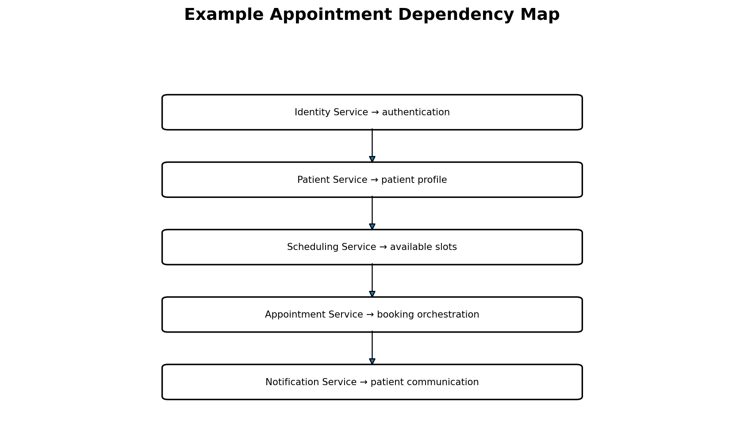
Figure 1. Simplified dependency hypotheses for appointment booking. Validate every arrow against code, configuration, events or runtime traces.
Dependency class | Evidence to inspect | Architectural concern
Service-to-service | HTTP clients, SDKs, service URLs, event handlers | Runtime coupling, latency, failure propagation
API contract | OpenAPI specs, models, generated clients | Breaking changes and version compatibility
Data | Connection settings, ORM models, migrations | Data ownership and shared-database coupling
Library | Package manifests and lock files | Version drift, vulnerabilities and upgrade blast radius
Messaging | Topics, queues, publishers, consumers | Delivery, ordering, duplicates and dead-letter handling
Infrastructure | Kubernetes manifests, Terraform, cloud references | Permissions, capacity and deployment coupling
External systems | Third-party SDKs, URLs and config | Vendor dependency, rate limits and outages

For every dependency record source, target, type, direction, protocol/contract, evidence path, criticality, data sensitivity, failure behaviour, confidence and validation action.

6. Change impact analysis
Dependency mapping becomes useful when an architect asks: “If we change this service, what else could break?”
- Identify direct consumers and upstream dependencies.
- Inspect request/response fields, schemas, event payloads and shared package versions.
- Check tests, mocks, generated clients, deployment values and configuration references.
- Classify impact as Breaking, Potentially breaking, Compatible, Operational or Unknown.
- Recommend contract tests, consumer-driven tests, versioning, staged rollout or migration steps.

7. Architecture options trade-off
Definition: structured comparison of credible solutions against requirements and constraints. A trade-off is explicit: improving one quality attribute may increase cost, complexity or risk elsewhere.
Case-study problem: after successful appointment booking, a patient should receive a notification. Compare three communication approaches.
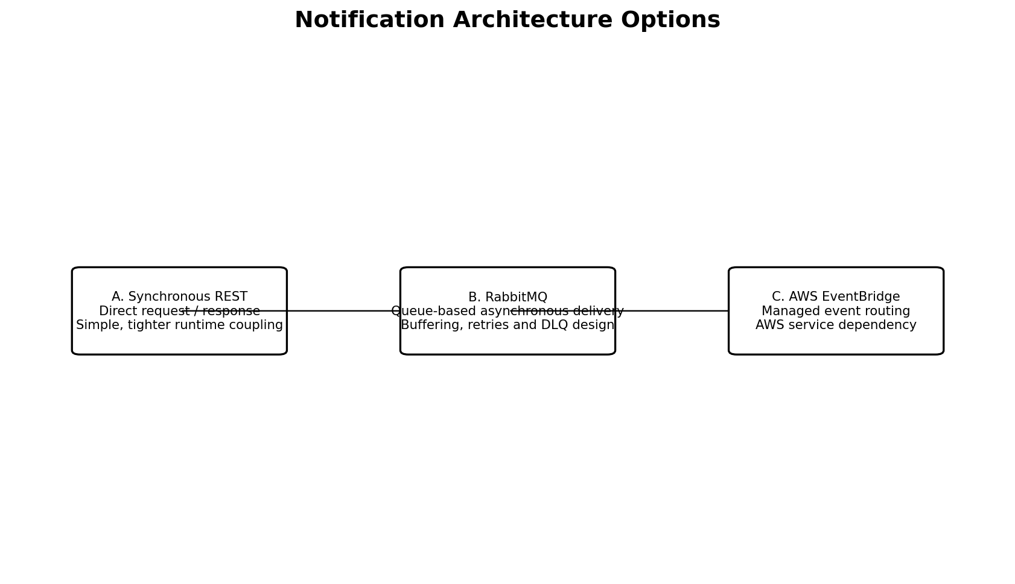
Figure 2. Three candidate notification approaches. These are options to evaluate, not a pre-approved design.
Criterion | Synchronous REST | RabbitMQ | AWS EventBridge
Interaction | Direct request/response | Message through broker | Publish event to managed event bus
Runtime coupling | Tighter; caller may wait | Looser; consumer processes asynchronously | Looser; event target processes asynchronously
Failure handling | Timeouts, retries, fallback and idempotency | Acknowledgements, retries, DLQ and idempotency | Retry policy, target failure handling, DLQ and idempotency
Operations | Operate both services | Operate/manage broker and consumers | Managed event routing; monitor targets
Portability | Generally portable | Portable if self-managed; offerings vary | AWS-specific dependency
Fit | Simple flow where synchronous response is required | Need buffering and explicit broker control | AWS-native routing and managed integration are priorities

These are qualitative starting points, not universal scores. Validate throughput, latency, volume, retention, ordering, delivery semantics, security, regional strategy, team skills and total cost.

8. Decision criteria and weighted matrix
Agree criteria and weights before scoring. Example weights below are illustrative and should be adjusted with stakeholders.
Criterion | Example weight | Questions
Reliability / recoverability | 20% | Can work survive temporary downstream failure?
Security and compliance | 15% | How are identity, encryption, audit and data minimisation handled?
Operational fit | 15% | Can the team run, monitor and recover it?
Scalability | 15% | Can it absorb bursts and growth?
Total cost | 15% | What are infrastructure, licensing, support and people costs?
Maintainability / portability | 10% | How difficult is change? Is lock-in acceptable?
Performance / latency | 10% | What is the end-to-end latency requirement?

Use a consistent 1–5 scale, define each score, multiply score by weight and document evidence or assumptions. The score supports discussion; it does not replace architectural judgement.

9. Architecture Decision Record (ADR)
An ADR is a concise, version-controlled record of a significant architecture decision and the reasoning behind it. It helps future teams understand what was selected, why alternatives were rejected and what consequences were accepted.
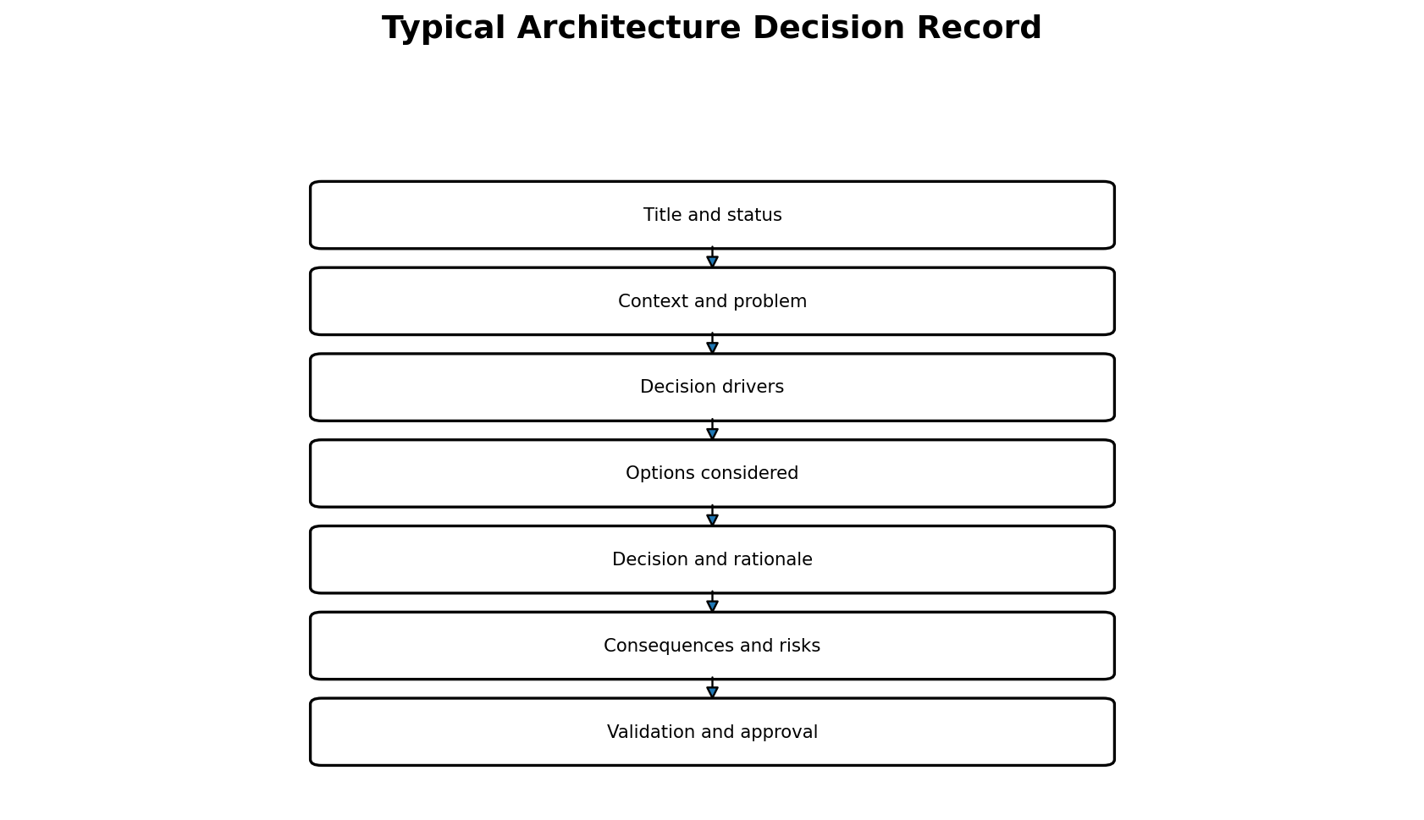
Figure 3. Typical ADR structure.
ADR section | What to write
Title and status | Unique ID, short title and status: Proposed, Accepted, Rejected, Superseded or Deprecated.
Context | Business/technical background, current state and constraints.
Problem / drivers | Question to resolve and quality attributes driving the choice.
Options considered | Credible alternatives, including doing nothing where relevant.
Decision | Selected option and rationale linked to requirements and evidence.
Consequences | Benefits, compromises, costs and new responsibilities.
Risks and mitigations | Failure modes, security risks, migration risks and controls.
Validation | POC, load/security testing, stakeholder approval and review date.

An AI-generated ADR remains Proposed until the accountable architect approves it. A draft must not silently trigger implementation.

10. End-to-end workshop workflow
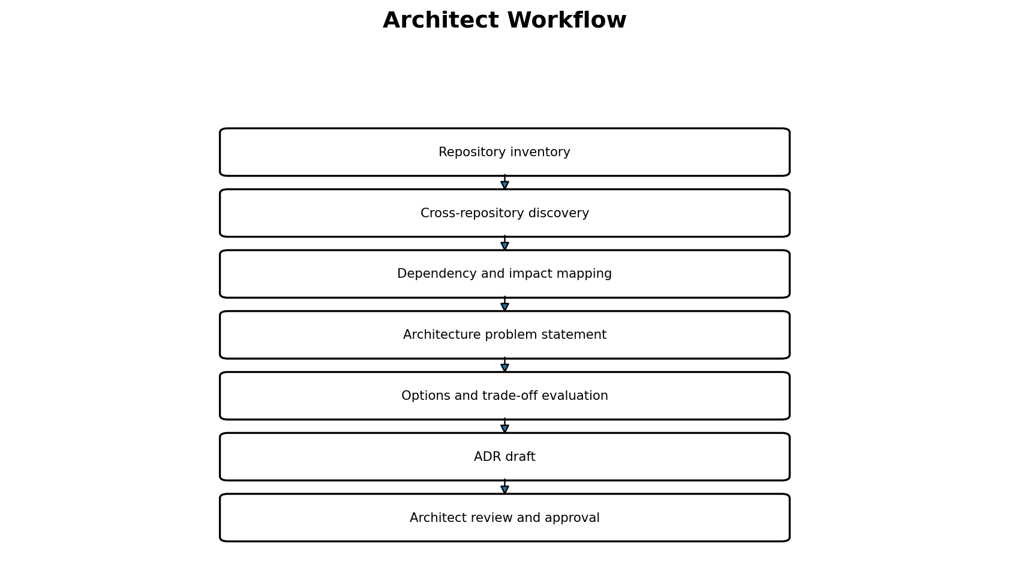
Figure 4. Recommended sequence for the practical exercise.
Phase | Activity | Deliverable
Prepare | Confirm repository access, scope and authoritative docs | Repository list and scope statement
Discover | Reconstruct the business flow across repositories | Discovery report with file-path evidence
Map | Trace APIs, events, databases, libraries and infrastructure | Dependency matrix and diagram
Impact | Select a change and identify affected components | Impact assessment and open questions
Problem | Define one architecture problem and decision drivers | Problem statement and requirements
Compare | Evaluate at least three credible alternatives | Trade-off table and assumptions
Draft | Record context, options, proposed decision and consequences | ADR in Markdown
Review | Validate evidence, security, operations, cost and assumptions | Revised ADR and approval actions

11. Suggested facilitator run sheet (3.5 hours)
Time | Activity | Emphasis
0:00–0:15 | Introduction | Why repository-by-repository understanding is insufficient.
0:15–0:55 | Cross-repository discovery | Require repository paths and code evidence.
0:55–1:35 | Dependency mapping | Separate confirmed dependencies from inferred relationships.
1:35–1:45 | Break | —
1:45–2:25 | Change impact | Trace the blast radius of a service/API change.
2:25–3:05 | Options trade-off | Compare REST, RabbitMQ and EventBridge.
3:05–3:30 | ADR draft and review | Challenge assumptions, consequences, risks and approval.
3:30–3:35 | Wrap-up | Capture decisions, unknowns and follow-up owners.

12. Evidence and AI guardrails
- Require claims to include repository, file path and relevant symbol/configuration reference where possible.
- Label findings Confirmed, Strongly indicated, Hypothesis or Unknown.
- Do not infer production traffic, deployment topology, database ownership or SLOs from code alone.
- Runtime traces, logs, cloud configuration and interviews may be needed to confirm actual behaviour.
- Never expose secrets, credentials, patient data or production personal information to an AI agent; use synthetic data.
- Disclose inaccessible repositories and incomplete analysis.
- Do not accept performance or cost claims without measured inputs and current pricing.
- Architecture approval remains with the accountable architect/governance body.

13. Discussion questions
- Which repositories are needed to trace appointment booking end to end?
- Which dependencies are confirmed by source code, and which need runtime validation?
- What happens if Scheduling is unavailable during booking?
- What happens if booking is committed but notification delivery fails?
- Is immediate notification required, or is eventual delivery acceptable?
- What delivery semantics are needed, and how will duplicates be handled?
- Who owns patient and appointment data? Are services accessing one another’s databases?
- What operating skills and monitoring capabilities exist for each messaging option?
- What evidence could change the recommendation?
- Who must approve the ADR before implementation?

14. Definition of done
- All in-scope repositories are inventoried; missing access is recorded.
- Key workflow paths are traced with evidence.
- Dependency map distinguishes facts from hypotheses.
- One change-impact scenario is documented.
- At least three options are evaluated against agreed criteria.
- Assumptions, unknowns, risks and validation activities are explicit.
- ADR is ready for peer review and remains Proposed pending approval.
- Action owners and next steps are captured.

15. Glossary
Term | Meaning
Repository | Version-controlled project containing source code and related assets.
Blast radius | Components, teams or users potentially affected by a change or failure.
Trade-off | Balance among competing qualities, constraints, costs or risks.
ADR | Architecture Decision Record; durable record of a decision and its rationale.
Idempotency | Repeated processing of the same request/event is safe against unintended duplicate effects.
DLQ | Dead-letter queue; destination for messages that cannot be processed under configured policies.
POC | Proof of concept; limited experiment to validate a technical assumption.
SLO | Service Level Objective; measurable target for reliability or performance.

Facilitator closing message: “Use AI to widen discovery and accelerate structured analysis. Use evidence to challenge its conclusions. The architect remains accountable for the decision.”

