Jira → Devin Automation Runbook
Smart Hospital & Patient Management System · as of 16 Oct 2026
Creating a Task in Jira project UST-HealthCare (KAN) automatically starts a Devin session that analyses the ticket, builds the microservice, runs tests and opens a pull request on Msocial123/UST-HealthCare-Project. This runbook explains how that works, every setting involved, and how to test and troubleshoot it.

1. How it works
One Jira event drives the whole run: the automation turns "issue created in KAN" into a Devin session, and the session ends with a pull request a human reviews.
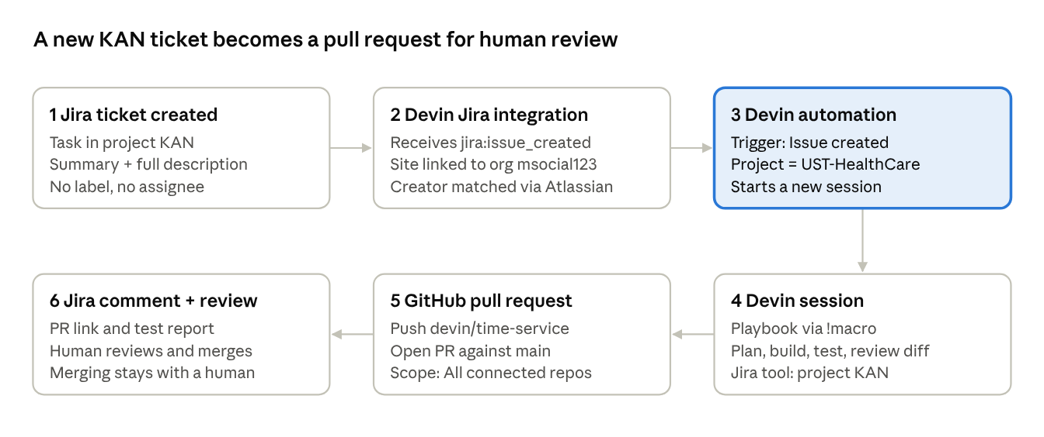
The highlighted box is the only part you configure per project; steps 1–2 and 5–6 depend on the one-time connections in section 3.

2. Components
Six pieces take part; Devin is the only one that writes code, and every PR still needs a human review.
System | Role in the flow | Where it is configured
Jira Cloud — muralik1403.atlassian.net, project UST-HealthCare (KAN) | Source of work. A new Task fires the "issue created" event | Jira → Apps → Devin (app installed, site linked)
Devin Jira integration | Receives Jira events; links the Jira site to Devin org msocial123 | Devin → Settings → Connections → Jira
Devin automation "KAN - Issue created -> Smart Hospital" | Decides which events start a session, with what instructions, tools and limits | Devin → Automations → the automation → Edit
Devin playbook "Smart Hospital — Analyze, Plan & Build" | Standard workflow and guardrails for every session | Devin → Settings → Connections → Jira → Playbooks
GitHub — Msocial123/UST-HealthCare-Project (public) | Devin clones, branches, pushes and opens the PR here | Devin → Settings → Connections → GitHub
Repo rules — AGENTS.md, Smart_Hospital_Repository_Rules.md | Project instructions Devin reads before coding | Repository root

3. One-time setup checklist
All of these must be true before a ticket can trigger a working session; every item is already done for KAN.
- Devin for Jira app installed in Jira, and the site linked to Devin (Jira → Apps → Devin shows connected).
- Devin → Settings → Connections → Jira shows Connected (admin account muralik1403).
- Atlassian account linked to your Devin user — profile → Settings → Connections → Atlassian shows "Unlink user". Required because the Devin and Jira logins use different emails; without it the Issue created trigger cannot be saved.
- GitHub connected — Settings → Connections → GitHub shows @Msocial123 with UST-HealthCare-Project in its Repositories list.
- GitHub Automation scope = All connected repos — GitHub connection → General. The repo is public; with "Private repos only" sessions got git 403 and could not push.
- Playbook saved — listed under Active playbooks, macro !smart_hospital__analyze_plan__build.
- Session mode = Direct session creation ON (Jira connection page), so Devin builds instead of only posting a scoping comment.
- One automation only — the old label-based rule (label + status Done) was deleted so a ticket never starts two sessions.

4. Automation options
Open it at Devin → left sidebar Automations → KAN - Issue created -> Smart Hospital → Edit (top right).
Direct link: app.devin.ai/org/msocial123/automations/8a68be6f560c47cb8c20ddf3ff4a3cae/edit
Setting | Current value | What it does / why
Name | KAN - Issue created -> Smart Hospital | Label only
Active toggle | On | Off stops all new sessions; use it to pause
Trigger | Jira → Issue created, project equals UST-HealthCare | Any new KAN issue starts a session. Other triggers: Issue updated, Label added, Status changed, Assigned, Comment created or edited
Trigger response | Reply → Comments on the issue | Devin posts its final summary as a Jira comment
Step before the agent runs | Not used | Optional pre-step
Agent type | Start new session | One fresh session per ticket (alternative: Message existing session)
Instructions | !smart_hospital__analyze_plan__build + short brief | The macro attaches the playbook; session shows "Used playbook"
Agent mode | Org default (Normal) | Session behaviour mode
Run as | System User | Identity the session acts as. Alternative: Creator (you) — try if Devin cannot comment on Jira
MCPs → Jira | Built-in, Specific projects: KAN | Jira tools for KAN. Specific projects turns off the Atlassian MCP server; All projects left the session with no Jira tool
Notifications | None | Optional alert when a run completes
Advanced → Auto-start child sessions | On | Session may spawn helper sessions
Advanced → Shared scratchpad | On | Memory shared across this automation's sessions
Advanced → Network policy | git-manager.devin.ai, pypi.org, files.pythonhosted.org | Allowed domains; PyPI lets Devin install Python packages
Advanced → Virtual environment | Default (Ubuntu) | OS of the session
Advanced → Limits | Not set | Spend limit per session and rate limit; recommended before wider use

Not in this editor: Session mode, Playbooks and older label-style automations live on Settings → Connections → Jira; Automation scope lives on the GitHub connection.

5. Playbook
- Name: Smart Hospital — Analyze, Plan & Build (default playbook).
- Macro: !smart_hospital__analyze_plan__build (double underscores). The older label !smart_hospital_analyze_plan_build does not match it.
- Attached by: the macro as the first word of the automation's Instructions (there is no Playbook field on this automation type).
- Workflow: read ticket → read README and AGENTS.md → analyse → plan → implement only the scope → tests → run and fix → review diff → report.
- Guardrails: Python 3.12+, FastAPI, Pydantic v2; synthetic data; no secrets; no Docker, Kubernetes, frontend or CI/CD unless asked; acceptance criteria are the checklist.

6. Writing a Jira story that works
A ticket triggers on creation, so it must be complete when you click Create. Use the per-service story documents that accompany this runbook.
- Project / type: UST-HealthCare (KAN), Task.
- Summary: <Service name> - Endpoints, Tests and Pull-Request Readiness.
- Labels and Assignee: leave empty — a playbook label or assigning Devin can start a second session.
- Description: Objective, Part 1 Analysis and Plan, Part 2 Build, Part 3 Endpoints, Part 4 Tests, Part 5 PR Readiness, Scope and Constraints, Acceptance Criteria.
- Do not create test or placeholder tickets in KAN — each one starts a paid session.

7. Running a test
A session starts within about a minute; a finished PR took 30–60 minutes for KAN-6 and KAN-7.
When | Where to look | What you should see
~1 min | Devin → Automations → the automation → Events | "Created KAN-n: …" row, Succeeded, with View session
~1 min | The session | "Build … KAN-n" and "Used playbook: Smart Hospital — Analyze, Plan & Build"
5–10 min | The Jira ticket | Devin's plan comment (first run with the KAN-only Jira setting — to confirm)
10–40 min | The session | Tasks ticking off: scaffold, models, tests, README, commit, push, PR
30–60 min | GitHub → Pull requests | PR against main from devin/<timestamp>-<service>
End | The Jira ticket | PR link and completion report comment

Automation sessions run as System User and are hidden from Sessions when filtered to your own; open them from the automation's Events tab.

8. Troubleshooting
Symptom | Cause | Fix
Creating a ticket started nothing | Only automation was label-based and required status Done | Created Issue created automation; deleted old rule
Label rule never matched the playbook | Single vs double underscores in the label | Attach playbook by macro in Instructions
"Link your Jira user to use this trigger" | Atlassian account not linked (different emails) | Profile → Settings → Connections → Atlassian → Link
"@Devin" comment did nothing | Typed as text, not a real mention | Type @Dev and pick Devin from the list
Session could not install packages | PyPI domains not in network policy | Added pypi.org and files.pythonhosted.org
Ticket looked "not triggered" (KAN-7) | It had triggered; no Jira tool and session hidden by the Sessions filter | Check Events tab; Jira scope set to KAN
git 403 on push; no PR | GitHub Automation scope Private repos only; repo is public | Set All connected repos; PRs #3 and #4 opened
"No Jira tool", jira_projects null | Jira MCP on All projects | Specific projects: KAN. Open: confirm on next ticket; fallback Run as → Creator
Warning: pull commands failed | Repo maintenance commands in Devin environment | Open: review environment setup commands

9. Webinar demo script
- Architecture (1 min) — eight-service diagram; Identity built, Patient and Provider built by Devin from Jira.
- Settings tour (3 min) — Jira connection page → Automations → Edit (trigger, macro, Jira tool, network) → GitHub Automation scope.
- Create the ticket live (2 min) — paste the prepared story; no label; Create.
- Show the trigger (1–2 min) — refresh Events until "Created KAN-n" appears; open View session; point out "Used playbook".
- Watch Devin start (2 min) — reads AGENTS.md, builds a task list, posts the plan.
- Show a finished result (3 min) — PR #3 or #4: files, tests, README, completion report; Jira ticket with PR link.
- Close (1 min) — humans review and merge; guardrails from AGENTS.md and the playbook.

10. Open items
☐ Confirm Devin posts on Jira itself on the next ticket; fallback: Run as → Creator.
☐ Review and merge PR #3 and PR #4; test results are Devin's own report.
☐ Expect a small root README.md conflict when the second PR merges.
☐ Fix the failing repository maintenance commands in Devin.
☐ Consider spend and rate limits under Advanced → Limits.

