Smart Hospital: AWS Infrastructure Session Prompts
Repository: Msocial123/UST-HealthCare-Project
Session date: 26 Oct 2026
Requested by: Murali (Msocial123)
Devin session: https://app.devin.ai/sessions/479e3ef38f22439594a2d5a9bd245ac5
The prompts appear exactly as typed, in the order they were sent.
# | Prompt | Outcome
1 | Build the Terraform infrastructure | Modular Terraform (bootstrap, 13 modules, dev environment). S3 remote state with S3 native locking. us-east-1. No AWS monitoring services. PR #14: https://github.com/Msocial123/UST-HealthCare-Project/pull/14 (merged).
2 | Test the infrastructure on AWS | Asked for new keys through Devin Secrets and a confirmation of the cost.
3 | Reply on cost and credentials | Bootstrap and dev environment applied (162 AWS resources), then verified: EKS nodes Ready, RDS available, ALB smoke test returned 200. Fixes from the first real apply are in PR #15: https://github.com/Msocial123/UST-HealthCare-Project/pull/15.
4 | List the services | Inventory of the 8 microservices and 16 AWS services, with resource names and counts.
5 | Export the prompts | This document.

Prompt 1: Build the Terraform infrastructure

Prompt (verbatim)
Act as DevOps Engineer - Now we have to focus on the deployment of the application for that need to build the entire infra using the Terraform - Modules using the Architecture diagram. We have create dev environment to pass all the variables we have to use the terraform.tfvars file , State file has to be store in the remote (S3 Bucket) , State Locking Mechanism also need to be implement. Entire infra has to build as per the Architecture expect Monitoring Services. Going to setup Monitoring using the Datadog so don't use any aws cloud native services. Entire infra has to build on US-East region based on this create the entire terraform code - Create a different brach and start buiilding the terraform code

Attachment
Smart Hospital AWS Microservices Architecture.png (architecture diagram, shown below)
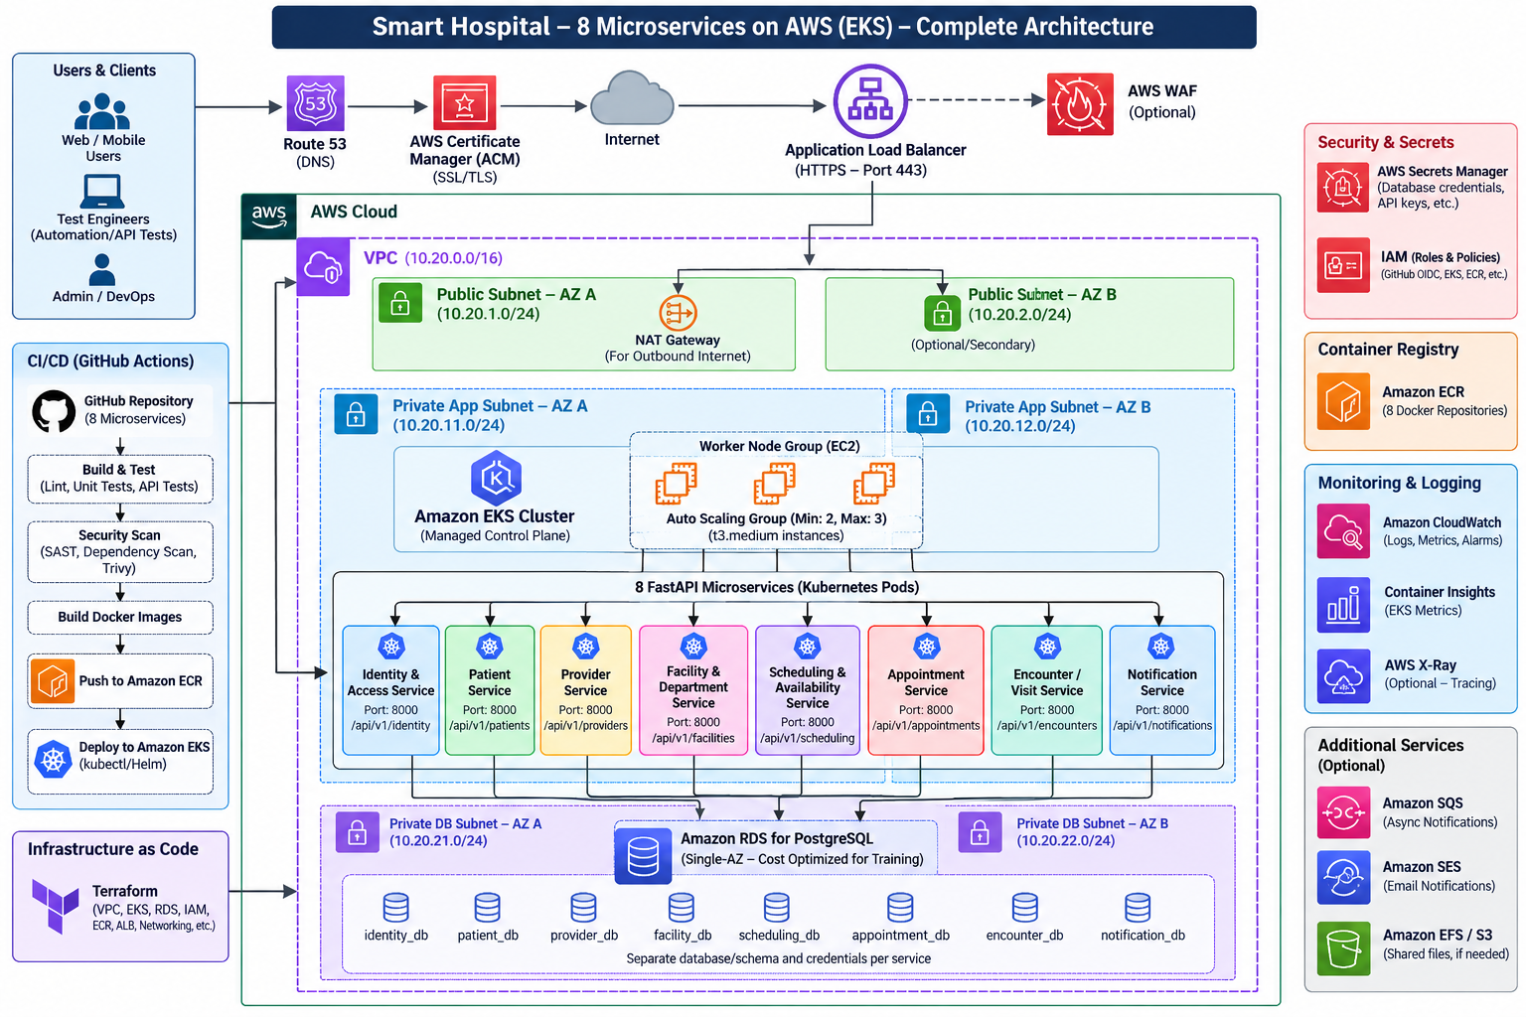

Outcome
Modular Terraform (bootstrap, 13 modules, dev environment). S3 remote state with S3 native locking. us-east-1. No AWS monitoring services. PR #14: https://github.com/Msocial123/UST-HealthCare-Project/pull/14 (merged).

Prompt 2: Test the infrastructure on AWS

Prompt (verbatim)
Mate - Test the Infra here is the AWS Credencials - Provided the complete Access Key and Secret Key - Test it and let me know once Infra is up

Attachment
Murali_accessKeys.csv. Not reproduced here: the file was deleted unopened and the key pair was rotated.

Outcome
Asked for new keys through Devin Secrets and a confirmation of the cost.

Prompt 3: Reply on cost and credentials

Prompt (verbatim)
Yes I am fine with the cost and also Access Key , Secret Key Stored in the Secret use those credencials to login and Test it

Attachment
None

Outcome
Bootstrap and dev environment applied (162 AWS resources), then verified: EKS nodes Ready, RDS available, ALB smoke test returned 200. Fixes from the first real apply are in PR #15: https://github.com/Msocial123/UST-HealthCare-Project/pull/15.

Prompt 4: List the services

Prompt (verbatim)
Can you list out the number of services so that I can cross check

Attachment
None

Outcome
Inventory of the 8 microservices and 16 AWS services, with resource names and counts.

Prompt 5: Export the prompts

Prompt (verbatim)
Extra the prompts whatever I used - Give me a word document format I will download it

Attachment
None

Outcome
This document.

Other actions (not prompts)
- Approved the environment setup update that installs Terraform and TFLint.
- Approved the environment setup update that installs AWS CLI v2 and kubectl.
- Merged PR #14.

