**The analysis by creating visualizations using IBM Cognos and integrating Python code for advanced analysis.**

**TEAM MEMBER**

**810021205089 : SOUNDARPANDIYAN M**

**PHASE 4 : PROJECT SUBMISSION**

**Sentiment Analysis**: Use Python libraries like Pandas and Matplotlib to perform more complex analyses on the data, such as time series analysis, user segmentation, or machine learning-based predictions.

|  |  |
| --- | --- |
| In [1]:   |  | | --- | | *# This Python 3 environment comes with many helpful analytics libraries installed*  *# For example, here's several helpful packages to load in*  import numpy as np *# linear algebra* import pandas as pd *# data processing, CSV file I/O (e.g. pd.read_csv)* from sklearn.model_selection import train_test_split *# function for s plitting data to train and test sets*  import nltk from nltk.corpus import stopwords from nltk.classify import SklearnClassifier  from wordcloud import WordCloud,STOPWORDS import matplotlib.pyplot as plt  %matplotlib inline | |
| |  | | --- | | *# Input data files are available in the "../input/" directory.*  *# For example, running this (by clicking run or pressing Shift+Enter) w ill list the files in the input directory*  from subprocess import check_output | |

I decided to only do sentiment analysis on this dataset, therfore I dropped the unnecessary colunns, keeping only sentiment and text.

|  |  |
| --- | --- |
| In [2]:   |  | | --- | | data = pd.read_csv('../input/Sentiment.csv')  *# Keeping only the neccessary columns* data = data[['text','sentiment']] | |

First of all, splitting the dataset into a training and a testing set. The test set is the 10% of the original dataset. For this particular analysis I dropped the neutral tweets, as my goal was to only differentiate positive and negative tweets.

|  |  |
| --- | --- |
| In [3]:   |  | | --- | | *# Splitting the dataset into train and test set* train, test = train_test_split(data,test_size = 0.1)  *# Removing neutral sentiments* train = train[train.sentiment != "Neutral"] | |

As a next step I separated the Positive and Negative tweets of the training set in order to easily visualize their contained words. After that I cleaned the text from hashtags, mentions and links. Now they were ready for a WordCloud visualization which shows only the most emphatic words of the Positive and Negative tweets.

|  |  |
| --- | --- |
| In [4]:   |  | | --- | | train_pos = train[ train['sentiment'] == 'Positive'] train_pos = train_pos['text'] train_neg = train[ train['sentiment'] == 'Negative'] train_neg = train_neg['text']  def wordcloud_draw(data, color = 'black'):  words = ' '.join(data) cleaned_word = " ".join([word for word **in** words.split() if 'http' **not** **in** word **and** **not** word.startswith('@') **and** **not** word.startswith('#') **and** word != 'RT'  ]) wordcloud = WordCloud(stopwords=STOPWORDS, background_color=color, width=2500, height=2000  ).generate(cleaned_word) plt.figure(1,figsize=(13, 13)) plt.imshow(wordcloud) plt.axis('off') plt.show() | |
| |  | | --- | | print("Positive words") wordcloud_draw(train_pos,'white') print("Negative words") wordcloud_draw(train_neg) | |

**Positive words**

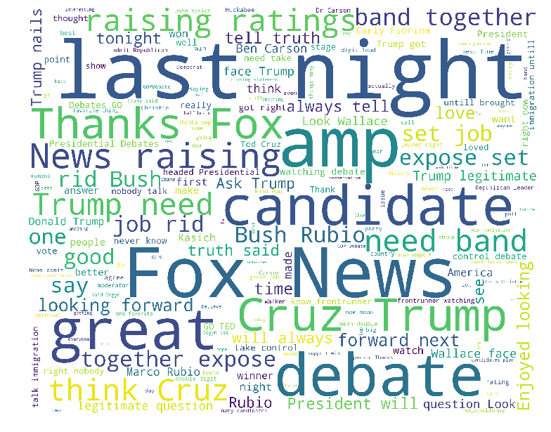

**Negative words**

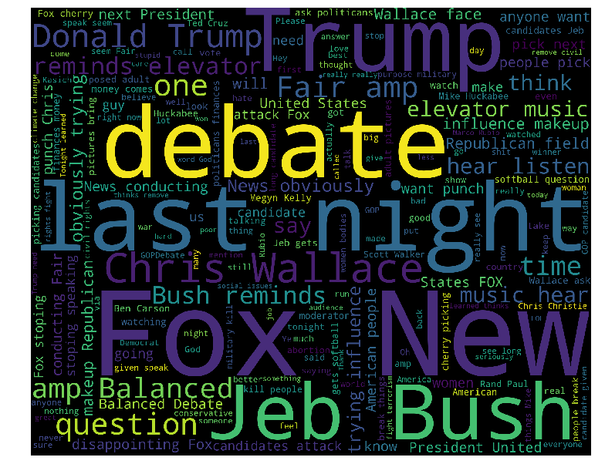

|  |
| --- |
|  |
| Interesting to notice the following words and expressions in the positive word set: truth, strong, legitimate, together, love, job  In my interpretation, people tend to believe that their ideal candidate is truthful, legitimate, above good and bad.    At the same time, negative tweets contains words like: influence, news, elevator music, disappointing, softball, makeup, cherry picking, trying  In my understanding people missed the decisively acting and considered the scolded candidates too soft and cherry picking. |

After the vizualization, I removed the hashtags, mentions, links and stopwords from the training set.

Stop Word: Stop Words are words which do not contain important significance to be used in Search Queries. Usually these words are filtered out from search queries because they return vast amount of unnecessary information. ( the, for, this etc. )

|  |  |
| --- | --- |
| In [5]:   |  | | --- | | tweets = [] stopwords_set = set(stopwords.words("english"))  for index, row **in** train.iterrows():  words_filtered = [e.lower() for e **in** row.text.split() if len(e) >  = 3] words_cleaned = [word for word **in** words_filtered if 'http' **not** **in** word **and** **not** word.startswith('@') **and** **not** word.startswith('#') | |
| |  | | --- | | **and** word != 'RT'] words_without_stopwords = [word for word **in** words_cleaned if **not** word **in** stopwords_set] tweets.append((words_without_stopwords, row.sentiment))  test_pos = test[ test['sentiment'] == 'Positive'] test_pos = test_pos['text'] test_neg = test[ test['sentiment'] == 'Negative'] test_neg = test_neg['text'] | |

As a next step I extracted the so called features with nltk lib, first by measuring a frequent distribution and by selecting the resulting keys.

|  |  |
| --- | --- |
| In [6]:   |  | | --- | | *# Extracting word features* def get_words_in_tweets(tweets):  all = [] for (words, sentiment) **in** tweets:  all.extend(words) return all  def get_word_features(wordlist): wordlist = nltk.FreqDist(wordlist) features = wordlist.keys() return features w_features = get_word_features(get_words_in_tweets(tweets)) | |
| |  | | --- | | def extract_features(document): document_words = set(document) features = {} for word **in** w_features:  features['contains(**%s**)' % word] = (word **in** document_words) return features | |

Hereby I plotted the most frequently distributed words. The most words are centered around debate nights.

In

[7]:

wordcloud_draw(w_features)

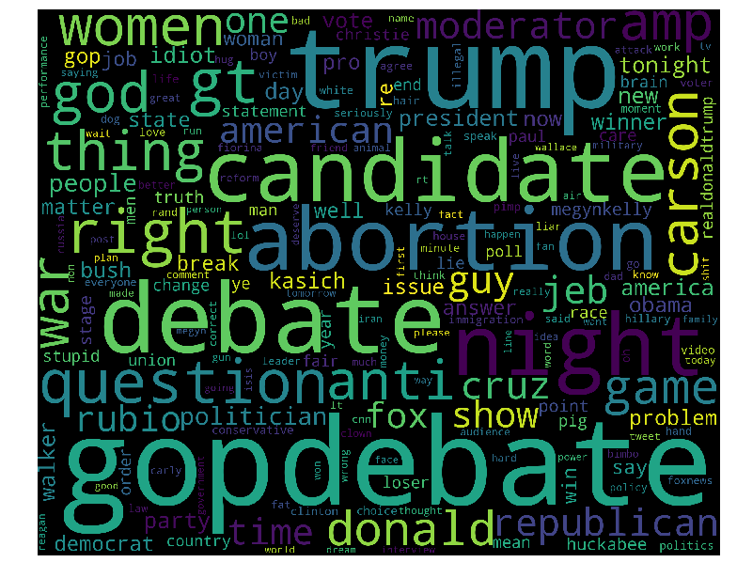

Using the nltk NaiveBayes Classifier I classified the extracted tweet word features.

|  |  |
| --- | --- |
| In [8]:   |  | | --- | | *# Training the Naive Bayes classifier* training_set = nltk.classify.apply_features(extract_features,tweets) classifier = nltk.NaiveBayesClassifier.train(training_set) | |

Finally, with not-so-intelligent metrics, I tried to measure how the classifier algorithm scored.

|  |  |
| --- | --- |
| In [9]:   |  | | --- | | neg_cnt = 0 pos_cnt = 0 for obj **in** test_neg:  res = classifier.classify(extract_features(obj.split())) if(res == 'Negative'): neg_cnt = neg_cnt + 1 for obj **in** test_pos:  res = classifier.classify(extract_features(obj.split())) if(res == 'Positive'): pos_cnt = pos_cnt + 1  print('[Negative]: **%s**/**%s** ' % (len(test_neg),neg_cnt)) print('[Positive]: **%s**/**%s** ' % (len(test_pos),pos_cnt)) | |
| |  | | --- | | Output: |   **[Negative]: 842/795**  **[Positive]: 220/74** |

In this project I was curious how well nltk and the NaiveBayes Machine Learning algorithm performs for Sentiment Analysis. In my experience, it works rather well for negative comments. The problems arise when the tweets are ironic, sarcastic has reference or own difficult context.

Consider the following tweet: "Muhaha, how sad that the Liberals couldn't destroy Trump. Marching forward." As you may already thought, the words sad and destroy highly influences the evaluation, although this tweet should be positive when observing its meaning and context.