happy number

class Solution {
public boolean isHappy(int n) {
while(n>=10){
n=findsquaressum(n);
}
return n==1||n==7;
}
int findsquaressum(int n){
int res=0;
while(n>0){
res+=(n%10)*(n%10);
n/=10;
}
return res;
}
}

amstrong code normal

import java.util.*;
public class Main
{
public static void main(String[] args) {

Scanner sc=new Scanner(System.in);
int n=sc.nextInt();
int num=n,count=0,rem,ams=0,mul=1;
count=(int)Math.log10(n)+1;
n=num;
int c=count;
while(n>0)
{
rem=n%10;
while(count>0)
{
mul=mul*rem;
count--;
}
count=c;
ams+=mul;
n=n/10;
mul=1;
}
if(num==ams)
System.out.println(true);
else
System.out.println(false);
}
}

Optimized code for armstrong number

import java.util.*;
public class Main
{
public static void main(String[] args) {

Scanner sc=new Scanner(System.in);
int n=sc.nextInt();
int count=(int)Math.log10(n)+1;
int num=n;
int rem,sum=0;
while(n>0)
{
rem=n%10;
sum+=Math.pow(rem,count);
n/=10;
}
if(sum==num)
System.out.println("yes");
else
System.out.println("no");
}
}

Perfect number

class Solution {
public boolean checkPerfectNumber(int num) {
if (num <= 0) {
return false;
}
int sum = 0;
for (int i = 1; i * i <= num; i++) {
if (num % i == 0) {
sum += i;
if (i * i != num) {
sum += num / i;
}

}
}
return sum - num == num;

}
}

Problem :
https://www.hackerrank.com/challenges/java-loops/copy-from/221098083

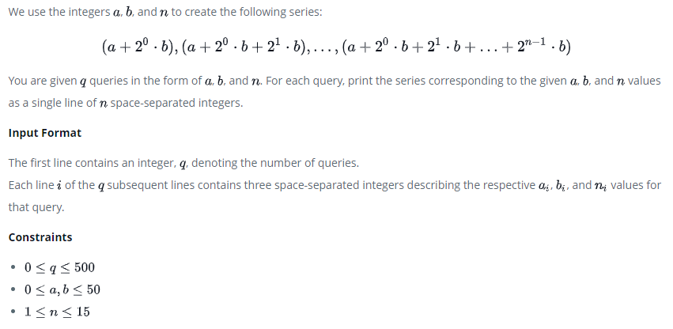
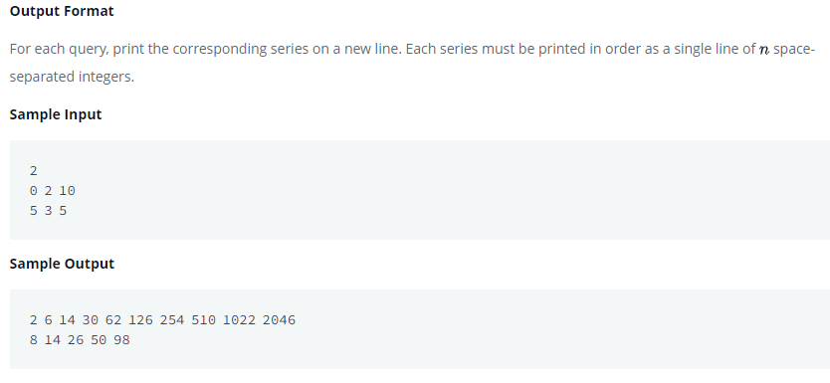
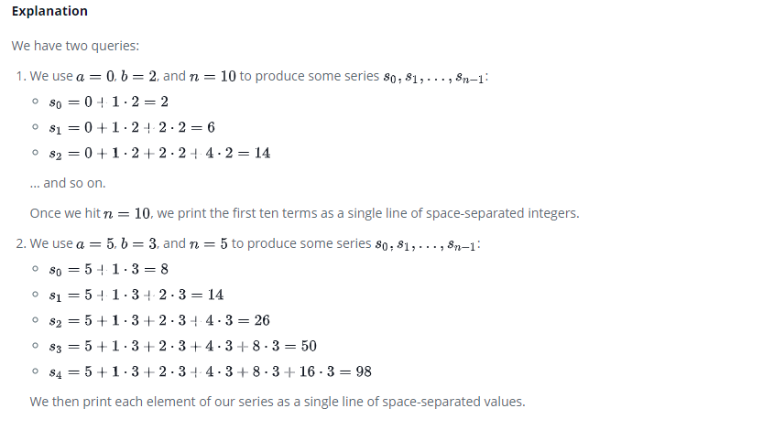

Solution:
import java.util.*;
import java.io.*;

class Solution{
public static void main(String []argh) {
Scanner in = new Scanner(System.in);
int t=in.nextInt();
if((t>=0)&&(t<=500))
{
while(t>0)
{

int a = in.nextInt();
int b = in.nextInt();
int n = in.nextInt();
if(((n>=1)&&(n<=15))&&((a>=0)&&(a<=50))&&((b>=0)&&(b<=50)))
{
int sum=a;
for(int j=0;j<n;j++)
{
sum+=Math.pow(2,j)*b;
System.out.print(sum+" ");
}
System.out.println();
}

t--;
}
}
in.close();
}
}

