PROLOG LAB SHEET
Factorial Calculation Using Recursion
Execution + Line-by-Line + Trace + Backtracking
1. Problem Statement
Write a Prolog program to calculate the factorial of a number using recursion and demonstrate its execution line by line.
2. Basic Concept
Factorial means multiplying a number by all positive integers smaller than it.
5! = 5 × 4 × 3 × 2 × 1 = 120
Main rule:
N! = N × (N-1)!
Stopping condition (base case):
0! = 1
3. Recursion
Recursion means a predicate calls itself again with a smaller value until it reaches a stopping condition.
factorial(4)
↓
factorial(3)
↓
factorial(2)
↓
factorial(1)
↓
factorial(0) ← Stop
4. Complete Prolog Code
factorial(0, 1).
factorial(N, Result) :-
N > 0,
N1 is N - 1,
factorial(N1, Result1),
Result is N * Result1.
First rule = base case. Second rule = recursive rule.
5. Line-by-Line Explanation
factorial(0, 1).
→ Base case: 0! = 1. It stops recursion.
factorial(N, Result) :-
→ Recursive rule. N is input and Result is output.
N > 0,
→ Checks whether N is greater than 0.
N1 is N - 1,
→ Calculates one smaller number. Example: 4 becomes 3.
factorial(N1, Result1),
→ Recursive call: the same predicate is called again.
Result is N * Result1.
→ Multiplies N by the result returned from recursion.
6. Save the Program
Open Notepad, paste the code and save it as:
factorial.pl
Example:
D:\Prolog\factorial.pl
Make sure it is .pl, not .txt.
7. Consult in SWI-Prolog
Open SWI-Prolog and type:
?- [factorial].
Expected:
true.
This means the file was loaded successfully.
8. Execute the Base Case
Run:
?- factorial(0, X).
Prolog matches:
factorial(0, 1).
Therefore:
X = 1.
Because 0! = 1.
9. Main Execution: factorial(4, X)
Run:
?- factorial(4, X).
Step 1: Start
factorial(4, X)
First Prolog checks factorial(0,1). But 4 does not match 0, so it tries the recursive rule.
Step 2: Check condition
N = 4
4 > 0 → TRUE
So Prolog continues.
Step 3: Calculate N1
N1 is N - 1
N1 is 4 - 1
N1 = 3
Now it calls:
factorial(3, Result1)
Step 4: Execute factorial(3)
3 > 0 → TRUE
N1 is 3 - 1 → 2
factorial(2, Result2)
Step 5: Execute factorial(2)
2 > 0 → TRUE
N1 is 2 - 1 → 1
factorial(1, Result3)
Step 6: Execute factorial(1)
1 > 0 → TRUE
N1 is 1 - 1 → 0
factorial(0, Result4)
Step 7: Base Case
factorial(0, Result4)
Matches:
factorial(0, 1).
So Result4 = 1. Recursion stops here.
10. Result Returns Upward
Going down:
4 → 3 → 2 → 1 → 0
Coming back:
factorial(0) = 1
factorial(1) = 1 × 1 = 1
factorial(2) = 2 × 1 = 2
factorial(3) = 3 × 2 = 6
factorial(4) = 4 × 6 = 24
X = 24.
11. Execution Table
Step | N | Operation | Next | Result
1 | 4 | 4 > 0; 4-1=3 | factorial(3) | waiting
2 | 3 | 3 > 0; 3-1=2 | factorial(2) | waiting
3 | 2 | 2 > 0; 2-1=1 | factorial(1) | waiting
4 | 1 | 1 > 0; 1-1=0 | factorial(0) | waiting
5 | 0 | Base case | stop | 1
6 | 1 | 1×1 | return | 1
7 | 2 | 2×1 | return | 2
8 | 3 | 3×2 | return | 6
9 | 4 | 4×6 | return | 24
12. Trace
Trace lets us watch how Prolog executes the query.
?- trace.
Then:
?- factorial(4, X).
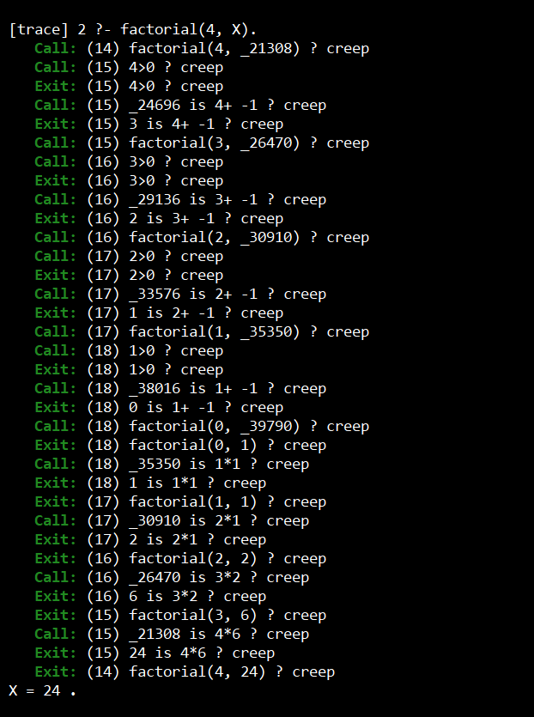
The exact display can differ slightly by SWI-Prolog version, but conceptually:
Call: factorial(4, X)
Call: 4 > 0
Exit: 4 > 0
Call: N1 is 4 - 1
Exit: N1 = 3
Call: factorial(3, Result1)
...
Call: factorial(0, Result4)
Exit: factorial(0, 1)
Exit: factorial(1, 1)
Exit: factorial(2, 2)
Exit: factorial(3, 6)
Exit: factorial(4, 24)
X = 24.
13. Trace Events
Event | Meaning | Easy Meaning
Call | Predicate starts. | ঢুকছে
Exit | Predicate succeeds. | সফল হয়ে বের হচ্ছে
Redo | Goes back to try another possibility. | আবার চেষ্টা
Fail | Current goal cannot succeed. | ব্যর্থ
14. Trace Flow
CALL factorial(4,X)
↓
CALL factorial(3,R1)
↓
CALL factorial(2,R2)
↓
CALL factorial(1,R3)
↓
CALL factorial(0,R4)
↓
EXIT factorial(0,1)
↑
EXIT factorial(1,1)
↑
EXIT factorial(2,2)
↑
EXIT factorial(3,6)
↑
EXIT factorial(4,24)
This is the key execution sequence to explain to the teacher.
15. Backtracking
Backtracking means Prolog goes back to a previous choice point to search for another solution.
For factorial(4,X), there is only one valid answer:
?- factorial(4, X).
X = 24.
Now type ; after the answer:
X = 24 ;
false.
Prolog searched for another solution. There is no second valid factorial result for 4, so it returns false.
16. Why Backtracking Is Limited Here
For a fixed non-negative number, this factorial program normally has only one answer. Backtracking is much more visible in programs with multiple facts/rules or multiple possible solutions.
17. Stop Trace
?- notrace.
18. Complete Lab Demonstration Order
1. ?- [factorial].
true.
2. ?- factorial(0, X).
X = 1.
3. ?- factorial(4, X).
X = 24.
4. ?- trace.
5. ?- factorial(4, X).
Trace shows Call/Exit steps.
X = 24.
6. Press ;
false.
7. ?- notrace.
This sequence demonstrates saving/loading, normal execution, recursion, trace and backtracking.
19. Common Mistakes
factorial(0,1) লেখা কিন্তু period না দেওয়া
Fix: Every Prolog fact/rule ends with a period.
factorial.pl.txt
Fix: Save the file as factorial.pl.
N1 = N - 1
Fix: Use N1 is N - 1 for arithmetic evaluation.
Recursive call ভুলে যাওয়া
Fix: Use factorial(N1, Result1).
File consult না করা
Fix: Run ?- [factorial]. first.
21. What to Say During Demonstration
“First I consult the factorial.pl file. Then I run factorial(4, X). Prolog checks the base case, but 4 does not match 0. So it uses the recursive rule. It checks 4 > 0, calculates 4 - 1 = 3, and calls factorial(3). The same process continues until factorial(0). The base case returns 1. Then the results return upward: 1, 2, 6 and finally 24. With trace, I can see Call and Exit events. If I press semicolon after X = 24, Prolog backtracks to search for another answer, but there is none, so it returns false.”
22. Final Result
The factorial program was implemented and executed successfully using recursion. The execution was demonstrated step by step, trace was observed, and backtracking was tested.
End of Lab Sheet

