INSTALL DERBY ON WINDOWS
Make sure you have the latest Java version installed.
Download Apache Derby.
https://db.apache.org/derby/index.html
Go to downloads and download the appropriate file.
Extract the files. You’ll have a folder db-derby-10.14.2.0-bin. Go inside that folder to see another folder by the same name. Move that folder to C drive and rename it to derby.
Open up Notepad as Administrator. (Right click on Notepad icon and choose Run as Administrator.) Open the file setEmbeddedCP.bat in the C:\derby\bin directory. Modify the following line in the file.

@rem SET DERBY_INSTALL
to
set DERBY_INSTALL=C:\derby
Save and close the file.
Go to
C:\derby\bin and run setEmbeddedCP at the prompt.
You should see something like the following.
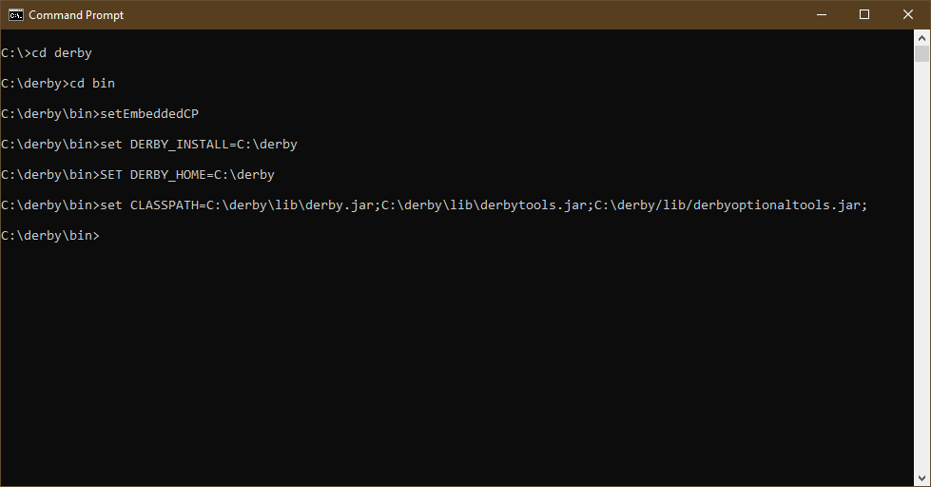

Set the CLASSPATH variable at the prompt.
set CLASSPATH=C:\derby\lib\derby.jar;C:\derby\lib\derbytools.jar;C:\derby\lib\derbyoptionaltools.jar;

Locate the directory where the MavBox files are located.
At the command prompt, go to that directory.
At the prompt type
java -jar c:\derby\lib\derbyrun.jar ij
At the ij> prompt type in the following. Make sure the quotes are not curly, but straight.
connect 'jdbc:derby:rentals;create=true;user=admin;password=admin';
At the ij> prompt type in
run 'rentals.sql';
At the ij> prompt type in
exit;
Output should be as follows:
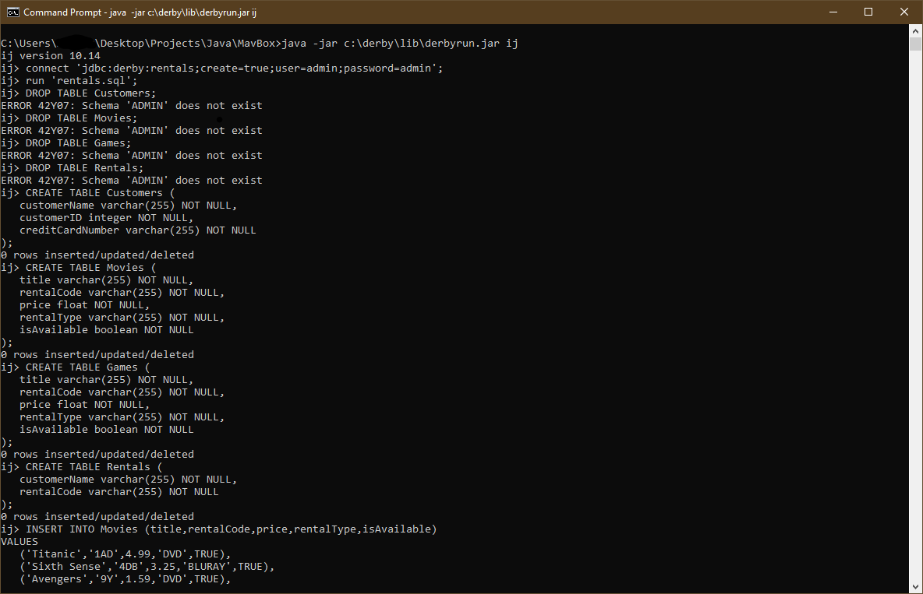

You may now compile MavBoxTest and then run it to utilize the program.

You should see the following.

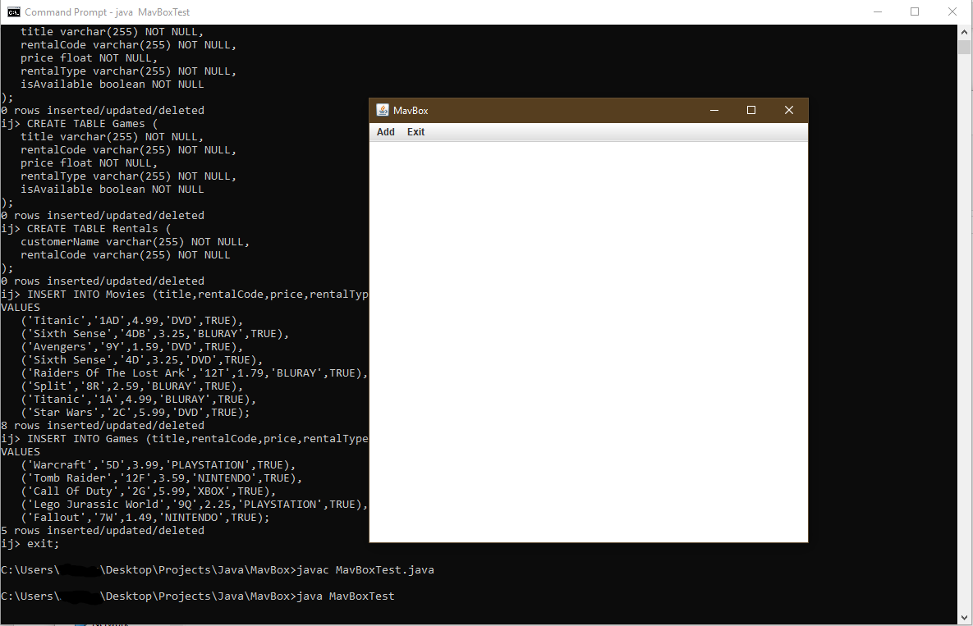

You may now add a customer under the add tab in the menu bar. Customers need a name, ID number of only numbers, and a credit card number in the format xxxx-xxxx-xxxx-xxxx .
Once you add a customer you can then assign them a rental under the add tab in the menu bar. Type in the customers name, select type of movie and then enter the rental code 1AD.
To test that the database is working and the information was saved you may write the database. To do so go to the exit tab in the menu bar and click ‘Write to database’.
Output should be as follows:
