1. **首先配置ODBC数据源（必须32位）**

进入如下目录C:\Windows\SysWOW64，找到odbcad32.exe文件，打开；

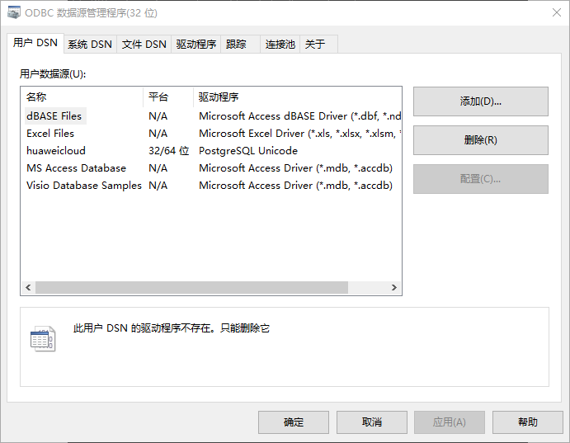

点击 “添加”

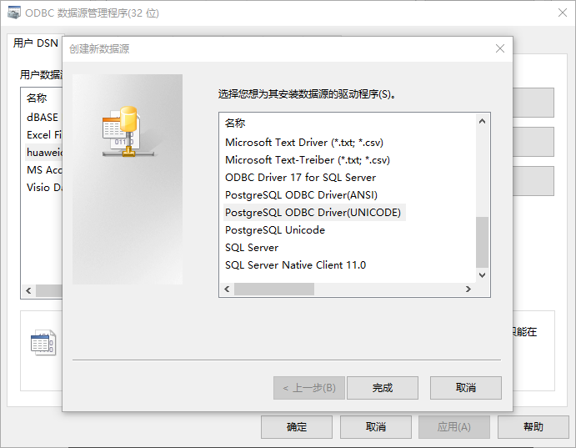

选择PostgreSQL ODBC Driver(UNICODE)

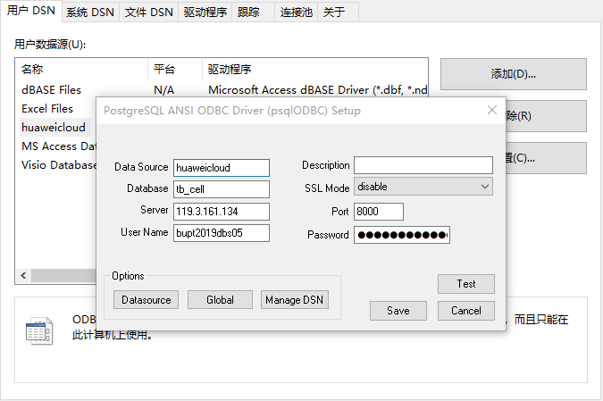

如上输入需要的信息，点击test

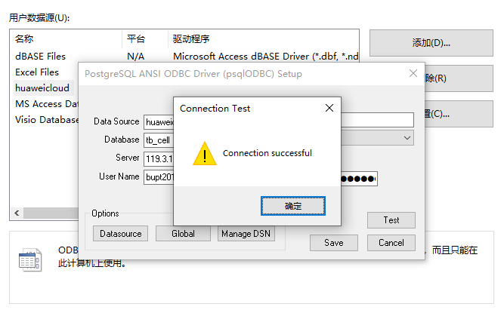

数据源配置完毕

**2、编写ODBC接口实验代码**

ODBC接口代码示例：

// 此示例演示如何通过ODBC方式获取openGauss中的数据。

// DBtest.c (compile with: libodbc.so)

#include <windows.h>

#include <stdlib.h>

#include <stdio.h>

#include <sqlext.h>

#include <sqltypes.h>

SQLHENV V_OD_Env; // Handle ODBC environment

SQLHSTMT V_OD_hstmt; // Handle statement

SQLHDBC V_OD_hdbc; // Handle connection

//char typename[100];

SQLINTEGER value = 100;

SQLINTEGER V_OD_erg, V_OD_buffer, V_OD_err, V_OD_id;

int main(int argc, char *argv[])

{

// 1. 申请环境句柄

V_OD_erg = SQLAllocHandle(SQL_HANDLE_ENV, SQL_NULL_HANDLE, &V_OD_Env);

if ((V_OD_erg != SQL_SUCCESS) && (V_OD_erg != SQL_SUCCESS_WITH_INFO))

{

printf("Error AllocHandle\n");

exit(0);

}

// 2. 设置环境属性（版本信息）

SQLSetEnvAttr(V_OD_Env, SQL_ATTR_ODBC_VERSION, (void*)SQL_OV_ODBC3, 0);

// 3. 申请连接句柄

V_OD_erg = SQLAllocHandle(SQL_HANDLE_DBC, V_OD_Env, &V_OD_hdbc);

if ((V_OD_erg != SQL_SUCCESS) && (V_OD_erg != SQL_SUCCESS_WITH_INFO))

{

SQLFreeHandle(SQL_HANDLE_ENV, V_OD_Env);

exit(0);

}

// 4. 设置连接属性

//SQLSetConnectAttr(V_OD_hdbc, SQL_ATTR_AUTOCOMMIT, SQL_AUTOCOMMIT_ON, 0);

// 5. 连接数据源

V_OD_erg = SQLConnect(V_OD_hdbc, (SQLCHAR*) "huaweicloud", SQL_NTS,

(SQLCHAR*) "your username", SQL_NTS, (SQLCHAR*) "password", SQL_NTS);

if ((V_OD_erg != SQL_SUCCESS) && (V_OD_erg != SQL_SUCCESS_WITH_INFO))

{

printf("Error SQLConnect %d\n", V_OD_erg);

SQLFreeHandle(SQL_HANDLE_ENV, V_OD_Env);

exit(0);

}

printf("Connected !\n");

// 6. 设置语句属性

SQLSetStmtAttr(V_OD_hstmt, SQL_ATTR_QUERY_TIMEOUT, (SQLPOINTER *)3, 0);

// 7. 申请语句句柄

SQLAllocHandle(SQL_HANDLE_STMT, V_OD_hdbc, &V_OD_hstmt);

// 8. 直接执行SQL语句。

//SQLCHAR tmp[300];

SQLRETURN ret;

ret=SQLExecDirect(V_OD_hstmt,(SQLCHAR*)"select * from tbMRODATA;", SQL_NTS);//你的数据库中必须有你要查找的表，否则会报错

printf("select result:%d\n",ret);

//SQLExecDirect(V_OD_hstmt, "CREATE TABLE customer_t1(c_customer_sk INTEGER, c_customer_name VARCHAR(32));", SQL_NTS);

//SQLExecDirect(V_OD_hstmt, "insert into customer_t1 values(1,1);", SQL_NTS);

//SQLExecDirect(V_OD_hstmt, "update customer_t1 SET c_customer_name ='new data' WHERE c_customer_sk = 1;", SQL_NTS);

// 9. 断开数据源连接并释放句柄资源

SQLFreeHandle(SQL_HANDLE_STMT, V_OD_hstmt);

SQLDisconnect(V_OD_hdbc);

SQLFreeHandle(SQL_HANDLE_DBC, V_OD_hdbc);

SQLFreeHandle(SQL_HANDLE_ENV, V_OD_Env);

return(0);

}

输出如下结果即代表连接成功

