**INNOVATION**

Title: Market Basket Insights: A Comprehensive Analysis of Innovative Techniques

**1. Introduction:**

Market basket analysis is a vital aspect of retail analytics, enabling businesses to understand customer behavior and preferences. This report delves into innovative techniques, including ensemble methods and deep learning architectures, to improve prediction accuracy and robustness in market basket insights. Furthermore, advanced association analysis techniques and visualization tools are explored to enhance the presentation of insights.



**2 Ensemble Methods:**

Ensemble methods involve combining multiple models to enhance predictive performance. Techniques such as Random Forest, Gradient Boosting, and Bagging can be applied to market basket analysis. By aggregating predictions from diverse models, ensemble methods often outperform individual models, ensuring a more accurate and robust analysis of customer purchasing patterns.

**3. Deep Learning Architectures:**

Deep learning techniques, particularly neural networks, offer the ability to handle complex, non-linear relationships in data. Architectures like Recurrent Neural Networks (RNNs) and Long Short-Term Memory networks (LSTMs) are well-suited for sequential data like customer purchase histories. These models can capture intricate patterns within market baskets, leading to more accurate predictions and uncovering hidden associations.

**4. Advanced Association Analysis Techniques:**

a. Sequential Pattern Mining:Utilizes algorithms like GSP (Generalized Sequential Patterns) and SPADE (Sequential PAttern Discovery using Equivalence classes) to find sequential patterns in customer purchases, offering insights into the order of item selection.

b. Frequent Itemset Mining: Algorithms like Apriori and FP-Growth help identify sets of items frequently purchased together. This information aids in optimizing product placement and bundling strategies.

c. Temporal Pattern Mining: Analyzing purchasing patterns over time, considering factors like seasonality or trends, provides a deeper understanding of customer behavior, enhancing the prediction system’s accuracy.

**5. Visualization Tools for Enhanced Insights Presentation:**

**a. Heat Maps:** Visualizing item co-occurrence using heat maps can provide an intuitive representation of frequently purchased item combinations, aiding in strategic product placement.

**b. Network Graphs:** Representing item relationships as nodes and edges can reveal complex associations within the market basket data. Advanced graph algorithms can identify key products with high centrality, offering valuable insights for marketing strategies.

**c. Interactive Dashboards:**Tools like Tableau or Power BI can create interactive dashboards, allowing stakeholders to explore market basket insights dynamically. Filters and drill-down features enhance user experience and facilitate deeper analysis.

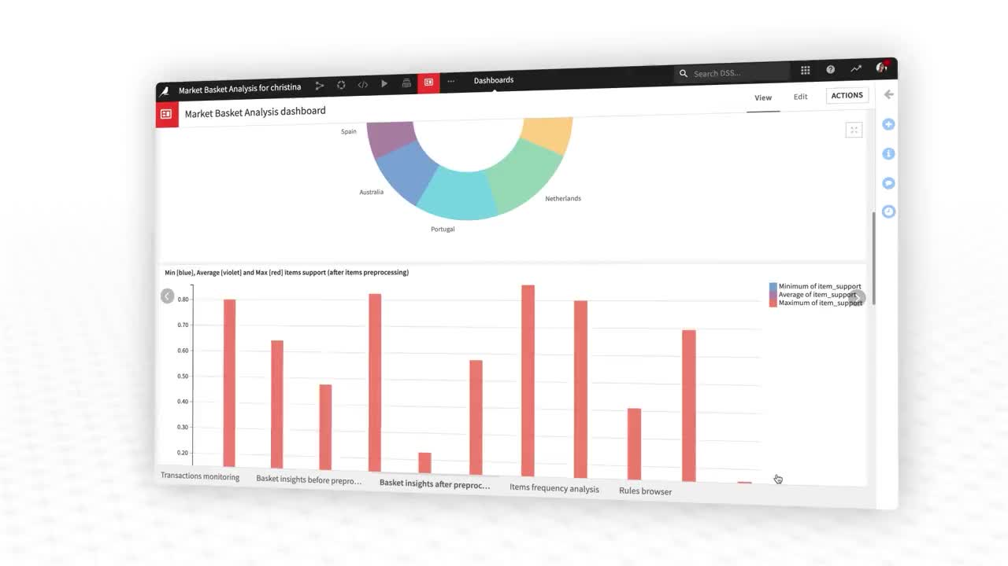

**6. Conclusion:**

Incorporating ensemble methods and deep learning architectures significantly enhances the accuracy and robustness of market basket analysis. Advanced association analysis techniques enable the discovery of intricate patterns, while visualization tools offer compelling ways to present insights. By integrating these innovative techniques, businesses can gain deeper understanding, optimize inventory management, and devise targeted marketing strategies, ultimately leading to improved customer satisfaction and increased revenue.