Azure Blob Storage to Azure SQL Database using Azure Databricks
Step 1: Create Azure Blob Storage
Description
Azure Blob Storage is used as the source layer to store raw files such as CSV, JSON, or Parquet. It provides highly scalable and cost-effective object storage for data ingestion.
Activities Performed
- Created a Storage Account.
- Configured the resource group and region.
- Selected the appropriate performance and redundancy options.

Step 2: Create Blob Container
Description
A Blob Container acts as a logical folder inside the Storage Account. It organizes source files and controls access permissions.
Activities Performed
- Created a new container.
- Assigned a meaningful container name.
- Configured the access level.
Step 3: Upload Source Files
Description
The source dataset is uploaded into the Blob Container. These files will be processed by Azure Databricks.
Activities Performed
- Uploaded CSV files.
- Verified file names and sizes.
- Ensured successful upload.
Outcome
The raw data is now available in Azure Blob Storage.

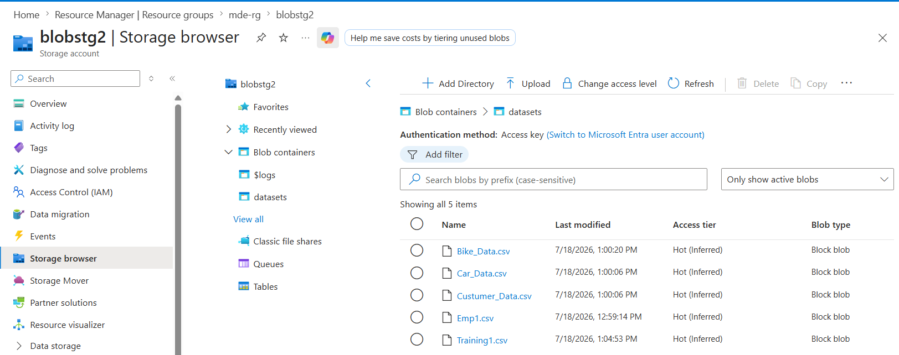

Step 4: Create Azure Databricks Workspace
Description
Azure Databricks is a cloud-based analytics platform built on Apache Spark. It enables distributed data processing for large datasets.
Activities Performed
- Created a Databricks Workspace.
- Selected the pricing tier.
- Configured networking and region.
Outcome
The workspace is ready for developing notebooks and executing Spark jobs.
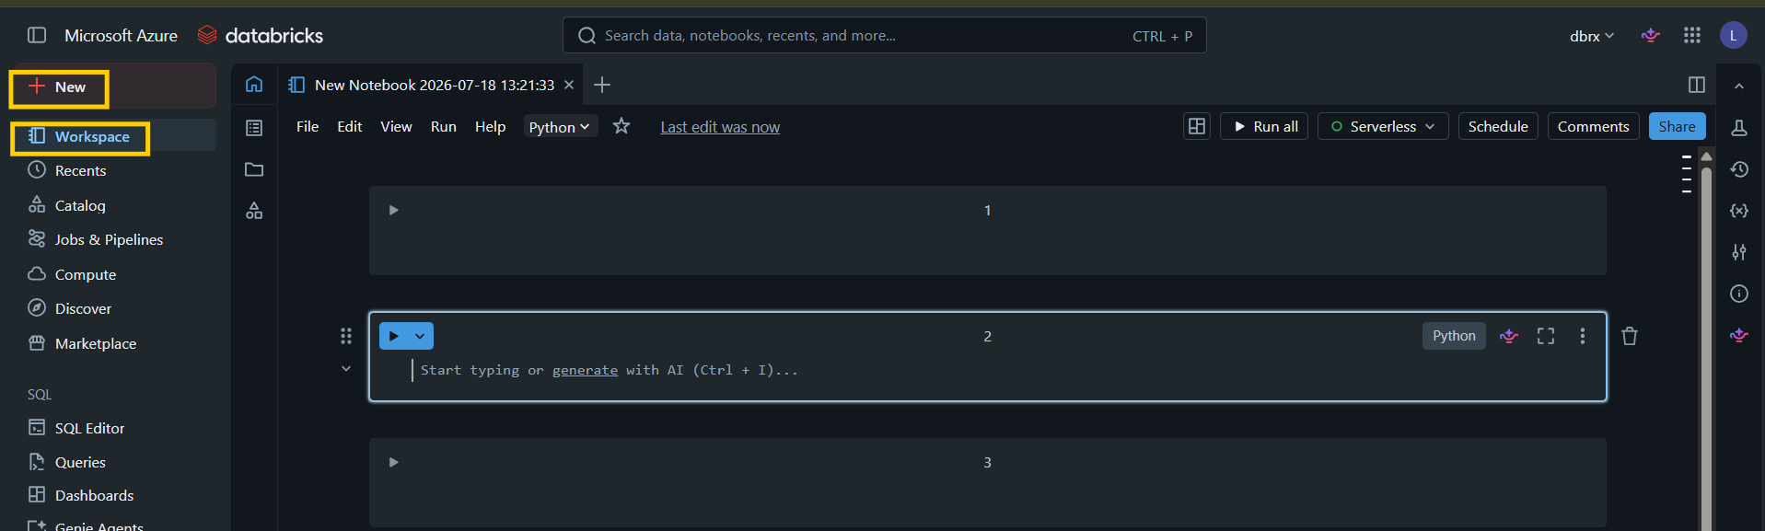
Step 5: Create Databricks Cluster
Description
A Databricks Cluster provides the compute resources required to execute PySpark code. It consists of one driver node and one or more worker nodes.
Activities Performed
- Selected the Databricks Runtime version.
- Chose the virtual machine size.
- Configured worker nodes.
- Started the cluster.
Outcome
The cluster is running and ready to execute notebooks.
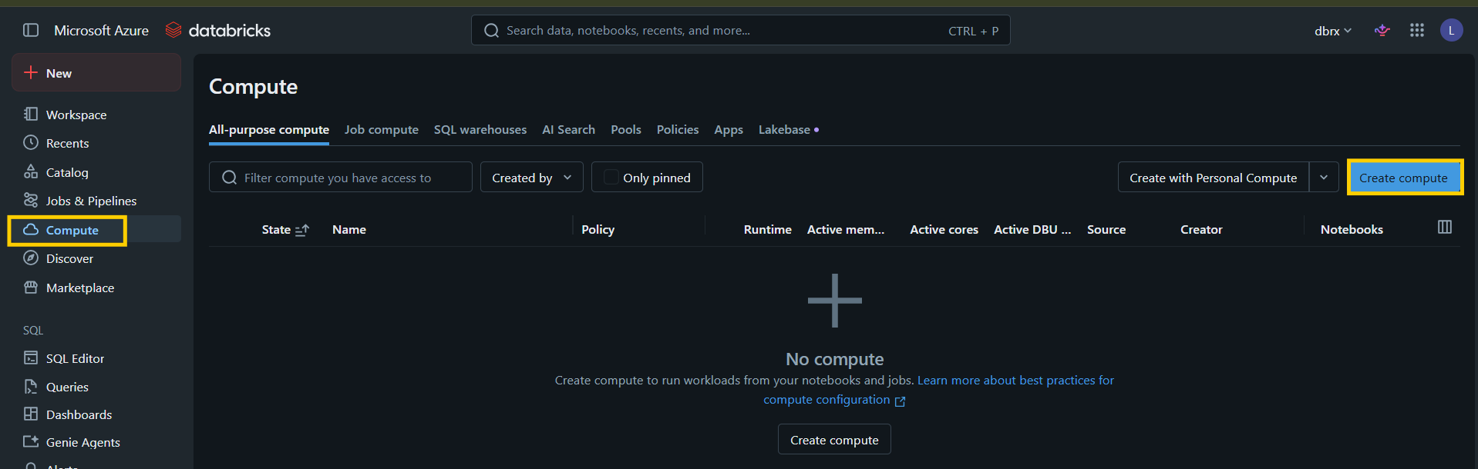
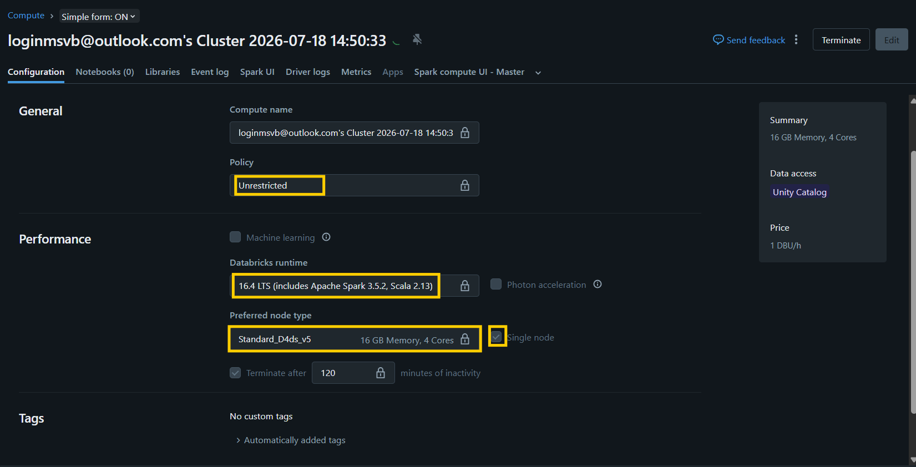
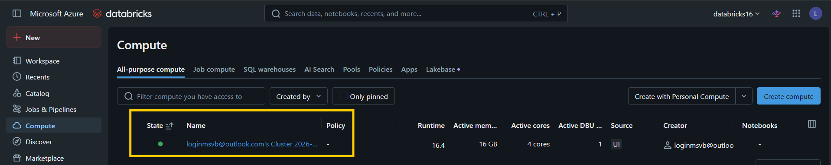

Step 7: Configure Azure Blob Storage Authentication (Account Key Method)
Description
Before Azure Databricks can read files from Azure Blob Storage, authentication must be configured. In this project, the Storage Account Access Key authentication method is used. The access key allows Databricks to securely connect to the Azure Storage Account and access the files stored within the Blob Container.
Why is this Step Required?
Azure Blob Storage is protected by authentication mechanisms. Databricks cannot directly access the storage account unless valid credentials are provided. By configuring the Storage Account Access Key in the notebook, Spark is authorized to read and write data to Azure Blob Storage.
Activities Performed
- Navigated to the Azure Portal.
- Opened the Storage Account.
- Selected Security + Networking → Access Keys.
- Copied Key1 (Access Key).
- Used the Storage Account Name and Access Key in the Databricks notebook configuration.
Sample PySpark Configuration
spark.conf.set(
"fs.azure.account.key.<storage-account-name>.blob.core.windows.net",
"<storage-account-access-key>"
)
Replace:
- <storage-account-name> with your Azure Storage Account name.
- <storage-account-access-key> with the copied Access Key.
Outcome
The Databricks notebook is successfully authenticated with Azure Blob Storage, allowing Spark to access files stored in the Blob Container for further processing.
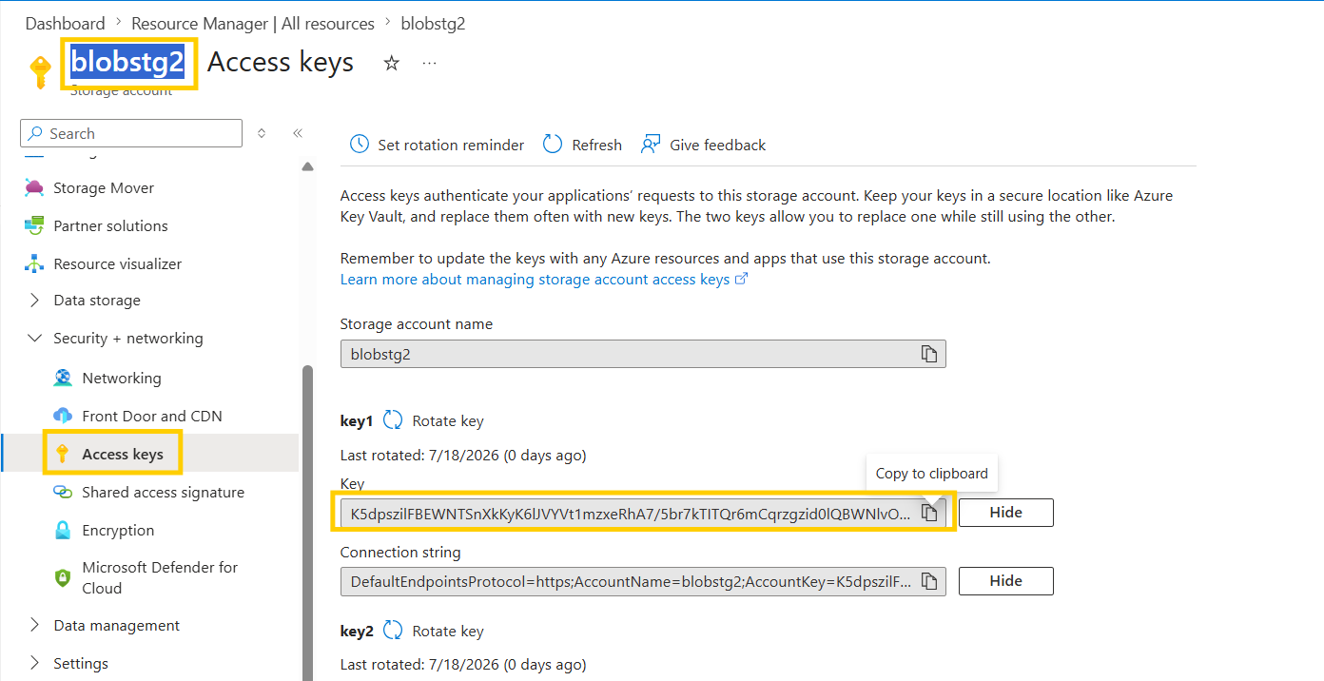
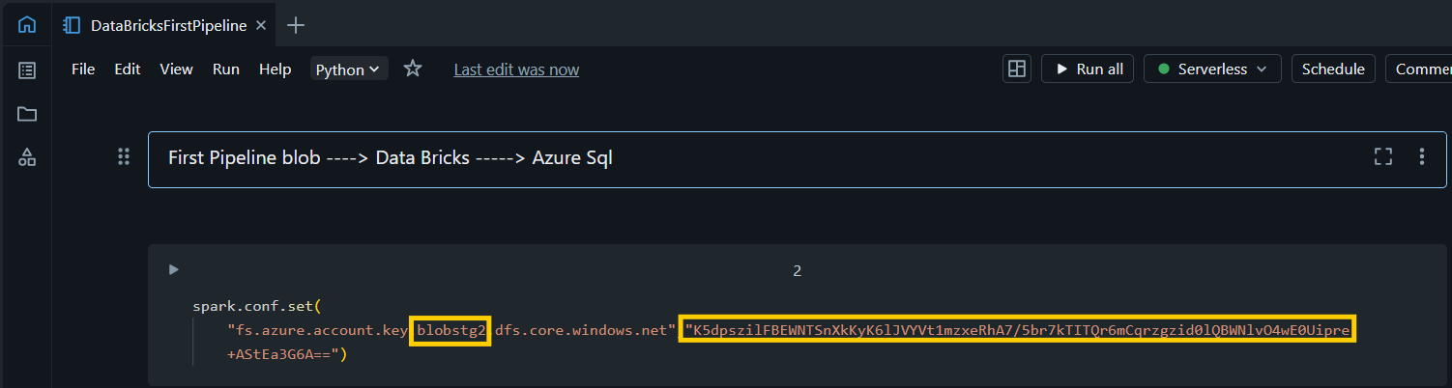
Step 7: Read Data from Azure Blob Storage
Description
The notebook connects to Azure Blob Storage and reads the source CSV file into a Spark DataFrame.
Activities Performed
- Configured the storage path.
- Read the CSV file using Spark.
- Enabled schema inference and header options.
Outcome
The source data is successfully loaded into a Spark DataFrame.

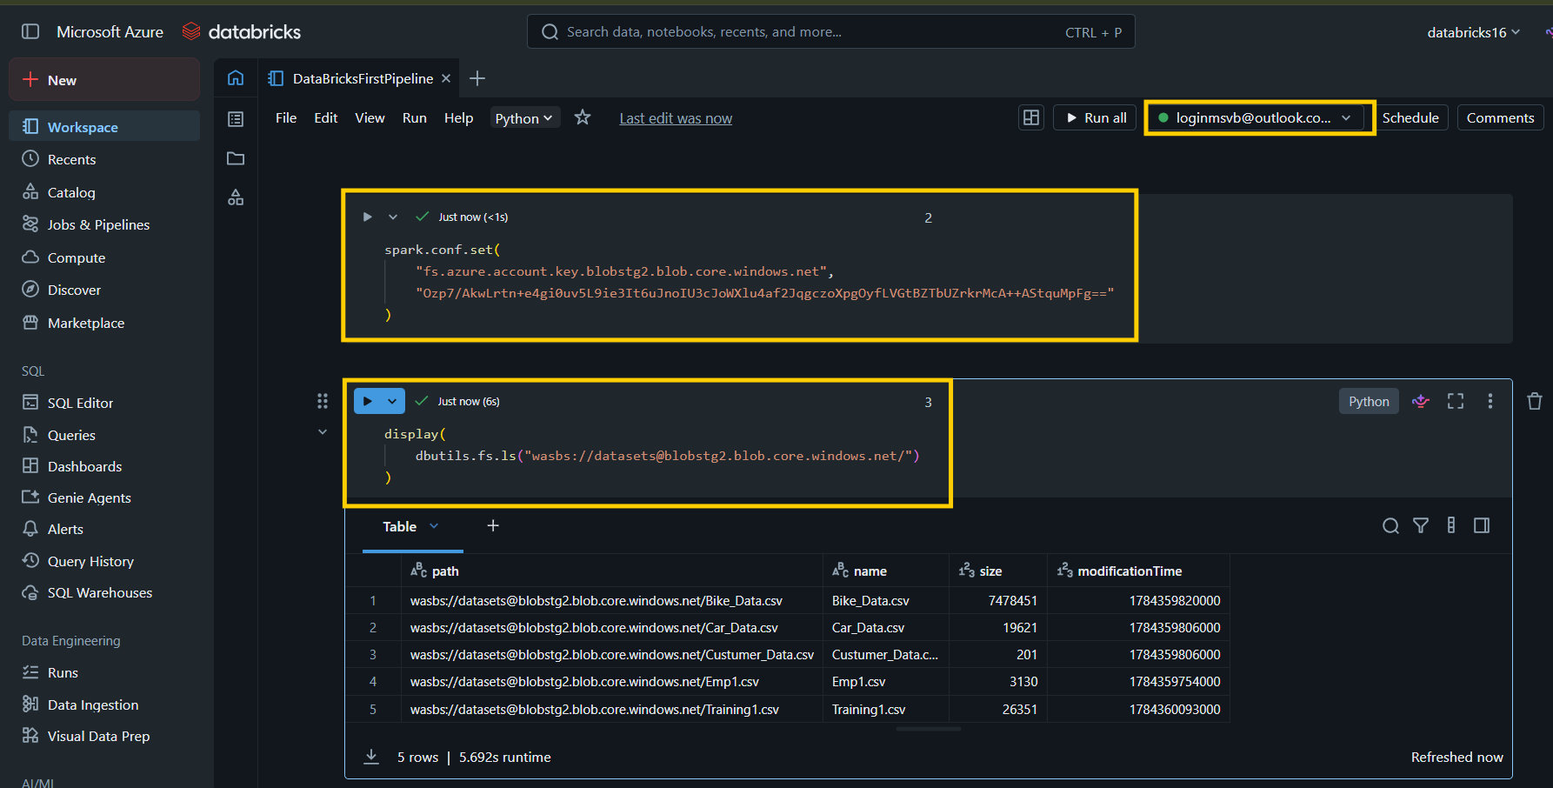
Step 8: Explore the Data
Description
The loaded data is analyzed to understand its structure and quality before applying transformations.
Activities Performed
- Displayed sample records.
- Verified the schema.
- Counted the number of rows.
Outcome
The dataset structure is confirmed for further processing.

Step 9: Data Cleaning
Description
Data cleaning removes inconsistencies and prepares the dataset for analysis.
Activities Performed
- Removed duplicate records.
- Handled null values.
- Trimmed whitespace.
- Converted data types.
- Renamed columns.
Outcome
The dataset is clean and standardized.

Step 10: Data Transformation
Description
Business rules are applied to enrich and transform the data.
Activities Performed
- Created derived columns.
- Filtered invalid records.
- Calculated business metrics.
- Applied aggregation and formatting.
Outcome
The transformed dataset is ready for loading into the destination database.

Step 11: Create Azure SQL Database
Description
Azure SQL Database serves as the destination where processed data is stored for reporting and analytics.
Activities Performed
- Created the Azure SQL Database.
- Configured server settings.
- Allowed firewall access.
- Created the required tables.
Outcome
The destination database is ready to receive processed data.

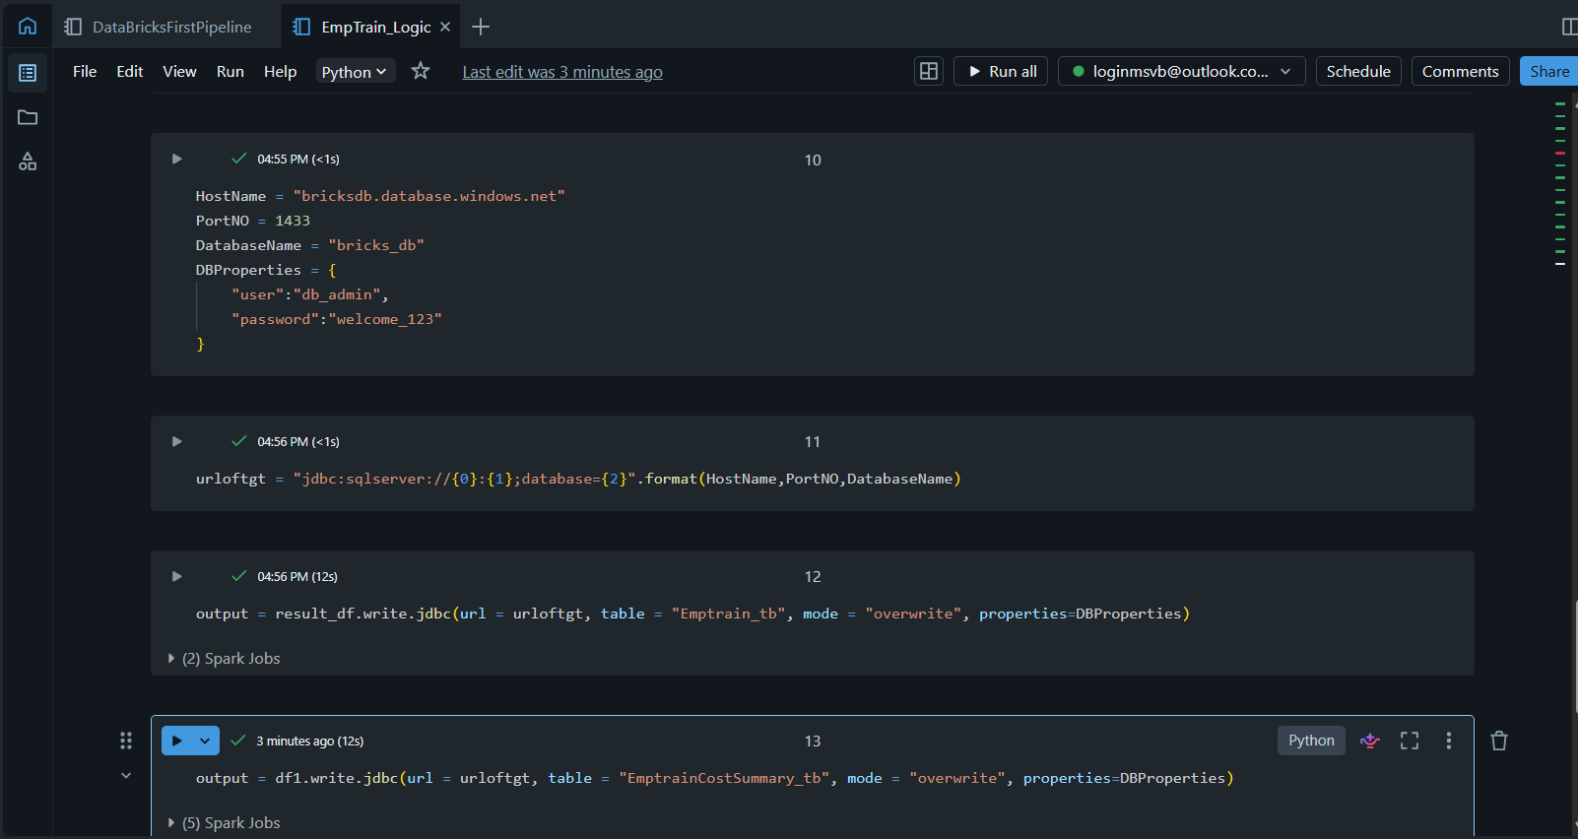
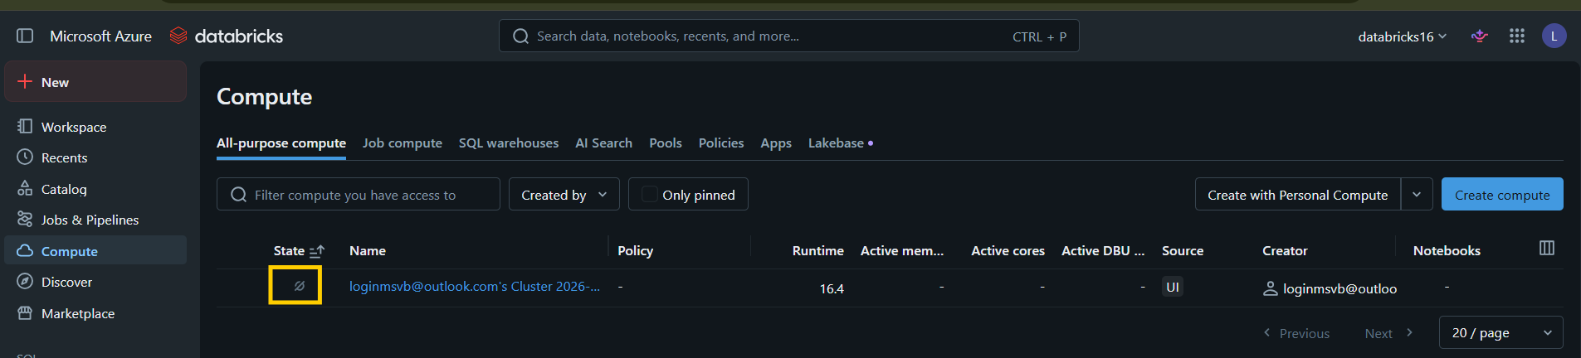

Step 12: Load Data into Azure SQL Database
Description
The transformed Spark DataFrame is written into Azure SQL Database using a JDBC connection.
Activities Performed
- Configured JDBC connection properties.
- Specified the target table.
- Loaded the transformed data.
Outcome
The processed records are successfully stored in Azure SQL Database.
📷 Screenshot: Data Loading

Step 13: Validate the Data
Description
Data validation ensures that all records have been loaded correctly and that the transformation results meet business expectations.
Activities Performed
- Verified record counts.
- Compared source and destination data.
- Executed SQL queries to validate the loaded data.
Outcome
The loaded data is verified and ready for reporting.
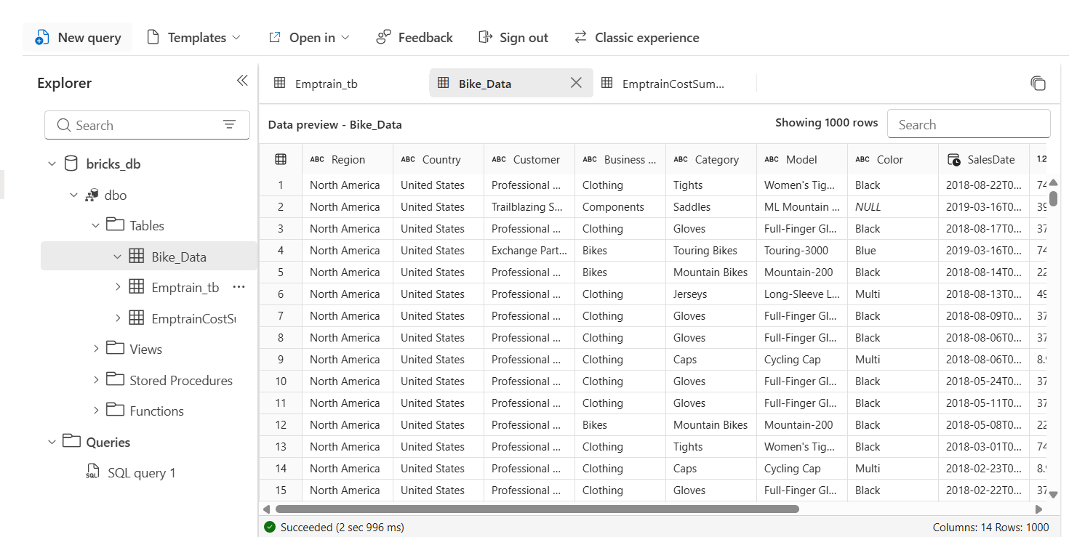
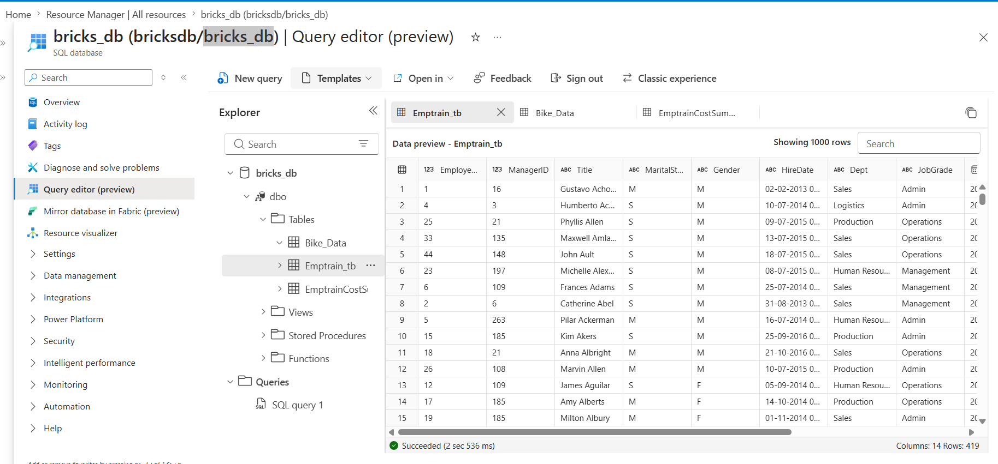
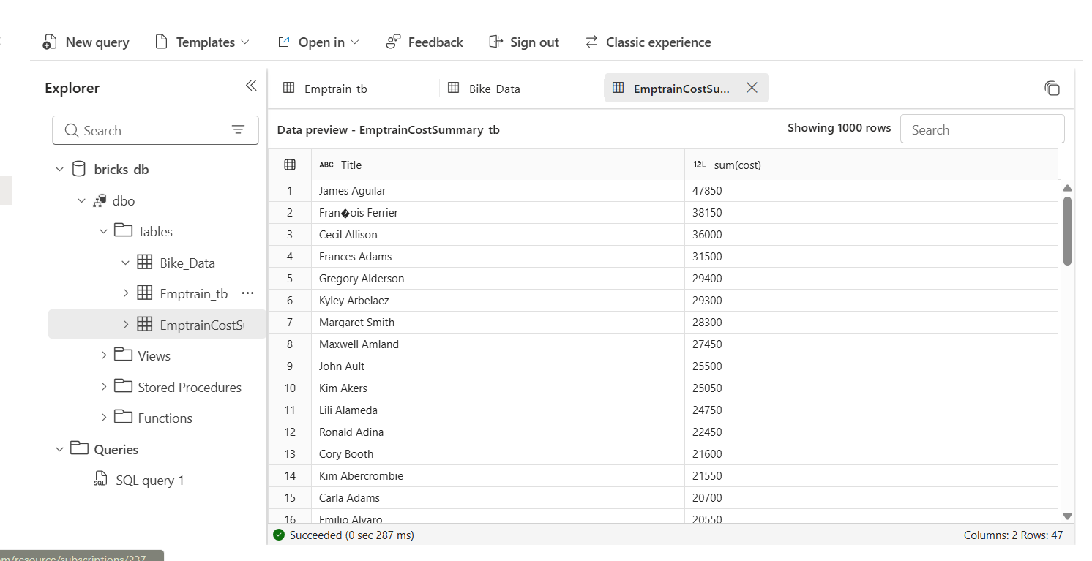

Step 14: Project Summary
Description
This project demonstrates an end-to-end Azure ETL pipeline that integrates storage, distributed processing, and relational database services.
Key Achievements
- Successfully ingested raw data from Azure Blob Storage.
- Processed and transformed data using Azure Databricks with PySpark.
- Loaded the transformed dataset into Azure SQL Database.
- Verified the successful data load through SQL validation.
- Built a scalable and maintainable cloud-based ETL solution suitable for analytical workloads.

