Pipeline Overview
This pipeline performs data transformation by joining data from multiple source tables, applying business rules, and generating aggregated results. The processed data is then prepared for analytical reporting and loaded into the target dataset.
Azure Blob Storage
Azure Blob Storage is a Microsoft Azure cloud storage service used to store large amounts of unstructured data such as files, images, videos, documents, backups, and CSV/JSON/Parquet files.
Purpose in this Project:
Azure Blob Storage is used as the source location to store raw input data before it is processed by the Azure Data Factory pipeline.
Steps to Create Azure Blob Storage:
- Sign in to the Azure portal.
- Create a Storage Account.
- Select the required Subscription, Resource Group, and Region.
- Enter a unique Storage Account Name.
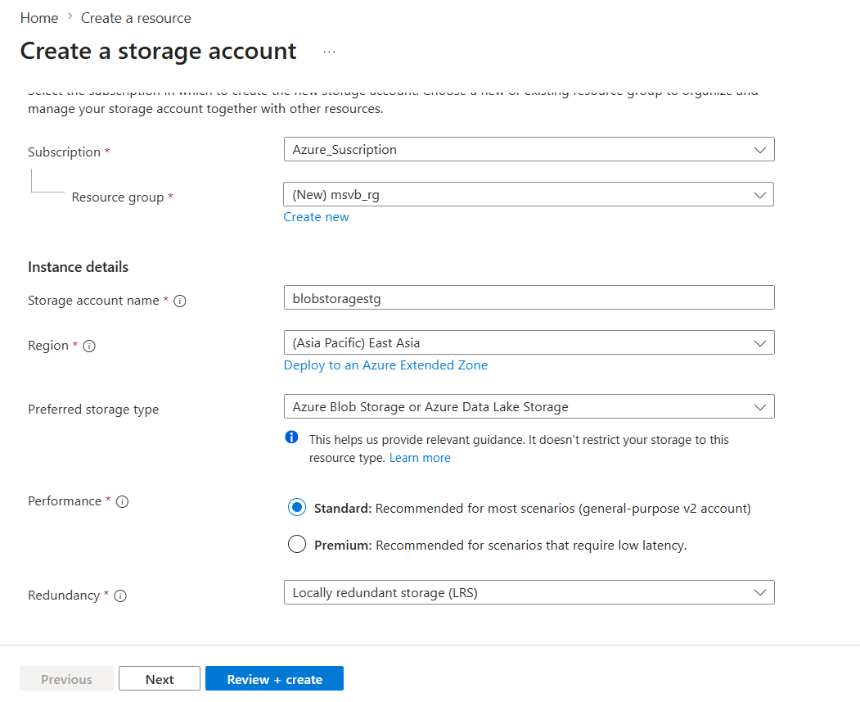
6.Choose the required Performance and Redundancy options.
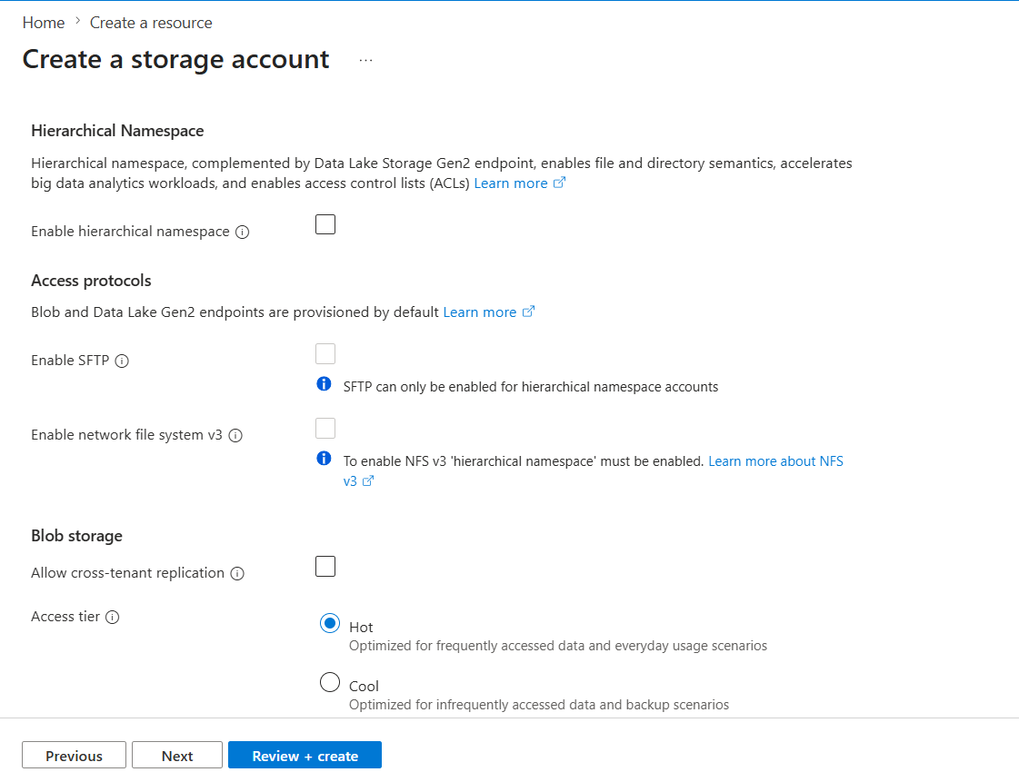
Review and click Create.
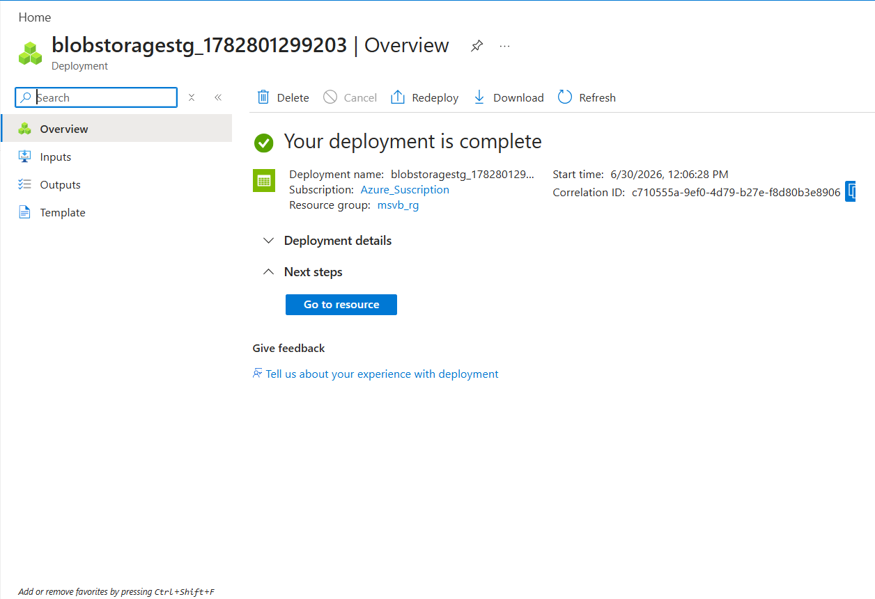
Open the Storage Account and create a Blob Container to upload data files.
Azure Data Lake Storage Gen2 (ADLS Gen2)
Definition:
Azure Data Lake Storage Gen2 (ADLS Gen2) is a scalable and secure cloud storage service designed for storing large volumes of structured, semi-structured, and unstructured data. It is optimized for big data analytics and data engineering workloads.
Purpose in this Project:
ADLS Gen2 is used as the destination storage to store the transformed data generated by the Azure Data Factory pipeline.
Steps to Create ADLS Gen2
- Sign in to the Azure portal.
- Click Create a Resource → Storage Account.
- Select the Subscription, Resource Group, and Region.
- Enter a unique Storage Account Name.
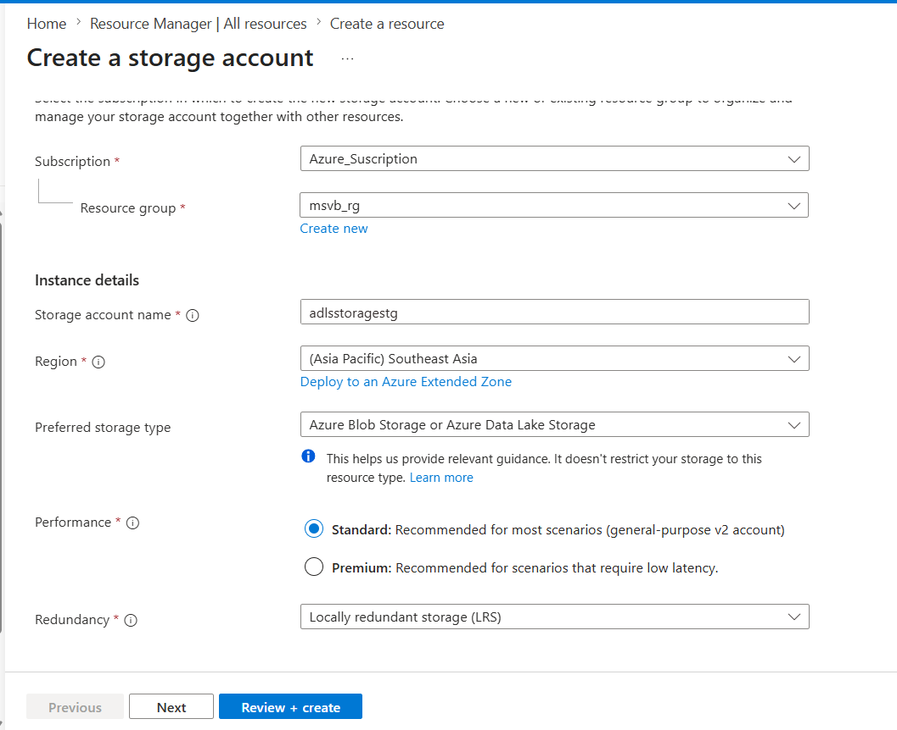
- Under the Advanced tab, enable Hierarchical Namespace (this enables ADLS Gen2).
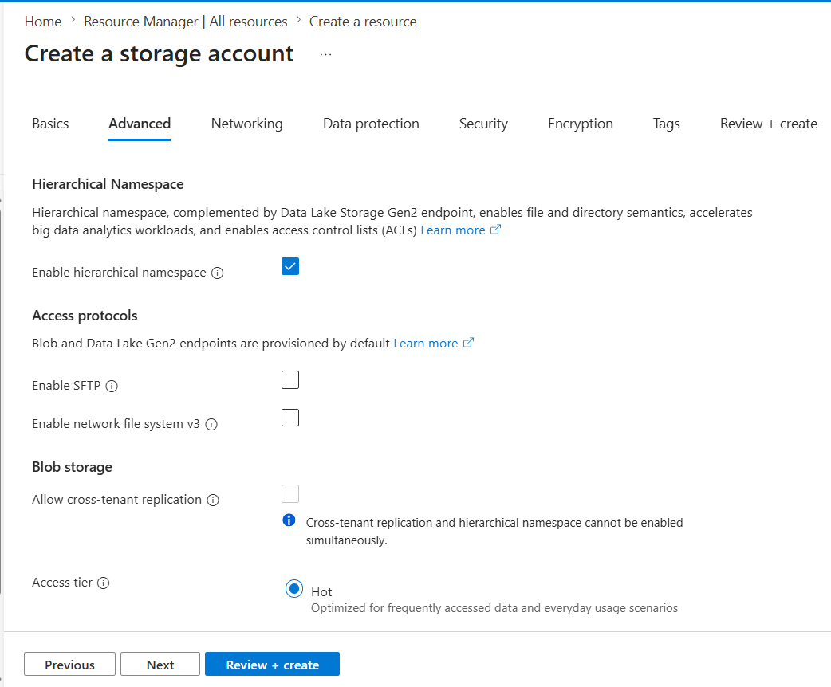
- Review the configuration and click Create.
- Open the Storage Account and create a File System (Container) to store the data.
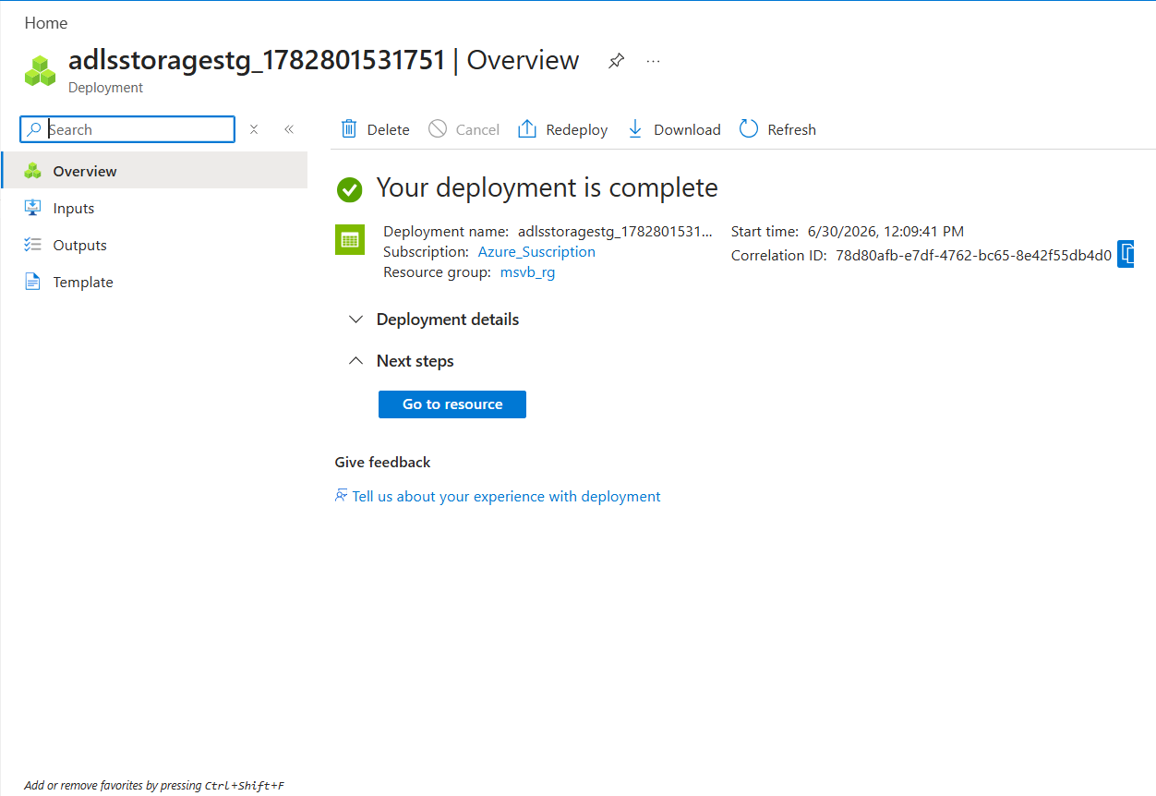
- Upload or access files through the created File System.
Note: ADLS Gen2 is enabled by turning on the Hierarchical Namespace feature in an Azure Storage Account.

Azure SQL Database
Definition:
Azure SQL Database is a fully managed relational database service provided by Microsoft Azure. It is used to store, manage, and query structured data without the need to manage the underlying infrastructure.
Purpose in this Project:
Azure SQL Database is used to store the transformed data from the Azure Data Factory pipeline for reporting, analysis, and further processing.
Steps to Create Azure SQL Database
- Sign in to the Azure portal.
- Click Create a Resource → SQL Database.
- Select the Subscription and Resource Group.
- Enter a unique Database Name.
- Create a new SQL Server or select an existing one.
- Choose the required Compute + Storage configuration.
- Review the settings and click Create.
- Configure the Firewall Rules to allow client access.
- Connect to the database using SQL Server Management Studio (SSMS) or Azure Data Studio.
Note: Azure SQL Database supports T-SQL and integrates seamlessly with Azure Data Factory for data ingestion and transformation workflows.

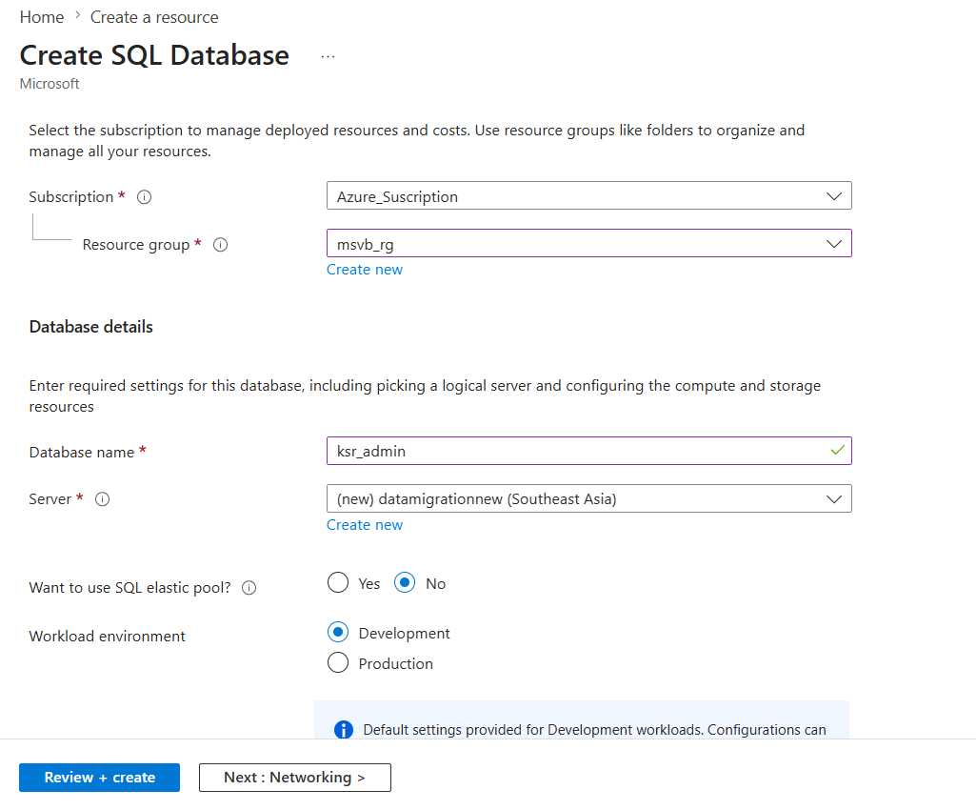
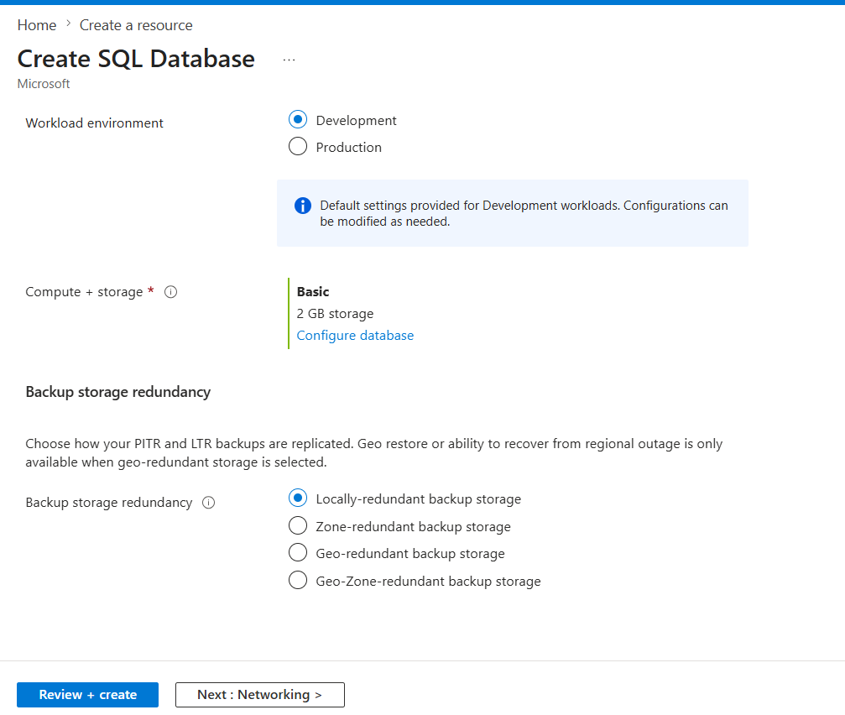
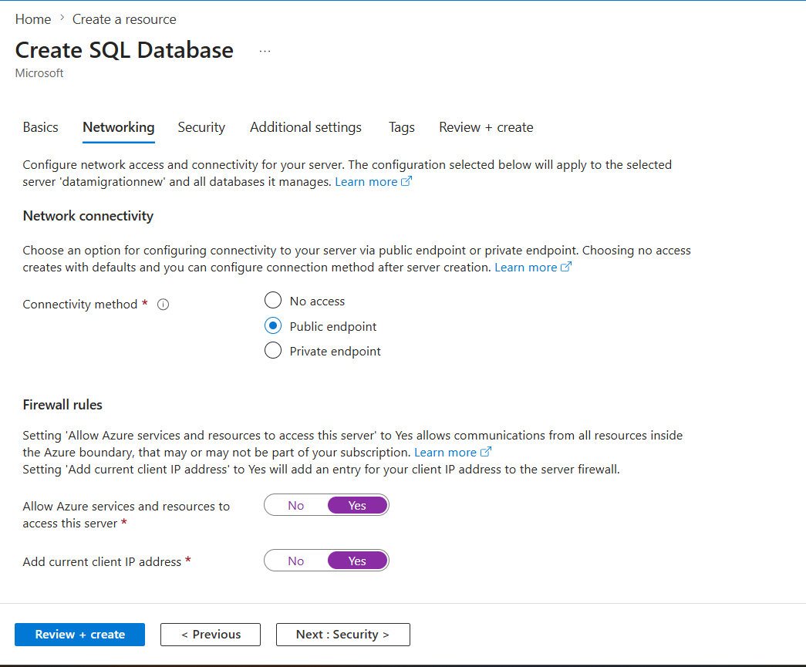
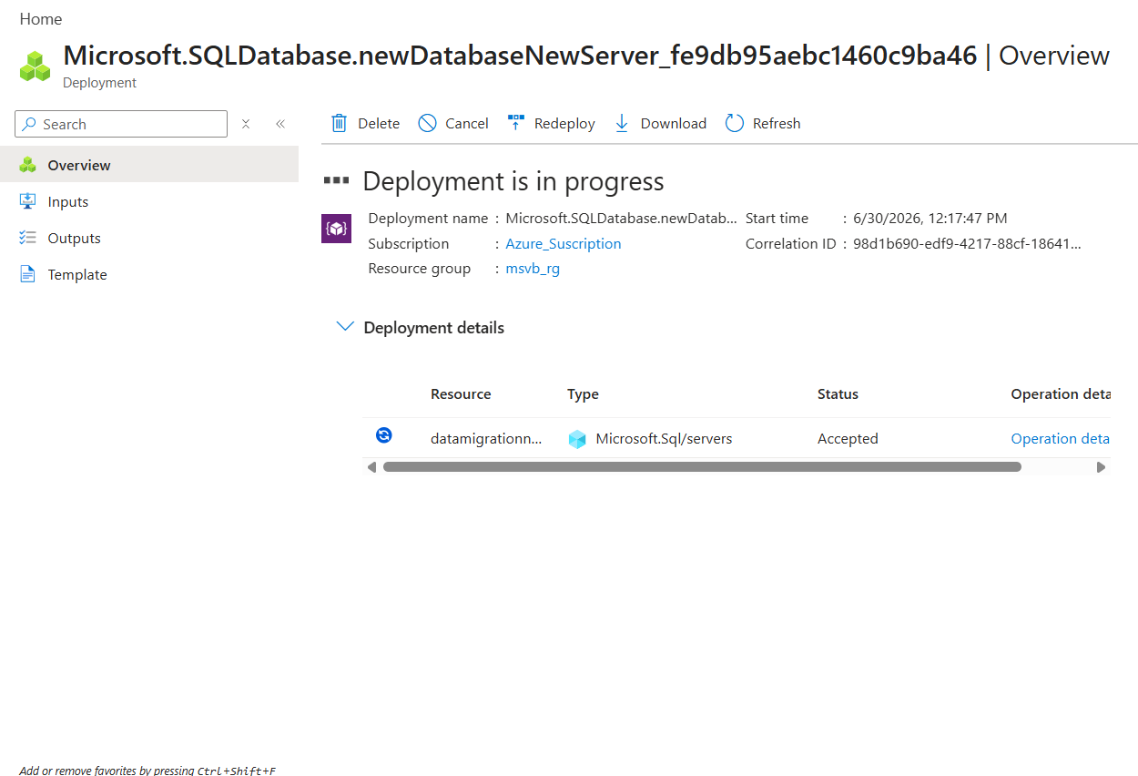
Azure Data Factory (ADF)
Definition:
Azure Data Factory (ADF) is a cloud-based data integration service provided by Microsoft Azure. It is used to create, schedule, and manage data pipelines that move and transform data between different data sources and destinations.
Purpose in this Project:
Azure Data Factory is used to ingest data from Azure Blob Storage, perform transformations using Mapping Data Flows (such as joins, filters, derived columns, aggregations, sorting, and grouping), and load the processed data into ADLS Gen2 and Azure SQL Database.
Steps to Create Azure Data Factory
- Sign in to the Azure portal.
- Click Create a Resource → Data Factory.
- Select the Subscription and Resource Group.
- Enter a unique Data Factory Name.
- Choose the required Region.
- Review the configuration and click Create.
- After deployment, open the Data Factory and click Launch Studio.
- Create Linked Services, Datasets, and Pipelines to build and execute data workflows.
Note: Azure Data Factory supports both data movement (Copy Activity) and data transformation (Mapping Data Flow), enabling end-to-end ETL/ELT pipelines.

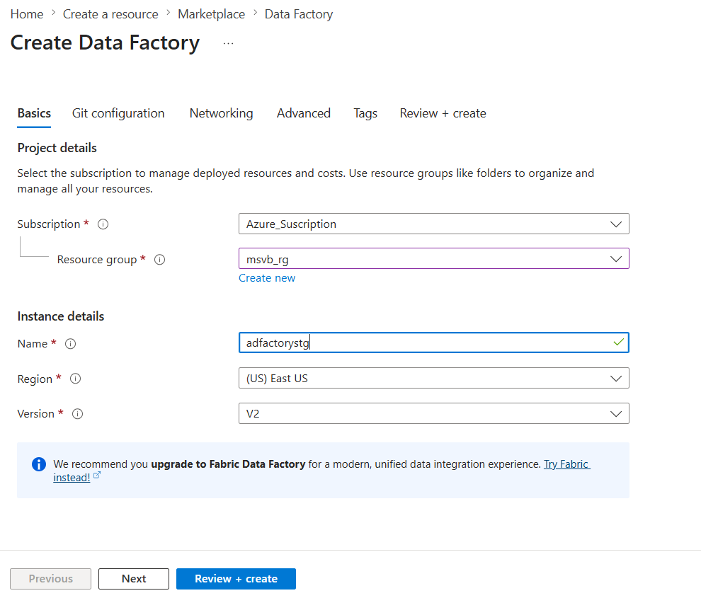
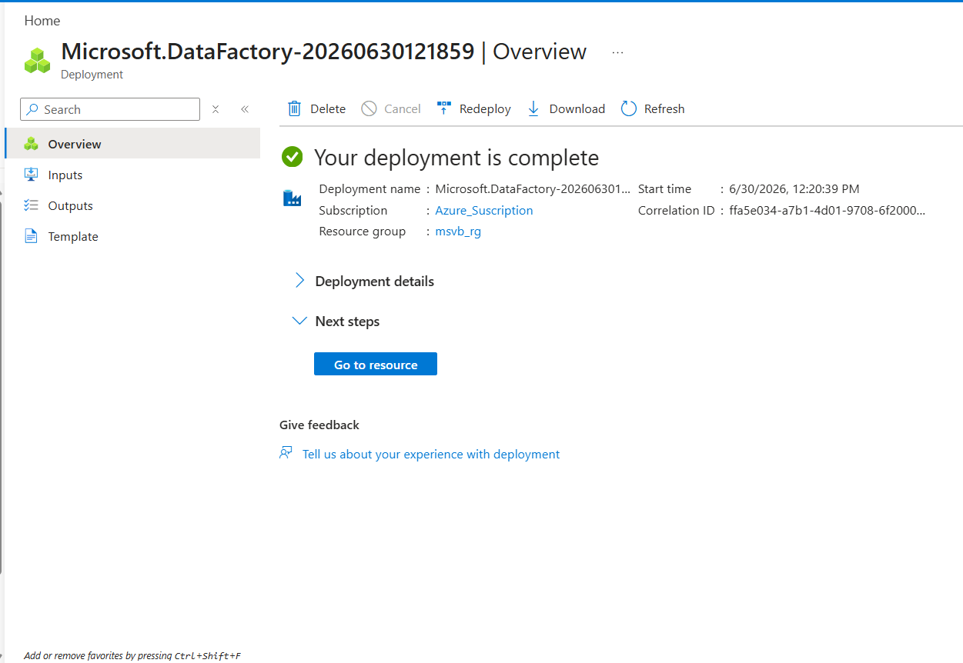
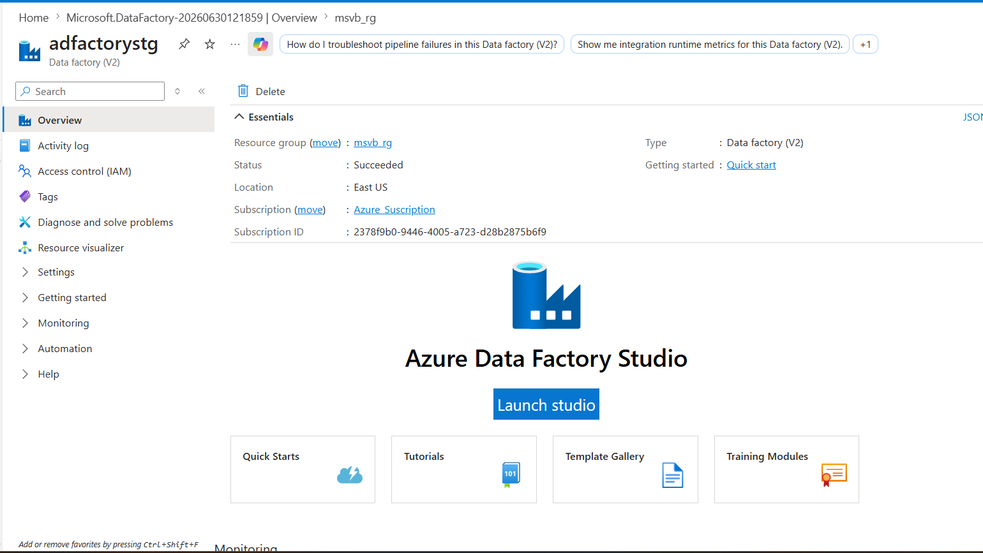
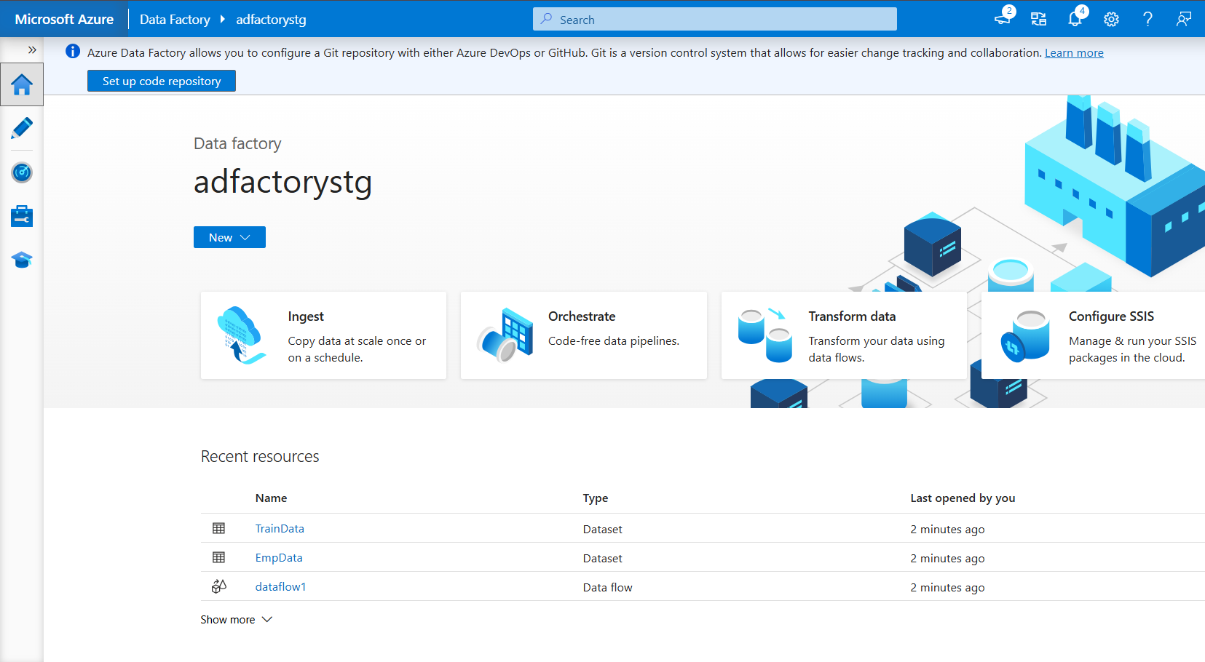
Data Flow Transformation | Description
Source | Reads data from the source dataset and passes it to the data flow for processing.
Join | Combines data from two datasets using a common key to create a unified dataset.
Filter | Removes records that do not meet the specified business conditions.
Derived Column | Creates new columns or modifies existing columns using expressions and business logic.
Select | Selects, renames, or removes columns to define the required output schema.
Aggregate | Performs summary calculations such as SUM, COUNT, AVG, MIN, and MAX on grouped data.
Group By | Groups records based on one or more columns before applying aggregation functions.
Sort | Arranges records in ascending or descending order based on specified columns.
Sink | Writes the transformed data to the target destination such as ADLS Gen2 or Azure SQL Database.

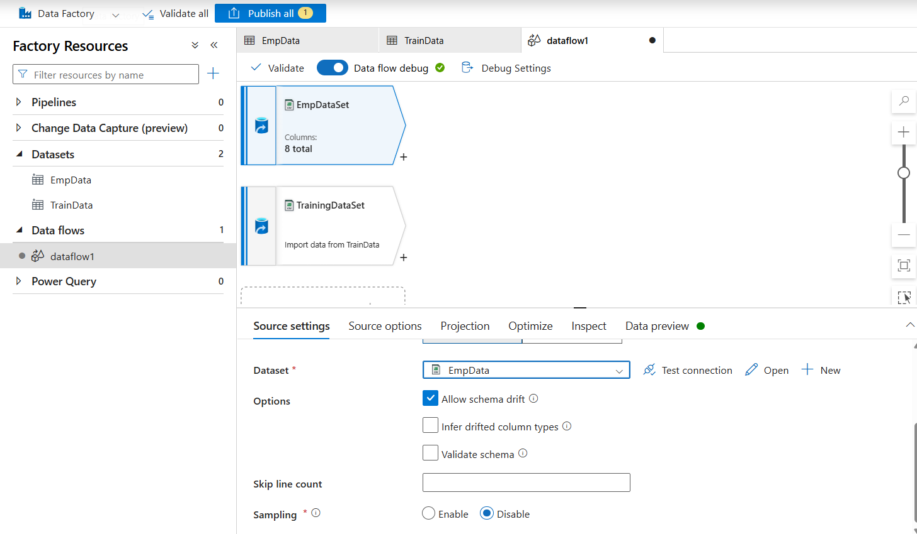
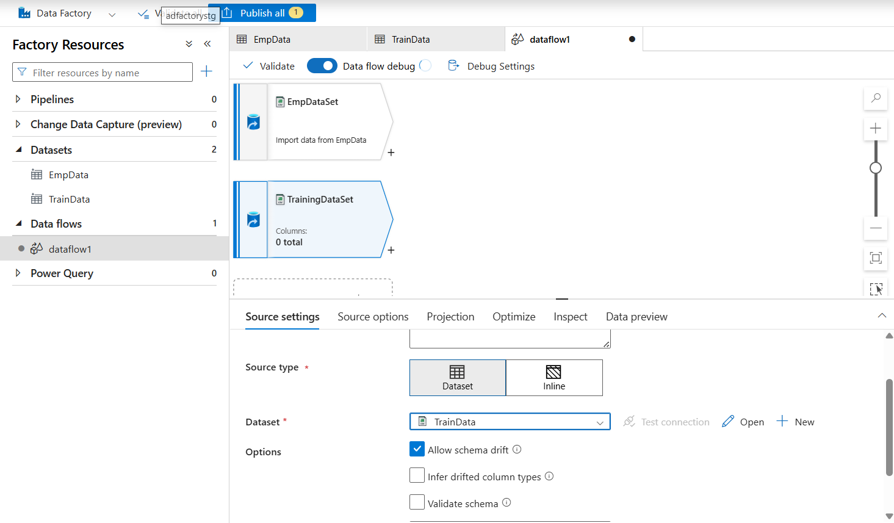
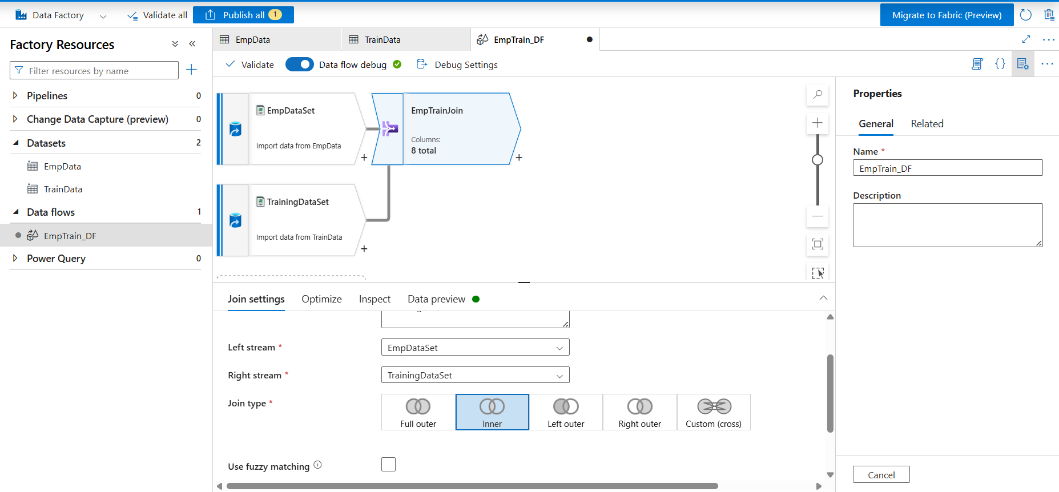
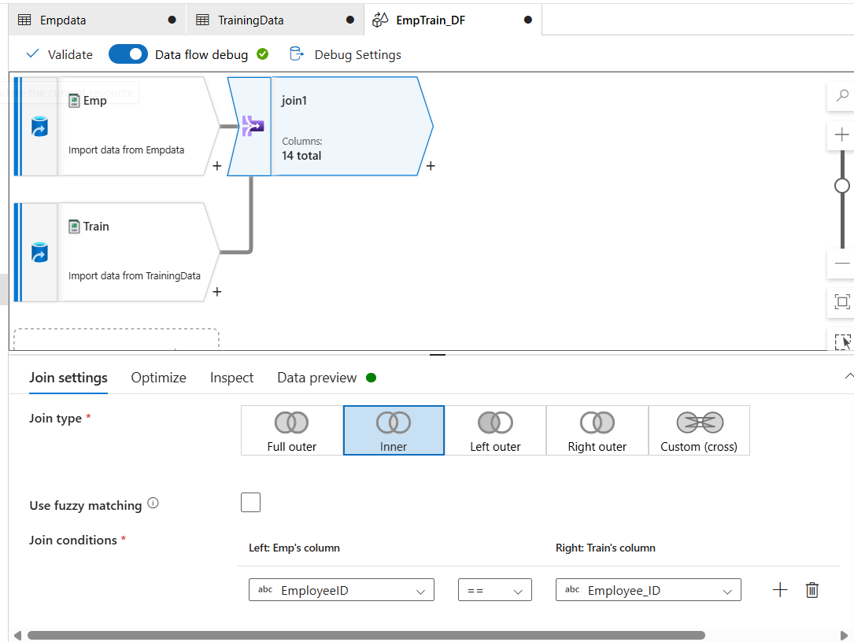
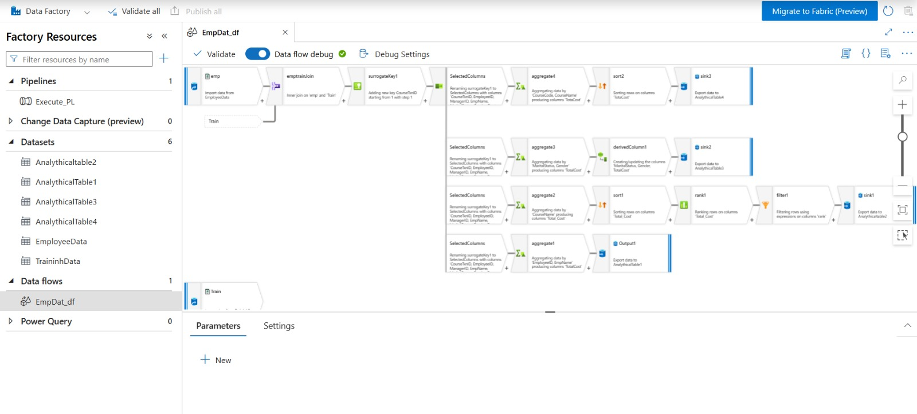

Pipeline Trigger
Definition:
A Pipeline Trigger in Azure Data Factory is used to automatically or manually start the execution of a pipeline.
One-Line Description
Trigger: Initiates the pipeline execution either manually, on a schedule, or based on an event.
Types of Triggers
Trigger Type | Description
Manual Trigger (Debug/Trigger Now) | Executes the pipeline manually whenever required.
Schedule Trigger | Runs the pipeline automatically at a specified date and time.
Tumbling Window Trigger | Executes the pipeline at fixed time intervals while maintaining state.
Event Trigger | Starts the pipeline automatically when an event occurs, such as a file being created or deleted in Azure Blob Storage or ADLS Gen2.
In This Project
Manual Trigger: The pipeline is executed manually using the Trigger Now option to process the input data and load the transformed output into the target destination.
Verification: After executing the pipeline, navigate to Azure SQL Database and verify that the target tables have been created successfully and that the transformed data has been loaded correctly.
Or, as a simple step:
Step 8: Execute the pipeline and verify in Azure SQL Database that the target tables are created and populated with the transformed data.

