|  |
| --- |
| Part 1  Create a view named "initialCustomers" that shows the first name, last name, and email address of customers that have an id of less than 100. Once that is complete, select and view your newly created view.  create view initialCustomers as  SELECT first_name, last_name, email  FROM sakila.customer  Where customer_id > 100;  Select * from initialCustomers; |

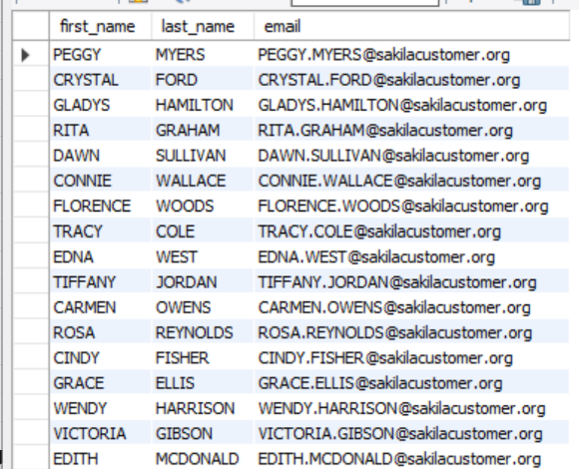

|  |
| --- |
| PArt 2Create a table named "ProductList". Include the following columns:ProductIdProductName Include the following requirements:   1. Every product should have an automatically generated id number that should be unique for each product. 2. Give each column a data type that would apply 3. Give the DateAdded column a default value for the current local time. 4. All columns CANNOT be null.  PriceDateAddedEmployeeSupportId CREATE TABLE ProductList (  ProductID INTEGER PRIMARY KEY AUTO_INCREMENT,  ProductName VARCHAR(50) UNIQUE not null,  Price decimal (5,2) not null,  DateAdded DATETIME default current_timestamp,  EmployeeSupportId VARCHAR(5) not null  CHECK (length(EmployeeSupportId) = 5)  );  Insert one product into the table following the given guidelines when the table was created.  -- Don't include the ProductId or the DateAdded  insert into ProductList (ProductName , Price, EmployeeSupportId )  value ("popcorn","3.93","f4y8*");  Run a query to see the single product in your table.  Select * from ProductList; |