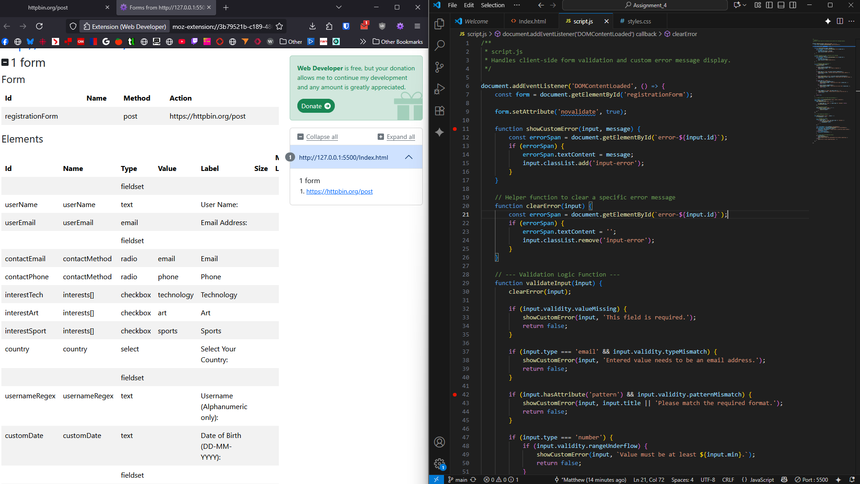

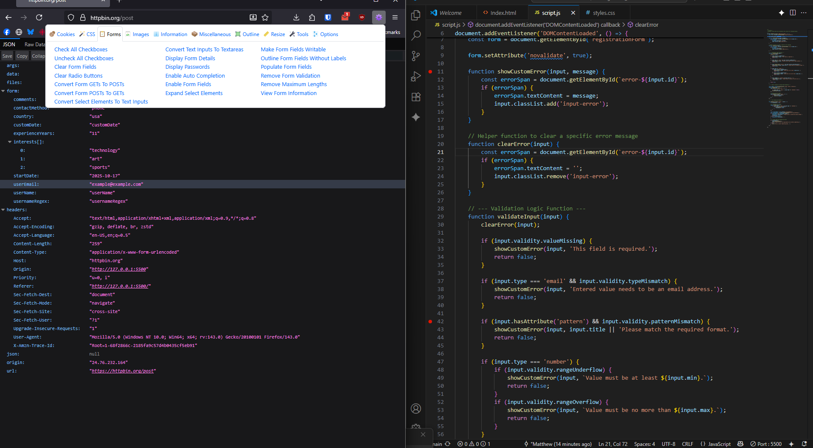

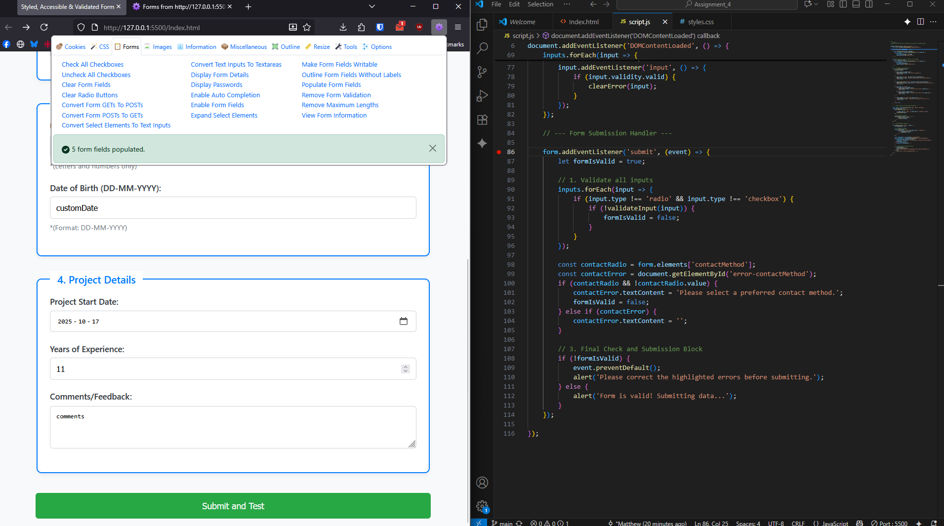

I added the correct break points to my code and slowly went thought with a debugging extension to attempt to throw the various error codes as show in the screenshots above. Having a debugine extension proved useful to auto populate data and then I manually manitpuylated it to be incorrect. My code seemed robust enough to handle a lot of the errors I threw at it tho.