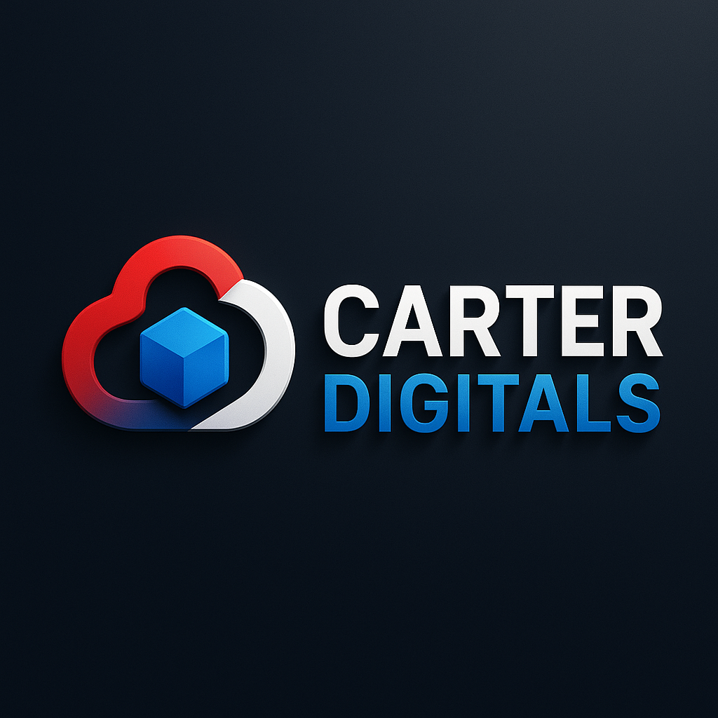
CARTER DIGITALS
(PTY) LTD

High-Agility Digital Infrastructure & AI-Enabled Solutions
For South Africa's Forward-Thinking Institutions
COMPANY PROFILE · 2025 / 2026
B-BBEE  LEVEL 1  135% Procurement | 100%  BLACK-OWNED  YOUTH-OWNED | CSD  REGISTERED  POPIA Compliant | 5–7 DAY  DELIVERY  Guaranteed

Kabelo Kadiaka · Founder & Director
kabelokadiaka4@gmail.com · 072 402 6893 · carterdigitals.co.za

01 · WHO WE ARE
Built Different. Built African. Built to Win.

South Africa doesn't need more digital vendors promising the world from a PowerPoint. It needs builders — people who show up, deliver on time, and leave institutions stronger than they found them.
Carter Digitals (Pty) Ltd is a Pretoria-based digital services studio built exactly for that purpose. We design and deliver high-performance websites, bespoke web applications, internal business tools, and strategic brand collateral — for schools, law firms, medical practices, guesthouses, SMEs, and government-aligned institutions across South Africa.
We are 100% Black-Owned, B-BBEE Level 1 certified, CSD registered, and engineered for speed — delivering production-ready digital infrastructure in 5–7 business days. Not weeks. Not months. Days.
We don't just build websites. We build institutional credibility — the kind that earns trust before a word is read, opens procurement doors that were previously closed, and compounds in value the longer it runs.

L1  B-BBEE Level 1 — EME | 135%  Procurement Recognition | 5–7  Day Delivery Guarantee | 100%  Black & Youth Owned

"We don't ask you to trust our pitch. We ask you to look at what we've already built — and let the work speak."

Registered Name | Carter Digitals (Pty) Ltd
CIPC Registration | 2025/907839/07
SARS Tax Reference | 9382428234
B-BBEE Status | Level 1 Contributor (EME) — 135% Procurement Recognition
Ownership | 100% Black-Owned | 100% Youth-Owned
CSD Registration | Registered & Active
Compliance | POPIA Compliant across all data handling & processing
Location | 1457 Block L, Soshanguve, Pretoria, Gauteng

02 · CORE SERVICES
What We Deliver — From a Single Page to a Full Platform

From a single landing page to a full enterprise web application — we design, develop, and deliver digital infrastructure that works. Every engagement is treated with the same discipline, regardless of scope.

🌐 Website Development  Custom, mobile-first websites for schools, SMEs, law firms, medical practices, guesthouses, and institutions. Built on Next.js with Vercel global hosting and SEO from day one.  Next.js · Vercel · SEO · Mobile-First · 5–7 Day Delivery |  | ⚙️ Bespoke Web Applications  Custom-built web apps for any business challenge — client portals, booking systems, inventory management, quoting tools, and interactive dashboards.  React · FastAPI · PostgreSQL · Custom Logic
🛠️ Internal Business Tools  Staff dashboards, invoice trackers, pipeline managers, HR systems, and any internal process that deserves better than a spreadsheet. Built around your exact workflows.  Operations · Dashboards · Automation · Portals |  | 🎨 Logo & Brand Identity  Professional logo design, brand colour systems, typography guides, and complete identity packages — built for digital and print use from day one.  Logo Design · Brand Kit · Style Guide · Print-Ready
🖨️ Flyers, Posters & Print Media  High-impact promotional materials — event flyers, A5/A4 service posters, promotional banners, and social media graphics. Print-ready PDF files delivered with every order.  Flyers · Posters · Banners · Social Graphics · Print-Ready |  | 📊 Pitch Decks & Company Profiles  Investor-ready pitch decks and corporate company profiles that open doors — designed for tenders, funding applications, enterprise meetings, and government procurement.  Pitch Decks · Company Profiles · Proposals · Tenders

03 · WEBSITE DEVELOPMENT
Your Digital Foundation — Built Right, Built to Last

A website is not a marketing expense. It is infrastructure. It is the 24-hour front door to your institution — working while you sleep, answering questions you don't have time to answer, and earning trust with every visitor who lands on it.
At Carter Digitals, website development is our flagship service — and the discipline we have refined to a science. Every site we build is fast, secure, mobile-first, and engineered to rank. We don't use templates. We don't use page builders. We build on Next.js — the same framework powering some of the world's most demanding digital platforms — deployed on Vercel's global infrastructure for guaranteed uptime and blazing-fast load speeds.

Why Next.js & Vercel?
In South Africa's real-world bandwidth conditions, speed is not a luxury — it is the difference between a visitor who stays and one who leaves. Next.js delivers sub-second load times, built-in SEO optimisation, and a performance architecture that Google rewards with higher search rankings. Vercel ensures your site is live 24/7, anywhere in the country, without downtime.

- Mobile-first design — built for the smartphone-first South African user
- Core Web Vitals optimised — the performance metrics Google uses to rank your site
- Built-in SEO from day one — not bolted on as an afterthought
- WhatsApp click-to-chat, Google Maps, and contact forms — standard on every build
- Google Business Profile setup — get found locally before anyone else
- Year 1 hosting and domain included — zero extra cost to get online

"In the time it takes most agencies to finish their proposal, we've already launched your site."

04 · SMALL BUSINESS WEBSITE PACKAGES
Pick Your Package. Go Live in 5–7 Days.

No lock-in contracts. No hidden fees. All packages include free Year 1 hosting and domain. Optional monthly retainers for businesses that want a continuous digital partnership.

TIER 1 · LAUNCH  Vula  Get online and start getting calls.  R3,999  + R399/mo retainer (optional) | TIER 2 · MOST POPULAR  Khula  Convert visitors into paying clients.  R7,999  + R799/mo retainer (optional) | TIER 3 · PREMIUM  Elevate  A fully managed digital engine.  R14,999  + R1,199/mo retainer (optional)
✔ Up to 4 pages | ✔ Up to 8 pages incl. Portfolio & Blog | ✔ Sanity CMS — full content management
✔ Hosting & domain — Year 1 free | ✔ Hosting & domain — Year 1 free | ✔ Hosting & domain — Year 1 free
✔ Lead form + WhatsApp integration | ✔ AI WhatsApp chatbot — 24/7 | ✔ AI chatbot — 24/7 sales & support
✔ Google Business Profile setup | ✔ Quote / booking request system | ✔ E-commerce ready
✔ Mobile-first branded design | ✔ SEO keyword targeting (3 keywords) | ✔ Advanced SEO + monthly ranking report
✔ Basic SEO | ✔ Google Analytics + Search Console | ✔ Custom integrations (CRM, payments)
✔ 5–7 day delivery | ✔ Everything in Vula included | ✔ Everything in Khula included

05 · SCHOOL WEBSITE PACKAGES
Built for Institutions That Shape the Next Generation

A school's website is not a formality — it is the first place a parent goes when deciding whether to trust you with their child. We build school websites that earn that trust immediately, with every page, every interaction, every load time.

TIER 1 · FOUNDATION  Presença  Be found and trusted online.  R4,999  + R499/mo retainer (optional) | TIER 2 · MOST POPULAR  Ikredibo  Build community trust & enrolment.  R9,999  + R899/mo retainer (optional) | TIER 3 · PREMIUM  Mastery  Full content control + 24/7 AI.  R18,999  + R1,499/mo retainer (optional)
✔ 5 pages (Home, About, Grades, News, Contact) | ✔ 10 pages (Staff, Gallery, Admissions+) | ✔ Sanity CMS — full content management
✔ Hosting & domain — Year 1 free | ✔ Hosting & domain — Year 1 free | ✔ Hosting & domain — Year 1 free
✔ Mobile-first fast design | ✔ News & announcements system | ✔ AI chatbot — 24/7 admissions & FAQ
✔ WhatsApp click-to-chat | ✔ Parent enquiry / enrolment form | ✔ Unlimited pages + downloads portal
✔ Google Maps + contact form | ✔ Google Analytics dashboard | ✔ Staff / SGB portal with login
✔ Basic SEO | ✔ Branded school email | ✔ Advanced SEO + Search Console

06 · ADD-ON SERVICES
Bolt-On Extras — Supercharge Any Package

Every package can be extended with powerful add-ons — each one designed to be activated immediately after your site goes live, so your digital investment starts compounding from day one.

Add-On Service | Once-Off | Monthly
AI Chatbot & WhatsApp Automation | R4,999 | R499/mo
SEO & Google Setup | R999 | —
Hosting & Domain Management | R1,990/yr | R199/mo
Sanity CMS Setup & Training | R3,499 | R349/mo
Company Profile & Pitch Deck | R1,999 | —

07 · BEYOND WEBSITES
Bespoke Web Applications & Internal Business Tools

Your business has problems a website alone won't solve. If your team is managing critical processes in WhatsApp groups or spreadsheets — we can fix that.
We build custom software engineered around your exact workflows — not generic SaaS tools that almost fit, but purpose-built applications that do exactly what you need, with exactly the logic your team operates on.

📈 Operations Dashboards  Live KPI displays, staff performance trackers, project pipelines, and Kanban boards — purpose-built for your team's daily operations and management needs.  Real-Time Data · KPIs · Kanban · Performance Tracking |  | 💰 Quoting, Invoicing & CRM Tools  Automated quote generators, invoice trackers with status updates, client management systems, and payment milestone dashboards built for your exact pricing model.  Quotes · Invoicing · CRM · Payment Milestones
📅 Booking & Scheduling Systems  Online appointment booking, resource scheduling, calendar integrations, and automated WhatsApp confirmation flows — eliminating manual admin entirely.  Appointments · Scheduling · WhatsApp Automation |  | 🤖 AI-Powered Business Tools  Intelligent chatbots, document processors, automated reporting tools, and AI assistants that handle repetitive tasks around the clock — so your team focuses on what matters.  AI · Chatbots · Document Processing · Automation
🔐 Portals & Secure Login Systems  Staff portals, client-facing portals, supplier dashboards, and multi-user systems with role-based access control — for organisations that need secure, structured information sharing.  Portals · Role-Based Access · Secure Login · Multi-User |  | 🛒 E-Commerce & Payment Systems  Online stores, product catalogues, service booking funnels with integrated payment gateways, order tracking, and fulfilment workflows — built to convert and scale.  E-Commerce · Payment Gateways · Order Tracking · Fulfilment

08 · HOW WE WORK
The 5-Phase Delivery Framework — Accountable at Every Step

Our lean delivery model removes the bloat typical of large agencies. No unnecessary meetings. No ambiguous sprints. No junior teams executing senior promises. Just a clear, disciplined process — and a production-ready system at the end.

PHASE | WHAT WE DO
Phase 1  Discovery & Alignment | We map your institutional goals, stakeholder expectations, technical constraints, and compliance requirements before a single line of code is written.
Phase 2  Architecture & Wireflow | We design the information hierarchy, user journeys, and system architecture upfront — eliminating scope creep before it starts.
Phase 3  Design & Build | We develop your platform using modern, secure frameworks, building content and interface as a unified experience.
Phase 4  QA & Compliance | We conduct cross-device testing, refine all messaging, and validate against security, accessibility, SEO, and regulatory standards.
Phase 5  Launch, Handover & Enablement | We deploy, document, and equip your team for full ownership — so you're never dependent on us to operate what we've built.

09 · THE PERSON BEHIND THE WORK
Meet Kabelo Kadiaka

KK  Kabelo Kadiaka  Founder & Director  Carter Digitals (Pty) Ltd  Soshanguve, Pretoria  B-BBEE LEVEL 1  135% PROCUREMENT  5–7 DAY DELIVERY  FOUNDED 2023 |  | AI-Augmented. Human-Driven. Built to Deliver.  Capability over credentials. Outcomes over promises.  Kabelo Kadiaka is the founder and director of Carter Digitals — a digital services studio rooted in Pretoria's Soshanguve and built to serve South Africa's forward-thinking institutions. With deep expertise spanning full-stack web development, enterprise cloud architecture on GCP, and AI-augmented systems engineering, Kabelo delivers enterprise-grade output at startup speed.  From township SME landing pages to AI-powered enterprise platforms — the quality, discipline, and speed are the same.  Carter Digitals is named in tribute to a close friend who passed away in April 2021. The company exists as a living monument to that friendship — and as proof that the dream of building something real from nothing is still possible.  Technical Stack: Next.js · React · Python / FastAPI · PostgreSQL · GCP / Vertex AI · Vercel · Sanity CMS · WhatsApp API · Make.com

10 · ENGAGEMENT MODELS
Structured for Your Reality. Flexible by Design.

Every institution has different risk tolerances, budget cycles, and decision-making timelines. Our engagement models are designed to meet you where you are — with clear outcomes at every stage.

Project-Based — Best for defined initiatives
Fixed scope, fixed cost, milestone-driven delivery. You know exactly what you're getting, when you're getting it, and what it costs. No ambiguity. No hidden fees. No surprises.

Retainer & Ongoing Support — Best for long-term partnerships
Continuous optimisation, performance monitoring, content updates, and technical support — delivered on a predictable monthly basis. Ideal for institutions that want a trusted digital partner, not a one-time vendor.

Prototype-to-Production — Best for risk-sensitive mandates
We deliver a fully functional pilot before committing to full-scale rollout. You validate real-world performance and stakeholder reception before the full investment — eliminating implementation risk at the most critical stage.

READY WHEN YOU ARE
Let's Build Something That Works For You

No obligation. A 30-minute discovery call. No pitch. No pressure. Just clarity on what we can build together — and what it will take to get you there.

Kabelo Kadiaka
Founder & Director · Carter Digitals (Pty) Ltd
✉ kabelokadiaka4@gmail.com
☎ 072 402 6893
🌐 carterdigitals.co.za
■ 1457 Block L, Soshanguve, Pretoria, Gauteng
Translating real-world value into digital systems.
CIPC: 2025/907839/07 · B-BBEE Level 1 — 135% Procurement · POPIA Compliant · CSD Registered

